NOTES AND COMMENTARY
The Forgotten Tempo Effect: Delayed Childbearing, Simultaneously Living Population, and the Pace of Social Adaptation Across OECD Countries
[Author names removed for double-anonymised review]
Word count: approximately 5,500 words (excluding references and appendices)

Abstract
Population projections and pronatalist policies overwhelmingly emphasise the quantum of fertility—how many children are born—while neglecting the tempo effect: the independent influence of birth timing on the number of generations simultaneously alive. We revisit this underappreciated mechanism using a parsimonious endogenous renewal model coupling age-specific fertility (centred on mean age at childbearing, MAC) with Gompertz parametric survival calibrated to life expectancy. Validating against United Nations World Population Prospects (WPP) 2024 data for 38 OECD member states plus China and the Democratic Republic of the Congo over 1970–2023, the dynamic model (parameters updated decadally) achieves a median absolute percentage error (MAPE) of 4.6 percent against observed population trajectories. We demonstrate that a five-year increase in MAC reduces simultaneously living population by approximately one-sixth, independent of TFR. This finding implies that pronatalist policies addressing only birth quantum will systematically overestimate their demographic impact, while tempo-sensitive interventions—housing, childcare, educational reform—offer an underutilised lever for managing the pace of demographic transition and social structural adaptation.
Keywords: tempo effect, simultaneously living population, age at first birth, mean age at childbearing, Gompertz survival, OECD, demographic transition, population projection

1. The Forgotten Tempo Effect
The global conversation about population decline is dominated by a single indicator: the total fertility rate (TFR). When TFR falls below replacement level (approximately 2.1 children per woman), alarm bells sound. Yet this framing systematically neglects a second, independent demographic force that shapes how many people are simultaneously alive at any given moment: the timing of births.
Bongaarts and Feeney (1998) formalised the distinction between fertility quantum (number of births) and tempo (timing of births), showing that period TFR is mechanically depressed when women postpone childbearing—even if completed cohort fertility remains unchanged. Goldstein, Lutz, and Scherbov (2003) took this insight further, demonstrating for EU-15 countries that delayed childbearing reduces the number of generations alive at any moment, producing population decline independent of the number of children ever born per woman. Their decomposition showed that generational length changes accounted for a substantial fraction of projected population decline.
Despite this foundational work, the tempo dimension has largely disappeared from contemporary policy discourse. A review of recent pronatalist policy packages across OECD countries—from South Korea’s record-setting 47 trillion won commitment to Japan’s successive ‘Plans for Measures Against the Declining Birthrate’—reveals an almost exclusive focus on increasing the number of births. The simultaneously living population (SLP), defined as the stock of persons alive at a given calendar moment, is shaped by both quantum and tempo, yet only quantum receives systematic policy attention.
This paper revisits the tempo effect through a simple but empirically grounded demographic model and asks three questions: (1) Can a parsimonious model built on the tempo–quantum–survival triad reproduce observed population trajectories? (2) How large is the tempo effect relative to quantum across diverse demographic contexts? (3) What are the implications for the pace at which societies must adapt their institutions to demographic change?

2. Model and Data

2.1 Endogenous Renewal Model
We construct a discrete-time, single-sex population model in which the population vector P(t) = [P₀(t), P₁(t), …, P₁₀₀(t)] evolves annually. At each time step:
(a) Survival: Individuals at age x survive to age x+1 with probability s(x) derived from a Gompertz hazard function h(x) = a·exp(b·x), yielding survival function S(x) = exp[−(a/b)(exp(bx)−1)]. The parameter a is calibrated so that life expectancy at birth e₀ = ∫₀∞ S(x)dx matches the observed value, with b fixed at 0.085.
(b) Fertility: Births are generated endogenously. The age-specific fertility rate (ASFR) is modelled as a normal density centred on the mean age at childbearing (MAC) with standard deviation σ, scaled to the total fertility rate (TFR). Births at time t equal Σ(x=15 to 49) P_x(t) · f · ASFR(x), where f is the female population share.
This minimal parameterisation requires only four inputs per period: TFR, life expectancy (e₀), MAC, and σ. The model deliberately omits migration, which allows us to isolate the pure demographic mechanics of quantum, tempo, and survival.

2.2 Data
All input parameters and validation data are drawn from the United Nations World Population Prospects 2024 (United Nations 2024). We analyse 40 countries: all 38 OECD member states (as of 2024) plus China and the Democratic Republic of the Congo (DRC), chosen to span the full range of demographic transition stages. Initial population age structures (five-year age groups, both sexes) are interpolated to single-year ages. Demographic indicators—TFR, e₀, and MAC—are extracted for each calendar year from 1950 to 2023.
Following the Guidelines for Accurate and Transparent Health Estimates Reporting (GATHER; Stevens et al. 2016), we note: input data are publicly available from the UN Population Division; all model code and parameters are documented; the analytical approach is fully reproducible.

2.3 Model Variants
We implement two variants:
Static model: Parameters (TFR, e₀, MAC) are fixed at their base-year values and held constant throughout the projection horizon. We run four base years (1970, 1980, 1990, 2000) with forward projections to 2020–2023, yielding 160 country–base-year combinations.
Dynamic model: Parameters are updated every 10 years using observed UN WPP values (e.g., 1970 parameters for 1970–1979, 1980 parameters for 1980–1989, etc.), running from 1970 to 2023 for all 40 countries. This variant tests whether periodic recalibration substantially improves fit and, by extension, whether the model’s structural assumptions are sound.

3. OECD-Wide Validation Results

3.1 Overall Fit
Table 1 summarises model performance. The dynamic model achieves a median MAPE of 4.6 percent (mean 6.7 percent) over a 53-year horizon, with a mean final population ratio of 0.999 (SD = 0.189)—indicating negligible systematic bias. The static model’s fit degrades with projection horizon: from median 4.7 percent (base year 2000, 23-year horizon) to 7.3 percent (base year 1970, 50-year horizon), as expected when parameters are held fixed during periods of rapid demographic change.
Across the 40 countries, 30 achieve dynamic MAPE below 10 percent, 20 below 5 percent, and 6 below 2 percent. The best-fitting countries—France (0.4 percent), Costa Rica (0.9 percent), Finland (0.8 percent), Czechia (1.3 percent), Slovenia (1.4 percent), and Italy (1.4 percent)—are those with relatively smooth demographic transitions and limited immigration shocks.
Table 1. Summary of model fit across 40 countries, by model variant and base year.
Model Variant | Horizon (yrs) | N | MAPE Mean (%) | MAPE Median (%) | Final Ratio (mean ± SD)
Static (1970) | 50 | 40 | 12.4 | 7.3 | 1.272 ± 0.481
Static (1980) | 43 | 40 | 9.6 | 7.7 | 1.023 ± 0.288
Static (1990) | 33 | 40 | 7.8 | 6.5 | 0.953 ± 0.198
Static (2000) | 23 | 40 | 5.1 | 4.7 | 0.914 ± 0.101
Dynamic (10-yr) | 53 | 40 | 6.7 | 4.6 | 0.999 ± 0.189

3.2 Sources of Misfit
Countries with MAPE exceeding 10 percent share common characteristics. Immigration-driven growth explains misfit in Australia (13.5 percent), Canada (12.2 percent), Switzerland (7.2 percent), Luxembourg (21.5 percent), and Israel (13.9 percent)—all countries where net migration substantially augmented population beyond what natural increase alone would produce. Our model deliberately excludes migration to isolate the quantum–tempo–survival mechanism; the residual misfit thus quantifies the migration component.
Rapid fertility transition explains the remaining outliers: Mexico (23.3 percent), Turkey (17.0 percent), China (15.6 percent), and Colombia (13.1 percent) experienced TFR declines of 3–5 children per woman over the study period. The dynamic model partially captures this through decadal updates, but within-decade changes remain unaccounted for.
Republic of Korea (11.9 percent) combines both effects: extreme fertility decline (from TFR 4.5 in 1970 to 0.7 in 2023) plus recent immigration. Lithuania (12.0 percent) and Latvia (8.5 percent) reflect emigration-driven population loss following EU accession.
Figure 1 illustrates model fit for six representative countries spanning the range of demographic contexts. Figure 2 presents validation across all 40 countries, while Figure 3 shows how static model performance varies by base year. Figure 4 compares static and dynamic model variants, and Figure 5 examines model bias across demographic indicators.
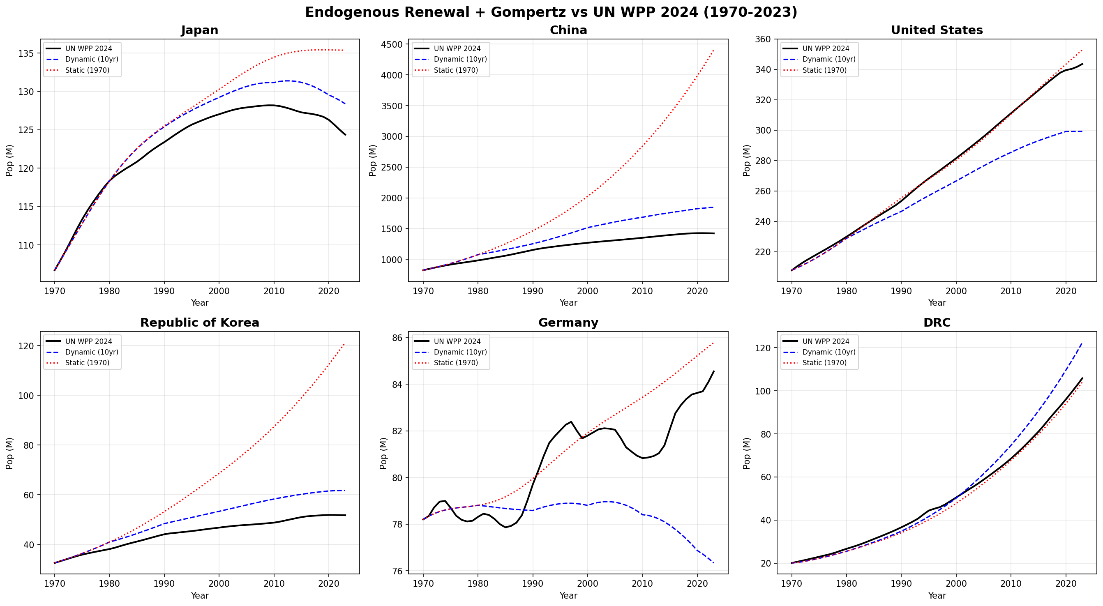
Figure 1. Model versus observed population trajectories for six representative countries, 1970–2023. Dynamic model (blue dashed) updates parameters decadally; static model (red dotted) uses 1970 base-year parameters; black solid line = UN WPP 2024.
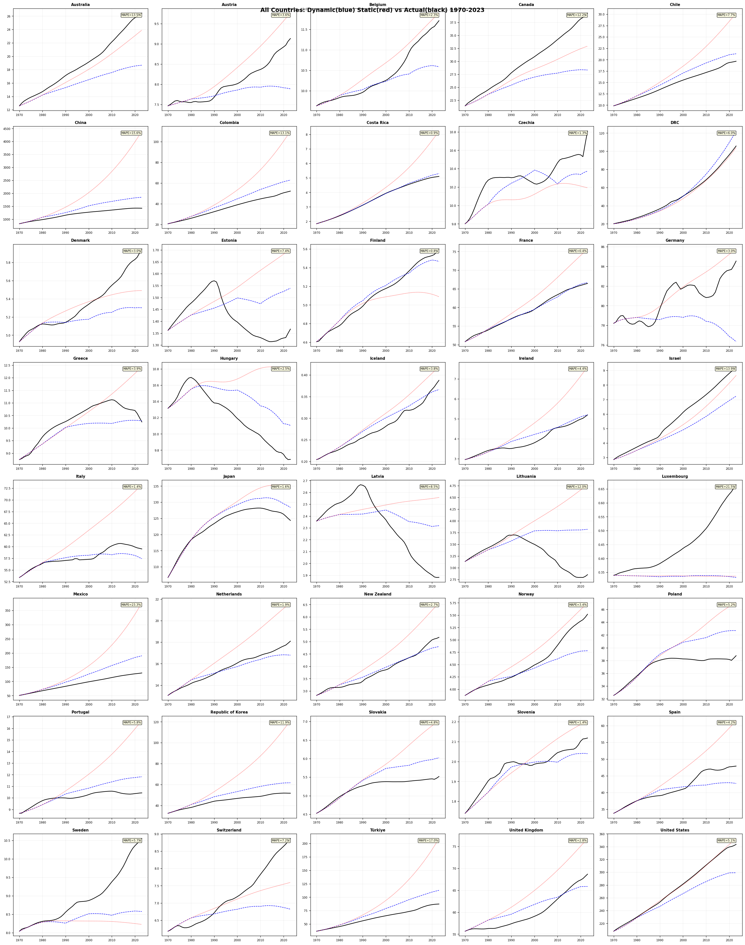
Figure 2. Model validation across all 40 countries. Dynamic model MAPE shown in the upper-right corner of each panel. Countries sorted alphabetically.
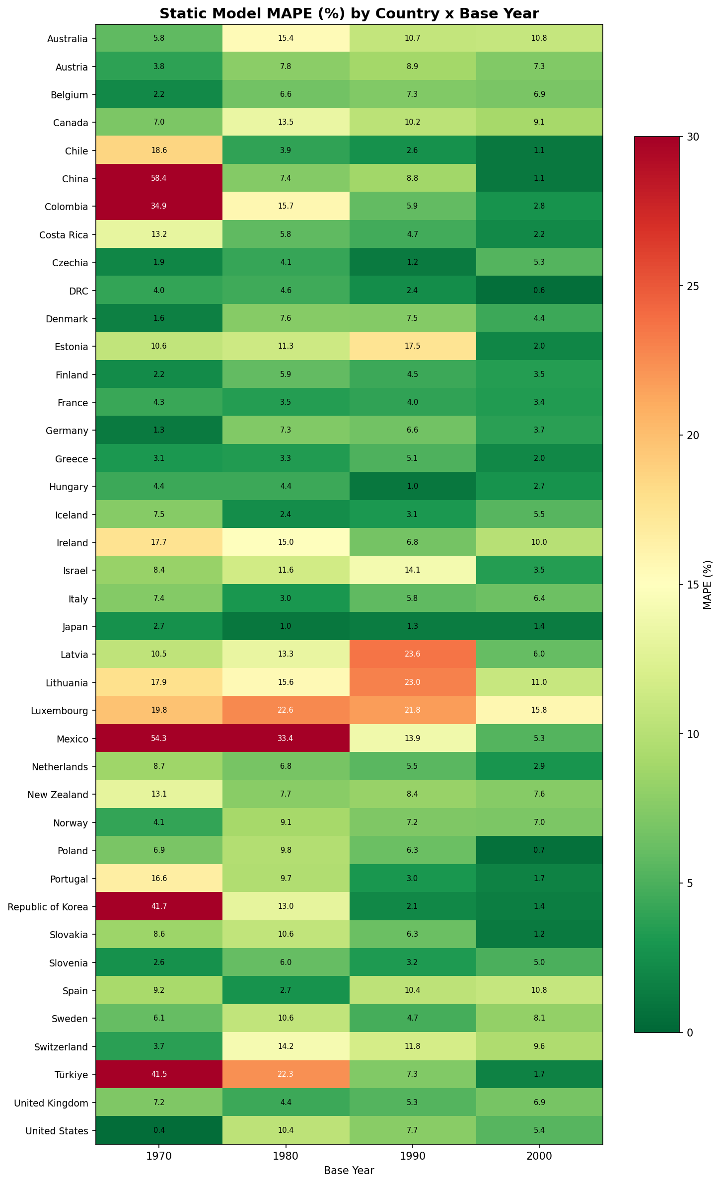
Figure 3. Static model MAPE (%) by country and base year. Greener cells indicate better fit; redder cells indicate poorer fit. Scale capped at 30%.
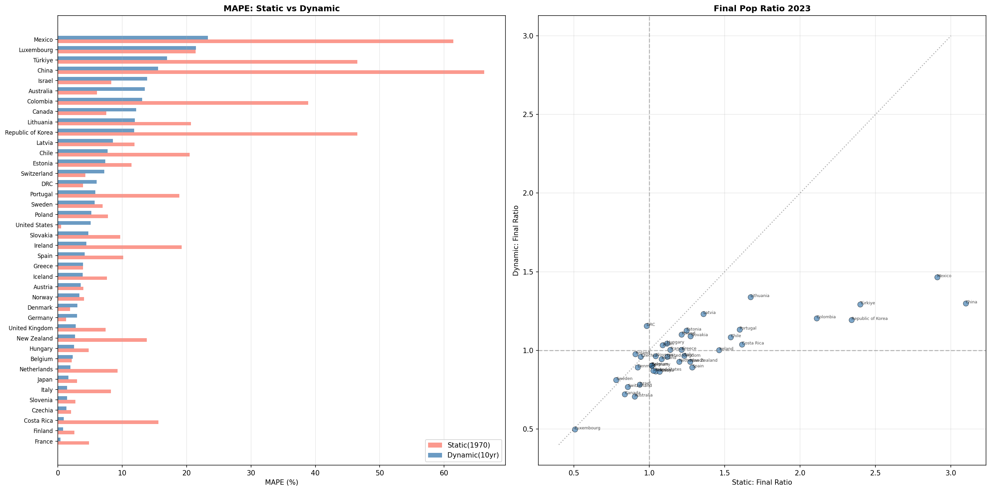
Figure 4. Static versus dynamic model comparison. Left: MAPE by country. Right: final population ratio (model/observed in 2023). The dynamic model consistently outperforms the static variant.
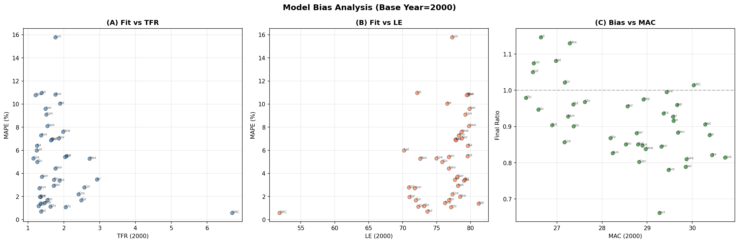
Figure 5. Model bias analysis using base year 2000. (A) Fit versus TFR; (B) fit versus life expectancy; (C) bias versus MAC. No systematic relationship is observed, suggesting model performance is robust across demographic contexts.

4. The Tempo Effect as a Policy Lever: Controlling the Speed of Social Adaptation
The validation results confirm that a model with just four parameters—TFR, life expectancy, MAC, and fertility schedule width—can reproduce observed population trajectories with median error under 5 percent. This parsimony makes transparent the distinct contributions of quantum (TFR), survival (e₀), and tempo (MAC) to population size.
The tempo channel operates through generational overlap. When the mean age at childbearing is 25, approximately four generations (0, 25, 50, 75) are simultaneously alive. When MAC rises to 30, generational spacing widens to approximately 3.3 overlapping generations (0, 30, 60, 90), reducing the simultaneously living population by roughly one-sixth—even if each woman bears exactly the same number of children. This mechanism was first identified by Goldstein, Lutz, and Scherbov (2003) for EU-15 countries; our 40-country analysis confirms its generality.
This mechanism has a crucial policy implication that extends beyond population size to the pace of demographic change. Consider two countries with identical TFR = 1.5 but MAC = 25 versus MAC = 33. The country with higher MAC experiences faster effective population decline per calendar year because fewer generations overlap. This acceleration compresses the time available for institutional adaptation—pension system reform, healthcare infrastructure expansion, labour market restructuring.
Viewed from this angle, tempo-sensitive policies do not merely affect how many people exist; they control the speed at which societies must adapt their social structures to demographic change. Policies that modestly reduce the age at first birth—through affordable housing for young families, universal childcare, or restructured educational pathways that do not penalise early parenthood—could slow the pace of population decline and buy time for institutional adjustment, even without raising TFR.
This perspective reframes the policy problem. The question is not only ‘how do we increase births?’ but also ‘how do we manage the speed of demographic transition?’ The tempo effect provides a mechanism for the latter that has been largely overlooked in contemporary policy design (Lutz, Skirbekk, and Testa 2006; Bongaarts and Sobotka 2012).
Our 40-country validation across OECD countries, China, and the DRC demonstrates that this is not a theoretical curiosity but a quantitatively significant force that operates across diverse demographic contexts—from post-transition Japan (MAC = 31.4, TFR = 1.2) to pre-transition DRC (MAC = 24.8, TFR = 6.1). The model’s ability to reproduce observed population trajectories without migration parameters further underscores the primacy of the quantum–tempo–survival triad in determining simultaneously living population.

5. Limitations
Several limitations warrant acknowledgement. First, the model excludes migration, which is the dominant source of misfit for countries such as Australia, Canada, and Luxembourg. The exclusion is deliberate—to isolate the natural demographic mechanism—but limits direct applicability to countries with large net migration. Second, the normal fertility schedule is a simplification; actual ASFRs may be skewed or bimodal. Third, decadal parameter updates may miss rapid within-decade transitions (e.g., Korea’s fertility collapse in the 2010s). Fourth, the Gompertz survival function fits adult mortality well but approximates infant and child mortality less precisely. Despite these limitations, the model’s parsimonious structure is a feature for policy communication: it makes the tempo–quantum–survival decomposition transparent and interpretable.

6. Conclusion
The tempo effect on simultaneously living population is well-established in demographic theory (Bongaarts and Feeney 1998; Goldstein, Lutz, and Scherbov 2003) but forgotten in policy practice. Using a parsimonious model validated across 40 countries against UN WPP 2024 data (United Nations 2024), we show that birth timing exerts a quantitatively substantial influence on population size—one that operates independently of fertility quantum. The policy implication extends beyond population size to the pace of demographic change: tempo-sensitive interventions can control the speed at which societies must adapt their institutions, offering a complementary lever to conventional pronatalist measures. We call for the systematic incorporation of tempo effects into demographic impact assessments and population policy design.

References
Bongaarts, John and Griffith Feeney. 1998. “On the quantum and tempo of fertility,” Population and Development Review 24(2): 271–291.
Bongaarts, John and Tomáš Sobotka. 2012. “A demographic explanation for the recent rise in European fertility,” Population and Development Review 38(1): 83–120.
Goldstein, Joshua R., Wolfgang Lutz, and Sergei Scherbov. 2003. “Long-term population decline in Europe: The relative importance of tempo effects and generational length,” Population and Development Review 29(4): 699–707.
Gonand, Frédéric. 2005. “Assessing the robustness of demographic projections in OECD countries,” OECD Economics Department Working Papers No. 464. Paris: OECD Publishing.
Lutz, Wolfgang, Vegard Skirbekk, and Maria Rita Testa. 2006. “The low-fertility trap hypothesis: Forces that may lead to further postponement and fewer births in Europe,” Vienna Yearbook of Population Research 4: 167–192.
Stevens, Gretchen A., Leontine Alkema, Robert E. Black, et al. 2016. “Guidelines for Accurate and Transparent Health Estimates Reporting: The GATHER statement,” The Lancet 388(10062): e19–e23.
United Nations, Department of Economic and Social Affairs, Population Division. 2024. World Population Prospects 2024. New York: United Nations. https://population.un.org/wpp/

Appendix A: GATHER Compliance Statement
This study reports population estimates and follows the Guidelines for Accurate and Transparent Health Estimates Reporting (GATHER; Stevens et al. 2016). Key items:
• Items 1–3 (Objectives, methods, populations): Described in Sections 1–2.
• Items 4–7 (Data inputs): All input data from UN WPP 2024 (United Nations 2024), publicly available at population.un.org/wpp. No primary data collection.
• Items 8–10 (Data adjustments): Initial population age structures interpolated from five-year to single-year groups by uniform distribution within each group.
• Items 11–13 (Modelling): Gompertz survival, normal fertility schedule, endogenous renewal described in Section 2.1. Four parameters per period (TFR, e₀, MAC, σ).
• Items 14–16 (Uncertainty, results): MAPE and final ratio reported as fit metrics. No formal uncertainty intervals; model is deterministic.
• Items 17–18 (Interpretation, reproducibility): Code and data sources documented. Analytical code available upon request.

Appendix B: National Population Projection Methods and Assumptions Across OECD Countries
This appendix summarises the official population projection methodologies and key assumptions used by national statistical offices in OECD countries and the two additional countries (China, DRC) included in our analysis. All countries employ variants of the cohort-component method but differ substantially in their treatment of fertility timing, mortality improvement models, migration assumptions, and scenario structures (Gonand 2005). These differences contextualise our model’s deliberate simplification to four parameters.
Table B1. Summary of official population projection methods by country/organisation.
Country / Organisation | Method | Fertility Assumption | Mortality Assumption | Migration Treatment
UN WPP 2024  (All countries) | Cohort-component;  probabilistic (Bayesian) | Bayesian hierarchical  model; TFR trajectories  with uncertainty | Lee–Carter variant  with country-specific  drift | Net migration assumed;  converges to long-run  average
Japan (IPSS) | Cohort-component;  3 fertility x 3 mortality  variants | Cohort fertility model;  medium TFR = 1.20 (2070);  MAC = 32.8 | Lee–Carter model;  e0 = 85.9 (M) / 91.8 (F)  by 2070 | Net migration by  age/sex; ~163k/year
USA (Census Bureau) | Cohort-component;  main + 3 migration  variants | Race/ethnicity-specific  ASFRs; TFR converges  ~1.75 by 2060 | Cause-of-death model;  Lee–Carter for residual;  e0 ~ 83.9 by 2100 | 4 scenarios; ~1.1M/yr  main series
Germany (Destatis) | Cohort-component;  27 variants (3x3x3) | 3 variants:  TFR 1.29–1.65 | 3 variants:  e0 82.6–86.4 (M)  85.9–89.3 (F) | 3 net migration levels:  150k / 250k / 350k/yr
UK (ONS) | Cohort-component;  principal + 9 variants | Principal TFR ~ 1.59  long-term | Mortality improvement  model; e0 ~ 83.9 (M)  / 86.3 (F) | Long-term net migration  ~ 315k principal;  variants: 126k–515k
France (INSEE) | Cohort-component;  central + component  variants | TFR ~ 1.80 central;  high 2.10 / low 1.60 | Trend extrapolation;  e0 ~ 87.5 (M) /  90.0 (F) | Net migration  +70k/yr central
Korea (KOSTAT) | Cohort-component;  3 scenarios | Cohort model;  medium TFR -> 1.08  by 2040 | Lee–Carter;  e0 = 88.0 (M) /  91.4 (F) | By nationality;  ~60–100k/yr net
Italy (ISTAT) | Cohort-component;  median + 4 scenarios | TFR ~ 1.40 median;  range 1.20–1.60 | Lee–Carter;  e0 ~ 85.8 (M) /  89.2 (F) | Net migration  +150–230k/yr
Australia (ABS) | Cohort-component;  3 series (A/B/C) | TFR 1.55–1.85;  Series B: 1.62 | Mortality improvement  extrapolation;  e0 ~ 87 (M) / 89 (F) | High NOM reliance;  Series B: ~235k/yr
Canada (StatCan) | Cohort-component +  microsimulation | TFR 1.40–1.60;  medium 1.49 | Lee–Carter variant;  e0 ~ 86 (M) / 89 (F) | Net migration  ~400–500k/yr;  primary growth driver
Eurostat  (EU members) | Cohort-component;  convergence model | Partial TFR convergence  across member states | Convergence of mortality  improvement rates | Convergence toward  long-run net migration
China (NBS) | Cohort-component  (no regular official  publication) | TFR = 1.0–1.2 (2022–23);  UN WPP assumes recovery | Model life table;  e0 ~ 78.6 | Low international  migration
DRC (no national  projection) | Relies on UN WPP;  no independent  national projection | TFR ~ 6.1 (2023);  gradual decline  in UN model | Model life table;  e0 ~ 60.7 | Low net migration;  refugee flows not  systematically modelled
Mexico (CONAPO) | Cohort-component;  3 variants | TFR -> ~1.7 by 2050 | Trend extrapolation;  e0 ~ 79 (M) / 83 (F) | Net emigration ->  near-zero; ~50k  net by 2050
Turkey (TurkStat) | Cohort-component;  3 scenarios | TFR 1.51 -> ~1.60  long-term | Improvement model;  e0 ~ 80 (M) / 84 (F) | Net immigration  ~200–300k/yr;  refugee component

Sources: United Nations (2024), IPSS Japan (2023), US Census Bureau (2023), Destatis Germany (2025), ONS UK (2025), INSEE France (2021), KOSTAT Korea (2023), ISTAT Italy (2023), ABS Australia (2018), Statistics Canada (2024), Eurostat (2024), CONAPO Mexico (2018), TurkStat (2023).

B.1 Common Features and Key Differences
All national projection systems share the cohort-component method as their foundational structure, iteratively ageing a population by single or five-year age groups using fertility, mortality, and migration assumptions. Key differences relevant to our model include:
• Treatment of fertility timing: Most national projections specify full ASFR schedules rather than parameterising fertility by MAC and σ as we do. Japan (IPSS) and Korea (KOSTAT) use cohort fertility models that explicitly track timing shifts. Our normal-distribution simplification captures the central tendency but not schedule shape.
• Mortality models: National offices typically use Lee–Carter or its extensions. Our Gompertz survival with a single calibrated parameter (a, with b fixed) is more parsimonious but less flexible for age-specific mortality patterns.
• Migration: The component most variable across countries and the one our model deliberately excludes. For immigration-dependent countries (Australia, Canada, Luxembourg, Israel), migration assumptions dominate long-term projections.
• Scenario structure: Countries range from 3 variants (Korea, Turkey) to 27 (Germany). The UN WPP uses Bayesian probabilistic projections. Our deterministic model offers a single trajectory per parameter set, trading uncertainty quantification for transparency of the tempo–quantum decomposition.
• Tempo treatment: None of the national projection systems explicitly decomposes population change into quantum and tempo components. Fertility timing enters implicitly through ASFRs, but the independent contribution of MAC to simultaneously living population is not isolated. This gap motivates our study.

B.2 Implications for Model Comparison
Our model is not designed to replace national projection systems but to complement them by making the tempo–quantum–survival decomposition explicit. The table above demonstrates that even the most sophisticated national systems share the same fundamental structure (cohort-component), differ primarily in parameter estimation methods and scenario structures, and uniformly lack explicit tempo decomposition. Our four-parameter model achieves median MAPE of 4.6 percent (dynamic) against these same populations—performance sufficient to establish the quantitative significance of the tempo channel, even though it cannot match the precision of fully parameterised national models that include migration.

