Self-consistent thermospheric response limits the orbital-drag selectivity of a localized heat source: a coupled GITM–orbit study
T. Onishi
Affiliation: Shiga University, Japan [department and postal address to be completed by the author]. Corresponding author: T. Onishi, bougtoir@gmail.com

Abstract
Proposals to accelerate the decay of selected debris objects by locally heating the thermosphere assume that the resulting density enhancement stays where it was deposited. I test that assumption with a physically self-consistent model. A compact neutral heat source (100 GW for 1 h, centred at 300 km and 45°N) is inserted into the Global Ionosphere–Thermosphere Model (GITM) and paired with an unheated control, and the resulting density and wind fields drive drag on 256 synthetic circular orbits per shell at 300, 400 and 500 km. The perturbation reaches 204% at 400 km but spreads over most of the globe within hours. Over 12 h the ratio of mean extra Δv between objects that passed through the source and all others (selectivity) is 1.51 at 400 km, 2.03 at 500 km and 1.02 at 300 km; about 84% of the extra drag at 400 km falls on non-target objects. Static Gaussian patches matched to the GITM peak overstate selectivity by factors of 1.5–1.7 at 400 km and 2.8–3.6 at 500 km, and a source-centred 1000 km patch by 4.7–8.5. A 5°×2.5° repeat changes the 12 h selectivity by at most 1.1% at 400 and 500 km. In two-level tests, selectivity is lower at 100 GW than at 10 GW and disappears for deposition at 150 km. Under the tested conditions, the dynamically evolving GITM density field therefore yields much lower cumulative drag selectivity than prescribed static density patches imply.
Keywords: thermosphere; orbital debris; atmospheric drag; GITM; localized heating; density perturbation

1. Introduction
Most low-Earth-orbit debris removal concepts act on the object, either by adding drag area or by applying momentum directly, for example with ground- or space-based lasers [1–4]. An alternative family acts on the medium: if the neutral density along a target's path could be raised, its drag and decay rate would increase without contact. Enhanced ionospheric drag has been discussed for this purpose [5]. For neutral drag, the relevant question is whether a density enhancement can be made selective — larger for the objects one wants to remove than for the rest of the population sharing the shell.
The thermosphere is known to respond strongly and quickly to energy input. Storm-time heating raises density globally within hours [6–8], and localized auroral or cusp heating produces density enhancements that can approach a factor of two near 400 km [9–11]. Physics-based models reproduce these responses and show that sudden, intense heating launches travelling atmospheric disturbances and departures from hydrostatic balance that carry the perturbation away from the source [12,13]. In GITM, an idealized 50 GW substorm-like input raises the local density by about 14% [14]. The drag consequences of storm-time density increases are also well documented, including the loss of newly launched satellites [15–17].
What has not been established is how the horizontal and vertical redistribution of a localized perturbation translates into the drag received by objects that did, and did not, pass through the heated region. Screening studies that prescribe a static Gaussian density patch around the source implicitly assume that the perturbation stays put, which can inflate the apparent selectivity. Here I replace the prescribed patch with a self-consistent general circulation model, the Global Ionosphere–Thermosphere Model (GITM) [18], couple its paired heated and control fields directly to an orbit propagator, and ask three questions: (i) how selective the cumulative drag is over 12 h; (ii) by how much static patches overstate it; and (iii) whether the answer survives a change of model resolution. Predictions for the physical response and for selectivity were written down and committed before any heated output existed, and are scored against the results. The thermospheric response to localized heating — the local density increase, its spreading and the associated waves — is established physics and is not claimed as new; the contribution is the quantified division of the resulting extra drag between target and non-target objects. How such a heat source could be produced is outside the scope, and no engineering feasibility is claimed.

2. Methods

2.1. Thermosphere model and background state
GITM solves the non-hydrostatic Navier–Stokes equations for the neutral and ion species on a spherical grid with altitude as the vertical coordinate [18]. I used the public GITM source (commit c4fc315), compiled with GNU Fortran 11.4 and Open MPI 4.1.2, with 50 altitude levels starting at 100 km. The background was a quiet equinox (2002-03-21) with constant drivers: F10.7 = F10.7A = 150, interplanetary magnetic field B_{z} = −2 nT, solar wind 400 km s⁻¹, and a constant SuperMAG electrojet index SME = 150 nT driving the FTA auroral model. High-latitude electrodynamics used the Weimer model [19] and the lower boundary was set from NRLMSISE-00 [20]. Constant drivers ensure that heated and control runs differ only by the added heat source.
The coarse-grid background was spun up for 24 h from an MSIS initial state. Its global-mean density at 250, 400 and 500 km was 0.90, 1.07 and 1.29 times the NRLMSISE-00 value for the same time, and the 400 km neutral temperature differed from MSIS by +98.9 to +100.8 K; these and other acceptance criteria were set before the spin-up was inspected. One criterion failed: the minimum neutral temperature was 118 K, against a lower bound of 150 K, in a small high-latitude region near 100–107 km. I retain this failure as a limitation; it lies far below the heated layer and the orbit shells.

2.2. Localized heat source
A heating term was added to the GITM neutral energy equation through the model's user-perturbation hook. Its spatial shape is Gaussian in great-circle distance from the centre (σ_{h} = 1000 km) and in altitude (σ_{z} = 50 km around z₀ = 300 km, or 20 km around 150 km), and its time profile is a 1 h cosine-tapered boxcar with 10 min ramps, which deposits 3.0 × 10¹⁴ J at 100 GW. The heating rate is normalised on the discrete grid with a global MPI sum of weight × cell volume, so the deposited power equals the requested P₀ irrespective of grid or domain decomposition; the realized power on the coarse grid was 100.0 GW, and the realized horizontal width was 996 km on the coarse grid and 996 km on the fine grid. The source is an abstract neutral energy input; no heating mechanism or hardware is implied.

2.3. Experiments
Each heated case was paired with a control started from the same restart file with zero source power, so that every reported perturbation is a heated-minus-control difference at identical times. On the coarse grid (10°×5°) I ran three heated cases: 100 GW and 10 GW centred at 300 km, and 100 GW centred at 150 km, each for 12 h with heating from 1 h to 2 h. The 100 GW, 300 km pair was repeated on a fine grid (5°×2.5°). The fine pair was run to 3 h and then continued from its 3 h restart files to 12 h, with the source timing corrected for the restart origin; the 3 h outputs were kept unchanged. Table 1 lists the two configurations. Energy closure — the change in total neutral internal energy over the deposited energy at the first output after onset — was 1.035 and 1.044 for the coarse and fine 100 GW pairs, 1.055 for 10 GW and 1.045 for 150 km deposition.
Table 1. Configuration of the coarse- and fine-grid GITM experiments.
Item | Coarse grid | Fine grid
Background spin-up | 24 h from MSIS | 6 h from MSIS
Blocks × cells (lon × lat) | 4×4 × 9×9 → 36×36 | 8×8 × 9×9 → 72×72
Cell size | 10° × 5° | 5° × 2.5°
Cells per σ_{h} (latitude) | 1.7 | 3.4
Realized σ_{h} of source (km) | 996 | 996
MPI ranks | 2 | 4
Heated cases (P₀, z₀) | 100 GW, 300 km; 10 GW, 300 km; 100 GW, 150 km | 100 GW, 300 km
Deposited energy, 100 GW 300 km (J) | 3.0 × 10¹⁴ | 3.0 × 10¹⁴
Energy closure, first output after onset | 1.035 | 1.044
Case window | 12 h (paired control) | 0–3 h, restarted 3–12 h (paired control)
Cells per σ_{h} and realized σ_{h} are computed from the source as evaluated on each grid. The fine grid used four MPI ranks because a decomposition-dependent sanity check in the GITM potential solver stopped the two-rank run; the executable and grid were otherwise identical.

2.4. Orbit coupling and selectivity
For each of 300, 400 and 500 km, 256 synthetic circular orbits were generated at inclinations of 30°, 50°, 70° and 97° with random node and phase (fixed seed). Orbits were propagated with J2 secular rates at 10 s steps, and the GITM density (log-linear interpolation in space and time between 10 min outputs) and winds were sampled along each track. The cumulative extra drag velocity change of object i is
${Δv}_{i}^{extra}(t) = \frac{1}{2B}\int_{0}^{t}{\left[ρ_{p}{\left|v_{rel,p}\right|}^{2} − ρ_{c}{\left|v_{rel,c}\right|}^{2}\right]dt′}$ (1)
where subscripts p and c denote the heated and control runs, v_{rel} is the velocity relative to the co-rotating atmosphere plus the GITM wind, B = 30 kg m⁻² is the ballistic coefficient and t is time after heating onset. An object is a target if its ground track comes within σ_{h} of the source centre while the source is on (28 of 256 objects at 400 km). The selectivity is
$S(t) = \frac{{\left\langle {Δv}^{extra}(t)\right\rangle }_{T}}{{\left\langle {Δv}^{extra}(t)\right\rangle }_{N}}$ (2)
where angle brackets denote the mean over the target (T) or non-target (N) objects of a shell. Replacing linear by nearest-neighbour interpolation, removing winds, changing the Earth radius used for altitude, or doubling the output interval changed the 12 h selectivity at 400 and 500 km by at most 4%. Sampling uncertainty of S was estimated by resampling targets and non-targets separately with replacement (10,000 replicates, percentile 95% intervals).

2.5. Static comparators
To compare the evolving GITM perturbation with the prescribed-field assumption, the same orbits were also flown through static Gaussian patches imposed on the GITM control atmosphere. The peak-matched patch takes the amplitude, centre and e^{−1/2} area-equivalent width of the GITM perturbation at the time of its peak at each orbit altitude, and is held fixed while the GITM peak exceeds half its maximum. The source-centred patch, the form used in earlier screening, has the same amplitude and window but is centred on the source with σ = 1000 km. Because the peak-matched fit depends on discrete choices, I also recomputed it with the centre, width and time window taken from the other grid.

2.6. Resolution test
For each diagnostic, the fine-grid result was compared with the coarse-grid result in two ways: on its native grid, and after conservative remapping of ρ (area-weighted 2×2 means) to the coarse grid before differencing. The remapped comparison (A) measures the change due to the model's discretization; the native-versus-remapped difference (B) measures the change due only to evaluating diagnostics on a finer grid. The fine background was spun up for 6 h, against 24 h on the coarse grid, so A also contains any effect of the shorter spin-up. With two resolutions, these differences indicate sensitivity; they do not establish numerical convergence.

2.7. Frozen predictions
Before the first heated case was started, I committed quantitative predictions (PR1–PR12) to the project repository (docs/PRIOR_PREDICTIONS_FROZEN.md), derived from published simulations and observations, together with falsification rules, and a decision rule for the scientific contribution that required the direction of the GITM-versus-patch difference to be preserved across grids. Thresholds were not changed after results were available; the outcomes are scored in Section 3.6. These predictions were frozen prospectively within the project; they were not registered with an external registry.

3. Results

3.1. Physical response and redistribution
The 100 GW source raised the 400 km density by up to 204% and the 500 km density by up to 983%, with neutral temperature increases of up to 2544 K and O/N₂ decreases of up to 92% in the heated column. Fig. 1 shows that the perturbation, compact at the end of heating, is carried equatorward and westward; at 3 h after onset it covers 45% of the shell (participation area). By the end of the window the residual 400 km perturbation is a few per cent and nearly global, with weak negative anomalies near the original source. The area-integrated excess at 400 km peaks just after switch-off and then decays, while the participation area and radius of gyration keep growing for about 9 h (Fig. 2). The largest area with Δρ/ρ > 1% at 400 km was 77% of the shell, and the global-mean density increase peaked at 11.6%.
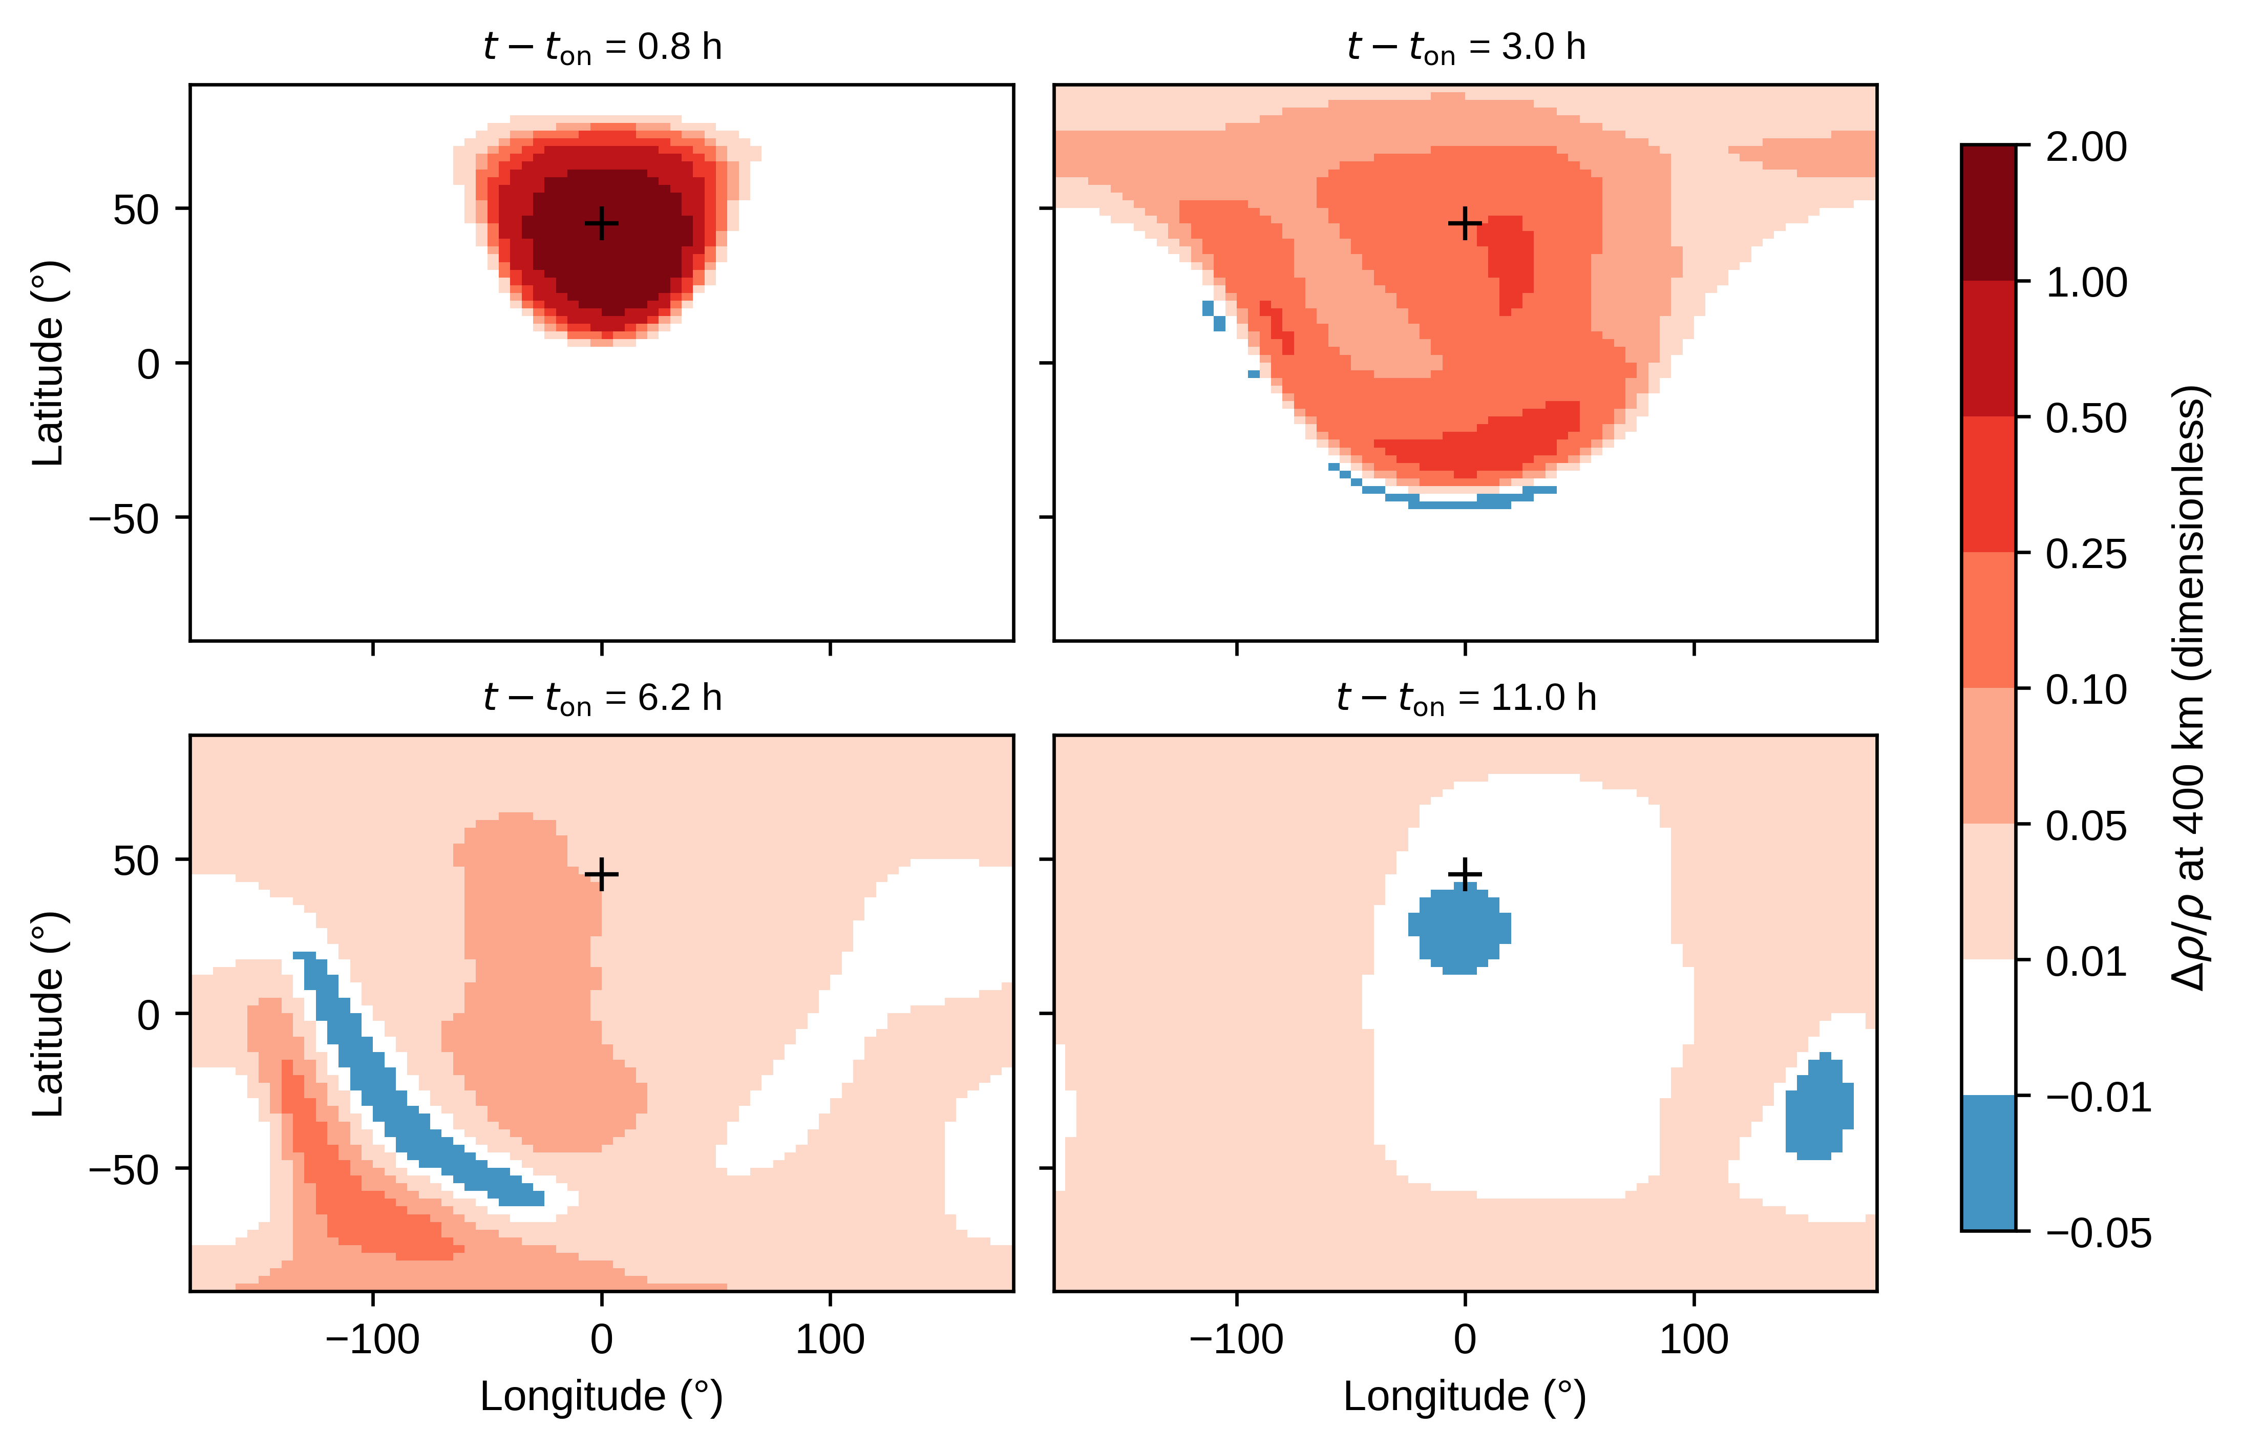
Fig. 1. Relative neutral mass-density perturbation Δρ/ρ (heated minus control, divided by control) at 400 km in the fine-grid (5°×2.5°) GITM pair, at four times after the onset of the 100 GW, 1 h heat source centred at 45°N, 0°E, 300 km (cross). Densities are interpolated log-linearly in altitude to 400 km; times are the nearest 10 min model outputs. The colour scale is non-linear and common to all panels; values between −0.01 and 0.01 are white. All plotted values (−0.030 to 1.94) lie inside the colour range (−0.05 to 2.0), so no cell is saturated.
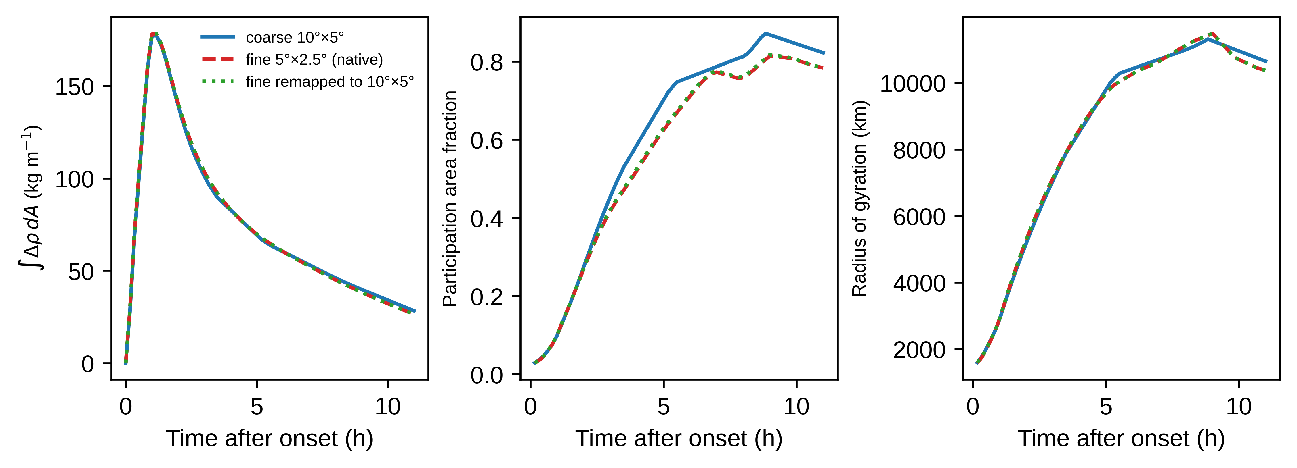
Fig. 2. Redistribution of the 400 km density perturbation for the 100 GW, 300 km case: (a) area-integrated excess ∫Δρ dA over the 400 km shell (kg m⁻¹), (b) participation area fraction, (∫Δρ₊ dA)²/(A∫Δρ₊² dA), where Δρ₊ is the positive part of Δρ and A the shell area, (c) anomaly-weighted radius of gyration about the anomaly centroid. Solid: coarse grid (10°×5°); dashed: fine grid (5°×2.5°); dotted: fine grid conservatively remapped (area-weighted 2×2 means of ρ) to the coarse grid before differencing.

3.2. Evolution of drag selectivity
Because targets are defined by their passage through the source while it is on, they collect most of their extra drag early, whereas non-targets keep accumulating drag from the spreading perturbation. As a result S(t) falls monotonically after the first hour at 400 and 500 km (Fig. 3): at 400 km from 5.3 at 1 h to 2.1 at 3 h and 1.51 at 11 h after onset; at 500 km from 10.9 to 3.1 and 2.03. Resampling the objects gives 95% intervals of 1.43–1.59 at 400 km and 1.84–2.21 at 500 km for the coarse 12 h values, so the orbit sample is not the limiting uncertainty. At 300 km, where the perturbation is smaller and broad, S settles near unity (1.02). By the end of the window non-targets account for 84% of the total extra Δv at 400 km and 77% at 500 km. Table 2 summarises the 12 h values. The target extra Δv at 400 km was 6.6 mm s⁻¹, 3.7% of the natural drag Δv over the same window, which shortens a 129 d orbital lifetime by about 0.010 d.

3.3. Comparison with static patches
Static patches give substantially higher selectivity (Fig. 4). Over 12 h, the peak-matched Gaussian overstates the GITM selectivity by factors of 1.5–1.7 at 400 km and 2.8–3.6 at 500 km, across both grids and all fit variants (Table 2). The source-centred σ = 1000 km patch overstates it by 4.7–5.8 at 400 km and 8.0–8.5 at 500 km. At 300 km, where the perturbation is weak and broad, the peak-matched patch is close to GITM.
Table 2. Twelve-hour drag selectivity from GITM and from static comparators, 100 GW source at 300 km.
Grid | Orbit altitude (km) | S, GITM | Non-target share of extra Δv (%) | S, peak-matched Gaussian | S_{GITM}/S_{Gauss}, all fit variants | S, source-centred σ = 1000 km
Coarse | 300 | 1.02 | 90 | 0.95 | — | 3.15
Coarse | 400 | 1.51 | 84 | 2.29 | 0.65–0.66 | 7.06
Coarse | 500 | 2.03 | 77 | 6.15 | 0.33–0.34 | 17.26
Fine, native | 300 | 0.98 | 90 | 0.89 | — | 3.19
Fine, native | 400 | 1.49 | 85 | 2.53 | 0.58–0.64 | 8.71
Fine, native | 500 | 2.04 | 77 | 7.12 | 0.29–0.35 | 16.26
Fine, remapped | 300 | 0.98 | 90 | 0.88 | — | 3.19
Fine, remapped | 400 | 1.48 | 85 | 2.28 | 0.63–0.66 | 7.44
Fine, remapped | 500 | 2.01 | 77 | 7.18 | 0.28–0.35 | 16.26
S is the ratio of mean extra Δv of target and non-target objects. The range in the sixth column covers the peak-matched fit with its own centre, width and window and with each of these taken from the other grid (two variants on the coarse grid, 7 on the fine grid); it was evaluated at 400 and 500 km only.
Over the first 3 h the comparison is different. At 400 km, the GITM selectivity is indistinguishable from that of the peak-matched patch (ratio 0.98–1.12 across grids and fit variants), and the sign of the difference depends on the fit. The sign change between grids comes from the half-maximum time window, which starts one 10 min output earlier on the fine grid; using the coarse-grid window on the fine grid restores agreement in sign, and the GITM selectivity itself differs between grids by 2%. At 400 km, the reduction relative to a static patch therefore emerges after switch-off, while the perturbation spreads, rather than during the heating hour. At 500 km the reduction is already present at 3 h (ratio 0.52–0.67).
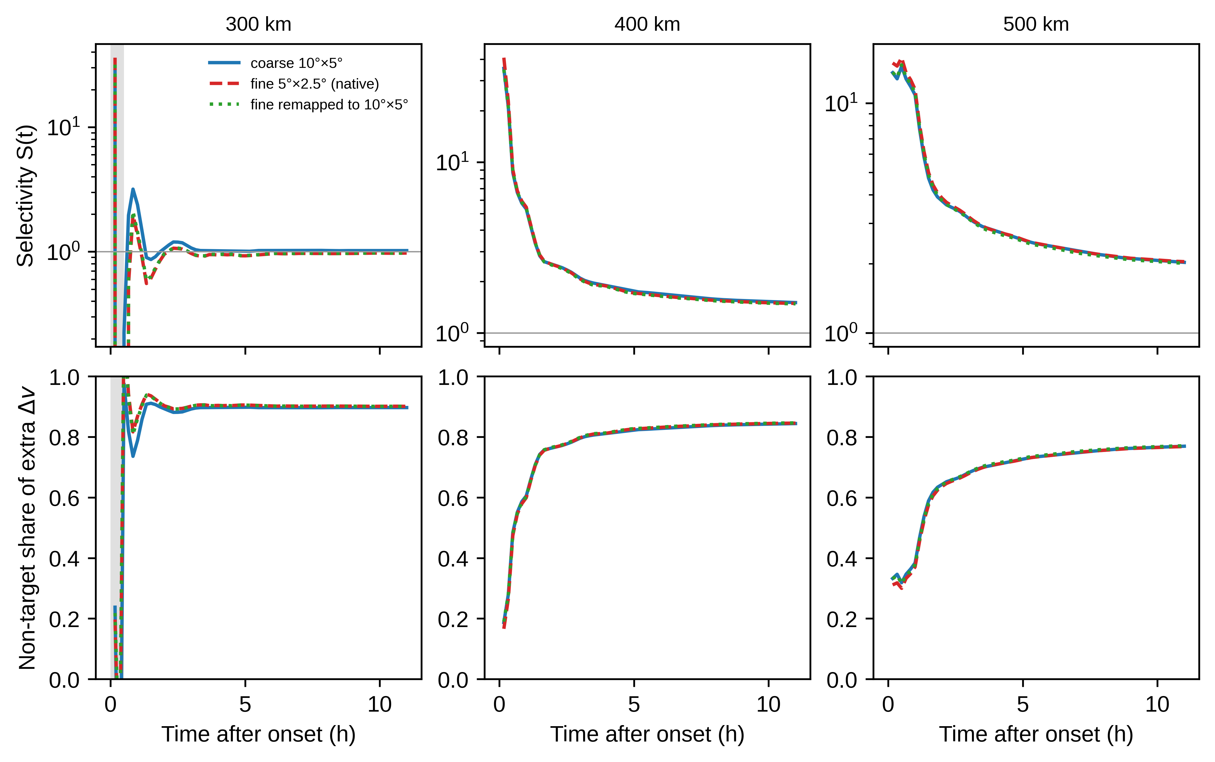
Fig. 3. Time evolution of the cumulative drag selectivity S(t) (mean extra Δv of target objects divided by that of non-target objects; top) and the non-target share of the total extra Δv (bottom) for 256 synthetic circular orbits per shell at 300, 400 and 500 km (B = 30 kg m⁻²). Line styles as in Fig. 2. Grey shading marks the first 30 min at 300 km, during which the cumulative extra Δv of the target or non-target group is still zero or negative in at least one run, so the ratio has no defined sign; values outside the shading are not filtered. Non-positive ratios cannot appear on the logarithmic axis.
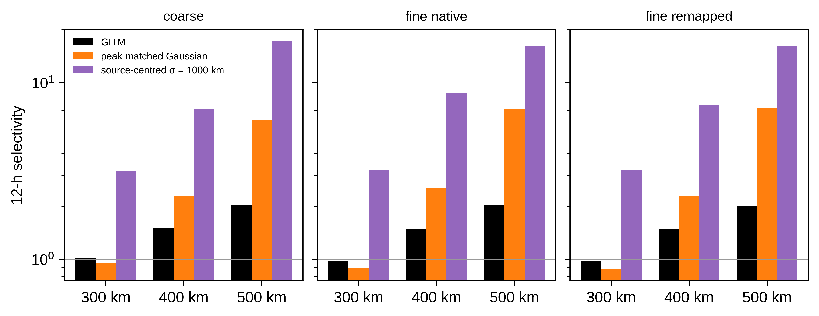
Fig. 4. Selectivity over the 12 h case window (11 h after onset) from GITM and from two static Gaussian density patches imposed on the GITM control atmosphere: a peak-matched fit (amplitude, centre and e^{−1/2} width of the GITM perturbation at its peak, switched on while the GITM peak exceeds half its maximum) and a source-centred patch with σ = 1000 km and the same amplitude and window. Panels: coarse grid, fine grid on its native grid, and fine grid remapped to the coarse grid. Logarithmic ordinate. The patches are diagnostic comparators for the prescribed-field assumption, not alternative physical solutions or upper bounds.

3.4. Sensitivity to model resolution
Of 69 diagnostic-by-altitude comparisons that can be remapped, 57 belong to diagnostics that changed by 20% or less between grids at every altitude (largest change 14%), and the diagnostic-grid effect B never exceeded 8% (Table 3). The 12 h selectivity, the target and non-target extra Δv, the peak and integrated perturbation, the affected area and the spreading rate are all robust in this sense, and the fine-grid curves overlie the coarse-grid curves throughout the 12 h (Figs. 2–3). The participation area differs by up to 11% in mid-window. The fine-vs-coarse change in peak Δρ/ρ at 400 km was −7% and in integrated excess +0.5%, so both frozen resolution criteria (PR8a: < 30%; PR8b: < 20%) were met over 3 h and 12 h. Two quantities are resolution-sensitive and are not used for any conclusion: the negative perturbation, whose integral is 2.0 times larger on the fine grid, and the end-of-window centroid, which is poorly defined once the perturbation is nearly global.
Table 3. Coarse- versus fine-grid sensitivity of the 100 GW, 300 km case over 12 h.
Metric | Altitude (km) | Coarse | Fine, native | Fine, remapped | A: model (%) | B: diagnostic (%)
Selectivity S (12 h) | 400 | 1.507 | 1.491 | 1.482 | −1.6 | +0.6
Selectivity S (12 h) | 500 | 2.029 | 2.044 | 2.012 | −0.8 | +1.6
Target extra Δv | 400 | 0.00664 | 0.006532 | 0.006491 | −2.3 | +0.6
Target extra Δv | 500 | 0.002766 | 0.002785 | 0.002742 | −0.9 | +1.6
Non-target extra Δv | 400 | 0.004408 | 0.004382 | 0.00438 | −0.6 | +0.0
Non-target extra Δv | 500 | 0.001364 | 0.001363 | 0.001363 | −0.0 | −0.0
Peak Δρ/ρ | 400 | 2.087 | 1.938 | 1.928 | −7.6 | +0.5
Peak Δρ/ρ | 500 | 9.984 | 9.718 | 9.607 | −3.8 | +1.2
Max ∫Δρ dA | 400 | 177.4 | 178.4 | 178.4 | +0.5 | −0.0
Max ∫Δρ dA | 500 | 92.22 | 93.52 | 93.53 | +1.4 | −0.0
Max area with Δρ/ρ > 1% | 400 | 0.777 | 0.7512 | 0.7527 | −3.1 | −0.2
Max area with Δρ/ρ > 1% | 500 | 0.8856 | 0.8424 | 0.8478 | −4.3 | −0.6
Radius of gyration, end | 400 | 1.065e+04 | 1.037e+04 | 1.037e+04 | −2.6 | −0.0
Radius of gyration, end | 500 | 1.133e+04 | 1.132e+04 | 1.132e+04 | −0.1 | +0.0
Mean spreading speed | 400 | 273.2 | 270.4 | 270 | −1.2 | +0.1
Mean spreading speed | 500 | 273.1 | 271.2 | 270.7 | −0.9 | +0.2
Min ∫Δρ⁻ dA (negative part) | 400 | −1.797 | −3.533 | −3.487 | +94.0 | +1.3
Min ∫Δρ⁻ dA (negative part) | 500 | −0.5146 | −1.137 | −1.122 | +118.0 | +1.4
Centroid latitude, end | 400 | −10.49 | 9.415 | 9.525 | −190.8 | −1.2
Centroid latitude, end | 500 | −25.61 | 9.76 | 9.79 | −138.2 | −0.3
A: remapped fine minus coarse, relative to coarse (model discretization plus the shorter fine spin-up). B: native fine minus remapped fine, relative to remapped (diagnostic grid only). Δv in m s⁻¹; integrals in kg m⁻¹; radius in km; speed in m s⁻¹; latitude in degrees.

3.5. Power and deposition altitude
Two further coarse-grid pairs bracket the dependence on source parameters (Fig. 5). Reducing the power to 10 GW reduced the 400 km peak only to 0.31 of its 100 GW value, whereas the global-mean density increase at 400 km fell from 11.6% to 1.7% and the maximum area with Δρ/ρ > 1% from 77% to 32%. The 12 h selectivity was correspondingly higher at 10 GW (1.93 at 400 km, 2.27 at 500 km). Depositing 100 GW at 150 km produced a 400 km peak 0.16 times that of 300 km deposition and selectivities of 0.97 and 0.95 at 400 and 500 km: lower-altitude heating raises density almost uniformly at orbit heights. These are two-level contrasts on one grid and do not define a scaling law.
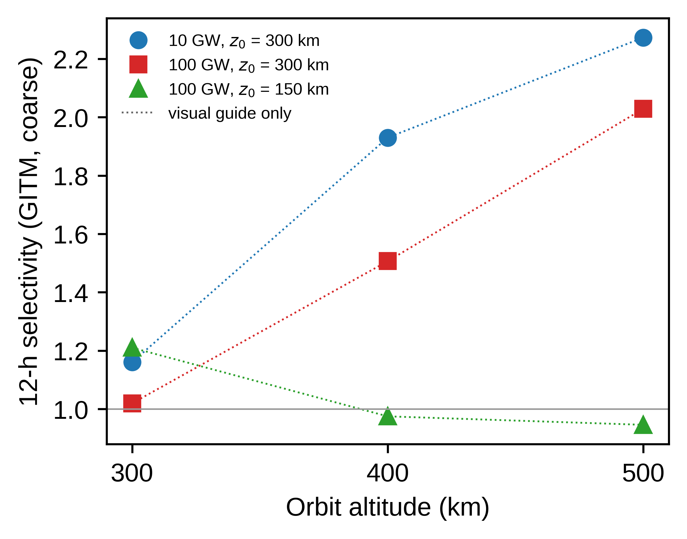
Fig. 5. Dependence of the 12 h GITM selectivity on heating power and deposition altitude (coarse grid only, two levels per factor): 10 GW and 100 GW deposited around 300 km (σ_{z} = 50 km), and 100 GW deposited around 150 km (σ_{z} = 20 km); same horizontal source shape, timing and orbit population in all cases. Markers are the three simulated orbit altitudes; dotted lines only guide the eye and do not imply a continuous altitude or power response.

3.6. Scorecard of frozen predictions
Of the 18 prospectively frozen outcomes evaluated on the primary configuration, 11 were confirmed, 5 falsified and 2 fell outside the predicted range without being falsified (Table 4). The falsifications are informative. The 400 km peak response was 204%, above the predicted 5–100% (PR1), so a 100 GW source does reach δ ≥ 1 (PR12). The response was less than linear in power, with a 10 GW/100 GW peak ratio of 0.31 (predicted 0.05–0.2; PR2). Deposition at 150 km was much less effective at 400 km than predicted (ratio 0.16, PR7). The predicted ≥ 3-fold reduction of selectivity relative to the peak-matched patch (PR10) held at 500 km, was not reached at 400 km (factor 1.52, outside the range but not falsified) and was falsified at 300 km (factor 0.93), where the perturbation is broad and selectivity is close to unity in both fields. The target extra Δv at 400 km (3.7% of natural drag) slightly exceeded the predicted range (PR9). All fine-grid rows reproduce the coarse-grid outcomes.
Table 4. Outcomes of the predictions frozen before the first heated run.
ID | Frozen prediction (abridged) | Altitude | Grid | Value | Outcome
PR1 | Peak Δρ/ρ at 400 km, 100 GW: 5–100% | — | coarse | 2.04 | falsified
PR2 | 10 GW/100 GW peak ratio 0.05–0.2 (≈ linear) | — | coarse | 0.31 | falsified
PR3 | 400 km peak 0.5–2 h after onset (h) | — | coarse | 0.834 | confirmed
PR4 | Depletion ≤ 1/3 of peak; O/N₂ decrease at source | — | coarse | 0.00955 | confirmed
PR5 | |Δρ/ρ| > 1% beyond 3000 km within 3 h | — | coarse | 1.52 | confirmed
PR6a | Local peak e-folding 1–4 h after switch-off (h) | — | coarse | 1.17 | confirmed
PR6b | Global-mean excess e-folding > 3 h (h) | — | coarse | 4 | confirmed
PR7 | 150 km/300 km ratio of 400 km peak within 1/3–3 | — | coarse | 0.162 | falsified
PR8a | Fine vs coarse peak Δρ/ρ change < 30% | — | coarse vs fine, 3 h | −0.0717 | confirmed
PR8b | Fine vs coarse integrated mass excess change < 20% | — | coarse vs fine, 3 h | 0.0208 | confirmed
PR8a | Fine vs coarse peak Δρ/ρ change < 30% | — | coarse vs fine, 12 h | −0.0717 | confirmed
PR8b | Fine vs coarse integrated mass excess change < 20% | — | coarse vs fine, 12 h | 0.0871 | confirmed
PR9 | Target extra Δv 0.1–3% of natural Δv over 12 h | — | coarse | 0.0366 | outside range, not falsified
PR10 | Gaussian/GITM selectivity ≥ 3 | 300 km | coarse | 0.933 | falsified
PR11 | GITM/Gaussian target extra Δv 0.3–3 | 300 km | coarse | 2.63 | confirmed
PR10 | Gaussian/GITM selectivity ≥ 3 | 400 km | coarse | 1.52 | outside range, not falsified
PR11 | GITM/Gaussian target extra Δv 0.3–3 | 400 km | coarse | 1.81 | confirmed
PR10 | Gaussian/GITM selectivity ≥ 3 | 500 km | coarse | 3.02 | confirmed
PR11 | GITM/Gaussian target extra Δv 0.3–3 | 500 km | coarse | 1.42 | confirmed
PR10 | Gaussian/GITM selectivity ≥ 3 | 300 km | fine, native | 0.914 | falsified
PR10 | Gaussian/GITM selectivity ≥ 3 | 400 km | fine, native | 1.7 | outside range, not falsified
PR10 | Gaussian/GITM selectivity ≥ 3 | 500 km | fine, native | 3.48 | confirmed
PR10 | Gaussian/GITM selectivity ≥ 3 | 300 km | fine, remapped | 0.9 | falsified
PR10 | Gaussian/GITM selectivity ≥ 3 | 400 km | fine, remapped | 1.54 | outside range, not falsified
PR10 | Gaussian/GITM selectivity ≥ 3 | 500 km | fine, remapped | 3.57 | confirmed
PR12 | 100 GW gives δ < 1 at 400 km | — | coarse | 2.04 | falsified
Values are those of the quantity named in the scorecard file; 12 h and fine-grid rows were added after the fine-grid extension using the unchanged rules.

4. Discussion
The central result is that, in a self-consistent thermosphere model, the drag selectivity of a localized heat source is much lower than a static density patch implies. Within a few hours of switch-off the perturbation spreads well beyond the source (Figs. 1–2), consistent with the wind and wave response known from auroral and cusp heating [12–14], and objects that never passed the source then collect most of the extra drag. The static comparators differ from the GITM field in persistence, shape, peak location and timing at once, and no transport budget was computed, so the difference is attributed to the time-evolving GITM field as a whole rather than to one mechanism. A static patch cannot represent this evolution, so it overstates selectivity by a factor that grows with altitude and with the time over which drag is accumulated. In this experiment the overstatement over 12 h is about 1.5–1.7-fold at 400 km and 2.8–3.6-fold at 500 km relative to a patch fitted to GITM itself, and 4.7–8.5-fold relative to a source-sized patch. These factors, rather than the absolute selectivity, are the more informative result, because they compare a self-consistent and a prescribed density field under the same forcing, background and orbits.
The power dependence points the same way. Increasing the power tenfold increased the 400 km peak only 3.2-fold but raised the global-mean increase 7.0-fold, so selectivity fell. Lowering the deposition altitude removed selectivity altogether. Within the tested range, therefore, neither more power nor deeper deposition makes the effect more selective; the most selective configuration tested is the weakest one, where the absolute effect on any object is also smallest. The target drag increment at 400 km for 100 GW sustained for 1 h was 3.7% of natural drag over 12 h, which changes the orbital lifetime by a negligible amount. The study does not address how such a source could be produced, and no engineering feasibility is claimed. Selectivity as defined here also depends on the target criterion (passage through the source footprint while it is on); other target definitions would give different values of S and were not tested.
Several limitations bound these conclusions. Only one physical model was used; TIE-GCM [21,22] and WACCM-X [23] could not be run in this environment, so model-structural uncertainty is not sampled. The background is one quiet equinox state with constant drivers. Only two horizontal resolutions were compared, the fine-grid background had a shorter spin-up, and no transport budget was computed to separate physical from numerical diffusion; the agreement between grids is evidence of robustness to resolution, not of convergence. The source is an idealized neutral energy input of fixed shape and duration. The orbit population is synthetic, circular and uses a single ballistic coefficient, and power and deposition altitude were each sampled at two levels on the coarse grid only. Finally, the GITM response was checked against an empirical background and published model results, not against observations of an equivalent artificial perturbation, which do not exist.

5. Conclusions
A compact 100 GW, 1 h neutral heat source in GITM produces a large local density increase that spreads over most of the globe within hours. Coupled to synthetic orbits, it gives 12 h target/non-target drag selectivities of about 1.5 at 400 km, 2 at 500 km and 1 at 300 km, with most of the extra drag falling on non-target objects. Static Gaussian patches overstate this selectivity by factors of 1.5–1.7 at 400 km and 2.8–3.6 at 500 km when fitted to the model, and by 4.7–8.5 when sized to the source. Doubling the horizontal resolution changed the 12 h selectivity at 400 and 500 km by at most 1.1%, which indicates robustness to resolution but not formal convergence. Any assessment of localized thermospheric heating for selective debris decay should therefore use a self-consistent, time-evolving thermosphere rather than prescribed static density patches.

Declaration of competing interest
The author declares no known competing financial interests or personal relationships that could have appeared to influence the work reported in this paper.

Funding
This research did not receive any specific grant from funding agencies in the public, commercial, or not-for-profit sectors.

CRediT authorship contribution statement
T. Onishi: Conceptualization, Methodology, Software, Formal analysis, Investigation, Data curation, Writing – original draft, Writing – review and editing, Visualization.

Data availability
The analysis code, GITM case configurations, the heating hook and all result tables are openly available at https://github.com/bougtoir/thermosphere-debris-selective-decay. The processed GITM fields used for the figures and the field and orbit analyses (about 0.4 GB, five paired heated/control files with SHA-256 checksums) and a snapshot of the code have been uploaded to a Zenodo record with the reserved DOI https://doi.org/10.5281/zenodo.24101202, which resolves once the record is published. Raw GITM output (about 54 GB, including failed and test runs) is listed file by file with SHA-256 checksums in data/physical/GITM_RUN_MANIFEST.csv of the repository and is available from the author on request.

Declaration of generative AI and AI-assisted technologies in the manuscript preparation process
During the preparation of this work the author used an AI software assistant (Devin, Cognition AI) to implement and run the simulation and analysis code and to draft text. The author reviewed and edited the content as needed and takes full responsibility for the content of the published article.

References
[1] Z. Serfontein, J. Kingston, S. Hobbs, I.E. Holbrough, J.C. Beck, Drag augmentation systems for space debris mitigation, Acta Astronautica 188 (2021) 278–288. https://doi.org/10.1016/j.actaastro.2021.05.038
[2] J.L. Rhatigan, W. Lan, Drag-enhancing deorbit devices for spacecraft self-disposal: A review of progress and opportunities, Journal of Space Safety Engineering 7 (2020) 340–344. https://doi.org/10.1016/j.jsse.2020.07.026
[3] W.O. Schall, Orbital debris removal by laser radiation, Acta Astronautica 24 (1991) 343–351. https://doi.org/10.1016/0094-5765(91)90184-7
[4] A.M. Rubenchik, C.P.J. Barty, R.J. Beach, A.C. Erlandson, J.A. Caird, C. Phipps, Laser Systems for Orbital Debris Removal, AIP Conference Proceedings (2010) 347–353. https://doi.org/10.1063/1.3507120
[5] B.G.A. Smith, C.J. Capon, M. Brown, R.R. Boyce, Ionospheric drag for accelerated deorbit from upper low earth orbit, Acta Astronautica 176 (2020) 520–530. https://doi.org/10.1016/j.actaastro.2020.07.007
[6] S. Bruinsma, J.M. Forbes, R.S. Nerem, X. Zhang, Thermosphere density response to the 20–21 November 2003 solar and geomagnetic storm from CHAMP and GRACE accelerometer data, Journal of Geophysical Research: Space Physics 111 (2006) 2005JA011284. https://doi.org/10.1029/2005ja011284
[7] E.K. Sutton, J.M. Forbes, D.J. Knipp, Rapid response of the thermosphere to variations in Joule heating, Journal of Geophysical Research: Space Physics 114 (2009) 2008JA013667. https://doi.org/10.1029/2008ja013667
[8] J.T. Emmert, Thermospheric mass density: A review, Advances in Space Research 56 (2015) 773–824. https://doi.org/10.1016/j.asr.2015.05.038
[9] H. Lühr, M. Rother, W. Köhler, P. Ritter, L. Grunwaldt, Thermospheric up‐welling in the cusp region: Evidence from CHAMP observations, Geophysical Research Letters 31 (2004) 2003GL019314. https://doi.org/10.1029/2003gl019314
[10] G. Crowley, D.J. Knipp, K.A. Drake, J. Lei, E. Sutton, H. Lühr, Thermospheric density enhancements in the dayside cusp region during strong B_{Y} conditions, Geophysical Research Letters 37 (2010) 2009GL042143. https://doi.org/10.1029/2009gl042143
[11] H.C. Carlson, T. Spain, A. Aruliah, A. Skjaeveland, J. Moen, First‐principles physics of cusp/polar cap thermospheric disturbances, Geophysical Research Letters 39 (2012) 2012GL053034. https://doi.org/10.1029/2012gl053034
[12] Y. Deng, A.D. Richmond, A.J. Ridley, H.-L. Liu, Assessment of the non‐hydrostatic effect on the upper atmosphere using a general circulation model (GCM), Geophysical Research Letters 35 (2008) 2007GL032182. https://doi.org/10.1029/2007gl032182
[13] L.C. Gardner, R.W. Schunk, Generation of traveling atmospheric disturbances during pulsating geomagnetic storms, Journal of Geophysical Research: Space Physics 115 (2010) 2009JA015129. https://doi.org/10.1029/2009ja015129
[14] X. Liu, A. Ridley, A simulation study of the thermosphere mass density response to substorms using GITM, Journal of Geophysical Research: Space Physics 120 (2015) 7987–8001. https://doi.org/10.1002/2014ja020962
[15] D.M. Oliveira, E. Zesta, Satellite Orbital Drag During Magnetic Storms, Space Weather 17 (2019) 1510–1533. https://doi.org/10.1029/2019sw002287
[16] T.-W. Fang, A. Kubaryk, D. Goldstein, Z. Li, T. Fuller‐Rowell, G. Millward, et al., Space Weather Environment During the SpaceX Starlink Satellite Loss in February 2022, Space Weather 20 (2022) e2022SW003193. https://doi.org/10.1029/2022sw003193
[17] Y. Baruah, S. Roy, S. Sinha, E. Palmerio, S. Pal, D.M. Oliveira, et al., The Loss of Starlink Satellites in February 2022: How Moderate Geomagnetic Storms Can Adversely Affect Assets in Low‐Earth Orbit, Space Weather 22 (2024) e2023SW003716. https://doi.org/10.1029/2023sw003716
[18] A.J. Ridley, Y. Deng, G. Tóth, The global ionosphere–thermosphere model, Journal of Atmospheric and Solar-Terrestrial Physics 68 (2006) 839–864. https://doi.org/10.1016/j.jastp.2006.01.008
[19] D.R. Weimer, Improved ionospheric electrodynamic models and application to calculating Joule heating rates, Journal of Geophysical Research: Space Physics 110 (2005) 2004JA010884. https://doi.org/10.1029/2004ja010884
[20] J.M. Picone, A.E. Hedin, D.P. Drob, A.C. Aikin, NRLMSISE‐00 empirical model of the atmosphere: Statistical comparisons and scientific issues, Journal of Geophysical Research: Space Physics 107 (2002). https://doi.org/10.1029/2002ja009430
[21] A.D. Richmond, E.C. Ridley, R.G. Roble, A thermosphere/ionosphere general circulation model with coupled electrodynamics, Geophysical Research Letters 19 (1992) 601–604. https://doi.org/10.1029/92gl00401
[22] L. Qian, A.G. Burns, B.A. Emery, B. Foster, G. Lu, A. Maute, et al., The NCAR TIE‐GCM, Geophysical Monograph Series (2014) 73–83. https://doi.org/10.1002/9781118704417.ch7
[23] H.-L. Liu, C.G. Bardeen, B.T. Foster, P. Lauritzen, J. Liu, G. Lu, et al., Development and Validation of the Whole Atmosphere Community Climate Model With Thermosphere and Ionosphere Extension (WACCM‐X 2.0), Journal of Advances in Modeling Earth Systems 10 (2018) 381–402. https://doi.org/10.1002/2017ms001232

