Quantifying the feasibility boundary of localized thermospheric density enhancement for selective orbital debris decay
[Authors] T. Onishi et al. Corresponding: bougtoir@gmail.com
Target journal: Advances in Space Research (manuscript class: modelling/feasibility study). Journal audit documented in docs/JOURNAL_AUDIT.md.

Abstract
Whether a spatially and temporally localized thermospheric density increase could selectively accelerate the orbital decay of low Earth orbit debris — while limiting collateral drag on protected spacecraft — is examined as a boundary problem rather than an engineering proposal. Using an NRLMSISE-00 climatology across four solar/geomagnetic regimes, a J2-secular semi-analytic propagator validated against a Cowell integrator, and abstract Gaussian density perturbations (static, advected, diffusing, relaxing, and an idealized on-target tracking bound), we simulate synthetic target and protected objects between 200 and 800 km. Drag response itself is not the limiting factor: enhancing density by a factor (1+delta) along the target's own path multiplies its drag impulse by the same factor, so the idealized bound of perfect co-location delivers 6.87 m/s in one day to a 400 km high-area-to-mass target against 1.37 m/s of natural drag. Even that bound is not reached by an intervention aimed at the predicted orbit: integrating the orbit while the enhancement acts leaves 3.53 m/s, a factor 1.95 lower, because the induced drag itself drifts the target along track out of a patch centred on the unperturbed ephemeris. The boundary is set instead by exposure, transport and geometry. An Earth-fixed pulse of the same peak amplitude is sampled for only 320 s of a 4.4% duty cycle and yields 3.98e-3 m/s per event; the 1726x gap decomposes multiplicatively into exposure duration (12x), in-patch occupancy (22.5x) and mean enhancement while inside (6.3x) to within 1.5%, and adding the co-location retention factor 0.51 reproduces the 887x gap of the simulated arm to within 1.5%. Horizontal diffusion and winds disperse a static patch on minutes-to-hours timescales: 11 of 27 surveyed (sigma_h, kappa, u) design combinations allow one hour of persistence, and none do when winds of 100 m/s are combined with patches small enough to be selective. Budget-matched controls show that localization buys collateral suppression, not benefit, and that a fixed spacetime or thermal-energy budget spent locally gives the target only 3.06e-3 m/s. Raising density by delta=5 at 400 km over a 200 km patch through hydrostatic expansion of the column below requires ~5.80e7 W sustained, a thermodynamic lower bound. Selective thermospheric drag is therefore mathematically well-posed and dimensionally simple, but confined by exposure geometry, transport and energetics to a narrow corner of parameter space that no identified mechanism reaches.

1. Introduction
The low Earth orbit debris population continues to grow and motivates both mitigation standards and active debris removal (ADR) concepts [1,2,3]. Non-contact removal ideas — momentum transfer by lasers or ion-beam shepherd concepts — avoid grapple risks [4]. A conceptually different route is to increase the ambient drag on a target alone by locally raising thermospheric density. Geomagnetic storms demonstrate that natural density enhancements of several hundred percent at 400–500 km produce operationally significant drag [5,6,7]. The question addressed here is deliberately narrow: under what conditions could a *localized* density perturbation produce useful differential decay between a synthetic target and protected spacecraft — and where does the concept fail quantitatively? We study the boundary, not a deployment design; no operational spacecraft are targeted and no hardware is specified. The contribution is a quantitative exclusion map that separates four independent gates — drag response, exposure geometry, transport persistence, and collateral selectivity — together with the thermodynamic lower bound on the energy each would require.

2. Methods

2.1 Background atmosphere
Neutral mass density is taken from NRLMSISE-00 [8,9] evaluated on a climatological orbit/attitude grid and cached as a lookup over altitude (200–800 km) for four regimes (quiet, moderate, active, storm). The model returns total mass density in g/cm^3; the wrapper converts to kg/m^3 and a regression test checks the resulting profile against published thermospheric magnitudes [10] at 200, 400 and 500 km. Model-form and density uncertainty (~15%) follow [10,11] and are propagated by Monte Carlo in Phase 10.

2.2 Orbit propagation and censoring
Two propagators are used: a DOP853 Cowell integrator with J2 and drag for validation, and a J2-secular semi-analytic integrator with orbit-averaged density for grid studies. Drag acceleration is -rho v_rel^2/(2B) along the relative wind with B = m/(C_d A) [12,13]; the semi-analytic decay rate da/dt = -(a rho v / B)(v_rel/v)^2 uses the same corotation factor v_rel/v = 1 - Omega_E a cos(i)/v as the Cowell reference, which brings the two propagators to 0.12% agreement over a ten-day drag-only decay. Baseline validation (Gate 2) required energy and angular-momentum conservation, convergence under tolerance tightening, J2 secular rates, fast-versus-Cowell decay agreement within 1%, and lifetime scaling with B [14]; all checks passed (results/tables/phase2_validation.csv). Objects that do not reach the reentry altitude inside the integration horizon are reported as right-censored lower bounds rather than known lifetimes; 21 of 396 baseline grid cells are censored in this sense and are excluded from any statistic that would treat the horizon as a measured lifetime.

2.3 Perturbation models and the idealized upper bound
The intervention is an abstract fractional enhancement rho' = rho(1+delta) shaped as a Gaussian patch (horizontal sigma_h, vertical sigma_v) in the co-rotating frame, optionally diffusing (sigma_h^2 += 2 kappa t), advecting with a horizontal wind, or relaxing on a cooling timescale tau. Three fidelity levels are kept explicitly distinct. (i) A mathematical perfect-localization upper bound: a tracking perturbation whose centre coincides with the target throughout the window. This is an upper bound on what any co-location strategy could achieve; it is not hardware, not a demonstrated atmospheric process, not a feasible control mechanism, and not evidence that co-location can be achieved. (ii) A simplified transport-constrained model in which the same patch diffuses, advects and relaxes with literature-guided coefficients [15,16]. (iii) Self-consistent neutral/plasma dynamics, energy deposition and the resulting circulation response, which are outside the scope of this study and are retained as limitations rather than modelled.

2.4 Cases, metrics and exposure classification
Case pairs A–G place synthetic high-A/m targets near protected objects with realistic ballistic coefficients; a 2000-object factorial population provides distributional context. Outcomes are lifetime change, semimajor-axis drop, extra drag impulse, equivalent delta-v, encounter statistics, and orbital energy removed. Absolute target benefit and absolute protected-object collateral are the primary quantities; a selectivity ratio is reported only as a secondary descriptor, and only after each exposure is classified as physical exposure, Gaussian-tail limited, below numerical resolution, or no encounter (closest approach beyond six patch sigmas). Ratios computed against a tail-limited or no-encounter denominator are labelled as undefined rather than reported as large selectivities.

3. Results

3.1 Baseline decay landscape and censoring
With the corrected density scaling, natural decay is fast at low altitude and slow above ~500 km: in the moderate regime a B = 30 kg/m^2 object decays from 400 km in 118 d and from 250 km (B = 10) in 1.2 d, while at 800 km the same grid is right-censored at the integration horizon (21 of 396 cells). The regime that matters for an intervention is therefore the one where natural drag is already weak, which is also where the required absolute density increase is largest (Fig. 1, Fig. 2, Table 1).
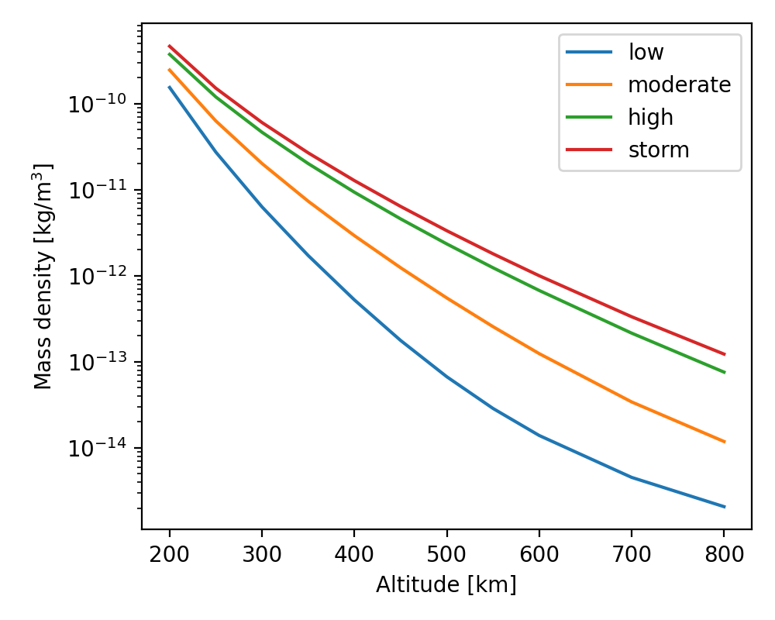
Figure 1. NRLMSISE-00 climatological mass-density profiles (200-800 km) for the four solar/geomagnetic regimes used here.
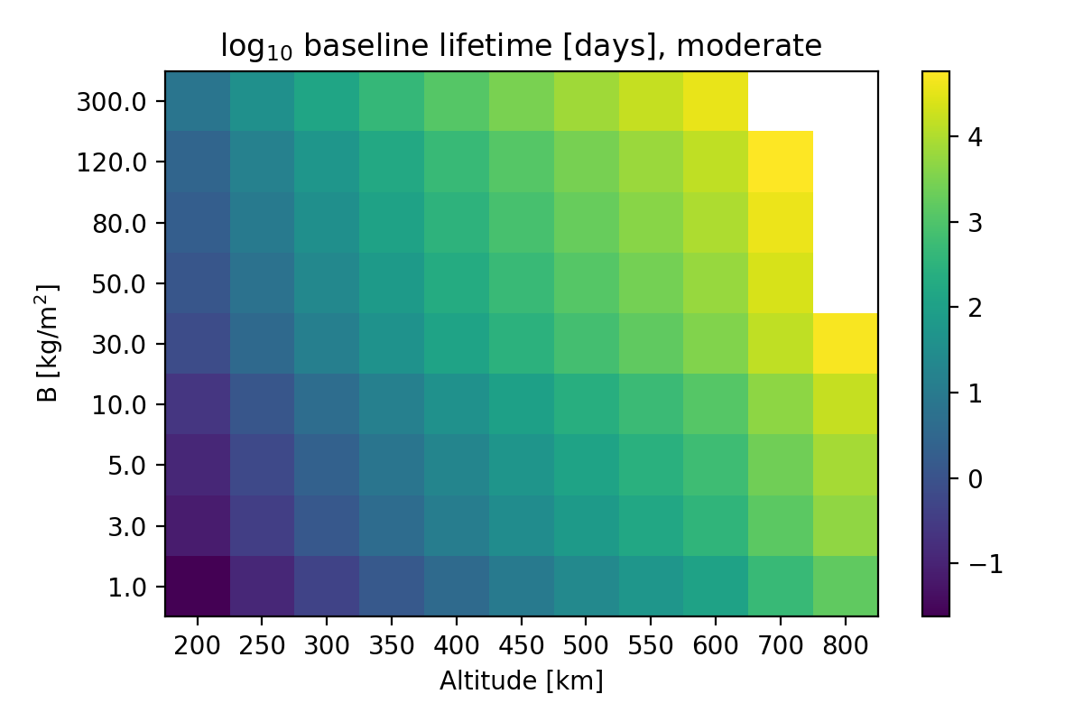
Figure 2. Baseline decay lifetime (log10 days) over altitude and ballistic coefficient B in the moderate regime; cells at the horizon are right-censored.
Table 1. Baseline decay lifetime and the background-density multiplier required for 1/10/50/90% lifetime reduction (moderate regime).
altitude_km | B_kgm2 | lifetime0_days | mult_for_1pct_reduction | mult_for_10pct_reduction | mult_for_50pct_reduction | mult_for_90pct_reduction
200 | 5 | 0.1193 | 1.1 | 1.5 | 2 | 30
200 | 30 | 0.7158 | 1.1 | 1.5 | 2 | 30
200 | 80 | 1.909 | 1.1 | 1.5 | 2 | 30
250 | 5 | 0.6208 | 1.1 | 1.5 | 2 | 30
250 | 30 | 3.725 | 1.1 | 1.5 | 2 | 30
250 | 80 | 9.933 | 1.1 | 1.5 | 2 | 30
300 | 5 | 2.308 | 1.1 | 1.5 | 2 | 10
300 | 30 | 13.85 | 1.1 | 1.5 | 2 | 30
300 | 80 | 36.93 | 1.1 | 1.5 | 2 | 10
350 | 5 | 7.152 | 1.1 | 1.5 | 2 | 30
350 | 30 | 42.91 | 1.1 | 1.5 | 2 | 30
350 | 80 | 114.4 | 1.1 | 1.5 | 2 | 30
400 | 5 | 19.7 | 1.1 | 1.5 | 2 | 30
400 | 30 | 118.2 | 1.1 | 1.5 | 2 | 10
400 | 80 | 315.2 | 1.1 | 1.5 | 2 | 30
450 | 5 | 49.94 | 1.1 | 1.5 | 2 | 30
450 | 30 | 299.6 | 1.1 | 1.5 | 2 | 10
450 | 80 | 799 | 1.1 | 1.5 | 2 | 30
500 | 5 | 119 | 1.1 | 1.5 | 2 | 30
500 | 30 | 714 | 1.1 | 1.5 | 2 | 30
500 | 80 | 1904 | 1.1 | 1.5 | 2 | 30
550 | 5 | 269.9 | 1.1 | 1.5 | 2 | 10
550 | 30 | 1619 | 1.1 | 1.5 | 2 | 30
550 | 80 | 4318 | 1.1 | 1.5 | 2 | 10
600 | 5 | 585.7 | 1.1 | 1.5 | 2 | 10
600 | 30 | 3514 | 1.1 | 1.5 | 2 | 10
600 | 80 | 9371 | 1.1 | 1.5 | 2 | 10
700 | 5 | 2413 | 1.1 | 1.5 | 2 | 10
700 | 30 | 1.448e+04 | 1.1 | 1.5 | 2 | 30
700 | 80 | 3.86e+04 | 1.1 | 1.5 | 2 | 10
800 | 5 | 8169 | 1.1 | 1.5 | 2 | 30
800 | 30 | 4.901e+04 | 1.1 | 1.5 | 2 | 30
800 | 80 | inf | nan | nan | nan | nan

3.2 Transit limitation of a fixed patch
A best-case-sited Earth-fixed Gaussian pulse (delta = 5, sigma_h = 200 km, 2 h) is sampled by the case-A target for 320 s — 4.4% of the window — and adds 3.98e-3 m/s, which is 3.5% of the natural drag impulse the same object receives over the same 2 h window. The limitation is exposure, not amplitude: the object crosses the patch once per revolution at ~7.7 km/s, and the mean enhancement it experiences while inside is only 0.79 against a peak of 3.15 (Table 2, Table 6).

3.3 Idealized co-location upper bound and the gap decomposition
The idealized tracking bound sustains the enhancement on the target for a full day and yields 6.87 m/s, exactly delta = 5 times the 1.37 m/s of natural drag over the same window (a total impulse of (1+delta) x natural), as the drag equation requires. It shortens the 250 km target's lifetime by 0.7 d. The ratio between this bound and the fixed pulse, 1726x, is reproduced to 1.5% by the product of three exposure factors — window duration 12x, fraction of the window spent inside the patch 22.5x, and mean enhancement while inside 6.3x — confirming that sustained co-location, not peak amplitude, controls the outcome. This bound is a mathematical limit on co-location strategies and not a claim that such co-location is achievable (Table 2, Table 6).
The bound is stated in the perfect-co-location convention, in which the exposure is evaluated on the unperturbed ephemeris so that the enhancement follows the object however it moves. Measuring the same intervention along the trajectory the drag itself produces — the convention used by every simulated scenario here — gives 3.53 m/s, a retention of 0.51 of the bound, because the induced decay drifts the target along track relative to a patch centred on the predicted orbit and the mean enhancement it then experiences falls from 5.00 to 2.31. The two values are different quantities and are reported separately throughout (Table 6): the bound limits what any co-location strategy could achieve, and the drift-aware value is what the modelled intervention achieves. Because the drift depends on the induced decay itself, the drift-aware values are step-size sensitive; the integrator is second-order in the step and the convergence ladder is reported in orbit_step_convergence.csv.
Table 2. Per-object outcomes for representative cases under the baseline, Earth-fixed pulse, and idealized tracking-bound scenarios.
scenario | case | obj_type | alt_km | B | lifetime_d | delta_lifetime_d | delta_a_km | extra_deltav_ms
baseline | A_target_highAm_400 | target | 400 | 5 | 21.12 | 0 | 0 | 0
fixed_pulse | A_target_highAm_400 | target | 400 | 5 | 21.9 | -0.7758 | 0.007389 | 0.003986
tracking | A_target_highAm_400 | target | 400 | 5 | 18.9 | 2.226 | 0.003729 | 3.53
baseline | A_protected_400 | protected | 400 | 80 | 342 | 0 | 0 | 0
fixed_pulse | A_protected_400 | protected | 400 | 80 | 338.6 | 3.394 | 0.001361 | 0.0002954
tracking | A_protected_400 | protected | 400 | 80 | 342.1 | -0.05378 | -0.0008486 | 4.246e-06
baseline | B_target_compact_500 | target | 500 | 120 | 1826 | 0 | 0 | 0
fixed_pulse | B_target_compact_500 | target | 500 | 120 | 1826 | 0 | 0.002375 | 3.466e-05
tracking | B_target_compact_500 | target | 500 | 120 | 1826 | 0 | 0.2817 | 0.0587
baseline | B_protected_500 | protected | 500 | 100 | 1826 | 0 | 0 | 0
fixed_pulse | B_protected_500 | protected | 500 | 100 | 1826 | 0 | 0.008009 | 7.872e-06
tracking | B_protected_500 | protected | 500 | 100 | 1826 | 0 | 0.0003025 | 4.429e-217
baseline | C_frag_00 | target | 450 | 8 | 78.06 | 0 | 0 | 0
fixed_pulse | C_frag_00 | target | 450 | 8 | 79.11 | -1.045 | 0.002747 | 0.001035
tracking | C_frag_00 | target | 450 | 8 | 74.9 | 3.161 | -0.005849 | 1.727
baseline | C_frag_01 | target | 455 | 11 | 118.4 | 0 | 0 | 0
fixed_pulse | C_frag_01 | target | 455 | 11 | 117.3 | 1.051 | 0.0001953 | 0.001061
tracking | C_frag_01 | target | 455 | 11 | 118.3 | 0.1046 | 0.0005647 | 1.433e-10
baseline | C_frag_02 | target | 460 | 14 | 164.6 | 0 | 0 | 0
fixed_pulse | C_frag_02 | target | 460 | 14 | 163.2 | 1.453 | 0.0001385 | 0.0007832
tracking | C_frag_02 | target | 460 | 14 | 164.6 | 0.00617 | 0.0005486 | 2.976e-36
baseline | C_frag_03 | target | 465 | 17 | 218.1 | 0 | 0 | 0
fixed_pulse | C_frag_03 | target | 465 | 17 | 216.5 | 1.604 | 0.0004985 | 0.0003995
tracking | C_frag_03 | target | 465 | 17 | 218 | 0.01795 | 0.002059 | 5.378e-78
baseline | C_frag_04 | target | 470 | 20 | 279.9 | 0 | 0 | 0
fixed_pulse | C_frag_04 | target | 470 | 20 | 278.2 | 1.676 | 0.002089 | 0.0001372
tracking | C_frag_04 | target | 470 | 20 | 280 | -0.1368 | 0.002128 | 4.162e-136
baseline | C_frag_05 | target | 450 | 23 | 224.5 | 0 | 0 | 0
fixed_pulse | C_frag_05 | target | 450 | 23 | 225.3 | -0.8284 | -0.008707 | 5.506e-05
tracking | C_frag_05 | target | 450 | 23 | 224.5 | 0.03211 | -0.00116 | 0
baseline | C_frag_06 | target | 455 | 26 | 277.2 | 0 | 0 | 0
fixed_pulse | C_frag_06 | target | 455 | 26 | 279.2 | -2.033 | -0.0007072 | 9.201e-06
tracking | C_frag_06 | target | 455 | 26 | 277.3 | -0.1295 | 0.0002582 | 0
baseline | C_frag_07 | target | 460 | 29 | 339.7 | 0 | 0 | 0
fixed_pulse | C_frag_07 | target | 460 | 29 | 338.1 | 1.588 | 0.001809 | 9.938e-07
tracking | C_frag_07 | target | 460 | 29 | 339.6 | 0.077 | 0.001845 | 0
baseline | C_frag_08 | target | 465 | 32 | 409.6 | 0 | 0 | 0
fixed_pulse | C_frag_08 | target | 465 | 32 | 408.2 | 1.343 | 0.001433 | 6.918e-08
tracking | C_frag_08 | target | 465 | 32 | 409.6 | -0.04675 | 0.0002078 | 0
baseline | C_frag_09 | target | 470 | 35 | 488.3 | 0 | 0 | 0
fixed_pulse | C_frag_09 | target | 470 | 35 | 488.1 | 0.2059 | 0.00202 | 1.576e-08
tracking | C_frag_09 | target | 470 | 35 | 488.3 | -0.01507 | -0.0001054 | 0
baseline | C_protected_450 | protected | 450 | 90 | 880.6 | 0 | 0 | 0
fixed_pulse | C_protected_450 | protected | 450 | 90 | 878.4 | 2.182 | 0.004523 | 1.143e-05
tracking | C_protected_450 | protected | 450 | 90 | 880.5 | 0.07541 | -0.001774 | 0
baseline | D_target_550 | target | 550 | 20 | 1056 | 0 | 0 | 0
fixed_pulse | D_target_550 | target | 550 | 20 | 1058 | -1.96 | 7.901e-05 | 3.923e-05
tracking | D_target_550 | target | 550 | 20 | 1052 | 4.085 | -0.001512 | 0.1628
baseline | D_protected_550 | protected | 550 | 85 | 1826 | 0 | 0 | 0
fixed_pulse | D_protected_550 | protected | 550 | 85 | 1826 | 0 | -0.0001137 | 3.322e-05
tracking | D_protected_550 | protected | 550 | 85 | 1826 | 0 | -9.754e-05 | 1.274e-81
baseline | E_target_400_i28 | target | 400 | 15 | 66.34 | 0 | 0 | 0
fixed_pulse | E_target_400_i28 | target | 400 | 15 | 65.71 | 0.6352 | -1.29e-06 | 0.001472
tracking | E_target_400_i28 | target | 400 | 15 | 61.45 | 4.893 | -0.0002563 | 1.854
baseline | E_protected_400_i51 | protected | 400 | 70 | 298.5 | 0 | 0 | 0
fixed_pulse | E_protected_400_i51 | protected | 400 | 70 | 297.3 | 1.248 | 0.006178 | 1.002e-05
tracking | E_protected_400_i51 | protected | 400 | 70 | 298.6 | -0.07107 | 0.005824 | 0.00618
baseline | F_target_750 | target | 750 | 25 | 1826 | 0 | 0 | 0
fixed_pulse | F_target_750 | target | 750 | 25 | 1826 | 0 | -6.463e-05 | 3.214e-06
tracking | F_target_750 | target | 750 | 25 | 1826 | 0 | 0.0197 | 0.00964
baseline | F_protected_750 | protected | 750 | 100 | 1826 | 0 | 0 | 0
fixed_pulse | F_protected_750 | protected | 750 | 100 | 1826 | 0 | 5.24e-06 | 1.43e-06
tracking | F_protected_750 | protected | 750 | 100 | 1826 | 0 | 4.183e-05 | 7.381e-224
baseline | G_target_250 | target | 250 | 10 | 1.462 | 0 | 0 | 0
fixed_pulse | G_target_250 | target | 250 | 10 | 1.622 | -0.16 | 0.000256 | 0.03171
tracking | G_target_250 | target | 250 | 10 | 0.7312 | 0.7303 | -0.003288 | 12.62
baseline | G_protected_250 | protected | 250 | 80 | 11 | 0 | 0 | 0
fixed_pulse | G_protected_250 | protected | 250 | 80 | 10.66 | 0.3367 | -0.0006368 | 0.008506
tracking | G_protected_250 | protected | 250 | 80 | 11.04 | -0.03875 | -0.0009323 | 6.049e-80
Table 6. Decomposition of the fixed-pulse versus idealized-tracking gap into exposure duration, in-patch occupancy and effective in-patch enhancement.
scenario | ephemeris | window_s | time_fraction_in_patch | peak_delta | delta_eff_in_patch | extra_dv_ms | natural_dv_ms
fixed_pulse | unperturbed | 7200 | 0.04444 | 3.152 | 0.7941 | 0.003979 | 0.1128
tracking_bound_perfect | unperturbed | 8.64e+04 | 1 | 5 | 5 | 6.869 | 1.374
tracking_simulated | drag_updated | 8.64e+04 | 1 | 5 | 2.312 | 3.53 | 1.527

3.4 Uniform versus localized enhancement under matched budgets
Under matched target exposure, localization changes collateral far more than benefit: a uniform delta = 5 gives the case-A target 7.97 m/s and the on-target localized patch 3.53 m/s — the same peak amplitude on the target, the difference being the co-location the localized patch loses as the induced drag drifts the target out of it, and a uniform enhancement additionally keeps acting as the orbit decays into denser air — while the uniform arm delivers 4.33e-1 m/s to the protected object and the localized arm leaves it at 4.25e-6 m/s — a Gaussian-tail value, classified as not physically meaningful, so the apparent selectivity ratio is reported as undefined rather than as five orders of magnitude of performance. The comparison reverses once the *intervention* rather than the target exposure is held fixed. The localized patch occupies a fraction 4.35e-4 of the equivalent global shell, so the same enhanced spacetime volume spread uniformly gives the target 3.06e-3 m/s and the protected object 1.87e-4 m/s, and the same lower-bound thermal energy spread uniformly gives the target 5.10e-4 m/s. Localization is therefore necessary for safety and is the only way to make a finite budget useful, but the conclusion about 'how much better' localization is depends explicitly on the matching convention, and none of these conventions is privileged (Fig. 3, Fig. 7, Table 3, Table 7).
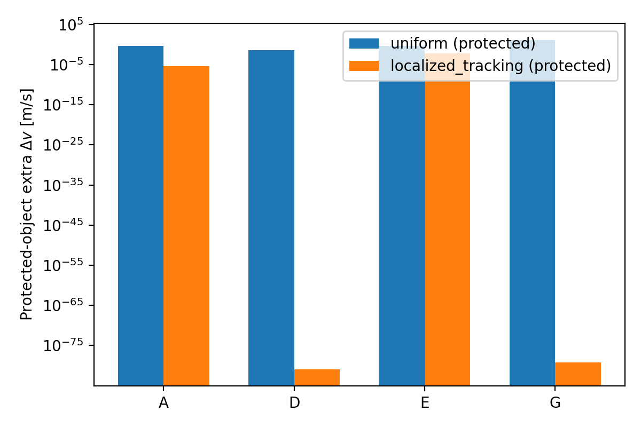
Figure 3. Absolute collateral delta-v imparted to protected objects under uniform versus localized enhancement, by case pair.
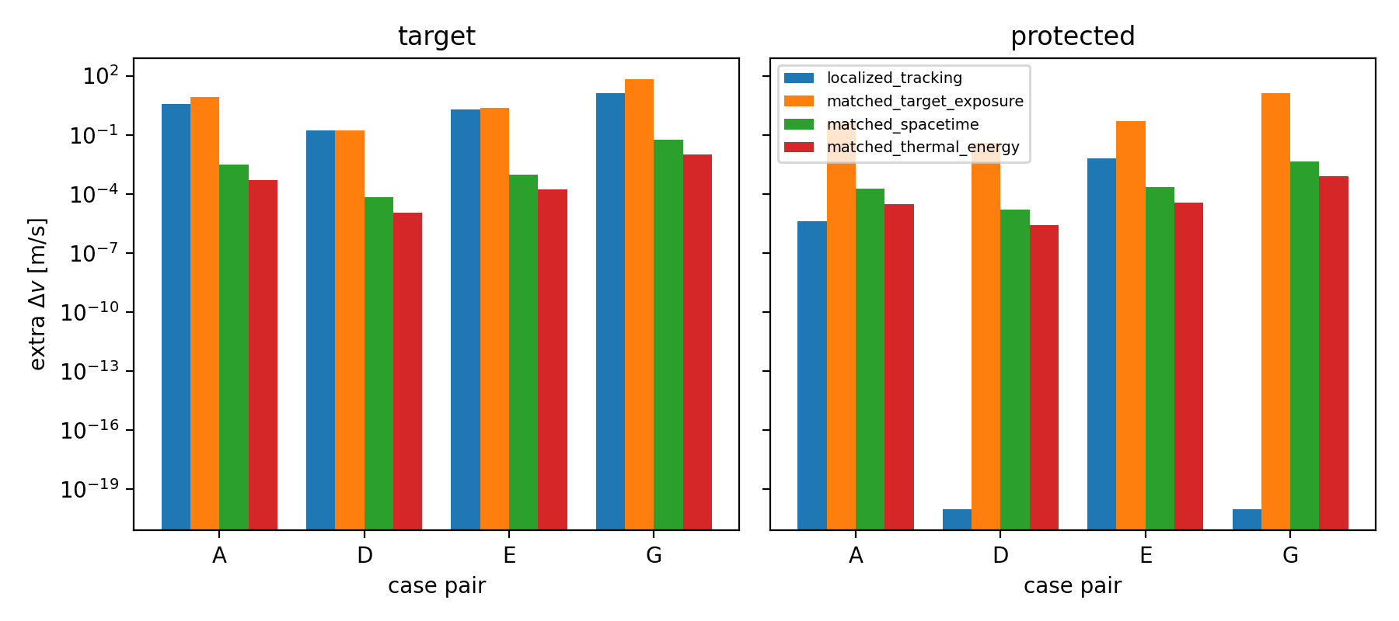
Figure 7. Target benefit (left) and protected-object collateral (right) under four matching conventions: the idealized localized bound, matched target exposure, matched enhanced spacetime volume, and matched lower-bound thermal energy.
Table 3. Target benefit, absolute protected-object collateral, exposure classification of the protected object, and the resulting selectivity ratio where it is defined.
scenario | pair | target_dv_ms | protected_dv_ms | protected_class | protected_encounters | selectivity_ratio | ratio_status
uniform | A | 7.967 | 0.4327 | physical_exposure | 1 | 18.4119 | physical
uniform | D | 0.163 | 0.03828 | physical_exposure | 1 | 4.25954 | physical
uniform | E | 2.307 | 0.4948 | physical_exposure | 1 | 4.66302 | physical
uniform | G | 64.48 | 13.19 | physical_exposure | 1 | 4.88934 | physical
localized_tracking | A | 3.53 | 4.246e-06 | gaussian_tail | 1 | undefined | tail_limited
localized_tracking | D | 0.1628 | 1.274e-81 | no_encounter | 0 | undefined | undefined_no_encounter
localized_tracking | E | 1.854 | 0.00618 | physical_exposure | 29 | 300.05 | physical
localized_tracking | G | 12.62 | 6.049e-80 | no_encounter | 0 | undefined | undefined_no_encounter
optimized_localized | A | 3.519 | 3.691e-06 | gaussian_tail | 1 | undefined | tail_limited
Table 7. Budget-matched exposure controls for each case pair and matching convention.
pair | matching | obj_type | ephemeris | delta_uniform | extra_dv_ms | rel_to_natural | exposure_class
A | localized_tracking | target | drag_updated | 5 | 3.53 | 2.312 | physical_exposure
A | matched_target_exposure | target | drag_updated | 5 | 7.967 | 5.007 | physical_exposure
A | matched_spacetime | target | drag_updated | 0.002177 | 0.003058 | 0.002177 | physical_exposure
A | matched_thermal_energy | target | drag_updated | 0.0003629 | 0.0005098 | 0.000363 | gaussian_tail
A | localized_tracking | protected | drag_updated | 5 | 4.246e-06 | 4.94e-05 | gaussian_tail
A | matched_target_exposure | protected | drag_updated | 5 | 0.4327 | 5 | physical_exposure
A | matched_spacetime | protected | drag_updated | 0.002177 | 0.0001871 | 0.002177 | physical_exposure
A | matched_thermal_energy | protected | drag_updated | 0.0003629 | 3.119e-05 | 0.0003629 | gaussian_tail
D | localized_tracking | target | drag_updated | 5 | 0.1628 | 4.993 | physical_exposure
D | matched_target_exposure | target | drag_updated | 5 | 0.163 | 5 | physical_exposure
D | matched_spacetime | target | drag_updated | 0.002083 | 6.778e-05 | 0.002083 | physical_exposure
D | matched_thermal_energy | target | drag_updated | 0.0003473 | 1.13e-05 | 0.0003474 | gaussian_tail
D | localized_tracking | protected | drag_updated | 5 | 1.274e-81 | 1.665e-79 | no_encounter
D | matched_target_exposure | protected | drag_updated | 5 | 0.03828 | 5 | physical_exposure
D | matched_spacetime | protected | drag_updated | 0.002083 | 1.594e-05 | 0.002083 | physical_exposure
D | matched_thermal_energy | protected | drag_updated | 0.0003473 | 2.658e-06 | 0.0003473 | gaussian_tail
E | localized_tracking | target | drag_updated | 5 | 1.854 | 4.032 | physical_exposure
E | matched_target_exposure | target | drag_updated | 5 | 2.307 | 5.002 | physical_exposure
E | matched_spacetime | target | drag_updated | 0.002177 | 0.0009683 | 0.002177 | physical_exposure
E | matched_thermal_energy | target | drag_updated | 0.0003629 | 0.0001614 | 0.0003629 | gaussian_tail
E | localized_tracking | protected | drag_updated | 5 | 0.00618 | 0.06293 | physical_exposure
E | matched_target_exposure | protected | drag_updated | 5 | 0.4948 | 5 | physical_exposure
E | matched_spacetime | protected | drag_updated | 0.002177 | 0.0002137 | 0.002177 | physical_exposure
E | matched_thermal_energy | protected | drag_updated | 0.0003629 | 3.563e-05 | 0.0003629 | gaussian_tail
G | localized_tracking | target | drag_updated | 5 | 12.62 | 0.1406 | physical_exposure
G | matched_target_exposure | target | drag_updated | 5 | 64.48 | 1.161 | physical_exposure
G | matched_spacetime | target | drag_updated | 0.002276 | 0.05815 | 0.002285 | physical_exposure
G | matched_thermal_energy | target | drag_updated | 0.0003795 | 0.009678 | 0.0003809 | gaussian_tail
G | localized_tracking | protected | drag_updated | 5 | 6.049e-80 | 3.046e-80 | no_encounter
G | matched_target_exposure | protected | drag_updated | 5 | 13.19 | 5.011 | physical_exposure
G | matched_spacetime | protected | drag_updated | 0.002276 | 0.004523 | 0.002277 | physical_exposure
G | matched_thermal_energy | protected | drag_updated | 0.0003795 | 0.000754 | 0.0003796 | gaussian_tail

3.5 Transport and spreading boundary
Persistence of a localized patch was surveyed over a factorial design of horizontal scale, eddy/turbulent diffusivity and horizontal wind. Of the 27 surveyed (sigma_h, kappa, u) combinations, 11 (41%) allow a sub-1000 km patch to persist for one hour. This is a fraction of a design grid, not a probability: no probability distribution over thermospheric transport parameters is assumed, and varying the grid bounds moves the fraction between 8% and 56%. The restriction that matters is conditional rather than marginal: among combinations that are small enough to be selective (sigma_h <= 200 km) and exposed to winds of 100 m/s — within the observed thermospheric range [15] — the surviving fraction is 0% in every grid variant tested. Observed traveling atmospheric disturbances propagate at 460–730 m/s [16], so a localized enhancement is expected to be transported and sheared rather than held in place (Fig. S4).

3.6 Uncertainty and global sensitivity
Monte Carlo (n=256) over delta, sigmas, density and B uncertainty gives a median target delta-v of 3.52e0 m/s (IQR 2.22e0). Sobol' indices were checked over the ladder N = 32, 256, 512, 1024, 2048 base samples and are reported at N = 1024: between N = 1024 and N = 2048 no total-order index moves by more than 0.002, and 0 S1 > ST ordering violations remain outside confidence intervals at the largest rung; the response is dominated by `delta_max` (ST = 0.54), with the exposure geometry parameters second. Indices are reported as computed and are never post-hoc constrained (Fig. S2, Fig. S3, Table 4). The horizontal patch scale is not inert even in the tracking bound (ST = 0.15): the patch centre follows the unperturbed ephemeris, so the along-track drift caused by the induced drag itself carries the object towards the edge of a small patch within a day. Perfect co-location therefore requires either continuous re-targeting or a patch large enough to tolerate the drift — which is the same selectivity/size conflict that transport imposes.
Table 4. Sobol' first-order and total-order sensitivity indices for the target extra delta-v at the converged sample size.
param | S1 | ST | S1_conf | ST_conf
delta_max | 0.5086 | 0.5448 | 0.05871 | 0.05093
sigma_h_km | 0.08738 | 0.1483 | 0.02989 | 0.01866
sigma_v_km | -0.000257 | 0.001341 | 0.003016 | 0.0003463
rho_scale | 0.02237 | 0.02292 | 0.01278 | 0.00271
B_scale | 0.008696 | 0.01032 | 0.008224 | 0.001197
duration_h | 0.2911 | 0.3472 | 0.05648 | 0.03977

3.7 Negative controls
All mandatory negative controls behave as required: high altitude (750 km: <= 9.64e-3 m/s), high B = 200 (1.72e-1 m/s), a 60 s burst (5.37e-3 m/s) and a mis-timed pulse (0 m/s, no encounter) are all small compared with natural drag over the same window. The near-identical-trajectory control produces the expected failure of selectivity: the co-orbital protected twin absorbs 4.16e-1 m/s, comparable to its target, because it shares the target's trajectory tube (Table 5, Fig. S1).
Table 5. Mandatory negative controls and the simulated outcome of each.
control | case | extra_deltav_ms | a_drop_km | encounter_count
high_altitude_750km | F_target_750 | 0.00964 | 0.1656 | 1
high_altitude_750km | F_protected_750 | 0.002408 | 0.04137 | 1
high_B_200 | neg_highB | 0.172 | 2.802 | 1
near_identical_trajectory | neg_twin | 0.4164 | 7.249 | 1
diffuse_3000km | A_target_highAm_400 | 7.463 | 280 | 1
diffuse_3000km | A_protected_400 | 0.41 | 7.235 | 1
short_60s | A_target_highAm_400 | 0.005365 | 280 | 1
poor_timing_fixed_pulse | A_target_highAm_400 | 0 | 280 | 0

3.8 Generalized scaling
Simulated delta-v collapses onto Pi = dv B/(rho delta v_rel^2 T) = 1.06 ± 0.26 across regimes, altitudes and B, with a log-log slope of 1.01 and R^2 = 0.9995. The expected value is 1/2 from a = rho v_rel^2/(2B) and is recovered once the factor of two and the corotation correction are carried consistently; the collapse is therefore a dimensional reduction and an internal-consistency check, not independent validation, because the simulator and the predictor share the same drag equation. Its value is that it lets any other choice of delta, duration, density regime and ballistic coefficient be evaluated without rerunning the simulation (Fig. 6).
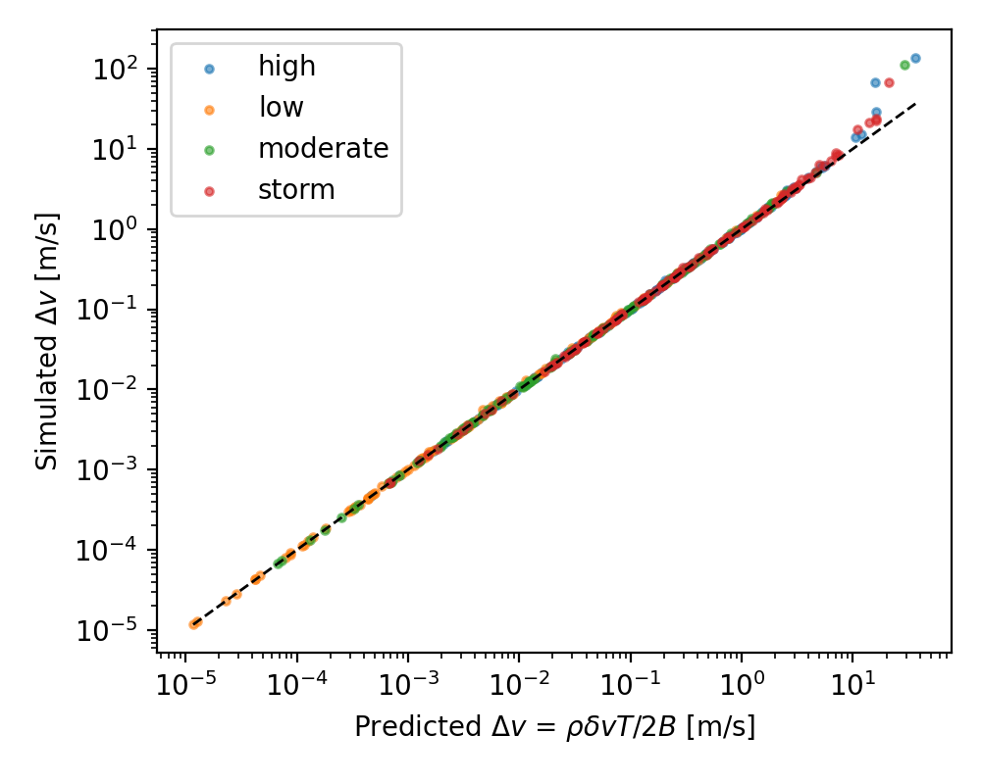
Figure 6. Simulated extra delta-v against the predicted value rho*delta*v_rel^2*T/(2B); all regimes, altitudes and ballistic coefficients collapse onto the identity line.

3.9 Timing, Pareto structure and the feasibility map
Tracking outcome is nearly insensitive to window start (mean 1.06e0 m/s, std 1.40e-1), while fixed-pulse outcomes stay orders of magnitude lower at every start time, so no timing strategy rescues a fixed patch. In the design sweep, selectivity degrades to ~117 once sigma_h reaches ~400 km, where protected objects begin to share the enhanced region; at small sigma_h the protected collateral falls into the Gaussian tail and the ratio ceases to be meaningful. Collecting the gates gives the exclusion map: the concept is excluded by exposure geometry for any Earth-fixed patch, by transport for any patch small enough to be selective in realistic winds, by trajectory sharing for co-orbital and track-crossing protected objects, and by energetics at the scale required; what remains mathematically open is the narrow corner in which an enhancement is sustained on the target for a large fraction of its remaining lifetime (Fig. 4, Fig. 5).
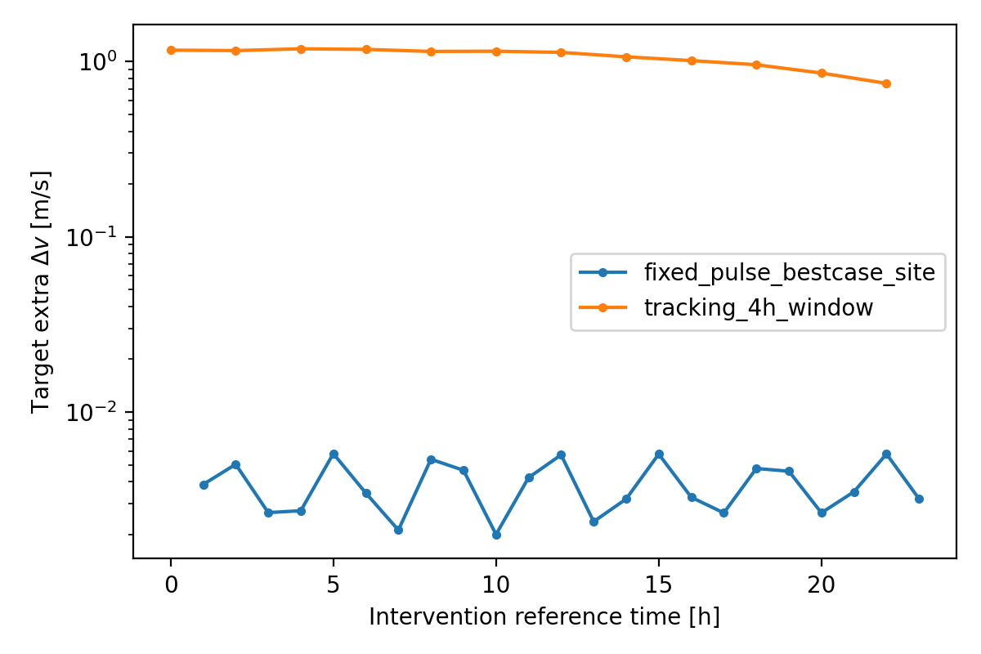
Figure 4. Target extra delta-v versus intervention reference time for a best-case-sited fixed pulse and for a 4 h tracking window.
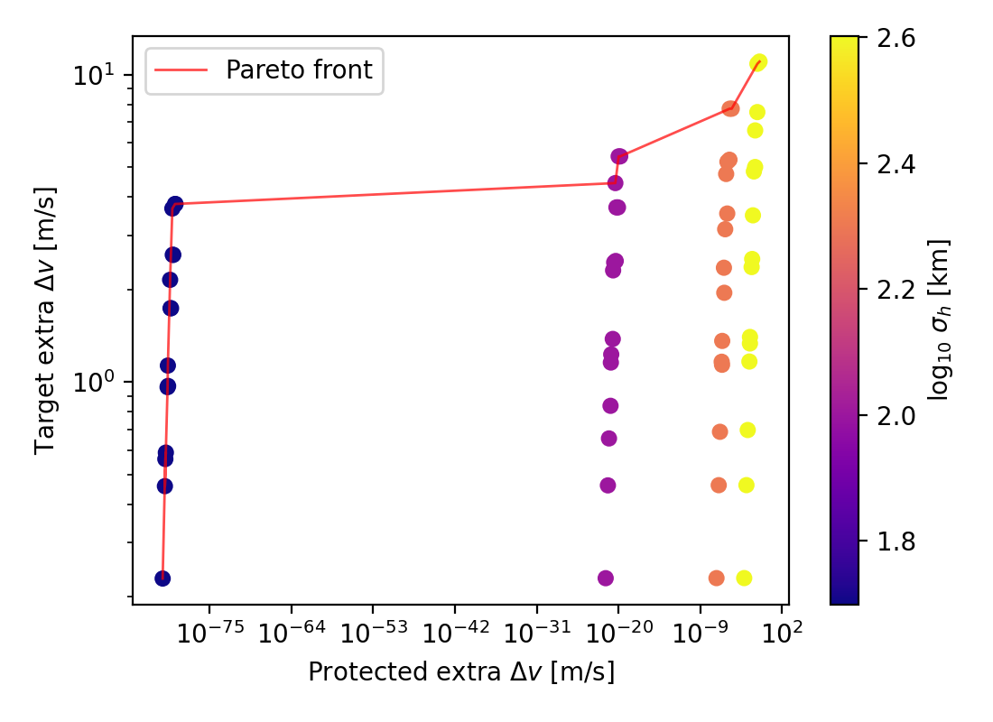
Figure 5. Target benefit against protected-object collateral over the design sweep; the Pareto front is highlighted and colour encodes horizontal patch scale.

4. Discussion

4.1 Geometry
An orbiting object samples any Earth-fixed structure for tens of seconds per revolution, so the useful quantity is not the peak enhancement but the integral of delta along the trajectory. The decomposition in Section 3.3 shows this explicitly: duration, occupancy and in-patch amplitude enter multiplicatively, and the first two dominate. Any concept that cannot follow the target loses three orders of magnitude before atmospheric physics is even considered, and increasing delta cannot recover it because the response is linear in delta.

4.2 Transport
A patch that must persist for hours to days is acted on by diffusion, mean winds and the cooling relaxation of any heated volume. Thermospheric winds of tens to over a hundred m/s are routine [15] and disturbances of the kind an intervention would create are observed to propagate away from their source at several hundred m/s [16]. In our survey the combinations that survive an hour are exactly those with large patches and weak winds — that is, the combinations that are too large to be selective. The transport and selectivity requirements are therefore in direct conflict, which is the single most robust element of the negative result.

4.3 Selectivity
Perfect localization suppresses collateral by many orders of magnitude, but only for objects that do not share the target's trajectory tube. Co-orbital twins receive comparable drag, track-crossing objects at similar altitude receive a physically meaningful fraction (case pair E: 29 encounters and 6.18e-3 m/s), and a dispersed fragment cloud cannot be covered by a single localized enhancement at all. The very large selectivity ratios that appear in the tables for remote pairs are Gaussian-tail or no-encounter artefacts of the patch shape and are reported as undefined; the defensible statement is about the absolute collateral delta-v, which is below any operationally relevant level for non-co-located objects.

4.4 Energetics
Raising density at a fixed altitude cannot be done by heating the air there — in situ heating lowers the local density — so the relevant thermodynamic accounting is the expansion of the column below. For an isothermal hydrostatic layer, scaling the column temperature and scale height by (1+eps) multiplies the density at altitude z by exp[L eps / (H (1+eps))] with L the column length, so with q = ln(1+delta) H / L the requirement is eps = q/(1-q) exactly; the commonly used first-order form eps = q understates it, and q >= 1 means the density increase is unreachable by uniform heating of that column at any temperature. Raising delta = 5 at 400 km requires warming the column by a fractional 63% (691 K at the top of the column) and costs at least 5.02e12 J, i.e. ~5.80e7 W sustained over a day for a sigma_h = 200 km patch; the in-situ bound of 1.83e10 J understates this by a factor 274 at this altitude. Both are thermodynamic lower bounds, not delivered engineering energy: no deposition efficiency, coupling mechanism or loss budget is modelled, and no engineering energy requirement can be inferred robustly from them. For scale, the global upper atmosphere receives ~464 GW from solar EUV and ~95 GW from Joule dissipation on average [17]; the bound above is a small fraction of that globally but must be delivered into a single patch and sustained, which is why storms — which do deliver it — produce global, not selective, enhancements.
Table 8. Thermodynamic lower bounds on the energy required to sustain a density enhancement: in-situ heating bound, fractional warming of the column below, column-expansion energy, and the equivalent sustained power for a one-day intervention.
altitude_km | delta | E_insitu_J | q_column | eps_column | dT_column_at_top_K | E_column_expansion_J | E_column_per_day_W
300 | 1 | 6.377e+10 | 0.1932 | 0.2395 | 258.6 | 1.885e+12 | 2.181e+07
300 | 5 | 1.063e+11 | 0.4995 | 0.9981 | 1078 | 7.853e+12 | 9.089e+07
300 | 20 | 1.215e+11 | 0.8488 | 5.613 | 6061 | 4.417e+13 | 5.112e+08
300 | 1 | 2.551e+11 | 0.1932 | 0.2395 | 258.6 | 7.538e+12 | 8.725e+07
300 | 5 | 4.251e+11 | 0.4995 | 0.9981 | 1078 | 3.141e+13 | 3.636e+08
300 | 20 | 4.859e+11 | 0.8488 | 5.613 | 6061 | 1.767e+14 | 2.045e+09
300 | 1 | 6.377e+12 | 0.1932 | 0.2395 | 258.6 | 1.885e+14 | 2.181e+09
300 | 5 | 1.063e+13 | 0.4995 | 0.9981 | 1078 | 7.853e+14 | 9.089e+09
300 | 20 | 1.215e+13 | 0.8488 | 5.613 | 6061 | 4.417e+15 | 5.112e+10
400 | 1 | 1.098e+10 | 0.1497 | 0.176 | 192.8 | 1.399e+12 | 1.619e+07
400 | 5 | 1.831e+10 | 0.3869 | 0.6312 | 691.1 | 5.015e+12 | 5.805e+07
400 | 20 | 2.092e+10 | 0.6575 | 1.92 | 2102 | 1.525e+13 | 1.765e+08
400 | 1 | 4.394e+10 | 0.1497 | 0.176 | 192.8 | 5.595e+12 | 6.476e+07
400 | 5 | 7.323e+10 | 0.3869 | 0.6312 | 691.1 | 2.006e+13 | 2.322e+08
400 | 20 | 8.369e+10 | 0.6575 | 1.92 | 2102 | 6.101e+13 | 7.062e+08
400 | 1 | 1.098e+12 | 0.1497 | 0.176 | 192.8 | 1.399e+14 | 1.619e+09
400 | 5 | 1.831e+12 | 0.3869 | 0.6312 | 691.1 | 5.015e+14 | 5.805e+09
400 | 20 | 2.092e+12 | 0.6575 | 1.92 | 2102 | 1.525e+15 | 1.765e+10
500 | 1 | 2.316e+09 | 0.1215 | 0.1383 | 151.7 | 1.101e+12 | 1.274e+07
500 | 5 | 3.86e+09 | 0.314 | 0.4577 | 502.1 | 3.643e+12 | 4.217e+07
500 | 20 | 4.411e+09 | 0.5335 | 1.144 | 1255 | 9.104e+12 | 1.054e+08
500 | 1 | 9.264e+09 | 0.1215 | 0.1383 | 151.7 | 4.402e+12 | 5.095e+07
500 | 5 | 1.544e+10 | 0.314 | 0.4577 | 502.1 | 1.457e+13 | 1.687e+08
500 | 20 | 1.764e+10 | 0.5335 | 1.144 | 1255 | 3.642e+13 | 4.215e+08
500 | 1 | 2.316e+11 | 0.1215 | 0.1383 | 151.7 | 1.101e+14 | 1.274e+09
500 | 5 | 3.86e+11 | 0.314 | 0.4577 | 502.1 | 3.643e+14 | 4.217e+09
500 | 20 | 4.411e+11 | 0.5335 | 1.144 | 1255 | 9.104e+14 | 1.054e+10
600 | 1 | 5.482e+08 | 0.1033 | 0.1152 | 126.4 | 9.176e+11 | 1.062e+07
600 | 5 | 9.136e+08 | 0.2671 | 0.3644 | 399.9 | 2.902e+12 | 3.359e+07
600 | 20 | 1.044e+09 | 0.4538 | 0.8309 | 911.8 | 6.617e+12 | 7.659e+07
600 | 1 | 2.193e+09 | 0.1033 | 0.1152 | 126.4 | 3.671e+12 | 4.248e+07
600 | 5 | 3.654e+09 | 0.2671 | 0.3644 | 399.9 | 1.161e+13 | 1.344e+08
600 | 20 | 4.177e+09 | 0.4538 | 0.8309 | 911.8 | 2.647e+13 | 3.063e+08
600 | 1 | 5.482e+10 | 0.1033 | 0.1152 | 126.4 | 9.176e+13 | 1.062e+09
600 | 5 | 9.136e+10 | 0.2671 | 0.3644 | 399.9 | 2.902e+14 | 3.359e+09
600 | 20 | 1.044e+11 | 0.4538 | 0.8309 | 911.8 | 6.617e+14 | 7.659e+09
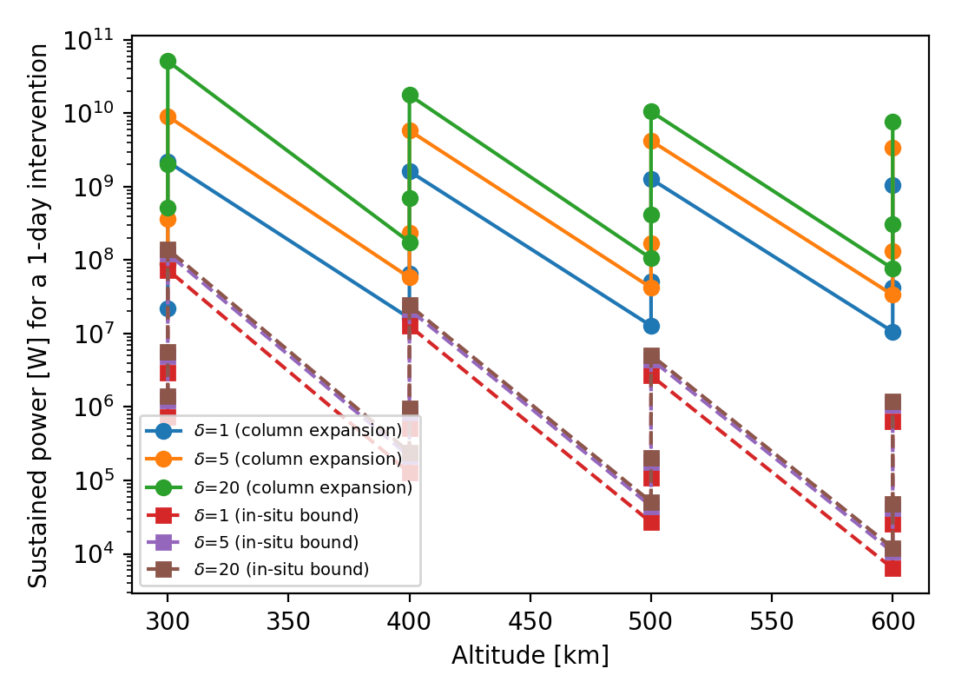
Figure 8. Sustained power corresponding to the thermodynamic lower bounds of Table 8, versus altitude and enhancement amplitude.

4.5 Implications
The practical implication is that the concept fails for reasons that are independent of the drag physics and therefore cannot be engineered around by increasing amplitude. Natural storm-time enhancements already realize delta of order unity to several, globally, and the observed operational consequences of those events [6,7] are the uniform control realized by nature. Differential-drag station-keeping and drag-augmentation devices achieve selective decay by changing B of the object rather than rho of the atmosphere, and the comparison in Section 3.4 explains why that is the favourable side of the trade: it requires no sustained energy input and is intrinsically co-located with the target.

5. Limitations
This is a boundary study with synthetic targets. It uses a climatological density lookup rather than assimilated densities, a circular-approximation secular decay integrator (agreeing with the Cowell reference to 0.12% on a ten-day drag-only test), and an idealized tracking bound used as an upper limit rather than a mechanism. No plasma/neutral coupling, self-consistent heating, deposition physics, or circulation response is modelled; the transport treatment is a parameterized diffusion/advection/relaxation surrogate, not a general-circulation simulation, and its survival fractions are fractions of a design grid rather than probabilities. Energy accounting reports thermodynamic lower bounds only. Lifetimes beyond the integration horizon are right-censored. No public catalog was used for targeting and no observational dataset was ingested; all numbers are model output.

6. Conclusions
Within the modelled system, localized thermospheric density enhancement is excluded as a selective debris-removal mechanism for every configuration we could construct that respects exposure geometry, transport persistence and collateral constraints simultaneously: Earth-fixed patches are limited by transit time to sub-percent contributions relative to natural drag, patches small enough to be selective do not survive realistic winds for an hour, co-orbital and track-crossing spacecraft receive comparable collateral, and the thermodynamic lower bound on sustaining a useful enhancement is 5.80e7 W for a single patch. What remains mathematically possible is the idealized limit of an enhancement co-located with the target for a large fraction of its remaining lifetime, which would multiply its drag by (1+delta); nothing in this study indicates that such co-location can be realized, and no technological feasibility is claimed. The quantitative boundary — and the dimensionless group that lets it be re-evaluated for any other parameter choice — is the result.

Data and code availability
All results regenerate from `make all` (or `make quick`) in the accompanying repository; every number in this manuscript is written from results/tables CSVs by scripts/build_manuscript.py.

References
1. Liou, J.-C.; Johnson, N. L. (2006). Risks in space from orbiting debris. Science 311(5759) 340-341. doi:10.1126/science.1121337
2. IADC (2021). IADC Space Debris Mitigation Guidelines (Rev. 3). IADC-02-01 Rev.3.
3. Shan, M.; Guo, J.; Gill, E. K. A. (2016). Review and comparison of active space debris capturing and removal methods. Progress in Aerospace Sciences 80 18-32. doi:10.1016/j.paerosci.2015.11.001
4. Phipps, C. R.; Baker, K. L.; Libby, S. B.; Liedahl, D. A.; Olivier, S. S.; Pleasance, L. D.; Rubenchik, A.; Trebes, J. E.; George, E. V.; Marcovici, B.; Reilly, J. P.; Valley, M. T. (2012). Removing orbital debris with lasers. Advances in Space Research 49(9) 1283-1300. doi:10.1016/j.asr.2012.02.003
5. Bruinsma, S.; Forbes, J. M.; Nerem, R. S.; Zhang, X. (2006). Thermosphere density response to the 20-21 November 2003 solar and geomagnetic storm from CHAMP and GRACE accelerometer data. Journal of Geophysical Research 111 A06303. doi:10.1029/2005JA011284
6. Parker, W. E.; Linares, R. (2024). Satellite Drag Analysis During the May 2024 Gannon Geomagnetic Storm. Journal of Spacecraft and Rockets 61(5). doi:10.2514/1.A36164
7. Berger, T. E.; Dominique, M.; Lucas, G.; Pilinski, M.; Ray, V.; Sewell, R.; et al. (2023). The Thermosphere Is a Drag: The 2022 Starlink Incident and the Threat of Geomagnetic Storms to Low Earth Orbit Space Operations. Space Weather 21(3). doi:10.1029/2022SW003330
8. Picone, J. M.; Hedin, A. E.; Drob, D. P.; Aikin, A. C. (2002). NRLMSISE-00 empirical model of the atmosphere: Statistical comparisons and scientific issues. Journal of Geophysical Research 107(A12) 1468. doi:10.1029/2002JA009430
9. NRL Space Science Division (2024). NRLMSISE-00 model code and documentation. NRL MAP pub.
10. Emmert, J. T. (2015). Thermospheric mass density: A review. Advances in Space Research 56(5) 773-824. doi:10.1016/j.asr.2015.05.038
11. Bowman, B.; Tobiska, W. K.; Marcos, F. A.; Huang, C.; Lin, C. S.; Burke, W. J. (2008). A New Empirical Thermospheric Density Model JB2008 Using New Solar and Geomagnetic Indices. AIAA/AAS Astrodynamics Specialist Conference AIAA-2008-6438. doi:10.2514/6.2008-6438
12. King-Hele, D. (1987). Satellite Orbits in an Atmosphere: Theory and Application. Blackie & Son Ltd (Glasgow/London).
13. Moe, M. M.; Moe, K. (2005). Gas surface interactions and satellite drag coefficients. Planetary and Space Science 53(8) 793-801. doi:10.1016/j.pss.2005.03.005
14. Vallado, D. A.; Crawford, P. (2008). SGP4 Orbit Determination. AIAA/AAS Astrodynamics Specialist Conference AIAA-2008-6770. doi:10.2514/6.2008-6770
15. Drob, D. P.; Emmert, J. T.; Meriwether, J. W.; Makela, J. J.; Doornbos, E.; Conde, M.; Hernandez, G.; Noto, J.; Zawdie, K. A.; McDonald, S. E.; et al. (2015). An update to the Horizontal Wind Model (HWM): The quiet time thermosphere. Earth and Space Science 2(7) 301-319. doi:10.1002/2014EA000089
16. Bruinsma, S. L.; Forbes, J. M. (2007). Global observation of traveling atmospheric disturbances (TADs) in the thermosphere. Geophysical Research Letters 34(14) L14103. doi:10.1029/2007GL030243
17. Knipp, D. J.; Tobiska, W. K.; Emery, B. A. (2004). Direct and indirect thermospheric heating sources for solar cycles 21-23. Solar Physics 224(1-2) 495-505. doi:10.1007/s11207-005-6393-4

