Supplementary material

Supplementary figures
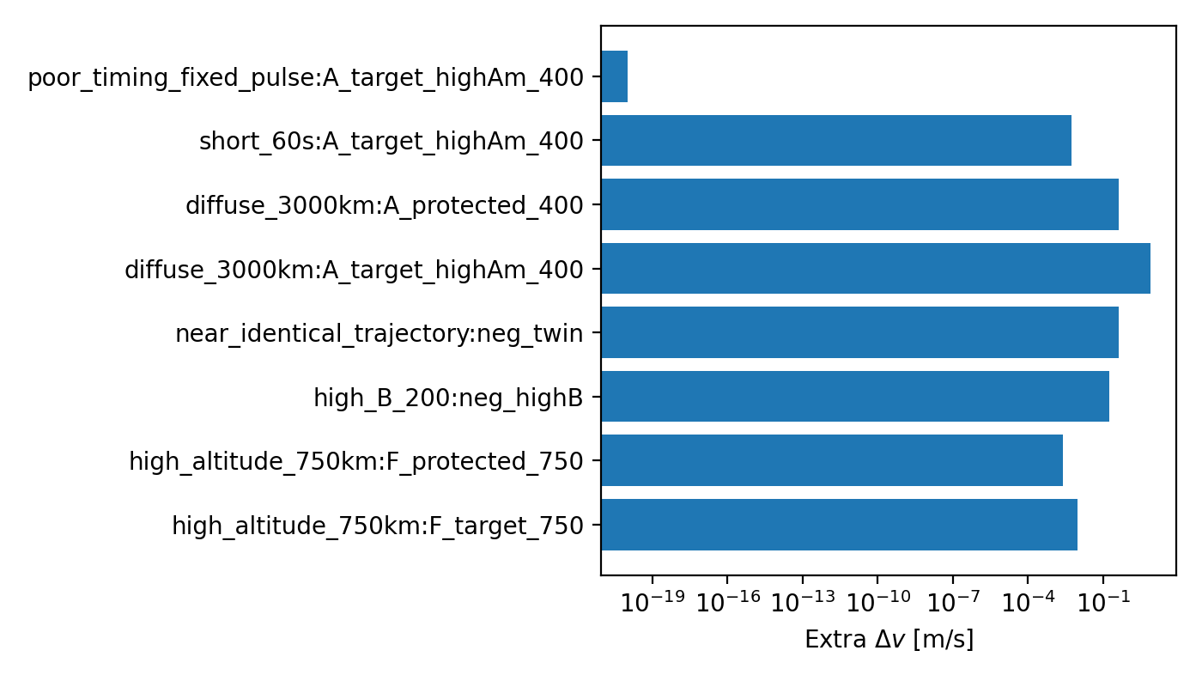
Figure S1. Extra delta-v for each mandatory negative control (cited in Section 3.7).
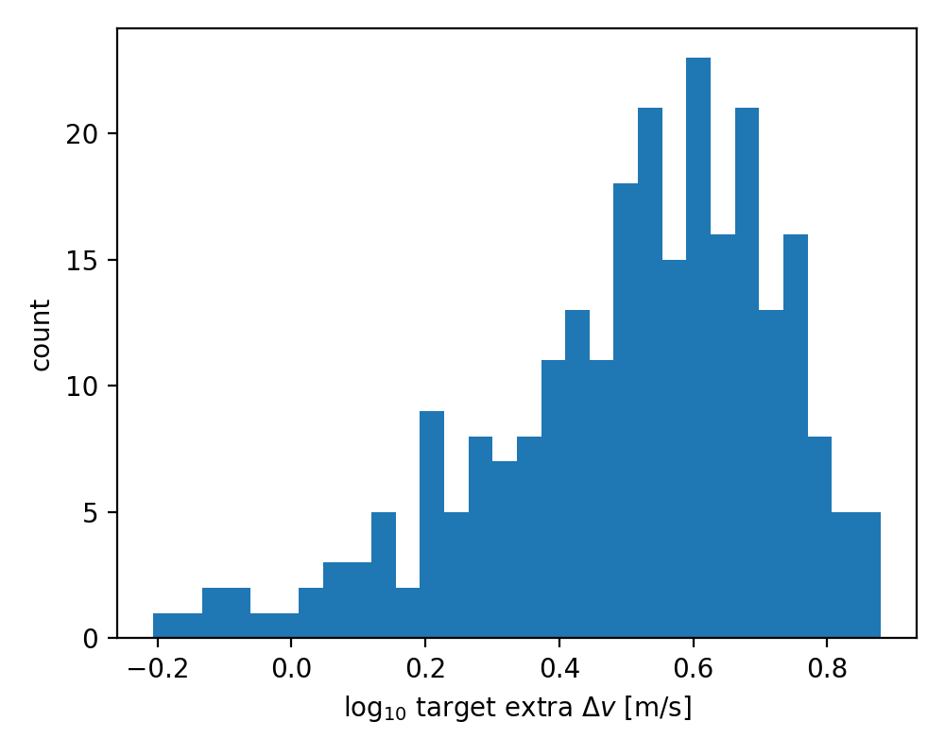
Figure S2. Monte Carlo distribution of target extra delta-v (cited in Section 3.6).
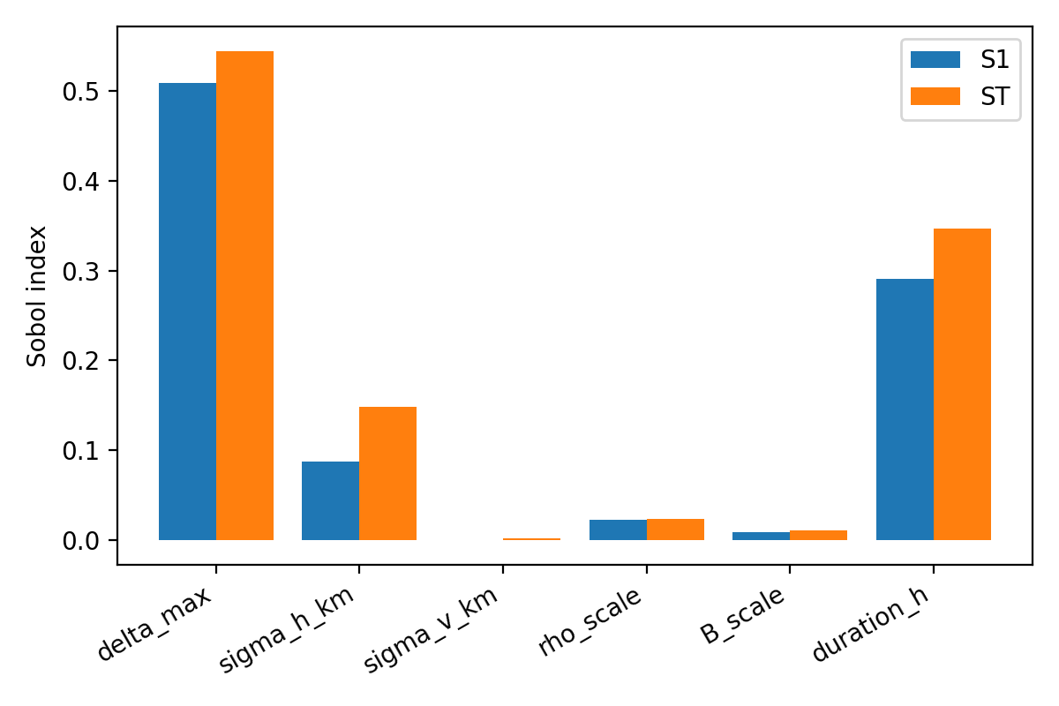
Figure S3. Sobol' first-order and total-order sensitivity indices (cited in Section 3.6).
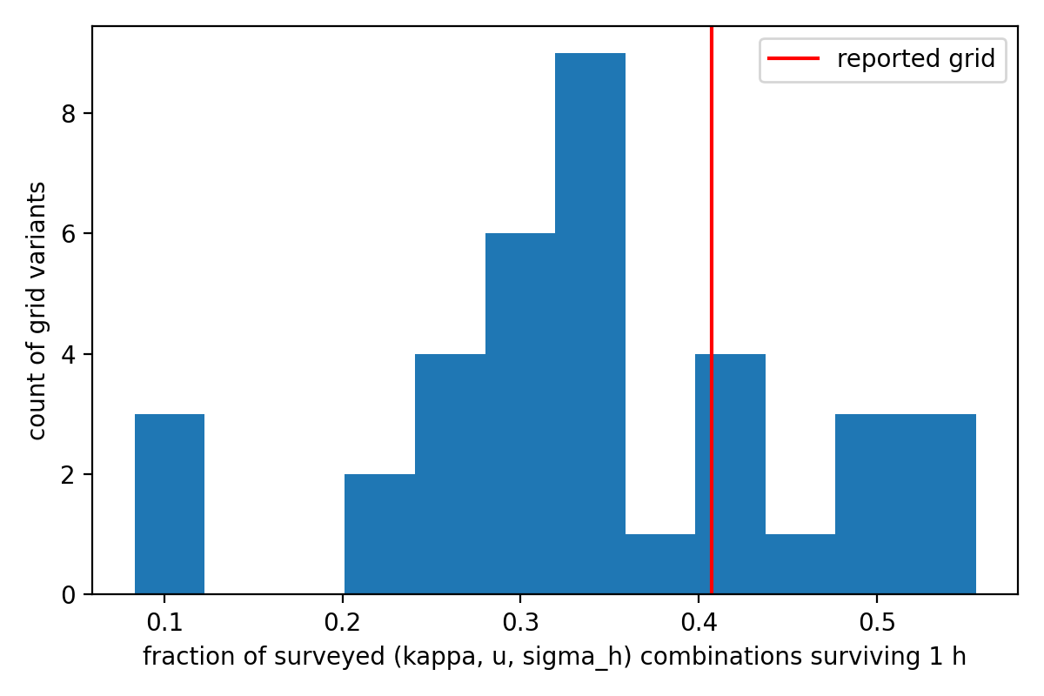
Figure S4. Distribution of the surviving fraction over grid variants of the transport design space (cited in Section 3.5).

Supplementary tables

Exposure classification audit
scenario | pair | case | obj_type | alt_km | inc_deg | B_kgm2 | peak_delta | n_sigma_closest | encounter_count | time_fraction_in_patch | extra_dv_ms | natural_dv_ms | rel_to_natural | exposure_class
uniform | A | A_target_highAm_400 | target | 400 | 51.6 | 5 | 5 | -0 | 1 | 1 | 6.869 | 1.374 | 5 | physical_exposure
localized_tracking | A | A_target_highAm_400 | target | 400 | 51.6 | 5 | 5 | -0 | 1 | 1 | 6.869 | 1.374 | 5 | physical_exposure
uniform | A | A_protected_400 | protected | 400 | 51.6 | 80 | 5 | -0 | 1 | 1 | 0.4292 | 0.08584 | 5 | physical_exposure
localized_tracking | A | A_protected_400 | protected | 400 | 51.6 | 80 | 5.621e-05 | 4.774 | 1 | 1 | 4.599e-06 | 0.08584 | 5.358e-05 | gaussian_tail
uniform | D | D_target_550 | target | 550 | 97.6 | 20 | 5 | -0 | 1 | 1 | 0.1626 | 0.03252 | 5 | physical_exposure
localized_tracking | D | D_target_550 | target | 550 | 97.6 | 20 | 5 | -0 | 1 | 1 | 0.1626 | 0.03252 | 5 | physical_exposure
uniform | D | D_protected_550 | protected | 550 | 97.6 | 85 | 5 | -0 | 1 | 1 | 0.03825 | 0.00765 | 5 | physical_exposure
localized_tracking | D | D_protected_550 | protected | 550 | 97.6 | 85 | 3.224e-79 | 19.1 | 0 | 0 | 1.31e-81 | 0.00765 | 1.712e-79 | no_encounter
uniform | E | E_target_400_i28 | target | 400 | 28.5 | 15 | 5 | -0 | 1 | 1 | 2.209 | 0.4417 | 5 | physical_exposure
localized_tracking | E | E_target_400_i28 | target | 400 | 28.5 | 15 | 5 | -0 | 1 | 1 | 2.209 | 0.4417 | 5 | physical_exposure
uniform | E | E_protected_400_i51 | protected | 400 | 51.6 | 70 | 5 | -0 | 1 | 1 | 0.4901 | 0.09803 | 5 | physical_exposure
localized_tracking | E | E_protected_400_i51 | protected | 400 | 51.6 | 70 | 4.932 | 0.1659 | 29 | 0.2062 | 0.006155 | 0.09803 | 0.06279 | physical_exposure
uniform | G | G_target_250 | target | 250 | 51.6 | 10 | 5 | -0 | 1 | 1 | 76.23 | 15.25 | 5 | physical_exposure
localized_tracking | G | G_target_250 | target | 250 | 51.6 | 10 | 5 | -0 | 1 | 1 | 76.23 | 15.25 | 5 | physical_exposure
uniform | G | G_protected_250 | protected | 250 | 51.6 | 80 | 5 | -0 | 1 | 1 | 9.525 | 1.905 | 5 | physical_exposure
localized_tracking | G | G_protected_250 | protected | 250 | 51.6 | 80 | 3.224e-79 | 19.1 | 0 | 0 | 3.192e-79 | 1.905 | 1.676e-79 | no_encounter

Transport-grid sensitivity
sigma_set | kappa_set | wind_set | criterion_h | n_combinations | frac_surviving | n_selective | frac_surviving_selective_sigma | n_selective_windy | frac_surviving_selective_windy | n_selective_wind100 | frac_surviving_selective_wind100
frozen | frozen | frozen | 0.5 | 27 | 0.6296 | 18 | 0.4444 | 12 | 0.25 | 12 | 0.25
frozen | frozen | frozen | 1 | 27 | 0.4074 | 18 | 0.2778 | 12 | 0 | 12 | 0
frozen | frozen | frozen | 3 | 27 | 0.2963 | 18 | 0.2778 | 12 | 0 | 12 | 0
frozen | frozen | frozen | 6 | 27 | 0.2222 | 18 | 0.1667 | 12 | 0 | 12 | 0
frozen | frozen | no_zero_wind | 0.5 | 36 | 0.5 | 24 | 0.25 | 24 | 0.25 | 18 | 0.1667
frozen | frozen | no_zero_wind | 1 | 36 | 0.3333 | 24 | 0.125 | 24 | 0.125 | 18 | 0
frozen | frozen | no_zero_wind | 3 | 36 | 0.08333 | 24 | 0 | 24 | 0 | 18 | 0
frozen | frozen | no_zero_wind | 6 | 36 | 0 | 24 | 0 | 24 | 0 | 18 | 0
frozen | frozen | quiet_only | 0.5 | 27 | 0.7407 | 18 | 0.6111 | 12 | 0.5 | 6 | 0.5
frozen | frozen | quiet_only | 1 | 27 | 0.5556 | 18 | 0.3333 | 12 | 0.25 | 6 | 0
frozen | frozen | quiet_only | 3 | 27 | 0.2222 | 18 | 0 | 12 | 0 | 6 | 0
frozen | frozen | quiet_only | 6 | 27 | 0.1111 | 18 | 0 | 12 | 0 | 6 | 0
frozen | frozen | storm_included | 0.5 | 36 | 0.4722 | 24 | 0.3333 | 18 | 0.1667 | 18 | 0.1667
frozen | frozen | storm_included | 1 | 36 | 0.3056 | 24 | 0.2083 | 18 | 0 | 18 | 0
frozen | frozen | storm_included | 3 | 36 | 0.2222 | 24 | 0.2083 | 18 | 0 | 18 | 0
frozen | frozen | storm_included | 6 | 36 | 0.1667 | 24 | 0.125 | 18 | 0 | 18 | 0
frozen | log_uniform_9 | frozen | 0.5 | 81 | 0.6543 | 54 | 0.4815 | 36 | 0.25 | 36 | 0.25
frozen | log_uniform_9 | frozen | 1 | 81 | 0.4198 | 54 | 0.2963 | 36 | 0 | 36 | 0
frozen | log_uniform_9 | frozen | 3 | 81 | 0.2963 | 54 | 0.2778 | 36 | 0 | 36 | 0
frozen | log_uniform_9 | frozen | 6 | 81 | 0.2716 | 54 | 0.2407 | 36 | 0 | 36 | 0
frozen | log_uniform_9 | no_zero_wind | 0.5 | 108 | 0.5 | 72 | 0.25 | 72 | 0.25 | 54 | 0.1667
frozen | log_uniform_9 | no_zero_wind | 1 | 108 | 0.3333 | 72 | 0.125 | 72 | 0.125 | 54 | 0
frozen | log_uniform_9 | no_zero_wind | 3 | 108 | 0.08333 | 72 | 0 | 72 | 0 | 54 | 0
frozen | log_uniform_9 | no_zero_wind | 6 | 108 | 0 | 72 | 0 | 72 | 0 | 54 | 0
frozen | log_uniform_9 | quiet_only | 0.5 | 81 | 0.7654 | 54 | 0.6481 | 36 | 0.5 | 18 | 0.5
frozen | log_uniform_9 | quiet_only | 1 | 81 | 0.5556 | 54 | 0.3333 | 36 | 0.25 | 18 | 0
frozen | log_uniform_9 | quiet_only | 3 | 81 | 0.2222 | 54 | 0 | 36 | 0 | 18 | 0
frozen | log_uniform_9 | quiet_only | 6 | 81 | 0.1111 | 54 | 0 | 36 | 0 | 18 | 0
frozen | log_uniform_9 | storm_included | 0.5 | 108 | 0.4907 | 72 | 0.3611 | 54 | 0.1667 | 54 | 0.1667
frozen | log_uniform_9 | storm_included | 1 | 108 | 0.3148 | 72 | 0.2222 | 54 | 0 | 54 | 0
frozen | log_uniform_9 | storm_included | 3 | 108 | 0.2222 | 72 | 0.2083 | 54 | 0 | 54 | 0
frozen | log_uniform_9 | storm_included | 6 | 108 | 0.2037 | 72 | 0.1806 | 54 | 0 | 54 | 0
frozen | conservative_low | frozen | 0.5 | 27 | 0.6667 | 18 | 0.5 | 12 | 0.25 | 12 | 0.25
frozen | conservative_low | frozen | 1 | 27 | 0.4444 | 18 | 0.3333 | 12 | 0 | 12 | 0
frozen | conservative_low | frozen | 3 | 27 | 0.3333 | 18 | 0.3333 | 12 | 0 | 12 | 0
frozen | conservative_low | frozen | 6 | 27 | 0.2963 | 18 | 0.2778 | 12 | 0 | 12 | 0
frozen | conservative_low | no_zero_wind | 0.5 | 36 | 0.5 | 24 | 0.25 | 24 | 0.25 | 18 | 0.1667
frozen | conservative_low | no_zero_wind | 1 | 36 | 0.3333 | 24 | 0.125 | 24 | 0.125 | 18 | 0
frozen | conservative_low | no_zero_wind | 3 | 36 | 0.08333 | 24 | 0 | 24 | 0 | 18 | 0
frozen | conservative_low | no_zero_wind | 6 | 36 | 0 | 24 | 0 | 24 | 0 | 18 | 0
frozen | conservative_low | quiet_only | 0.5 | 27 | 0.7778 | 18 | 0.6667 | 12 | 0.5 | 6 | 0.5
frozen | conservative_low | quiet_only | 1 | 27 | 0.5556 | 18 | 0.3333 | 12 | 0.25 | 6 | 0
frozen | conservative_low | quiet_only | 3 | 27 | 0.2222 | 18 | 0 | 12 | 0 | 6 | 0
frozen | conservative_low | quiet_only | 6 | 27 | 0.1111 | 18 | 0 | 12 | 0 | 6 | 0
frozen | conservative_low | storm_included | 0.5 | 36 | 0.5 | 24 | 0.375 | 18 | 0.1667 | 18 | 0.1667
frozen | conservative_low | storm_included | 1 | 36 | 0.3333 | 24 | 0.25 | 18 | 0 | 18 | 0
frozen | conservative_low | storm_included | 3 | 36 | 0.25 | 24 | 0.25 | 18 | 0 | 18 | 0
frozen | conservative_low | storm_included | 6 | 36 | 0.2222 | 24 | 0.2083 | 18 | 0 | 18 | 0
selective_only | frozen | frozen | 0.5 | 27 | 0.4074 | 27 | 0.4074 | 18 | 0.1667 | 18 | 0.1667
selective_only | frozen | frozen | 1 | 27 | 0.2963 | 27 | 0.2963 | 18 | 0 | 18 | 0
selective_only | frozen | frozen | 3 | 27 | 0.2593 | 27 | 0.2593 | 18 | 0 | 18 | 0
selective_only | frozen | frozen | 6 | 27 | 0.1852 | 27 | 0.1852 | 18 | 0 | 18 | 0
selective_only | frozen | no_zero_wind | 0.5 | 36 | 0.25 | 36 | 0.25 | 36 | 0.25 | 27 | 0.1111
selective_only | frozen | no_zero_wind | 1 | 36 | 0.08333 | 36 | 0.08333 | 36 | 0.08333 | 27 | 0
selective_only | frozen | no_zero_wind | 3 | 36 | 0 | 36 | 0 | 36 | 0 | 27 | 0
selective_only | frozen | no_zero_wind | 6 | 36 | 0 | 36 | 0 | 36 | 0 | 27 | 0
selective_only | frozen | quiet_only | 0.5 | 27 | 0.6296 | 27 | 0.6296 | 18 | 0.5 | 9 | 0.3333
selective_only | frozen | quiet_only | 1 | 27 | 0.3333 | 27 | 0.3333 | 18 | 0.1667 | 9 | 0
selective_only | frozen | quiet_only | 3 | 27 | 0 | 27 | 0 | 18 | 0 | 9 | 0
selective_only | frozen | quiet_only | 6 | 27 | 0 | 27 | 0 | 18 | 0 | 9 | 0
selective_only | frozen | storm_included | 0.5 | 36 | 0.3056 | 36 | 0.3056 | 27 | 0.1111 | 27 | 0.1111
selective_only | frozen | storm_included | 1 | 36 | 0.2222 | 36 | 0.2222 | 27 | 0 | 27 | 0
selective_only | frozen | storm_included | 3 | 36 | 0.1944 | 36 | 0.1944 | 27 | 0 | 27 | 0
selective_only | frozen | storm_included | 6 | 36 | 0.1389 | 36 | 0.1389 | 27 | 0 | 27 | 0
selective_only | log_uniform_9 | frozen | 0.5 | 81 | 0.4321 | 81 | 0.4321 | 54 | 0.1667 | 54 | 0.1667
selective_only | log_uniform_9 | frozen | 1 | 81 | 0.3086 | 81 | 0.3086 | 54 | 0 | 54 | 0
selective_only | log_uniform_9 | frozen | 3 | 81 | 0.284 | 81 | 0.284 | 54 | 0 | 54 | 0
selective_only | log_uniform_9 | frozen | 6 | 81 | 0.2469 | 81 | 0.2469 | 54 | 0 | 54 | 0
selective_only | log_uniform_9 | no_zero_wind | 0.5 | 108 | 0.25 | 108 | 0.25 | 108 | 0.25 | 81 | 0.1111
selective_only | log_uniform_9 | no_zero_wind | 1 | 108 | 0.08333 | 108 | 0.08333 | 108 | 0.08333 | 81 | 0
selective_only | log_uniform_9 | no_zero_wind | 3 | 108 | 0 | 108 | 0 | 108 | 0 | 81 | 0
selective_only | log_uniform_9 | no_zero_wind | 6 | 108 | 0 | 108 | 0 | 108 | 0 | 81 | 0
selective_only | log_uniform_9 | quiet_only | 0.5 | 81 | 0.6543 | 81 | 0.6543 | 54 | 0.5 | 27 | 0.3333
selective_only | log_uniform_9 | quiet_only | 1 | 81 | 0.3333 | 81 | 0.3333 | 54 | 0.1667 | 27 | 0
selective_only | log_uniform_9 | quiet_only | 3 | 81 | 0 | 81 | 0 | 54 | 0 | 27 | 0
selective_only | log_uniform_9 | quiet_only | 6 | 81 | 0 | 81 | 0 | 54 | 0 | 27 | 0
selective_only | log_uniform_9 | storm_included | 0.5 | 108 | 0.3241 | 108 | 0.3241 | 81 | 0.1111 | 81 | 0.1111
selective_only | log_uniform_9 | storm_included | 1 | 108 | 0.2315 | 108 | 0.2315 | 81 | 0 | 81 | 0
selective_only | log_uniform_9 | storm_included | 3 | 108 | 0.213 | 108 | 0.213 | 81 | 0 | 81 | 0
selective_only | log_uniform_9 | storm_included | 6 | 108 | 0.1852 | 108 | 0.1852 | 81 | 0 | 81 | 0
selective_only | conservative_low | frozen | 0.5 | 27 | 0.4444 | 27 | 0.4444 | 18 | 0.1667 | 18 | 0.1667
selective_only | conservative_low | frozen | 1 | 27 | 0.3333 | 27 | 0.3333 | 18 | 0 | 18 | 0
selective_only | conservative_low | frozen | 3 | 27 | 0.3333 | 27 | 0.3333 | 18 | 0 | 18 | 0
selective_only | conservative_low | frozen | 6 | 27 | 0.2963 | 27 | 0.2963 | 18 | 0 | 18 | 0
selective_only | conservative_low | no_zero_wind | 0.5 | 36 | 0.25 | 36 | 0.25 | 36 | 0.25 | 27 | 0.1111
selective_only | conservative_low | no_zero_wind | 1 | 36 | 0.08333 | 36 | 0.08333 | 36 | 0.08333 | 27 | 0
selective_only | conservative_low | no_zero_wind | 3 | 36 | 0 | 36 | 0 | 36 | 0 | 27 | 0
selective_only | conservative_low | no_zero_wind | 6 | 36 | 0 | 36 | 0 | 36 | 0 | 27 | 0
selective_only | conservative_low | quiet_only | 0.5 | 27 | 0.6667 | 27 | 0.6667 | 18 | 0.5 | 9 | 0.3333
selective_only | conservative_low | quiet_only | 1 | 27 | 0.3333 | 27 | 0.3333 | 18 | 0.1667 | 9 | 0
selective_only | conservative_low | quiet_only | 3 | 27 | 0 | 27 | 0 | 18 | 0 | 9 | 0
selective_only | conservative_low | quiet_only | 6 | 27 | 0 | 27 | 0 | 18 | 0 | 9 | 0
selective_only | conservative_low | storm_included | 0.5 | 36 | 0.3333 | 36 | 0.3333 | 27 | 0.1111 | 27 | 0.1111
selective_only | conservative_low | storm_included | 1 | 36 | 0.25 | 36 | 0.25 | 27 | 0 | 27 | 0
selective_only | conservative_low | storm_included | 3 | 36 | 0.25 | 36 | 0.25 | 27 | 0 | 27 | 0
selective_only | conservative_low | storm_included | 6 | 36 | 0.2222 | 36 | 0.2222 | 27 | 0 | 27 | 0
fine | frozen | frozen | 0.5 | 54 | 0.5185 | 36 | 0.3611 | 24 | 0.125 | 24 | 0.125
fine | frozen | frozen | 1 | 54 | 0.3889 | 36 | 0.25 | 24 | 0 | 24 | 0
fine | frozen | frozen | 3 | 54 | 0.2593 | 36 | 0.2222 | 24 | 0 | 24 | 0
fine | frozen | frozen | 6 | 54 | 0.2222 | 36 | 0.1667 | 24 | 0 | 24 | 0
fine | frozen | no_zero_wind | 0.5 | 72 | 0.4167 | 48 | 0.1875 | 48 | 0.1875 | 36 | 0.08333
fine | frozen | no_zero_wind | 1 | 72 | 0.25 | 48 | 0.0625 | 48 | 0.0625 | 36 | 0
fine | frozen | no_zero_wind | 3 | 72 | 0.04167 | 48 | 0 | 48 | 0 | 36 | 0
fine | frozen | no_zero_wind | 6 | 72 | 0 | 48 | 0 | 48 | 0 | 36 | 0
fine | frozen | quiet_only | 0.5 | 54 | 0.6481 | 36 | 0.4722 | 24 | 0.375 | 12 | 0.25
fine | frozen | quiet_only | 1 | 54 | 0.5 | 36 | 0.25 | 24 | 0.125 | 12 | 0
fine | frozen | quiet_only | 3 | 54 | 0.1667 | 36 | 0 | 24 | 0 | 12 | 0
fine | frozen | quiet_only | 6 | 54 | 0.05556 | 36 | 0 | 24 | 0 | 12 | 0
fine | frozen | storm_included | 0.5 | 72 | 0.3889 | 48 | 0.2708 | 36 | 0.08333 | 36 | 0.08333
fine | frozen | storm_included | 1 | 72 | 0.2917 | 48 | 0.1875 | 36 | 0 | 36 | 0
fine | frozen | storm_included | 3 | 72 | 0.1944 | 48 | 0.1667 | 36 | 0 | 36 | 0
fine | frozen | storm_included | 6 | 72 | 0.1667 | 48 | 0.125 | 36 | 0 | 36 | 0
fine | log_uniform_9 | frozen | 0.5 | 162 | 0.5309 | 108 | 0.3796 | 72 | 0.125 | 72 | 0.125
fine | log_uniform_9 | frozen | 1 | 162 | 0.4136 | 108 | 0.287 | 72 | 0 | 72 | 0
fine | log_uniform_9 | frozen | 3 | 162 | 0.2778 | 108 | 0.25 | 72 | 0 | 72 | 0
fine | log_uniform_9 | frozen | 6 | 162 | 0.2593 | 108 | 0.2222 | 72 | 0 | 72 | 0
fine | log_uniform_9 | no_zero_wind | 0.5 | 216 | 0.4167 | 144 | 0.1875 | 144 | 0.1875 | 108 | 0.08333
fine | log_uniform_9 | no_zero_wind | 1 | 216 | 0.25 | 144 | 0.0625 | 144 | 0.0625 | 108 | 0
fine | log_uniform_9 | no_zero_wind | 3 | 216 | 0.04167 | 144 | 0 | 144 | 0 | 108 | 0
fine | log_uniform_9 | no_zero_wind | 6 | 216 | 0 | 144 | 0 | 144 | 0 | 108 | 0
fine | log_uniform_9 | quiet_only | 0.5 | 162 | 0.6605 | 108 | 0.4907 | 72 | 0.375 | 36 | 0.25
fine | log_uniform_9 | quiet_only | 1 | 162 | 0.5 | 108 | 0.25 | 72 | 0.125 | 36 | 0
fine | log_uniform_9 | quiet_only | 3 | 162 | 0.1667 | 108 | 0 | 72 | 0 | 36 | 0
fine | log_uniform_9 | quiet_only | 6 | 162 | 0.05556 | 108 | 0 | 72 | 0 | 36 | 0
fine | log_uniform_9 | storm_included | 0.5 | 216 | 0.3981 | 144 | 0.2847 | 108 | 0.08333 | 108 | 0.08333
fine | log_uniform_9 | storm_included | 1 | 216 | 0.3102 | 144 | 0.2153 | 108 | 0 | 108 | 0
fine | log_uniform_9 | storm_included | 3 | 216 | 0.2083 | 144 | 0.1875 | 108 | 0 | 108 | 0
fine | log_uniform_9 | storm_included | 6 | 216 | 0.1944 | 144 | 0.1667 | 108 | 0 | 108 | 0
fine | conservative_low | frozen | 0.5 | 54 | 0.5556 | 36 | 0.4167 | 24 | 0.125 | 24 | 0.125
fine | conservative_low | frozen | 1 | 54 | 0.4259 | 36 | 0.3056 | 24 | 0 | 24 | 0
fine | conservative_low | frozen | 3 | 54 | 0.3148 | 36 | 0.3056 | 24 | 0 | 24 | 0
fine | conservative_low | frozen | 6 | 54 | 0.2963 | 36 | 0.2778 | 24 | 0 | 24 | 0
fine | conservative_low | no_zero_wind | 0.5 | 72 | 0.4167 | 48 | 0.1875 | 48 | 0.1875 | 36 | 0.08333
fine | conservative_low | no_zero_wind | 1 | 72 | 0.25 | 48 | 0.0625 | 48 | 0.0625 | 36 | 0
fine | conservative_low | no_zero_wind | 3 | 72 | 0.04167 | 48 | 0 | 48 | 0 | 36 | 0
fine | conservative_low | no_zero_wind | 6 | 72 | 0 | 48 | 0 | 48 | 0 | 36 | 0
fine | conservative_low | quiet_only | 0.5 | 54 | 0.6667 | 36 | 0.5 | 24 | 0.375 | 12 | 0.25
fine | conservative_low | quiet_only | 1 | 54 | 0.5 | 36 | 0.25 | 24 | 0.125 | 12 | 0
fine | conservative_low | quiet_only | 3 | 54 | 0.1667 | 36 | 0 | 24 | 0 | 12 | 0
fine | conservative_low | quiet_only | 6 | 54 | 0.05556 | 36 | 0 | 24 | 0 | 12 | 0
fine | conservative_low | storm_included | 0.5 | 72 | 0.4167 | 48 | 0.3125 | 36 | 0.08333 | 36 | 0.08333
fine | conservative_low | storm_included | 1 | 72 | 0.3194 | 48 | 0.2292 | 36 | 0 | 36 | 0
fine | conservative_low | storm_included | 3 | 72 | 0.2361 | 48 | 0.2292 | 36 | 0 | 36 | 0
fine | conservative_low | storm_included | 6 | 72 | 0.2222 | 48 | 0.2083 | 36 | 0 | 36 | 0

Sobol convergence ladder
N_base | n_model_evals | param | S1 | S1_conf | ST | ST_conf | S1_minus_ST | ordering_violation | sum_S1 | y_mean | y_std | wall_s
32 | 256 | delta_max | 0.8029 | 0.27 | 0.5489 | 0.1946 | 0.2541 | False | 1.28 | 3.499 | 1.501 | 10.29
32 | 256 | sigma_h_km | 0.05216 | 0.09932 | 0.07368 | 0.05151 | -0.02152 | False | 1.28 | 3.499 | 1.501 | 10.29
32 | 256 | sigma_v_km | 0.007036 | 0.009469 | 0.001095 | 0.0009605 | 0.005941 | False | 1.28 | 3.499 | 1.501 | 10.29
32 | 256 | rho_scale | 0.05127 | 0.06237 | 0.02254 | 0.01286 | 0.02873 | False | 1.28 | 3.499 | 1.501 | 10.29
32 | 256 | B_scale | 0.009577 | 0.04468 | 0.006277 | 0.003138 | 0.0033 | False | 1.28 | 3.499 | 1.501 | 10.29
32 | 256 | duration_h | 0.3574 | 0.3147 | 0.4286 | 0.2099 | -0.07114 | False | 1.28 | 3.499 | 1.501 | 10.29
256 | 2048 | delta_max | 0.5099 | 0.1189 | 0.5548 | 0.09518 | -0.04496 | False | 0.9313 | 3.506 | 1.495 | 99.58
256 | 2048 | sigma_h_km | 0.08396 | 0.05944 | 0.1509 | 0.03961 | -0.06691 | False | 0.9313 | 3.506 | 1.495 | 99.58
256 | 2048 | sigma_v_km | 0.003604 | 0.00396 | 0.001146 | 0.000633 | 0.002458 | False | 0.9313 | 3.506 | 1.495 | 99.58
256 | 2048 | rho_scale | 0.02854 | 0.03004 | 0.02415 | 0.005384 | 0.004385 | False | 0.9313 | 3.506 | 1.495 | 99.58
256 | 2048 | B_scale | 0.007887 | 0.01766 | 0.01066 | 0.002381 | -0.002771 | False | 0.9313 | 3.506 | 1.495 | 99.58
256 | 2048 | duration_h | 0.2975 | 0.1058 | 0.3697 | 0.08855 | -0.07224 | False | 0.9313 | 3.506 | 1.495 | 99.58
512 | 4096 | delta_max | 0.5155 | 0.08501 | 0.5597 | 0.07914 | -0.04425 | False | 0.9446 | 3.506 | 1.49 | 161.5
512 | 4096 | sigma_h_km | 0.0938 | 0.04299 | 0.1495 | 0.02735 | -0.05571 | False | 0.9446 | 3.506 | 1.49 | 161.5
512 | 4096 | sigma_v_km | -5.644e-05 | 0.004358 | 0.001329 | 0.0004688 | -0.001386 | False | 0.9446 | 3.506 | 1.49 | 161.5
512 | 4096 | rho_scale | 0.0227 | 0.01878 | 0.02466 | 0.003533 | -0.001951 | False | 0.9446 | 3.506 | 1.49 | 161.5
512 | 4096 | B_scale | 0.006654 | 0.01344 | 0.01033 | 0.001663 | -0.00368 | False | 0.9446 | 3.506 | 1.49 | 161.5
512 | 4096 | duration_h | 0.306 | 0.06842 | 0.363 | 0.06162 | -0.05702 | False | 0.9446 | 3.506 | 1.49 | 161.5
1024 | 8192 | delta_max | 0.5086 | 0.05258 | 0.5448 | 0.04849 | -0.03617 | False | 0.918 | 3.508 | 1.492 | 335.1
1024 | 8192 | sigma_h_km | 0.08738 | 0.02804 | 0.1483 | 0.02095 | -0.06093 | False | 0.918 | 3.508 | 1.492 | 335.1
1024 | 8192 | sigma_v_km | -0.000257 | 0.003136 | 0.001341 | 0.0003473 | -0.001598 | False | 0.918 | 3.508 | 1.492 | 335.1
1024 | 8192 | rho_scale | 0.02237 | 0.0115 | 0.02292 | 0.0024 | -0.0005467 | False | 0.918 | 3.508 | 1.492 | 335.1
1024 | 8192 | B_scale | 0.008696 | 0.008096 | 0.01032 | 0.0009969 | -0.001621 | False | 0.918 | 3.508 | 1.492 | 335.1
1024 | 8192 | duration_h | 0.2911 | 0.04874 | 0.3472 | 0.03802 | -0.05602 | False | 0.918 | 3.508 | 1.492 | 335.1
2048 | 16384 | delta_max | 0.5101 | 0.04237 | 0.5442 | 0.03626 | -0.03411 | False | 0.9272 | 3.508 | 1.491 | 670.7
2048 | 16384 | sigma_h_km | 0.09338 | 0.02347 | 0.1504 | 0.01483 | -0.05705 | False | 0.9272 | 3.508 | 1.491 | 670.7
2048 | 16384 | sigma_v_km | 0.0001056 | 0.001926 | 0.001231 | 0.0002206 | -0.001125 | False | 0.9272 | 3.508 | 1.491 | 670.7
2048 | 16384 | rho_scale | 0.02132 | 0.008852 | 0.02315 | 0.001925 | -0.001828 | False | 0.9272 | 3.508 | 1.491 | 670.7
2048 | 16384 | B_scale | 0.008792 | 0.006527 | 0.0104 | 0.0008594 | -0.001603 | False | 0.9272 | 3.508 | 1.491 | 670.7
2048 | 16384 | duration_h | 0.2935 | 0.03668 | 0.3468 | 0.03105 | -0.05332 | False | 0.9272 | 3.508 | 1.491 | 670.7

Phase 5 spreading models
model | target_exposure | protected_exposure | selectivity_ratio | target_enc | protected_enc | target_tfrac | exposure_retention
M0_static | 6.653e-14 | 5.014e-14 | 3.539 | 1 | 1 | 0.02222 | 1
M1_diffusion_weak | 6.652e-14 | 5.013e-14 | 3.538 | 1 | 1 | 0.02222 | 0.9998
M1_diffusion_mod | 6.524e-14 | 4.978e-14 | 3.495 | 1 | 1 | 0.02222 | 0.9806
M1_diffusion_strong | 5.623e-14 | 4.661e-14 | 3.217 | 1 | 1 | 0.025 | 0.8452
M2_adv_diff | 4.04e-14 | 6.579e-14 | 1.638 | 1 | 1 | 0.02222 | 0.6073
M2_adv_strong | 6.089e-16 | 1.364e-14 | 0.1191 | 1 | 1 | 0.01944 | 0.009152
M2_relax_1h | 2.308e-14 | 4.112e-14 | 1.497 | 1 | 1 | 0.02222 | 0.3469
M2_relax_10m | 1.403e-15 | 3.923e-15 | 0.9539 | 1 | 1 | 0.02083 | 0.02109

Phase 6 outcomes
regime | scenario | case | obj_type | alt_km | inc_deg | B | lifetime_d | delta_lifetime_d | delta_a_km | encounter_count | extra_impulse_ms | extra_deltav_ms | orbital_energy_removed_J_perkg | reentry
moderate | baseline | A_target_highAm_400 | target | 400 | 51.6 | 5 | 21.12 | 0 | 0 | 0 | 0 | 0 | 0 | False
moderate | fixed_pulse | A_target_highAm_400 | target | 400 | 51.6 | 5 | 21.9 | -0.7758 | 0.007389 | 1 | 0.003986 | 0.003986 | 34.88 | True
moderate | tracking | A_target_highAm_400 | target | 400 | 51.6 | 5 | 18.9 | 2.226 | 0.003729 | 1 | 3.53 | 3.53 | 17.6 | False
moderate | baseline | A_protected_400 | protected | 400 | 51.6 | 80 | 342 | 0 | 0 | 0 | 0 | 0 | 0 | False
moderate | fixed_pulse | A_protected_400 | protected | 400 | 51.6 | 80 | 338.6 | 3.394 | 0.001361 | 1 | 0.0002954 | 0.0002954 | 6.425 | True
moderate | tracking | A_protected_400 | protected | 400 | 51.6 | 80 | 342.1 | -0.05378 | -0.0008486 | 1 | 4.246e-06 | 4.246e-06 | -4.005 | False
moderate | baseline | B_target_compact_500 | target | 500 | 97.4 | 120 | 1826 | 0 | 0 | 0 | 0 | 0 | 0 | False
moderate | fixed_pulse | B_target_compact_500 | target | 500 | 97.4 | 120 | 1826 | 0 | 0.002375 | 1 | 3.466e-05 | 3.466e-05 | 10.18 | False
moderate | tracking | B_target_compact_500 | target | 500 | 97.4 | 120 | 1826 | 0 | 0.2817 | 1 | 0.0587 | 0.0587 | 1208 | False
moderate | baseline | B_protected_500 | protected | 500 | 97.4 | 100 | 1826 | 0 | 0 | 0 | 0 | 0 | 0 | False
moderate | fixed_pulse | B_protected_500 | protected | 500 | 97.4 | 100 | 1826 | 0 | 0.008009 | 1 | 7.872e-06 | 7.872e-06 | 34.6 | False
moderate | tracking | B_protected_500 | protected | 500 | 97.4 | 100 | 1826 | 0 | 0.0003025 | 0 | 4.429e-217 | 4.429e-217 | 1.307 | False
moderate | baseline | C_frag_00 | target | 450 | 97.4 | 8 | 78.06 | 0 | 0 | 0 | 0 | 0 | 0 | False
moderate | fixed_pulse | C_frag_00 | target | 450 | 97.4 | 8 | 79.11 | -1.045 | 0.002747 | 1 | 0.001035 | 0.001035 | 12.96 | True
moderate | tracking | C_frag_00 | target | 450 | 97.4 | 8 | 74.9 | 3.161 | -0.005849 | 1 | 1.727 | 1.727 | -27.61 | False
moderate | baseline | C_frag_01 | target | 455 | 97.4 | 11 | 118.4 | 0 | 0 | 0 | 0 | 0 | 0 | True
moderate | fixed_pulse | C_frag_01 | target | 455 | 97.4 | 11 | 117.3 | 1.051 | 0.0001953 | 1 | 0.001061 | 0.001061 | 0.922 | True
moderate | tracking | C_frag_01 | target | 455 | 97.4 | 11 | 118.3 | 0.1046 | 0.0005647 | 0 | 1.433e-10 | 1.433e-10 | 2.665 | True
moderate | baseline | C_frag_02 | target | 460 | 97.4 | 14 | 164.6 | 0 | 0 | 0 | 0 | 0 | 0 | True
moderate | fixed_pulse | C_frag_02 | target | 460 | 97.4 | 14 | 163.2 | 1.453 | 0.0001385 | 1 | 0.0007832 | 0.0007832 | 0.6537 | True
moderate | tracking | C_frag_02 | target | 460 | 97.4 | 14 | 164.6 | 0.00617 | 0.0005486 | 0 | 2.976e-36 | 2.976e-36 | 2.59 | True
moderate | baseline | C_frag_03 | target | 465 | 97.4 | 17 | 218.1 | 0 | 0 | 0 | 0 | 0 | 0 | False
moderate | fixed_pulse | C_frag_03 | target | 465 | 97.4 | 17 | 216.5 | 1.604 | 0.0004985 | 1 | 0.0003995 | 0.0003995 | 2.353 | False
moderate | tracking | C_frag_03 | target | 465 | 97.4 | 17 | 218 | 0.01795 | 0.002059 | 0 | 5.378e-78 | 5.378e-78 | 9.72 | True
moderate | baseline | C_frag_04 | target | 470 | 97.4 | 20 | 279.9 | 0 | 0 | 0 | 0 | 0 | 0 | False
moderate | fixed_pulse | C_frag_04 | target | 470 | 97.4 | 20 | 278.2 | 1.676 | 0.002089 | 1 | 0.0001372 | 0.0001372 | 9.858 | True
moderate | tracking | C_frag_04 | target | 470 | 97.4 | 20 | 280 | -0.1368 | 0.002128 | 0 | 4.162e-136 | 4.162e-136 | 10.04 | True
moderate | baseline | C_frag_05 | target | 450 | 97.4 | 23 | 224.5 | 0 | 0 | 0 | 0 | 0 | 0 | True
moderate | fixed_pulse | C_frag_05 | target | 450 | 97.4 | 23 | 225.3 | -0.8284 | -0.008707 | 1 | 5.506e-05 | 5.506e-05 | -41.09 | False
moderate | tracking | C_frag_05 | target | 450 | 97.4 | 23 | 224.5 | 0.03211 | -0.00116 | 0 | 0 | 0 | -5.474 | False
moderate | baseline | C_frag_06 | target | 455 | 97.4 | 26 | 277.2 | 0 | 0 | 0 | 0 | 0 | 0 | True
moderate | fixed_pulse | C_frag_06 | target | 455 | 97.4 | 26 | 279.2 | -2.033 | -0.0007072 | 1 | 9.201e-06 | 9.201e-06 | -3.338 | False
moderate | tracking | C_frag_06 | target | 455 | 97.4 | 26 | 277.3 | -0.1295 | 0.0002582 | 0 | 0 | 0 | 1.219 | True
moderate | baseline | C_frag_07 | target | 460 | 97.4 | 29 | 339.7 | 0 | 0 | 0 | 0 | 0 | 0 | False
moderate | fixed_pulse | C_frag_07 | target | 460 | 97.4 | 29 | 338.1 | 1.588 | 0.001809 | 1 | 9.938e-07 | 9.938e-07 | 8.538 | True
moderate | tracking | C_frag_07 | target | 460 | 97.4 | 29 | 339.6 | 0.077 | 0.001845 | 0 | 0 | 0 | 8.71 | True
moderate | baseline | C_frag_08 | target | 465 | 97.4 | 32 | 409.6 | 0 | 0 | 0 | 0 | 0 | 0 | False
moderate | fixed_pulse | C_frag_08 | target | 465 | 97.4 | 32 | 408.2 | 1.343 | 0.001433 | 2 | 6.918e-08 | 6.918e-08 | 6.764 | True
moderate | tracking | C_frag_08 | target | 465 | 97.4 | 32 | 409.6 | -0.04675 | 0.0002078 | 0 | 0 | 0 | 0.9807 | False
moderate | baseline | C_frag_09 | target | 470 | 97.4 | 35 | 488.3 | 0 | 0 | 0 | 0 | 0 | 0 | False
moderate | fixed_pulse | C_frag_09 | target | 470 | 97.4 | 35 | 488.1 | 0.2059 | 0.00202 | 2 | 1.576e-08 | 1.576e-08 | 9.535 | True
moderate | tracking | C_frag_09 | target | 470 | 97.4 | 35 | 488.3 | -0.01507 | -0.0001054 | 0 | 0 | 0 | -0.4973 | False
moderate | baseline | C_protected_450 | protected | 450 | 97.4 | 90 | 880.6 | 0 | 0 | 0 | 0 | 0 | 0 | False
moderate | fixed_pulse | C_protected_450 | protected | 450 | 97.4 | 90 | 878.4 | 2.182 | 0.004523 | 1 | 1.143e-05 | 1.143e-05 | 21.35 | False
moderate | tracking | C_protected_450 | protected | 450 | 97.4 | 90 | 880.5 | 0.07541 | -0.001774 | 0 | 0 | 0 | -8.375 | False
moderate | baseline | D_target_550 | target | 550 | 97.6 | 20 | 1056 | 0 | 0 | 0 | 0 | 0 | 0 | True
moderate | fixed_pulse | D_target_550 | target | 550 | 97.6 | 20 | 1058 | -1.96 | 7.901e-05 | 1 | 3.923e-05 | 3.923e-05 | 0.3729 | True
moderate | tracking | D_target_550 | target | 550 | 97.6 | 20 | 1052 | 4.085 | -0.001512 | 1 | 0.1628 | 0.1628 | -7.135 | False
moderate | baseline | D_protected_550 | protected | 550 | 97.6 | 85 | 1826 | 0 | 0 | 0 | 0 | 0 | 0 | False
moderate | fixed_pulse | D_protected_550 | protected | 550 | 97.6 | 85 | 1826 | 0 | -0.0001137 | 1 | 3.322e-05 | 3.322e-05 | -0.4766 | False
moderate | tracking | D_protected_550 | protected | 550 | 97.6 | 85 | 1826 | 0 | -9.754e-05 | 0 | 1.274e-81 | 1.274e-81 | -0.4088 | False
moderate | baseline | E_target_400_i28 | target | 400 | 28.5 | 15 | 66.34 | 0 | 0 | 0 | 0 | 0 | 0 | True
moderate | fixed_pulse | E_target_400_i28 | target | 400 | 28.5 | 15 | 65.71 | 0.6352 | -1.29e-06 | 1 | 0.001472 | 0.001472 | -0.00609 | True
moderate | tracking | E_target_400_i28 | target | 400 | 28.5 | 15 | 61.45 | 4.893 | -0.0002563 | 1 | 1.854 | 1.854 | -1.21 | True
moderate | baseline | E_protected_400_i51 | protected | 400 | 51.6 | 70 | 298.5 | 0 | 0 | 0 | 0 | 0 | 0 | False
moderate | fixed_pulse | E_protected_400_i51 | protected | 400 | 51.6 | 70 | 297.3 | 1.248 | 0.006178 | 1 | 1.002e-05 | 1.002e-05 | 29.16 | False
moderate | tracking | E_protected_400_i51 | protected | 400 | 51.6 | 70 | 298.6 | -0.07107 | 0.005824 | 29 | 0.00618 | 0.00618 | 27.49 | False
moderate | baseline | F_target_750 | target | 750 | 98 | 25 | 1826 | 0 | 0 | 0 | 0 | 0 | 0 | False
moderate | fixed_pulse | F_target_750 | target | 750 | 98 | 25 | 1826 | 0 | -6.463e-05 | 1 | 3.214e-06 | 3.214e-06 | -0.254 | False
moderate | tracking | F_target_750 | target | 750 | 98 | 25 | 1826 | 0 | 0.0197 | 1 | 0.00964 | 0.00964 | 77.44 | False
moderate | baseline | F_protected_750 | protected | 750 | 98 | 100 | 1826 | 0 | 0 | 0 | 0 | 0 | 0 | False
moderate | fixed_pulse | F_protected_750 | protected | 750 | 98 | 100 | 1826 | 0 | 5.24e-06 | 1 | 1.43e-06 | 1.43e-06 | 0.02056 | False
moderate | tracking | F_protected_750 | protected | 750 | 98 | 100 | 1826 | 0 | 4.183e-05 | 0 | 7.381e-224 | 7.381e-224 | 0.1642 | False
moderate | baseline | G_target_250 | target | 250 | 51.6 | 10 | 1.462 | 0 | 0 | 0 | 0 | 0 | 0 | True
moderate | fixed_pulse | G_target_250 | target | 250 | 51.6 | 10 | 1.622 | -0.16 | 0.000256 | 1 | 0.03171 | 0.03171 | 1.208 | True
moderate | tracking | G_target_250 | target | 250 | 51.6 | 10 | 0.7312 | 0.7303 | -0.003288 | 1 | 12.62 | 12.62 | -15.52 | False
moderate | baseline | G_protected_250 | protected | 250 | 51.6 | 80 | 11 | 0 | 0 | 0 | 0 | 0 | 0 | True
moderate | fixed_pulse | G_protected_250 | protected | 250 | 51.6 | 80 | 10.66 | 0.3367 | -0.0006368 | 1 | 0.008506 | 0.008506 | -3.006 | True
moderate | tracking | G_protected_250 | protected | 250 | 51.6 | 80 | 11.04 | -0.03875 | -0.0009323 | 0 | 6.049e-80 | 6.049e-80 | -4.4 | True

Phase 8 timing
experiment | t_s | case | obj_type | extra_deltav_ms | encounter_count | a_drop_km
fixed_pulse_bestcase_site | 3600 | A_target_highAm_400 | target | 0.00386 | 1 | 280
fixed_pulse_bestcase_site | 3600 | A_protected_400 | protected | 0.0002725 | 1 | 6.422
fixed_pulse_bestcase_site | 7200 | A_target_highAm_400 | target | 0.00503 | 1 | 280
fixed_pulse_bestcase_site | 7200 | A_protected_400 | protected | 0.0003257 | 1 | 6.435
fixed_pulse_bestcase_site | 1.08e+04 | A_target_highAm_400 | target | 0.002667 | 1 | 280
fixed_pulse_bestcase_site | 1.08e+04 | A_protected_400 | protected | 0.0002328 | 1 | 6.425
fixed_pulse_bestcase_site | 1.44e+04 | A_target_highAm_400 | target | 0.002732 | 1 | 280
fixed_pulse_bestcase_site | 1.44e+04 | A_protected_400 | protected | 0.0002167 | 1 | 6.426
fixed_pulse_bestcase_site | 1.8e+04 | A_target_highAm_400 | target | 0.00579 | 1 | 280
fixed_pulse_bestcase_site | 1.8e+04 | A_protected_400 | protected | 0.0003594 | 1 | 6.432
fixed_pulse_bestcase_site | 2.16e+04 | A_target_highAm_400 | target | 0.003445 | 1 | 280
fixed_pulse_bestcase_site | 2.16e+04 | A_protected_400 | protected | 0.00027 | 1 | 6.427
fixed_pulse_bestcase_site | 2.52e+04 | A_target_highAm_400 | target | 0.00212 | 1 | 280
fixed_pulse_bestcase_site | 2.52e+04 | A_protected_400 | protected | 0.0001827 | 1 | 6.432
fixed_pulse_bestcase_site | 2.88e+04 | A_target_highAm_400 | target | 0.005375 | 1 | 280
fixed_pulse_bestcase_site | 2.88e+04 | A_protected_400 | protected | 0.000347 | 1 | 6.435
fixed_pulse_bestcase_site | 3.24e+04 | A_target_highAm_400 | target | 0.00465 | 1 | 280
fixed_pulse_bestcase_site | 3.24e+04 | A_protected_400 | protected | 0.00032 | 1 | 6.433
fixed_pulse_bestcase_site | 3.6e+04 | A_target_highAm_400 | target | 0.002001 | 1 | 280
fixed_pulse_bestcase_site | 3.6e+04 | A_protected_400 | protected | 0.0001748 | 1 | 6.433
fixed_pulse_bestcase_site | 3.96e+04 | A_target_highAm_400 | target | 0.004223 | 1 | 280
fixed_pulse_bestcase_site | 3.96e+04 | A_protected_400 | protected | 0.0003015 | 1 | 6.433
fixed_pulse_bestcase_site | 4.32e+04 | A_target_highAm_400 | target | 0.005694 | 1 | 280
fixed_pulse_bestcase_site | 4.32e+04 | A_protected_400 | protected | 0.0003562 | 1 | 6.435
fixed_pulse_bestcase_site | 4.68e+04 | A_target_highAm_400 | target | 0.002369 | 1 | 280
fixed_pulse_bestcase_site | 4.68e+04 | A_protected_400 | protected | 0.0001935 | 1 | 6.438
fixed_pulse_bestcase_site | 5.04e+04 | A_target_highAm_400 | target | 0.003191 | 1 | 280
fixed_pulse_bestcase_site | 5.04e+04 | A_protected_400 | protected | 0.0002539 | 1 | 6.434
fixed_pulse_bestcase_site | 5.4e+04 | A_target_highAm_400 | target | 0.005756 | 1 | 280
fixed_pulse_bestcase_site | 5.4e+04 | A_protected_400 | protected | 0.0003509 | 1 | 6.442
fixed_pulse_bestcase_site | 5.76e+04 | A_target_highAm_400 | target | 0.003262 | 1 | 280
fixed_pulse_bestcase_site | 5.76e+04 | A_protected_400 | protected | 0.0002376 | 1 | 6.435
fixed_pulse_bestcase_site | 6.12e+04 | A_target_highAm_400 | target | 0.002655 | 1 | 280
fixed_pulse_bestcase_site | 6.12e+04 | A_protected_400 | protected | 0.0002255 | 1 | 6.436
fixed_pulse_bestcase_site | 6.48e+04 | A_target_highAm_400 | target | 0.004761 | 1 | 280
fixed_pulse_bestcase_site | 6.48e+04 | A_protected_400 | protected | 0.000304 | 1 | 6.444
fixed_pulse_bestcase_site | 6.84e+04 | A_target_highAm_400 | target | 0.004593 | 1 | 280
fixed_pulse_bestcase_site | 6.84e+04 | A_protected_400 | protected | 0.0002981 | 1 | 6.439
fixed_pulse_bestcase_site | 7.2e+04 | A_target_highAm_400 | target | 0.002658 | 1 | 280
fixed_pulse_bestcase_site | 7.2e+04 | A_protected_400 | protected | 0.0002236 | 1 | 6.433

Phase 9 Pareto
delta_max | sigma_h_km | duration_s | target_dv_ms | target_a_drop_km | protected_dv_ms | protected_a_drop_km | selectivity | on_pareto_front
1 | 50 | 1.44e+04 | 0.229 | 280 | 4.841e-82 | 6.424 | 4.731e+80 | True
1 | 50 | 4.32e+04 | 0.5607 | 280 | 1.105e-81 | 6.427 | 5.076e+80 | True
1 | 50 | 8.64e+04 | 0.5884 | 280 | 1.296e-81 | 6.427 | 4.541e+80 | True
1 | 100 | 1.44e+04 | 0.2296 | 280 | 1.886e-22 | 6.424 | 1.217e+21 | False
1 | 100 | 4.32e+04 | 0.6544 | 280 | 5.265e-22 | 6.427 | 1.243e+21 | False
1 | 100 | 8.64e+04 | 0.8356 | 280 | 8.508e-22 | 6.427 | 9.822e+20 | False
1 | 200 | 1.44e+04 | 0.2298 | 280 | 1.525e-07 | 6.424 | 1.507e+06 | False
1 | 200 | 4.32e+04 | 0.6877 | 280 | 4.503e-07 | 6.427 | 1.527e+06 | False
1 | 200 | 8.64e+04 | 1.137 | 280 | 8.493e-07 | 6.427 | 1.338e+06 | False
1 | 400 | 1.44e+04 | 0.2298 | 280 | 0.0008141 | 6.426 | 282.3 | False
1 | 400 | 4.32e+04 | 0.697 | 280 | 0.002439 | 6.432 | 285.8 | False
1 | 400 | 8.64e+04 | 1.333 | 280 | 0.00481 | 6.437 | 277.2 | False
2 | 50 | 1.44e+04 | 0.4577 | 280 | 9.682e-82 | 6.424 | 4.727e+80 | True
2 | 50 | 4.32e+04 | 0.9611 | 280 | 2.209e-81 | 6.427 | 4.35e+80 | True
2 | 50 | 8.64e+04 | 0.9697 | 280 | 2.592e-81 | 6.427 | 3.742e+80 | False
2 | 100 | 1.44e+04 | 0.4603 | 280 | 3.772e-22 | 6.424 | 1.22e+21 | False
2 | 100 | 4.32e+04 | 1.229 | 280 | 1.053e-21 | 6.427 | 1.167e+21 | False
2 | 100 | 8.64e+04 | 1.379 | 280 | 1.702e-21 | 6.427 | 8.105e+20 | False
2 | 200 | 1.44e+04 | 0.461 | 280 | 3.049e-07 | 6.424 | 1.512e+06 | False
2 | 200 | 4.32e+04 | 1.359 | 280 | 9.005e-07 | 6.427 | 1.509e+06 | False
2 | 200 | 8.64e+04 | 1.949 | 280 | 1.699e-06 | 6.427 | 1.148e+06 | False
2 | 400 | 1.44e+04 | 0.4612 | 280 | 0.001628 | 6.427 | 283.3 | False
2 | 400 | 4.32e+04 | 1.4 | 280 | 0.004876 | 6.437 | 287 | False
2 | 400 | 8.64e+04 | 2.511 | 280 | 0.009609 | 6.446 | 261.3 | False
5 | 50 | 1.44e+04 | 1.13 | 280 | 2.421e-81 | 6.424 | 4.667e+80 | True
5 | 50 | 4.32e+04 | 1.736 | 280 | 5.523e-81 | 6.427 | 3.144e+80 | False
5 | 50 | 8.64e+04 | 1.736 | 280 | 6.479e-81 | 6.427 | 2.68e+80 | False
5 | 100 | 1.44e+04 | 1.156 | 280 | 9.43e-22 | 6.424 | 1.226e+21 | False
5 | 100 | 4.32e+04 | 2.448 | 280 | 2.632e-21 | 6.427 | 9.3e+20 | False
5 | 100 | 8.64e+04 | 2.473 | 280 | 4.254e-21 | 6.427 | 5.815e+20 | False
5 | 200 | 1.44e+04 | 1.163 | 280 | 7.623e-07 | 6.424 | 1.525e+06 | False
5 | 200 | 4.32e+04 | 3.138 | 280 | 2.251e-06 | 6.427 | 1.394e+06 | False
5 | 200 | 8.64e+04 | 3.53 | 280 | 4.246e-06 | 6.427 | 8.314e+05 | False
5 | 400 | 1.44e+04 | 1.164 | 280 | 0.00407 | 6.432 | 286.1 | False
5 | 400 | 4.32e+04 | 3.483 | 280 | 0.01218 | 6.451 | 285.9 | False
5 | 400 | 8.64e+04 | 5.003 | 280 | 0.02394 | 6.475 | 208.9 | False
10 | 50 | 1.44e+04 | 2.148 | 280 | 4.841e-81 | 6.424 | 4.437e+80 | True
10 | 50 | 4.32e+04 | 2.59 | 280 | 1.105e-80 | 6.427 | 2.345e+80 | False
10 | 50 | 8.64e+04 | 2.59 | 280 | 1.296e-80 | 6.427 | 1.999e+80 | False
10 | 100 | 1.44e+04 | 2.306 | 280 | 1.886e-21 | 6.424 | 1.222e+21 | False
10 | 100 | 4.32e+04 | 3.696 | 280 | 5.265e-21 | 6.427 | 7.02e+20 | False
10 | 100 | 8.64e+04 | 3.696 | 280 | 8.508e-21 | 6.427 | 4.345e+20 | False
10 | 200 | 1.44e+04 | 2.352 | 280 | 1.525e-06 | 6.424 | 1.543e+06 | False
10 | 200 | 4.32e+04 | 5.203 | 280 | 4.503e-06 | 6.427 | 1.155e+06 | False
10 | 200 | 8.64e+04 | 5.283 | 280 | 8.493e-06 | 6.427 | 6.221e+05 | False
10 | 400 | 1.44e+04 | 2.364 | 280 | 0.008139 | 6.44 | 290.4 | False
10 | 400 | 4.32e+04 | 6.581 | 280 | 0.02433 | 6.475 | 270.5 | False
10 | 400 | 8.64e+04 | 7.549 | 280 | 0.04763 | 6.521 | 158.5 | False
20 | 50 | 1.44e+04 | 3.666 | 280 | 9.682e-81 | 6.424 | 3.786e+80 | True
20 | 50 | 4.32e+04 | 3.791 | 280 | 2.209e-80 | 6.427 | 1.716e+80 | True
20 | 50 | 8.64e+04 | 3.791 | 280 | 2.592e-80 | 6.427 | 1.463e+80 | False
20 | 100 | 1.44e+04 | 4.435 | 280 | 3.772e-21 | 6.424 | 1.176e+21 | True
20 | 100 | 4.32e+04 | 5.417 | 280 | 1.053e-20 | 6.427 | 5.145e+20 | True
20 | 100 | 8.64e+04 | 5.417 | 280 | 1.702e-20 | 6.427 | 3.184e+20 | True
20 | 200 | 1.44e+04 | 4.748 | 280 | 3.049e-06 | 6.424 | 1.557e+06 | False
20 | 200 | 4.32e+04 | 7.743 | 280 | 9.005e-06 | 6.427 | 8.598e+05 | True
20 | 200 | 8.64e+04 | 7.744 | 280 | 1.698e-05 | 6.427 | 4.559e+05 | True
20 | 400 | 1.44e+04 | 4.839 | 280 | 0.01628 | 6.457 | 297.3 | False
20 | 400 | 4.32e+04 | 10.84 | 280 | 0.04854 | 6.523 | 223.4 | True
20 | 400 | 8.64e+04 | 11.02 | 280 | 0.09423 | 6.613 | 117 | True

Phase 10 negative controls
control | case | extra_deltav_ms | a_drop_km | encounter_count
high_altitude_750km | F_target_750 | 0.00964 | 0.1656 | 1
high_altitude_750km | F_protected_750 | 0.002408 | 0.04137 | 1
high_B_200 | neg_highB | 0.172 | 2.802 | 1
near_identical_trajectory | neg_twin | 0.4164 | 7.249 | 1
diffuse_3000km | A_target_highAm_400 | 7.463 | 280 | 1
diffuse_3000km | A_protected_400 | 0.41 | 7.235 | 1
short_60s | A_target_highAm_400 | 0.005365 | 280 | 1
poor_timing_fixed_pulse | A_target_highAm_400 | 0 | 280 | 0

Phase 12 classification
regime | alt_km | delta | sigma_h_km | sigma_v_km | kappa_h | advection_ms | patch_air_mass_kg | heating_fraction | E_thermal_min_J | tau_diff_s | tau_adv_s | transport_survivable_1h | classification
low | 250 | 1 | 50 | 30 | 1000 | 0 | 3.232e+04 | 0.5 | 1.623e+09 | 1.25e+06 | inf | True | thermodynamically_conceivable
low | 250 | 1 | 50 | 30 | 1000 | 100 | 3.232e+04 | 0.5 | 1.623e+09 | 1.25e+06 | 500 | False | transport_limited
low | 250 | 1 | 50 | 30 | 1000 | 300 | 3.232e+04 | 0.5 | 1.623e+09 | 1.25e+06 | 166.7 | False | transport_limited
low | 250 | 1 | 50 | 30 | 1e+05 | 0 | 3.232e+04 | 0.5 | 1.623e+09 | 1.25e+04 | inf | True | thermodynamically_conceivable
low | 250 | 1 | 50 | 30 | 1e+05 | 100 | 3.232e+04 | 0.5 | 1.623e+09 | 1.25e+04 | 500 | False | transport_limited
low | 250 | 1 | 50 | 30 | 1e+05 | 300 | 3.232e+04 | 0.5 | 1.623e+09 | 1.25e+04 | 166.7 | False | transport_limited
low | 250 | 1 | 50 | 30 | 1e+06 | 0 | 3.232e+04 | 0.5 | 1.623e+09 | 1250 | inf | False | transport_limited
low | 250 | 1 | 50 | 30 | 1e+06 | 100 | 3.232e+04 | 0.5 | 1.623e+09 | 1250 | 500 | False | transport_limited
low | 250 | 1 | 50 | 30 | 1e+06 | 300 | 3.232e+04 | 0.5 | 1.623e+09 | 1250 | 166.7 | False | transport_limited
low | 250 | 1 | 200 | 30 | 1000 | 0 | 5.171e+05 | 0.5 | 2.596e+10 | 2e+07 | inf | True | thermodynamically_conceivable
low | 250 | 1 | 200 | 30 | 1000 | 100 | 5.171e+05 | 0.5 | 2.596e+10 | 2e+07 | 2000 | False | transport_limited
low | 250 | 1 | 200 | 30 | 1000 | 300 | 5.171e+05 | 0.5 | 2.596e+10 | 2e+07 | 666.7 | False | transport_limited
low | 250 | 1 | 200 | 30 | 1e+05 | 0 | 5.171e+05 | 0.5 | 2.596e+10 | 2e+05 | inf | True | thermodynamically_conceivable
low | 250 | 1 | 200 | 30 | 1e+05 | 100 | 5.171e+05 | 0.5 | 2.596e+10 | 2e+05 | 2000 | False | transport_limited
low | 250 | 1 | 200 | 30 | 1e+05 | 300 | 5.171e+05 | 0.5 | 2.596e+10 | 2e+05 | 666.7 | False | transport_limited
low | 250 | 1 | 200 | 30 | 1e+06 | 0 | 5.171e+05 | 0.5 | 2.596e+10 | 2e+04 | inf | True | thermodynamically_conceivable
low | 250 | 1 | 200 | 30 | 1e+06 | 100 | 5.171e+05 | 0.5 | 2.596e+10 | 2e+04 | 2000 | False | transport_limited
low | 250 | 1 | 200 | 30 | 1e+06 | 300 | 5.171e+05 | 0.5 | 2.596e+10 | 2e+04 | 666.7 | False | transport_limited
low | 250 | 1 | 1000 | 30 | 1000 | 0 | 1.293e+07 | 0.5 | 6.49e+11 | 5e+08 | inf | True | thermodynamically_conceivable
low | 250 | 1 | 1000 | 30 | 1000 | 100 | 1.293e+07 | 0.5 | 6.49e+11 | 5e+08 | 1e+04 | True | thermodynamically_conceivable
low | 250 | 1 | 1000 | 30 | 1000 | 300 | 1.293e+07 | 0.5 | 6.49e+11 | 5e+08 | 3333 | False | transport_limited
low | 250 | 1 | 1000 | 30 | 1e+05 | 0 | 1.293e+07 | 0.5 | 6.49e+11 | 5e+06 | inf | True | thermodynamically_conceivable
low | 250 | 1 | 1000 | 30 | 1e+05 | 100 | 1.293e+07 | 0.5 | 6.49e+11 | 5e+06 | 1e+04 | True | thermodynamically_conceivable
low | 250 | 1 | 1000 | 30 | 1e+05 | 300 | 1.293e+07 | 0.5 | 6.49e+11 | 5e+06 | 3333 | False | transport_limited
low | 250 | 1 | 1000 | 30 | 1e+06 | 0 | 1.293e+07 | 0.5 | 6.49e+11 | 5e+05 | inf | True | thermodynamically_conceivable
low | 250 | 1 | 1000 | 30 | 1e+06 | 100 | 1.293e+07 | 0.5 | 6.49e+11 | 5e+05 | 1e+04 | True | thermodynamically_conceivable
low | 250 | 1 | 1000 | 30 | 1e+06 | 300 | 1.293e+07 | 0.5 | 6.49e+11 | 5e+05 | 3333 | False | transport_limited
low | 250 | 5 | 50 | 30 | 1000 | 0 | 3.232e+04 | 0.8333 | 2.704e+09 | 1.25e+06 | inf | True | thermodynamically_conceivable
low | 250 | 5 | 50 | 30 | 1000 | 100 | 3.232e+04 | 0.8333 | 2.704e+09 | 1.25e+06 | 500 | False | transport_limited
low | 250 | 5 | 50 | 30 | 1000 | 300 | 3.232e+04 | 0.8333 | 2.704e+09 | 1.25e+06 | 166.7 | False | transport_limited
low | 250 | 5 | 50 | 30 | 1e+05 | 0 | 3.232e+04 | 0.8333 | 2.704e+09 | 1.25e+04 | inf | True | thermodynamically_conceivable
low | 250 | 5 | 50 | 30 | 1e+05 | 100 | 3.232e+04 | 0.8333 | 2.704e+09 | 1.25e+04 | 500 | False | transport_limited
low | 250 | 5 | 50 | 30 | 1e+05 | 300 | 3.232e+04 | 0.8333 | 2.704e+09 | 1.25e+04 | 166.7 | False | transport_limited
low | 250 | 5 | 50 | 30 | 1e+06 | 0 | 3.232e+04 | 0.8333 | 2.704e+09 | 1250 | inf | False | transport_limited
low | 250 | 5 | 50 | 30 | 1e+06 | 100 | 3.232e+04 | 0.8333 | 2.704e+09 | 1250 | 500 | False | transport_limited
low | 250 | 5 | 50 | 30 | 1e+06 | 300 | 3.232e+04 | 0.8333 | 2.704e+09 | 1250 | 166.7 | False | transport_limited
low | 250 | 5 | 200 | 30 | 1000 | 0 | 5.171e+05 | 0.8333 | 4.327e+10 | 2e+07 | inf | True | thermodynamically_conceivable
low | 250 | 5 | 200 | 30 | 1000 | 100 | 5.171e+05 | 0.8333 | 4.327e+10 | 2e+07 | 2000 | False | transport_limited
low | 250 | 5 | 200 | 30 | 1000 | 300 | 5.171e+05 | 0.8333 | 4.327e+10 | 2e+07 | 666.7 | False | transport_limited
low | 250 | 5 | 200 | 30 | 1e+05 | 0 | 5.171e+05 | 0.8333 | 4.327e+10 | 2e+05 | inf | True | thermodynamically_conceivable
low | 250 | 5 | 200 | 30 | 1e+05 | 100 | 5.171e+05 | 0.8333 | 4.327e+10 | 2e+05 | 2000 | False | transport_limited
low | 250 | 5 | 200 | 30 | 1e+05 | 300 | 5.171e+05 | 0.8333 | 4.327e+10 | 2e+05 | 666.7 | False | transport_limited
low | 250 | 5 | 200 | 30 | 1e+06 | 0 | 5.171e+05 | 0.8333 | 4.327e+10 | 2e+04 | inf | True | thermodynamically_conceivable
low | 250 | 5 | 200 | 30 | 1e+06 | 100 | 5.171e+05 | 0.8333 | 4.327e+10 | 2e+04 | 2000 | False | transport_limited
low | 250 | 5 | 200 | 30 | 1e+06 | 300 | 5.171e+05 | 0.8333 | 4.327e+10 | 2e+04 | 666.7 | False | transport_limited
low | 250 | 5 | 1000 | 30 | 1000 | 0 | 1.293e+07 | 0.8333 | 1.082e+12 | 5e+08 | inf | True | thermodynamically_conceivable
low | 250 | 5 | 1000 | 30 | 1000 | 100 | 1.293e+07 | 0.8333 | 1.082e+12 | 5e+08 | 1e+04 | True | thermodynamically_conceivable
low | 250 | 5 | 1000 | 30 | 1000 | 300 | 1.293e+07 | 0.8333 | 1.082e+12 | 5e+08 | 3333 | False | transport_limited
low | 250 | 5 | 1000 | 30 | 1e+05 | 0 | 1.293e+07 | 0.8333 | 1.082e+12 | 5e+06 | inf | True | thermodynamically_conceivable
low | 250 | 5 | 1000 | 30 | 1e+05 | 100 | 1.293e+07 | 0.8333 | 1.082e+12 | 5e+06 | 1e+04 | True | thermodynamically_conceivable
low | 250 | 5 | 1000 | 30 | 1e+05 | 300 | 1.293e+07 | 0.8333 | 1.082e+12 | 5e+06 | 3333 | False | transport_limited
low | 250 | 5 | 1000 | 30 | 1e+06 | 0 | 1.293e+07 | 0.8333 | 1.082e+12 | 5e+05 | inf | True | thermodynamically_conceivable
low | 250 | 5 | 1000 | 30 | 1e+06 | 100 | 1.293e+07 | 0.8333 | 1.082e+12 | 5e+05 | 1e+04 | True | thermodynamically_conceivable
low | 250 | 5 | 1000 | 30 | 1e+06 | 300 | 1.293e+07 | 0.8333 | 1.082e+12 | 5e+05 | 3333 | False | transport_limited
low | 250 | 20 | 50 | 30 | 1000 | 0 | 3.232e+04 | 0.9524 | 3.091e+09 | 1.25e+06 | inf | True | thermodynamically_conceivable
low | 250 | 20 | 50 | 30 | 1000 | 100 | 3.232e+04 | 0.9524 | 3.091e+09 | 1.25e+06 | 500 | False | transport_limited
low | 250 | 20 | 50 | 30 | 1000 | 300 | 3.232e+04 | 0.9524 | 3.091e+09 | 1.25e+06 | 166.7 | False | transport_limited
low | 250 | 20 | 50 | 30 | 1e+05 | 0 | 3.232e+04 | 0.9524 | 3.091e+09 | 1.25e+04 | inf | True | thermodynamically_conceivable
low | 250 | 20 | 50 | 30 | 1e+05 | 100 | 3.232e+04 | 0.9524 | 3.091e+09 | 1.25e+04 | 500 | False | transport_limited
low | 250 | 20 | 50 | 30 | 1e+05 | 300 | 3.232e+04 | 0.9524 | 3.091e+09 | 1.25e+04 | 166.7 | False | transport_limited

