Supplementary material
Supplementary Figure S1. NPC of S2 vs the secondary rooftop-PV overlay S3 by zone (scenario-based upper bound; does not alter the primary VoF conclusion).
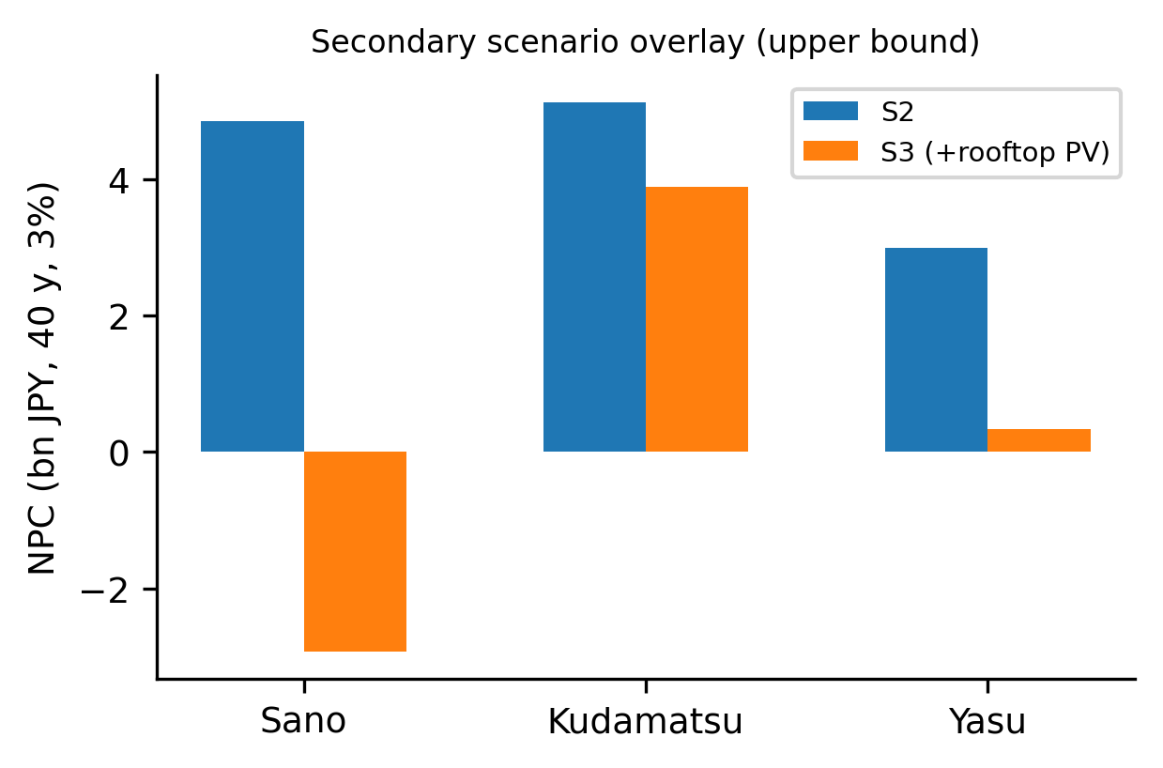
Benchmark note. A second public MV benchmark (Iwamoto 11-bus) failed to converge in pandapower 3.5.5 and is excluded from validation statistics; the AC agreement reported in the main text covers all 672 feasible synthesized feeders.
Additional machine-readable tables (cluster-level results, engineering-assumption sensitivity, Monte-Carlo sweep, claim-evidence matrix) are provided as CSV files in the submission package.

