Engineering-feasible screening of underground distribution renewal: separating routing-policy and conductor-sizing effects
Original research article for Sustainable Energy, Grids and Networks
[Authors and affiliations to be completed locally]
Corresponding author: [to be completed locally]

Abstract
Underground distribution renewal can preserve a reconstructed route or use the construction window to screen alternative routes and equipment. External analysts often lack utility topology and loading records, making the defensible scope of such screening uncertain. We develop a reproducible geospatial experiment with explicit evidence labels, reconstructed radial route ensembles, a 6.6-kV/210–105-V electrical hierarchy, catalogued cables and transformers, iterative active/reactive loss propagation, and mandatory connectivity, voltage, thermal and power-balance gates. Three Japanese municipal study zones are treated as synthetic screening cases, not observed utility networks. A fixed-conductor minimum-construction policy changes net present cost by 0.2%, 0.4% and 0.2%, whereas best-found combined routing and bounded conductor screening changes it by 3.7%, 5.8% and 4.5%. A paired ablation separates routing-policy and conductor-sizing contributions. Conditional scenario sampling varies reconstruction, candidate policy and cost/load assumptions while holding topology and equipment fixed within each draw. The results show that route reconsideration and conductor sizing must not be conflated. They support transparent early-stage screening under stated assumptions, not claims about actual municipal feeders, project savings or globally optimal designs.
Keywords: distribution planning; undergrounding; conductor sizing; Steiner tree; voltage feasibility; reconstruction uncertainty

1. Introduction
Renewal of overhead distribution assets creates a choice between reproducing an incumbent corridor underground and screening alternative radial routes and equipment. Underground construction can reduce exposure to some external hazards, but project-specific capital and repair costs make screening assumptions consequential. ¹ Distribution planning has long represented reconfiguration, expansion and conductor allocation as coupled decisions. ² ³
Recent methods address topology planning with learning-based expansion optimization and jointly screen geographically constrained feeder routing and conductor sizing. ⁴ ⁵ Those methods motivate the decision structure here, but they assume decision-ready network models. The present contribution is instead an evidence-bound workflow for sparse public data; it is not a claim of a superior optimization algorithm.
The difficulty is greater when the analyst has roads and building footprints but not utility feeder connectivity, conductor records, phase assignments, switches, protection zones or customer loads. In that setting, a reconstructed graph is a modeled object. Treating it as an observed network, or treating a joint routing-and-sizing contrast as a pure topology effect, would overstate the evidence.
This study contributes a forensic and reproducible screening framework that (i) labels observed, reconstructed, modeled and assumed quantities; (ii) rejects electrically infeasible candidates; (iii) distinguishes a fixed-conductor routing-policy contrast from a combined routing-and-sizing contrast; (iv) compares the radial approximation quantitatively with AC power flow; and (v) reports uncertainty as conditional scenario sampling rather than calibrated project probability. The analysis does not claim global optimization or construction readiness.

2. Methods

2.1 Evidence boundary and modeled demand
Roads and building footprints were archived from OpenStreetMap. ⁶ Buildings define modeled demand geography, not observed customer load, phase connection or transformer assignment. Municipal security-light inventories provide location evidence in Sano and Kudamatsu. Sano has 9,519 records; 370 are additional records sharing an identifier, so record coordinates are not asserted to be exact pole coordinates. Kudamatsu has 4,227 security-light identifiers, which are not pole identifiers. Yasu contributes no municipal pole or light inventory. None of the three cases observes feeder connectivity or equipment.
Each building's modeled peak demand equals projected footprint area multiplied by the reported number of floors, or two assumed floors when that tag is absent, and an assumed class-specific density of 20–60 W/m². The values are summed after snapping building centroids to road nodes. No empirical load calibration, customer coincidence factor or temporal diversity model is applied; the resulting aggregate is a deliberately conservative coincident screening load, not an observed municipal peak.
Positive modeled demand nodes were clustered only within connected road-graph components, with singleton components retained. The Sano, Kudamatsu and Yasu cases contain 147, 49 and 57 clusters and modeled coincident peak demands of 51.48, 17.24 and 20.01 MW, respectively (Figure 1; Table 1).
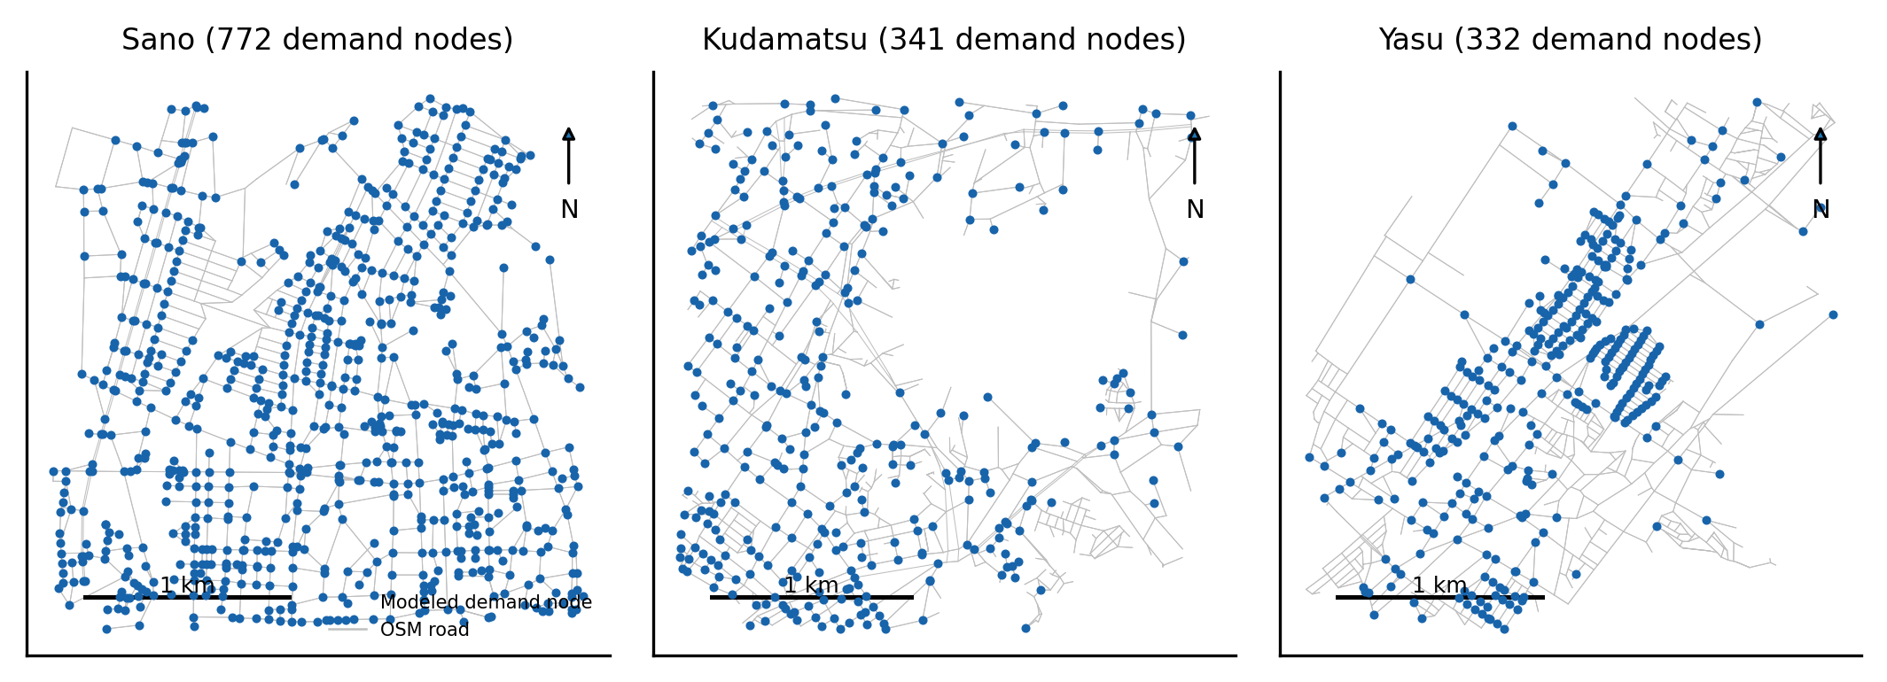
Figure 1. Study zones and modeled demand nodes.
Table 1. Evidence and modeled-study-zone summary.
Municipality | Municipal evidence tier | Observed records | Modeled clusters | Modeled demand (MW)
Sano | pole-ID-linked light inventory | 9519 | 147 | 51.48
Kudamatsu | geolocated light anchors without pole linkage | 4227 | 49 | 17.24
Yasu | roads/buildings only | 0 | 57 | 20.01

2.2 Reconstruction and scenario definitions
Each non-singleton cluster uses two reconstruction families: jittered, anchor-biased Steiner candidates and shuffled incremental cheapest-attachment candidates. Each family contains 12 replicates. Steiner construction is a graph heuristic, not proof of a globally optimal utility layout.
The graph approximations follow established work. ⁷ ⁸
S0 is a reconstructed legacy route. S1 places reference conductors on each S0 tree. S1.5 is a fixed-conductor minimum-construction Steiner policy. S2 is the best-found member of a declared weighted-candidate set after bounded one-edge-at-a-time economic conductor search. Figure 2 shows representative modeled routes. Route difference is Jaccard edge-set divergence:
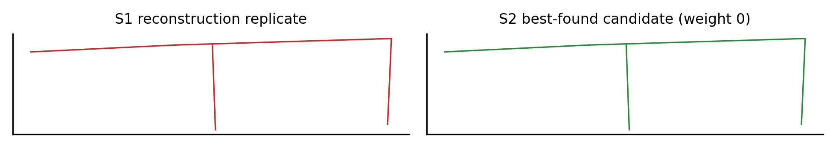
Figure 2. Example reconstructed and best-found candidate routes.
D_edge = 1 - |E_S1 intersect E_S2| / |E_S1 union E_S2|
The primary fixed-conductor routing-policy estimand is [NPC(S1)−NPC(S1.5)]/NPC(S1). The combined screening estimand is [NPC(S1)−NPC(S2)]/NPC(S1). Neither is a likelihood, causal treatment effect or calibrated project saving.

2.3 Electrical hierarchy and feasibility
The model uses a 6.6-kV balanced three-phase primary, catalogued single-phase 6.6-kV/210–105-V transformers and a single-phase 210-V outer-conductor secondary equivalent at power factor 0.90. Sano is evaluated at 50 Hz and Kudamatsu and Yasu at 60 Hz. Each road-snapped demand site has an explicit transformer. Loads are divided into planning units no larger than 35 kW, each with a 25-m equivalent LV stub. These are assumptions required because customer-level secondary geometry is unavailable.
Active and reactive customer power plus line losses are propagated upstream to convergence. For three-phase MV, I=S/(√3V), voltage change is √3I(R cosφ+X sinφ), and loss is 3I²R. For the single-phase LV equivalent, I=S/V, voltage change is 2I(R cosφ+X sinφ), and loss is 2I²R. Transformer no-load and load losses are added upstream. Source input must equal customer demand plus modeled losses within the frozen tolerance.
The approximation is related to radial distribution-flow models. ⁹ ¹⁰
MV, transformer and LV voltage-drop gates are 3.0%, 2.5% and 4.0%. Equivalent customer voltage must remain within 0.905–1.019 pu. Cable and transformer loading cannot exceed 100%; sizing targets 80%. Cable ampacity is multiplied by an assumed 0.65 buried-duct factor. Connectivity, radiality and complete demand service are mandatory. No voltage clipping, limit relaxation or exclusion of failed clusters is permitted.
Each connected cluster has an independent local 1.0-pu source. Shared substations, upstream feeders, switching, protection coordination and inter-cluster constraints are outside the model boundary. Consequently, the gates establish internal feasibility of the screening model, not feasibility of an actual utility system.

2.4 Static-horizon objective and attribution
The objective includes trench/duct, conductor and transformer capital cost; annual O&M; variable line and transformer load loss; and transformer no-load loss. It discounts a static representative annual loss estimate over 40 years at 3%. It does not include replacement timing, failure rates, salvage, reliability, outage damage or construction staging, and is therefore described as a static-horizon NPC screen rather than a complete life-cycle model.
NPC = C_cap + [C_cap f_OM + E_loss p_e] sum_(t=1)^h (1+r)^(-t)
Conductor unit prices scale from the reference area with an assumed exponent of 0.65. A bounded local search accepts feasible one-step conductor upsizes that reduce NPC until no such move remains. The procedure is best-found and locally screened; it is not a mixed-integer global-optimality certificate.
This installed-cost-versus-loss trade-off is consistent with classical economic conductor selection. ¹¹
A paired 2×2 policy ablation compares a representative reconstructed legacy route and the minimum-construction route, each with reference and bounded-search conductors. Shapley averaging attributes the paired contrast to routing policy and conductor sizing. A second accounting decomposition reports trench, conductor, transformer and loss components. These are model-policy attributions, not causal marginal effects.

2.5 Validation and conditional scenario sampling
The balanced radial calculation was compared with pandapower AC power flow ¹² on three radial feeders extracted from the CIGRE LV benchmark. Predeclared tolerances were 0.003 pu for minimum-voltage error and 10% for relative line-loss error. The comparison validates only the balanced radial-line approximation. It does not validate the municipal reconstruction, local-source boundary, transformer placement, 105-V service abstraction, unbalanced operation, protection or contingencies. The separate case11_iwamoto network failed to converge under all attempted solvers and is excluded from validation claims.
Conditional scenario sampling uses 5,000 draws per municipality. Each draw coherently selects one reconstruction family and replicate across the city and one S2 candidate-policy weight, then varies construction, conductor and transformer costs; conductor area-price exponent; electricity value; O&M; discount rate; horizon; load factor; and demand. Topology and equipment are not reoptimized or resized within a draw. Reported intervals and positive-draw frequencies therefore describe the declared frozen-design scenario sampler, not calibrated probabilities or confidence intervals for real projects.

3. Results

3.1 Feasibility and benchmark agreement
All clusters entering S1, S1.5 and S2 summaries passed the frozen model gates. Across the three cases, maximum modeled MV drop was 0.59% and minimum equivalent customer voltage was 0.9700 pu (Table 2). These replace the quarantined 29–38% primary-drop results, which combined aggregation and network-structure defects.
Table 2. Feasible base-case screening results.
Municipality | S1 NPC (bn JPY) | S1.5 NPC (bn JPY) | S2 NPC (bn JPY) | Routing-policy savings (%) | Combined savings (%) | Max MV drop (%) | Min customer voltage (pu)
Sano | 27.92 | 27.87 | 26.89 | 0.18 | 3.69 | 0.322 | 0.9737
Kudamatsu | 15.17 | 15.10 | 14.28 | 0.41 | 5.81 | 0.593 | 0.9700
Yasu | 11.93 | 11.91 | 11.40 | 0.15 | 4.47 | 0.433 | 0.9710
All 3 benchmark feeders passed. Maximum minimum-voltage error was 0.002557 pu and maximum relative line-loss error was 7.41%.

3.2 Routing-policy and combined screening contrasts
The fixed-conductor S1-to-S1.5 routing-policy savings are 0.18%, 0.41% and 0.15%. The combined best-found S1-to-S2 screening savings are 3.69%, 5.81% and 4.47%, corresponding to 1.03, 0.88 and 0.53 billion JPY (Table 2; Figure 3). The large difference between the two contrasts demonstrates why joint routing and conductor effects cannot be labeled as topology value.
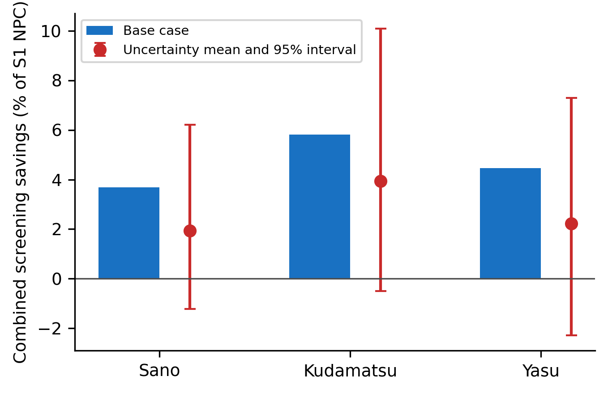
Figure 3. Base-case and conditional scenario-sampling savings.
S2 peak loss changes relative to S1 are +10.3%, +11.1% and +9.8%. The objective prices losses but does not minimize them independently; feasible lower-cost conductors can increase loss. The repaired results therefore do not support a general claim that route and equipment screening halves peak loss.

3.3 Paired attribution and scenario sampling
In the paired representative-route ablation, routing-policy Shapley contributions are 0.02, 0.03 and 0.01 billion JPY; conductor contributions are 0.98, 0.80 and 0.47 billion JPY (Figure 4; Table 3). The attribution is specific to this paired policy contrast and candidate ensemble.
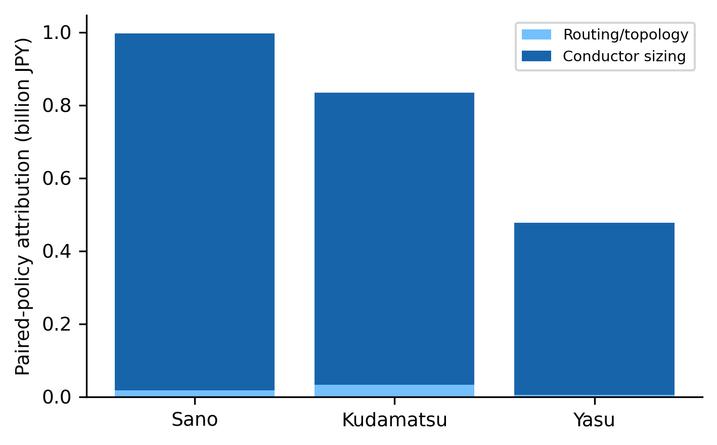
Figure 4. Paired Shapley attribution to routing and conductors.
Table 3. Paired routing-policy/conductor attribution.
Municipality | Routing-policy Shapley (bn JPY) | Conductor Shapley (bn JPY) | Interaction (bn JPY)
Sano | 0.02 | 0.98 | 0.00
Kudamatsu | 0.03 | 0.80 | 0.00
Yasu | 0.01 | 0.47 | 0.00
Conditional scenario-sampling means are 1.94%, 3.94% and 2.22%. The 2.5th–97.5th percentile ranges are [-1.22, 6.21]%, [-0.50, 10.09]% and [-2.28, 7.29]% (Table 4). Topology and equipment remain frozen within every draw; these ranges must not be interpreted as calibrated project uncertainty.
Table 4. Conditional scenario sampling with topology and equipment frozen within each draw.
Municipality | Mean combined savings (%) | 2.5th percentile (%) | 97.5th percentile (%) | Positive-draw frequency
Sano | 1.94 | -1.22 | 6.21 | 0.825
Kudamatsu | 3.94 | -0.50 | 10.09 | 0.943
Yasu | 2.22 | -2.28 | 7.29 | 0.784

4. Discussion
The principal result is a separation of estimands. Under common reference conductors, choosing a minimum-construction routing policy produces a small NPC contrast. The larger combined S1–S2 contrast additionally reflects bounded conductor sizing. This distinction is scientifically and practically important: a planner should first test whether a like-for-like renewal case embeds an uneconomic equipment standard, then evaluate whether the incremental route effect justifies survey, easement and implementation costs omitted from the graph screen.
The direct within-study baselines also delimit the optimization claim. S1 tests reconstructed legacy policies; S1.5 tests a minimum-construction Steiner policy with fixed conductors; the paired ablation tests routing and conductor decisions in both orders; and S2 searches a finite weighted candidate set. These comparisons demonstrate improvement over declared baselines, not superiority over all distribution-planning algorithms.
Candidate-route diversity is limited: 164 of 253 clusters have only one unique route in the declared weight grid, and 249 select the zero-weight boundary. This is a negative diagnostic, not evidence of a broadly effective topology optimizer. It confines the route result to the tested heuristics and makes the fixed-conductor S1.5 comparison the more transferable routing-policy baseline.
The municipal evidence does not support claims about actual feeder routes or bankable savings. Demand is synthetic, routes are reconstructed, each cluster has an independent idealized source, transformer sites are modeled, and secondary circuits are reduced to equivalent stubs. The 0.65 ampacity factor and conductor price curve are assumptions rather than installation-specific ratings or quotations. Shared-substation capacity, phase imbalance, switching, reliability, faults, protection, harmonics, transients, construction access and permitting are omitted.
The uncertainty analysis also has a deliberate boundary. It coherently samples reconstruction and candidate policies and varies a broad parameter set, but it does not redesign equipment after demand or price changes. Intervals may therefore understate adaptation available to a planner and cannot be interpreted as posterior or frequentist uncertainty about a real project. The within-ensemble prefix-stability diagnostic likewise does not establish independent-seed algorithmic convergence.
A rooftop-PV scenario from the canonical package is excluded from the headline analysis. Building footprints do not establish roof suitability, ownership, hourly generation, hosting capacity, curtailment, export value or reinforcement requirements. A defensible extension requires time-series load and irradiance and unbalanced hosting-capacity analysis.
Future work should use utility topology, equipment and interval-load data; model shared upstream assets; jointly redesign under each scenario; add reliability and resilience value; obtain local construction bids; and compare heuristic candidates with exact or bounded mathematical programs on tractable instances.

5. Conclusions
A repaired, feasibility-gated analysis retains positive combined screening contrasts in three synthetic municipal cases, but the fixed-conductor routing-policy effects are much smaller. The evidence supports a reproducible early-stage method for separating routing and conductor decisions under explicit assumptions. It does not identify observed utility topology, certify global optimality, estimate calibrated project probability or replace detailed engineering.

Declarations
Funding: none. Declaration of competing interests: none declared. Ethics approval: not applicable; the study uses public infrastructure and geographic data and contains no human participants.
Data and code availability: archived raw public-data snapshots, retrieval metadata, checksums, processing scripts, machine-readable results and reproduction instructions accompany the submission package.
Declaration of generative AI and AI-assisted technologies: during preparation, the authors used an AI coding assistant for code review, reproducibility checking and language drafting. The authors reviewed and edited all outputs and take responsibility for the content.

Figure captions
Figure 1. Municipal study zones. Grey lines are archived OpenStreetMap roads and blue points are road-snapped modeled building-demand nodes. Neither layer reveals utility connectivity.
Figure 2. Representative reconstructed legacy route and best-found S2 candidate. Both are modeled screening objects, not observed utility routes.
Figure 3. Base-case combined screening contrast and conditional scenario-sampling percentiles. Topology and equipment are frozen within each draw.
Figure 4. Paired Shapley attribution to routing policy and conductor sizing. Values are policy-screening attributions, not causal effects.

References
1. Taheri, Babak; Molzahn, Daniel K.; Grijalva, Santiago Improving distribution system resilience by undergrounding lines and deploying mobile generators Electric Power Systems Research 2023;214:108804. https://doi.org/10.1016/j.epsr.2022.108804
2. Baran, M.E.; Wu, F.F. Network reconfiguration in distribution systems for loss reduction and load balancing IEEE Transactions on Power Delivery 1989;4:1401-1407. https://doi.org/10.1109/61.25627
3. Camargo, Vera; Lavorato, Marina; Romero, Ruben Specialized genetic algorithm to solve the electrical distribution system expansion planning 2013 IEEE Power &amp; Energy Society General Meeting 2013;:1-5. https://doi.org/10.1109/PESMG.2013.6672615
4. Xiang, Yue; Dai, Jiakun; Xue, Ping; Liu, Junyong Autonomous topology planning for distribution network expansion: A learning-based decoupled optimization method Applied Energy 2023;348:121522. https://doi.org/10.1016/j.apenergy.2023.121522
5. Li, Zhengbo; Liu, Youbo; Xiang, Yue; Yang, Haolan; Wang, Lingfeng; Liu, Junyong Reliability-centered Planning with Geographic Graph Constraints for Feeder Routing and Conductor Sizing Journal of Modern Power Systems and Clean Energy 2024;13:2074-2085. https://doi.org/10.35833/mpce.2024.000884
6. Haklay, M.; Weber, P. OpenStreetMap: User-Generated Street Maps IEEE Pervasive Computing 2008;7:12-18. https://doi.org/10.1109/MPRV.2008.80
7. Hwang, F. K.; Richards, Dana S. Steiner tree problems Networks 1992;22:55-89. https://doi.org/10.1002/net.3230220105
8. Kou, L.; Markowsky, G.; Berman, L. A fast algorithm for Steiner trees Acta Informatica 1981;15:141-145. https://doi.org/10.1007/BF00288961
9. Baran, M.E.; Wu, F.F. Optimal capacitor placement on radial distribution systems IEEE Transactions on Power Delivery 1989;4:725-734. https://doi.org/10.1109/61.19265
10. Gan, Lingwen; Low, Steven H. Convex relaxations and linear approximation for optimal power flow in multiphase radial networks 2014 Power Systems Computation Conference 2014;:1-9. https://doi.org/10.1109/PSCC.2014.7038399
11. Tram, H.N.; Wall, D.L. Optimal conductor selection in planning radial distribution systems IEEE Transactions on Power Systems 1988;3:200-206. https://doi.org/10.1109/59.43199
12. Thurner, Leon; Scheidler, Alexander; Schafer, Florian; Menke, Jan-Hendrik; Dollichon, Julian; Meier, Friederike; Meinecke, Steffen; Braun, Martin Pandapower—An Open-Source Python Tool for Convenient Modeling, Analysis, and Optimization of Electric Power Systems IEEE Transactions on Power Systems 2018;33:6510-6521. https://doi.org/10.1109/TPWRS.2018.2829021

