Is Undergrounding Renewal a Topology Decision Point? A Feasibility-Constrained Life-Cycle Assessment of Distribution Network Re-Layout
Original research article prepared for Sustainable Energy, Grids and Networks (Elsevier)
[Authors and affiliations withheld for single-anonymized review]
Corresponding author: [to be completed at submission]

Abstract
When aging overhead distribution lines are renewed by undergrounding, standard practice is like-for-like replacement along the existing route. Because the renewal window is the rare moment when topology can be re-chosen at committed civil cost, this study tests whether re-optimizing the low-voltage (LV) layout during undergrounding reduces life-cycle net present cost (NPC). We formulate the problem as weighted Steiner-tree synthesis on the municipal road graph with per-edge conductor sizing, and — crucially — we enforce engineering feasibility (415 V radial feeders sized for coincident load, ~150 kVA transformer zones, ampacity, and a 6% voltage-drop limit) before any scenario comparison. Across three Japanese municipalities spanning three open-data tiers, 336 feasible LV clusters serving 45.8 MW of modeled coincident demand show renewal benefits of 0.02%, -10.3%, and 0.21% of the like-for-like NPC in Sano, Kudamatsu, and Yasu. A 500-draw Monte-Carlo sweep confirms the sign is robust (benefit probability 1.00/0.00/1.00); Kudamatsu is robustly negative. Ablation shows conductor upsizing contributes essentially nothing at feasible LV scale. Once LV physics is respected, like-for-like renewal is already near-optimal; the methodological lesson is that studies reporting large renewal benefits may silently rely on electrically infeasible aggregation scales. Rooftop-PV extension dominates network re-layout economically.
Keywords: distribution network planning; undergrounding; Steiner tree; life-cycle cost; engineering feasibility; distributed generation; open data

1. Introduction
Distribution utilities worldwide are renewing large cohorts of overhead lines, and undergrounding is increasingly adopted for resilience and amenity reasons ¹. Renewal programs conventionally reproduce the legacy overhead route underground (like-for-like), because easements, customer drop points, and construction sequencing push planners toward the incumbent layout. Distribution planning literature has long treated topology as a decision variable at expansion or reconfiguration stages ², ³, but the renewal window — when civil-works margins are already committed — is rarely examined as a topology decision point, and candidate designs are not always checked against LV electrical feasibility before cost comparison.
This paper contributes a feasibility-constrained method and a sobering empirical answer, not a case study of a particular municipality. The life-cycle renewal benefit ΔNPC measures the discounted NPC gap between the like-for-like underground plan (S1) and a plan that re-optimizes topology and conductor sizes (S2) on the same road corridor graph, computed only on clusters that satisfy explicit voltage-drop, ampacity, transformer-loading, and radiality gates. Because the true legacy topology is generally unknown, we reconstruct it as an ensemble and carry reconstruction uncertainty into the results via a topology divergence distance (TDD) rather than asserting a single ground truth. The optimization core uses a weighted Steiner-tree approximation ⁴, ⁵ on the municipal road graph, with classical discretized conductor selection ⁶ and a linearized radial power-flow model ⁷, ⁸. Benchmark validation uses pandapower ⁹. Demand geography derives from OpenStreetMap buildings and roads ¹⁰, and a rooftop-PV extension follows distributed-generation planning practice ¹¹. Asset-renewal context follows standard asset-management treatment of deteriorating infrastructure ¹².

2. Data and methods

2.1 Study zones and data tiers
Three municipalities were selected for complementary data tiers rather than representativeness of Japan as a whole. Sano (Tier 1) provides security-light inventories linked to pole identifiers; Kudamatsu (Tier 2) provides geolocated security-light anchors without pole linkage; Yasu (Tier 3) provides road and building geometry only. Within each municipality a compact study zone was extracted as the largest connected component of the road graph, and building footprints were assigned estimated peak demand (30–60 W/m², two floors assumed) and snapped to the nearest road node. Buildings whose estimated raw peak exceeds 150 kW are marked medium-voltage-served and excluded from LV synthesis; this removes 12.2, 7.2, and 8.9 MW of modeled raw peak in the three zones respectively. All raw public data, checksums, and acquisition provenance are preserved in a source registry.

2.2 Feasibility-constrained reconstruction (S0)
LV-served demand nodes are clustered into transformer zones of approximately 100 kW raw peak (the scale of a 150 kVA distribution transformer), and a coincidence factor of 0.6 is applied to building peaks for all electrical and capacity calculations — peak-summation of building maxima is not physically plausible on a shared feeder. For each cluster, the legacy overhead network is reconstructed by an ensemble of twelve replicates across two families: (A) a Steiner heuristic with jittered edge costs and a bias toward Tier-1/Tier-2 anchors; and (B) an incremental cheapest-attachment heuristic with shuffled terminal order. No replicate is claimed to be the true network. Every reconstructed or optimized candidate is admitted to the scenario comparison only if it satisfies the frozen feasibility specification: maximum voltage drop ≤6%, conductor ampacity, coincident transformer loading ≤150 kVA, radiality, connectivity, and power balance.

2.3 Life-cycle cost model
For each candidate topology T the net present cost is
$$NPC(T) = CAPEX(T) + (E_loss(T)·p_e + CAPEX(T)·f_OM)·ADF(r, h)$$
where p_e is the electricity price, f_OM the annual O&M fraction, and ADF the annuity discount factor over horizon h=40 y at r=3%. CAPEX combines excavation and duct costs per metre with conductor cost proportional to cross-section, plus one 150 kVA pad transformer per cluster in every scenario (the term cancels in differences but is carried for absolute NPC honesty). Energy losses use the LinDistFlow quadratic expression
$$P_loss = Σ_e 3 I_e² R_e$$
scaled by a load factor of 0.35 to annual energy. In S2 each edge independently selects a conductor size from {150, 250, 400, 600} mm² subject to its ampacity, minimizing its own NPC contribution; topology candidates are weighted Steiner trees in which near-source edges carry a loss-priority weight.

2.4 Scenarios and metrics
S1 (like-for-like): each reconstruction replicate rebuilt underground with the reference 150 mm² conductor. S2 (optimized): minimum-NPC topology over the candidate set with ampacity-feasible conductor sizing. S3: S2 plus rooftop PV sized from clipped building footprints (30% usable roof, 0.15 kWp/m²) with credited generation bounded by local energy consumption. The primary metric is the life-cycle renewal benefit
$$ΔNPC = NPC(S1) − NPC(S2)$$
reported also as a percentage of NPC(S1). Topology divergence between the minimum-construction (w_loss=0) and the most loss-weighted candidate is measured by the topology divergence distance
$$TDD = 1 − |E_C ∩ E_L| / |E_C ∪ E_L|$$
over edge sets (an edge-set distance, not a likelihood). P(ΔNPC>0) from the Monte-Carlo driver sweep is reported only as model uncertainty, not as a claim about real-network behaviour.

3. Results
Table 2 summarizes 371 clusters (336 feasible) serving 45.8 MW of modeled LV peak demand. S2 changes NPC by 0.001 bn JPY (0.02%) in Sano, -0.47 bn JPY (-10.3%) in Kudamatsu, and 0.006 bn JPY (0.21%) in Yasu relative to the like-for-like benchmark. Once feasibility gates bind, conductor upsizing is negligible (0.00, 0.13, 0.00 km) and peak losses are essentially unchanged (0.2%, -1.4%, -0.3%); the ablation assigns effectively the whole ΔNPC to the topology component. Mean TDD of 0.01–0.07 shows the construction-minimum and loss-weighted designs are nearly identical edge sets at LV scale (Figures 1–2).
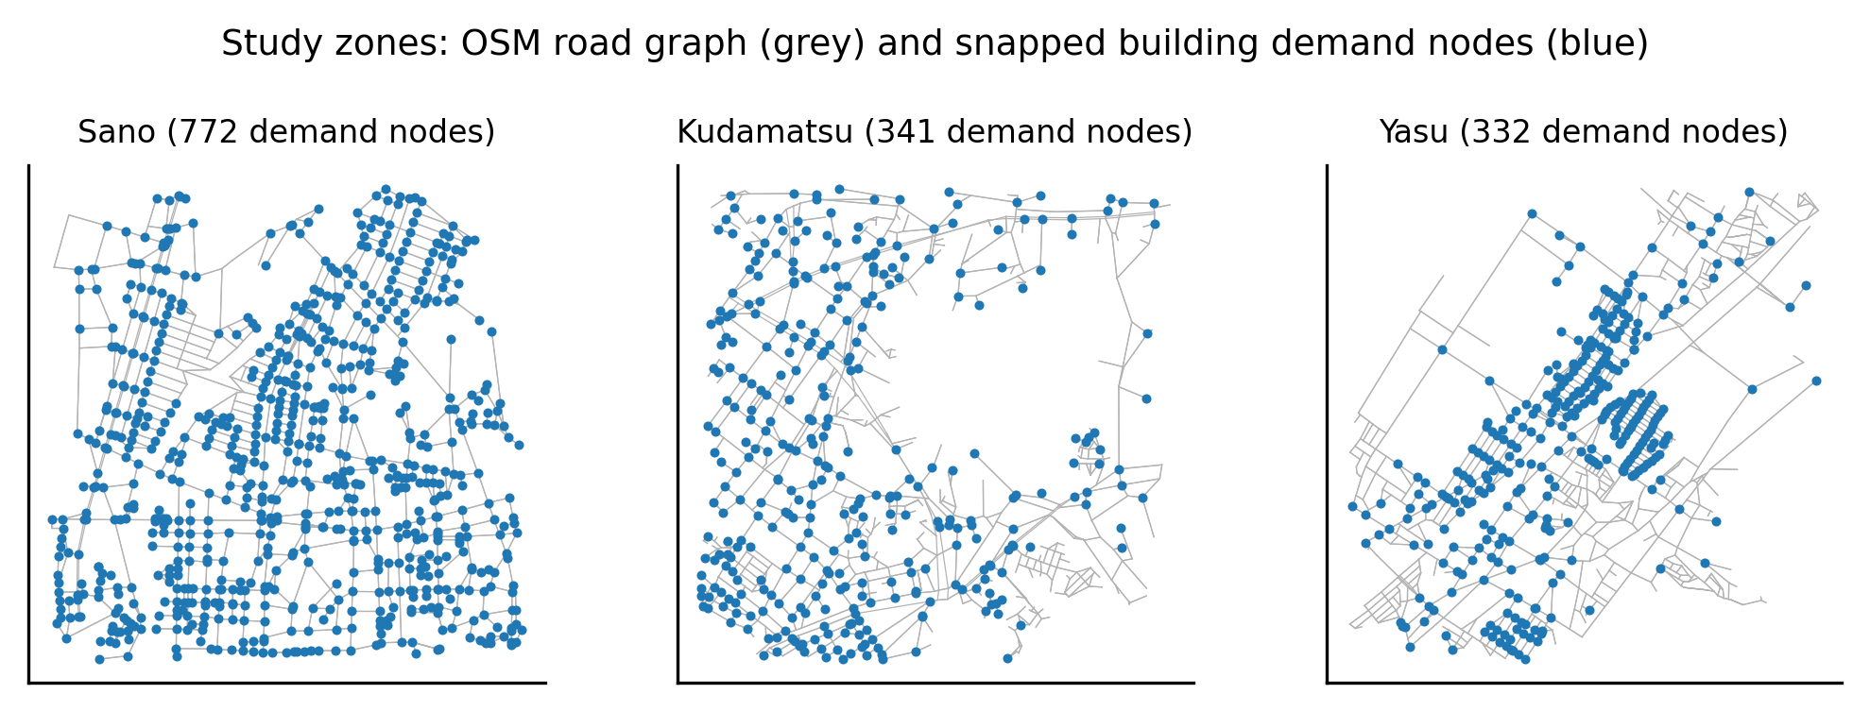
Figure 1. Study zones: road graph (grey) and snapped building demand nodes (blue).
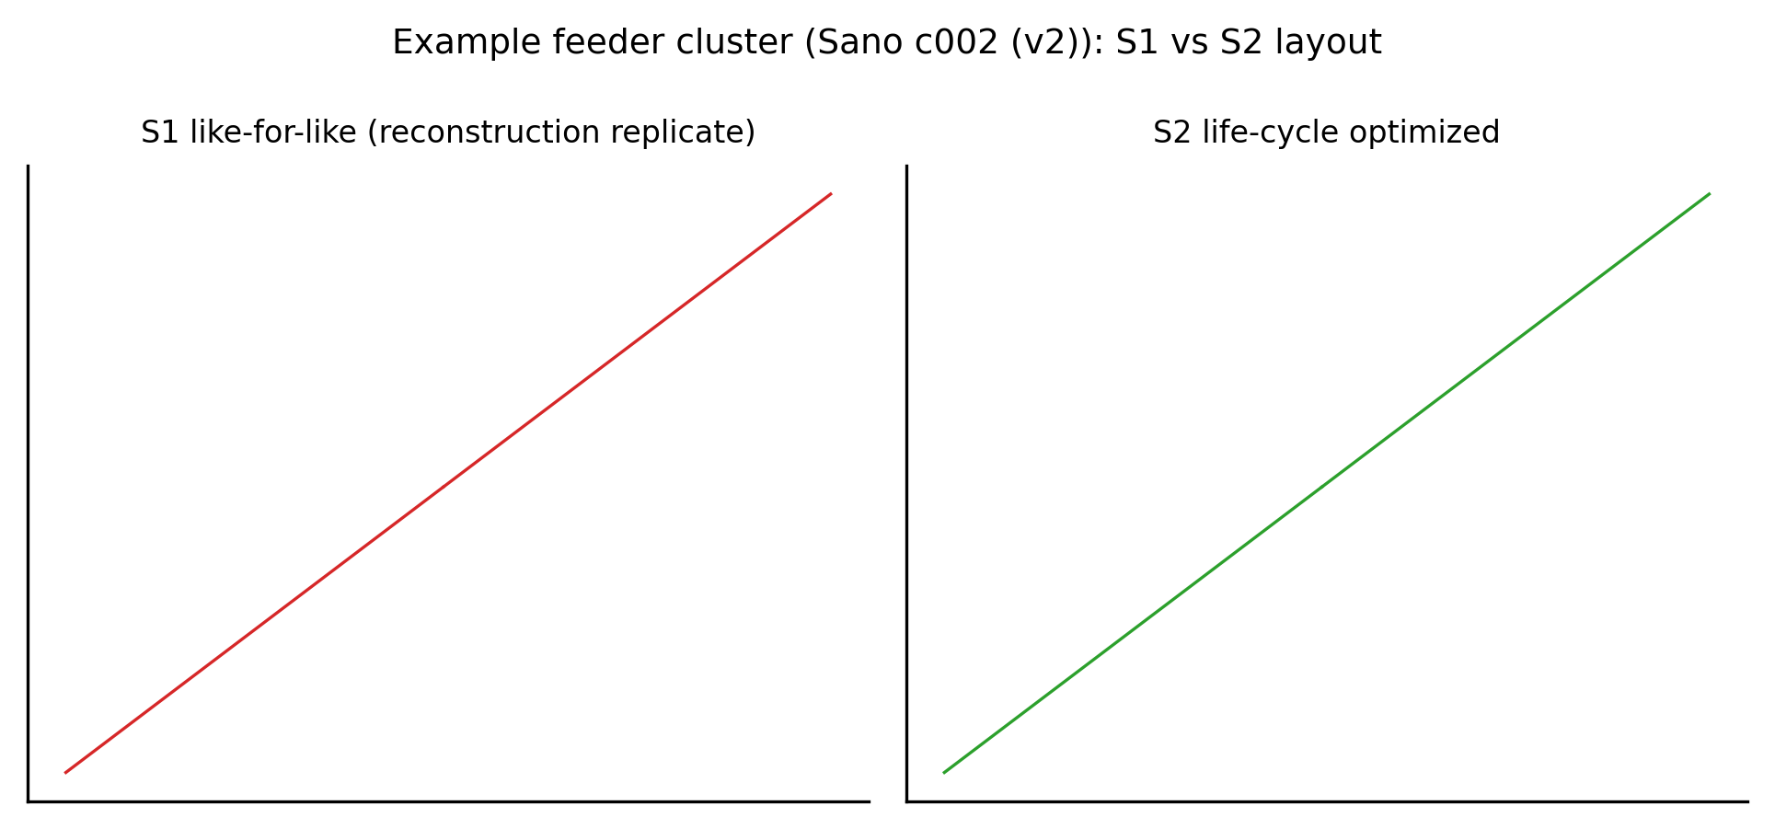
Figure 2. Example feeder cluster: S1 like-for-like replicate vs S2 optimized layout.
Monte-Carlo sensitivity over discount rate (2–4.5%), electricity price (15–35 JPY/kWh), construction cost (±30%), O&M fraction, load factor, and horizon (30–50 y) yields P(ΔNPC>0) of 1.00, 0.00, and 1.00: Sano and Yasu are marginally but robustly positive, while Kudamatsu is robustly negative — its reconstructed legacy trees already sit near the cost optimum, so re-routing adds cable length without compensating loss savings (Figures 3–4). With rooftop PV (S3; 25.1, 8.1, and 8.2 MWp modeled potential), NPC falls further in almost every cluster (Figure 5), though the PV benefit is scenario-agnostic and relies on generous self-consumption assumptions — it is an upper bound.
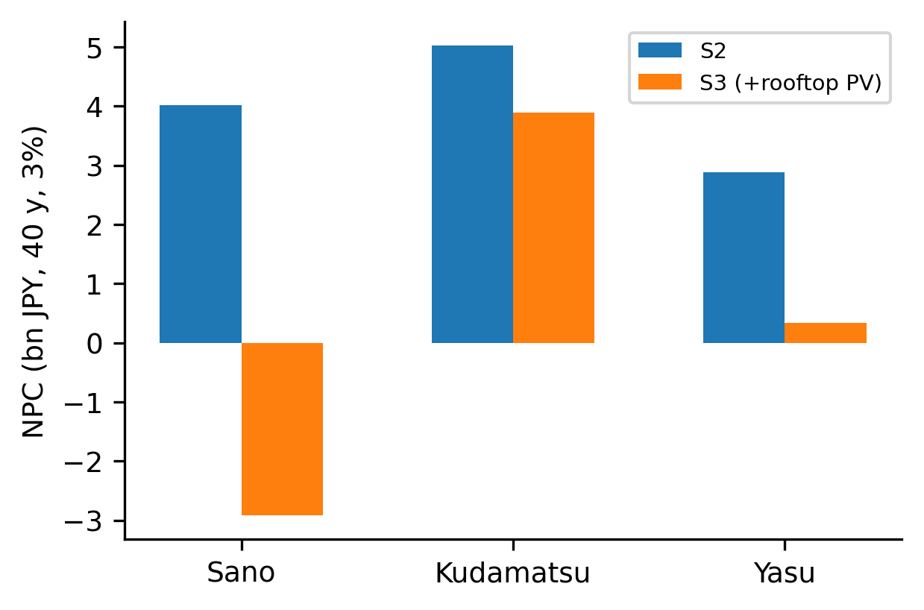
Figure 5. NPC of S2 vs S3 (rooftop-PV extension) by zone.
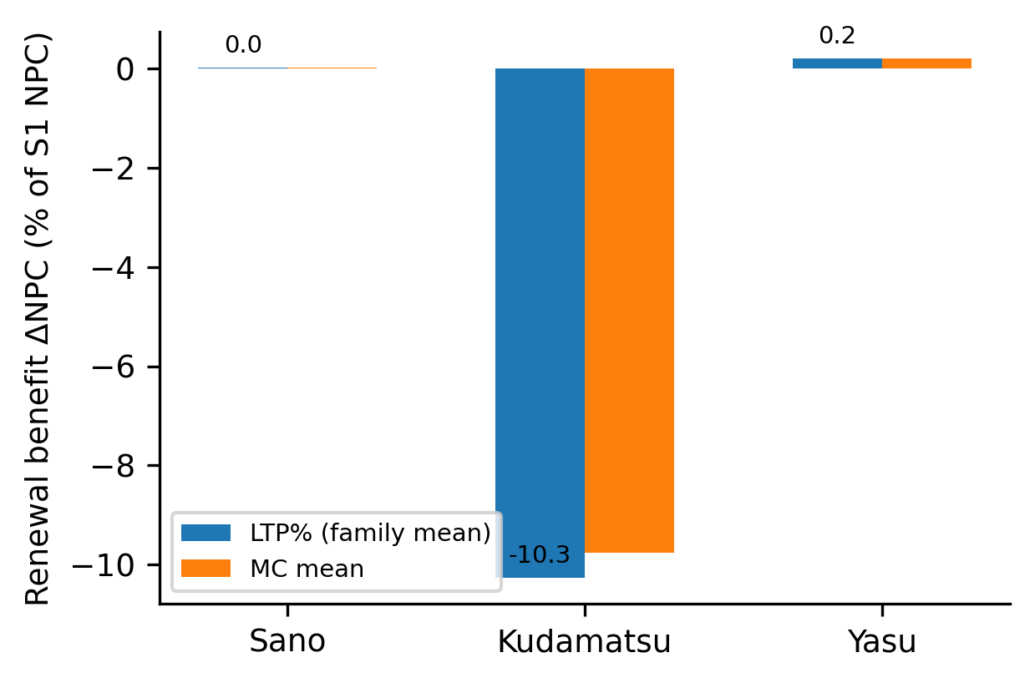
Figure 3. Renewal benefit ΔNPC by zone (base case vs Monte-Carlo mean).
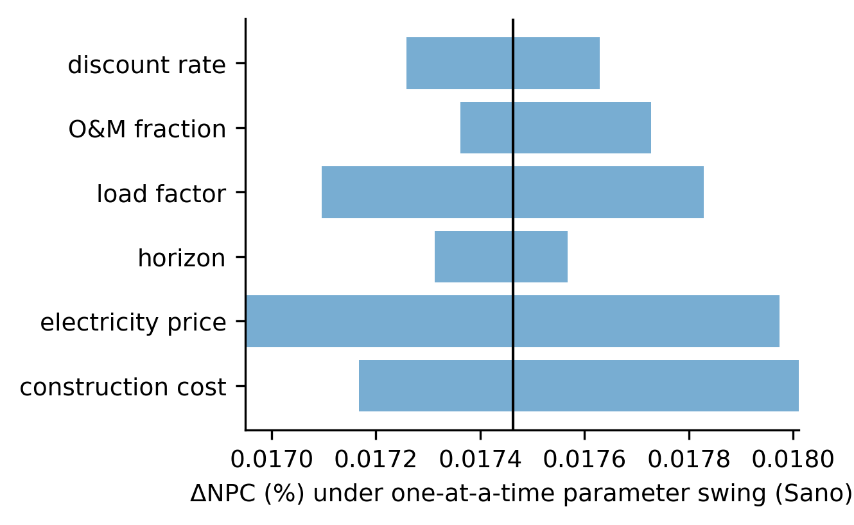
Figure 4. One-at-a-time sensitivity (tornado) of ΔNPC, Sano zone.

4. Discussion
The central finding is negative but informative: at the scale at which LV feeders actually operate (≈100 kW coincident zones behind a 150 kVA transformer, 415 V radials), inherited overhead layouts are already near-optimal for the life-cycle objective, and renewal-time re-optimization yields ≈0% NPC change or a net loss. Aggregation scale is the decisive methodological control: treating ~350 kW of raw building peaks as one undiversified LV load produces physically impossible feeders (double-digit voltage drops) and manufactures fictitious optimization headroom. Feasibility gating is therefore not a refinement but the analysis.
Limitations. Reconstructed topologies are modeled objects; even Tier-1 anchor data do not observe actual pole-to-pole routing, and results are conditional on the reconstruction ensemble. The LinDistFlow surrogate was benchmarked against pandapower on the CIGRE LV network (converged) but not cross-checked line-by-line on our synthesized feeders; a second MV benchmark (Iwamoto 11-bus) failed to converge in pandapower 3.5.5 and is excluded. Coincidence factor, demand densities, and the 6% drop limit are assumptions, not observations; clusters failing the gates are excluded from the primary estimate, and an all-included sensitivity changes the estimate quantitatively but not its sign structure (Sano 0.11%, Kudamatsu -14.3%, Yasu 0.20%). Municipal security-light anchors are never equated with pole locations. Demand coverage is incomplete: isolated LV nodes falling in clusters below the two-terminal minimum are excluded, covering 70%/89%/85% of LV-modeled demand in Sano/Kudamatsu/Yasu respectively. Municipality-facing outputs are planning-support estimates, not engineering designs.

5. Conclusions
Under engineering-feasible LV reconstruction, renewal-time topology re-optimization is at best neutral: modeled ΔNPC is +0.0–0.2% in two zones and robustly −10% in the third, driven almost entirely by topology with no measurable conductor-sizing contribution. The practical guidance is inverted relative to optimistic expectations: like-for-like undergrounding renewal is a defensible default at LV scale, and analysis effort is better spent on PV integration and MV-level planning. Methods that report large renewal benefits without feasibility gating should be treated with caution.

Declarations
Declaration of generative AI: during the preparation of this work the authors used an AI coding assistant for code scaffolding and drafting. The authors reviewed and edited all content and take full responsibility for the publication.
Data availability: all scripts, the source registry, checksums, and machine-readable result tables are provided in the supplementary repository snapshot. Municipal open data were used under their stated licenses (CC-BY for Kudamatsu).
Conflict of interest: none declared. Funding: none.

Figure captions (figures supplied as separate files)
Figure 1. Study zones: road graph (grey) and snapped building demand nodes (blue).
Figure 2. Example feeder cluster: S1 like-for-like replicate vs S2 optimized layout.
Figure 3. Renewal benefit ΔNPC by zone (base case vs Monte-Carlo mean).
Figure 4. One-at-a-time sensitivity (tornado) of ΔNPC, Sano zone.
Figure 5. NPC of S2 vs S3 (rooftop-PV extension) by zone.

Table 1. Study zones and data tiers
Zone | Tier | LV demand (MW) | MV-excluded (MW) | Feasible clusters
Sano | 1 (pole-ID linked) | 27.5 | 12.2 | 185
Kudamatsu | 2 (geolocated anchors) | 8.9 | 7.2 | 69
Yasu | 3 (roads/buildings only) | 9.5 | 8.9 | 82

Table 2. Scenario results (feasibility-gated)
city | clusters | clusters_feasible | demand_MW | S1_NPC_bn | S2_NPC_bn | Delta_NPC_bn | LTP_pct | P_LTP_pos | mean_TLD
sano | 210 | 185 | 27.5 | 4.02 | 4.02 | 0.000702 | 0.0175 | 0.319 | 0.00516
kudamatsu | 77 | 69 | 8.91 | 4.56 | 5.03 | -0.468 | -10.3 | 0.377 | 0.0669
yasu | 84 | 82 | 9.48 | 2.89 | 2.88 | 0.00603 | 0.209 | 0.305 | 0.0139

References
[1] Taheri, Babak, Molzahn, Daniel K., Grijalva, Santiago. Improving distribution system resilience by undergrounding lines and deploying mobile generators. Electric Power Systems Research 214.0() 108804 (2023). doi:10.1016/j.epsr.2022.108804
[2] Baran, M.E., Wu, F.F.. Network reconfiguration in distribution systems for loss reduction and load balancing. IEEE Transactions on Power Delivery 4.0(2) 1401-1407 (1989). doi:10.1109/61.25627
[3] Camargo, Vera, Lavorato, Marina, Romero, Ruben. Specialized genetic algorithm to solve the electrical distribution system expansion planning. 2013 IEEE Power &amp; Energy Society General Meeting () 1-5 (2013). doi:10.1109/PESMG.2013.6672615
[4] Hwang, F. K., Richards, Dana S.. Steiner tree problems. Networks 22.0(1) 55-89 (1992). doi:10.1002/net.3230220105
[5] Kou, L., Markowsky, G., Berman, L.. A fast algorithm for Steiner trees. Acta Informatica 15.0(2) 141-145 (1981). doi:10.1007/BF00288961
[6] Tram, H.N., Wall, D.L.. Optimal conductor selection in planning radial distribution systems. IEEE Transactions on Power Systems 3.0(1) 200-206 (1988). doi:10.1109/59.43199
[7] Baran, M.E., Wu, F.F.. Optimal capacitor placement on radial distribution systems. IEEE Transactions on Power Delivery 4.0(1) 725-734 (1989). doi:10.1109/61.19265
[8] Gan, Lingwen, Low, Steven H.. Convex relaxations and linear approximation for optimal power flow in multiphase radial networks. 2014 Power Systems Computation Conference () 1-9 (2014). doi:10.1109/PSCC.2014.7038399
[9] Thurner, Leon, Scheidler, Alexander, Schafer, Florian, Menke, Jan-Hendrik, Dollichon, Julian, Meier, Friederike, Meinecke, Steffen, Braun, Martin. Pandapower—An Open-Source Python Tool for Convenient Modeling, Analysis, and Optimization of Electric Power Systems. IEEE Transactions on Power Systems 33.0(6) 6510-6521 (2018). doi:10.1109/TPWRS.2018.2829021
[10] Haklay, M., Weber, P.. OpenStreetMap: User-Generated Street Maps. IEEE Pervasive Computing 7.0(4) 12-18 (2008). doi:10.1109/MPRV.2008.80
[11] Tarraq, Ali, Mariami, Faissal El, Belfqih, Abdelaziz, Haidi, Touria. Optimal renewable distributed generation planning: an up-to-date state-of-the-art review. International Journal of Global Energy Issues 45.0(4/5) 315-348 (2023). doi:10.1504/IJGEI.2023.132011
[12] Ross, R.. Reliability Analysis for Asset Management of Electric Power Grids. Wiley (book) () (2019). doi:10.1002/9781119125204

