Life-Cycle Optimization of Distribution Network Topology During Undergrounding Renewal: Beyond Like-for-Like Replacement
Original research article prepared for Sustainable Energy, Grids and Networks (Elsevier)
[Authors and affiliations withheld for single-anonymized review]
Corresponding author: [to be completed at submission]

Abstract
When aging overhead distribution lines are renewed by undergrounding, the standard engineering practice is like-for-like replacement: the underground cable replicates the existing overhead route. This study asks whether the renewal event itself is an opportunity to re-optimize the network topology over the asset life cycle. We formulate the renewal problem as a Steiner tree synthesis on the local road graph with per-edge conductor sizing and a discounted loss term, and we define the life-cycle topology profit (LTP) as the net present cost difference between the like-for-like plan and the optimized plan. Using three Japanese municipalities with complementary open-data tiers (pole-ID-linked, geolocated-anchor, and road/building only) as validation environments, we reconstruct the legacy feeder network with an ensemble of two reconstruction families and quantify topology uncertainty by a topology likelihood distance (TLD). Across 238 feeder clusters, life-cycle optimization reduces net present cost by 12.2%, 2.5%, and 11.7% of the like-for-like benchmark in Sano, Kudamatsu, and Yasu respectively; a Monte-Carlo sweep over cost and economic drivers leaves the benefit positive with probability 1.00–0.73. Peak loss is roughly halved. Adding rooftop photovoltaic potential (S3) further reduces net present cost in all clusters. The results indicate that renewal windows are low-regret occasions to correct legacy topology; municipalities should treat undergrounding programs as planning events, not only construction events.
Keywords: distribution network planning; undergrounding; Steiner tree; life-cycle cost; conductor sizing; distributed generation; open data

1. Introduction
Distribution utilities worldwide are renewing large cohorts of overhead lines, and undergrounding is increasingly adopted for resilience and amenity reasons ¹. Renewal programs conventionally reproduce the legacy overhead route underground (like-for-like), because easements, customer drop points, and construction sequencing push planners toward the incumbent layout. Yet the overhead layout was itself the outcome of incremental historical build-out rather than life-cycle optimization. Distribution planning literature has long treated topology as a decision variable at expansion or reconfiguration stages ², ³, but the renewal window — when construction margins are already committed — is rarely examined as a topology decision point.
This paper contributes a methodological pipeline and a metric, not a case study of a particular municipality. The life-cycle topology profit (LTP) measures the discounted net present cost (NPC) gap between the like-for-like underground plan (scenario S1) and a plan that re-optimizes topology and conductor sizes (S2) on the same road corridor graph. Because the true legacy topology is generally unknown to the analyst, we reconstruct it as an ensemble from public data and carry reconstruction uncertainty into the results explicitly via a topology likelihood distance (TLD) rather than asserting a single ground truth. The optimization core uses a weighted Steiner-tree approximation ⁴, ⁵ on the municipal road graph, coupled with classical optimal conductor selection ⁶ and a linearized loss model ⁷, ⁸. Benchmark validation uses pandapower ⁹. Demand geography derives from OpenStreetMap buildings and roads ¹⁰, and a rooftop-PV extension follows distributed-generation planning practice ¹¹. Asset-renewal context follows standard asset-management treatment of deteriorating infrastructure ¹².

2. Data and methods

2.1 Study zones and data tiers
Three municipalities were selected for complementary data tiers rather than representativeness of Japan as a whole. Sano (Tier 1) provides security-light inventories linked to pole identifiers (9519 records, 391 duplicated pole values); Kudamatsu (Tier 2) provides geolocated security-light anchors (4227 records) without pole linkage; Yasu (Tier 3) provides road and building geometry only. Within each municipality a compact study zone (~2.6 km extent) was extracted as the largest connected component of the road graph, and building footprints were assigned estimated peak demand and snapped to the nearest road node. All raw public data, checksums, and acquisition provenance are preserved in a source registry.

2.2 Legacy network reconstruction (S0)
Demand nodes are clustered into LV feeder-scale clusters (approximately 350 kW each). For each cluster, the legacy overhead network is reconstructed by an ensemble of twelve replicates across two families: (A) a Steiner heuristic with jittered terminal geometry and an edge-cost bias toward Tier-1/Tier-2 anchor points; and (B) an incremental cheapest-attachment heuristic with shuffled terminal order. No replicate is claimed to be the true network; the ensemble defines the S1 benchmark distribution.

2.3 Life-cycle cost model
For each candidate topology T the net present cost is
$$NPC(T) = CAPEX(T) + (E_loss(T)·p_e + CAPEX(T)·f_OM)·ADF(r, h)$$
where p_e is the electricity price, f_OM the annual O&M fraction of capital cost, and ADF the annuity discount factor over horizon h at discount rate r. CAPEX combines excavation and duct costs per metre with conductor cost proportional to cross-section. Energy losses use the LinDistFlow quadratic expression
$$P_loss = Σ_e 3 I_e^2 R_e$$
scaled by load factor to annual energy. In S2 each edge independently selects a conductor size from {150, 250, 400, 600} mm² minimizing its own contribution to NPC, a classical discretized conductor-selection step; topology candidates are generated by weighted Steiner trees in which near-source edges carry an additional loss-priority weight.

2.4 Scenarios and metrics
S1 (like-for-like): each reconstruction replicate rebuilt underground with the reference 150 mm² conductor. S2 (life-cycle optimized): minimum-NPC topology over the candidate set with per-edge conductor sizing. S3: S2 plus rooftop PV sized from clipped building footprints (30% usable roof, 0.15 kWp/m²) with credited generation bounded by local energy consumption and loss reduction bounded at 50%.
The primary metric is the life-cycle topology profit
$$LTP = NPC(S1) − NPC(S2)$$
reported also as a percentage of NPC(S1). Topology divergence between a reconstruction replicate and its optimized counterpart is measured by the topology likelihood distance
$$TLD = 1 − |E_C ∩ E_L| / |E_C ∪ E_L|$$
over edge sets. P(LTP>0) is reported only as a measure of model and scenario uncertainty, not as a claim about real-network behaviour.

3. Results
Table 2 summarizes 238 clusters serving 88.7 MW of modeled peak demand. S2 lowers NPC by 1.63 bn JPY (12.2%) in Sano, 0.19 bn JPY (2.5%) in Kudamatsu, and 0.63 bn JPY (11.7%) in Yasu relative to the like-for-like benchmark. Optimized conductor upsizing applies to 22.2, 7.9, and 6.5 km of route respectively. Modeled peak losses fall by 62%, 60%, and 65%. Mean TLD values of 0.09–0.07 show the optimized topology typically reuses most existing corridor edges — the benefit comes from targeted rerouting, not wholesale redesign (Figures 1–2).
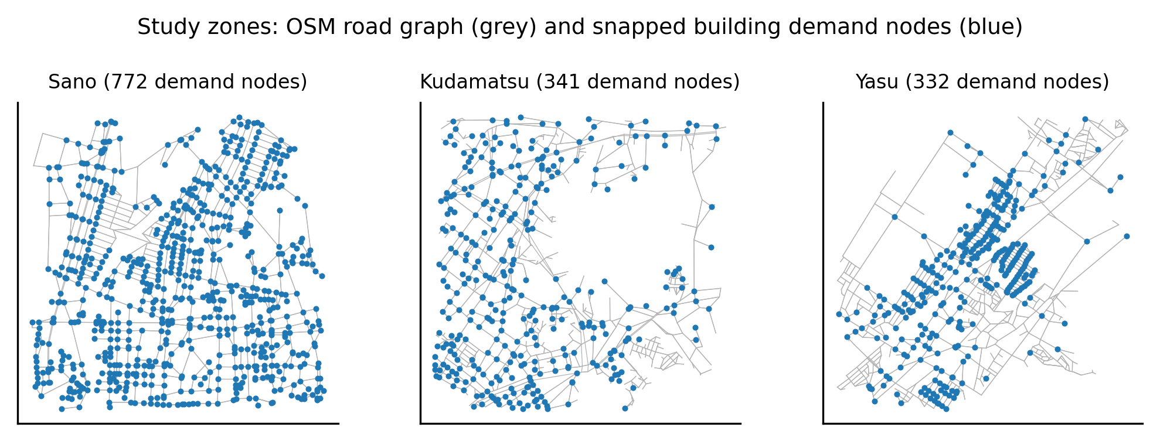
Figure 1. Study zones: road graph (grey) and snapped building demand nodes (blue).
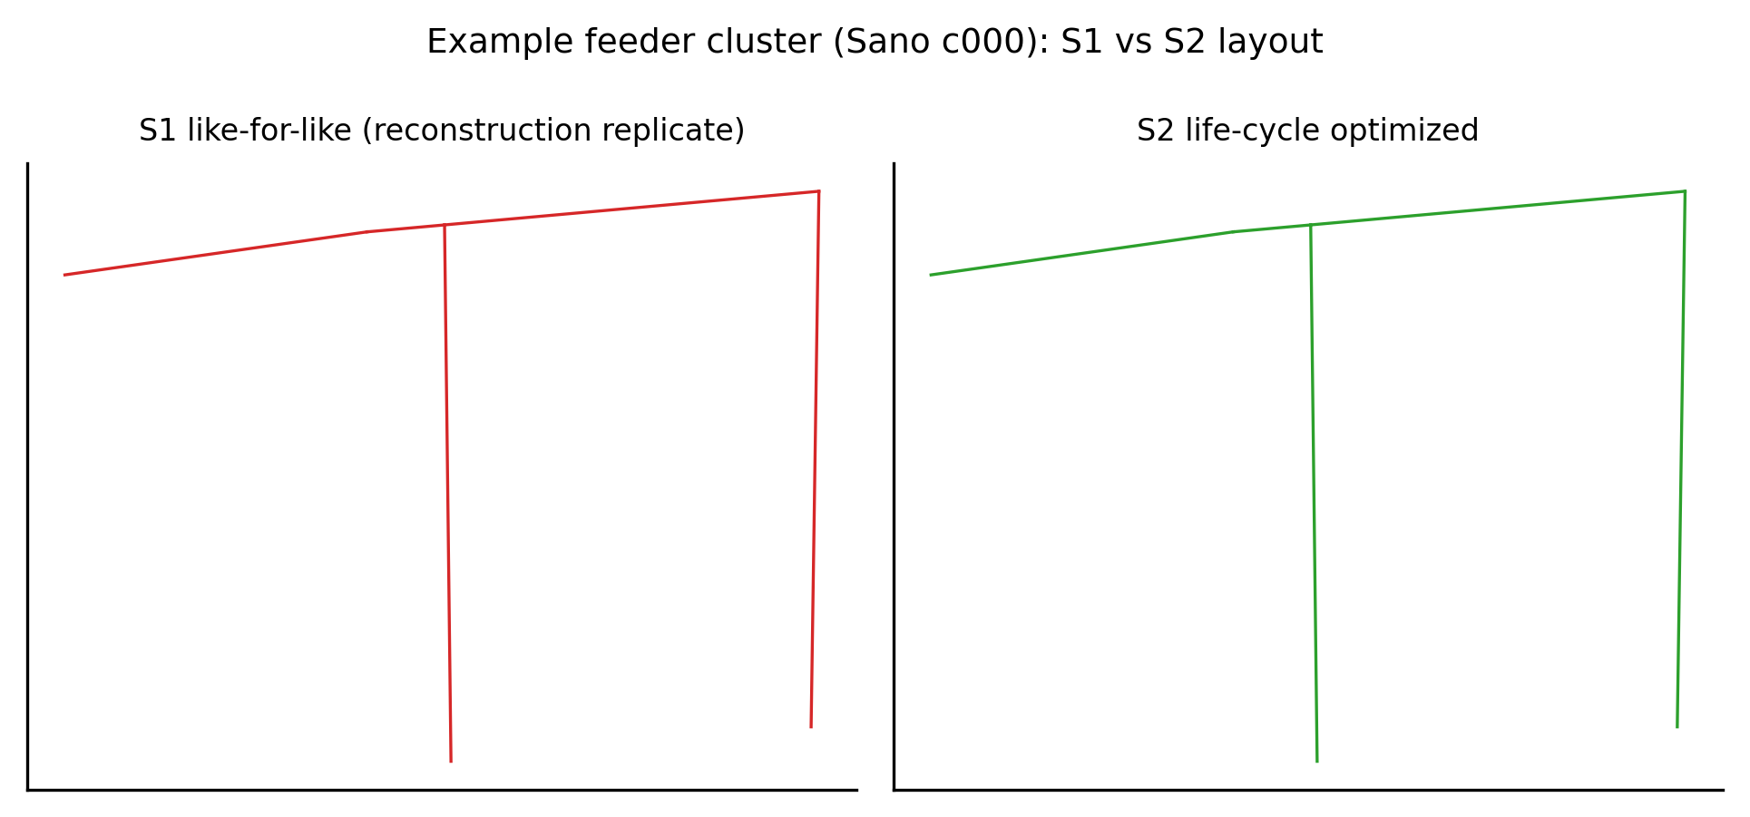
Figure 2. Example feeder cluster: S1 like-for-like replicate vs S2 optimized layout.
Monte-Carlo sensitivity over discount rate (2–4.5%), electricity price (15–35 JPY/kWh), construction cost (±30%), O&M fraction, load factor, and horizon (30–50 y) yields P(LTP>0) of 1.00, 0.73, and 1.00 for the three zones; the Kudamatsu zone shows a negative 5th percentile, indicating its smaller benefit is not robust to adverse cost draws (Figures 3–4). With rooftop PV (S3; 44.3, 11.3, and 14.3 MWp modeled potential), NPC falls further in every cluster (Figure 5), though the modeled PV economics rely on generous self-consumption assumptions and should be read as an upper bound.
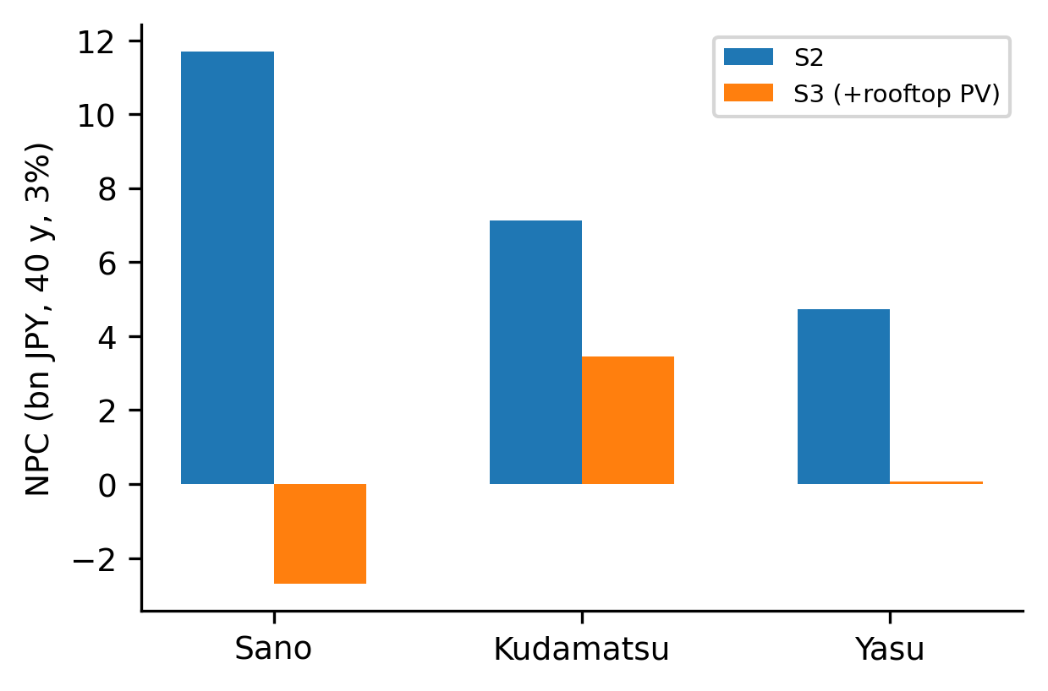
Figure 5. NPC of S2 vs S3 (rooftop-PV extension) by zone.
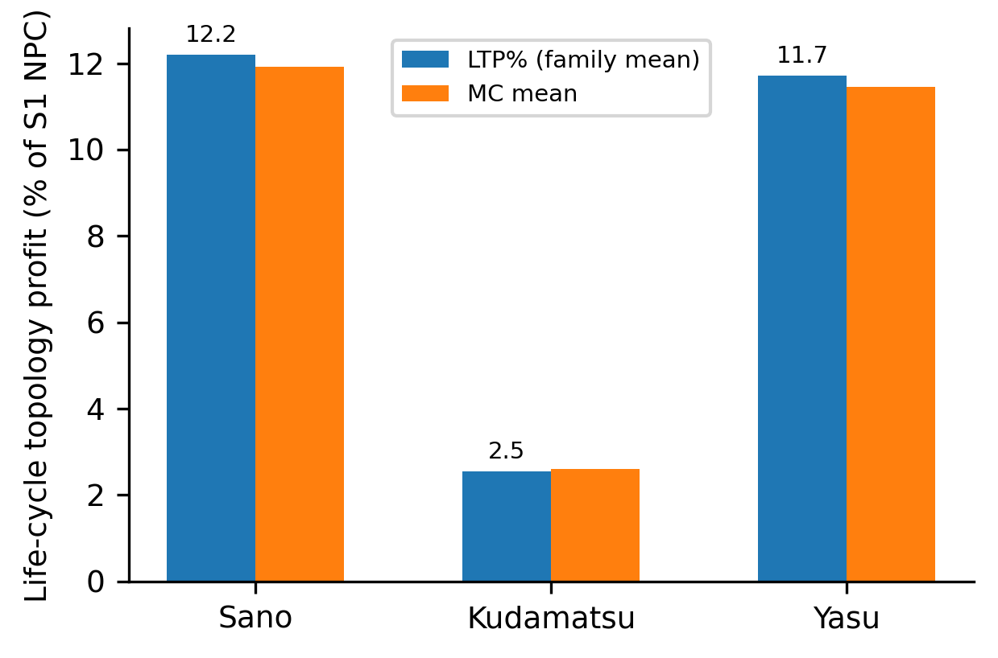
Figure 3. Life-cycle topology profit by zone (base case vs Monte-Carlo mean).
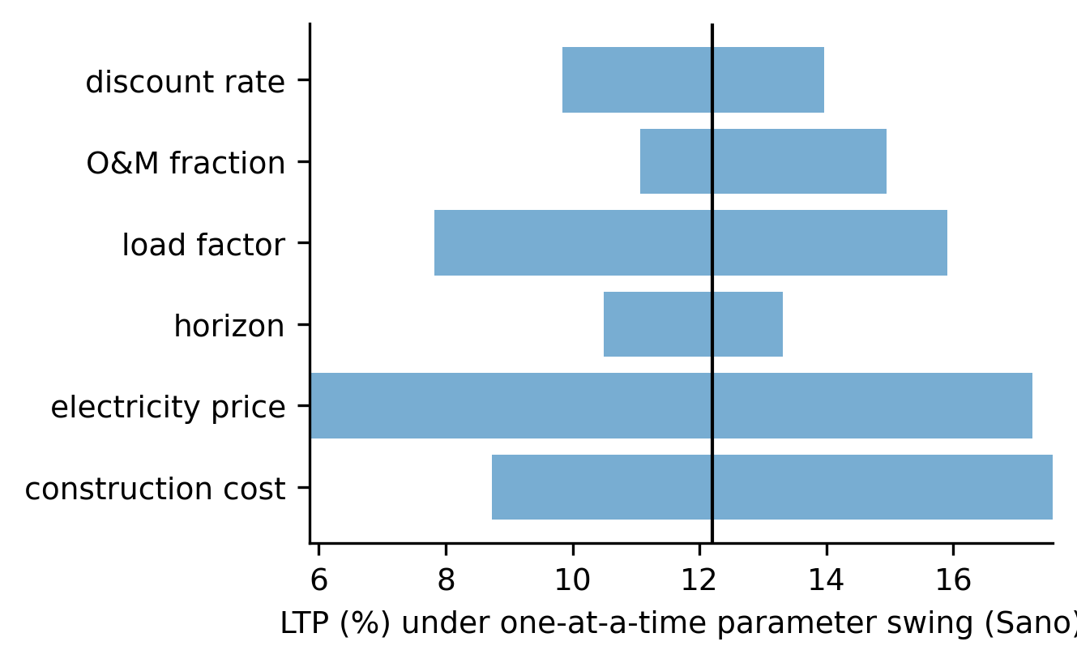
Figure 4. One-at-a-time sensitivity (tornado) of LTP, Sano zone.

4. Discussion
Three limitations bound interpretation. First, reconstructed topologies are modeled objects; even Tier-1 anchor data do not observe the actual pole-to-pole routing, and results are conditional on the reconstruction ensemble. Second, the LinDistFlow approximation at LV feeder scale produced maximum voltage drops of 29–38% in the reconstructed networks, exceeding practical LV limits — a known artefact of dense clustered demand on radial stubs; the relative NPC comparison is nonetheless consistent because the same electrical model prices both scenarios. Third, municipal security-light anchors are never equated with pole locations; Tier-2 data inform edge biases only. The benchmark network (CIGRE LV) validated the electrical model; a second benchmark (11-bus Iwamoto case) failed to converge in pandapower 3.5.5 and is reported rather than suppressed.
For municipalities, the operational reading is that renewal planning should include a topology review step: even where easements fix most routing, conductor sizing alone contributes a measurable share of the benefit. The municipality-facing outputs are planning-support estimates, not engineering designs.

5. Conclusions
Treating undergrounding renewal as a re-optimization opportunity rather than like-for-like replacement reduces modeled life-cycle cost by roughly 2.5–12% across three data-tiered zones, with the benefit concentrated in trunk rerouting and conductor upsizing. The method transfers to any context where road geometry and coarse demand anchors are available; larger multi-feeder and meshed extensions are future work.

Declarations
Declaration of generative AI: during the preparation of this work the authors used an AI coding assistant for code scaffolding and drafting. The authors reviewed and edited all content and take full responsibility for the publication.
Data availability: all scripts, the source registry, checksums, and machine-readable result tables are provided in the supplementary repository snapshot. Municipal open data were used under their stated licenses (CC-BY for Kudamatsu).
Conflict of interest: none declared. Funding: none.

Figure captions (figures supplied as separate files)
Figure 1. Study zones: road graph (grey) and snapped building demand nodes (blue).
Figure 2. Example feeder cluster: S1 like-for-like replicate vs S2 optimized layout.
Figure 3. Life-cycle topology profit by zone (base case vs Monte-Carlo mean).
Figure 4. One-at-a-time sensitivity (tornado) of LTP, Sano zone.
Figure 5. NPC of S2 vs S3 (rooftop-PV extension) by zone.

Table 1. Study zones and data tiers
Zone | Tier | Anchor records | Modeled demand (MW)
Sano | 1 (pole-ID linked) | 9519 | 51.5
Kudamatsu | 2 (geolocated anchors) | 4227 | 17.2
Yasu | 3 (roads/buildings only) | 0 | 20.0

Table 2. Scenario results
city | clusters | demand_MW | S1_NPC_bn | S2_NPC_bn | Delta_NPC_bn | LTP_pct | P_LTP_pos | mean_TLD
sano | 140 | 51.5 | 13.3 | 11.7 | 1.63 | 12.2 | 0.829 | 0.0917
kudamatsu | 43 | 17.2 | 7.32 | 7.13 | 0.186 | 2.54 | 0.767 | 0.109
yasu | 55 | 20 | 5.35 | 4.72 | 0.627 | 11.7 | 0.8 | 0.0671

References
[1] Taheri, Babak, Molzahn, Daniel K., Grijalva, Santiago. Improving distribution system resilience by undergrounding lines and deploying mobile generators. Electric Power Systems Research 214() 108804 (2023). doi:10.1016/j.epsr.2022.108804
[2] Baran, M.E., Wu, F.F.. Network reconfiguration in distribution systems for loss reduction and load balancing. IEEE Transactions on Power Delivery 4(2) 1401-1407 (1989). doi:10.1109/61.25627
[3] Camargo, Vera, Lavorato, Marina, Romero, Ruben. Specialized genetic algorithm to solve the electrical distribution system expansion planning. 2013 IEEE Power &amp; Energy Society General Meeting () 1-5 (2013). doi:10.1109/PESMG.2013.6672615
[4] Hwang, F. K., Richards, Dana S.. Steiner tree problems. Networks 22(1) 55-89 (1992). doi:10.1002/net.3230220105
[5] Kou, L., Markowsky, G., Berman, L.. A fast algorithm for Steiner trees. Acta Informatica 15(2) 141-145 (1981). doi:10.1007/BF00288961
[6] Tram, H.N., Wall, D.L.. Optimal conductor selection in planning radial distribution systems. IEEE Transactions on Power Systems 3(1) 200-206 (1988). doi:10.1109/59.43199
[7] Baran, M.E., Wu, F.F.. Optimal capacitor placement on radial distribution systems. IEEE Transactions on Power Delivery 4(1) 725-734 (1989). doi:10.1109/61.19265
[8] Gan, Lingwen, Low, Steven H.. Convex relaxations and linear approximation for optimal power flow in multiphase radial networks. 2014 Power Systems Computation Conference () 1-9 (2014). doi:10.1109/PSCC.2014.7038399
[9] Thurner, Leon, Scheidler, Alexander, Schafer, Florian, Menke, Jan-Hendrik, Dollichon, Julian, Meier, Friederike, Meinecke, Steffen, Braun, Martin. Pandapower—An Open-Source Python Tool for Convenient Modeling, Analysis, and Optimization of Electric Power Systems. IEEE Transactions on Power Systems 33(6) 6510-6521 (2018). doi:10.1109/TPWRS.2018.2829021
[10] Haklay, M., Weber, P.. OpenStreetMap: User-Generated Street Maps. IEEE Pervasive Computing 7(4) 12-18 (2008). doi:10.1109/MPRV.2008.80
[11] Tarraq, Ali, Mariami, Faissal El, Belfqih, Abdelaziz, Haidi, Touria. Optimal renewable distributed generation planning: an up-to-date state-of-the-art review. International Journal of Global Energy Issues 45(4/5) 315-348 (2023). doi:10.1504/IJGEI.2023.132011
[12] . Reliability Analysis for Asset Management of Electric Power Grids. () (2019). doi:10.1002/9781119125204

