Supplemental Materials
Is Network Reconfiguration Worth It at Infrastructure Renewal? A Feasibility-Gated Economic Screening of Low-Voltage Distribution Re-Layout during Undergrounding
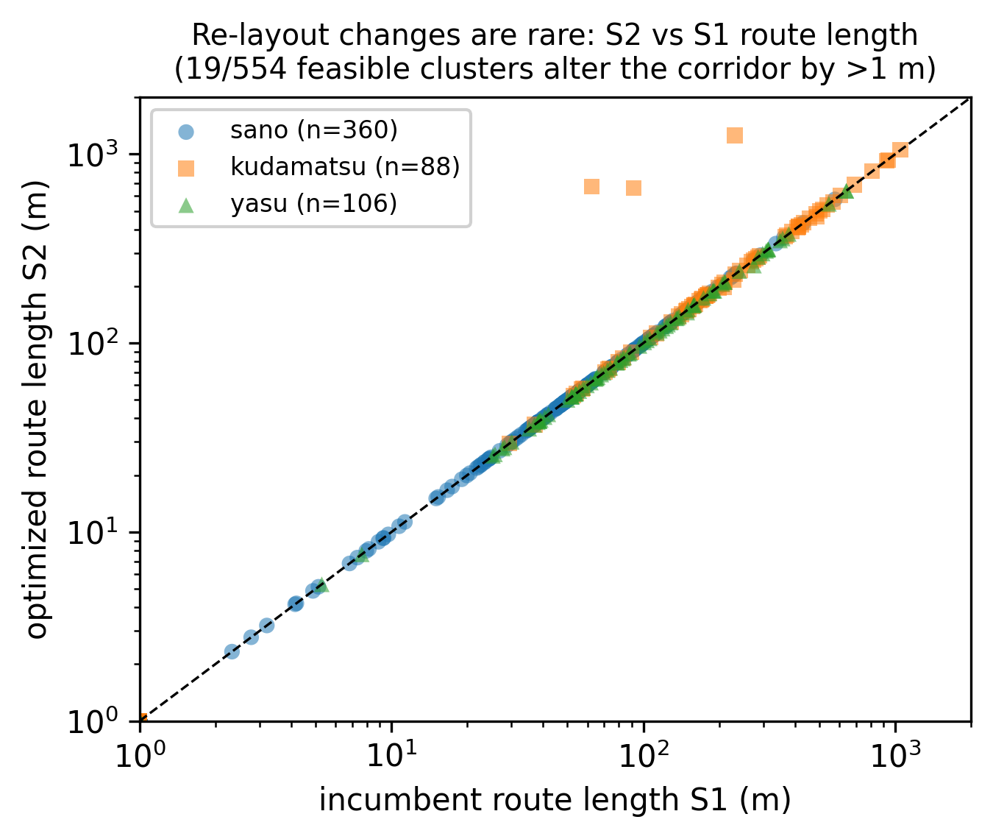
Fig. S1. Route length of the least-cost feasible redesign versus the reconstructed incumbent for all feasible clusters (log–log axes).

