Supplementary material
Supplementary Figure S1. NPC of S2 vs the secondary rooftop-PV overlay S3 by zone (scenario-based upper bound; does not alter the primary VoF conclusion).
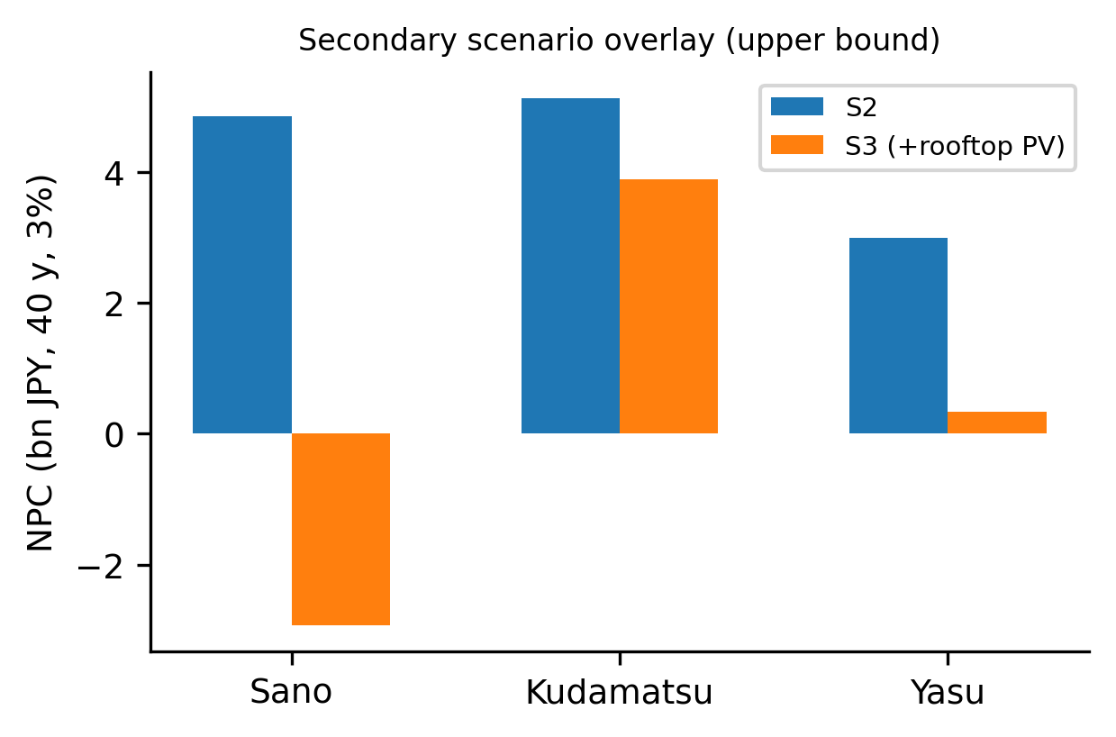
Benchmark note. A second public MV benchmark (Iwamoto 11-bus) failed to converge in pandapower 3.5.5 and is excluded from validation statistics; the AC agreement reported in the main text covers all 672 feasible synthesized feeders.
Supplementary Table S2. Within-zone Moran's I of cluster VoF (inverse-distance weights on demand-terminal centroids; 200-permutation p-values). Near-zero values indicate negligible spatial clustering of VoF within zones.
city | n | Moran's I | permutation p
sano | 360 | -0.001 | 0.154
kudamatsu | 88 | -0.023 | 0.766
yasu | 106 | -0.005 | 0.274
Supplementary Table S3. Zero-mass structure of VoF by zone: positive-VoF clusters per zone and conditional medians (CEUS_ZERO_MASS_SUMMARY.csv). Positive incidence differs across zones (3/360, 13/88, 8/106 of electrically feasible clusters; 2 further cases within numerical tolerance); the pooled ~96% zero share is driven mainly by Sano.
city | feasible clusters | positive VoF | median VoF% | positive | max VoF%
kudamatsu | 88 | 13 | 0.582 | 5.079
sano | 360 | 3 | 0.486 | 1.066
yasu | 106 | 8 | 0.241 | 6.098
Morphology robustness note. Convex-hull demand density is degenerate for 427 of 554 feasible clusters (fewer than three terminals or hull area < 1e-4 km²); the hull-density association is therefore reported only on the 127 non-degenerate feasible clusters, and density is re-expressed on a fixed 100-m buffer support in the main text.
Additional machine-readable tables (cluster-level results, morphology descriptors, engineering-assumption sensitivity, Monte-Carlo sweep) are provided as CSV files in the submission package.

