The Value of Topology Flexibility at Infrastructure Renewal: A Feasibility-Gated Geospatial Assessment of Low-Voltage Re-Layout During Undergrounding

Abstract
Urban renewal programs that replace aging overhead distribution lines with underground cables face a rarely asked investment question: when the corridor is already committed, is re-drawing the local network worth anything? This study quantifies the value of topology flexibility (VoF) at renewal as an infrastructure investment decision problem. Legacy low-voltage networks are reconstructed from open municipal and OpenStreetMap data in three Japanese study zones spanning three observability tiers; candidate re-layouts are synthesized as weighted Steiner trees on the road graph under explicit engineering feasibility gates (coincident-load sizing, ampacity, ~150 kVA transformer zones, 6% voltage-drop limit) with AC power-flow validation on the synthesized feasible feeders. Across 554 feasible feeder clusters serving 58.6 MW of modeled demand, VoF is 0.01%, 0.39%, and 0.20% of like-for-like life-cycle cost — inside a prespecified 1% practical-equivalence margin. Residual flexibility value is rare and spatially concentrated: 96% of feasible clusters show zero value, and apparent morphology correlates do not survive adjustment for cluster size. Like-for-like renewal is a defensible default at this scale; the transferable contribution is a screening method that tells asset managers where re-layout assessment is worth its engineering cost, not the magnitudes themselves.
Keywords: infrastructure renewal; asset management; undergrounding; life-cycle cost; network reconstruction; Steiner tree; investment decision

1. Introduction
A large share of urban infrastructure is invisible: electricity, water and communications networks buried beneath or strung above streets are only partially recorded, and their spatial form is known approximately at best. As cities worldwide renew aging overhead distribution by undergrounding, each renewal project opens a bounded but real design choice: keep the inherited low-voltage layout, or use the committed civil works to re-route it. Whether that option is worth exercising is a question of urban spatial structure, network physics and life-cycle economics at once — yet their integration for renewal-time topology decisions remains less developed. Urban morphology research has built a mature quantitative vocabulary for street and settlement form (Barthélemy, 2011); (Cardillo et al., 2006); (Louf and Barthélemy, 2014); (Boeing, 2018); (Levinson, 2012), and geospatial work has shown that infrastructure networks co-located with urban form carry morphology-dependent structure (Abdel-Mottaleb and Zhang, 2020). Parallel work on hidden utility networks reconstructs their geospatial topology from proxies — street-view imagery, design rules, open GIS data (Zhang et al., 2025); (Abhilash Bandam et al., 2021); (Liu et al., 2025); (Babli et al., 2025) — and spatial-network models explain how such systems grow (Fu et al., 2016). Decision support for buried-utility rehabilitation is an established theme (Hadzilacos et al., 2000), network geometry has been inferred from incomplete surface evidence (Chahinian et al., 2019), and geospatial integration methods tolerate partial utility semantics (Gilbert et al., 2021). In the engineering-management literature, renewal is formalized as a life-cycle replacement problem (Ochs et al., 2014), yet the renewal window is rarely treated as a spatial design choice. What neither stream does is treat the reconstructed network as an object of decision: how much is the option to re-layout worth, conditional on the spatial structure actually inherited?
This paper poses that question for undergrounding renewal. Economics work already shows undergrounding fails cost-benefit tests as a blanket policy (Fenrick and Getachew, 2012); (Larsen, 2016), while resilience-oriented studies find targeted undergrounding can pay (Taheri et al., 2023). But inside a committed undergrounding program a different marginal question remains: does re-drawing the network at renewal beat like-for-like replacement? Distribution-planning methods optimize feeder routing against a fixed or greenfield demand surface (Samui et al., 2012); (Kumar et al., 2014); (Camargo et al., 2013); (Tram and Wall, 1988); (Baran and Wu, 1989a, 1989b); none frames the renewal window as a choice set in which the incumbent remains admissible.
We formulate renewal as exactly that choice set. The estimand is the value of topology flexibility (VoF): the mean over legacy reconstruction replicates of max(0, NPC(replicate) − NPC(best feasible redesign)), a nonnegative measure in which retaining the incumbent is an admissible decision rather than a forced redesign. This estimand design separates an honest option value from the inflated savings that appear when incumbent layouts are excluded from the comparison. We then ask a specifically urban question that turns the estimand into a geospatial hypothesis: is residual flexibility value uniform, or does it concentrate where urban morphology leaves routing slack? Using the street-network and settlement descriptors standard in quantitative urban morphology, we show that value — where it exists at all — is confined to a small minority of clusters, and its apparent morphology correlates reduce to cluster size under adjustment. The contribution is threefold: (i) a feasibility-gated, incumbent-admissible estimand for renewal-time network decisions; (ii) an open-data reconstruction pipeline spanning three observability tiers with AC-validated electrical constraints; and (iii) evidence that the option value of re-layout is both bounded (<0.5% of life-cycle cost) and spatially structured — a screening rule for where re-layout assessment is worth its engineering cost. Figure 1 summarizes the data-to-decision pipeline.
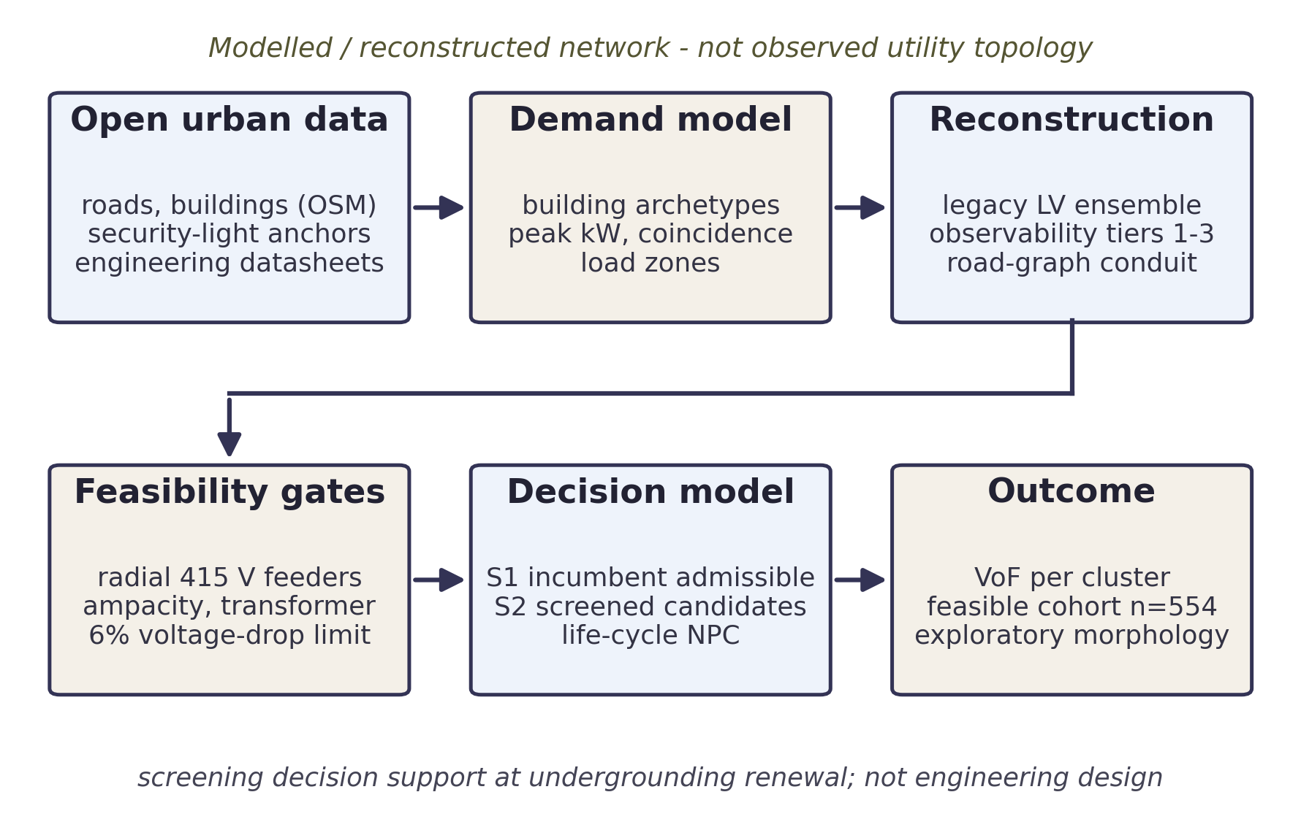
Figure 1. Data-to-decision pipeline: open geospatial inputs, zone construction, feasibility-gated reconstruction, and the incumbent-admissible renewal decision model.

2. Data and methods

2.1 Study zones and data tiers
The three Japanese municipalities were selected based on the availability of publicly accessible spatial data relevant to reconstructing low-voltage distribution-network layouts, rather than to represent Japanese municipalities statistically (Table 1). The available information differed in observability: Sano (Tier 1) provides security-light records carrying pole numbers and coordinates; Kudamatsu (Tier 2) provides geolocated security-light records without verified pole linkage; Yasu (Tier 3) provides road and building geometry only. These differences were retained as explicit data tiers in the reconstruction framework. Within each municipality a compact study zone was extracted as the largest connected component of the OpenStreetMap road graph (Haklay and Weber, 2008) (Figure 2), and building footprints were assigned estimated peak demand (30–60 W/m², two floors assumed) and snapped to the nearest road node. Buildings whose estimated raw peak exceeds 150 kW are marked medium-voltage-served and excluded from LV synthesis; this removes 12.2, 7.2, and 8.9 MW respectively. All distances use projected metric coordinates; mean building-to-road snap distances are 37–49 m and are disclosed as modeled-demand-surface error.
Table 1. Study zones and data tiers
Zone | Tier | LV demand (MW) | MV-excluded (MW) | Feasible clusters
Sano | 1 (pole-ID linked anchors) | 38.4 | 12.2 | 360
Kudamatsu | 2 (geolocated anchors) | 9.5 | 7.2 | 88
Yasu | 3 (roads/buildings only) | 10.7 | 8.9 | 106

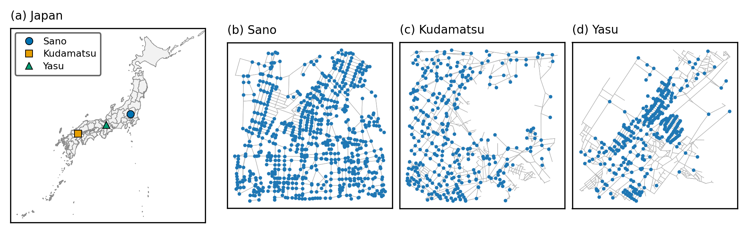
Figure 2. Geographic context and study zones. (a) Locations of Sano (Tochigi), Kudamatsu (Yamaguchi) and Yasu (Shiga) within Japan (markers show municipal positions; analyzed areas are submunicipal; prefecture boundaries from geoBoundaries Japan ADM1 (William & Mary geoLab, https://www.geoboundaries.org/, CC-BY-4.0) and northern island coastlines from Natural Earth 10m land (public domain); markers distinguished in the legend). (b–d) Road graph (grey) and snapped building demand nodes (blue) in each selected study zone (Sano 772, Kudamatsu 341, Yasu 332 nodes). Municipal locations provide geographic context and are not representative of each city in its entirety.
The municipalities occupy geographically distinct settings. Sano, in southwestern Tochigi Prefecture at the northern edge of the Kanto Plain, combines an urbanized and industrialized southern sector with mountainous, forested areas to the north (Sano City Office, 2024). Kudamatsu, in southeastern Yamaguchi Prefecture, is a coastal city facing the Seto Inland Sea with an established manufacturing base (Kudamatsu City Office, 2024). Yasu, in southern Shiga Prefecture on the shore of Lake Biwa, includes lowlands with urban, agricultural and industrial uses (Yasu City Office, 2025). These contrasts provide geographic context for the selected zones (Figure 2a) but do not establish a representative sample of Japanese municipalities; municipal-level characteristics are descriptive and are not treated as measured histories of electricity demand or network evolution within the analyzed districts.

2.2 Legacy network reconstruction
Because actual LV cable routing is unobserved, legacy topologies are reconstructed as an ensemble under each tier's evidence: geo-referenced LV synthesis from open data follows the precedent of (Abhilash Bandam et al., 2021); (Zhang et al., 2025); (Liu et al., 2025); (Babli et al., 2025), using security-light anchors as demand-side routing priors (never equated with pole or cable locations) and the road graph as the admissible conduit space. Feeder clusters are formed under a ~150 kVA transformer-zone constraint; 24-replicate and leave-one-family-out ensembles carry reconstruction uncertainty forward rather than collapsing it. Unlike surface-anchor mapping that treats proxy locations as network nodes (Chahinian et al., 2019), anchors here are routing priors inside a road-graph conduit space graded by observability tier, following the incomplete-semantics integration logic of (Gilbert et al., 2021).

2.3 Engineering feasibility and electrical model
All synthesized topologies are gated by engineering feasibility before any cost comparison: 415 V radial feeders, coincident peak load, ampacity, transformer loading, and a 6% voltage-drop limit. The linearized branch-flow model (Gan and Low, 2014) was validated against pandapower AC power flow (Thurner et al., 2018) on the synthesized feasible feeders — 672 feeder–scenario objects spanning the 336 clusters in which both the incumbent and a feasible redesign replicate exist; the agreement bounds the surrogate's error on the modeled objects (it does not validate them as the real municipal networks). A second public MV benchmark (Iwamoto 11-bus) failed to converge in pandapower 3.5.5 and is excluded from the validation statistics; the AC agreement reported below covers all 672 feasible synthesized feeders.

2.4 Re-layout optimization and the VoF estimand
Re-layout is formulated as weighted Steiner-tree synthesis on the road graph with per-edge conductor sizing, approximated by a fast Steiner heuristic(Kou et al., 1981); (Hwang and Richards, 1992). Candidate sets are enumerated per feeder cluster; the incumbent-like replicate remains in the admissible set, and 'best' is always taken within the enumerated candidate set, not over the untried re-layout space. Life-cycle cost NPC combines trenching/cable capex and 40-year discounted losses at frozen engineering prices. The primary estimand is
$$VoF = mean_r max(0, NPC(S1_r) - min_c∈feasible NPC(c))$$
a nonnegative quantity: zero whenever no feasible redesign beats the incumbent. For transparency we also report the conventional naive ΔNPC contrast (S1 mean vs S2 best, incumbent excluded) as a secondary statistic whose artifact-proneness is part of the findings. Reported VoF percentages below 1e-4% of incumbent NPC are treated as numerically zero (a post-hoc computational classification, not a prespecified threshold): two clusters carry positive VoF at ~1e-15%, within solver/reporting tolerance, and are reported separately from materially positive cases.

2.5 Urban morphology descriptors
At feeder-cluster scale we compute an exploratory, interpretable descriptor set from the processed road graph and demand surface: number of demand terminals, coincident demand (kW), convex-hull area (km²), demand density (kW/km²), mean road-edge length (m), mean node degree, incumbent route length per terminal (m), and mean distance to the demand centroid (m) — metrics in the tradition of planar-graph street-network analysis (Cardillo et al., 2006); (Barthélemy, 2011); (Boeing, 2018). Edge-based metrics (mean edge length, mean degree) are computed on road-network edges internal to each cluster, not on the feeder graph. Convex-hull density is degenerate for clusters with fewer than three terminals, so density is also computed on a fixed-radius support: the union of 100-m buffers around demand terminals (kW per buffered km², and road length per buffered km²); clusters whose hull is degenerate (terminals < 3 or hull area < 1e-4 km²) are excluded from the hull-density association rather than silently clipped. Their association with cluster VoF is assessed descriptively (Spearman rank summaries plus within-zone sign consistency); clusters nested in three purposive zones are not treated as independent city samples. Numerically, the hull density is degenerate for 427 of the 554 feasible clusters; hull-based associations are therefore reported on the 127 non-degenerate feasible clusters only.

3. Results
Table 2 summarizes 589 clusters (554 feasible) serving 58.6 MW of modeled LV peak demand — 75%, 55%, and 53% of total zone demand in Sano/Kudamatsu/Yasu (the remainder is MV-served by design and cancels in contrasts). Figure 3 compares optimized against incumbent route length across all feasible clusters: the corridor changes in only a small minority. The primary VoF estimand gives 0.01%, 0.39%, and 0.20% of like-for-like NPC — all inside the prespecified 1% practical-equivalence margin (Figure 4). The secondary naive contrast gives 0.01%, -10.1%, and 0.20%; the negative Kudamatsu value is an estimand artifact (incumbent excluded from the candidate set) and is not robust to the LV/MV boundary assumption (Table 3). AC validation on the 672 feeder–scenario objects spanning 336 clusters with both feasible replicates gives max voltage-magnitude deviation 0.019 pu against a 0.02 tolerance and feasibility agreement 1.00.
Table 2. Scenario results (feasibility-gated)
city | clusters | feasible | demand MW | S1 NPC (bn JPY) | S2 NPC | VoF (bn JPY) | VoF % (primary) | ΔNPC bn (secondary) | ΔNPC % (secondary)
sano | 385 | 360 | 38.4 | 4.84 | 4.84 | 0.0007 | 0.014 | 0.001 | 0.01
kudamatsu | 96 | 88 | 9.5 | 4.65 | 5.12 | 0.0183 | 0.394 | -0.468 | -10.1
yasu | 108 | 106 | 10.7 | 3.00 | 2.99 | 0.0060 | 0.201 | 0.006 | 0.20

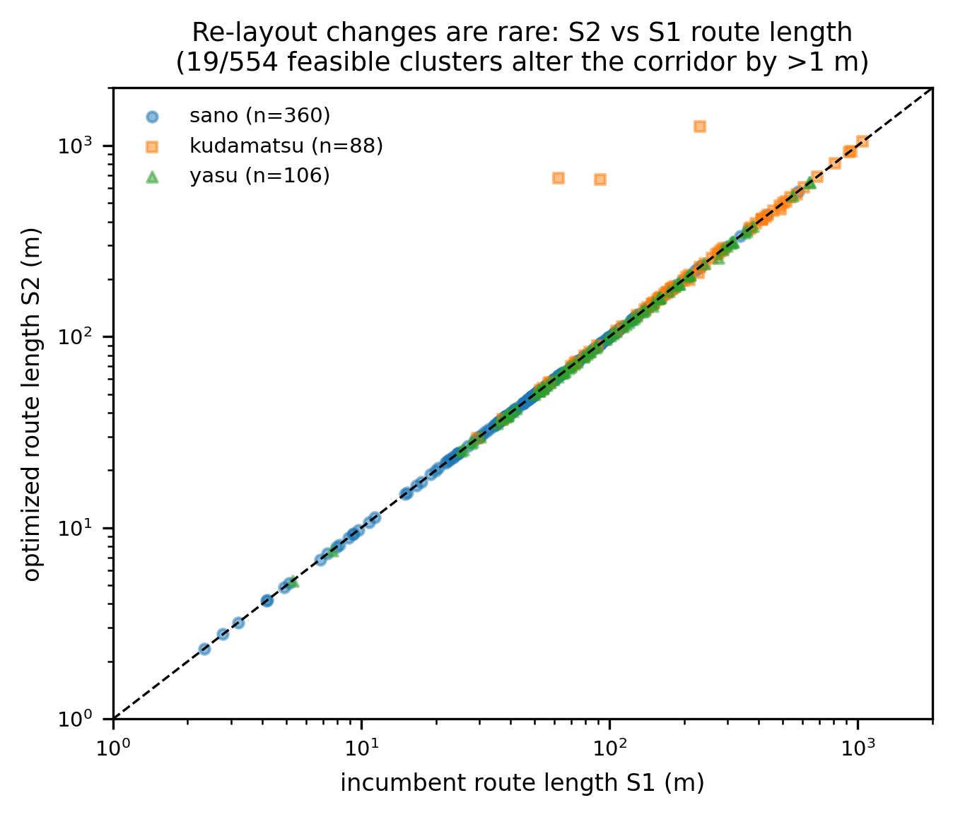
Figure 3. Optimized vs incumbent route length for all 554 feasible clusters (log-log; 19 clusters alter the corridor by >1 m).
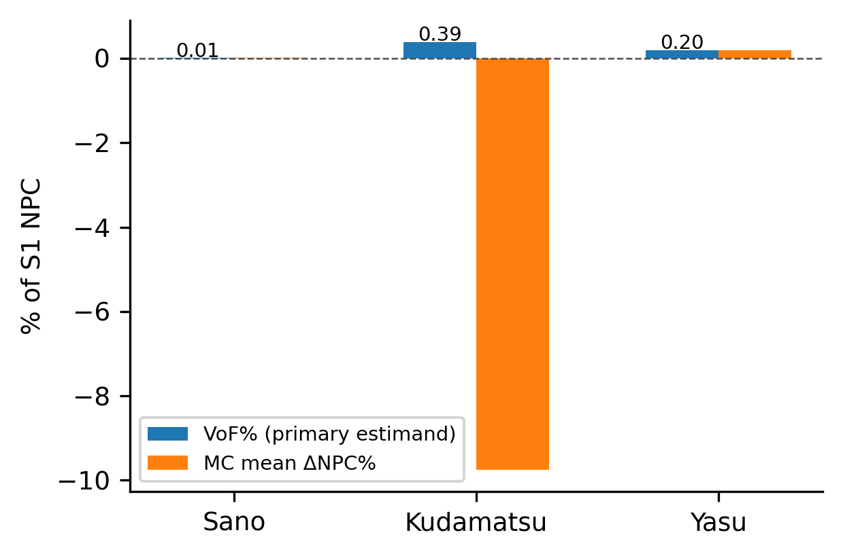
Figure 4. Primary estimand VoF by zone vs Monte-Carlo mean of the secondary naive ΔNPC; band = prespecified 1% practical-equivalence margin.
Table 3. Boundary/parameter sensitivity (reused frozen variants: VoF% primary | naive ΔNPC% secondary)
variant | city | VoF % | naive ΔNPC %
baseline | sano | 0.014 | 0.01
baseline | kudamatsu | 0.394 | -10.06
baseline | yasu | 0.201 | 0.20
MV threshold 120 kW | sano | 0.094 | 0.09
MV threshold 120 kW | kudamatsu | 0.201 | -2.21
MV threshold 120 kW | yasu | 0.782 | 0.78
MV threshold 200 kW | sano | 0.074 | -2.23
MV threshold 200 kW | kudamatsu | 0.561 | 0.27
MV threshold 200 kW | yasu | 0.947 | 0.94
transformer 80 kVA | sano | 0.001 | 0.00
transformer 80 kVA | kudamatsu | 0.441 | -7.46
transformer 80 kVA | yasu | 0.107 | -0.11
transformer 130 kVA † | sano | 0.015 | 0.02
transformer 130 kVA † | kudamatsu | 0.320 | -11.97
transformer 130 kVA † | yasu | 0.226 | 0.23
24-replicate ensemble | sano | 0.003 | 0.00
24-replicate ensemble | kudamatsu | 0.380 | -10.11
24-replicate ensemble | yasu | 0.241 | 0.24
† At a 130 kVA transformer limit the gate removes a further 8/6/9 clusters (Sano/Kudamatsu/Yasu) relative to the 150 kVA baseline; VoF on the remaining feasible cohort is essentially unchanged, indicating the rating is only mildly binding at the declared cluster scale.
At feeder-cluster scale (554 feasible clusters), VoF is zero for 95.7% of clusters (24 positive; two further cases sit within numerical tolerance; Table 4) — the option value is concentrated, not diffuse. Where nonzero, it associates descriptively with urban spatial structure (Figure 5, Table 5), but the association is a size effect: pooled Spearman ρ is 0.32 for terminal count, 0.29 for spatial span, 0.29 for cluster area and 0.27 for incumbent route length per terminal — yet rank-residual adjustment for terminal count collapses every one to ≈0 (span -0.01, area 0.01, route/terminal -0.03, road density -0.19). Larger clusters mechanically offer more candidate routes; we find no evidence of an independent morphology correlate beyond cluster size, and demand density is non-replicable across spatial supports (hull ρ = -0.28 on non-degenerate clusters vs buffer ρ = -0.04). Within-zone Moran's I of VoF is near zero (Table 6), though a non-significant permutation result cannot prove absence of dependence in zero-heavy data. Cost decomposition (Figure 6) shows the per-zone S1−S2 difference decomposed into capex, discounted loss-NPC and residual (O&M/transformer) terms in common monetary units; the non-negative VoF is small in every zone, consistent with the bounded estimand interpretation.
Table 4. Zero-mass structure of VoF by zone: positive-VoF clusters per electrically feasible zone cohort and conditional magnitudes (two further cases sit within numerical tolerance).
city | feasible clusters | positive VoF | zero share | median VoF % | positive | max VoF %
Sano | 360 | 3 | 0.992 | 0.486 | 1.066
Kudamatsu | 88 | 13 | 0.852 | 0.582 | 5.079
Yasu | 106 | 8 | 0.925 | 0.241 | 6.098
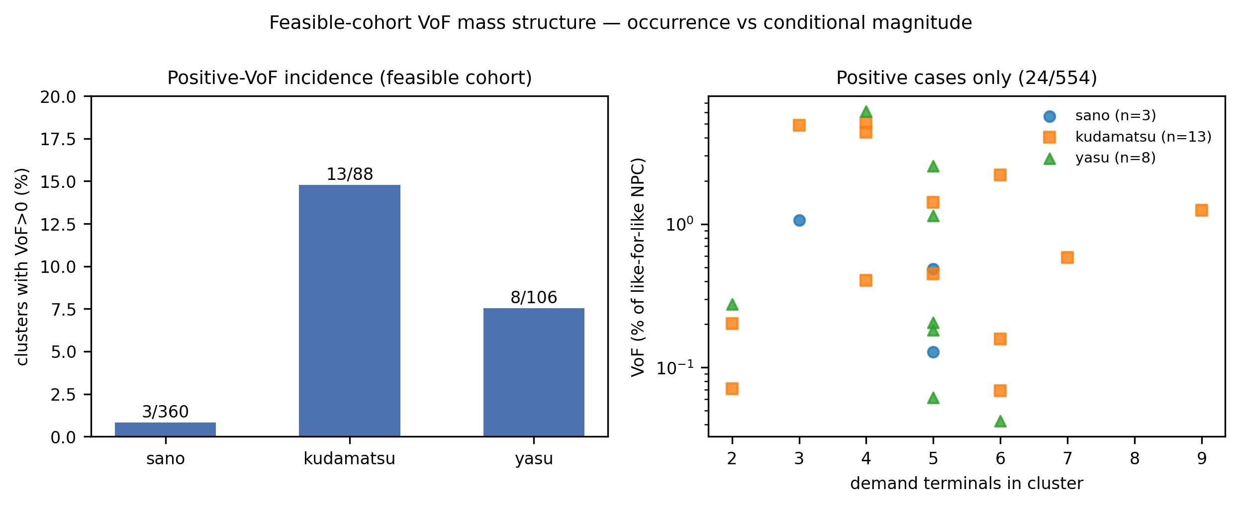
Figure 5. Feasible-cohort VoF mass structure: positive-VoF incidence by zone and conditional magnitudes for the 24 positive clusters (95.7% of feasible clusters have zero VoF).
Table 5. Morphology descriptors vs VoF on the 554 electrically feasible clusters (pooled Spearman ρ, and ρ after rank-residual adjustment for terminal count; spatially dependent, descriptive only)
descriptor | ρ (pooled) | ρ | terminal count | n
demand terminals (n) | 0.316 | — | 554
coincident demand (kW) | 0.130 | -0.033 | 554
convex-hull area (km²) | 0.295 | 0.006 | 127
demand density, hull (kW/km²) | -0.278 | -0.039 | 127
demand density, 100-m buffer (kW/km²) | -0.039 | -0.063 | 554
road density (km/km²) | 0.229 | -0.192 | 554
mean road-edge length (m) | 0.163 | 0.081 | 296
mean road node degree | 0.286 | -0.289 | 296
route length / terminal (m) | 0.274 | -0.027 | 554
spatial span (m) | 0.290 | -0.011 | 554
topology divergence distance † | 0.372 | 0.780 | 554
† tld is derived from the reconstructed topology itself and is an endogenous diagnostic, not an urban-morphology predictor; included for completeness only. n < 554 reflects declared sub-denominators (non-degenerate hulls; clusters with internal road edges).
Table 6. Within-zone Moran's I of cluster VoF (inverse-distance weights on demand-terminal centroids; 200-permutation p-values; feasible cohort).
city | n | Moran's I | permutation p
Sano | 360 | -0.001 | 0.154
Kudamatsu | 88 | -0.023 | 0.766
Yasu | 106 | -0.005 | 0.274
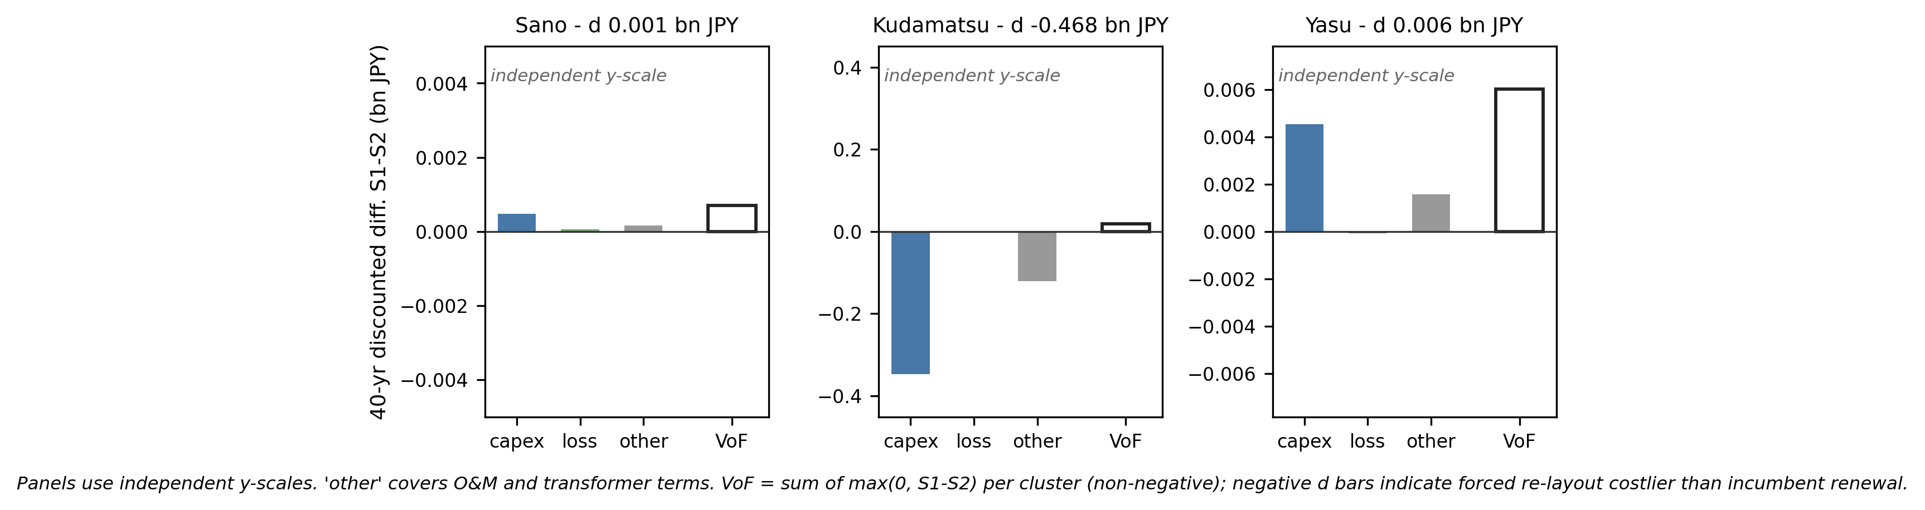
Figure 6. S1−S2 decomposition per zone in common monetary units (bn JPY, 40-yr discounted): capex, loss-cost and residual differences, alongside the non-negative VoF aggregate; panels use independent y-scales.

4. Discussion
The finding is bounded and geographically interpretable. Relative to reconstruction work that maps hidden utility networks (Zhang et al., 2025); (Abhilash Bandam et al., 2021); (Liu et al., 2025); (Babli et al., 2025) this study adds the decision layer those maps feed into: the reconstruction is not the answer, it is the choice set over which a renewal option is priced, and feasibility gating decides which reconstructed alternatives are physically realizable. Relative to rehabilitation decision-support systems (Hadzilacos et al., 2000) the DSS object is similar — a buried-network renewal decision — but the estimand differs: not which pipes to rehabilitate, but whether the spatial topology itself is worth re-drawing. And relative to proxy-location network inference (Chahinian et al., 2019) and geospatial integration under incomplete semantics (Gilbert et al., 2021), the anchors here are graded by observability tier and the inferred topology is carried into an engineering decision rather than ending at map accuracy. Relative to system-level undergrounding economics (Larsen, 2016); (Fenrick and Getachew, 2012) the result sharpens the 'undergrounding is rarely cost-effective' conclusion: even once the corridor is paid for, the incumbent layout is already near the life-cycle optimum, so the residual value of re-design is small and spatially rare — confined to a small minority of feasible clusters, and apparent morphology correlates reduce to cluster size rather than independent urban-form effects (Abdel-Mottaleb and Zhang, 2020). The morphology analysis is exploratory and zero-mass-dominated (96% of feasible clusters show no flexibility value); we present it only as a screening diagnostic for where detailed re-layout engineering might be worth commissioning, not as a predictive model. Within these reconstructed, demand-constrained networks, the limited benefit of re-layout is consistent with the possibility that successive locally economical connections can leave an inherited layout close to the current cost minimum, although the actual historical evolution of utility networks was not observed.
Two methodological controls produce the bounded result. First, feasibility gating: treating ~350 kW of raw building peaks as one undiversified LV load produces physically impossible feeders (double-digit voltage drops) and manufactures fictitious headroom. Second, estimand design: the negative Kudamatsu ΔNPC is an incumbent-exclusion artifact and is sensitive to the LV/MV boundary assumption (Table 3); under the optional estimand all zones stay inside the practical-equivalence margin. Mechanistically the negative contrast traces to a few small wide-area clusters where any rewiring costs 2–10× the incumbent corridor with no compensating loss reduction.
Limitations. Reconstructed topologies are modeled objects: anchor data do not observe actual pole-to-pole routing, and results are conditional on the reconstruction ensemble (stability checked by 24-replicate and leave-one-family-out). Study zones are compact extractions chosen for data-tier contrast, not city samples; OSM completeness is unverified; demand, coincidence, the 6% drop limit and the 150 kW LV/MV boundary are assumptions, several of which materially move the secondary contrast though not the VoF ordering. Morphology associations are descriptive over 554 feasible spatially dependent clusters in three zones, are dominated by zero mass, and collapse under size adjustment — usable only as an exploratory screening diagnostic, not as coefficients. MV-served demand is excluded by design; municipality-facing outputs are planning-support estimates, not engineering designs.

5. Conclusions
Urban renewal is a spatial decision, and the option to re-draw hidden infrastructure can be priced. Under feasibility-gated reconstruction and an incumbent-admissible estimand, renewal-time topology re-optimization stays within the prespecified 1% practical-equivalence margin of like-for-like renewal in all three study zones (VoF 0.01–0.39% of life-cycle cost). What little flexibility value remains is size-structured: where any remains, it sits in a handful of larger clusters — a screening pattern, not a morphology law. The transferable outputs are the screening estimand and the reconstruction-plus-gating pipeline; the magnitudes are zone-specific modeled results.

Acknowledgements
[to be completed at submission]

Declarations
Declaration of generative AI: during the preparation of this work the author used an AI coding assistant for code scaffolding and drafting. The author reviewed and edited all content and takes full responsibility for the publication.
Data availability: all scripts, the source registry, checksums, and machine-readable result tables (cluster-level results, morphology descriptors, engineering-assumption sensitivity, Monte-Carlo sweep, spatial diagnostics and zero-mass summaries) are provided in the public repository snapshot (github.com/bougtoir/underground-topology). Municipal open data were used under their stated licenses (CC-BY for Kudamatsu); OpenStreetMap data under ODbL; map layers from geoBoundaries Japan ADM1 (CC-BY-4.0) and Natural Earth (public domain).
Conflict of interest: none declared. Funding: none.

References
Abdel-Mottaleb, N. and Zhang, Q. (2020). Water distribution–transportation interface connectivity responding to urban geospatial morphology. Journal of Infrastructure Systems 26(3): 04020025. doi:10.1061/(ASCE)IS.1943-555X.0000563
Abhilash Bandam, Syranidou, C., Linssen, J. and Stolten, D. (2021). Geo-referenced synthetic low-voltage distribution networks: a data-driven approach. 2021 IEEE PES Innovative Smart Grid Technologies Europe (ISGT Europe), pp. 244–249. doi:10.1109/ISGTEurope52324.2021.9639916
Babli, M., Gebhard, T. and Brucherseifer, E. (2025). Open data-driven reconstruction of power distribution grid: a land use-based approach. Electronics 14(7): 1414. doi:10.3390/electronics14071414
Baran, M.E. and Wu, F.F. (1989a). Network reconfiguration in distribution systems for loss reduction and load balancing. IEEE Transactions on Power Delivery 4(2): 1401–1407. doi:10.1109/61.25627
Baran, M.E. and Wu, F.F. (1989b). Optimal capacitor placement on radial distribution systems. IEEE Transactions on Power Delivery 4(1): 725–734. doi:10.1109/61.19265
Barthélemy, M. (2011). Spatial networks. Physics Reports 499(1–3): 1–101. doi:10.1016/j.physrep.2010.11.002
Boeing, G. (2018). A multi-scale analysis of 27,000 urban street networks: every US city, town, urbanized area, and Zillow neighborhood. Environment and Planning B: Urban Analytics and City Science 47(4): 590–615. doi:10.1177/2399808318784595
Camargo, V., Lavorato, M. and Romero, R. (2013). Specialized genetic algorithm to solve the electrical distribution system expansion planning. 2013 IEEE Power & Energy Society General Meeting, pp. 1–5. doi:10.1109/PESMG.2013.6672615
Chahinian, N., Delenne, C., Commandré, B., Derras, M., Deruelle, L. and Bailly, J.-S. (2019). Automatic mapping of urban wastewater networks based on manhole cover locations. Computers, Environment and Urban Systems 78: 101370. doi:10.1016/j.compenvurbsys.2019.101370
Cardillo, A., Scellato, S., Latora, V. and Porta, S. (2006). Structural properties of planar graphs of urban street patterns. Physical Review E 73(6): 066107. doi:10.1103/PhysRevE.73.066107
Fenrick, S.A. and Getachew, L. (2012). Cost and reliability comparisons of underground and overhead power lines. Utilities Policy 20(1): 31–37. doi:10.1016/j.jup.2011.10.002
Fu, G., Wilkinson, S. and Dawson, R. (2016). A spatial network model for civil infrastructure system development. Computer-Aided Civil and Infrastructure Engineering 31(9): 661–680. doi:10.1111/mice.12204
Gilbert, T., James, P., Smith, L., Barr, S. and Morley, J. (2021). Topological integration of BIM and geospatial water utility networks across the building envelope. Computers, Environment and Urban Systems 86: 101570. doi:10.1016/j.compenvurbsys.2020.101570
Gan, L. and Low, S.H. (2014). Convex relaxations and linear approximation for optimal power flow in multiphase radial networks. 2014 Power Systems Computation Conference, pp. 1–9. doi:10.1109/PSCC.2014.7038399
Hadzilacos, T., Kalles, D., Preston, N., Melbourne, P., Camarinopoulos, L., Eimermacher, M., Kallidromitis, V., Frondistou-Yannas, S. and Saegrov, S. (2000). UtilNets: a water mains rehabilitation decision-support system. Computers, Environment and Urban Systems 24(3): 215–232. doi:10.1016/S0198-9715(99)00058-7
Haklay, M. and Weber, P. (2008). OpenStreetMap: user-generated street maps. IEEE Pervasive Computing 7(4): 12–18. doi:10.1109/MPRV.2008.80
Hwang, F.K. and Richards, D.S. (1992). Steiner tree problems. Networks 22(1): 55–89. doi:10.1002/net.3230220105
Kou, L., Markowsky, G. and Berman, L. (1981). A fast algorithm for Steiner trees. Acta Informatica 15(2): 141–145. doi:10.1007/BF00288961
Kudamatsu City Office (2024). City profile (Shi no Purofīru). Kudamatsu City, Yamaguchi, Japan. https://www.city.kudamatsu.lg.jp/shiseijouhou/gaiyou.html
Kumar, D., Samantaray, S.R. and Joos, G. (2014). A reliability assessment based graph theoretical approach for feeder routing in power distribution networks including distributed generations. International Journal of Electrical Power & Energy Systems 57: 11–30. doi:10.1016/j.ijepes.2013.11.039
Larsen, P.H. (2016). A method to estimate the costs and benefits of undergrounding electricity transmission and distribution lines. Energy Economics 60: 47–61. doi:10.1016/j.eneco.2016.09.011
Levinson, D. (2012). Network structure and city size. PLoS ONE 7(1): e29721. doi:10.1371/journal.pone.0029721
Liu, D., Giraldo, J.S., Palensky, P. and Vergara, P.P. (2025). Topology identification and parameters estimation of LV distribution networks using open GIS data. International Journal of Electrical Power & Energy Systems 164: 110395. doi:10.1016/j.ijepes.2024.110395
Louf, R. and Barthélemy, M. (2014). A typology of street patterns. Journal of The Royal Society Interface 11(101): 20140924. doi:10.1098/rsif.2014.0924
Ochs, K.S., Miller, M.E., Thal, A.E. and Ritschel, J.D. (2014). Proposed method for analyzing infrastructure investment decisions involving rapidly evolving technology: case study of LED streetlights. Journal of Management in Engineering 30(1): 41–49. doi:10.1061/(ASCE)ME.1943-5479.0000177
Sano City Office (2024). Topography of Sano (Chisei). Sano City, Tochigi, Japan. https://www.city.sano.lg.jp/kurashi_gyosei/shiseijoho_nyusatsu/sanoshinogaiyo/intro/8598.html
Samui, A., Singh, S., Ghose, T. and Samantaray, S.R. (2012). A direct approach to optimal feeder routing for radial distribution system. IEEE Transactions on Power Delivery 27(1): 253–260. doi:10.1109/TPWRD.2011.2167522
Taheri, B., Molzahn, D.K. and Grijalva, S. (2023). Improving distribution system resilience by undergrounding lines and deploying mobile generators. Electric Power Systems Research 214: 108804. doi:10.1016/j.epsr.2022.108804
Thurner, L., Scheidler, A., Schafer, F., Menke, J.-H., Dollichon, J., Meier, F., Meinecke, S. and Braun, M. (2018). Pandapower — an open-source Python tool for convenient modeling, analysis, and optimization of electric power systems. IEEE Transactions on Power Systems 33(6): 6510–6521. doi:10.1109/TPWRS.2018.2829021
Tram, H.N. and Wall, D.L. (1988). Optimal conductor selection in planning radial distribution systems. IEEE Transactions on Power Systems 3(1): 200–206. doi:10.1109/59.43199
Zhang, F., Xu, Z., Zhu, R., Liang, C. and Gu, D. (2025). Geospatial mapping of urban utility networks integrating street view images and design rules. Computer-Aided Civil and Infrastructure Engineering 40(27): 4884–4903. doi:10.1111/mice.70085
Yasu City Office (2025). About Yasu City (Shi no Shōkai). Yasu City, Shiga, Japan. https://www.city.yasu.lg.jp/soshiki/kouhouhisho/gaiyou/1450766759558.html

