Mind the Gap: Clinical Practice Guidelines and WADA Therapeutic Use Exemptions Are Diverging—A Call for Harmonization

[Author Name], MD, CSCS

[Institutional Affiliation]
[Department/Division]
[City, Country]

Corresponding Author: [Author Name], MD, CSCS
[Address]
Email: [email]
ORCID: [ORCID ID]

Word Count: ~1,500 (excluding references and figure legend)
Keywords: therapeutic use exemption; anti-doping; clinical practice guidelines; prohibited list; athlete health

INTRODUCTION
The World Anti-Doping Agency (WADA) Therapeutic Use Exemption (TUE) system represents a critical safeguard, ensuring that athletes with legitimate medical conditions can receive necessary treatment while preserving sporting integrity. However, an emerging and under-recognized problem threatens this balance: the growing divergence between WADA’s regulatory framework and current evidence-based clinical practice guidelines. We argue that this “clinical-competition gap” places athletes at risk of receiving suboptimal medical care or inadvertent anti-doping rule violations (ADRVs).
THE WIDENING GAP
We conducted a scoping review mapping WADA’s 2025–2026 Prohibited List and TUE Physician Guidelines against current clinical practice guidelines across seven major disease areas. The findings reveal systematic discrepancies of clinical significance (Figure 1).
In male hypogonadism, the Endocrine Society (2018) and EAU (2024) guidelines recommend testosterone replacement therapy (TRT) for men with consistently low testosterone and symptoms, regardless of whether the etiology is “organic” or “functional.” The TRAVERSE trial (2023) further established cardiovascular safety of TRT. Yet WADA’s TUE Physician Guidelines explicitly restrict TUE approval to organic causes, excluding late-onset hypogonadism (LOH)—precisely the condition affecting the rapidly growing masters athlete population. An athlete with biochemically confirmed LOH (testosterone <300 ng/dL on two morning measurements) whose symptoms persist despite lifestyle modification faces a binary choice: forgo guideline-recommended treatment or retire from competition.
For attention-deficit/hyperactivity disorder (ADHD), all major guidelines—including NICE (2024), the Australian ADHD Guideline (2022), and APA recommendations—designate stimulant medications (methylphenidate, lisdexamfetamine) as first-line pharmacotherapy. These are universally prohibited in-competition under WADA’s S6 category. The paradox is stark: ADHD is a 24/7 condition, yet WADA prohibits its optimal treatment only in-competition, effectively requiring athletes to discontinue long-acting formulations on competition days—a practice no clinical guideline endorses. While TUE applications for stimulants are possible, the process demands extensive neuropsychological documentation dating to childhood, imposing substantial time and financial burdens.
The asthma landscape presents a subtler but significant challenge. GINA 2025 established ICS-formoterol maintenance and reliever therapy (MART) as the preferred track across all severity steps. During exacerbations, cumulative daily formoterol doses may approach WADA’s 54 μg threshold (delivered dose per 24 hours), and the urinary formoterol threshold of 40 ng/mL may be exceeded with clinically appropriate MART use—creating ADRV risk for athletes following guideline-recommended therapy.
Perhaps the most pressing emerging gap involves GLP-1 receptor agonists. The ADA Standards of Care 2025 now positions semaglutide and tirzepatide as preferred agents for type 2 diabetes with cardiovascular risk or weight management needs. These agents are currently on WADA’s Monitoring Program (since 2024) and may be added to the Prohibited List. Should this occur, athletes with type 2 diabetes following ADA guidelines would be forced to abandon first-line therapy, potentially shifting to insulin—which itself requires a TUE and carries hypoglycemic risk.
Additional gaps exist in cardiovascular medicine (mineralocorticoid receptor antagonists such as spironolactone, a pillar of heart failure therapy, are prohibited as diuretics), glucocorticoid management (2022 prohibition of intra-articular injections in-competition with washout periods inconsistent with clinical practice), and PCOS/fertility treatment (letrozole, the WHO-recommended first-line ovulation induction agent, is always prohibited).
WHY DOES THIS GAP EXIST?
Three structural factors drive this divergence. First, a temporal mismatch: clinical guidelines undergo rapid evidence-based revisions (GINA annually, ADA annually, ESC every 3–5 years), while WADA TUE Physician Guidelines, though described as “living documents,” may lag by 1–3 years in reflecting new clinical standards. Second, a criteria mismatch: clinical guidelines are grounded in patient-centered outcomes, whereas WADA’s criteria emphasize preventing performance enhancement—sometimes leading to divergent interpretations of the same evidence (as seen in the organic vs. functional hypogonadism distinction). Third, an emerging drug mismatch: novel therapeutic classes (GLP-1 receptor agonists, SGLT2 inhibitors) are adopted into clinical practice faster than WADA’s regulatory apparatus can evaluate and accommodate them.
WHAT SHOULD WE DO?
We propose four actionable steps. First, WADA should establish a formal mechanism to review and update TUE Physician Guidelines within 12 months of major clinical guideline revisions. Second, the rigid organic/functional distinction for hypogonadism TUEs should be re-evaluated in light of the Endocrine Society’s symptom-plus-biochemistry approach and the growing masters athlete population. Third, before adding GLP-1 receptor agonists to the Prohibited List, WADA should conduct a formal impact assessment on athletes with type 2 diabetes. Fourth, anti-doping education for prescribing physicians—who often have limited knowledge of the Prohibited List—should be integrated into sports medicine curricula and continuing medical education.
The TUE system was designed to protect athletes’ right to health. When clinical guidelines and anti-doping regulations diverge, it is athletes who bear the consequences—forced to choose between optimal medical care and their sporting careers. Closing this gap is not merely a regulatory convenience; it is an ethical imperative.

FIGURE LEGEND
Figure 1. Conceptual framework illustrating the clinical-competition gap in anti-doping. Evidence-based clinical practice guidelines and WADA anti-doping regulations converge on the athlete, creating gaps through update timing lags, divergent diagnostic criteria, prohibition of guideline-recommended first-line therapies, and TUE process barriers. These gaps result in suboptimal treatment, delayed care access, anti-doping rule violation risk, privacy concerns, geographic disparities, and career impact.

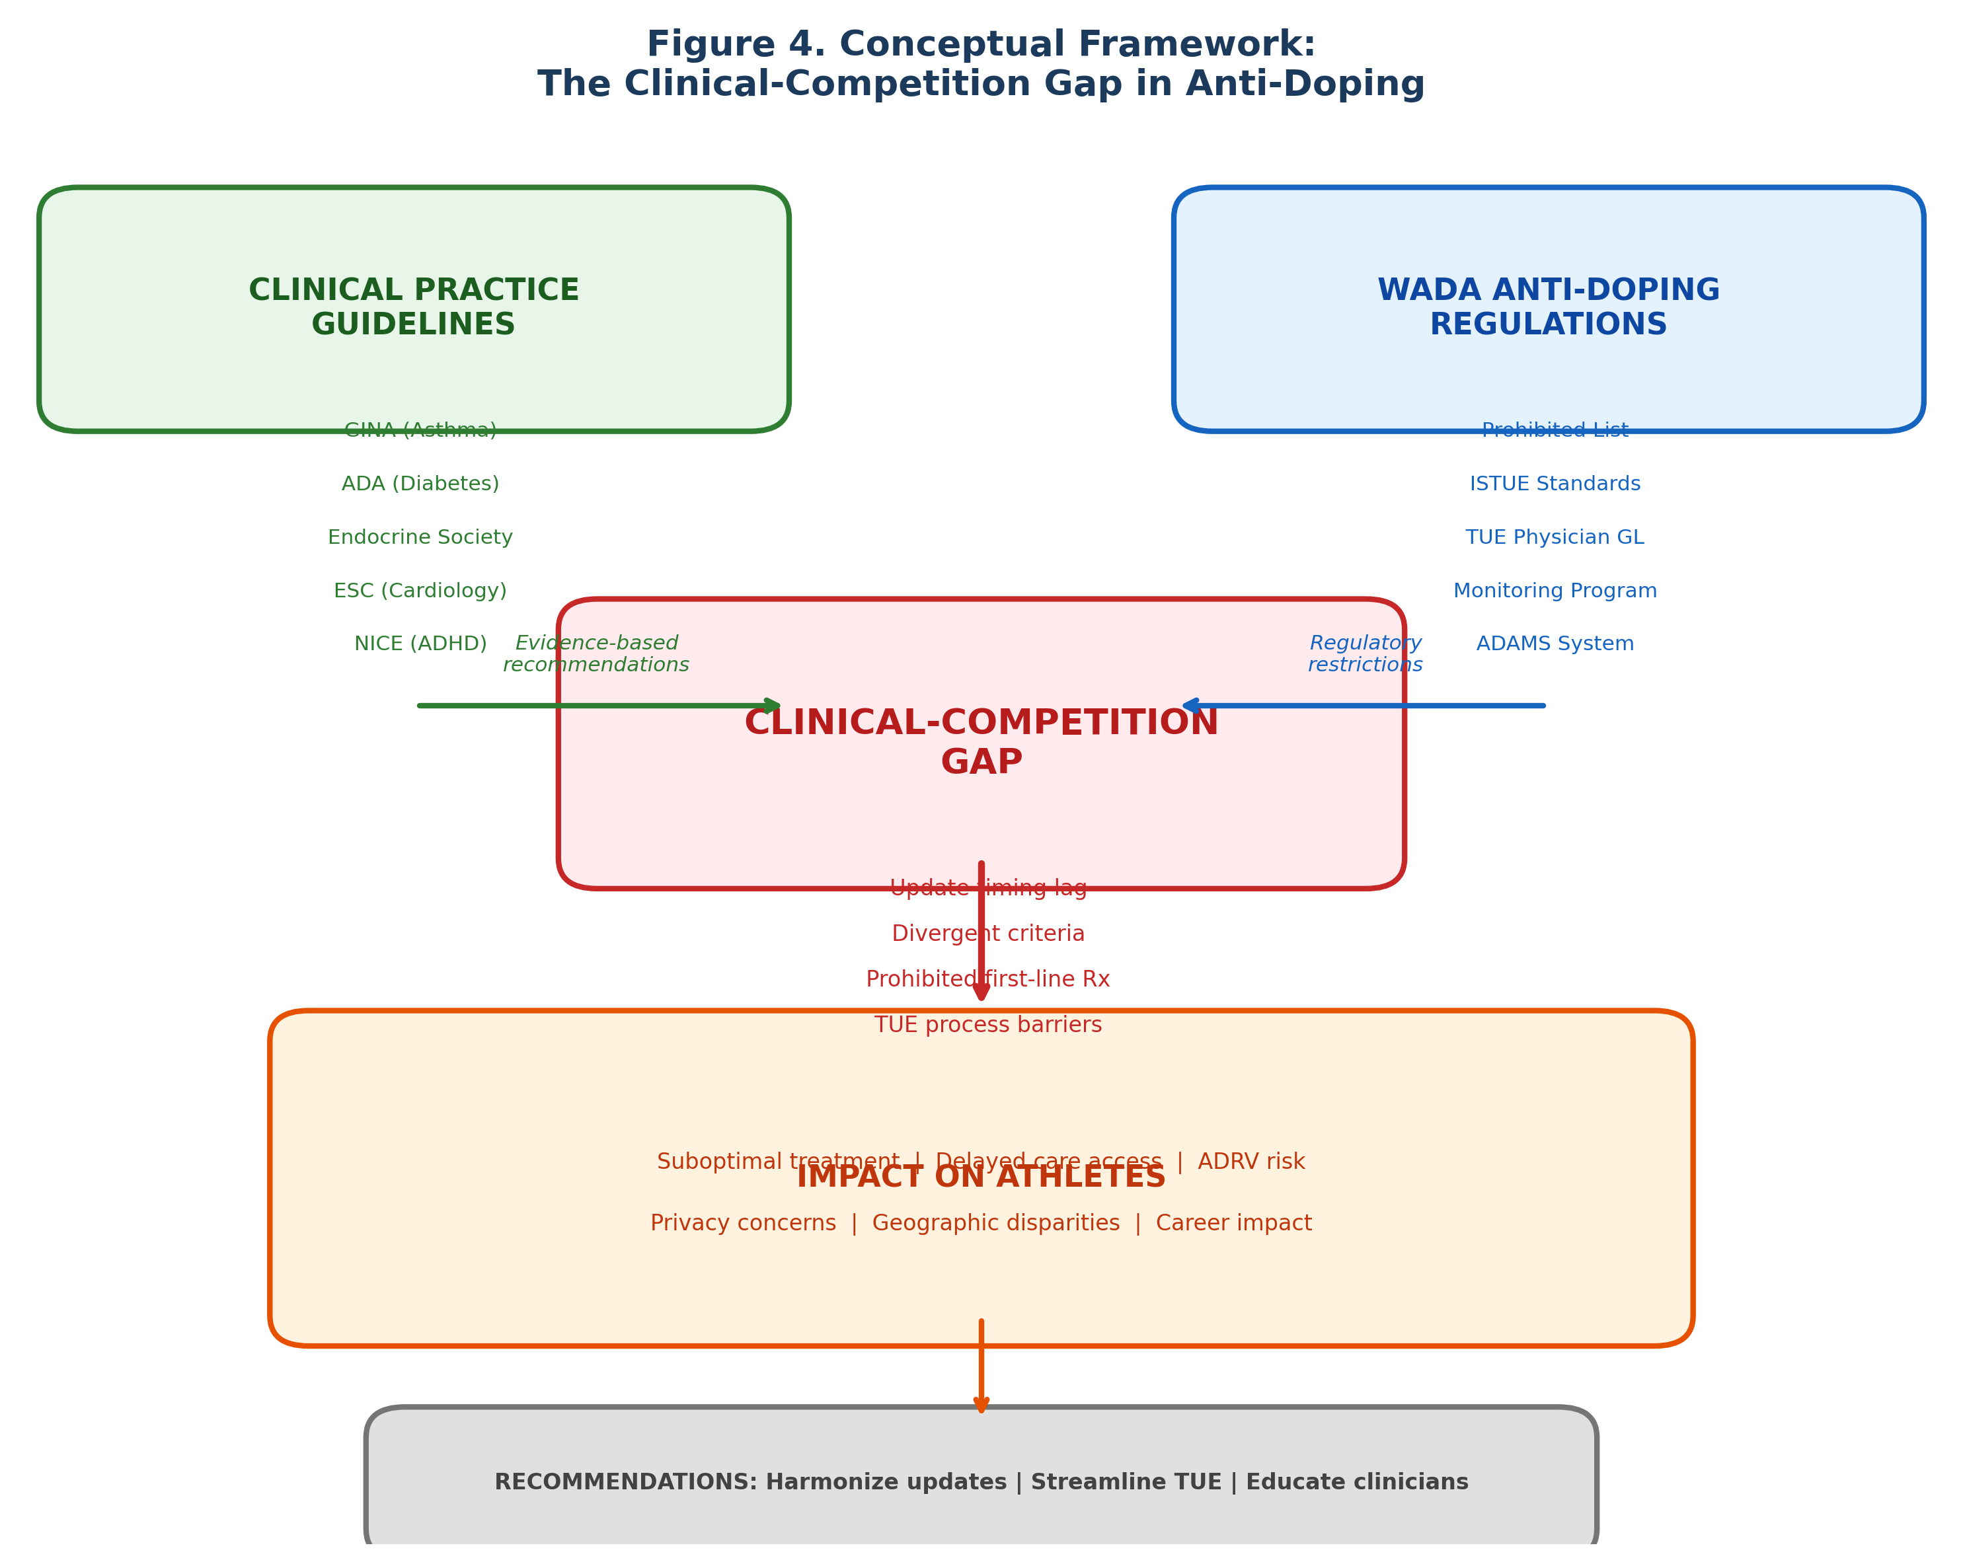

REFERENCES
1. World Anti-Doping Agency. World Anti-Doping Code International Standard for Therapeutic Use Exemptions (ISTUE). Montreal: WADA; 2021.
2. World Anti-Doping Agency. The 2026 Prohibited List International Standard. Montreal: WADA; 2025.
3. World Anti-Doping Agency. TUE Physician Guidelines – Male Hypogonadism. Montreal: WADA; 2025.
4. Bhasin S, Brito JP, Cunningham GR, et al. Testosterone therapy in men with hypogonadism: an Endocrine Society clinical practice guideline. J Clin Endocrinol Metab. 2018;103(5):1715–1744.
5. Lincoff AM, Bhasin S, Flevaris P, et al. Cardiovascular safety of testosterone-replacement therapy. N Engl J Med. 2023;389(2):107–117.
6. European Association of Urology. EAU Guidelines on Sexual and Reproductive Health. Arnhem: EAU; 2024.
7. National Institute for Health and Care Excellence. Attention deficit hyperactivity disorder: diagnosis and management. NICE guideline [NG87]. London: NICE; 2024 (updated).
8. Australian ADHD Professionals Association. Australian Evidence-Based Clinical Practice Guideline for ADHD. Melbourne: AADPA; 2022.
9. World Anti-Doping Agency. TUE Physician Guidelines – ADHD. Version 8.0. Montreal: WADA; 2026.
10. Global Initiative for Asthma. Global Strategy for Asthma Management and Prevention. Fontana: GINA; 2025.
11. World Anti-Doping Agency. TUE Physician Guidelines – Asthma. Version 9.3. Montreal: WADA; 2026.
12. American Diabetes Association Professional Practice Committee. Standards of Care in Diabetes—2025. Diabetes Care. 2025;48(Suppl 1):S1–S352.
13. World Anti-Doping Agency. 2026 Monitoring Program. Montreal: WADA; 2025.
14. McDonagh TA, Metra M, Adamo M, et al. 2021 ESC Guidelines for the diagnosis and treatment of acute and chronic heart failure. Eur Heart J. 2021;42(36):3599–3726.
15. Teede HJ, Tay CT, Laven JJE, et al. Recommendations from the 2023 international evidence-based guideline for the assessment and management of polycystic ovary syndrome. J Clin Endocrinol Metab. 2023;108(10):2447–2469.
16. Vernec A, Healy D, Banon T, Petroczi A. Prevalence of therapeutic use exemptions at the Olympic Games and Paralympic Games: an analysis of data from 2016 to 2022. Br J Sports Med. 2024;58(17):966–972.
17. World Anti-Doping Agency. Glucocorticoids and Therapeutic Use Exemptions Guidelines. Montreal: WADA; 2025.
18. Heuberger JAAC, Cohen AF. Review of WADA prohibited substances: limited evidence for performance-enhancing effects. Sports Med. 2019;49(4):525–539.

