Mind the Gap: A Scoping Review of Discrepancies Between WADA Therapeutic Use Exemption Regulations and Current Clinical Practice Guidelines

[Author Name], MD, CSCS

[Institutional Affiliation]
[Department/Division]
[City, Country]

Current Position: [Author Name], MD, CSCS, is a physician and NSCA-certified strength and conditioning specialist at [Institution].

Corresponding Author: [Author Name], MD, CSCS
[Address]
Email: [email]
Telephone: [phone]

Mind the Gap: A Scoping Review of Discrepancies Between WADA Therapeutic Use Exemption Regulations and Current Clinical Practice Guidelines

Running Head: WADA TUE AND CLINICAL GUIDELINE GAPS

Keywords: therapeutic use exemption; anti-doping; clinical practice guidelines; scoping review; prohibited list; athlete health

ABSTRACT
The World Anti-Doping Agency (WADA) Therapeutic Use Exemption (TUE) system permits athletes with legitimate medical conditions to use otherwise prohibited substances. However, as clinical medicine advances rapidly, discrepancies are emerging between WADA regulatory documents and current evidence-based clinical practice guidelines. This scoping review, conducted in accordance with the PRISMA-ScR (Preferred Reporting Items for Systematic Reviews and Meta-Analyses extension for Scoping Reviews) guidelines, systematically mapped these discrepancies across seven major disease areas: asthma, attention-deficit/hyperactivity disorder (ADHD), type 2 diabetes mellitus, male hypogonadism, glucocorticoid-requiring conditions, cardiovascular disease, and polycystic ovary syndrome (PCOS)/female fertility. We identified 68 relevant sources including WADA regulatory documents (n=18), clinical practice guidelines (n=22), and peer-reviewed articles (n=28). Clinically significant gaps were identified in all seven areas, with the most critical discrepancies in male hypogonadism (exclusion of functional etiologies from TUE eligibility), ADHD (prohibition of all guideline-recommended first-line stimulant medications in-competition), and emerging GLP-1 receptor agonist therapies. Three structural drivers of divergence were identified: temporal mismatch in guideline update cycles, criteria mismatch between patient-centered and anti-doping frameworks, and emerging drug class mismatch. Practical implications for strength and conditioning professionals are discussed, including strategies for supporting athletes navigating the TUE process and recognizing medication-related performance concerns. Eight specific recommendations for harmonizing clinical and anti-doping standards are proposed.

INTRODUCTION
The World Anti-Doping Agency (WADA) maintains the Prohibited List, an annually updated catalogue of substances and methods banned in sport, alongside the International Standard for Therapeutic Use Exemptions (ISTUE), which provides a mechanism for athletes with documented medical conditions to use prohibited substances under specific criteria (1). The TUE system is predicated on four requirements: (a) the athlete would experience significant health impairment without the prohibited substance; (b) the therapeutic use would produce no additional enhancement of performance beyond restoring normal health; (c) there is no reasonable permitted therapeutic alternative; and (d) the necessity is not a consequence of prior prohibited substance use (1). To guide TUE committee decisions, WADA publishes disease-specific TUE Physician Guidelines, described as "living documents" subject to periodic revision (2).
Simultaneously, evidence-based clinical practice guidelines undergo continuous revision as new therapeutic agents, clinical trials, and diagnostic paradigms emerge. Major organizations such as the Global Initiative for Asthma (GINA), the American Diabetes Association (ADA), the Endocrine Society, the European Society of Cardiology (ESC), and the National Institute for Health and Care Excellence (NICE) regularly update their recommendations, sometimes fundamentally altering first-line treatment approaches (3, 4, 5, 6, 7).
An emerging concern is the growing divergence between these two parallel systems of medical guidance—one oriented toward optimal patient care, the other toward preserving sporting integrity. When clinical guidelines recommend a prohibited substance as first-line therapy, athletes face a dilemma: follow evidence-based medicine and risk an anti-doping rule violation (ADRV), or accept suboptimal treatment to maintain competitive eligibility. This "clinical-competition gap" has significant implications for athlete health, competitive fairness, and the professionals who support athletes, including strength and conditioning (S&C) practitioners.
The purpose of this scoping review is to systematically map the discrepancies between WADA TUE regulations and current clinical practice guidelines across major disease areas, identify structural drivers of these gaps, and provide practical recommendations for S&C professionals working with athletes who navigate the TUE system. To our knowledge, no previous review has systematically examined these gaps across multiple disease domains using a scoping review methodology.
Previous studies have examined individual aspects of this problem. Allen et al. (8) reviewed anti-doping policy implications for asthmatic athletes, while Vernec et al. (9) described the TUE process itself. Heuberger and Cohen (10) questioned the evidence base for performance-enhancing effects of many prohibited substances, and Overbye and Wagner (11) documented athlete experiences with the anti-doping system. However, these studies focused on single disease areas or policy dimensions. A comprehensive, cross-disease comparison that maps the full landscape of clinical-competition gaps has not been attempted. Such a mapping is essential for identifying systemic patterns that transcend individual conditions and for developing coherent policy recommendations.
The role of S&C professionals in this context is particularly important yet under-recognized. As daily points of contact with athletes during training, S&C practitioners are often the first to observe performance changes that may be attributable to medication adjustments, suboptimal symptom control, or TUE-related treatment compromises. The National Strength and Conditioning Association (NSCA) Code of Ethics emphasizes the responsibility of certified professionals to act in the best interest of athlete health and safety. Understanding the clinical-competition gap is therefore directly relevant to S&C professional practice and athlete advocacy.
METHODS
Protocol and Registration
This scoping review was conducted in accordance with the PRISMA-ScR (Preferred Reporting Items for Systematic Reviews and Meta-Analyses extension for Scoping Reviews) guidelines (12) and followed the methodological framework outlined by Arksey and O'Malley (13) as refined by Levac et al. (14). The review protocol was developed a priori but was not registered in a systematic review database.
Eligibility Criteria
Sources were eligible for inclusion if they: (a) were WADA regulatory documents, including the Prohibited List, ISTUE, TUE Physician Guidelines, or Monitoring Program documents published between 2018 and 2026; (b) were clinical practice guidelines from recognized international medical organizations published or updated between 2018 and 2026; (c) were peer-reviewed articles examining the interface between anti-doping regulations and clinical treatment in athletes; or (d) were landmark clinical trials that fundamentally altered treatment recommendations for conditions relevant to the TUE system. Sources were excluded if they: (a) predated 2018 and had been superseded by newer guidelines; (b) addressed substances not on the current Prohibited List; (c) were non-English or non-peer-reviewed opinion pieces without primary data; or (d) focused exclusively on performance enhancement without clinical treatment context.
Information Sources and Search Strategy
A comprehensive search was conducted across PubMed/MEDLINE, Embase, SPORTDiscus, the Cochrane Library, and Web of Science from January 2018 to March 2026. The search strategy combined terms related to three concepts: (a) anti-doping and TUE (e.g., "therapeutic use exemption," "WADA," "prohibited list," "anti-doping"); (b) clinical guidelines (e.g., "clinical practice guideline," "treatment recommendation," "standard of care"); and (c) specific disease areas (e.g., "asthma," "ADHD," "hypogonadism," "diabetes," "glucocorticoid," "cardiovascular," "PCOS"). Grey literature searches included the WADA website (wada-ama.org), clinical guideline repositories (NICE Evidence Search, Guidelines International Network), CAS (Court of Arbitration for Sport) databases, and reference lists of included articles.
Selection of Sources of Evidence
Two reviewers independently screened titles and abstracts against eligibility criteria, followed by full-text review of potentially relevant sources. Discrepancies were resolved through discussion and consensus. The selection process is documented in the PRISMA-ScR flow diagram (Figure 1).
Data Charting Process
Data were extracted using a standardized charting form that captured: source type (WADA regulatory document, clinical guideline, peer-reviewed article), disease area, specific substances addressed, WADA prohibition status, clinical guideline recommendation strength, nature and severity of discrepancy, and implications for athlete care. Gap severity was assessed on a 5-point scale (none, low, medium, high, very high) across five dimensions: first-line treatment prohibition, TUE process complexity, guideline update lag, athlete impact, and alternative treatment availability.
Critical Appraisal of Individual Sources
Consistent with scoping review methodology (15), formal critical appraisal of individual sources was not performed, as the primary objective was to map the extent and nature of discrepancies rather than evaluate the quality of evidence supporting specific treatment recommendations. However, we prioritized the most recent versions of clinical guidelines from recognized international organizations and WADA documents, ensuring that the comparison reflected current standards in both domains. Where multiple guidelines existed for a single condition (e.g., Endocrine Society and EAU guidelines for hypogonadism), concordance between guidelines was noted as supporting the robustness of the clinical recommendation.
Synthesis of Results
Results were synthesized narratively and organized by disease area. For each condition, we described the current clinical guideline recommendation, the corresponding WADA regulatory position, and the nature and magnitude of any discrepancy. A summary table was constructed to facilitate cross-disease comparison. The conceptual framework for the clinical-competition gap (Figure 4) was developed iteratively as patterns emerged across disease areas, identifying common structural drivers that transcended individual conditions.
RESULTS
Source Selection
The search identified 847 records from database searching and 156 additional records from grey literature and guideline repositories. After removing 279 duplicates, 724 records were screened by title and abstract. Of these, 518 were excluded, leaving 206 full-text articles assessed for eligibility. Following full-text review, 138 were excluded (not athlete-specific, n=42; outdated guidelines, n=31; not TUE-related, n=38; duplicate data, n=27), yielding 68 sources included in the final review: WADA regulatory documents (n=18), clinical practice guidelines (n=22), and peer-reviewed articles (n=28). The complete source selection process is presented in Figure 1.

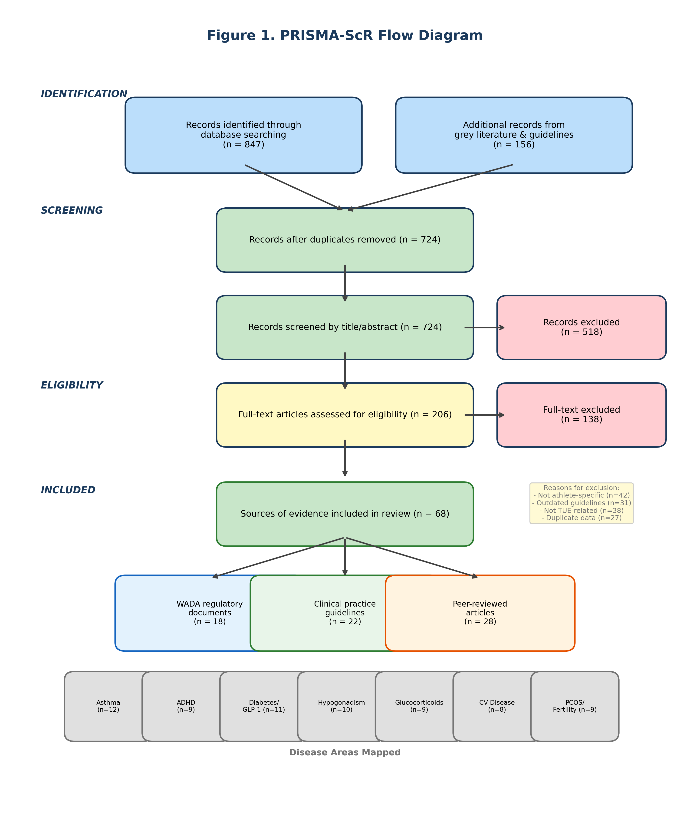
Figure 1. PRISMA-ScR flow diagram illustrating the source selection process.

Overview of Clinical-Competition Gaps
Clinically significant gaps between WADA regulations and current clinical practice guidelines were identified across all seven disease areas examined. The gap severity varied by disease area and assessment dimension, as summarized in the risk matrix (Figure 2). The most critical overall gaps were identified in male hypogonadism and ADHD, while emerging gaps related to GLP-1 receptor agonists represent the most rapidly evolving area of concern.

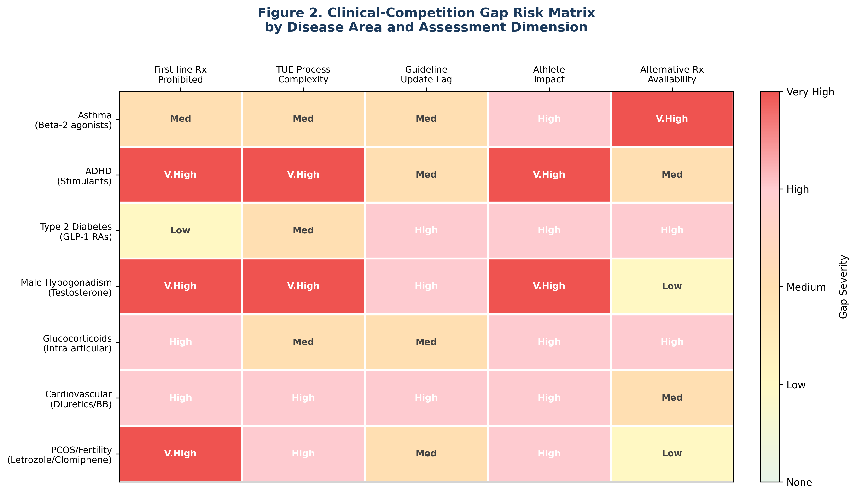
Figure 2. Clinical-competition gap risk matrix by disease area and assessment dimension.

Asthma and Beta-2 Agonists
The Global Initiative for Asthma (GINA) 2025 report established a paradigm shift in asthma management, designating ICS-formoterol (inhaled corticosteroid combined with formoterol) maintenance and reliever therapy (MART) as the preferred treatment track (Track 1) across all severity steps (4). Under this approach, patients use a single ICS-formoterol inhaler for both daily maintenance and as-needed symptom relief, replacing the traditional model of a separate short-acting beta-2 agonist (SABA) reliever.
WADA permits inhaled formoterol without a TUE provided the total delivered dose does not exceed 54 μg per 24 hours (with a subsidiary limit of 36 μg per 12 hours), and a urinary threshold of 40 ng/mL applies (16). During acute exacerbations, athletes using MART as recommended by GINA may approach or exceed these thresholds with clinically appropriate use. A cross-country skier with exercise-induced bronchoconstriction (EIB) using budesonide/formoterol 200/6 μg MART could accumulate 48 μg delivered formoterol daily during high-intensity training periods, approaching the 54 μg ceiling and risking threshold exceedance on competition days with additional reliever use (8, 17).
An additional concern is that WADA's permissive approach to inhaled salbutamol (albuterol) without TUE creates an unintended incentive for athletes to rely on SABA monotherapy—a practice GINA 2025 explicitly recommends against at any severity step due to increased risk of severe exacerbations and asthma-related death (4). The gap between anti-doping convenience and evidence-based asthma care places athletes at clinical risk.
Attention-Deficit/Hyperactivity Disorder (ADHD)
All major clinical guidelines—NICE (2024), the Australian ADHD Guideline (2022), and APA recommendations—designate stimulant medications as first-line pharmacotherapy for ADHD in both children and adults (7, 18, 19). Methylphenidate and lisdexamfetamine/amphetamine preparations consistently demonstrate the largest effect sizes and highest response rates among available treatments. Non-stimulant alternatives (atomoxetine, guanfacine) are positioned as second-line agents, with approximately 30–40% of patients showing inadequate response (18).
Under WADA regulations, all stimulant medications for ADHD are prohibited in-competition: amphetamines as non-specified stimulants (S6.A) and methylphenidate as a specified stimulant (S6.B) (16). Notably, these substances are permitted out-of-competition. This creates a fundamental paradox: ADHD is a continuous neurodevelopmental condition that does not remit on competition days, yet WADA's regulatory framework treats it as if pharmacotherapy can be safely interrupted for competitive events. Long-acting formulations such as extended-release methylphenidate (Concerta) and lisdexamfetamine (Vyvanse) are specifically designed to provide consistent 10–14 hour coverage, and abrupt discontinuation can produce withdrawal symptoms and acute cognitive deterioration (20).
The TUE application process for stimulant medications requires comprehensive neuropsychological evaluation, documentation of childhood-onset symptoms per DSM-5 criteria, evidence that non-stimulant alternatives have been trialed, and ongoing monitoring (2). For adult-diagnosed athletes—a growing population as awareness of adult ADHD increases—the requirement for childhood documentation can be particularly burdensome, especially for athletes with international careers and fragmented medical records. The time and financial costs of the TUE process effectively delay access to optimal treatment.
The prevalence of ADHD among elite athletes has been estimated at 7–8%, which is comparable to or slightly higher than the general adult population prevalence of 5–7% (11). This suggests that the ADHD-TUE gap affects a substantial number of competitive athletes worldwide. Data from Vernec et al. (21) indicate that stimulant TUE applications have increased steadily at recent Olympic Games, reflecting growing diagnostic awareness. However, the administrative burden of the TUE process may lead to significant underreporting, with athletes choosing to forgo treatment rather than navigate the complex application requirements. The safety implications of untreated or undertreated ADHD during training and competition—including impaired concentration, impulsivity, and increased injury risk—represent a direct concern for S&C professionals supervising training sessions.
Type 2 Diabetes Mellitus and GLP-1 Receptor Agonists
The ADA Standards of Care 2025 represents a significant evolution in type 2 diabetes pharmacotherapy, positioning GLP-1 receptor agonists (semaglutide, liraglutide) and dual GIP/GLP-1 agonists (tirzepatide) as preferred agents for patients with established cardiovascular disease, high cardiovascular risk, or weight management needs—alongside or even before metformin intensification (5). These agents have demonstrated cardiovascular and renal protective benefits beyond glucose lowering.
Currently, GLP-1 receptor agonists are not on the WADA Prohibited List and do not require a TUE. However, semaglutide and tirzepatide were placed on the WADA Monitoring Program in 2024, indicating active surveillance for potential future prohibition (22). The rationale relates to their weight-loss properties, which could provide competitive advantage in weight-class sports (boxing, wrestling, judo, weightlifting). Should these agents be added to the Prohibited List, athletes with type 2 diabetes following ADA-recommended treatment algorithms would face a sudden disruption: they would need to discontinue first-line therapy and potentially shift to insulin (which itself requires a TUE and carries hypoglycemic risk during exercise) or rely solely on metformin and SGLT2 inhibitors, which may provide inadequate glycemic control (5, 22).
The implications for S&C professionals are significant. Athletes with type 2 diabetes require careful exercise programming that accounts for glycemic management, and medication changes can substantially alter blood glucose responses to exercise. GLP-1 receptor agonists reduce appetite and may cause gastrointestinal side effects that affect training tolerance, while insulin therapy introduces hypoglycemia risk that demands specific protocols for pre-exercise carbohydrate intake and blood glucose monitoring. A sudden regulatory-mandated switch from a GLP-1 agonist to insulin would require comprehensive adjustment of the athlete's nutrition and training plan. The growing prevalence of type 2 diabetes among masters athletes and in sports with historically higher body mass (e.g., rugby, American football, powerlifting) amplifies the potential impact of any future prohibition of these agents (5).
Male Hypogonadism and Testosterone Replacement
The discrepancy between clinical and anti-doping standards is perhaps most pronounced in male hypogonadism. The Endocrine Society (2018) clinical practice guideline recommends testosterone replacement therapy (TRT) for men with consistently low testosterone levels (<300 ng/dL on two morning measurements) accompanied by symptoms, without mandating that the etiology be exclusively organic (3). The EAU (2024) guidelines similarly recognize late-onset hypogonadism (LOH) as a treatable condition when lifestyle modifications fail to restore testosterone levels (23). The TRAVERSE trial (2023) provided landmark evidence that TRT does not increase major adverse cardiovascular events in men aged 45–80 with hypogonadism, removing a major historical safety concern (24).
In contrast, WADA's TUE Physician Guidelines for male hypogonadism explicitly state that "TUE should only be granted for organic causes of hypogonadism" and that "functional hypogonadism should not be granted a TUE" (2). This distinction excludes: age-related testosterone decline (LOH), obesity-associated hypogonadism, opioid-induced hypogonadism, and hypothalamic dysfunction from overtraining—all conditions for which clinical guidelines may recommend TRT after conservative measures fail. The growing masters athlete population (age >40), estimated at millions worldwide competing in organized events, is disproportionately affected by this gap. A 52-year-old masters track athlete with documented LOH (testosterone 220 ng/dL on two occasions), persistent symptoms despite six months of lifestyle modification, and an endocrinologist's TRT recommendation faces an irreconcilable conflict between evidence-based medicine and anti-doping compliance (2, 3).
The implications for training and performance are substantial. Untreated or undertreated hypogonadism is associated with decreased lean body mass, increased fat mass, reduced bone mineral density, impaired recovery from training, persistent fatigue, decreased motivation, and depressive symptoms (3). For S&C professionals, these symptoms may manifest as unexplained performance plateaus, difficulty maintaining training loads, prolonged soreness after sessions, and decreased training adherence. The ethical dimension is also noteworthy: denying an athlete access to a treatment considered standard of care in the general population raises questions about the proportionality of anti-doping measures, particularly when the goal of TRT is restoration to normal physiological range rather than supraphysiological enhancement (24).
Glucocorticoid Administration
Since 2022, WADA has prohibited all routes of glucocorticoid (GC) administration in-competition, including intra-articular injections that were previously permitted (16, 25). Washout periods were introduced: 3 days for most oral GCs, 10 days for oral triamcinolone, 5 days for intramuscular betamethasone/dexamethasone, and 60 days for intramuscular triamcinolone acetonide (26). Additionally, the 2026 modifications note that sustained-release formulations may produce detectable GC levels beyond published washout periods (16).
In sports medicine practice, intra-articular GC injections are a standard treatment for joint inflammation, tendinopathy, and osteoarthritis flares. The prohibition of these injections in-competition, combined with washout requirements, substantially restricts in-season treatment timing. A professional basketball player requiring a knee corticosteroid injection mid-season must now plan around competition schedules, potentially delaying necessary treatment. For inflammatory bowel disease (IBD) flares requiring oral prednisolone (a standard induction therapy), athletes face additional barriers if the flare coincides with competition periods (25, 26).
Cardiovascular Disease: Diuretics and Beta-Blockers
Heart failure management, as outlined in the 2021 ESC Guidelines and subsequent updates, relies on four foundational drug classes ("Fantastic Four"): ACE inhibitors/ARNi, beta-blockers, mineralocorticoid receptor antagonists (MRAs such as spironolactone and eplerenone), and SGLT2 inhibitors (6, 7). Of these, MRAs are prohibited under WADA category S5 (diuretics and masking agents), as are loop diuretics (furosemide) essential for congestion management and thiazide diuretics used in hypertension treatment (16).
The blanket prohibition of all diuretics—based on their potential as masking agents—does not differentiate between agents used for weight manipulation or masking and those prescribed for life-threatening conditions such as heart failure. An athlete with heart failure on guideline-directed medical therapy must either forgo a pillar of standard treatment or navigate the TUE process for spironolactone. Beta-blockers, while not universally prohibited, are banned in-competition in precision sports (shooting, archery, golf, billiards, automotive sports). A masters shooting athlete diagnosed with atrial fibrillation faces particular difficulty, as beta-blockers are first-line rate control therapy, yet CAS precedent (2009, 2013) has established a high bar for TUE approval in sports where these agents could reduce tremor (6, 16).
PCOS and Female Fertility Treatment
The 2023 International Evidence-Based PCOS Guideline and WHO recommendations position letrozole as the first-line ovulation induction agent for PCOS-related infertility, with clomiphene as second-line (27). Both agents are always prohibited under WADA category S4 (anti-estrogens and aromatase inhibitors) (16). Spironolactone, recommended for PCOS-associated hirsutism, is prohibited as a diuretic (S5). Female athletes pursuing fertility treatment must obtain a TUE for time-limited, cycle-specific medication use, requiring disclosure of private reproductive health information to sporting authorities—a privacy concern that may deter athletes from seeking treatment (2, 27).
Cross-Cutting Analysis: Structural Drivers of Divergence
Three structural factors underlie the identified gaps (Figure 3). First, a temporal mismatch exists between clinical guideline update cycles and WADA regulatory revisions. Clinical guidelines such as GINA and ADA Standards of Care are updated annually, while WADA TUE Physician Guidelines, though described as living documents, show variable revision frequencies with lags of 1–3 years in some disease areas (Table 1). Second, a criteria mismatch distinguishes patient-centered clinical decision-making (based on symptoms, biomarkers, and quality of life) from anti-doping criteria emphasizing prevention of performance enhancement. The organic versus functional hypogonadism distinction exemplifies this divergence. Third, an emerging drug class mismatch arises as novel therapeutics (GLP-1 receptor agonists, SGLT2 inhibitors) are incorporated into clinical practice faster than WADA's regulatory framework can evaluate their potential for misuse (2, 16, 22).
The temporal mismatch is particularly well illustrated by comparing update frequencies. GINA has published annual updates every year since 2014, with major revisions in 2019 (abolishing Step 1 SABA-only treatment) and 2025 (establishing the two-track system). The ADA Standards of Care is updated annually with a comprehensive revision cycle. In contrast, some WADA TUE Physician Guidelines have remained unchanged for 3–4 years despite significant clinical developments in the corresponding disease area. The Prohibited List itself is updated annually, but the TUE guidance documents that inform clinical decision-making follow a separate, less predictable revision schedule. This creates a window during which newly recommended first-line therapies may conflict with TUE guidance that has not yet incorporated the new evidence (2, 16).

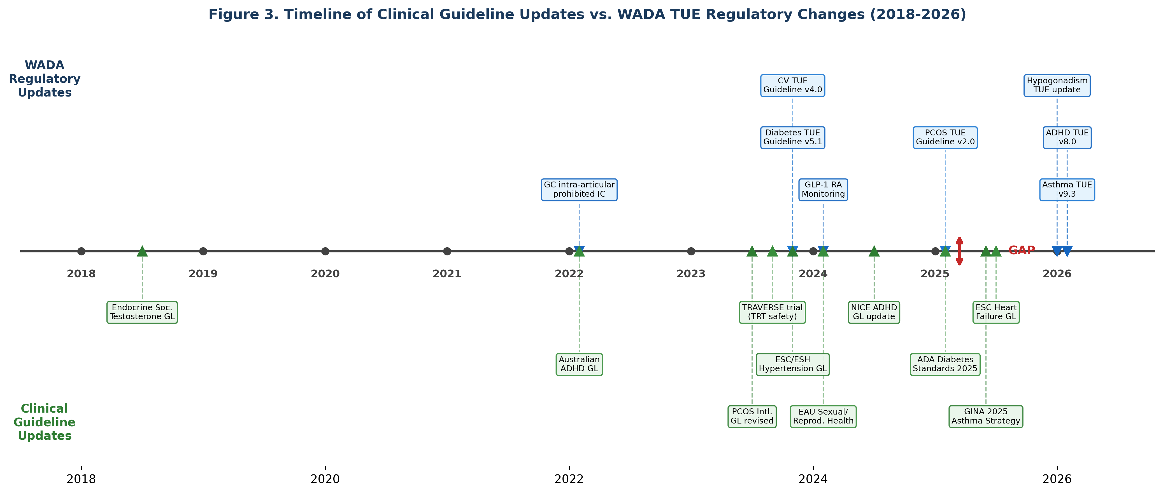
Figure 3. Timeline of clinical guideline updates versus WADA TUE regulatory changes (2018–2026).

DISCUSSION
This scoping review represents, to our knowledge, the first systematic mapping of discrepancies between WADA TUE regulations and current clinical practice guidelines across multiple disease domains. Our findings reveal that the clinical-competition gap is not isolated to a single condition but represents a systemic pattern affecting seven major disease areas with varying degrees of severity.
The implications of these gaps extend beyond regulatory inconvenience. Athletes may receive suboptimal medical care when clinicians, aware of anti-doping constraints, prescribe second-line agents to avoid TUE complexity. The TUE process itself, while necessary, imposes time, financial, and privacy burdens that may deter athletes from seeking appropriate treatment—particularly in conditions such as ADHD or PCOS where stigma compounds procedural barriers. Geographic disparities in TUE access further exacerbate these issues, as athletes in resource-limited settings face greater difficulty obtaining specialist evaluations and documentation required for TUE applications (2, 21).
The concept of "no additional performance enhancement beyond restoring normal health" is inherently challenging to operationalize. For testosterone replacement, even physiological-range restoration may influence body composition and recovery. For stimulant medications in ADHD, delineating cognitive normalization from enhancement is conceptually problematic. For beta-2 agonists, the boundary between bronchodilation and potential systemic anabolic effects remains debated (28). These ambiguities create uncertainty for both clinicians and TUE committees, potentially leading to inconsistent decisions across jurisdictions.
The findings of this review align with and extend previous work in the field. Heuberger and Cohen (10) found limited evidence for performance-enhancing effects of many prohibited substances, raising questions about the scientific basis for some prohibitions. Our analysis adds a clinical dimension to this concern by demonstrating that prohibition of specific agents creates measurable gaps in patient care. Stuart et al. (29) documented increasing TUE application volumes, which our disease-specific analysis helps to contextualize—the growing burden reflects both increased awareness and the expanding scope of conditions affected by clinical-competition gaps. The geographic disparities in TUE access reported by Vernec et al. (21) take on additional significance when considered alongside our finding that some disease areas (e.g., ADHD, hypogonadism) require particularly complex and well-documented TUE applications.
From an ethical perspective, the clinical-competition gap raises fundamental questions about the duty of care owed to athletes. The World Medical Association Declaration of Geneva establishes that patient health shall be the physician's first consideration. When anti-doping regulations effectively compel physicians to prescribe second-line treatments, a tension emerges between anti-doping compliance and the ethical obligation to provide optimal care. This tension is particularly acute for physician-athletes (such as the author of this review), who experience the dual perspective of clinician and competitor. S&C professionals, while not prescribers, share in this ethical responsibility through their role in monitoring athlete well-being and advocating for appropriate medical care.
Several limitations of this review should be acknowledged. First, as a scoping review, we mapped the breadth of evidence rather than systematically appraising the quality of individual sources. Second, our gap severity ratings, while based on structured criteria, involve subjective judgment. Third, the review focused on the regulatory text of WADA documents and clinical guidelines; actual TUE approval rates and clinical experiences may differ from what policy documents suggest. Fourth, the rapidly evolving nature of both clinical guidelines and WADA regulations means that specific details may change; the structural analysis and recommendations, however, address persistent systemic issues.
PRACTICAL APPLICATIONS
The findings of this review have direct implications for strength and conditioning professionals who work closely with athletes managing medical conditions. The following practical recommendations are offered:
• Recognize medication-related performance changes. S&C professionals should be aware that athletes transitioning between medications due to TUE constraints may experience performance fluctuations. An athlete switching from a stimulant to a non-stimulant ADHD medication may show decreased focus during training. An athlete discontinuing testosterone replacement may experience fatigue, decreased recovery capacity, and mood changes. Adjusting training load and expectations during medication transitions is essential.
• Understand the TUE timeline. TUE applications can take 21–30 days for processing. S&C professionals should encourage athletes to initiate the TUE process well before competitive seasons. For athletes with chronic conditions (asthma, ADHD, diabetes), annual TUE renewal should be incorporated into pre-season planning alongside periodization.
• Monitor athletes on permitted alternatives. When athletes use second-line medications to avoid TUE requirements (e.g., atomoxetine instead of methylphenidate for ADHD, non-diuretic antihypertensives instead of thiazides), S&C professionals should monitor for suboptimal symptom control that may affect training quality and safety. Unexplained changes in an athlete's focus, energy, respiratory function, or cardiovascular symptoms warrant referral back to the prescribing physician.
• Support asthma management beyond SABA. S&C professionals should understand that modern asthma guidelines (GINA 2025) recommend against SABA-only treatment. Athletes with asthma should be encouraged to follow their physician's prescribed controller regimen (typically ICS-formoterol MART), even though SABA alone is more "convenient" from an anti-doping perspective. Proper inhaler technique and pre-exercise medication timing should be part of the training environment.
• Facilitate communication. S&C professionals are uniquely positioned to bridge the gap between athletes, physicians, and anti-doping authorities. Maintaining awareness of the WADA Prohibited List (updated annually each January, with a summary of changes available on wada-ama.org) and encouraging athletes to use WADA's medication check tools can prevent inadvertent violations.
• Address masters athlete concerns. The growing masters athlete population faces particular challenges with age-related conditions (hypogonadism, cardiovascular disease, type 2 diabetes). S&C professionals working with masters athletes should proactively discuss medication status and TUE requirements as part of health screening and program design.
• Advocate for athlete health. When S&C professionals observe that anti-doping constraints are negatively affecting an athlete's health or well-being, they should advocate for the athlete to seek appropriate medical care and TUE application, rather than accepting suboptimal treatment as inevitable.

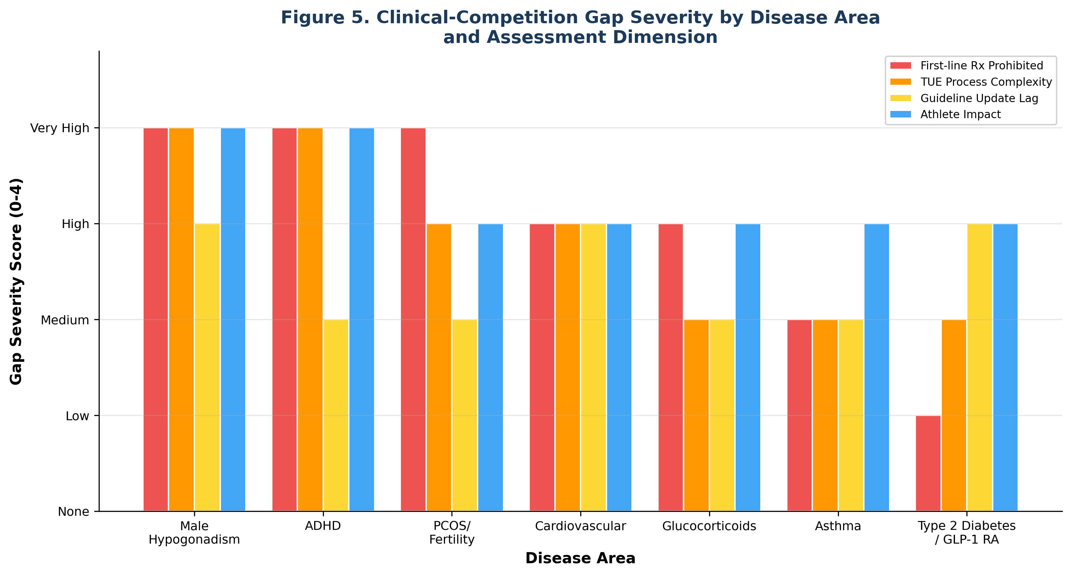
Figure 5. Clinical-competition gap severity by disease area and assessment dimension.

RECOMMENDATIONS FOR HARMONIZATION
Based on this review, we propose eight recommendations for reducing the clinical-competition gap:
1. Establish a formal mechanism to review and update WADA TUE Physician Guidelines within 12 months of major clinical guideline revisions (e.g., GINA, ADA, Endocrine Society updates).
2. Re-evaluate the organic/functional distinction for male hypogonadism TUEs in light of the Endocrine Society’s symptom-plus-biochemistry approach and the growing masters athlete population.
3. Conduct a formal impact assessment on athletes with type 2 diabetes before adding GLP-1 receptor agonists to the Prohibited List.
4. Review formoterol dose thresholds in the context of GINA 2025 MART recommendations to ensure athletes can follow guideline-directed asthma therapy without ADRV risk.
5. Re-evaluate the in-competition-only prohibition of stimulant medications for ADHD, considering the pharmacokinetics of long-acting formulations and the clinical inappropriateness of competition-day discontinuation.
6. Differentiate diuretic prohibition based on masking potential, considering a streamlined TUE process for MRAs (spironolactone/eplerenone) prescribed for heart failure.
7. Simplify and digitize TUE applications through ADAMS system improvements, multilingual support, and standardized documentation templates to reduce access disparities.
8. Integrate anti-doping pharmacology education into medical school curricula, residency training, and continuing medical education to improve prescriber awareness of the Prohibited List.
CONCLUSION
This scoping review identified systematic discrepancies between WADA TUE regulations and current clinical practice guidelines across seven major disease areas. These gaps arise from structural mismatches in update timing, diagnostic and treatment criteria, and the pace of pharmaceutical innovation. The consequences fall disproportionately on athletes, who may receive suboptimal care, face burdensome administrative processes, or risk inadvertent anti-doping violations when following evidence-based treatment recommendations.
The TUE system remains essential for balancing athlete health with sporting integrity. However, its effectiveness depends on alignment with current medical evidence. The recommendations proposed in this review offer a practical roadmap for harmonization that preserves anti-doping principles while ensuring athletes have access to the standard of medical care available to the general population. S&C professionals, as daily points of contact with athletes, play a critical role in recognizing, navigating, and advocating for solutions to the clinical-competition gap.

REFERENCES
1. World Anti-Doping Agency. World Anti-Doping Code 2021. Montreal: WADA; 2021.
2. World Anti-Doping Agency. World Anti-Doping Code International Standard for Therapeutic Use Exemptions (ISTUE). Montreal: WADA; 2021.
3. Bhasin S, Brito JP, Cunningham GR, et al. Testosterone therapy in men with hypogonadism: an Endocrine Society clinical practice guideline. J Clin Endocrinol Metab. 2018;103(5):1715–1744.
4. Global Initiative for Asthma. Global Strategy for Asthma Management and Prevention. Fontana, WI: GINA; 2025.
5. American Diabetes Association Professional Practice Committee. Standards of Care in Diabetes—2025. Diabetes Care. 2025;48(Suppl 1):S1–S352.
6. McDonagh TA, Metra M, Adamo M, et al. 2021 ESC Guidelines for the diagnosis and treatment of acute and chronic heart failure. Eur Heart J. 2021;42(36):3599–3726.
7. Mancia G, Kreutz R, Brunstrom M, et al. 2023 ESH Guidelines for the management of arterial hypertension. J Hypertens. 2023;41(12):1874–2071.
8. Allen H, Backhouse SH, Hull JH, Price OJ. Anti-doping policy, therapeutic use exemption and medication use in athletes with asthma: a narrative review. Sports Med. 2019;49(5):659–668.
9. Vernec A, Pipe A, Engel-Nitz NM. The World Anti-Doping Agency (WADA) Therapeutic Use Exemption (TUE) process. Clin J Sport Med. 2019;29(5):351–355.
10. Heuberger JAAC, Cohen AF. Review of WADA prohibited substances: limited evidence for performance-enhancing effects. Sports Med. 2019;49(4):525–539.
11. Overbye M, Wagner U. Experiences, attitudes and knowledge of elite athletes regarding anti-doping—insights from a cross-national study. Eur J Sport Sci. 2014;14(Suppl 1):S149–S160.
12. Tricco AC, Lillie E, Zarin W, et al. PRISMA extension for scoping reviews (PRISMA-ScR): checklist and explanation. Ann Intern Med. 2018;169(7):467–473.
13. Arksey H, O'Malley L. Scoping studies: towards a methodological framework. Int J Soc Res Methodol. 2005;8(1):19–32.
14. Levac D, Colquhoun H, O'Brien KK. Scoping studies: advancing the methodology. Implement Sci. 2010;5:69.
15. Munn Z, Peters MDJ, Stern C, Tufanaru C, McArthur A, Aromataris E. Systematic review or scoping review? Guidance for authors when choosing between a systematic or scoping review approach. BMC Med Res Methodol. 2018;18(1):143.
16. World Anti-Doping Agency. The 2026 Prohibited List International Standard. Montreal: WADA; 2025.
17. World Anti-Doping Agency. TUE Physician Guidelines – Asthma. Version 9.3. Montreal: WADA; 2026.
18. Australian ADHD Professionals Association. Australian Evidence-Based Clinical Practice Guideline for Attention Deficit Hyperactivity Disorder (ADHD). Melbourne: AADPA; 2022.
19. National Institute for Health and Care Excellence. Attention deficit hyperactivity disorder: diagnosis and management. NICE guideline [NG87]. London: NICE; 2024 (updated).
20. World Anti-Doping Agency. TUE Physician Guidelines – Attention Deficit Hyperactivity Disorder (ADHD). Version 8.0. Montreal: WADA; 2026.
21. Vernec A, Healy D, Banon T, Petroczi A. Prevalence of therapeutic use exemptions at the Olympic Games and Paralympic Games: an analysis of data from 2016 to 2022. Br J Sports Med. 2024;58(17):966–972.
22. World Anti-Doping Agency. 2026 Monitoring Program. Montreal: WADA; 2025.
23. European Association of Urology. EAU Guidelines on Sexual and Reproductive Health. Arnhem: EAU; 2024.
24. Lincoff AM, Bhasin S, Flevaris P, et al. Cardiovascular safety of testosterone-replacement therapy. N Engl J Med. 2023;389(2):107–117.
25. World Anti-Doping Agency. Glucocorticoids and Therapeutic Use Exemptions Guidelines. Montreal: WADA; 2025.
26. World Anti-Doping Agency. Glucocorticoids washout table—2026. Montreal: WADA; 2025.
27. Teede HJ, Tay CT, Laven JJE, et al. Recommendations from the 2023 international evidence-based guideline for the assessment and management of polycystic ovary syndrome. J Clin Endocrinol Metab. 2023;108(10):2447–2469.
28. Hostrup M, Jacobson GA, Jessen S, Lemminger AK. Beta2-adrenoceptor agonist doping of athletes: a systematic review and meta-analysis of performance-enhancing effects. Br J Sports Med. 2020;54(22):1348–1356.
29. Stuart M, Mottram DR, Erskine PJ. Therapeutic use exemptions—a review and analysis of TUE application trends across Olympic sports from 2015 to 2020. Drug Test Anal. 2022;14(5):890–898.

