yoshika: A Python Package for Pharmacokinetic-Pharmacodynamic Simulation of Local Anesthetics with Selectable Initial Compartment
Tatsuki Onishi
Data Science and AI Innovation Research Promotion Center, Shiga University
ORCID: 0000-0001-7261-9062
Corresponding author: bougtoir@gmail.com

Highlights
- First open-source PKPD simulator with selectable initial compartment for local anesthetics
- Simulates clinically distinct scenarios: successful block, failed block, IV, and depot
- Supports context-sensitive maximum dose framework for regional anesthesia safety
- Built-in parameters for lidocaine, bupivacaine, ropivacaine, and levobupivacaine
- Demonstrates route-adaptive PKPD integration feasibility for anesthesia information systems

Abstract
yoshika (Yielding Open Simulation of Hybrid Inter-disciplinary Kinetic Absorption) is an open-source Python package for pharmacokinetic-pharmacodynamic (PKPD) simulation of local anesthetics with a selectable initial compartment. Traditional three-compartment pharmacokinetic models assume intravenous administration where drug enters the central plasma compartment first. In regional anesthesia, however, drug is deposited directly into tissues: a successful peripheral nerve block deposits drug into vessel-poor tissue, while a failed block may deposit drug into vessel-rich tissue or directly into plasma. yoshika enables researchers and clinicians to simulate these clinically distinct scenarios by selecting the initial compartment of drug deposition and comparing the resulting concentration-time profiles and pharmacodynamic effects. The package includes built-in parameters for four local anesthetics (lidocaine, bupivacaine, ropivacaine, levobupivacaine), an effect-site compartment with sigmoid Emax pharmacodynamic model, and visualization utilities. By quantifying how the initial compartment determines peak plasma concentration and time-to-toxicity, yoshika supports the concept of context-sensitive maximum dose recommendations and route-adaptive PKPD simulation in anesthesia information management systems.
Keywords: pharmacokinetics; pharmacodynamics; local anesthetics; regional anesthesia; compartment model; simulation; Python; systemic toxicity

1. Introduction

1.1. The initial compartment problem in regional anesthesia
In regional anesthesia and pain medicine, local anesthetics (LAs) are injected near nerves and fascial planes rather than intravenously. The pharmacokinetic behavior of these drugs depends critically on the injection site and block success. Existing PK simulation tools (e.g., STANPUMP, Tivatrainer, Eleveld models) uniformly assume intravenous administration, where drug enters the central (plasma) compartment at time zero.¹ This assumption does not hold for regional anesthesia, where:
- A successful peripheral nerve block deposits the drug bolus into vessel-poor tissue (V3/BPT), resulting in slow absorption into plasma with a delayed, attenuated peak plasma concentration.
- A failed block with intravascular injection deposits the drug into vessel-rich tissue (V2/BRT) or directly into plasma, resulting in rapid systemic exposure and potentially toxic concentrations.
- Fascial plane blocks and depot injections involve absorption through a depot compartment with first-order absorption kinetics (kₐ).
To our knowledge, no existing open-source PKPD simulation package explicitly supports selectable initial compartment for local anesthetics.

1.2. Physicochemical basis of compartmental drug distribution
The pharmacokinetic behavior of LAs across tissue compartments is fundamentally governed by their physicochemical properties, particularly lipophilicity and ionization state. Strichartz et al. systematically measured octanol/buffer partition coefficients and pKa values for clinically used LAs, demonstrating that lipophilicity—as quantified by the partition coefficient—and temperature-dependent ionization are primary determinants of tissue distribution and nerve-blocking potency.² Their finding that the protonated species concentration in lipid remains nearly constant upon cooling, while the neutral species concentration decreases substantially, provided a physicochemical explanation for the increased blocking potency of LAs at lower temperatures.
Building on these fundamental properties, Kavčič et al. applied quantum chemical calculations to model the transfer energetics of seven LAs from extracellular fluid across the biological membrane to the axoplasm, demonstrating that LA transfer between compartments relies on pH differences and affinities toward lipophilic compartments.³ Their computational analysis showed that LAs are stored in Schwann cell membranes, adipose tissue, and other lipophilic compartments, from which they are slowly released—a process directly relevant to the vessel-poor tissue (BPT) compartment in pharmacokinetic models. Furthermore, local acidosis reduces LA storage in lipophilic compartments, decreasing the duration of action, while more lipophilic LAs (e.g., bupivacaine) exhibit greater storage capacity and longer duration.
These physicochemical principles provide the theoretical foundation for the compartmental modeling approach implemented in yoshika: the initial compartment of drug deposition determines the subsequent absorption kinetics because tissue-specific lipophilicity and pH govern the rate of drug transfer between compartments.

1.3. Clinical significance: systemic toxicity risk and context-sensitive dosing
The clinical significance of selectable initial compartment modeling lies in its direct implications for local anesthetic systemic toxicity (LAST) risk assessment. Traditional maximum recommended doses for LAs (e.g., bupivacaine 2 mg/kg, lidocaine 4.5 mg/kg without epinephrine) are derived from intravenous pharmacokinetic studies, where the entire dose enters the central plasma compartment instantaneously.^{4,5} This assumption produces the highest possible peak plasma concentration (Cmax) for a given dose.
However, in regional anesthesia, the initial compartment of drug deposition fundamentally alters the concentration-time profile:
- Successful block (BPT start): Drug deposited in vessel-poor tissue is absorbed slowly into plasma, producing a delayed and attenuated Cmax.
- Failed block (BRT start): Drug deposited near vessel-rich tissue is absorbed rapidly, producing an earlier and higher Cmax.
- Intravascular injection (Plasma start): Equivalent to IV bolus with immediate high Cmax and maximum toxicity risk.
We propose the concept of context-sensitive maximum dose for LAs, analogous to the context-sensitive half-time that transformed understanding of intravenous drug offset.⁶ Under this framework, the effective maximum safe dose is not a single fixed value but varies with the clinical scenario (Table 1).
Scenario | Initial Compartment | Expected Cmax | Dose Implication
Successful block | BPT (V3) | Low, delayed | Higher dose may be safe
Partial block | Mixed (BPT + BRT) | Intermediate | Standard limit applies
Failed block | BRT (V2) | Moderate-high, early | Lower dose may be needed
Intravascular injection | Plasma (V1) | Very high, immediate | Traditional IV limits apply
Epidural | Depot (multi-pathway) | Intermediate, delayed | Depot model approximation
Table 1. Proposed context-sensitive maximum dose framework.
This framework provides a pharmacokinetic rationale for the empirical observation that LAST is rare despite frequent exceeding of traditional mg/kg dose limits in regional anesthesia practice.⁴

1.4. Existing anesthesia simulators and positioning of yoshika
Several open-source anesthesia simulation tools exist, but none address the specific problem of initial compartment selection for local anesthetics in regional anesthesia.
The Python Anesthesia Simulator (PAS)¹⁰ provides a general framework for simulating the effects of propofol, remifentanil, and norepinephrine during total intravenous anesthesia (TIVA).
The Anesthesia Response Simulator (AReS)¹¹ extends TIVA simulation to propofol, remifentanil, norepinephrine, and rocuronium, with target-controlled infusion modules and surgical stimulus profiles.
The AMICAS simulator¹² provides a MATLAB/Simulink-based patient simulator for multi-drug dosing control during general anesthesia.
All three simulators focus exclusively on intravenous general anesthetics. yoshika fills this gap by providing a simulation tool specifically designed for local anesthetics with selectable initial compartment.

1.5. Aim
The aim of this study is to present yoshika, an open-source Python package for PKPD simulation of local anesthetics with selectable initial compartment, and to demonstrate how the choice of initial compartment affects predicted plasma concentration profiles and toxicity risk across clinically relevant scenarios.

2. Methods

2.1. Software architecture
yoshika is structured as a modular Python package with the following components:
- compartments: Compartment definitions (PLASMA, BRT, BPT, DEPOT) and initial condition logic.
- drugs: Drug parameter database with four built-in local anesthetics and custom drug support.
- model: Three-compartment PK ODE model solved with SciPy's solve_ivp (RK45 method).
- pd: Pharmacodynamic models (Emax, sigmoid Emax, effect-site equilibration).
- simulator: High-level API for single simulations and multi-scenario comparison.
- plotting: Matplotlib-based visualization utilities.
- utils: AUC calculation, half-life estimation, and unit conversion.

2.2. Pharmacokinetic model
yoshika implements a standard three-compartment mammillary PK model with an optional depot compartment. The ODEs are solved numerically using scipy.integrate.solve_ivp with the RK45 method.⁹
Initial Compartment | A_depot(0) | A1(0) | A2(0) | A3(0)
Plasma (IV) | 0 | Dose | 0 | 0
BRT (failed block) | 0 | 0 | Dose | 0
BPT (successful block) | 0 | 0 | 0 | Dose
Depot (fascial plane) | Dose | 0 | 0 | 0
Table 2. Initial conditions for each selectable compartment.

2.3. Pharmacodynamic model
yoshika includes an effect-site compartment linked to the central compartment via kₑ₀. The drug effect is computed using a sigmoid Emax model.

2.4. Drug parameter database
The package includes pharmacokinetic parameters for four commonly used local anesthetics: lidocaine, bupivacaine, ropivacaine, and levobupivacaine.^{7,8}

2.5. Epidural administration approximation
Epidural administration can be approximated using the Depot compartment in yoshika.⁸

3. Results

3.1. Comparison of plasma concentration profiles by initial compartment
Figure 1 shows the three-compartment model with selectable initial compartment. To demonstrate the core functionality, bupivacaine 150 mg administered to a 70 kg patient was simulated across three initial compartment scenarios.
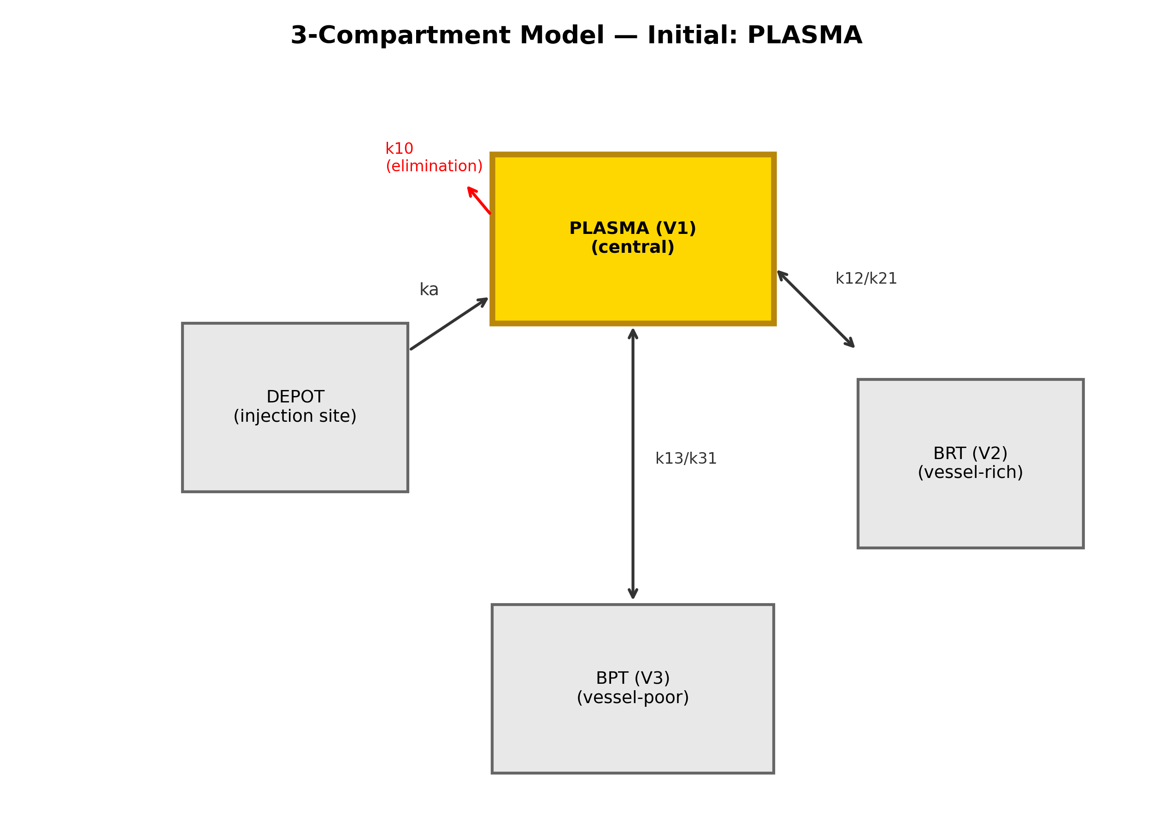
Figure 1. Three-compartment model with selectable initial compartment (plasma highlighted).
Figure 2 demonstrates the dramatic differences in plasma concentration-time profiles when bupivacaine 150 mg is administered to the same patient but with different initial compartments.
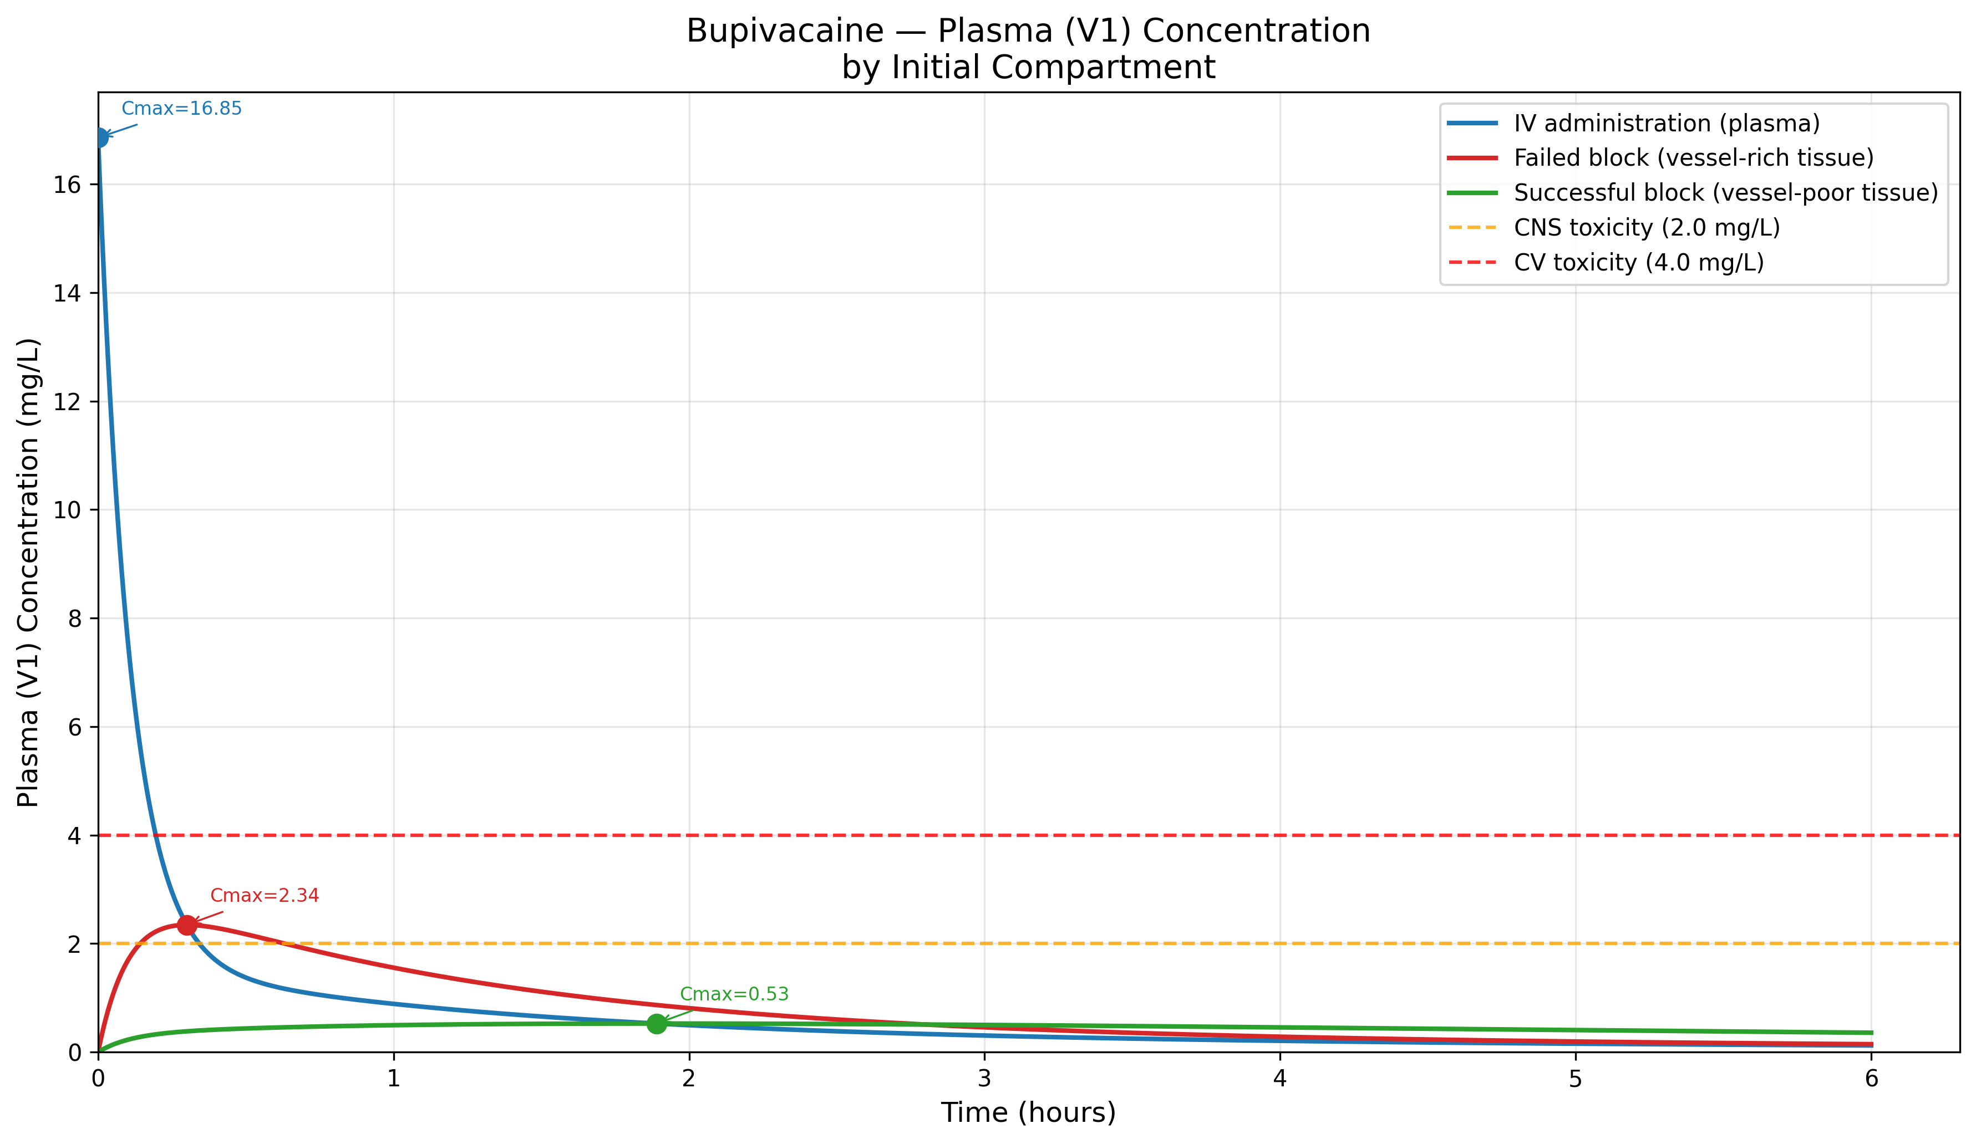
Figure 2. Bupivacaine 150 mg — Plasma concentration by initial compartment with toxicity thresholds.

3.2. Cross-drug comparison
Figure 3 extends the comparison to all four local anesthetics.
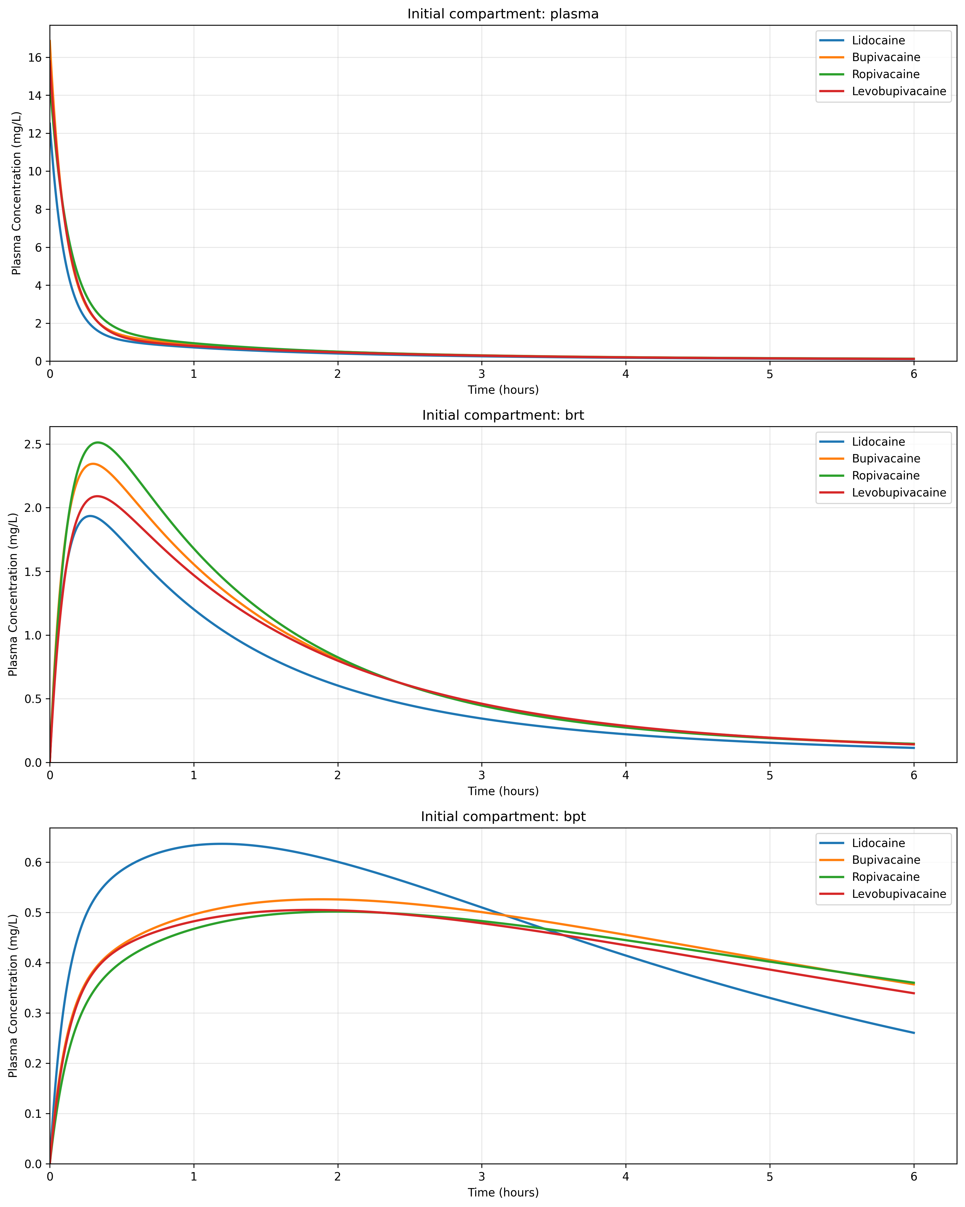
Figure 3. Plasma concentration comparison for all four local anesthetics by initial compartment.

3.3. Pharmacodynamic response
Figure 4 shows the effect-site response. Figure 5 shows the full compartment profile for BPT. Figure 6 provides a PK/PD summary.
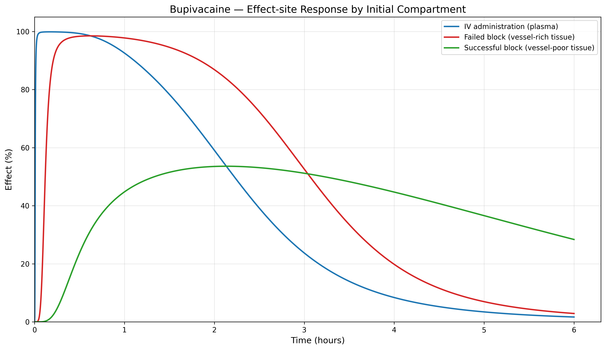
Figure 4. Bupivacaine — Effect-site response by initial compartment.
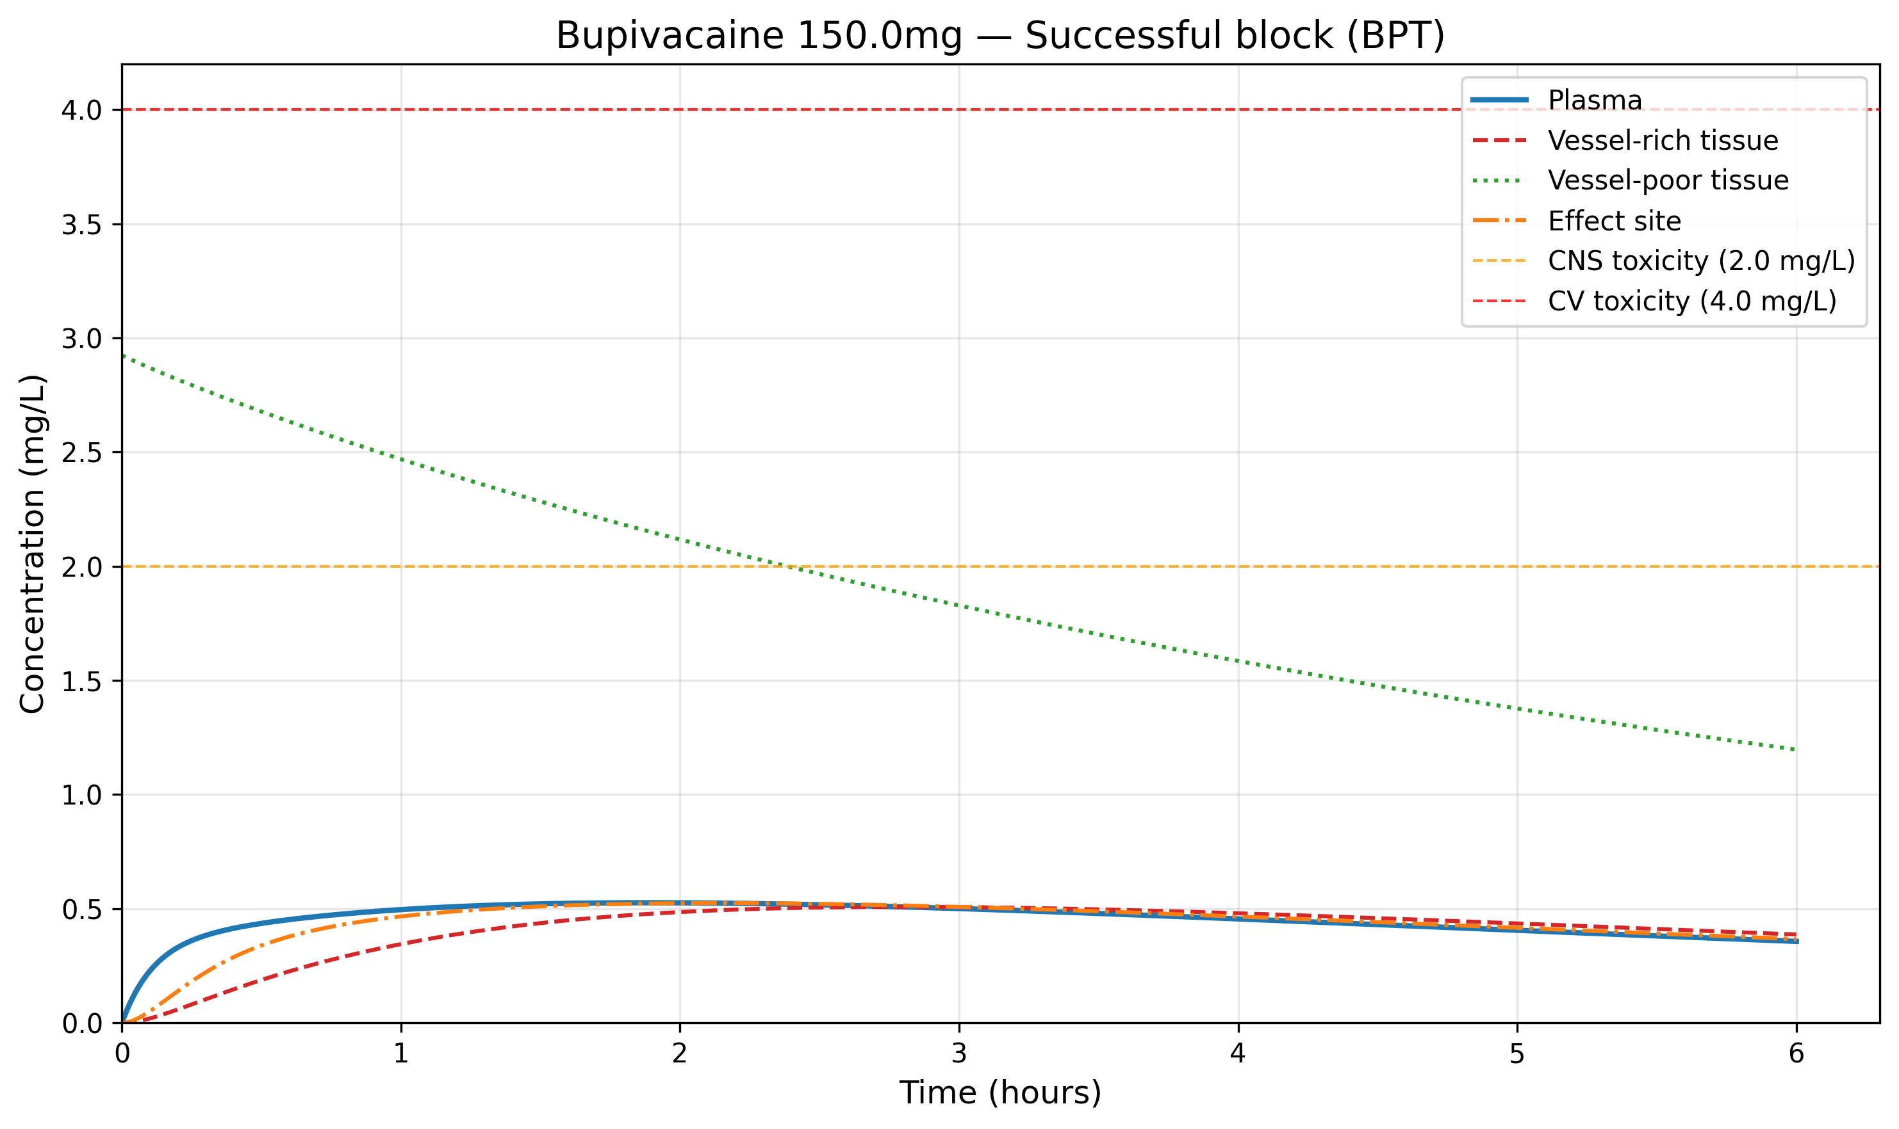
Figure 5. Bupivacaine 150 mg from BPT — Full compartment concentration profile.
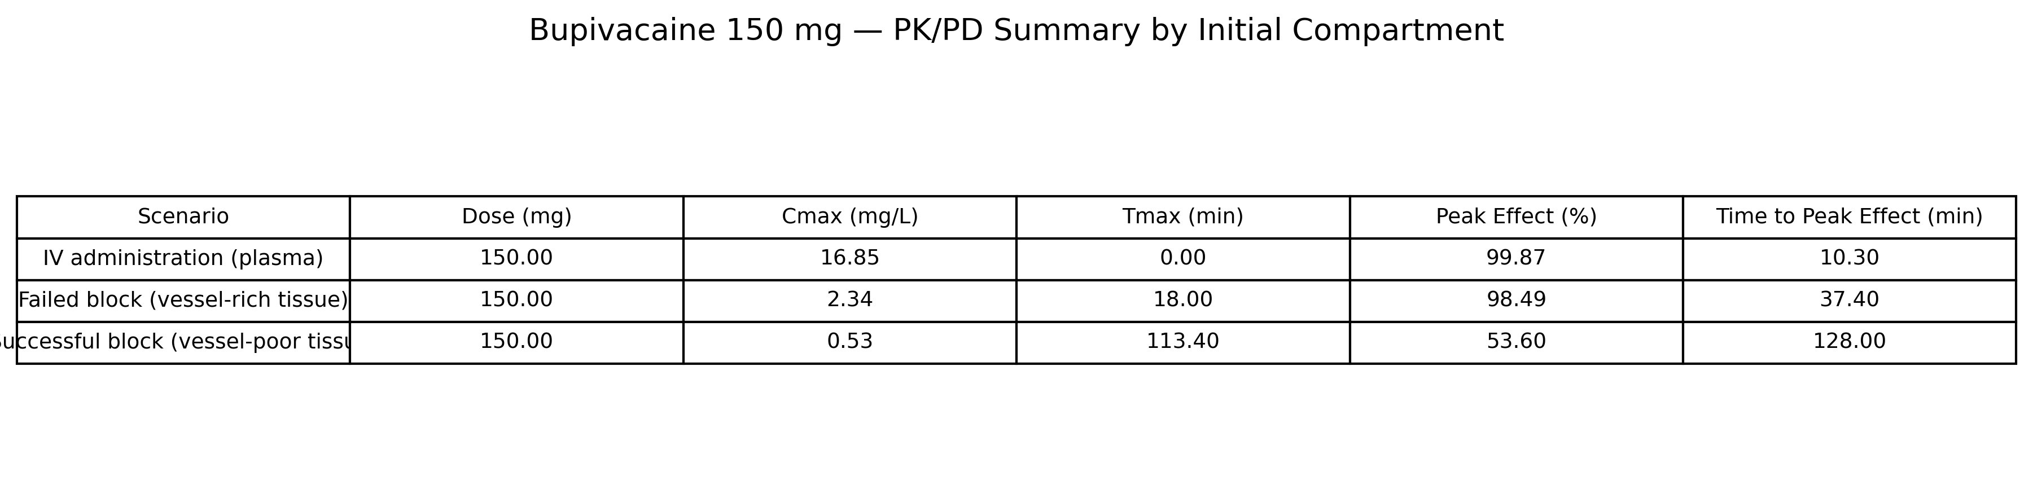
Figure 6. Bupivacaine 150 mg — PK/PD summary by initial compartment.

4. Discussion

4.1. Clinical implications
yoshika addresses a gap in the pharmacokinetic simulation landscape by providing the first open-source tool that allows users to select the initial compartment of drug deposition for local anesthetics.
In clinical pharmacology, yoshika provides a computational basis for reconsidering maximum recommended doses of local anesthetics.
In anesthesia information management systems (AIMS), yoshika demonstrates that route-adaptive PKPD simulation is computationally feasible.¹

4.2. Comparison with existing anesthesia simulators
Feature | PAS | AReS | AMICAS | yoshika
Drug class | General | General | General | Local anesthetics
Administration route | IV only | IV only | IV only | Selectable (IV, BRT, BPT, Depot)
Language | Python | Python/MATLAB | MATLAB/Simulink | Python
PD model | BIS, MAP, CO | BIS, MAP, CO, NMB | BIS, MAP, CO | Sigmoid Emax
Target application | TIVA drug control | Automated anesthesia | Multi-drug dosing | Regional anesthesia PKPD
License | Open source | MIT | Open source | MIT
Table 3. Comparison of open-source anesthesia simulators.

4.3. Limitations
Several limitations should be acknowledged.
First, the pharmacokinetic parameters used in yoshika are derived from intravenous pharmacokinetic studies.⁷ This assumption has not been validated with clinical data from regional anesthesia.
Second, the three-compartment model does not capture the full complexity of LA tissue pharmacokinetics, including pH-dependent ionization equilibria^{2,3} and site-specific absorption pathways.
Third, spinal (subarachnoid/intrathecal) administration is not modeled in the current version.
Fourth, the current version does not implement population pharmacokinetic variability or covariate models.

4.4. Future directions
Future development directions include systematic measurement of plasma concentration profiles after various regional block types, prospective validation of the context-sensitive maximum dose framework, and integration of population pharmacokinetic models.

5. Conclusions
yoshika is an open-source Python package that fills a specific gap in pharmacokinetic simulation tools: the ability to select the initial compartment of drug deposition for local anesthetics in regional anesthesia. The software is freely available under the MIT license at https://github.com/bougtoir/yoshika-pkpd. The manuscript source and reproduction code are available at https://github.com/bougtoir/yoshika-pkpd/tree/main/v1.

Software availability
The source code for yoshika is publicly available at https://github.com/bougtoir/yoshika-pkpd under the MIT license. The package requires Python >= 3.9 with NumPy, SciPy, Matplotlib, and Pandas as dependencies. Installation is available via pip install yoshika or from source. The manuscript source, figures, and reproduction scripts are available at https://github.com/bougtoir/yoshika-pkpd/tree/main/v1.

Declaration of competing interest
The authors declare that they have no known competing financial interests or personal relationships that could have appeared to influence the work reported in this paper.

Data availability
No data was used for the research described in the article. The software source code is publicly available at https://github.com/bougtoir/yoshika-pkpd.

CRediT authorship contribution statement
Tatsuki Onishi: Conceptualization, Methodology, Software, Validation, Writing – Original Draft, Writing – Review & Editing.

Acknowledgements
None.

References
[1] Eleveld DJ, Colin P, Absalom AR, Struys MMRF. Pharmacokinetic-pharmacodynamic model for propofol for broad application in anaesthesia and sedation. Br J Anaesth. 2018;120(5):942-959.
[2] Strichartz GR, Sanchez V, Arthur GR, Chafetz R, Martiny D. Fundamental properties of local anesthetics. II. Measured octanol buffer partition coefficients and pKa values of clinically used drugs. Anesth Analg. 1990;71(2):158-170.
[3] Kavčič H, Umek N, Vintar N, Mavri J. Local anesthetics transfer relies on pH differences and affinities toward lipophilic compartments. J Phys Org Chem. 2021;34(12):e4275.
[4] Rosenberg PH, Veering BT, Urmey WF. Maximum recommended doses of local anesthetics: a multifactorial concept. Reg Anesth Pain Med. 2004;29(6):564-575.
[5] De Cassai A, Pasin L, Boscolo A, et al. Local anaesthetic toxicity: moving beyond maximum recommended doses. Br J Anaesth. 2025.
[6] Hughes MA, Glass PSA, Jacobs JR. Context-sensitive half-time in multicompartment pharmacokinetic models for intravenous anesthetic drugs. Anesthesiology. 1992;76(3):334-341.
[7] Tucker GT, Mather LE. Clinical pharmacokinetics of local anaesthetics. Clin Pharmacokinet. 1979;4(4):241-278.
[8] Burm AGL. Clinical pharmacokinetics of epidural and spinal anaesthesia. Clin Pharmacokinet. 1989;16(5):283-311.
[9] Virtanen P, Gommers R, Oliphant TE, et al. SciPy 1.0: fundamental algorithms for scientific computing in Python. Nat Methods. 2020;17(3):261-272.
[10] Aubouin-Pairault B, Fiacchini M, Dang T. PAS: a Python Anesthesia Simulator for drug control. J Open Source Softw. 2023;8(88):5480.
[11] Hosseinirad S, Merlo M, Trovo F, Tognoli E, Metelli AM, Dumont GA. AReS: a patient simulator to facilitate testing of automated anesthesia. Comput Methods Programs Biomed. 2025;108901.
[12] Ionescu CM, Neckebroek M, Ghita M, Copot D. An open source patient simulator for design and evaluation of computer based multiple drug dosing control for anesthetic and hemodynamic variables. IEEE Access. 2021;9:8680-8694.

