yoshika: A Python Package for Pharmacokinetic-Pharmacodynamic Simulation of Local Anesthetics with Selectable Initial Compartment
Onishi Tatsuki
Data Science and AI Innovation Research Promotion Center, Shiga university

Highlights
- Open-source PKPD simulator with selectable initial compartment
- Models fascial plane block, nerve block, and IV routes independently
- Traditional IV-forced models overestimate Cmax by 4-5x for non-IV routes
- Shared rate constants; only initial conditions differ across scenarios
- Supports context-sensitive maximum dose assessment for local anesthetics

Abstract
yoshika (Yielding Open Simulation of Hybrid Inter-disciplinary Kinetic Absorption) is an open-source Python package for pharmacokinetic-pharmacodynamic (PKPD) simulation of local anesthetics with a selectable initial compartment. Traditional three-compartment pharmacokinetic models assume intravenous administration where drug enters the central plasma compartment first. In regional anesthesia, however, drug is deposited directly into tissues: a successful peripheral nerve block deposits drug into vessel-poor tissue, while a failed block may deposit drug into vessel-rich tissue or directly into plasma. yoshika enables researchers and clinicians to simulate these clinically distinct scenarios by selecting the initial compartment of drug deposition and comparing the resulting concentration-time profiles and pharmacodynamic effects. The package includes built-in parameters for four local anesthetics (lidocaine, bupivacaine, ropivacaine, levobupivacaine), an effect-site compartment with sigmoid Emax pharmacodynamic model, and visualization utilities. By quantifying how the initial compartment determines peak plasma concentration and time-to-toxicity, yoshika supports the concept of context-sensitive maximum dose recommendations and route-adaptive PKPD simulation in anesthesia information management systems.
Keywords: pharmacokinetics; pharmacodynamics; local anesthetics; regional anesthesia; compartment model; simulation; selectable initial compartment; systemic toxicity

1. Introduction

1.1 The initial compartment problem in regional anesthesia
In regional anesthesia and pain medicine, local anesthetics are injected near nerves and fascial planes rather than intravenously. The pharmacokinetic behavior of these drugs depends critically on the injection site and block success. Existing PK simulation tools (e.g., STANPUMP, Tivatrainer, Eleveld models) uniformly assume intravenous administration, where drug enters the central (plasma) compartment at time zero [1]. This assumption does not hold for regional anesthesia, where:
- A successful peripheral nerve block deposits the drug bolus into vessel-poor tissue (V3/BPT), resulting in slow absorption into plasma with a delayed, attenuated peak plasma concentration.
- A failed block with intravascular injection deposits the drug into vessel-rich tissue (V2/BRT) or directly into plasma, resulting in rapid systemic exposure and potentially toxic concentrations.
- Fascial plane blocks and depot injections involve absorption through a depot compartment with first-order absorption kinetics (kₐ$k_{a}$).
To our knowledge, no existing open-source PKPD simulation package explicitly supports selectable initial compartment for local anesthetics. The Python Anesthesia Simulator (PAS) [2] provides a general framework for anesthetic PK simulation but does not address the specific problem of initial compartment selection for regional anesthesia applications.

1.2 Clinical significance: initial compartment as a determinant of systemic toxicity risk
The clinical significance of selectable initial compartment modeling lies in its direct implications for local anesthetic systemic toxicity (LAST) risk assessment. Traditional maximum recommended doses for local anesthetics (e.g., bupivacaine 2 mg/kg, lidocaine 4.5 mg/kg without epinephrine) are derived from intravenous pharmacokinetic studies, where the entire dose enters the central plasma compartment instantaneously [3,4]. This assumption produces the highest possible peak plasma concentration (Cmax) for a given dose.
However, in regional anesthesia, the initial compartment of drug deposition fundamentally alters the concentration-time profile:
- Successful block (BPT start): Drug deposited in vessel-poor tissue is absorbed slowly into plasma, producing a delayed and attenuated Cmax. The block is effective, the duration is long, and systemic exposure is low.
- Failed block (BRT start): Drug deposited near vessel-rich tissue is absorbed rapidly, producing an earlier and higher Cmax. The block effect is short, and systemic exposure approaches IV-like kinetics.
- Intravascular injection (Plasma start): Equivalent to IV bolus with immediate high Cmax and maximum toxicity risk.
Importantly, “successful/vessel-poor/long-duration/slow-removal” and “failed/vessel-rich/short-duration/rapid-removal” are pharmacokinetically synonymous descriptions without positive or negative connotations—they represent neutral descriptions of drug disposition based on the anatomical site of deposition.

1.3 Context-sensitive maximum dose
We propose that yoshika enables exploration of a context-sensitive maximum dose concept for local anesthetics, analogous to the context-sensitive half-time that transformed understanding of intravenous drug offset [5]. Under this framework, the effective maximum safe dose is not a single fixed value but varies with the clinical scenario (Table 1).
Table 1. Proposed context-sensitive maximum dose framework.
Scenario | Initial Compartment | Expected Cmax | Dose Implication
Successful block | BPT (V3) | Low, delayed | Higher dose may be safe
Partial block | Mixed (BPT + BRT) | Intermediate | Standard limit applies
Failed block | BRT (V2) | Moderate-high, early | Lower dose may be needed
Intravascular injection | Plasma (V1) | Very high, immediate | Traditional IV limits apply
Epidural | Depot (multi-pathway) | Intermediate, delayed | Depot model approximation
This framework provides a pharmacokinetic rationale for the empirical observation that LAST is rare despite frequent exceeding of traditional mg/kg dose limits in regional anesthesia practice [3]. When the block is successful, the drug is sequestered in vessel-poor tissue with slow systemic release—precisely the scenario where doses above traditional limits are routinely administered safely.

1.4 Implications for anesthesia information management systems
Modern anesthesia information management systems (AIMS) increasingly incorporate real-time PKPD displays for intravenous agents (e.g., propofol, remifentanil) using standard three-compartment models that assume central compartment input [1]. When the same AIMS tracks local anesthetic doses administered via regional techniques, the underlying PK model remains unchanged, producing predictions based on IV kinetics that may significantly overestimate peak plasma concentrations after successful regional blocks.
yoshika demonstrates that route-adaptive PKPD simulation—adjusting the initial compartment based on the documented administration route—is computationally straightforward and can be integrated into existing AIMS infrastructure. The mathematical framework (depot-augmented compartment models with first-order absorption) is well-established and computationally inexpensive. The principal barrier to implementation is not technical but conceptual: the recognition that a single pharmacokinetic model cannot adequately describe drug behavior across fundamentally different routes of administration.

1.5 Safety implications: why the initial compartment matters for fascial plane blocks
Traditional PK simulators (e.g., STANPUMP, Tivatrainer, or similar model-based infusion tools) are constrained to model drug entry via the central plasma compartment (V1), equivalent to intravenous bolus injection. For local anesthetic infiltration and fascial plane blocks, this assumption is fundamentally incorrect: drug is deposited into tissue (fascial planes, subcutaneous tissue), not into the bloodstream. The distinguishing feature of yoshika is the ability to select the initial compartment that matches the actual route of administration.
Importantly, the inter-compartmental rate constants (k₁₀$k_{12}$, k₁₂$k_{21}$, k₂₁$k_{13}$, k₁₃$k_{31}$, k₃₁$k_{10}$) are shared across all simulation scenarios. The only difference between the traditional and yoshika models is which compartment receives the drug att = 0$t=0$. This single change in initial conditions produces dramatically different predictions (Cmax, Tmax):
- $C_{max}$Cmax overestimation: The traditional model (IV-forced) predicts Cmax$C_{max}$ of 11–17 mg/L for standard doses, far exceeding toxicity thresholds. These concentrations never actually occur after fascial plane blocks or infiltration. yoshika’s depot model predicts Cmax$C_{max}$ of 2–4 mg/L—the pharmacokinetically appropriate prediction for first-order absorption from tissue.
- $T_{max}$Tmax misidentification: The traditional model predicts Tmax = 0$T_{max}=0$ (instantaneous peak) for all drugs. yoshika’s depot model predicts Tmax$T_{max}$ of 12–16 minutes, and the BPT model (successful nerve block) predicts Tmax$T_{max}$ of 72–119 minutes. These delayed peaks represent the actual monitoring window during which plasma concentration is rising.
For fascial plane blocks used in ambulatory surgery, the clinical consequence is twofold. First, the traditional model generates false alarms by predicting supratoxic Cmax$C_{max}$ values that would never be observed clinically after non-IV administration. Second, the traditional model provides no information about when the actual peak will occur, because it assumes the peak has already passed at t = 0$t=0$. yoshika enables clinicians to identify the real monitoring window based on the actual route of administration (Figs. 7–11).
When Cmax$C_{max}$ from the depot model approaches toxicity thresholds—as seen with ropivacaine 150 mg ($C_{max}$Cmax = 3.39 mg/L vs central nervous system (CNS) threshold 2.2 mg/L) and bupivacaine 150 mg ($C_{max}$Cmax = 3.10 mg/L vs CNS threshold 2.0 mg/L)—the delayed $T_{max}$Tmax (14–16 min) becomes clinically relevant. These patients require monitoring through the actual peak, not merely through the first minutes after injection as the traditional model would suggest.
The ability to model the correct initial compartment is therefore not merely a modelling refinement but a prerequisite for accurate safety assessment of regional anesthesia techniques where drug does not enter plasma directly [6,7,8].

2. Software architecture and design

2.1 Package structure
yoshika is structured as a modular Python package with the following components:
- compartments: Compartment definitions (PLASMA, BRT, BPT, DEPOT) and initial condition logic.
- drugs: Drug parameter database with four built-in local anesthetics (lidocaine, bupivacaine, ropivacaine, levobupivacaine) and custom drug support.
- model: Three-compartment PK ODE model solved with SciPy’s solve_ivp (RK45 method) [9].
- pd: Pharmacodynamic models (Emax, sigmoid Emax, effect-site equilibration).
- simulator: High-level API for single simulations and multi-scenario comparison.
- plotting: Matplotlib-based visualization utilities for concentration-time curves, effect profiles, and comparison plots.
- utils: Utility functions for AUC calculation, half-life estimation, and unit conversion.
The package follows a clean separation of concerns: the PK model (ODE system) is independent of the PD model, and both are independent of the drug parameter database. This design allows users to substitute custom drug parameters, modify the PD model, or extend the compartment structure without affecting other components.

2.2 Software functionalities

2.2.1 Pharmacokinetic model
yoshika implements a standard three-compartment mammillary PK model with an optional depot compartment. The system of ordinary differential equations (ODEs) is:
$$\frac{dA_{depot}}{dt}=-k_{a}⋅A_{depot}$$
$$\frac{dA_{1}}{dt}=k_{a}⋅A_{depot}-(k_{10}+k_{12}+k_{13})⋅A_{1}+k_{21}⋅A_{2}+k_{31}⋅A_{3}$$
$$\frac{dA_{2}}{dt}=k_{12}⋅A_{1}-k_{21}⋅A_{2}$$
$$\frac{dA_{3}}{dt}=k_{13}⋅A_{1}-k_{31}⋅A_{3}$$
where A₁$A_{1}$, A₂$A_{2}$, A₃$A_{3}$ are drug amounts in plasma (V1), vessel-rich tissue (V2/BRT), and vessel-poor tissue (V3/BPT), respectively; $A_{depot}$A₄ is the amount in the depot compartment; $k_{10}$k₁₀ is the elimination rate constant; $k_{12}$k₁₂, $k_{21}$k₂₁, $k_{13}$k₁₃, $k_{31}$k₃₁ are intercompartmental transfer rate constants; and $k_{a}$kₐ is the absorption rate constant from the depot.
The initial conditions are set according to the selected compartment (Table 2):
Table 2. Initial conditions for each selectable compartment.
Initial Compartment | $$A_{depot}(0)$$ | $$A_{1}(0)$$ | $$A_{2}(0)$$ | $$A_{3}(0)$$
Plasma (IV) | 0 | Dose | 0 | 0
BRT (failed block) | 0 | 0 | Dose | 0
BPT (successful block) | 0 | 0 | 0 | Dose
Depot (fascial plane) | Dose | 0 | 0 | 0
The ODEs are solved numerically using scipy.integrate.solve_ivp with the RK45 method (explicit Runge-Kutta of order 5(4), Dormand-Prince) [9]. Concentrations are computed as C(t) = A(t)/V$C_{i}=A_{i}/V_{i}$ at each time point.

2.2.2 Pharmacodynamic model
yoshika includes an effect-site compartment linked to the central compartment via a first-order rate constant $k_{e0}$:
$$\frac{dC_{e}}{dt}=k_{e0}⋅(C_{p}-C_{e})$$
where $C_{e}$ is the effect-site concentration and $C_{p}$ is the plasma concentration. The drug effect is computed using a sigmoid Emax model:
$$E=E_{max}⋅\frac{C_{e}^{γ}}{EC_{50}^{γ}+C_{e}^{γ}}$$

2.2.3 Drug database
The package includes pharmacokinetic parameters for four commonly used local anesthetics: lidocaine, bupivacaine, ropivacaine, and levobupivacaine [10,11]. Parameters include compartment volumes ($V_{1}$V₁, $V_{2}$V₂, $V_{3}$V₃), clearances ($CL$CL₁, $Q_{2}$CL₂, $Q_{3}$CL₃), effect-site equilibration rate ($k_{e0}$kₑ₀), $EC_{50}$EC₅₀, Hill coefficient ($γ$γ), protein binding fraction, and toxicity thresholds for CNS and cardiovascular systems. Users can also define custom drug parameters via the DrugLibrary.add_custom() API.

2.2.4 Epidural administration approximation
Epidural administration can be approximated using the Depot compartment in yoshika. In epidural anesthesia, the drug is injected into the epidural space and is absorbed into the systemic circulation primarily through epidural venous plexus uptake, with concurrent diffusion across the dura into the cerebrospinal fluid (CSF). This absorption process follows approximately first-order kinetics, which is modeled by the depot compartment’s absorption rate constant ($k_{a}$). While the actual epidural pharmacokinetics involves parallel pathways (vascular absorption, dural penetration, and epidural fat sequestration), the depot model provides a reasonable first-order approximation of the systemic absorption phase [11].
Users can adjust the kₐ$k_{a}$ parameter to match published epidural absorption rates for specific local anesthetics. For example, epidural lidocaine has a reported systemic absorption half-life of approximately 10–20 minutes, corresponding to kₐ$k_{a}$ values of 0.035–0.069 min⁻¹$​^{-1}$.

2.2.5 Limitations: spinal (intrathecal) administration
Spinal (subarachnoid/intrathecal) administration is not modeled in the current version of yoshika. Intrathecal injection delivers drug directly into the cerebrospinal fluid (CSF), involving unique pharmacokinetics (CSF spread, direct spinal cord uptake, and subsequent systemic absorption) that differ fundamentally from the peripheral compartment model. Additionally, spinal anesthesia is predominantly a single-shot technique with relatively small doses (e.g., bupivacaine 10–15 mg), making systemic toxicity modeling less clinically relevant compared to larger-dose peripheral nerve blocks and epidural techniques.

3. Results and illustrative examples
The following example demonstrates the core functionality of yoshika: comparing plasma concentration profiles of bupivacaine 150 mg administered to a 70 kg patient across three initial compartment scenarios.
from yoshika import Simulator, Drug, Compartment
from yoshika.plotting import plot_comparison
from yoshika.drugs import DrugLibrary
sim = Simulator(drug=Drug.BUPIVACAINE, dose_mg=150, weight_kg=70)
results = sim.compare() # Plasma, BRT, BPT scenarios
table = Simulator.summary_table(results)
print(table)
params = DrugLibrary.get(Drug.BUPIVACAINE)
fig, ax = plot_comparison(results, drug_params=params)
fig.savefig("comparison.png", dpi=300)
Fig. 1 shows the three-compartment model with selectable initial compartment. Fig. 2 demonstrates the dramatic differences in plasma concentration-time profiles when bupivacaine 150 mg is administered to the same patient but with different initial compartments. The plasma-start scenario (equivalent to IV bolus) produces the highest and earliest Cmax, exceeding the CNS toxicity threshold. The BRT-start scenario (failed block) shows intermediate kinetics, while the BPT-start scenario (successful block) produces the lowest and most delayed Cmax, remaining below toxicity thresholds throughout.
Fig. 3 extends this comparison to all four local anesthetics. Fig. 4 shows the effect-site concentration and pharmacodynamic response for bupivacaine across initial compartments. Fig. 5 shows the full compartment concentration profile for bupivacaine from BPT. Fig. 6 provides a PKPD summary table comparing key parameters across initial compartments.
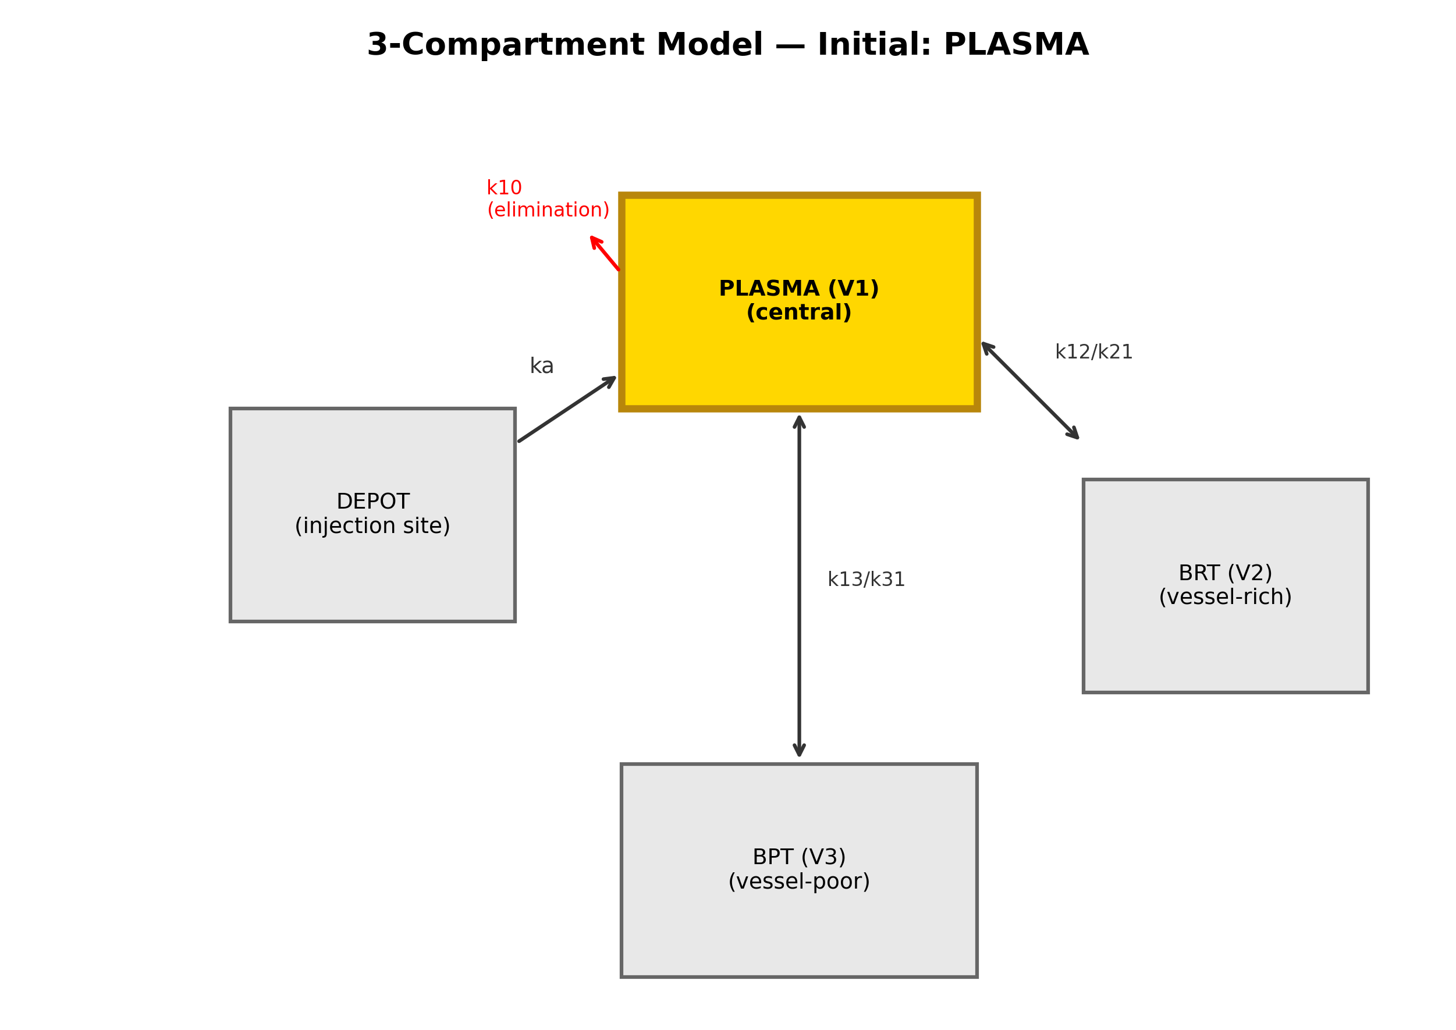
Fig. 1. Three-compartment model with selectable initial compartment (plasma highlighted).
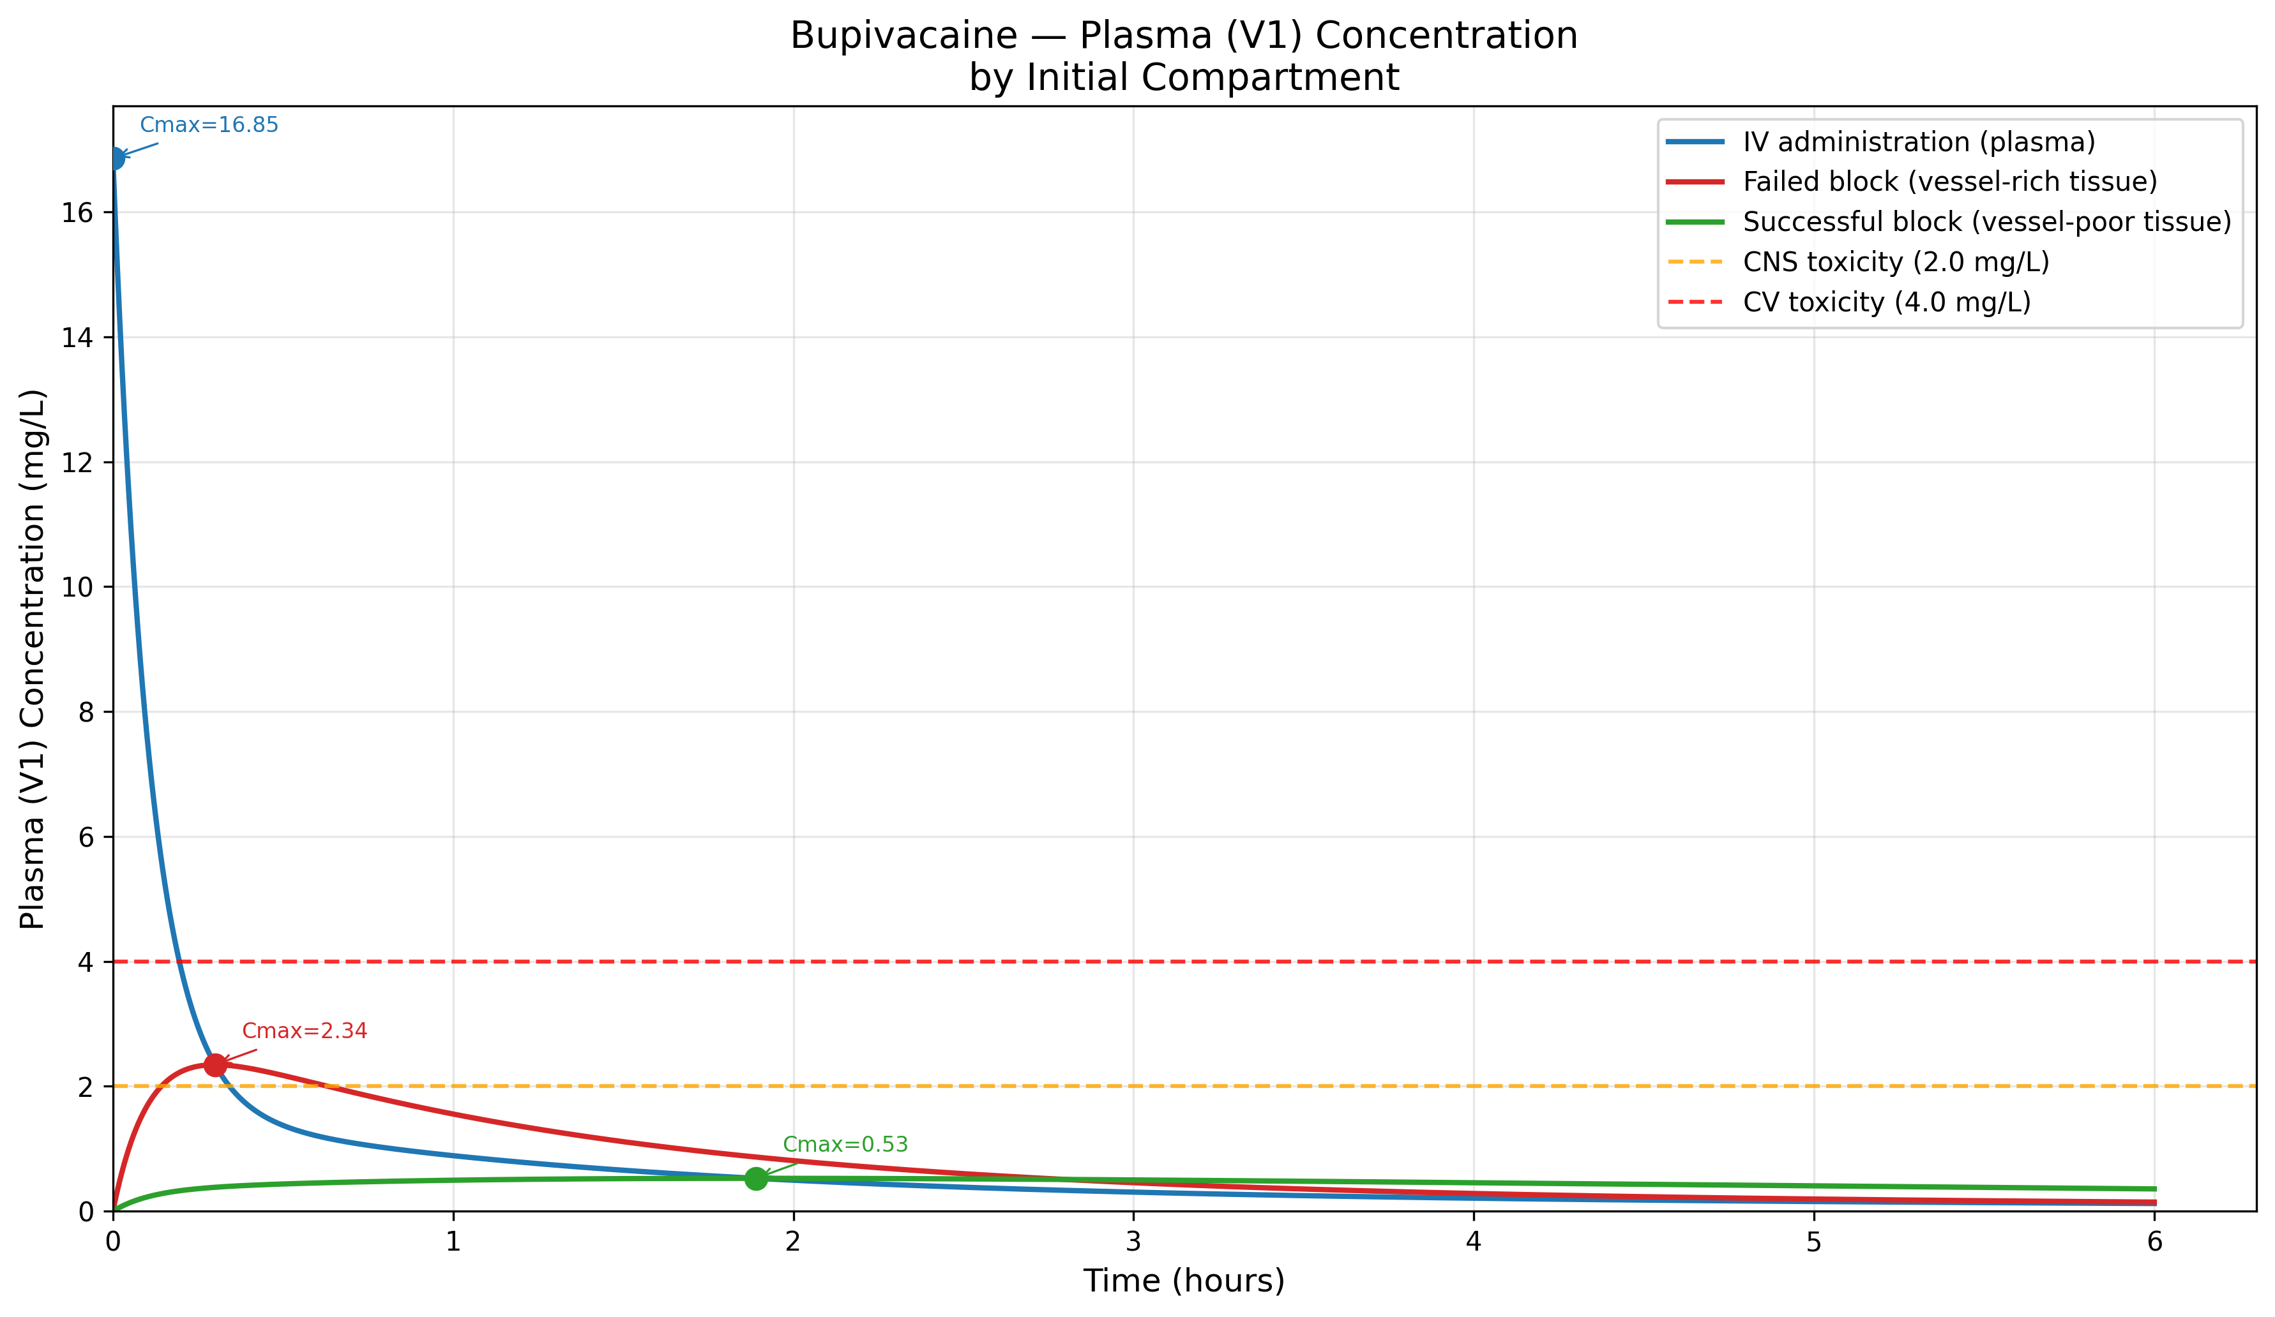
Fig. 2. Bupivacaine 150 mg – Plasma concentration by initial compartment with toxicity thresholds.
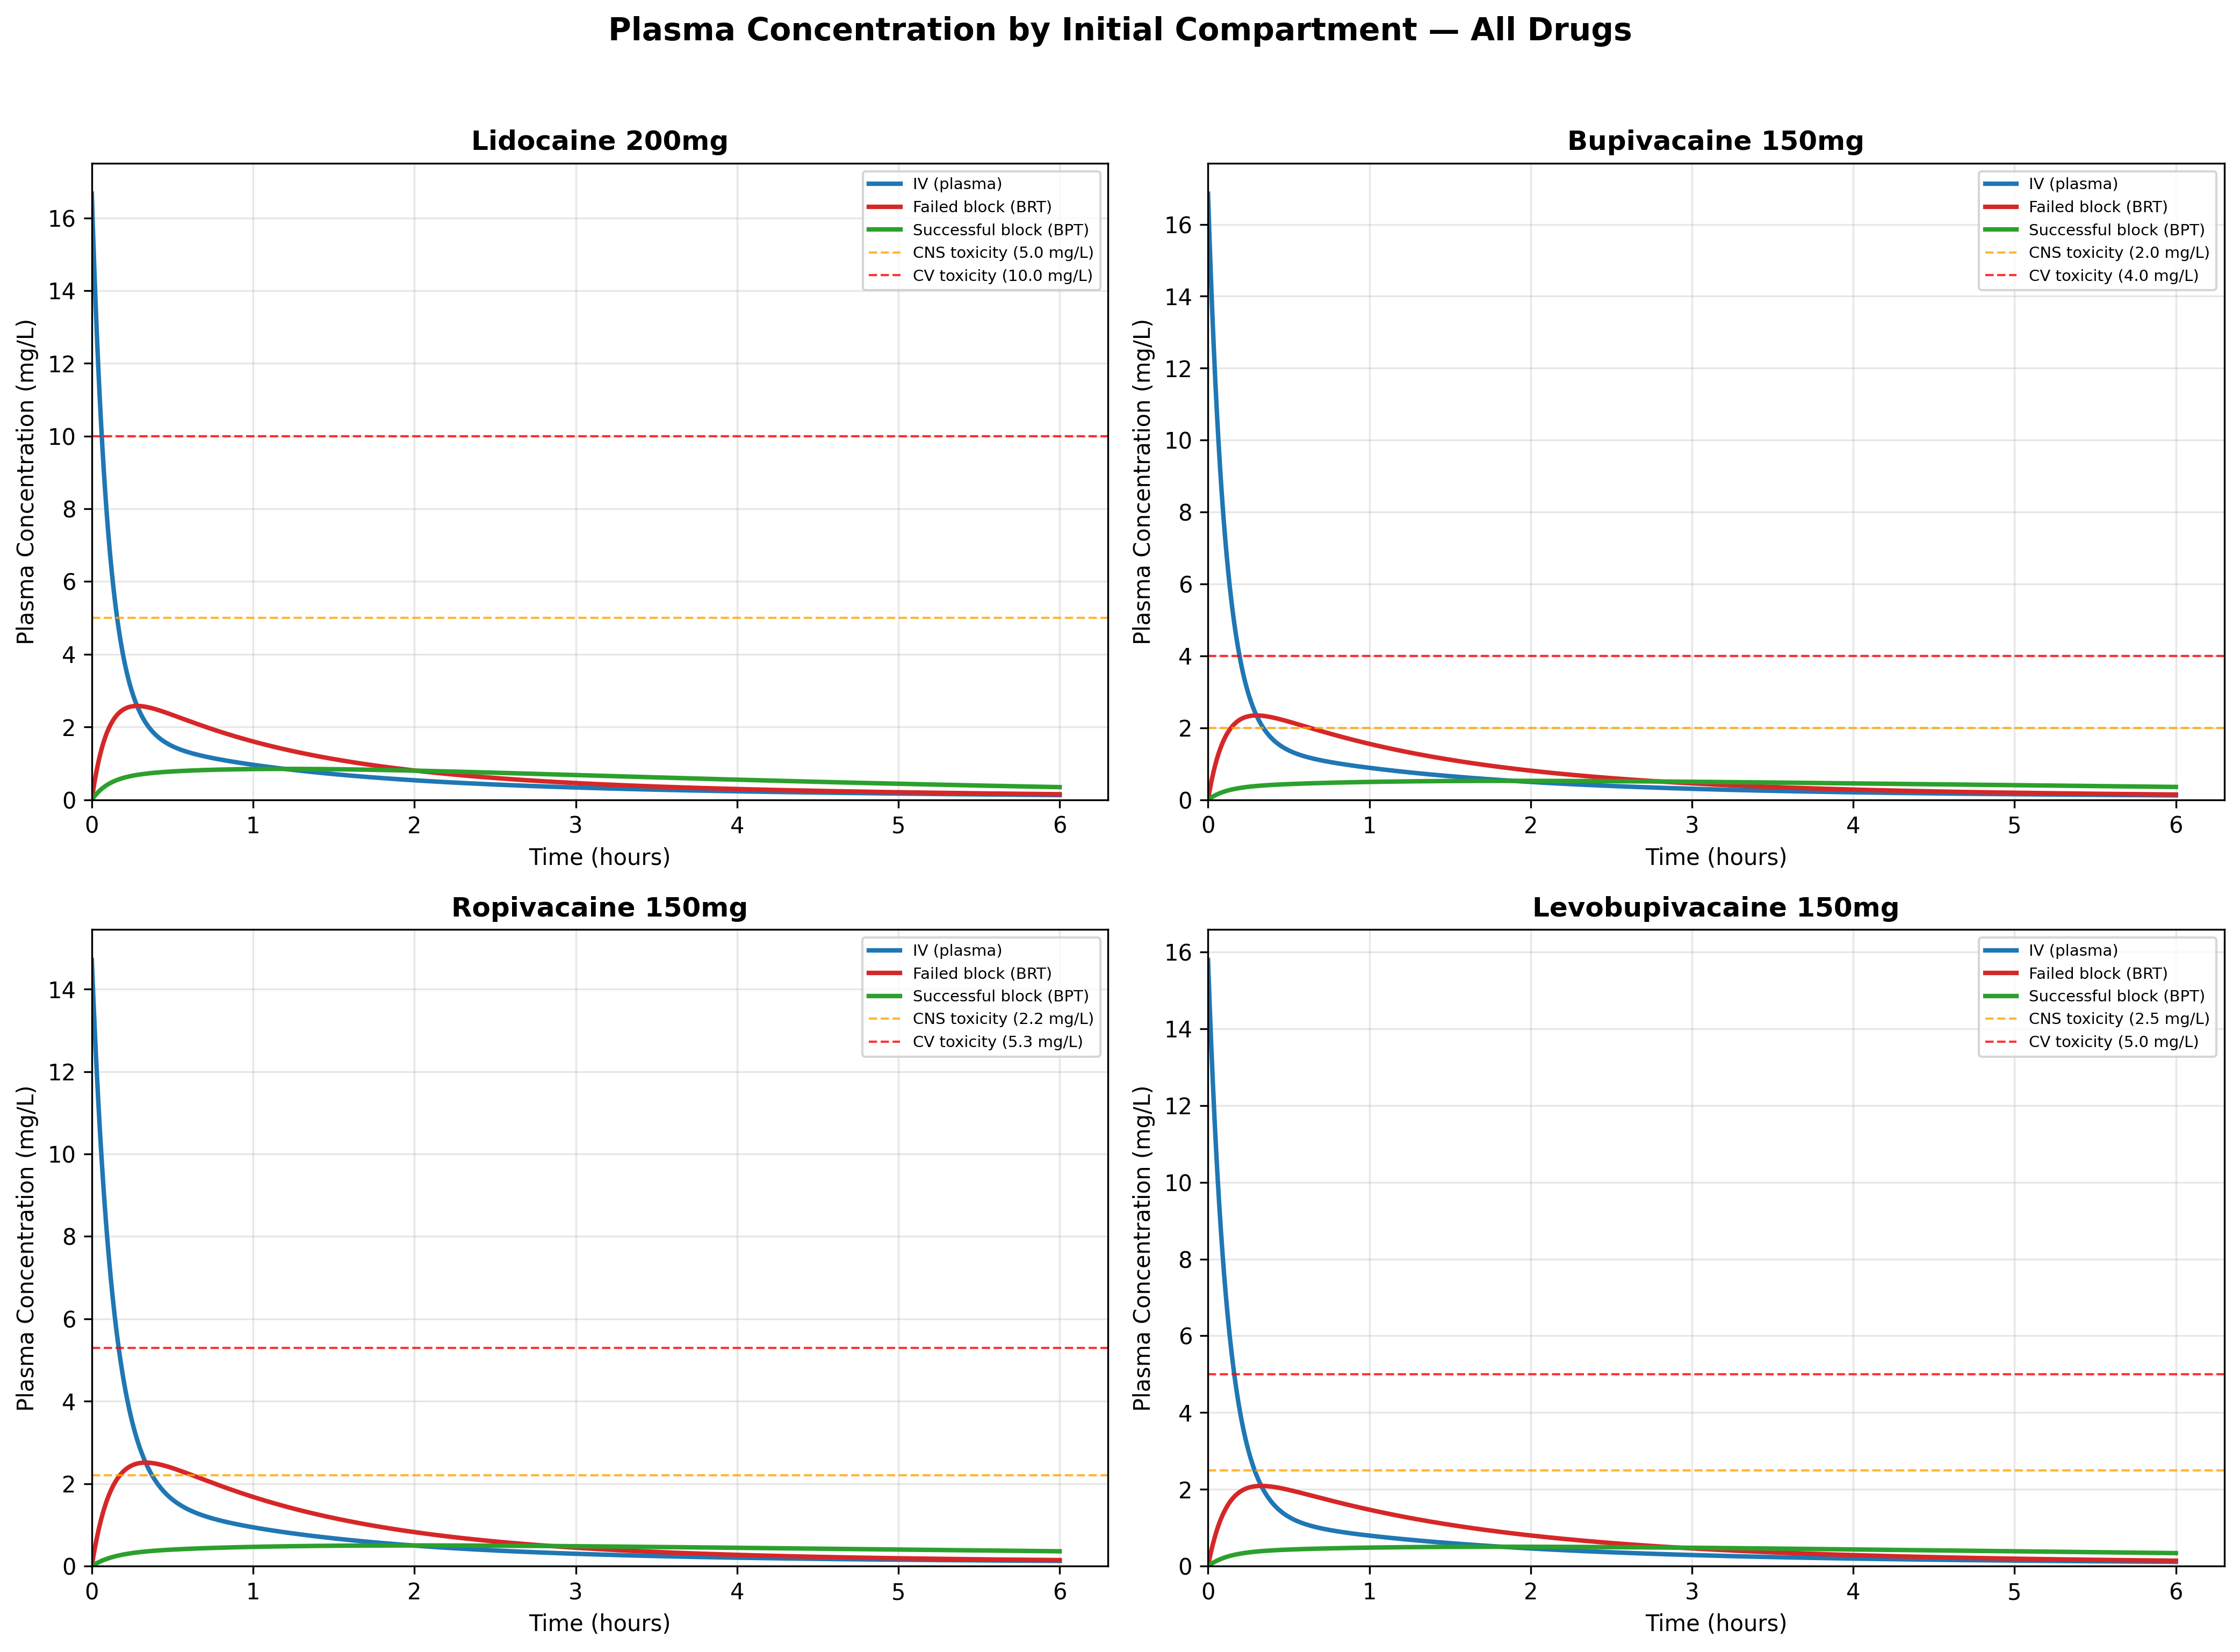
Fig. 3. Plasma concentration comparison for all four local anesthetics by initial compartment.
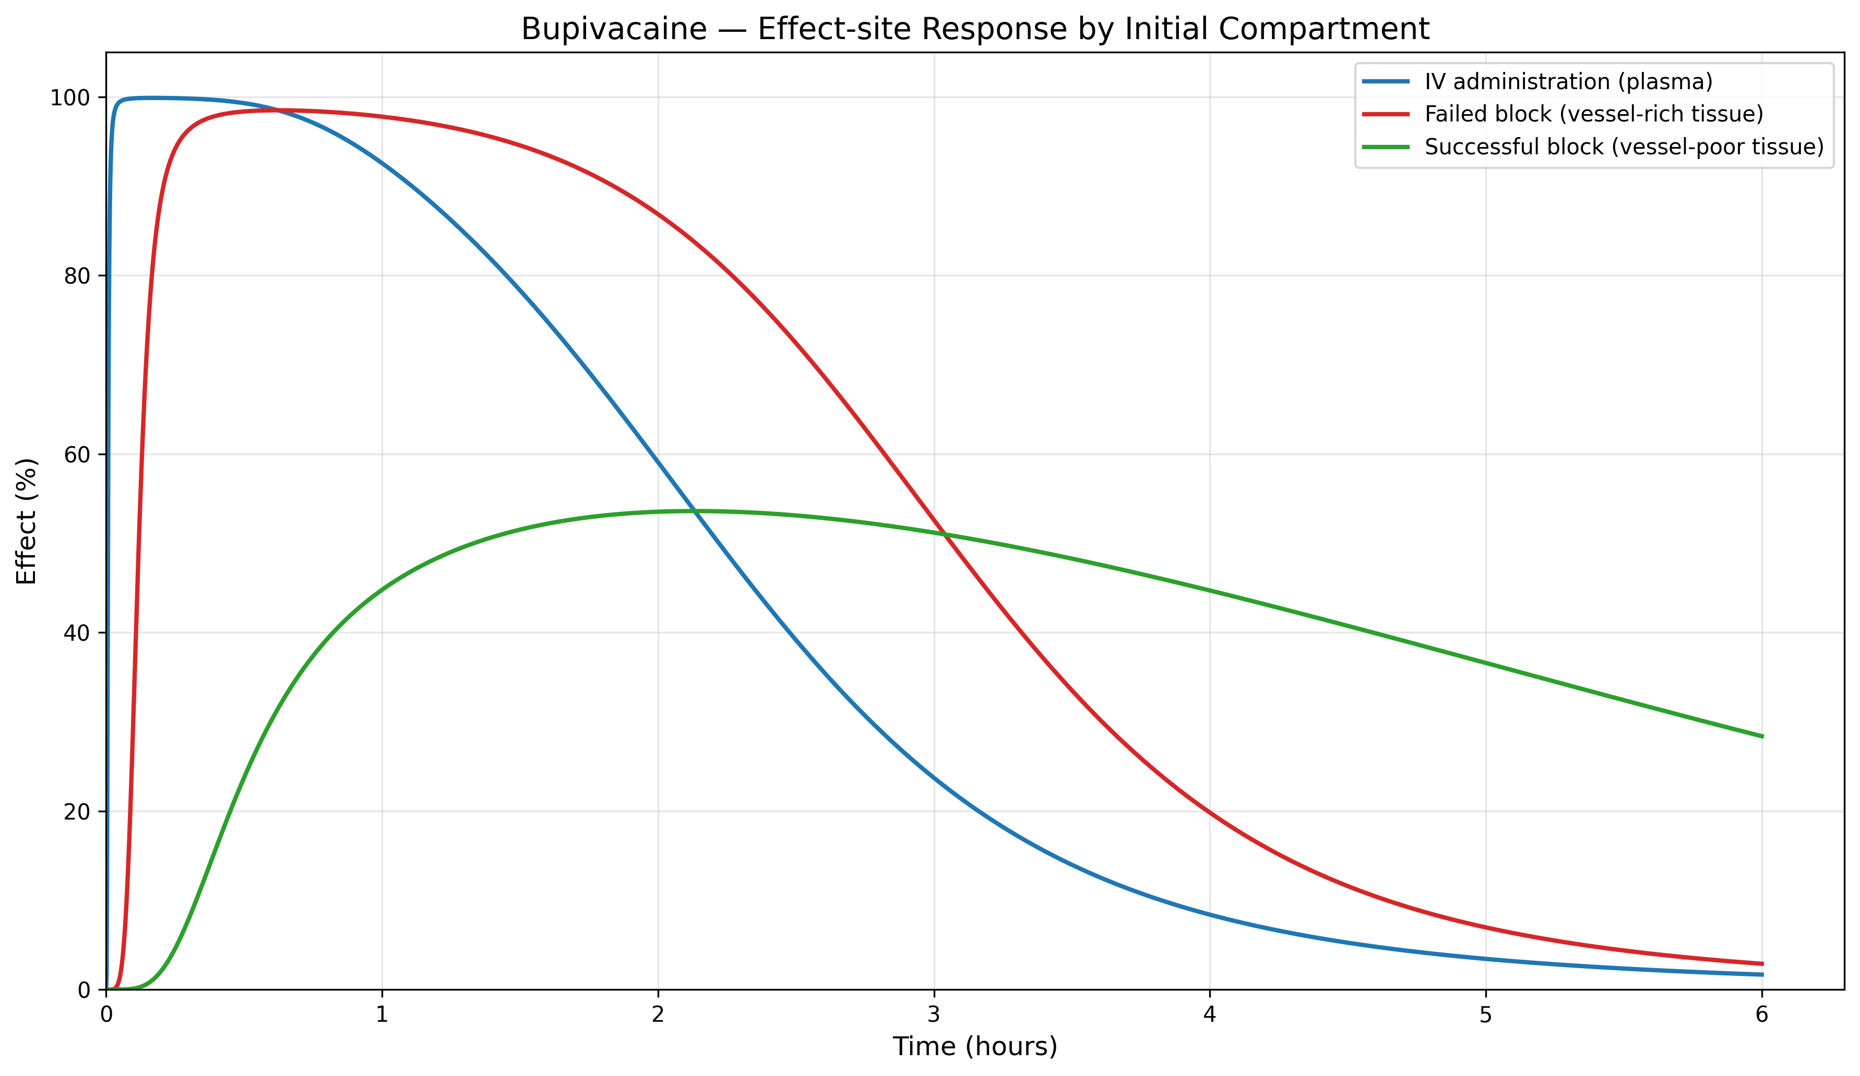
Fig. 4. Bupivacaine – Effect-site response by initial compartment.
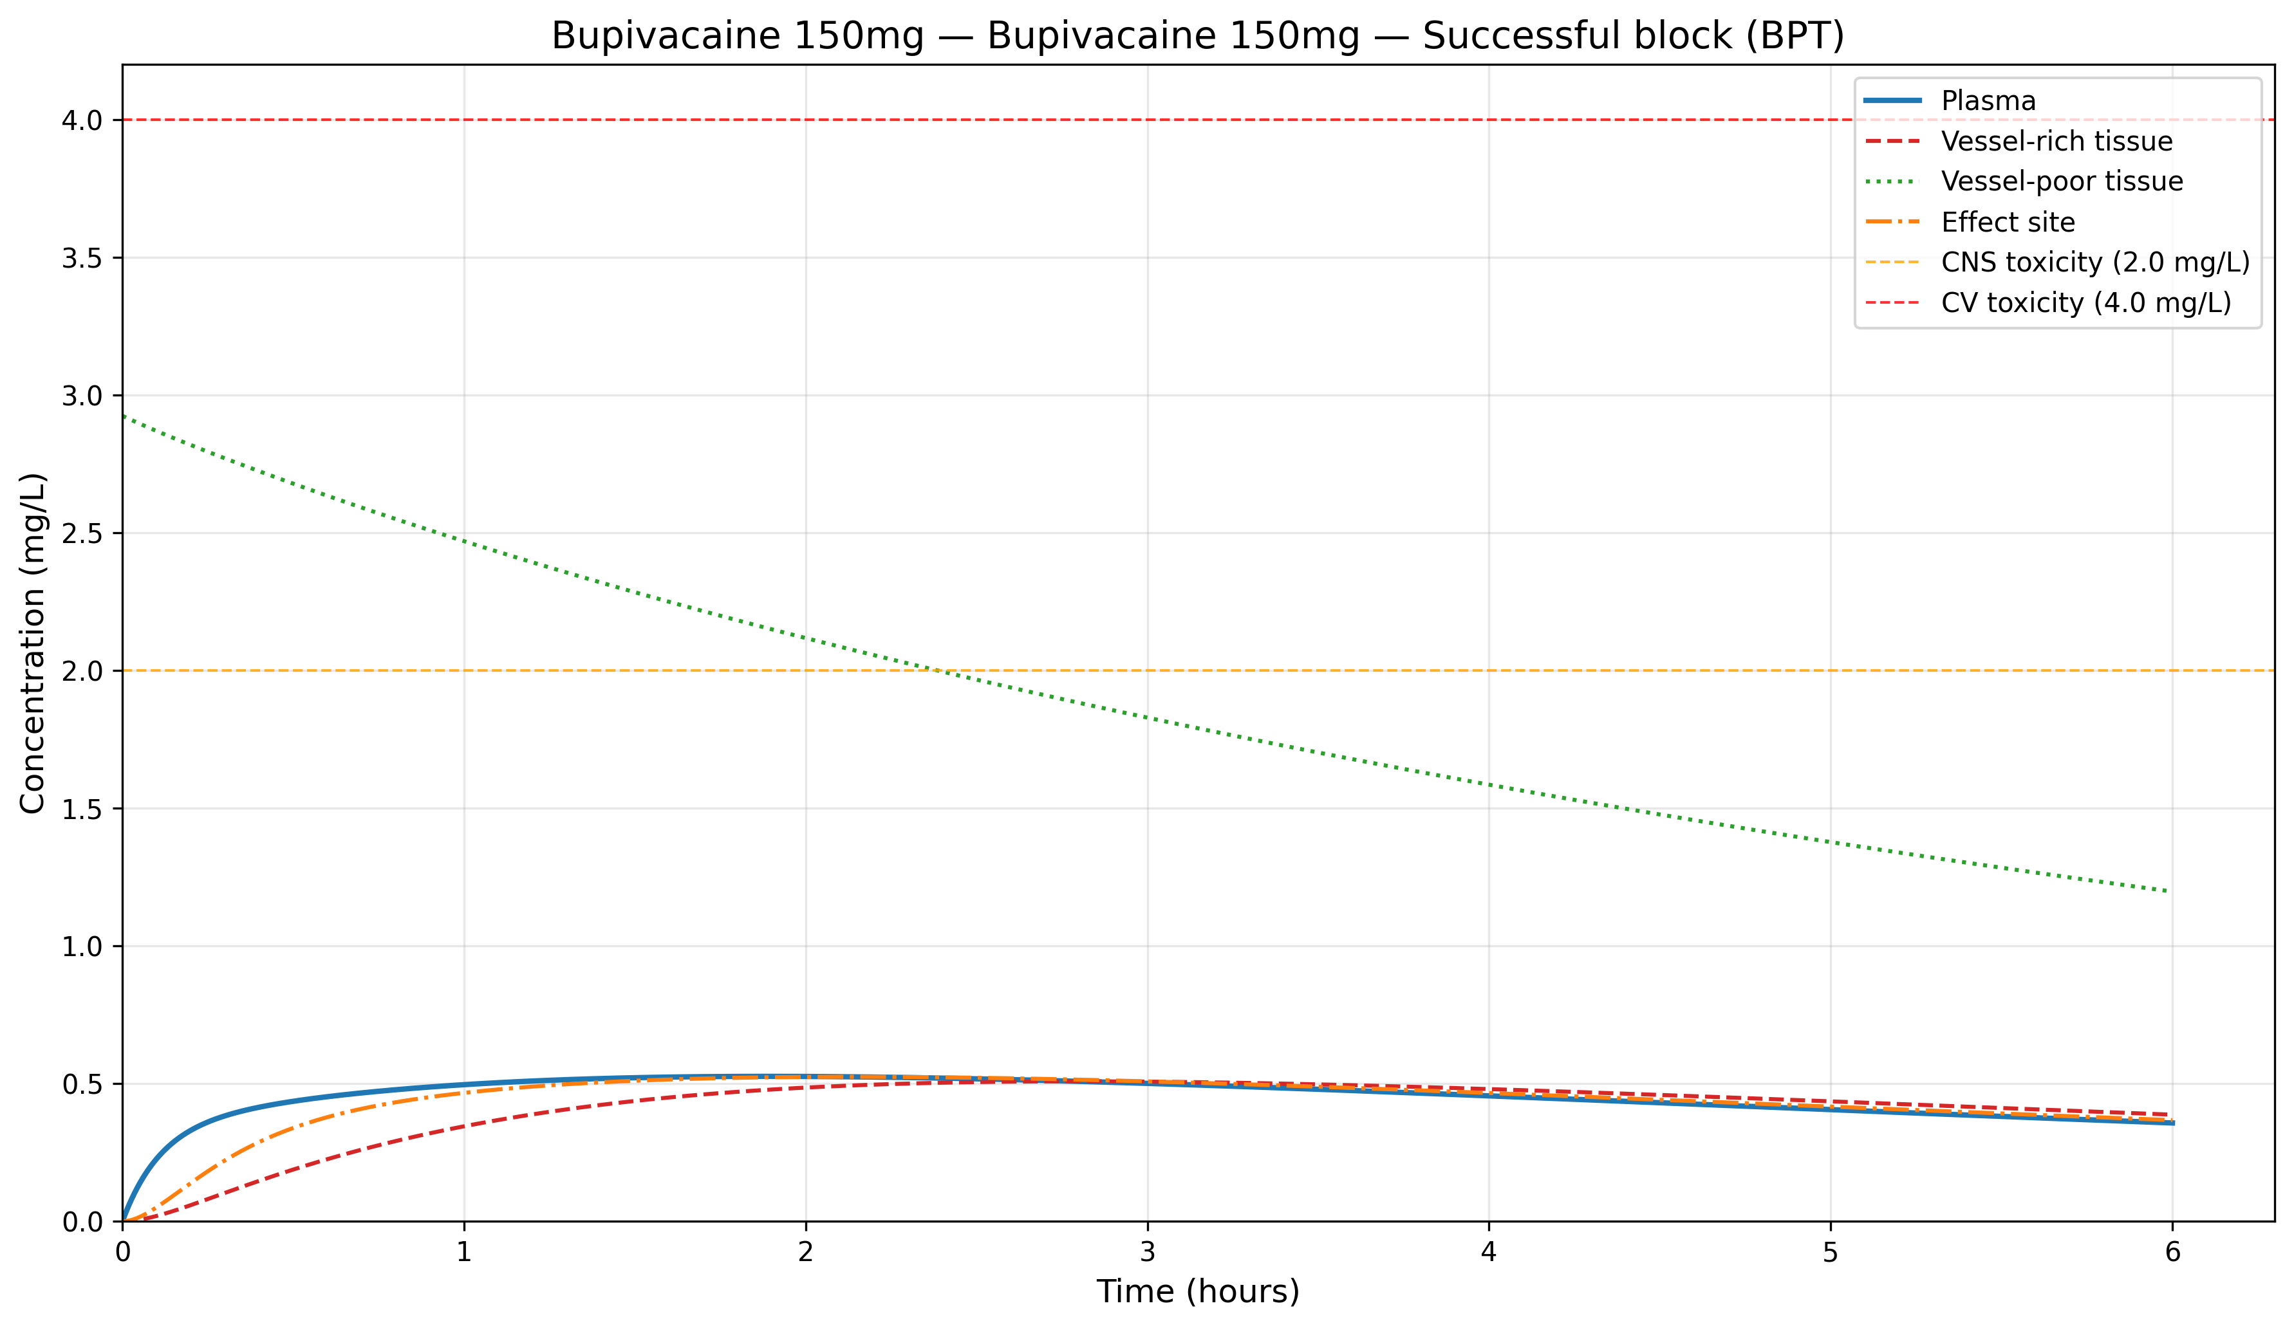
Fig. 5. Bupivacaine 150 mg from BPT – Full compartment concentration profile.
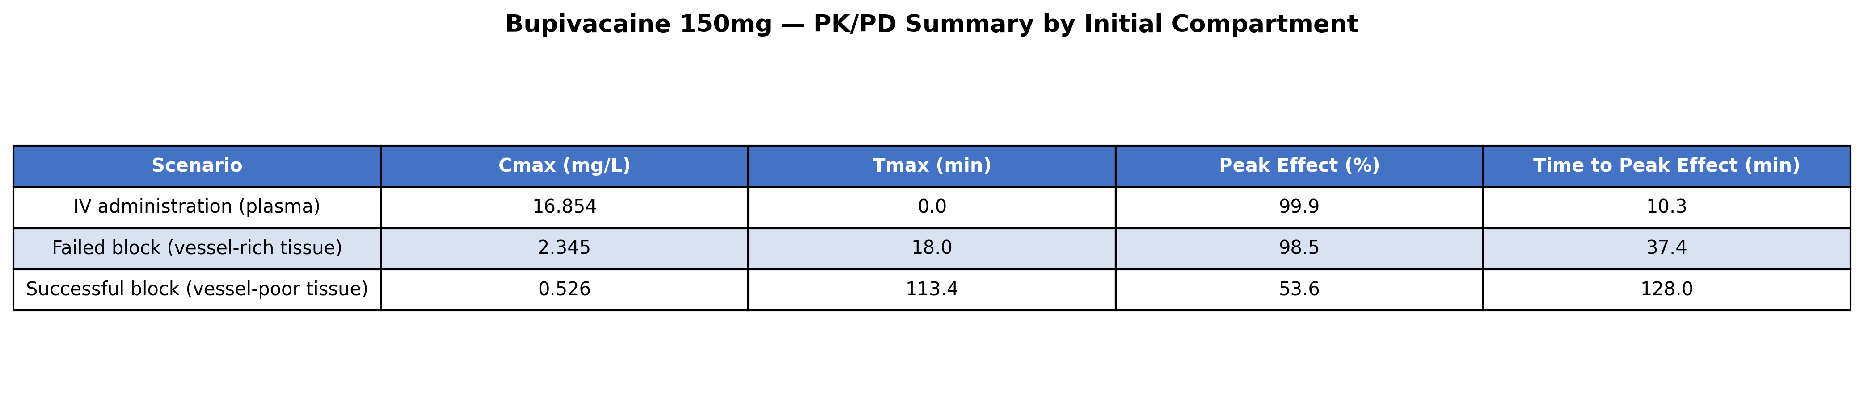
Fig. 6. Bupivacaine 150 mg – PKPD summary by initial compartment.

3.2 Safety comparison: IV-forced model vs fascial plane / nerve block
Traditional PK simulators are constrained to assume intravenous entry (Compartment.PLASMA). For fascial plane blocks and infiltration, yoshika selects the pharmacokinetically appropriate initial compartment (Compartment.DEPOT for fascial plane / infiltration, Compartment.BPT for successful nerve block). The rate constants are identical across all scenarios; only the initial conditions differ.
from yoshika import Compartment, Drug
from yoshika.drugs import DrugLibrary
from yoshika.model import PKModel
params = DrugLibrary.get(Drug.BUPIVACAINE)
# Traditional: forced IV entry (V1/plasma) — wrong for fascial plane block
pk_iv = PKModel(
drug_params=params, dose_mg=150,
initial_compartment=Compartment.PLASMA
).solve(duration_min=480)
# yoshika: fascial plane block deposits drug in depot compartment
pk_depot = PKModel(
drug_params=params, dose_mg=150,
initial_compartment=Compartment.DEPOT
).solve(duration_min=480)
print(f"Traditional (IV): Cmax={pk_iv.peak_plasma_concentration:.2f} mg/L, "
f"Tmax={pk_iv.time_to_peak:.0f} min")
print(f"yoshika (Depot): Cmax={pk_depot.peak_plasma_concentration:.2f} mg/L, "
f"Tmax={pk_depot.time_to_peak:.0f} min")
# Traditional (IV): Cmax=16.85 mg/L, Tmax=0 min <- overestimate
# yoshika (Depot): Cmax=3.10 mg/L, Tmax=14 min <- correct for fascial plane
Fig. 7 demonstrates the predicted plasma concentration–time profiles for four fascial plane block / infiltration scenarios. The traditional IV-forced model (red curves) predicts instantaneous supratoxic Cmax$C_{max}$ values (11–17 mg/L) that would never occur after non-IV administration. yoshika’s depot model (blue curves) predicts the pharmacokinetically correct first-order absorption profile, with Cmax$C_{max}$ of 2–4 mg/L peaking at 12–16 minutes. The BPT model (green dashed curves) represents successful nerve block with Cmax$C_{max}$ of 0.35–0.85 mg/L peaking at 72–119 minutes.
Fig. 8 directly compares Tmax$T_{max}$ across models and drugs. The traditional model invariably predicts Tmax = 0$T_{max}=0$—providing no information about when the real risk period occurs. yoshika’s depot model identifies Tmax$T_{max}$ at 12–16 minutes for all drugs, while the BPT model shows Tmax$T_{max}$ of 72–119 minutes for successful nerve blocks.
Fig. 9 maps Tmax$T_{max}$ onto a clinical timeline relative to typical day-surgery discharge (2 hours). Grey bars represent the in-hospital monitoring period. The traditional model’s Tmax = 0$T_{max}=0$ falsely suggests the risk period is over immediately, whereas yoshika identifies the actual monitoring window during which plasma concentration is still rising.
Fig. 10 compares Cmax$C_{max}$ against CNS and cardiovascular toxicity thresholds. The traditional model’s dramatic overestimation is immediately apparent: predicted Cmax$C_{max}$ values exceed even the cardiovascular (CV) toxicity threshold for all drugs, whereas the depot model shows Cmax$C_{max}$ near or below the CNS threshold. Fig. 11 provides a complete summary, highlighting that the depot model predicts Cmax$C_{max}$ above CNS threshold for ropivacaine 150 mg and bupivacaine 100–150 mg—clinically relevant predictions that require appropriate monitoring through Tmax$T_{max}$.
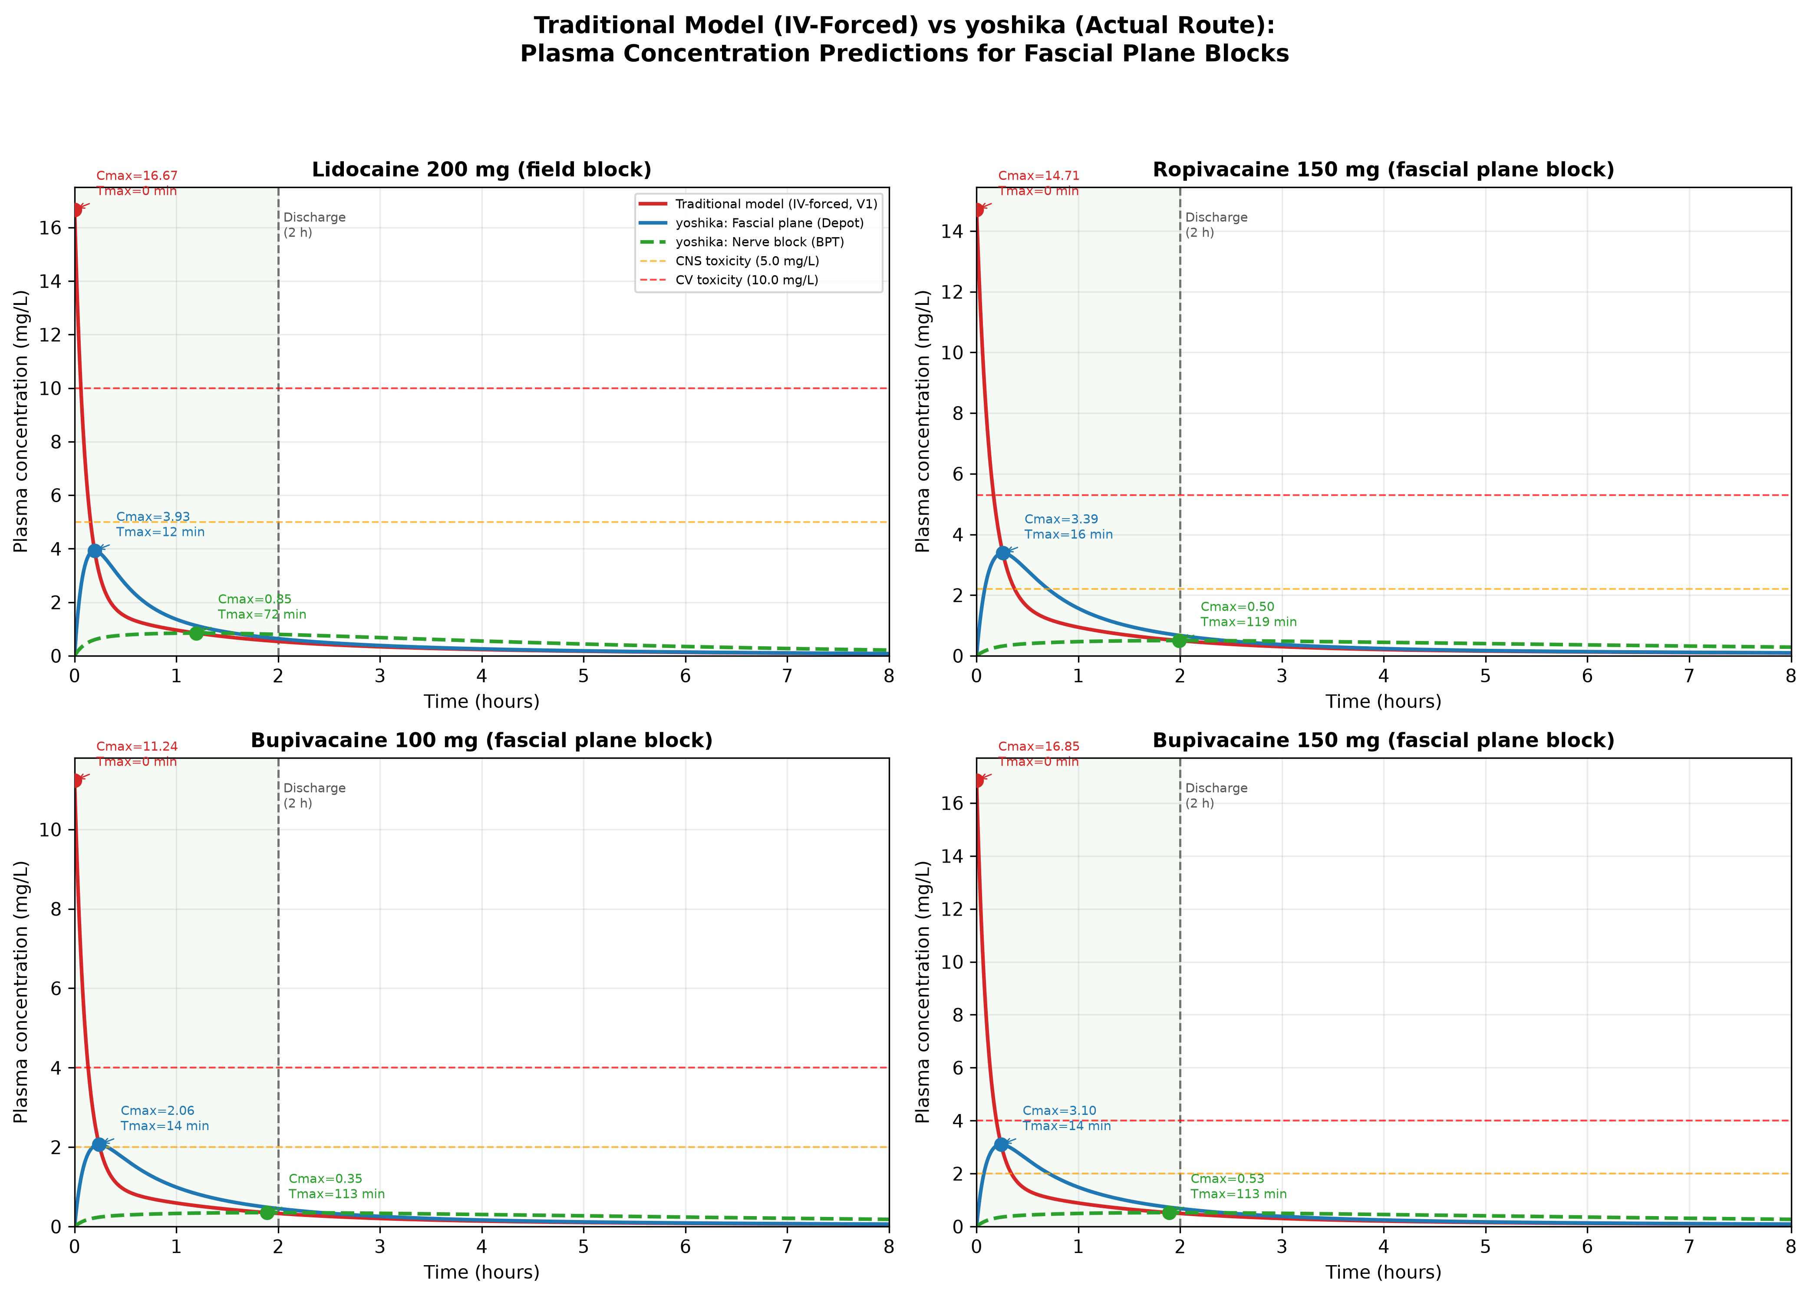
Fig. 7. Plasma concentration–time curves: traditional IV-forced model (red) vs yoshika fascial plane/depot (blue) and nerve block/BPT (green dashed) for four day-surgery scenarios. Green shading = in-hospital monitoring (0–2 h). Dashed lines = CNS and CV toxicity thresholds. Rate constants are shared; only the initial compartment differs.
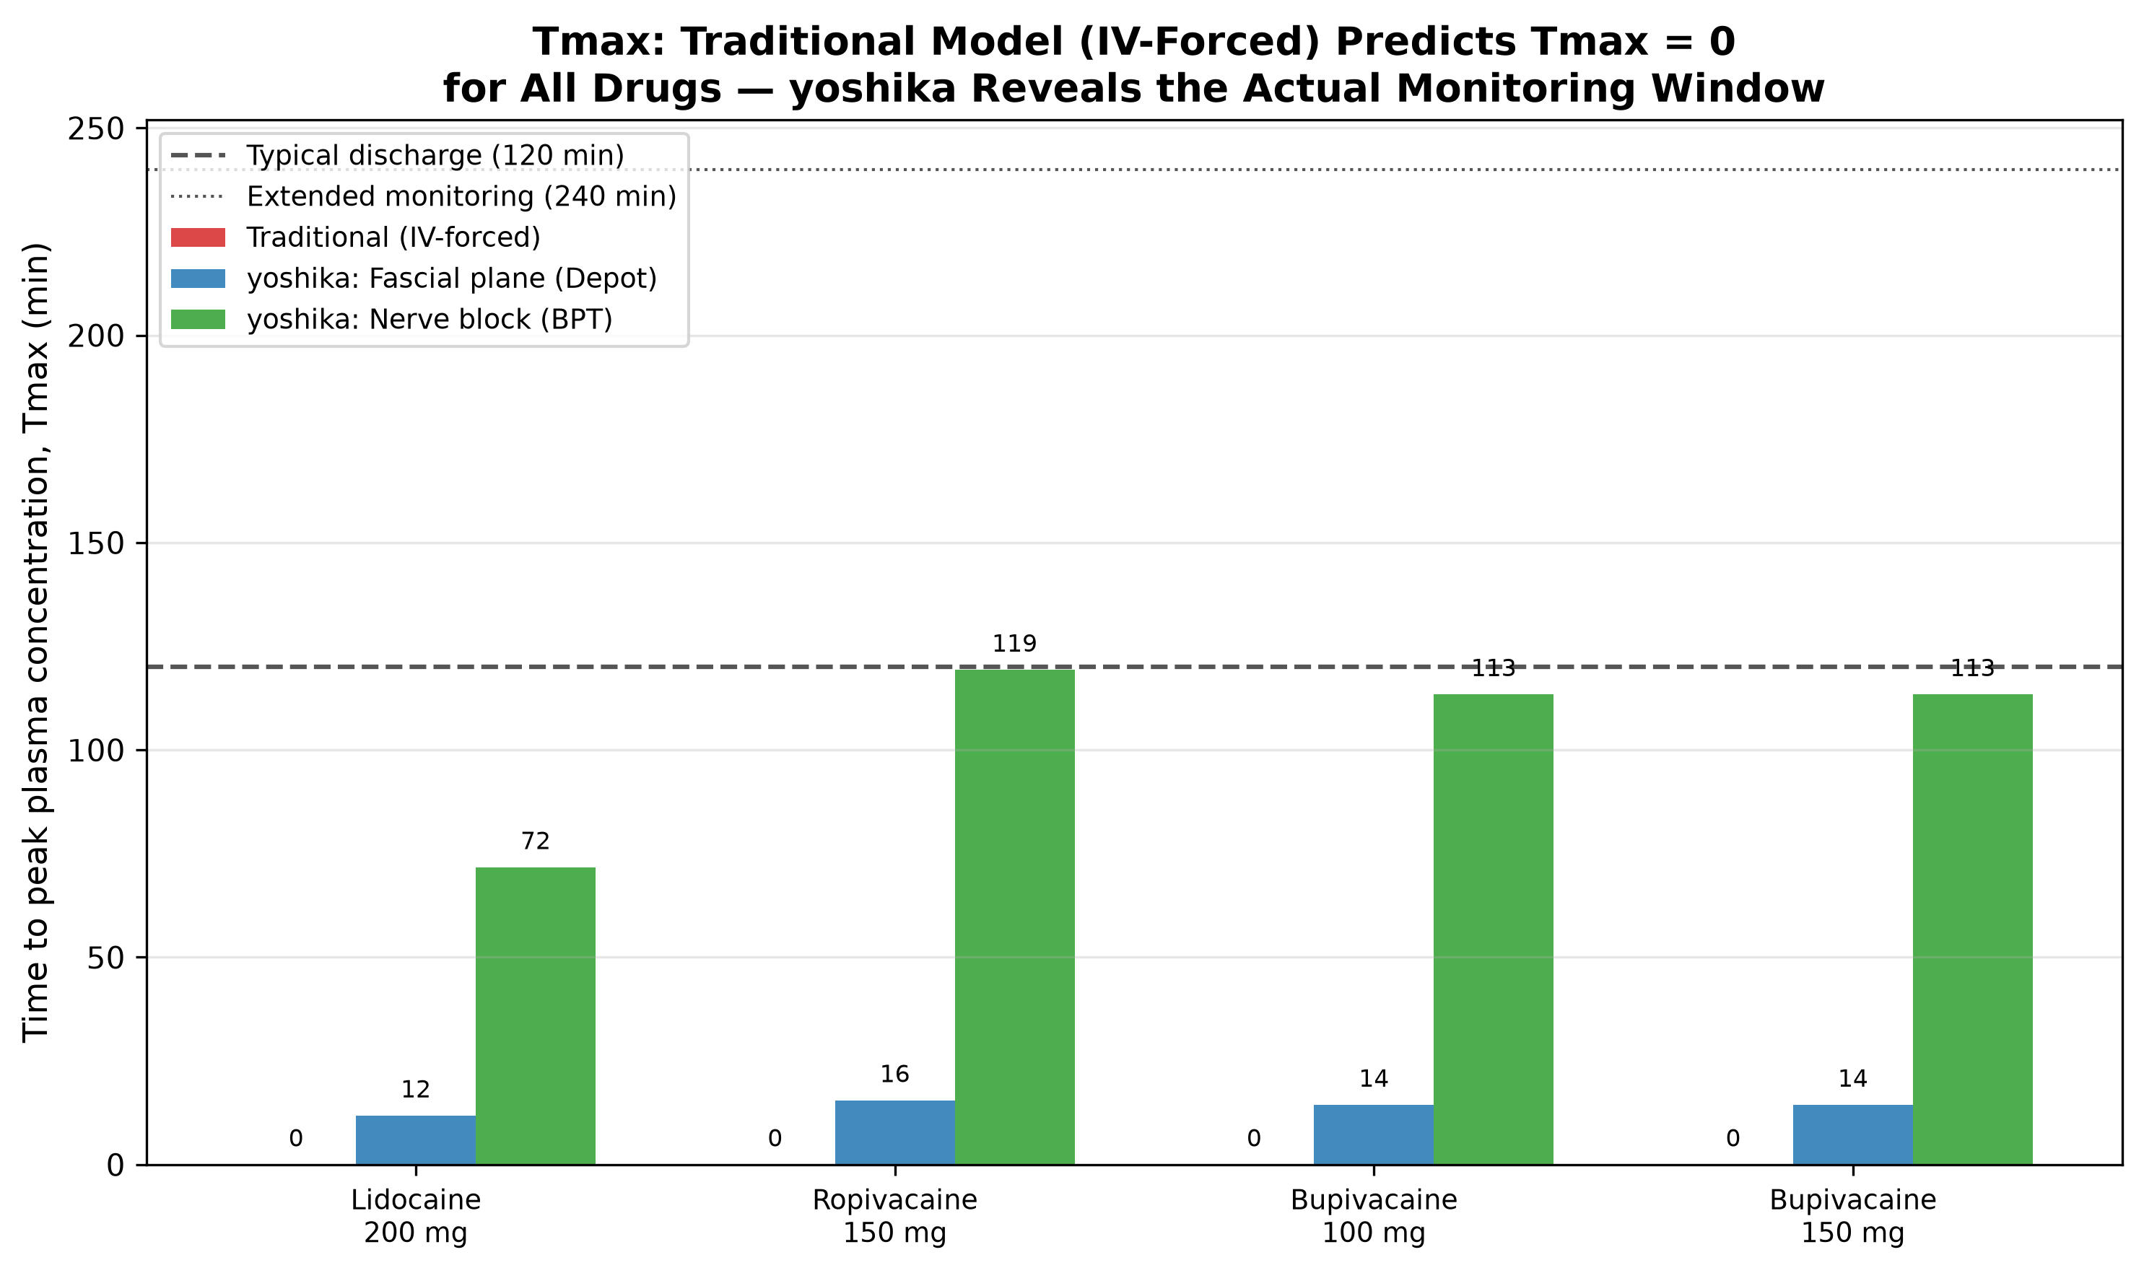
Fig. 8. Time to peak plasma concentration (Tmax$T_{max}$) by model and drug/dose. Traditional model predicts Tmax = 0$T_{max}=0$ for all drugs (IV assumption). yoshika depot model identifies actual Tmax$T_{max}$ at 12–16 min; BPT model at 72–119 min. Horizontal lines = discharge (120 min) and extended monitoring (240 min).
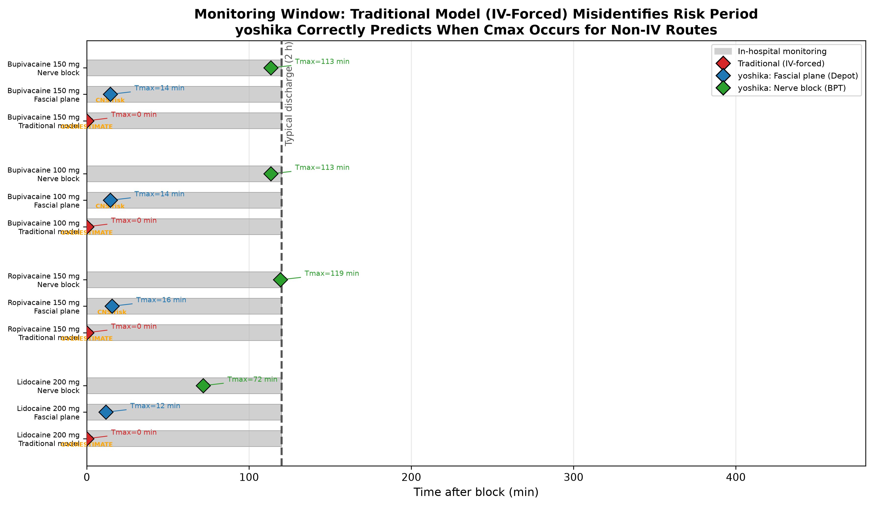
Fig. 9. Monitoring window: when does Tmax$C_{max}$ occur relative to discharge? Diamond markers = Tmax$T_{max}$ under each model. Traditional model (red) places peak at t = 0$t=0$ (wrong for non-IV routes). yoshika models identify the actual peak timing for fascial plane and nerve block routes.
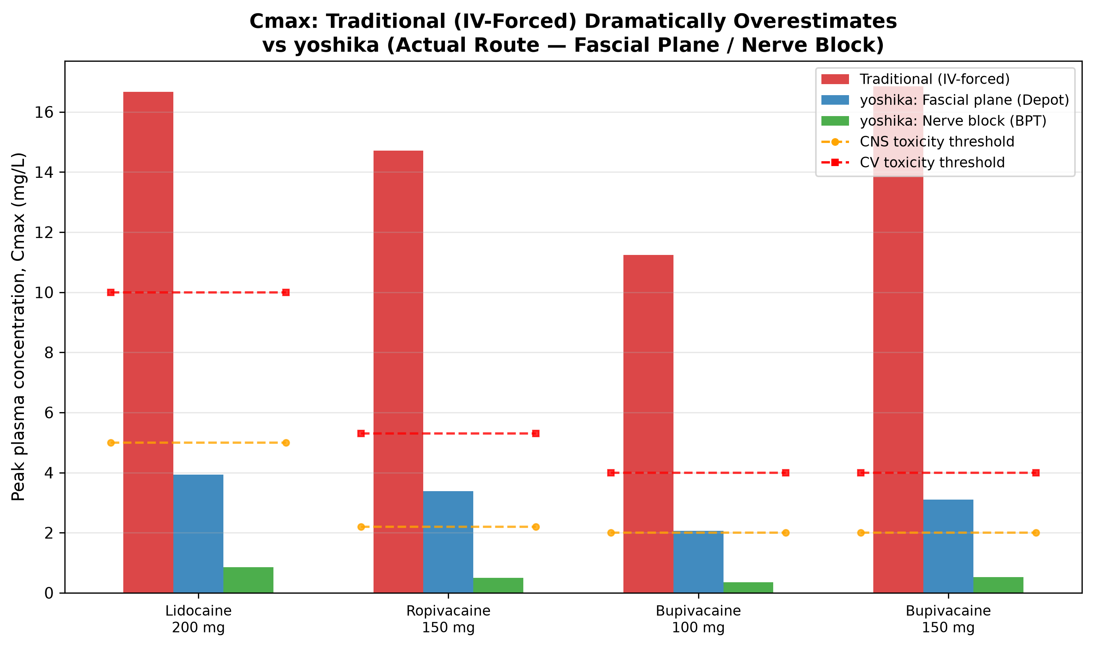
Fig. 10. Peak plasma concentration (Cmax$C_{max}$) vs toxicity thresholds. Traditional model dramatically overestimates Cmax$C_{max}$ for non-IV routes (false alarm). yoshika depot and BPT models give pharmacokinetically correct predictions.
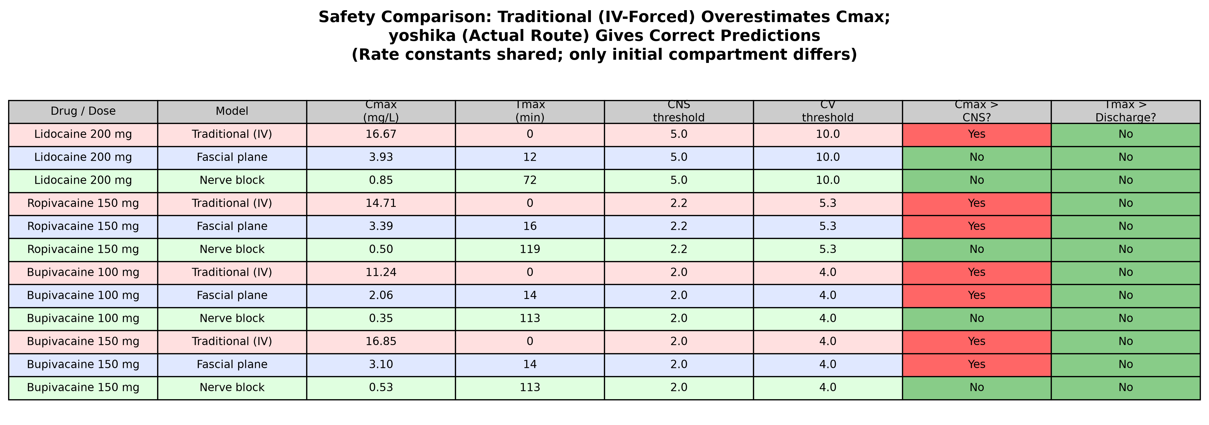
Fig. 11. Safety summary: rate constants shared across all models; only initial compartment differs. Red cells = Cmax$C_{max}$ exceeds CNS threshold or Tmax$T_{max}$ exceeds discharge time. Pink rows = traditional (IV-forced); blue = fascial plane (depot); green = nerve block (BPT).

4. Discussion
yoshika addresses a gap in the pharmacokinetic simulation landscape by providing the first open-source tool that allows users to select the initial compartment of drug deposition for local anesthetics. The impact of this software extends across several domains:
Accurate safety assessment for fascial plane blocks. The safety comparison analysis (§3.2) demonstrates that traditional PK simulators, constrained to IV entry, dramatically overestimate Cmax$C_{max}$ for fascial plane blocks and infiltration (11–17 mg/L predicted vs 2–4 mg/L actual). These false alarms may lead to unnecessarily conservative dosing or inappropriate clinical decisions. Equally important, the traditional model predicts Tmax = 0$T_{max}=0$, providing no information about when plasma concentration is actually rising. yoshika’s depot model identifies the real $T_{max}$ (12–16 min for fascial plane blocks), enabling evidence-based monitoring through the actual peak rather than empirical time-based rules. When the depot-predicted Cmax$C_{max}$ approaches toxicity thresholds (as with ropivacaine 150 mg and bupivacaine 100–150 mg), knowledge of the correct Tmax$T_{max}$ becomes clinically essential.
Clinical pharmacology and toxicology. By quantifying how the initial compartment determines peak plasma concentration and time-to-toxicity, yoshika provides a computational basis for reconsidering maximum recommended doses of local anesthetics. The context-sensitive maximum dose framework (Table 1) challenges the longstanding practice of applying IV-derived mg/kg limits to regional anesthesia, where absorption kinetics differ fundamentally from intravenous administration. The simulation data show that Cmax$C_{max}$Cmax from BPT (successful nerve block) is 20–30$×$ lower than the IV-forced prediction for the same dose, while Cmax$C_{max}$ from the depot model (fascial plane block) can approach or exceed CNS toxicity thresholds—a clinically relevant finding that would be obscured by the IV-forced model’s gross overestimation [6].
Anesthesia information management systems. yoshika demonstrates that route-adaptive PKPD simulation is computationally feasible with standard ODE solvers and can be integrated into existing AIMS infrastructure. This provides a proof-of-concept for AIMS vendors seeking to implement administration-route-specific pharmacokinetic predictions. Current AIMS that use traditional IV-forced models generate false toxicity alarms for regional and infiltration techniques while simultaneously providing no information about the actual timing of peak plasma concentration.
Clinical decision support. Block success can serve as a real-time pharmacokinetic risk indicator. If block success is inferred from clinical assessment (e.g., onset of sensory block within expected timeframes), clinicians could update their toxicity risk assessment in real time using yoshika’s simulation framework. A confirmed successful block indicates a low-risk pharmacokinetic trajectory (slow absorption from BPT), while failure to achieve blockade should prompt heightened vigilance and conservative redosing decisions. For ambulatory surgery specifically, yoshika-based monitoring recommendations could inform discharge criteria by predicting when Tmax$C_{max}$ will occur relative to the planned discharge time.
Education and training. yoshika provides an interactive simulation environment for anesthesia trainees to visualize how different injection sites and block outcomes affect drug disposition, reinforcing the pharmacokinetic principles underlying safe regional anesthesia practice.
Research. The modular design of yoshika facilitates extension to new drug models, custom compartment configurations, and population pharmacokinetic analyses. Future research directions include systematic measurement of plasma concentration profiles after various regional block types with concurrent documentation of block success, to parameterize compartment-specific absorption models, and prospective validation of the context-sensitive maximum dose framework.

5. Conclusion
yoshika is an open-source Python package that fills a specific gap in pharmacokinetic simulation tools: the ability to select the initial compartment of drug deposition for local anesthetics in regional anesthesia. By enabling simulation of clinically distinct scenarios—successful block (BPT start), failed block (BRT start), intravascular injection (Plasma start), and depot absorption (fascial plane/epidural)—yoshika provides a computational framework for exploring context-sensitive maximum dose recommendations and route-adaptive PKPD simulation.
The clinical significance of this approach is substantial: traditional mg/kg dose limits derived from IV pharmacokinetics do not account for the fundamentally different absorption kinetics of regional anesthesia. yoshika quantifies these differences and supports the development of evidence-based, route-specific dose guidelines. The software is freely available under the MIT license and can be installed via pip.

Declaration of competing interest
The authors declare that they have no known competing financial interests or personal relationships that could have appeared to influence the work reported in this paper.

CRediT authorship contribution statement
Tatsuki Onishi: Conceptualization, Methodology, Software, Validation, Writing – Original Draft, Writing – Review & Editing.

Acknowledgements
None.

Funding
None.

Declaration of generative artificial intelligence (AI) in scientific writing
I used Devin(devin.ai) to help with formatting the text and choosing words that suited the tone, and to help writing codes. The authors take full responsibility for the accuracy and content of the manuscript.

References
[1] Eleveld DJ, Colin P, Absalom AR, Struys MMRF. Pharmacokinetic-pharmacodynamic model for propofol for broad application in anaesthesia and sedation. British Journal of Anaesthesia 2018;120:942–59. https://doi.org/10.1016/j.bja.2018.01.018.
[2] Aubouin-Pairault B, Fiacchini M, Dang T. PAS: a Python Anesthesia Simulator for drug control. J Open Source Softw 2023;8(88):5480. https://doi.org/10.21105/joss.05480.
[3] Rosenberg PH, Veering BT, Urmey WF. Maximum recommended doses of local anesthetics: A multifactorial concept. Regional Anesthesia and Pain Medicine 2004;29:564–75. https://doi.org/10.1016/j.rapm.2004.08.003.
[4] De Cassai A, Geraldini F, Costa F, Tulgar S. Local anesthetics and erector spinae plane blocks: a spotlight on pharmacokinetic considerations and toxicity risks. Expert Opin Drug Metab Toxicol 2022;18(9):537–9. https://doi.org/10.1080/17425255.2022.2122811.
[5] Hughes MA, Glass PSA, Jacobs JR. Context-sensitive half-time in multicompartment pharmacokinetic models for intravenous anesthetic drugs. Anesthesiology 1992;76:334–41. https://doi.org/10.1097/00000542-199203000-00003.
[6] Neal JM, Barrington MJ, Fettiplace MR, Gitman M, Memtsoudis SG, Mörwald EE, et al. The Third American Society of Regional Anesthesia and Pain Medicine practice advisory on local anesthetic systemic toxicity. Regional Anesthesia and Pain Medicine 2018;43:113–23. https://doi.org/10.1097/AAP.0000000000000720.
[7] Macfarlane AJR, Gitman M, Bornstein KJ, El-Boghdadly K, Weinberg G. Updates in our understanding of local anaesthetic systemic toxicity: a narrative review. Anaesthesia 2021;76(Suppl 1):27–39. https://doi.org/10.1111/anae.15282.
[8] Di Gregorio G, Neal JM, Rosenquist RW, Weinberg GL. Clinical presentation of local anesthetic systemic toxicity: a review of published cases, 1979 to 2009. Reg Anesth Pain Med 2010;35(2):181–7. https://doi.org/10.1097/AAP.0b013e3181d2310b.
[9] Virtanen P, Gommers R, Oliphant TE, others. SciPy 1.0: Fundamental algorithms for scientific computing in Python. Nature Methods 2020;17:261–72. https://doi.org/10.1038/s41592-019-0686-2.
[10] Tucker GT, Mather LE. Clinical pharmacokinetics of local anaesthetics. Clinical Pharmacokinetics 1979;4:241–78. https://doi.org/10.2165/00003088-197904040-00001.
[11] Burm AGL. Clinical pharmacokinetics of epidural and spinal anaesthesia. Clinical Pharmacokinetics 1989;16:283–311. https://doi.org/10.2165/00003088-198916050-00002.

