yoshika: A Python Package for Pharmacokinetic-Pharmacodynamic Simulation of Local Anesthetics with Selectable Initial Compartment
28 March 2026

Highlights
- Open-source comparison of initial-compartment scenarios for local anesthetics
- Standard PK equations; scenarios differ only in input and absorption
- External validation: 90% of predicted Cmax values were within two-fold
- Intravenous input overstates and mis-times non-IV peak concentrations
- Framework for exploratory, route-aware dosing and monitoring hypotheses

Abstract
yoshika (Yielding Open Simulation of Hybrid Inter-disciplinary Kinetic Absorption) is an open-source Python package for pharmacokinetic-pharmacodynamic (PKPD) simulation of local anesthetics with selectable initial compartments. It uses a conventional three-compartment model; its contribution is a reproducible methodology that makes drug-deposition assumptions explicit and systematically comparable. Conventional simulators place the entire dose in plasma at time zero, whereas regional anesthesia deposits drug in tissue for subsequent absorption. yoshika allows initial placement in plasma, vessel-rich tissue, vessel-poor tissue, or a depot and compares concentration-time profiles and pharmacodynamic effects using shared disposition parameters. It includes built-in parameters for lidocaine, bupivacaine, ropivacaine, and levobupivacaine, an effect-site compartment with a sigmoid Emax model, visualization tools, and tests. External validation used Cmax and Tmax from ten published clinical pharmacokinetic records spanning intercostal, fascial-plane, peripheral-nerve, and epidural routes. With the depot absorption rate calibrated to observed Tmax, 90% of predicted Cmax values were within two-fold of observations (geometric mean fold error, 1.51; Pearson r = 0.81). The intravenous-input assumption overestimated Cmax approximately tenfold and predicted an instantaneous peak. yoshika is intended for exploratory and educational generation of route-aware hypotheses about peak exposure and monitoring windows, not as a validated clinical dosing tool.
Keywords: pharmacokinetics; pharmacodynamics; local anesthetics; regional anesthesia; compartment model; simulation; selectable initial compartment; systemic toxicity

1. Introduction

1.1 The initial compartment problem in regional anesthesia
In regional anesthesia and pain medicine, local anesthetics are injected near nerves and fascial planes rather than intravenously. The pharmacokinetic behavior of these drugs depends critically on the injection site and block success. Existing PK simulation tools (e.g., STANPUMP, Tivatrainer, Eleveld models) uniformly assume intravenous administration, where drug enters the central (plasma) compartment at time zero [1]. This assumption does not hold for regional anesthesia, where:
- A successful peripheral nerve block deposits the drug bolus into vessel-poor tissue (V3/BPT), resulting in slow absorption into plasma with a delayed, attenuated peak plasma concentration.
- A failed block with intravascular injection deposits the drug into vessel-rich tissue (V2/BRT) or directly into plasma, resulting in rapid systemic exposure and potentially toxic concentrations.
- Fascial plane blocks and depot injections involve absorption through a depot compartment with first-order absorption kinetics ($k_{a}$).
To our knowledge, no existing open-source PKPD simulation package explicitly supports selectable initial compartment for local anesthetics. The Python Anesthesia Simulator (PAS) [2] provides a general framework for anesthetic PK simulation but does not address the specific problem of initial compartment selection for regional anesthesia applications.
We emphasize at the outset what yoshika is and is not. Mathematically, changing the compartment that receives the dose at $t=0$ is a trivial change of initial conditions in a standard three-compartment model; it is not a new pharmacokinetic model, and we do not claim it to be. The contribution is instead a methodological and software one: a reproducible, open framework that makes the initial-compartment choice explicit and lets it be varied systematically, together with the observation—often overlooked in routine practice and in intravenous (IV)-oriented simulators—that this choice has large and clinically meaningful consequences for the predicted concentration-time profile. Whether the resulting predictions correspond to reality is an empirical question, which we address by external validation against published plasma concentration data (§3.3).

1.2 Clinical motivation: initial compartment and systemic toxicity risk
A potential clinical relevance of selectable initial compartment modeling lies in its implications for local anesthetic systemic toxicity (LAST) risk assessment. Traditional maximum recommended doses for local anesthetics (e.g., bupivacaine 2 mg/kg, lidocaine 4.5 mg/kg without epinephrine) are derived largely from intravenous and systemic pharmacokinetic studies, where the entire dose is assumed to enter the central plasma compartment instantaneously [3,4]. This assumption produces the highest possible peak plasma concentration ($C_{max}$) for a given dose.
Changing the initial compartment changes the simulated concentration-time profile in qualitatively different ways. We use the following scenario labels throughout; they are heuristic modelling scenarios, not validated anatomical mappings (see the caveat below):
- Vessel-poor-tissue start (labelled “successful block”): the initial amount is placed in the peripheral compartment with the smaller return rate constant, so it is released slowly into plasma, producing a delayed and attenuated $C_{max}$.
- Vessel-rich-tissue start (labelled “failed / vascular-rich block”): the initial amount is placed in the peripheral compartment with the faster return, producing an earlier and higher $C_{max}$ approaching intravenous-like kinetics.
- Plasma start (intravascular injection): equivalent to an intravenous bolus, with an immediate high $C_{max}$.
- Depot start (fascial plane / infiltration / epidural): first-order absorption into plasma through the depot rate constant $k_{a}$.
An important caveat, raised in review and which we make explicit here: the peripheral compartments V2 and V3 of a mammillary model are lumped, fitted compartments, not literal anatomical spaces. They therefore cannot be equated in a one-to-one fashion with “vessel-rich tissue”, “vessel-poor tissue”, a “successful” or “failed” block, or a “fascial plane” without independent validation. The scenario labels are used as convenient shorthand for distinct initial-condition/absorption regimes; the empirical question of whether they reproduce real plasma concentrations is addressed in §3.3.

1.3 Context-sensitive maximum dose
We propose that yoshika enables exploration of a context-sensitive maximum dose concept for local anesthetics, analogous to the context-sensitive half-time that transformed understanding of intravenous drug offset [5]. Under this framework, the effective maximum safe dose is not a single fixed value but varies with the clinical scenario (Table 1).
Table 1. Proposed context-sensitive maximum dose framework.
Scenario | Initial Compartment | Expected C_{max} | Dose Implication
Successful block | BPT (V3) | Low, delayed | Higher dose may be safe
Partial block | Mixed (BPT + BRT) | Intermediate | Standard limit applies
Failed block | BRT (V2) | Moderate-high, early | Lower dose may be needed
Intravascular injection | Plasma (V1) | Very high, immediate | Traditional IV limits apply
Epidural | Depot (multi-pathway) | Intermediate, delayed | Depot model approximation
This framework offers a possible pharmacokinetic rationale for the empirical observation that LAST is relatively rare despite frequent exceeding of traditional mg/kg dose limits in regional anesthesia practice [3]. If the slow-release (vessel-poor-tissue) scenario approximates a successful block, it would be consistent with the observation that doses above traditional limits are often tolerated. We stress that this remains a hypothesis to be tested prospectively rather than a demonstrated result.

1.4 Implications for anesthesia information management systems
Modern anesthesia information management systems (AIMS) increasingly incorporate real-time PKPD displays for intravenous agents (e.g., propofol, remifentanil) using standard three-compartment models that assume central compartment input [1]. When the same AIMS tracks local anesthetic doses administered via regional techniques, the underlying PK model remains unchanged, producing predictions based on IV kinetics that may significantly overestimate peak plasma concentrations after successful regional blocks.
yoshika demonstrates that route-adaptive PKPD simulation—adjusting the initial compartment based on the documented administration route—is computationally straightforward and can be integrated into existing AIMS infrastructure. The mathematical framework (depot-augmented compartment models with first-order absorption) is well-established and computationally inexpensive. The principal barrier to implementation is not technical but conceptual: the recognition that a single pharmacokinetic model cannot adequately describe drug behavior across fundamentally different routes of administration.

1.5 Why the initial compartment matters for fascial plane blocks
Conventional PK simulators (e.g., STANPUMP, Tivatrainer, or similar model-based infusion tools) are constrained to model drug entry via the central plasma compartment (V1), equivalent to intravenous bolus injection. For local anesthetic infiltration and fascial plane blocks, this assumption is physiologically inappropriate: drug is deposited into tissue (fascial planes, subcutaneous tissue) and absorbed over time, rather than entering the bloodstream instantaneously. The distinguishing feature of yoshika is the ability to select an initial compartment intended to represent the documented route of administration.
Importantly, the inter-compartmental rate constants ($k_{12}$, $k_{21}$, $k_{13}$, $k_{31}$, $k_{10}$) are shared across all simulation scenarios. The only difference between the traditional and yoshika models is which compartment receives the drug at $t=0$. This single change in initial conditions produces substantially different predictions, which we present in detail in §3.2:
- $C_{max}$ magnitude: The intravenous-input model predicts $C_{max}$ of 11–17 mg/L for standard doses, far exceeding toxicity thresholds. Such concentrations are not consistent with the plasma concentrations reported after fascial plane blocks or infiltration, which are typically a few mg/L (§3.3). yoshika’s depot model predicts $C_{max}$ of 2–4 mg/L, closer to the range reported in published pharmacokinetic studies.
- $T_{max}$ timing: The intravenous-input model predicts $T_{max}=0$ (instantaneous peak) for all drugs. yoshika’s depot model predicts a delayed $T_{max}$ (of order 10–40 minutes depending on the assumed absorption rate), and the vessel-poor-tissue scenario predicts a still later peak. Published studies likewise report peaks tens of minutes after injection rather than at $t=0$ (§3.3), so the delayed peak is the more plausible representation of the period during which plasma concentration is rising.
For fascial plane blocks used in ambulatory surgery, this suggests two practical points. First, the intravenous-input model may be misleading in predicting supratoxic $C_{max}$ values that are not observed clinically after non-intravenous administration. Second, it provides no information about when the peak occurs, because it assumes the peak has already passed at $t=0$. A route-aware simulation instead points to a later monitoring window based on the documented route of administration (§3.2).
When the depot-model $C_{max}$ approaches toxicity thresholds—for example, in simulations with ropivacaine 150 mg and bupivacaine 150 mg the predicted $C_{max}$ can approach or exceed the central nervous system (CNS) threshold at higher assumed absorption rates—the delayed $T_{max}$ becomes potentially relevant, suggesting monitoring beyond the first minutes after injection. These remain model-based hypotheses that require prospective confirmation.
Modelling a route-appropriate initial compartment is therefore proposed not as a clinically proven method but as a more plausible starting point than the intravenous-input assumption for exploring the systemic behaviour of regional anesthesia techniques in which drug does not enter plasma directly [6–8].

2. Software architecture and design

2.1 Package structure
yoshika is structured as a modular Python package with the following components:
- compartments: Compartment definitions (PLASMA, BRT, BPT, DEPOT) and initial condition logic.
- drugs: Drug parameter database with four built-in local anesthetics (lidocaine, bupivacaine, ropivacaine, levobupivacaine) and custom drug support.
- model: Three-compartment PK ordinary differential equation (ODE) model solved with SciPy’s solve_ivp (RK45 method) [9].
- pd: Pharmacodynamic models (Emax, sigmoid Emax, effect-site equilibration).
- simulator: High-level API for single simulations and multi-scenario comparison.
- plotting: Matplotlib-based visualization utilities for concentration-time curves, effect profiles, and comparison plots.
- utils: Utility functions for area under the curve (AUC) calculation, half-life estimation, and unit conversion.
The package follows a clean separation of concerns: the PK model (ODE system) is independent of the PD model, and both are independent of the drug parameter database. This design allows users to substitute custom drug parameters, modify the PD model, or extend the compartment structure without affecting other components.

2.2 Software functionalities

2.2.1 Pharmacokinetic model
yoshika implements a standard three-compartment mammillary PK model with an optional depot compartment. The system of ODEs is:
$$\frac{dA_{depot}}{dt}=−k_{a}⋅A_{depot}$$
$$\frac{dA_{1}}{dt}=k_{a}⋅A_{depot}−(k_{10}+k_{12}+k_{13})⋅A_{1}+k_{21}⋅A_{2}+k_{31}⋅A_{3}$$
$$\frac{dA_{2}}{dt}=k_{12}⋅A_{1}−k_{21}⋅A_{2}$$
$$\frac{dA_{3}}{dt}=k_{13}⋅A_{1}−k_{31}⋅A_{3}$$
where $A_{1}$, $A_{2}$, $A_{3}$ are drug amounts in plasma (V1), vessel-rich tissue (V2/BRT), and vessel-poor tissue (V3/BPT), respectively; $A_{depot}$ is the amount in the depot compartment; $k_{10}$ is the elimination rate constant; $k_{12}$, $k_{21}$, $k_{13}$, $k_{31}$ are intercompartmental transfer rate constants; and $k_{a}$ is the absorption rate constant from the depot.
The initial conditions are set according to the selected compartment (Table 2):
Table 2. Initial conditions for each selectable compartment.
Initial Compartment | A_{depot}(0) | A₁(0) | A₂(0) | A₃(0)
Plasma (IV) | 0 | Dose | 0 | 0
BRT (failed block) | 0 | 0 | Dose | 0
BPT (successful block) | 0 | 0 | 0 | Dose
Depot (fascial plane) | Dose | 0 | 0 | 0
The ODEs are solved numerically using scipy.integrate.solve_ivp with the RK45 method (explicit Runge-Kutta of order 5(4), Dormand-Prince) [9]. Concentrations are computed as $C_{i}=A_{i}/V_{i}$ at each time point.

2.2.2 Pharmacodynamic model
yoshika includes an effect-site compartment linked to the central compartment via a first-order rate constant $k_{e0}$:
$$\frac{dC_{e}}{dt}=k_{e0}⋅(C_{p}−C_{e})$$
where $C_{e}$ is the effect-site concentration and $C_{p}$ is the plasma concentration. The drug effect is computed using a sigmoid Emax model:
$$E=E_{max}⋅\frac{C_{e}^{γ}}{EC_{50}^{γ}+C_{e}^{γ}}$$

2.2.3 Drug database
The package includes pharmacokinetic parameters for four commonly used local anesthetics: lidocaine, bupivacaine, ropivacaine, and levobupivacaine [10,11]. Parameters include compartment volumes ($V_{1}$, $V_{2}$, $V_{3}$), clearances ($CL$, $Q_{2}$, $Q_{3}$), effect-site equilibration rate ($k_{e0}$), $EC_{50}$, Hill coefficient ($γ$), protein binding fraction, and toxicity thresholds for CNS and cardiovascular (CV) systems. The complete built-in parameter set, with units and literature sources, is given in Table 3. All disposition parameters are derived from intravenous or systemic pharmacokinetic studies; this provenance is central to the validation and limitations discussed in §3.3 and §4. Users can also define custom drug parameters via the DrugLibrary.add_custom() API.
Table 3. Built-in drug parameters with units and sources. Rate constants used internally are derived as k₁₀=CL/V₁, k₁₂=Q₂/V₁, k₂₁=Q₂/V₂, k₁₃=Q₃/V₁, and k₃₁=Q₃/V₃.
Parameter (unit) | Lidocaine | Bupivacaine | Ropivacaine | Levobupivacaine
V₁ (L) | 12.0 | 8.9 | 10.2 | 9.5
V₂ (L) | 26.0 | 22.6 | 18.5 | 24.0
V₃ (L) | 41.0 | 51.3 | 62.0 | 48.0
CL (L min⁻¹) | 0.64 | 0.47 | 0.44 | 0.50
Q₂ (L min⁻¹) | 0.81 | 0.60 | 0.52 | 0.55
Q₃ (L min⁻¹) | 0.26 | 0.17 | 0.18 | 0.16
k_{e0} (min⁻¹) | 0.12 | 0.077 | 0.065 | 0.075
k_{a} depot default (min⁻¹) | 0.06 | 0.04 | 0.045 | 0.042
EC₅₀ (mg L⁻¹) | 3.0 | 0.5 | 0.8 | 0.6
γ (Hill, dimensionless) | 2.0 | 3.0 | 2.5 | 2.8
CNS toxic threshold (mg L⁻¹) | 5.0 | 2.0 | 2.2 | 2.5
CV toxic threshold (mg L⁻¹) | 10.0 | 4.0 | 5.3 | 5.0
Protein binding (fraction) | 0.65 | 0.95 | 0.94 | 0.97
pK_{a} | 7.9 | 8.1 | 8.1 | 8.1
Molecular weight (g mol⁻¹) | 234.3 | 288.4 | 274.4 | 288.4
Disposition sources: lidocaine and bupivacaine [10,11]; ropivacaine and levobupivacaine disposition and toxicity thresholds are taken from the manufacturer and review literature cited in the package source. Values are provided as reasonable defaults for illustration and can be overridden by the user.

2.2.4 Epidural administration approximation
Epidural administration can be approximated using the Depot compartment in yoshika. In epidural anesthesia, the drug is injected into the epidural space and is absorbed into the systemic circulation primarily through epidural venous plexus uptake, with concurrent diffusion across the dura into the cerebrospinal fluid (CSF). This absorption process follows approximately first-order kinetics, which is modeled by the depot compartment’s absorption rate constant ($k_{a}$). While the actual epidural pharmacokinetics involves parallel pathways (vascular absorption, dural penetration, and epidural fat sequestration), the depot model provides a reasonable first-order approximation of the systemic absorption phase [11].
Users can adjust the $k_{a}$ parameter to match published epidural absorption rates for specific local anesthetics. For example, epidural lidocaine has a reported systemic absorption half-life of approximately 10–20 minutes, corresponding to $k_{a}$ values of 0.035–0.069 min$​^{−1}$.

2.2.5 Limitations: spinal (intrathecal) administration
Spinal (subarachnoid/intrathecal) administration is not modeled in the current version of yoshika. Intrathecal injection delivers drug directly into the cerebrospinal fluid (CSF), involving unique pharmacokinetics (CSF spread, direct spinal cord uptake, and subsequent systemic absorption) that differ fundamentally from the peripheral compartment model. Additionally, spinal anesthesia is predominantly a single-shot technique with relatively small doses (e.g., bupivacaine 10–15 mg), making systemic toxicity modeling less clinically relevant compared to larger-dose peripheral nerve blocks and epidural techniques.

2.3 Availability, installation, documentation, and testing
yoshika is released under the MIT license. The source code, documentation, and issue tracker are hosted on a public repository, and tagged releases are archived and installable from the Python Package Index (PyPI). The results in this paper were produced with version 0.1.0. Installation requires only a standard scientific Python stack (Python $≥$ 3.9, NumPy, SciPy, Matplotlib) and is performed with a single command:
pip install yoshika
The package ships with a test suite (executed with pytest) covering: (i) mass conservation of the ODE system in the absence of elimination; (ii) agreement of the numerical central-compartment solution with the closed-form one-compartment bolus solution as a limiting case; (iii) monotonic ordering of predicted $C_{max}$ across initial compartments (plasma $≥$ vessel-rich $≥$ vessel-poor); and (iv) reproduction of the published $C_{max}$/$T_{max}$ comparison in §3.3 from the bundled reference dataset. Worked examples, including all code used to generate the figures in this paper, are provided in the repository.

3. Results and illustrative examples
The following example demonstrates the core functionality of yoshika: comparing plasma concentration profiles of bupivacaine 150 mg administered to a 70 kg patient across three initial compartment scenarios.
from yoshika import Simulator, Drug, Compartment
from yoshika.plotting import plot_comparison
from yoshika.drugs import DrugLibrary
sim = Simulator(drug=Drug.BUPIVACAINE, dose_mg=150, weight_kg=70)
results = sim.compare() # Plasma, BRT, BPT scenarios
table = Simulator.summary_table(results)
print(table)
params = DrugLibrary.get(Drug.BUPIVACAINE)
fig, ax = plot_comparison(results, drug_params=params)
fig.savefig("comparison.png", dpi=300)
Fig. 1 shows the three-compartment model with selectable initial compartment.
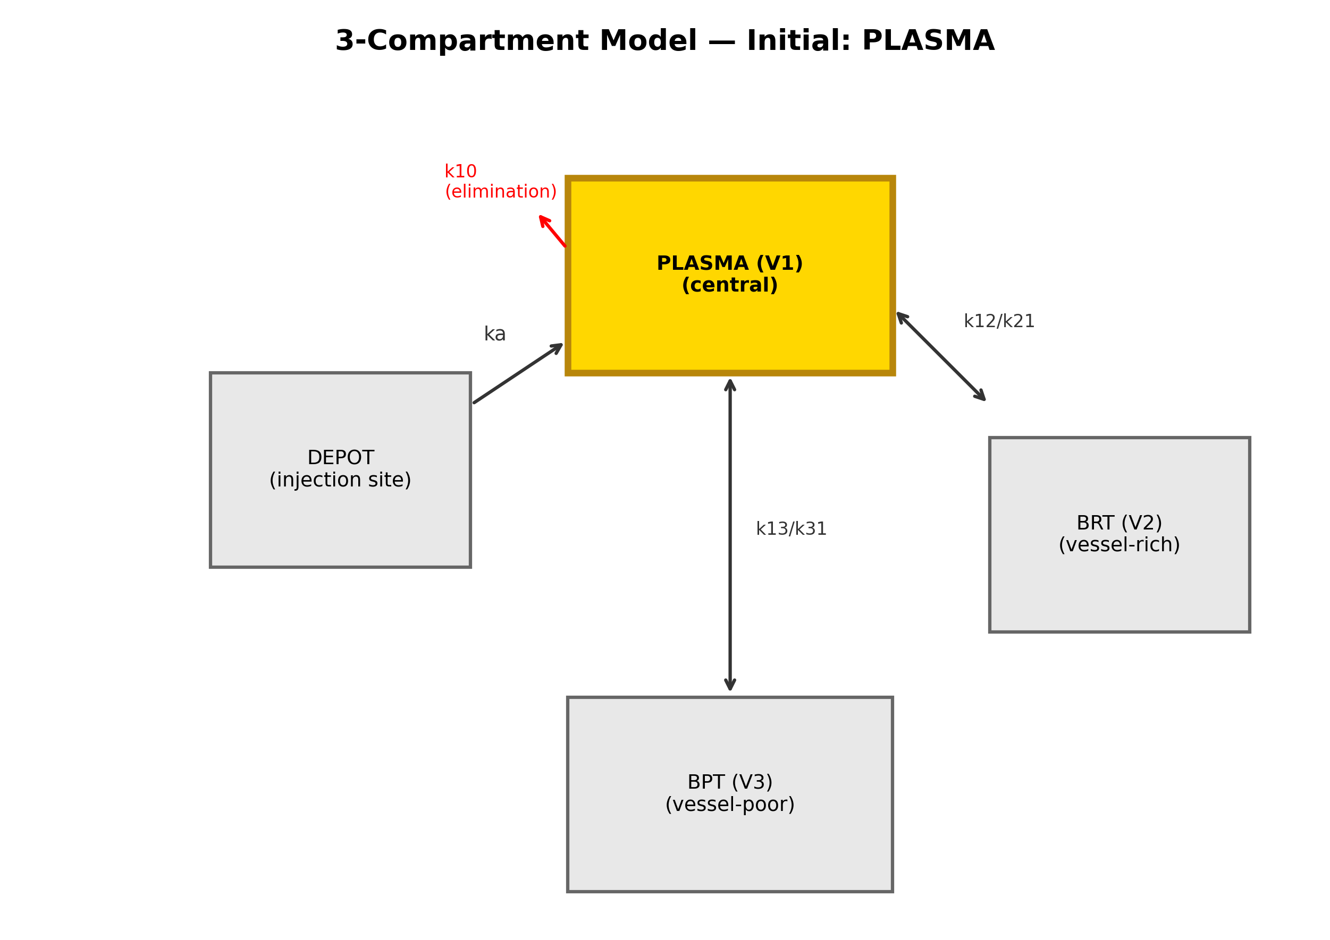
Figure 1. Three-compartment model with selectable initial compartment (plasma highlighted).
Fig. 2 demonstrates the differences in plasma concentration-time profiles when bupivacaine 150 mg is administered to the same patient but with different initial compartments. The plasma-start scenario (equivalent to IV bolus) produces the highest and earliest $C_{max}$, exceeding the CNS toxicity threshold. The BRT-start scenario (failed block) shows intermediate kinetics, while the BPT-start scenario (successful block) produces the lowest and most delayed $C_{max}$, remaining below toxicity thresholds throughout.
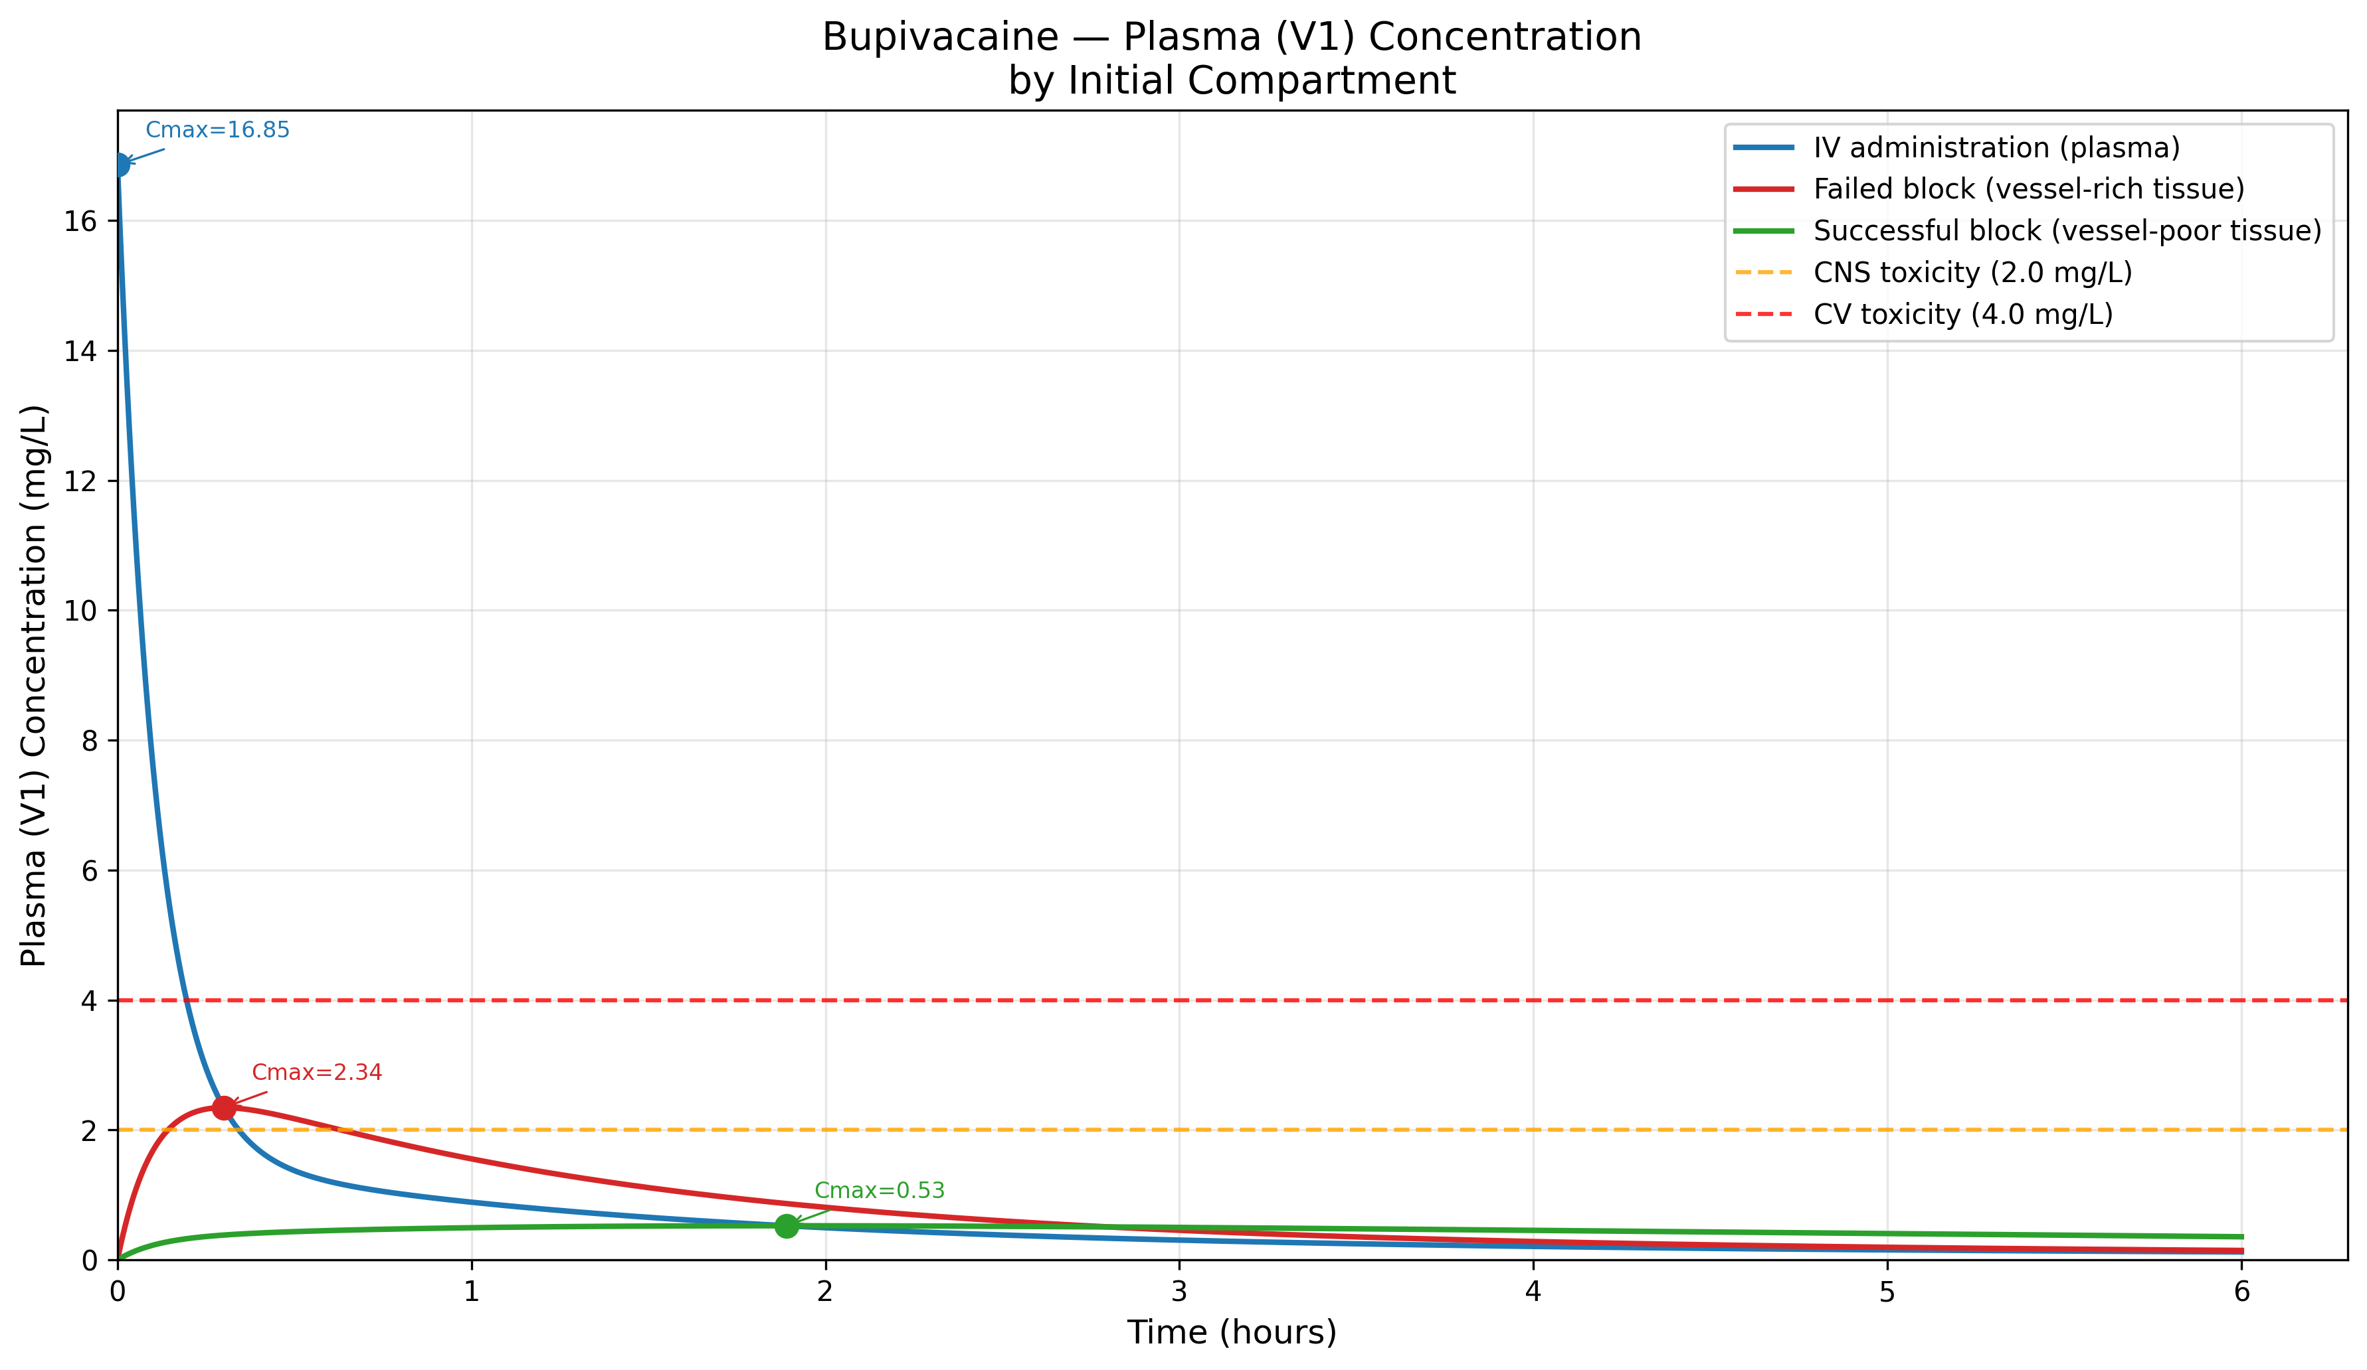
Figure 2. Bupivacaine 150 mg – Plasma concentration by initial compartment with toxicity thresholds.
Fig. 3 extends this comparison to all four local anesthetics.
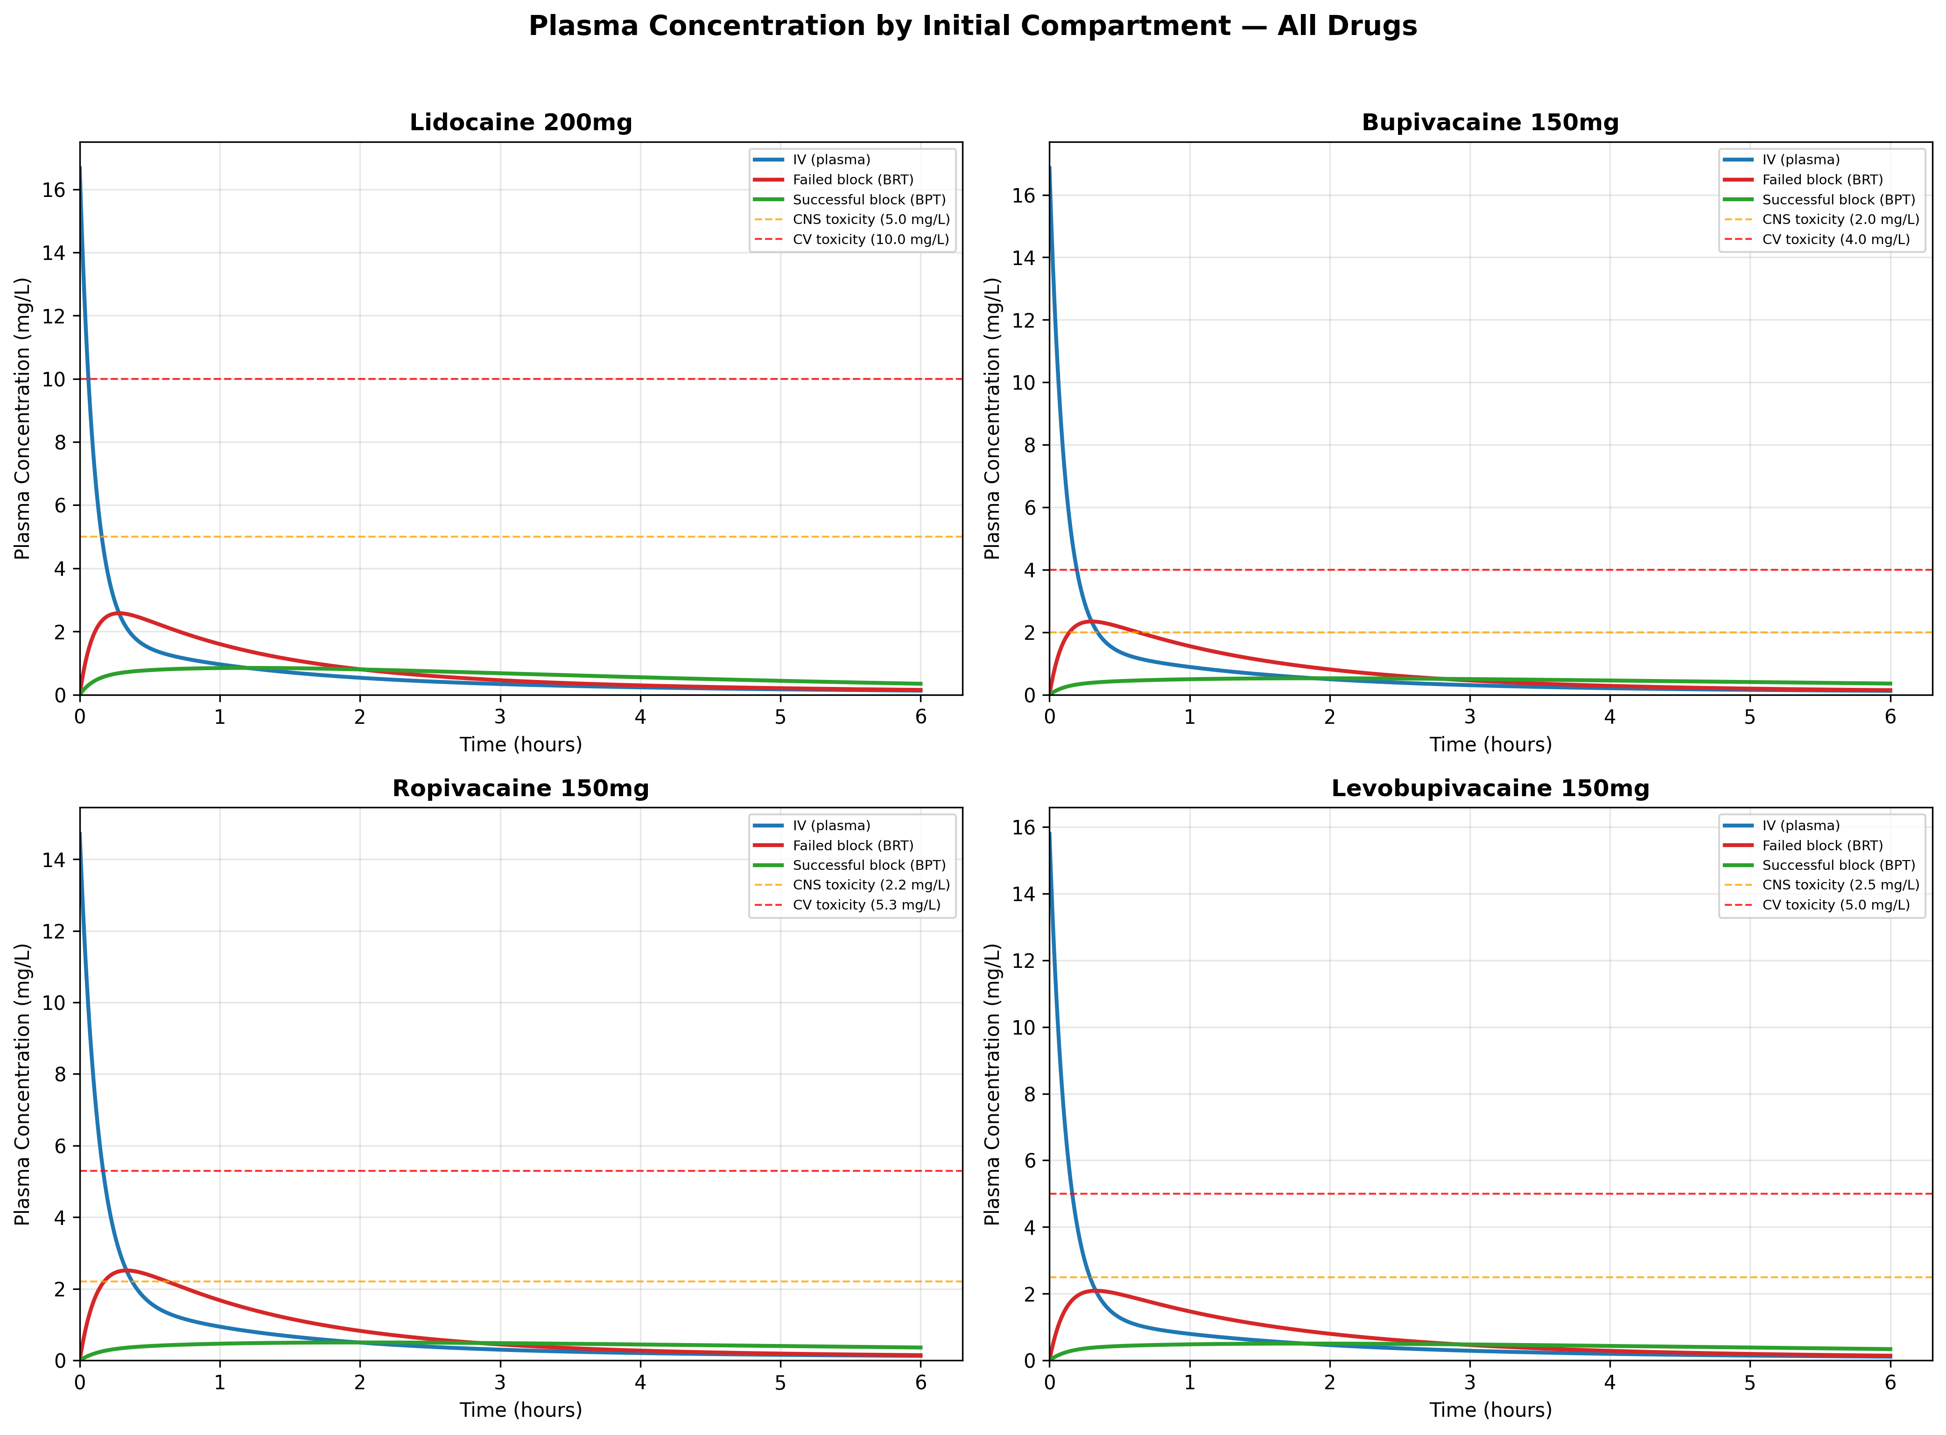
Figure 3. Plasma concentration comparison for all four local anesthetics by initial compartment.
Fig. 4 shows the effect-site concentration and pharmacodynamic response for bupivacaine across initial compartments.
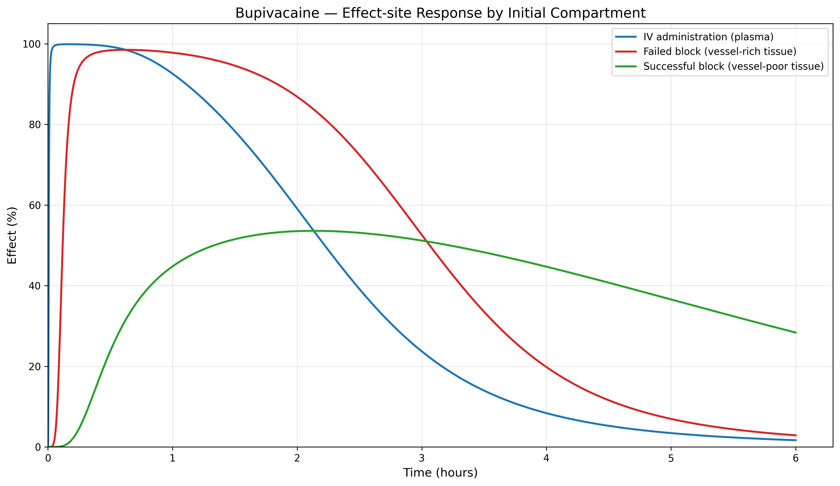
Figure 4. Bupivacaine – Effect-site response by initial compartment.
Fig. 5 shows the full compartment concentration profile for bupivacaine from BPT.
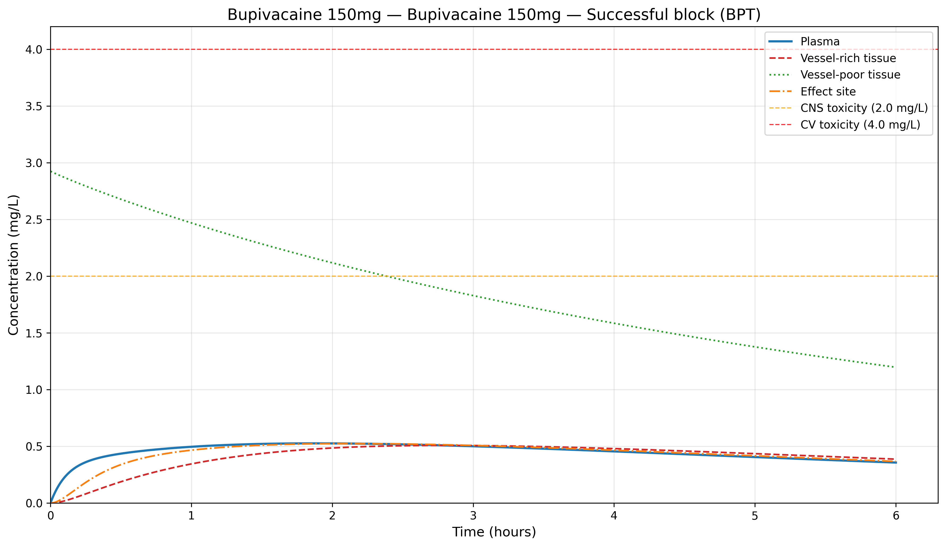
Figure 5. Bupivacaine 150 mg from BPT – Full compartment concentration profile.
Fig. 6 provides a PKPD summary comparing key parameters across initial compartments.
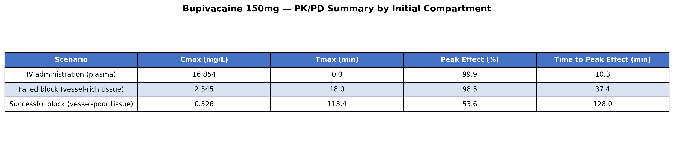
Figure 6. Bupivacaine 150 mg – PKPD summary by initial compartment.

3.2 Illustrative comparison: intravenous-input model vs route-aware scenarios
Conventional PK simulators are constrained to assume intravenous entry (Compartment.PLASMA). For fascial plane blocks and infiltration, yoshika instead lets the user select a route-aware initial compartment (Compartment.DEPOT for fascial plane / infiltration, Compartment.BPT for the vessel-poor-tissue / “successful block” scenario). The rate constants are identical across all scenarios; only the initial conditions differ. The values below are illustrative simulation outputs, not measured or clinically proven predictions; §3.3 compares them against published data.
from yoshika import Compartment, Drug
from yoshika.drugs import DrugLibrary
from yoshika.model import PKModel
params = DrugLibrary.get(Drug.BUPIVACAINE)
# Conventional: forced IV entry (V1/plasma) — inappropriate for fascial plane block
pk_iv = PKModel(
drug_params=params, dose_mg=150,
initial_compartment=Compartment.PLASMA
).solve(duration_min=480)
# yoshika: fascial plane block deposits drug in depot compartment
pk_depot = PKModel(
drug_params=params, dose_mg=150,
initial_compartment=Compartment.DEPOT
).solve(duration_min=480)
print(f"Traditional (IV): Cmax={pk_iv.peak_plasma_concentration:.2f} mg/L, "
f"Tmax={pk_iv.time_to_peak:.0f} min")
print(f"yoshika (Depot): Cmax={pk_depot.peak_plasma_concentration:.2f} mg/L, "
f"Tmax={pk_depot.time_to_peak:.0f} min")
# Conventional (IV): Cmax=16.85 mg/L, Tmax=0 min <- likely overstated for depot route
# yoshika (Depot): Cmax=3.10 mg/L, Tmax=14 min <- plausible for fascial plane
Fig. 7 shows the predicted plasma concentration–time profiles for four fascial plane block / infiltration scenarios. The intravenous-input model (red curves) predicts instantaneous supratoxic $C_{max}$ values (11–17 mg/L) that are not consistent with the concentrations reported after non-intravenous administration (§3.3). yoshika’s depot model (blue curves) predicts a first-order absorption profile with $C_{max}$ of 2–4 mg/L peaking at 12–16 minutes (for the default absorption rates). The vessel-poor-tissue scenario (green dashed curves) yields $C_{max}$ of 0.35–0.85 mg/L peaking substantially later.
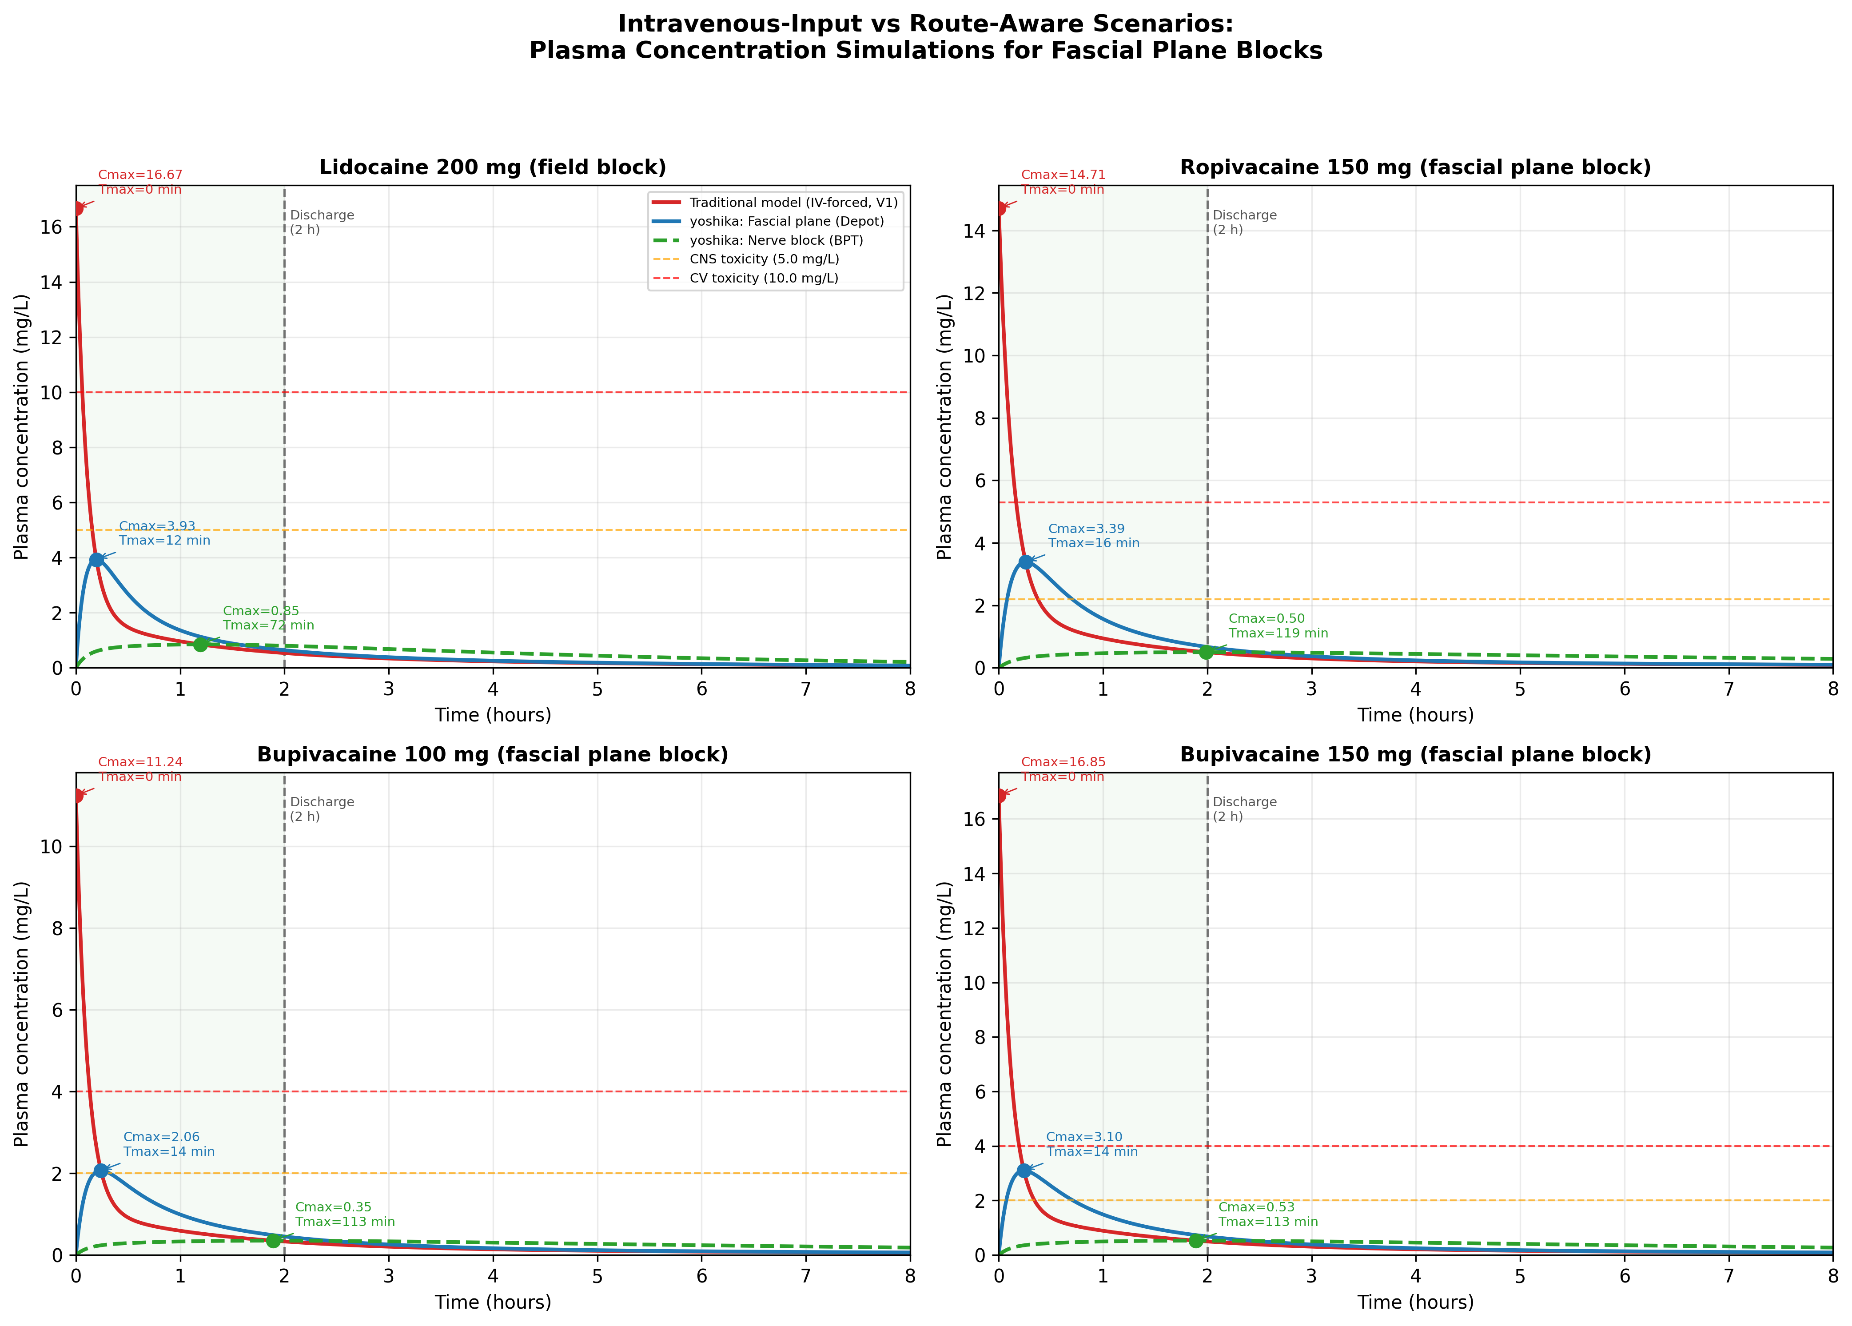
Figure 7. Plasma concentration–time curves: intravenous-input model (red) vs yoshika fascial plane/depot (blue) and vessel-poor-tissue/BPT (green dashed) for four day-surgery scenarios. Green shading = in-hospital monitoring (0–2 h). Dashed lines = CNS and CV toxicity thresholds. Rate constants are shared; only the initial compartment differs.
Fig. 8 compares $T_{max}$ across models and drugs. The intravenous-input model invariably predicts $T_{max}=0$—providing no information about when a peak would occur. yoshika’s depot model yields $T_{max}$ of 12–16 minutes for the default absorption rates, while the vessel-poor-tissue scenario yields much later peaks.
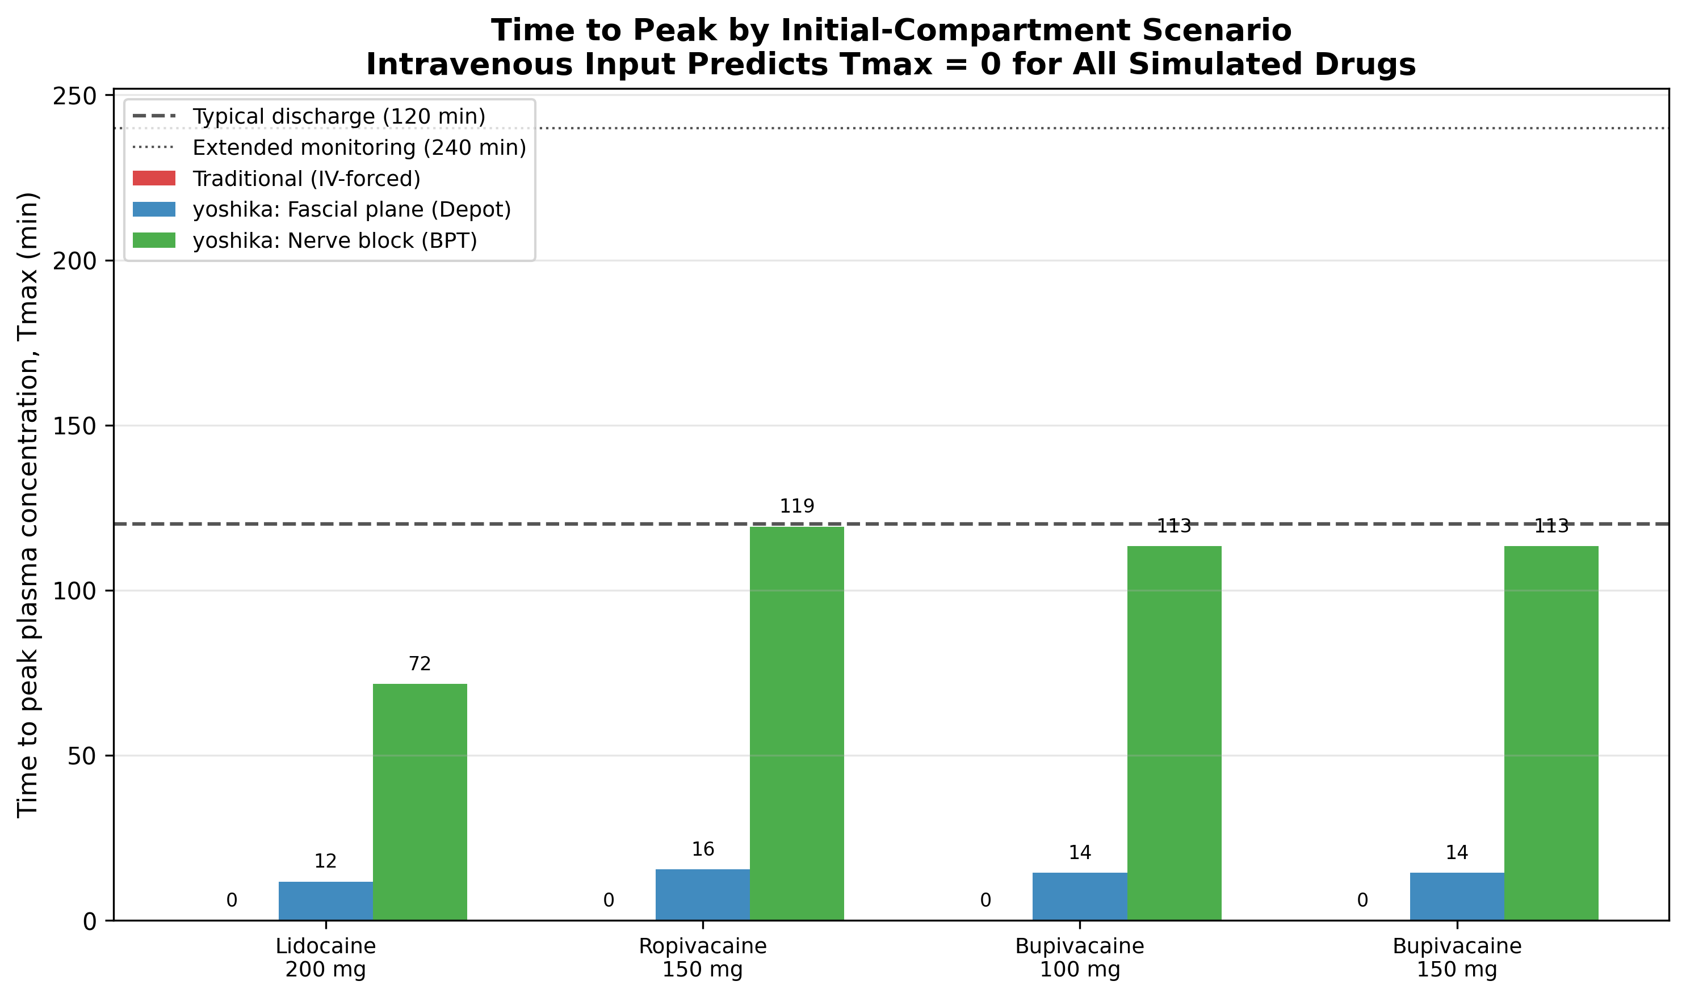
Figure 8. Time to peak plasma concentration ($T_{max}$) by model and drug/dose. The intravenous-input model predicts $T_{max}=0$ for all drugs (IV assumption). The depot scenario yields $T_{max}$ at 12–16 min and the vessel-poor-tissue scenario at 72–119 min (default absorption rates). Horizontal lines = discharge (120 min) and extended monitoring (240 min). Simulation outputs, not measured values.
Fig. 9 maps $T_{max}$ onto a clinical timeline relative to typical day-surgery discharge (2 hours). Grey bars represent the in-hospital monitoring period. The intravenous-input model’s $T_{max}=0$ implies the peak is over immediately, whereas a route-aware simulation points to a later window during which plasma concentration is still rising.
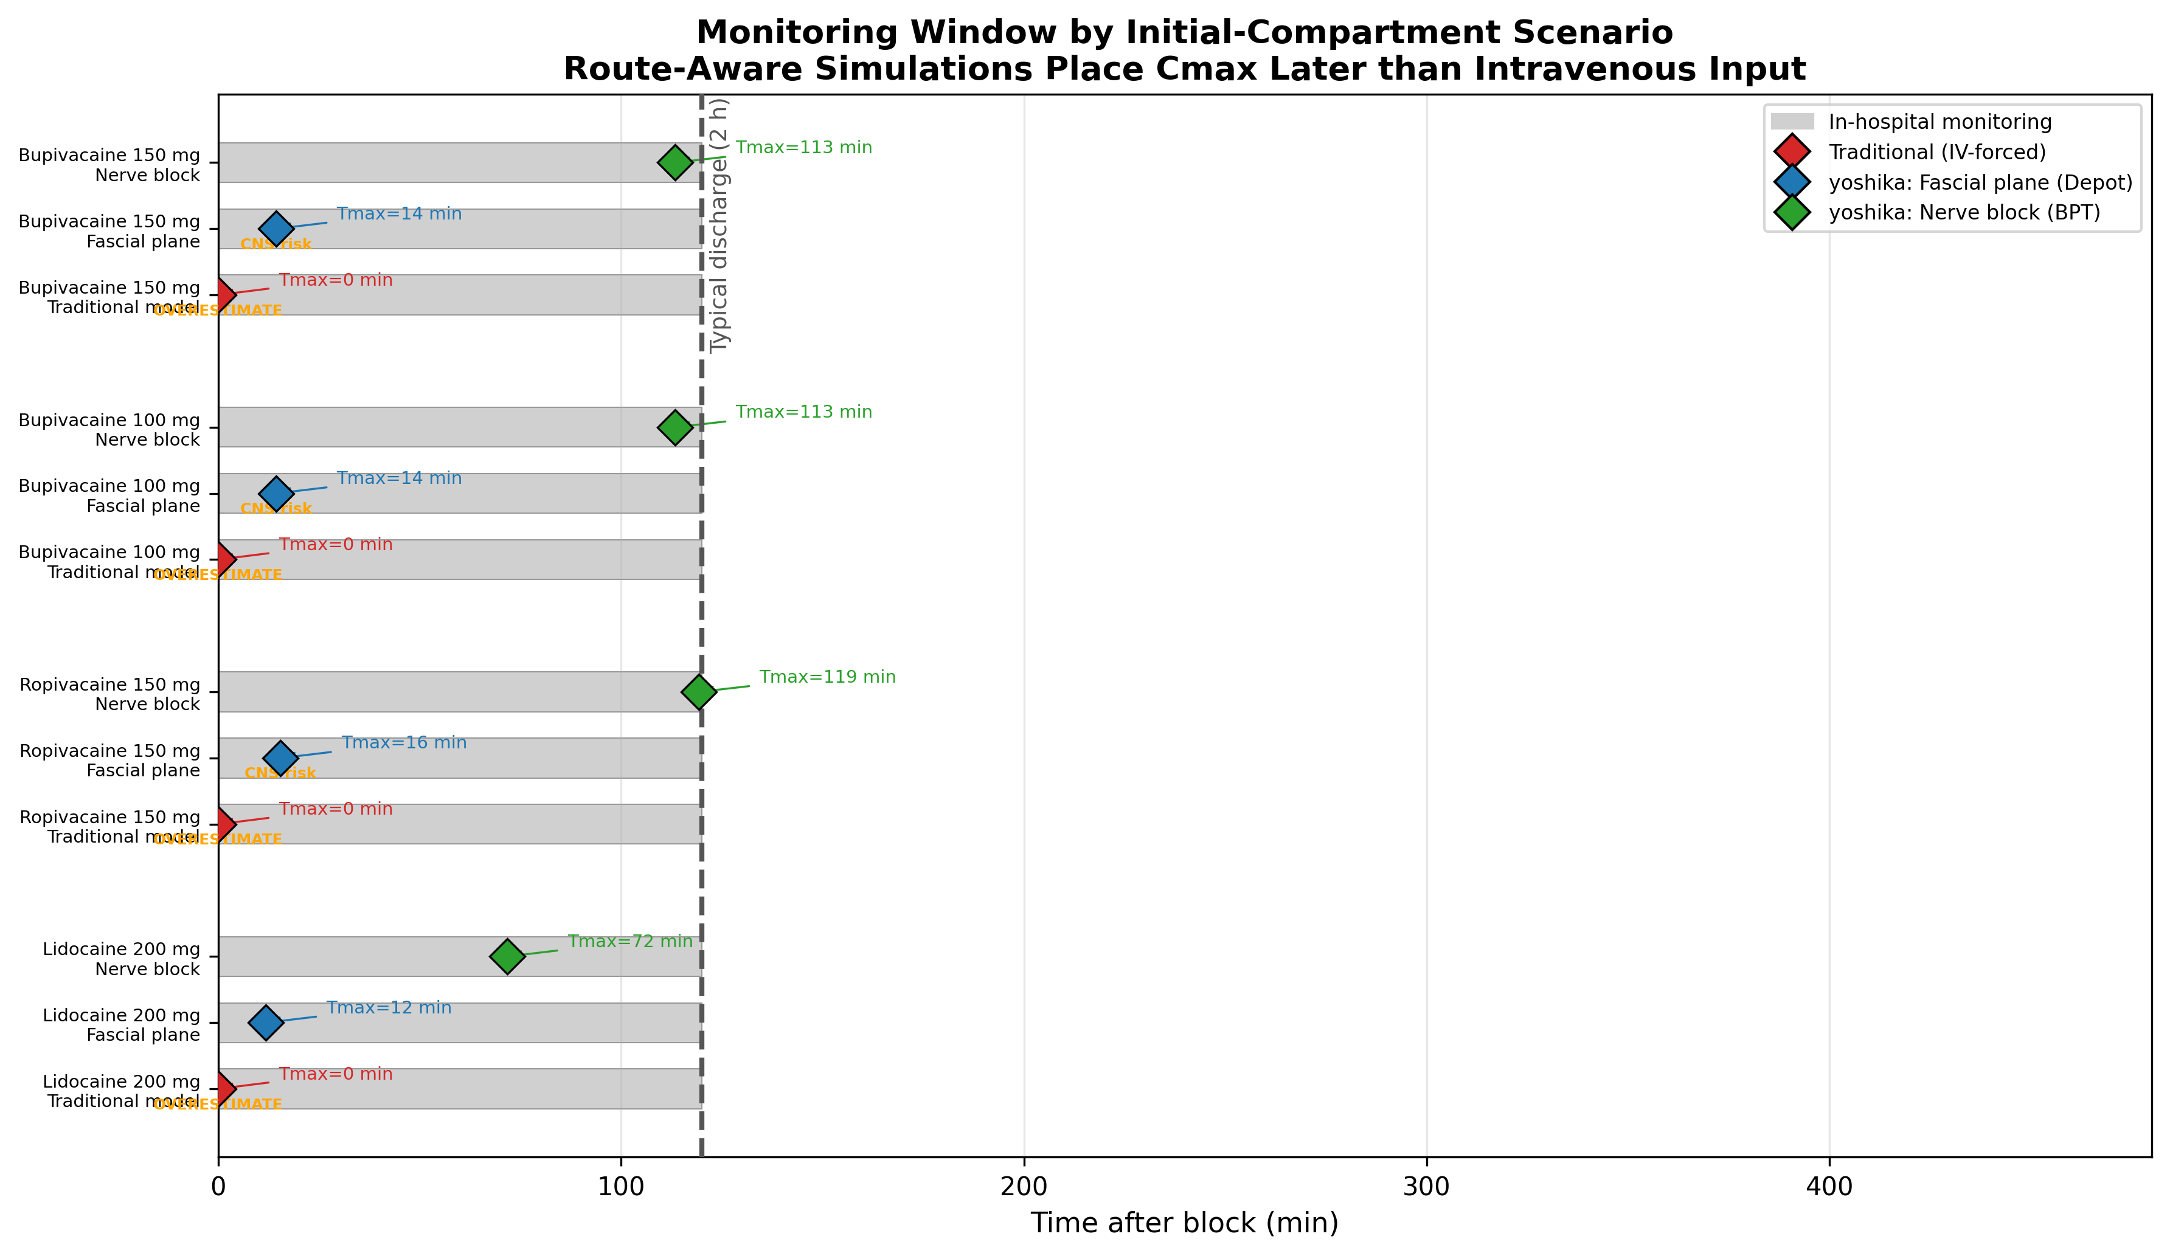
Figure 9. Monitoring window: when does $C_{max}$ occur relative to discharge? Diamond markers = $T_{max}$ under each model. The intravenous-input model (red) places the peak at $t=0$. The route-aware scenarios place the simulated peak later, in the fascial plane and vessel-poor-tissue cases. Simulation scenarios, not clinically proven predictions.
Fig. 10 compares $C_{max}$ against CNS and cardiovascular toxicity thresholds. The intravenous-input model’s overestimation is apparent: predicted $C_{max}$ values exceed even the CV toxicity threshold for all drugs, whereas the depot model shows $C_{max}$ near or below the CNS threshold.
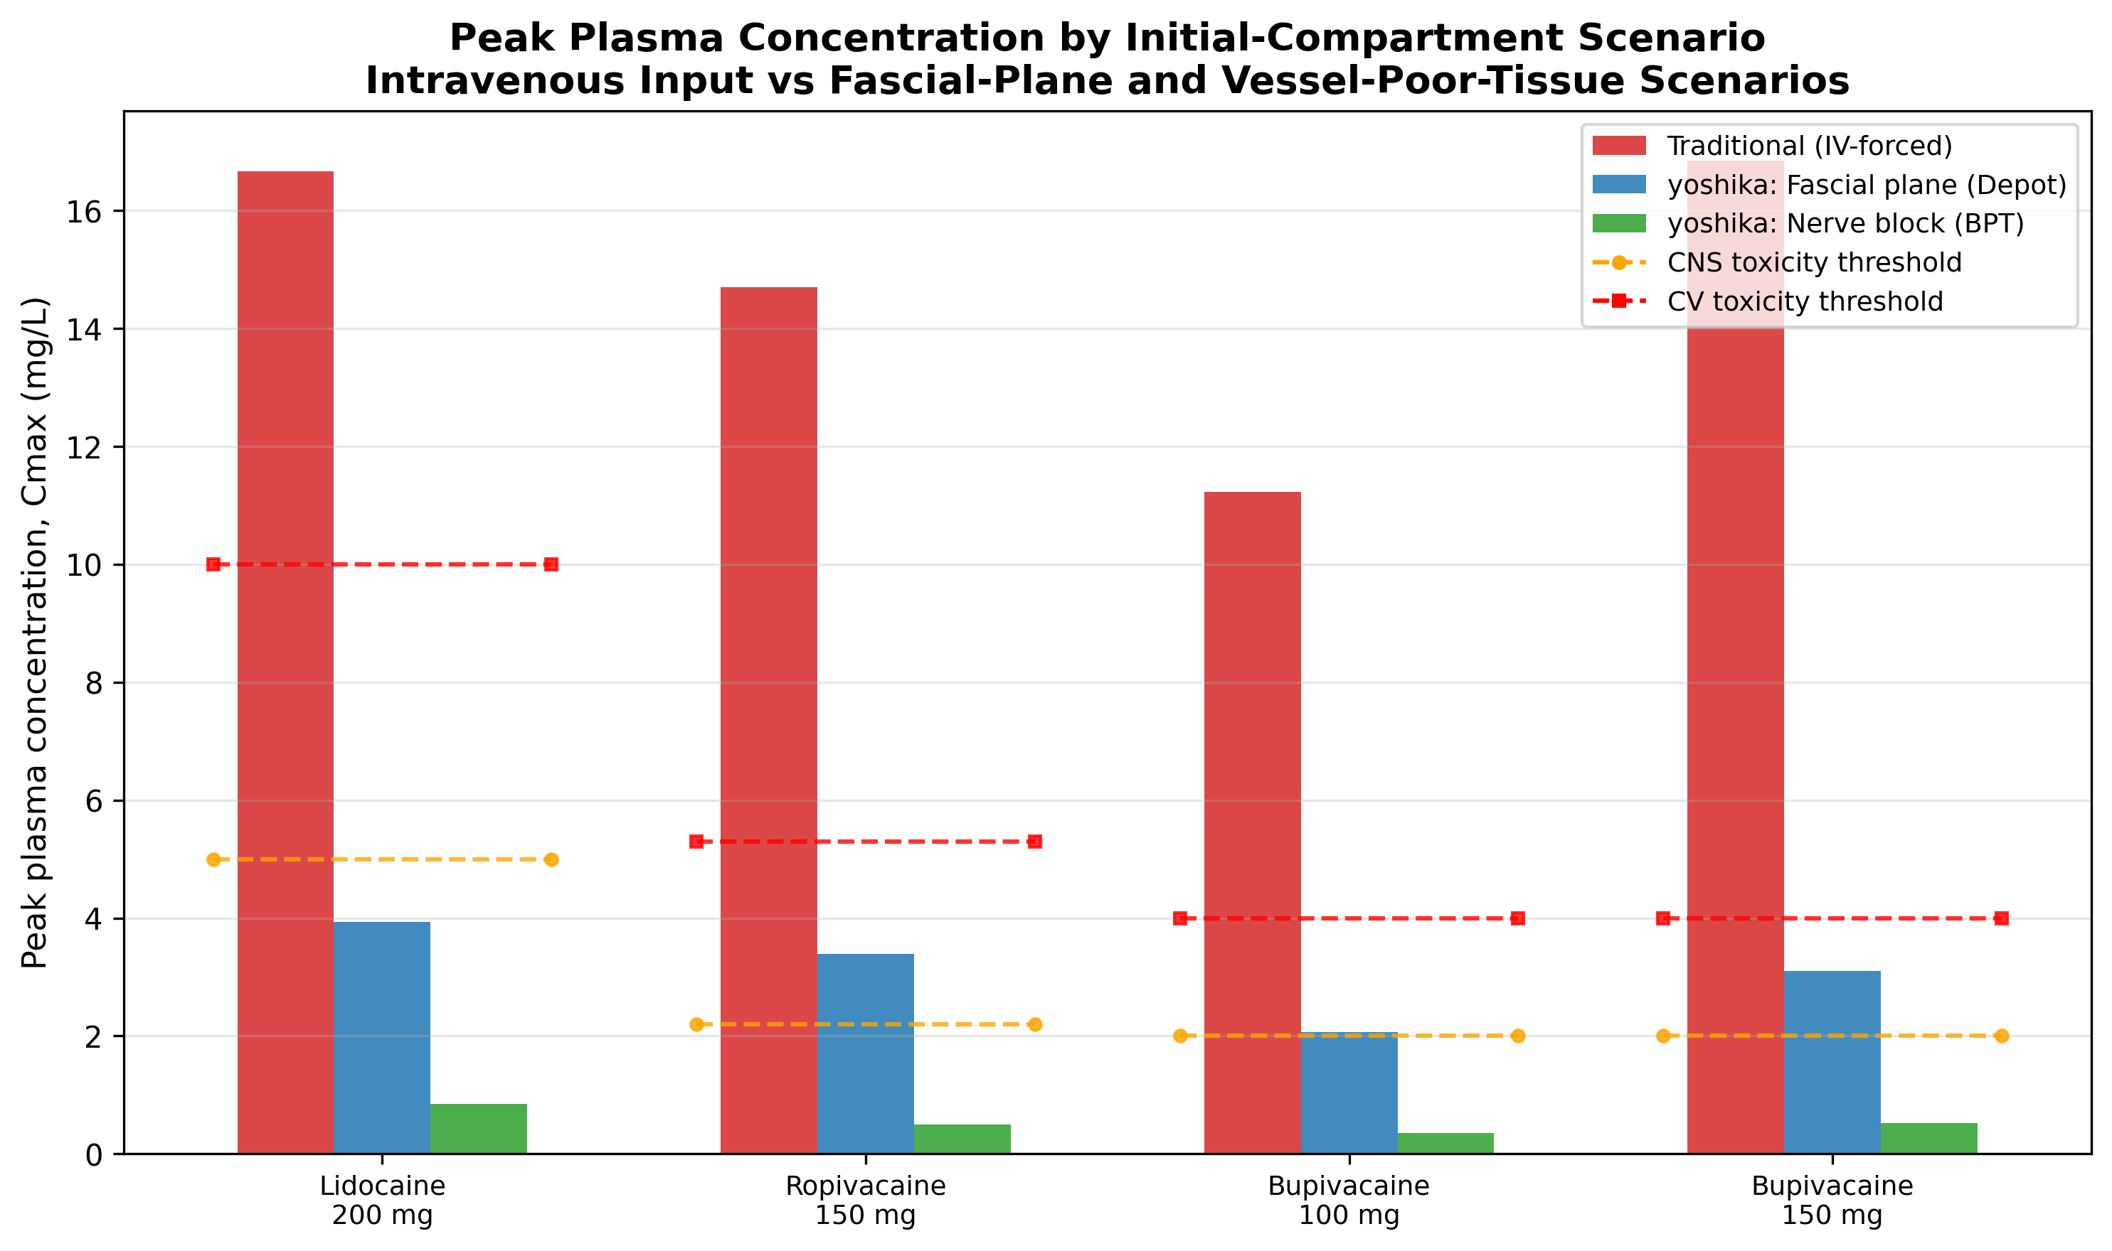
Figure 10. Peak plasma concentration ($C_{max}$) vs toxicity thresholds. The intravenous-input model predicts $C_{max}$ well above the thresholds for non-intravenous routes; the depot and vessel-poor-tissue scenarios predict lower values closer to those reported in published studies (§3.3). Simulation outputs.
Fig. 11 summarizes these simulations, noting that the depot model can predict $C_{max}$ near or above the CNS threshold for ropivacaine 150 mg and bupivacaine 100–150 mg—model-based signals that, if borne out, would warrant monitoring through $T_{max}$.
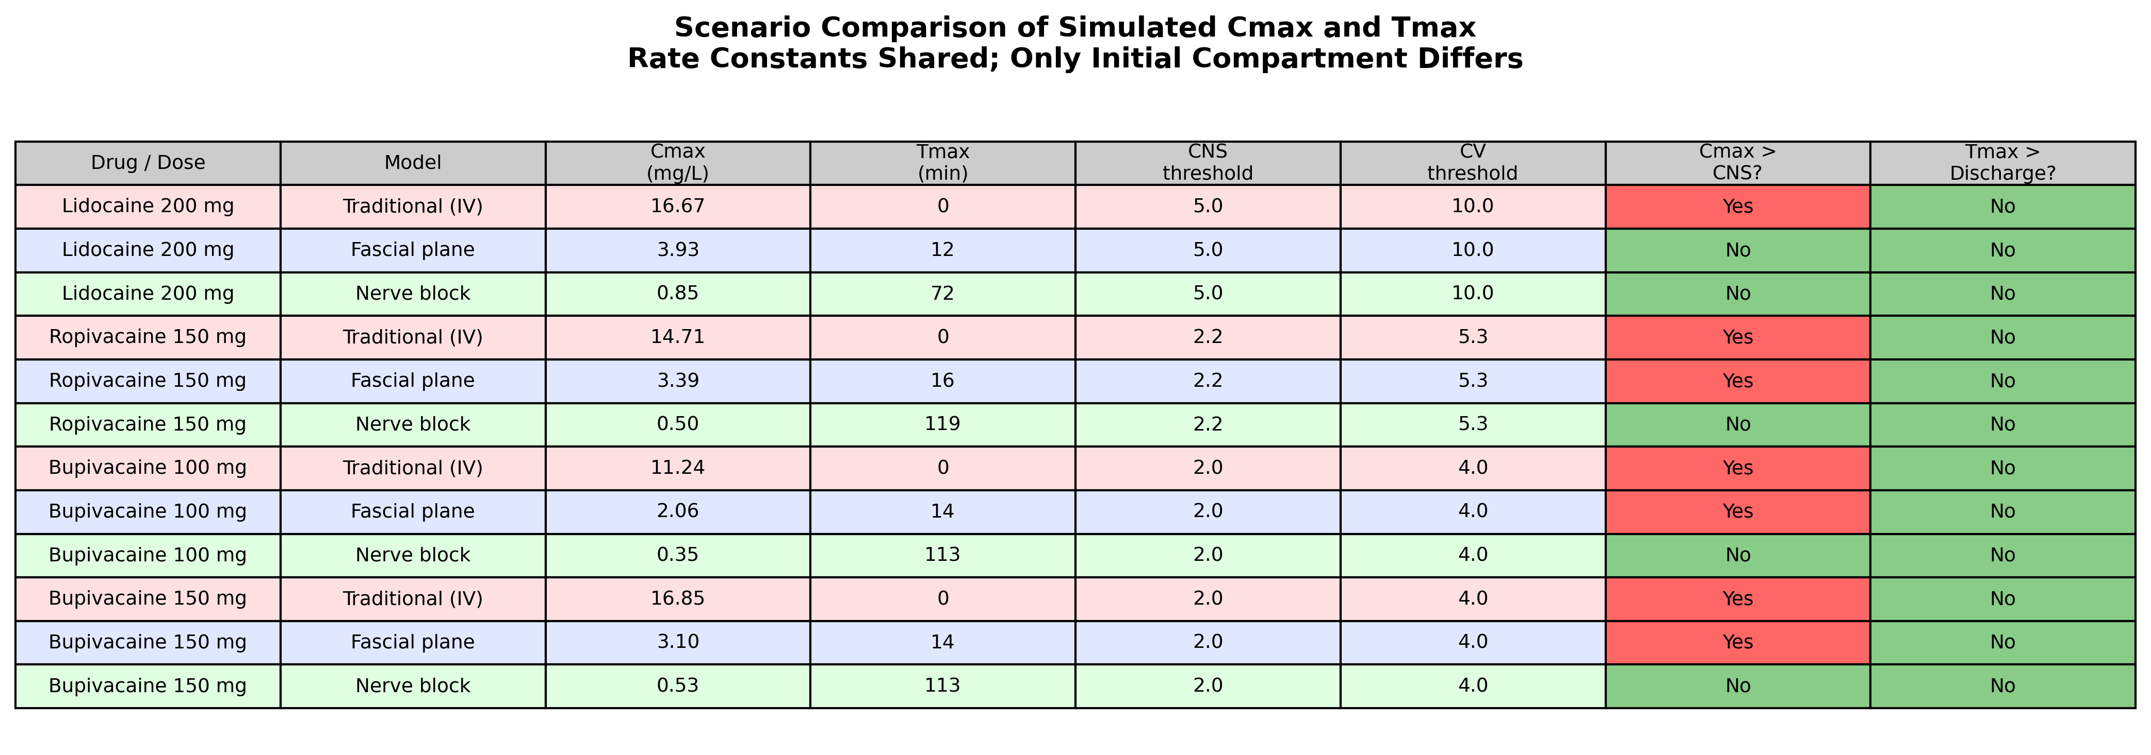
Figure 11. Safety summary: rate constants shared across all models; only initial compartment differs. Red cells = $C_{max}$ exceeds CNS threshold or $T_{max}$ exceeds discharge time. Pink rows = intravenous-input; blue = fascial plane (depot); green = vessel-poor-tissue (BPT).

3.3 External validation against published plasma concentration data
The illustrative outputs above raise an empirical question central to this work: can a three-compartment model with disposition parameters derived from intravenous data, combined with a first-order absorption (depot) input, reproduce plasma concentrations actually observed after non-intravenous administration? To address the concern that the model’s clinical interpretation is otherwise unvalidated, we compared model predictions against ten records digitized from published clinical pharmacokinetic studies spanning intercostal blocks [12,13], fascial plane blocks (transversus abdominis plane [TAP] and rectus sheath) [14], peripheral nerve blocks (brachial and axillary plexus) [15,16], and epidural administration [17], covering ropivacaine, bupivacaine, and lidocaine.
For each study we used the built-in disposition parameters unchanged and calibrated only the depot absorption rate constant $k_{a}$ so that the predicted time-to-peak matched the reported $T_{max}$ (a single degree of freedom per study, reflecting that absorption rate is the route- and site-specific quantity not contained in intravenous disposition data). We then compared the predicted peak concentration $C_{max}$ against the observed value, and contrasted this with the intravenous-input (“IV-forced”) baseline in which the whole dose is placed in plasma at $t=0$. The full record set is given in Table 4.
Table 4. External validation against published plasma concentration data. k_{a} was calibrated to the observed T_{max}; disposition parameters were unchanged. Fold error is predicted/observed C_{max}. The intravenous-input baseline predicts T_{max}=0 for every record.
Study (route) | Drug | Dose (mg) | Obs C_{max} | Pred C_{max} | Fold | Obs T_{max} (min) | IV C_{max} | Ref
Intercostal 0.75% (venous) | ropivacaine | 150 | 2.4 | 4.69 | 1.96 | 11 | 14.7 | [12]
Intercostal 1.0% (venous) | ropivacaine | 200 | 2.5 | 5.87 | 2.35 | 12 | 19.6 | [12]
Bilateral intercostal (venous) | ropivacaine | 140 | 1.1 | 2.20 | 2.00 | 21 | 13.7 | [13]
Bilateral intercostal (venous) | bupivacaine | 140 | 0.9 | 1.28 | 1.42 | 30 | 15.7 | [13]
TAP block (arterial) | ropivacaine | 150 | 1.83 | 1.40 | 0.76 | 35 | 14.7 | [14]
Rectus sheath (arterial) | ropivacaine | 150 | 1.79 | 1.03 | 0.57 | 53 | 14.7 | [14]
Brachial plexus (venous) | ropivacaine | 190 | 1.3 | 1.30 | 1.00 | 53 | 18.6 | [15]
Axillary plexus (venous) | ropivacaine | 175 | 1.28 | 1.21 | 0.95 | 52 | 17.2 | [16]
Axillary plexus (venous) | bupivacaine | 175 | 1.28 | 1.06 | 0.83 | 58 | 19.7 | [16]
Epidural 2% (venous) | lidocaine | 350 | 2.3 | 3.70 | 1.61 | 20 | 29.2 | [17]
Across the ten records, the geometric mean fold error of predicted versus observed $C_{max}$ was 1.51, with 9 of 10 predictions (90%) within two-fold of observation and a Pearson correlation of $r=0.81$ (Fig. 12).
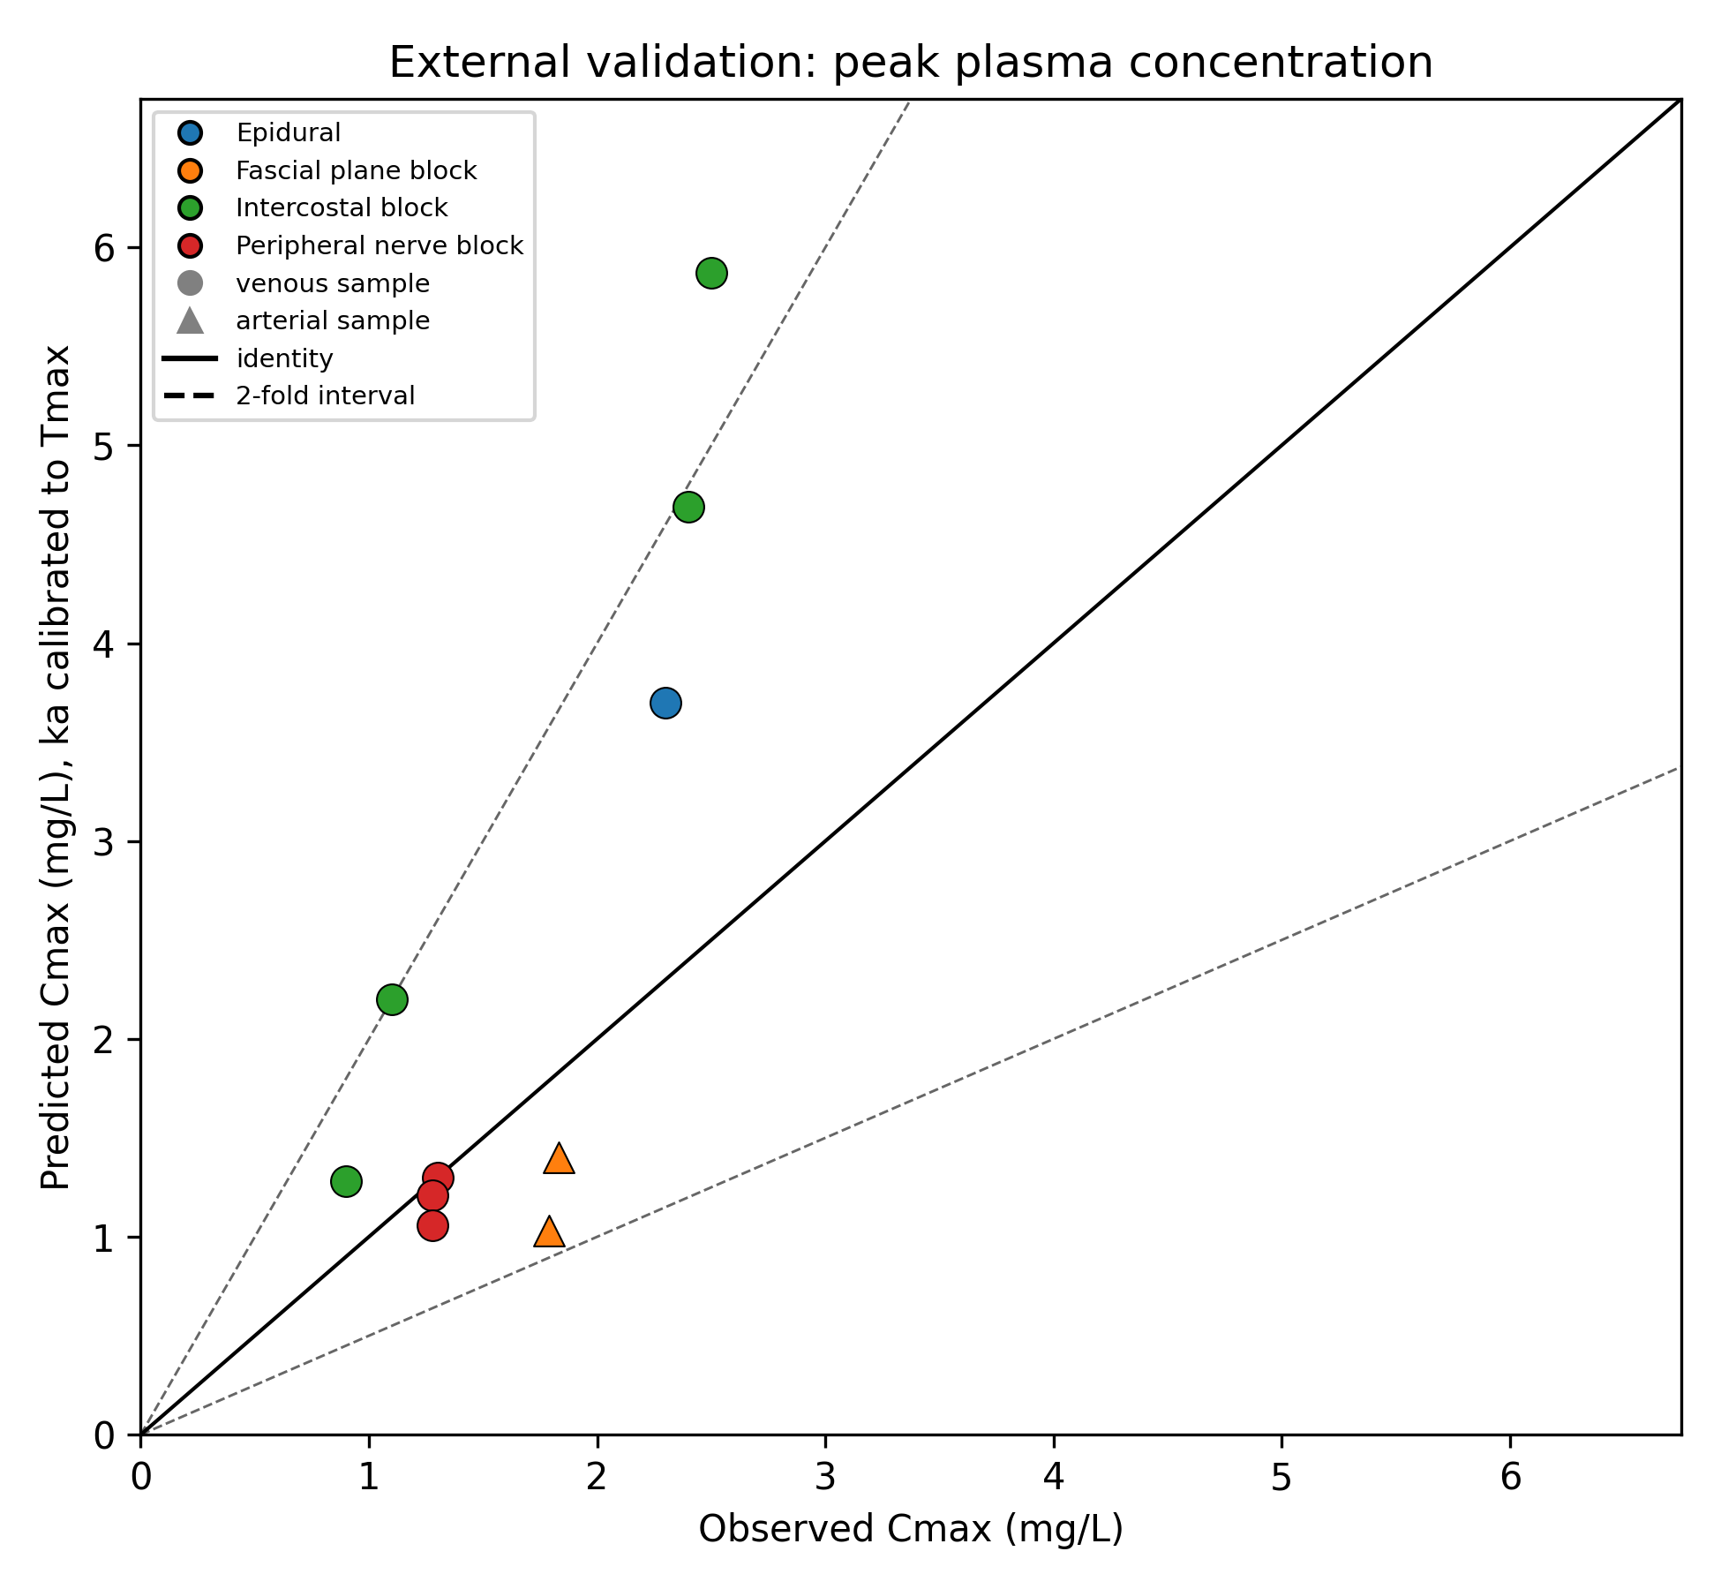
Figure 12. External validation: observed vs predicted $C_{max}$ (depot model, $k_{a}$ calibrated to observed $T_{max}$). Solid line = identity; shaded band = two-fold. 90% of predictions lie within two-fold (geometric mean fold error 1.51; $r=0.81$). Marker shape distinguishes venous (circle) and arterial (triangle) sampling.
By contrast, the intravenous-input baseline predicted $C_{max}$ of 14–29 mg/L—roughly an order of magnitude above the observed range of 0.9–2.5 mg/L—and predicted an instantaneous peak ($T_{max}=0$) for every study, whereas observed peaks occurred 11–58 minutes after injection (Fig. 13).
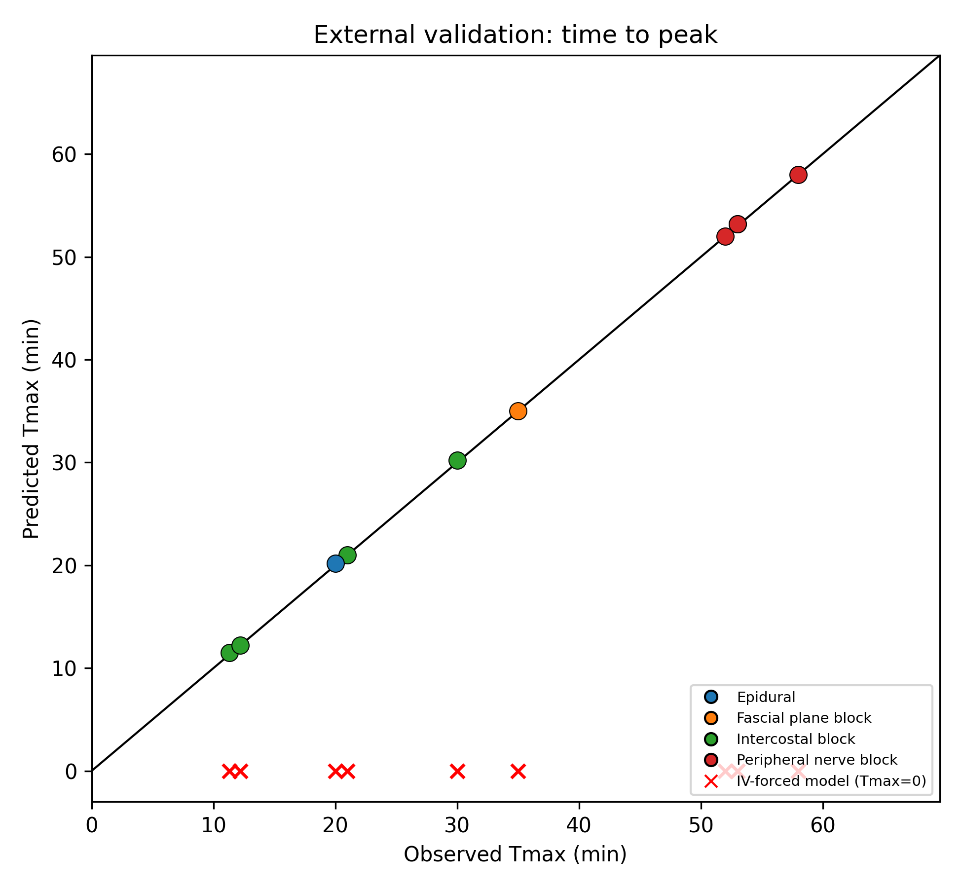
Figure 13. External validation: observed vs predicted $T_{max}$. The depot model reproduces the observed 11–58 min peaks (points near identity), whereas the intravenous-input baseline predicts $T_{max}=0$ for every study (red crosses along the horizontal axis).
Two patterns are worth stating plainly rather than obscuring. First, the model tended to overestimate $C_{max}$ for the fastest-absorbing intercostal records sampled from venous blood (fold errors up to 2.35), and to give its closest agreement for the slower peripheral nerve and fascial plane blocks. This is the expected direction of error: the disposition volumes are intravenous-derived, and venous samples underestimate the true arterial peak, so a model calibrated only on timing will read slightly high against venous $C_{max}$. Second, the two fascial plane records sampled from arterial blood were the only cases where the model modestly under-predicted (fold 0.57–0.76), consistent with the same sampling-site argument. We therefore interpret the validation as showing that the approach reproduces the correct order of magnitude and the qualitative timing of systemic exposure across routes—a substantial improvement over the intravenous-input assumption—while not being accurate enough to support quantitative dosing decisions. This distinction motivates the framing of yoshika as an exploratory and educational tool (§4).
Representative concentration-time curves for four administration routes are shown in Fig. 14.
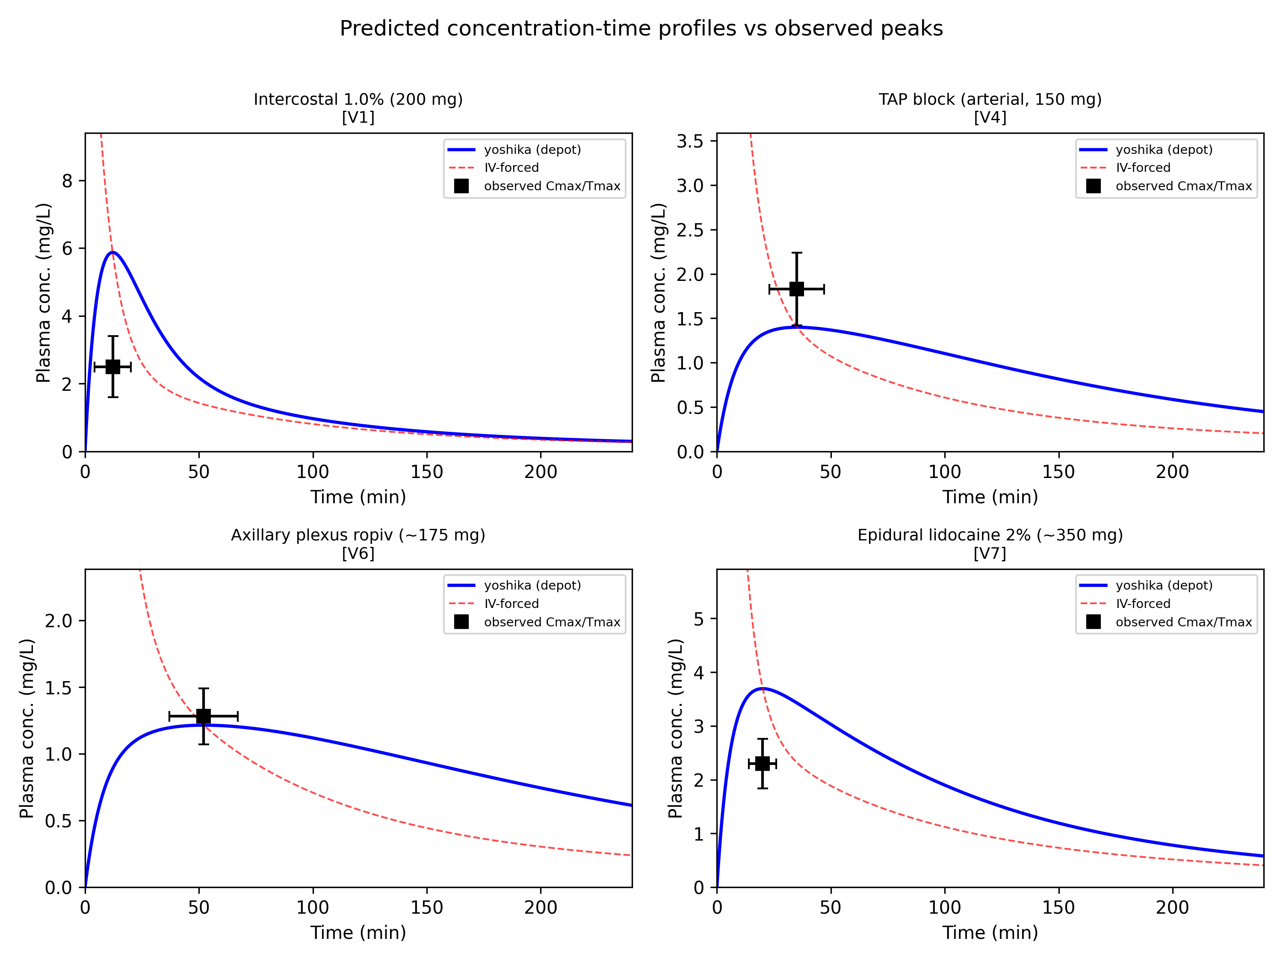
Figure 14. Representative predicted concentration-time curves (yoshika depot, blue; intravenous-input baseline, red dashed) against observed peak $C_{max}±$SD (black squares) for intercostal, TAP, axillary plexus, and epidural cases. The intravenous-input curve peaks off-scale at $t=0$; the depot curve tracks the observed peak magnitude and timing.

4. Discussion

4.1 Nature of the contribution and relation to existing models
We want to be explicit about what is and is not novel here, since this was a central point in review. yoshika does not introduce a new pharmacokinetic model. The equations are a standard three-compartment mammillary model with an optional first-order depot input, and placing the dose in a different compartment at $t=0$ is a mathematically trivial change of initial conditions. Existing frameworks such as the Python Anesthesia Simulator [2] already solve compartmental PK systems, and the disposition parameters we use are drawn from established clinical pharmacokinetic literature [10,11].
We also stress that the improved agreement in §3.3 is not, and should not be read as, a new predictive capability unreachable by conventional tools. Any standard compartmental simulator that adds a depot input and fits its absorption rate can reproduce exactly the same curves and the same validation result; there is no mathematics here that a conventional model cannot express. What the intravenous-input baseline gets wrong is therefore not a limitation of compartmental modelling but a limitation of its default use—placing the entire dose in plasma at $t=0$ regardless of the administration route. The value we claim is in making that default choice explicit and easy to vary and compare, and in testing it, rather than in any new equation.
Framed this way, the contribution is threefold and methodological. First, yoshika is, to our knowledge, the first open-source tool that treats the initial compartment as a first-class, user-selectable input for local anesthetics and makes systematic scenario-to-scenario comparison under shared disposition parameters straightforward and reproducible. Second, the paper draws attention to a consequence of this trivial change that is easy to overlook in intravenous-oriented simulators and in routine mg/kg-based practice: the choice of input compartment changes the predicted peak concentration by about an order of magnitude and moves the predicted peak from $t=0$ to tens of minutes later. Third—and this is what elevates the work above a mere software option—we provide an external validation (§3.3) showing that, with a single route-specific absorption parameter, the standard model reproduces observed $C_{max}$ within two-fold in 90% of ten published datasets, whereas the intravenous-input assumption is wrong by roughly an order of magnitude in both magnitude and timing. The novelty is thus a validated methodology and tool, not a new equation.

4.2 Potential applications
Framed as an exploratory and educational tool, yoshika may be useful across several domains.
Route-aware exploration of systemic exposure. The comparison in §3.2 and the validation in §3.3 together suggest that the intravenous-input assumption substantially overstates $C_{max}$ for fascial plane blocks and infiltration and mis-times the peak. A route-aware simulation gives predictions closer to reported concentrations and points to a plausible later monitoring window. We frame these as hypotheses for prospective testing rather than dosing instructions.
Block success as a real-time input to scenario selection. A practical extension follows from the observation that regional block success is accompanied by measurable local vascular and sympathetic changes: a successful block produces sympathectomy-mediated vasodilation that can be detected non-invasively, for example as an increase in the pulse-oximeter perfusion index or in skin temperature [18,19]. In principle such a signal could be used to inform the choice of input scenario in real time—if a block appears successful, the slow-release (vessel-poor-tissue) scenario may describe systemic exposure better than the intravenous-input assumption, implying a lower and later peak and hence a correspondingly later window for vigilance against delayed LAST; if the block appears to have failed, a faster-absorption scenario with earlier monitoring would be the more prudent default. We present this as a hypothesis enabled by the tool, not a validated protocol: prospective studies linking an objective block-success signal to measured plasma concentrations would be required before any such use.
Clinical pharmacology and toxicology. By making explicit how the assumed input route changes predicted peak concentration and timing, yoshika offers a computational aid for reconsidering how intravenous-derived mg/kg limits are applied to regional anesthesia, where absorption kinetics differ [3,6]. The context-sensitive maximum dose framework (Table 1) is presented as a conceptual proposal to be tested, not an established guideline.
Anesthesia information management systems. yoshika demonstrates that route-adaptive PKPD simulation is computationally inexpensive with standard ODE solvers and could in principle be integrated into AIMS infrastructure, motivating administration-route-specific predictions in place of a single intravenous-input model.
Education and training. yoshika provides an interactive environment for trainees to visualize how injection site and absorption assumptions affect drug disposition, reinforcing the pharmacokinetic principles underlying regional anesthesia.
Research. Its modular design facilitates extension to new drug models, custom compartment configurations, and population analyses. The bundled validation dataset and pipeline provide a reproducible baseline for future comparison.

4.3 Limitations and future work
Several limitations temper the interpretation of these results.
Lumped compartments and disposition provenance. As emphasized in §1.2, V2 and V3 are fitted lumped compartments, not anatomical spaces, and the disposition parameters are derived from intravenous or systemic data. Transferring them to peripheral injection sites is an approximation; the validation (§3.3) supports order-of-magnitude and timing fidelity but not quantitative accuracy, and the model should not be used for dosing decisions.
Calibration and sampling. In the validation, the absorption rate $k_{a}$ was calibrated to the observed $T_{max}$, so $T_{max}$ agreement is imposed rather than predicted; the independent test is on $C_{max}$. Reported concentrations also depend on sampling site (venous vs arterial) and assay, which contributes to the systematic over- and under-prediction patterns we describe.
Phenomenological description of absorption. The model is a phenomenological compartmental description. The ordinary differential equations are, at a mechanistic level, an approximation to the underlying diffusion (Smoluchowski) processes that govern local anesthetic transfer between tissue, membrane, and aqueous compartments [20,21]. In particular, after injection a substantial fraction of local anesthetic is stored in lipophilic compartments (Schwann cell and other membranes, adipose tissue) and released slowly; more lipophilic agents have larger storage capacity and correspondingly longer duration of action [22,23]. Local tissue acidosis increases the protonated fraction and lowers affinity for these lipophilic compartments, reducing storage capacity and shortening duration of action [21,23]. yoshika’s single depot rate constant lumps all of these effects into one absorption term and does not represent pH- or lipophilicity-dependent storage explicitly.
Perfusion and drug interactions. Local perfusion is a critical determinant of systemic absorption and duration that the fixed rate constants do not capture. Co-administered vasoconstrictors such as adrenaline can prolong duration of action severalfold (as exploited in dental surgery), whereas alcohol-induced vasodilation can shorten it substantially; a combination of local acidosis and vasodilation may in the extreme abolish the anesthetic effect. Representing these perfusion- and pH-dependent effects, ideally by coupling the compartmental model to a diffusion-based description of intraneural and peri-neural transport [20,21], is an important direction for future work.
Scope. Spinal (intrathecal) administration is not modeled (§2.2.5), and only four local anesthetics are parameterized by default. Prospective studies measuring plasma concentration profiles after various block types, with documented block success and sampling site, would be needed to parameterize site-specific absorption and to test the context-sensitive maximum dose hypothesis directly.

5. Conclusion
yoshika is an open-source Python package that makes the initial compartment of drug deposition a selectable input for local anesthetic PKPD simulation. Using a standard three-compartment model, it lets users compare route-aware scenarios—vessel-poor-tissue (“successful block”), vessel-rich-tissue (“failed block”), intravascular (plasma), and depot absorption (fascial plane/epidural)—under shared disposition parameters. Its contribution is methodological and practical rather than a new equation: it provides a reproducible tool for systematic comparison and draws attention, with external validation, to how strongly the assumed input route affects predicted peak exposure and timing.
External validation against ten published datasets indicates that a standard model with a single route-specific absorption parameter reproduces observed peak concentrations within two-fold in 90% of cases, whereas the intravenous-input assumption overstates peak concentration roughly tenfold and mis-times the peak. These findings support using route-aware simulation to generate hypotheses about regional anesthesia systemic exposure and monitoring, while further prospective validation is required before any clinical dosing application. The software is freely available under the MIT license and can be installed via pip.

Declaration of competing interest
The authors declare that they have no known competing financial interests or personal relationships that could have appeared to influence the work reported in this paper.

CRediT authorship contribution statement
Tatsuki Onishi: Conceptualization, Methodology, Software, Validation, Writing – Original Draft, Writing – Review & Editing.

Data availability
yoshika is openly available under the MIT license from its public source repository and from the Python Package Index (pip install yoshika; version 0.1.0). All code, the built-in drug parameters, the digitized validation dataset, and the scripts used to produce every figure and table in this article are included in the repository. The validation data were digitized from the cited published studies; no new patient data were generated.

Funding
This research did not receive any specific grant from funding agencies in the public, commercial, or not-for-profit sectors.

Ethics approval
Not applicable. This study did not involve human participants, human data, or animals; it uses only computational simulation and pharmacokinetic parameters and summary values already published in the cited literature.

Declaration of generative AI and AI-assisted technologies in the writing process
During the preparation of this work the author used generative AI and AI-assisted tools to support software development and to improve the language and readability of the manuscript. After using these tools, the author reviewed and edited the content as needed and takes full responsibility for the content of the publication.

Acknowledgements
The author thanks the reviewers for their constructive comments, which prompted the external validation and the expanded discussion of diffusion-based and perfusion-dependent mechanisms.

References
[1] Eleveld DJ, Colin P, Absalom AR, Struys MMRF. Pharmacokinetic-pharmacodynamic model for propofol for broad application in anaesthesia and sedation. British Journal of Anaesthesia 2018;120:942–59. https://doi.org/10.1016/j.bja.2018.01.018.
[2] Aubouin-Pairault B, Fiacchini M, Dang T. PAS: A Python anesthesia simulator for drug control. Journal of Open Source Software 2023;8:5480. https://doi.org/10.21105/joss.05480.
[3] Rosenberg PH, Veering BT, Urmey WF. Maximum recommended doses of local anesthetics: A multifactorial concept. Regional Anesthesia and Pain Medicine 2004;29:564–75. https://doi.org/10.1016/j.rapm.2004.08.003.
[4] De Cassai A, Geraldini F, Costa F, Tulgar S. Local anesthetics and erector spinae plane blocks: A spotlight on pharmacokinetic considerations and toxicity risks. Expert Opinion on Drug Metabolism & Toxicology 2022;18:537–9. https://doi.org/10.1080/17425255.2022.2122811.
[5] Hughes MA, Glass PSA, Jacobs JR. Context-sensitive half-time in multicompartment pharmacokinetic models for intravenous anesthetic drugs. Anesthesiology 1992;76:334–41. https://doi.org/10.1097/00000542-199203000-00003.
[6] Neal JM, Barrington MJ, Fettiplace MR, Gitman M, Memtsoudis SG, Mörwald EE, et al. The Third American Society of Regional Anesthesia and Pain Medicine practice advisory on local anesthetic systemic toxicity. Regional Anesthesia and Pain Medicine 2018;43:113–23. https://doi.org/10.1097/AAP.0000000000000720.
[7] Macfarlane AJR, Gitman M, Bornstein KJ, El-Boghdadly K, Weinberg G. Updates in our understanding of local anaesthetic systemic toxicity: A narrative review. Anaesthesia 2021;76 Suppl 1:27–39. https://doi.org/10.1111/anae.15282.
[8] Di Gregorio G, Neal JM, Rosenquist RW, Weinberg GL. Clinical presentation of local anesthetic systemic toxicity: A review of published cases, 1979 to 2009. Regional Anesthesia and Pain Medicine 2010;35:181–7. https://doi.org/10.1097/AAP.0b013e3181d2310b.
[9] Virtanen P, Gommers R, Oliphant TE, others. SciPy 1.0: Fundamental algorithms for scientific computing in Python. Nature Methods 2020;17:261–72. https://doi.org/10.1038/s41592-019-0686-2.
[10] Tucker GT, Mather LE. Clinical pharmacokinetics of local anaesthetics. Clinical Pharmacokinetics 1979;4:241–78. https://doi.org/10.2165/00003088-197904040-00001.
[11] Burm AGL. Clinical pharmacokinetics of epidural and spinal anaesthesia. Clinical Pharmacokinetics 1989;16:283–311. https://doi.org/10.2165/00003088-198916050-00002.
[12] Behnke H, Worthmann F, Cornelissen J, Kahl M, Wulf H. Plasma concentration of ropivacaine after intercostal blocks for video-assisted thoracic surgery. British Journal of Anaesthesia 2002;89:251–3. https://doi.org/10.1093/bja/aef185.
[13] Kopacz DJ, Emanuelsson B-M, Thompson GE, Carpenter RL, Stephenson CA. Pharmacokinetics of ropivacaine and bupivacaine for bilateral intercostal blockade in healthy male volunteers. Anesthesiology 1994;81:1139–48. https://doi.org/10.1097/00000542-199411000-00008.
[14] Murouchi T, Iwasaki S, Yamakage M. Chronological changes in ropivacaine concentration and analgesic effects between transversus abdominis plane block and rectus sheath block. Regional Anesthesia and Pain Medicine 2015;40:568–71. https://doi.org/10.1097/AAP.0000000000000288.
[15] Hickey R, Blanchard J, Hoffman J, Sjövall J, Ramamurthy S. Plasma concentrations of ropivacaine given with or without epinephrine for brachial plexus block. Canadian Journal of Anaesthesia 1990;37:878–82. https://doi.org/10.1007/BF03006624.
[16] Vainionpää VA, Haavisto ET, Huha TM, Korpi K, Nuutinen LS, Hollmén AI. A clinical and pharmacokinetic comparison of ropivacaine and bupivacaine in axillary plexus block. Anesthesia & Analgesia 1995;81:534–8. https://doi.org/10.1097/00000539-199509000-00019.
[17] Inoue R, Suganuma T, Echizen H, Ishizaki T, Kushida K, Tomono Y. Plasma concentrations of lidocaine and its principal metabolites during intermittent epidural anesthesia. Anesthesiology 1985;63:304–10. https://doi.org/10.1097/00000542-198509000-00011.
[18] Kus A, Gurkan Y, Gormus SK, Solak M, Toker K. Usefulness of perfusion index to detect the effect of brachial plexus block. Journal of Clinical Monitoring and Computing 2013;27:325–8. https://doi.org/10.1007/s10877-013-9439-4.
[19] Ginosar Y, Weiniger CF, Meroz Y, Kurz V, Bdolah-Abram T, Babchenko A, et al. Pulse oximeter perfusion index as an early indicator of sympathectomy after epidural anesthesia. Acta Anaesthesiologica Scandinavica 2009;53:1018–26. https://doi.org/10.1111/j.1399-6576.2009.01968.x.
[20] Smrkolj V, Pregeljc D, Kavčič H, Umek N, Mavri J. Micro-pharmacokinetics of lidocaine and bupivacaine transfer across a myelinated nerve fiber. Computers in Biology and Medicine 2023;165:107375. https://doi.org/10.1016/j.compbiomed.2023.107375.
[21] Smrkolj V, Kralj J, Mavri J, Umek N. Spatiotemporal dynamics of local anesthetic diffusion in nerve revealed by a 2D computational model. Biophysical Journal 2025;124:3706–16. https://doi.org/10.1016/j.bpj.2025.09.026.
[22] Strichartz GR, Sanchez V, Arthur GR, Chafetz R, Martiny D. Fundamental properties of local anesthetics. II. Measured octanol:Buffer partition coefficients and pKa values of clinically used drugs. Anesthesia & Analgesia 1990;71:158–70. https://doi.org/10.1213/00000539-199008000-00008.
[23] Kavčič H, Umek N, Vintar N, Mavri J. Local anesthetics transfer relies on pH differences and affinities toward lipophilic compartments. Journal of Physical Organic Chemistry 2021;34:e4275. https://doi.org/10.1002/poc.4275.

