yoshika: A Python package for route-aware pharmacokinetic-pharmacodynamic simulation of local anesthetics with a selectable initial compartment
Tatsuki Onishi (ORCID 0000-0001-7261-9062)
Data Science and AI Innovation Research Promotion Center, Shiga University, 1-1-1 Bamba, Hikone, Shiga 522-8522, Japan
Corresponding author: Tatsuki Onishi. Tel: +81-749-27-1023; e-mail: bougtoir@gmail.com
Abstract
yoshika is an open-source Python package for pharmacokinetic-pharmacodynamic (PKPD) simulation of local anesthetics in which the user chooses where the dose is first placed. Conventional simulators put the whole dose in plasma at time zero, which suits intravenous but not regional administration. yoshika instead starts the dose in plasma, vessel-rich tissue, vessel-poor tissue, or a first-order depot and compares concentration-time and effect-site profiles under shared disposition parameters. It ships parameters for four agents, a sigmoid-Emax effect-site model, plotting and tests, and a bundled external-validation pipeline against 10 published clinical datasets, so users can explore, reproducibly, how the administration route shifts peak exposure and its timing.
Keywords
Pharmacokinetics; Local anesthetics; Regional anesthesia; Compartment model; Simulation; Reproducibility
Code metadata
Nr | Code metadata description | Value
C1 | Current code version | v0.1.0
C2 | Permanent link to code/repository used for this code version | https://github.com/bougtoir/yoshika-pkpd
C3 | Permanent link to reproducible capsule | Archived on Zenodo, DOI https://doi.org/10.5281/zenodo.21816213 (concept DOI, resolves to the latest version; v0.1.0 is https://doi.org/10.5281/zenodo.21816214). The archive bundles the package source, tests, external-validation pipeline and published reference values, and a self-contained capsule at paper/software_impacts/reproducible_capsule that reproduces the external-validation results and figures
C4 | Legal code license | MIT License
C5 | Code versioning system used | git
C6 | Software code languages, tools and services used | Python; NumPy, SciPy, Matplotlib, pandas
C7 | Compilation requirements, operating environments and dependencies | Python >= 3.9 (Linux/macOS/Windows); numpy>=1.21, scipy>=1.7, matplotlib>=3.5, pandas>=1.3. Install: pip install yoshika (https://pypi.org/project/yoshika/)
C8 | If available, link to developer documentation/manual | https://github.com/bougtoir/yoshika-pkpd#readme
C9 | Support email for questions | bougtoir@gmail.com
1. Motivation and significance
Local anesthetics used in regional anesthesia are deposited near nerves or in fascial planes, not into the bloodstream. Yet widely used pharmacokinetic (PK) simulation tools (for example STANPUMP, Tivatrainer, and Eleveld-model implementations) assume intravenous administration, placing the entire dose in the central plasma compartment at time zero [1]. General anesthesia simulators such as the Python Anesthesia Simulator [2] solve compartmental PK systems but do not treat the site of initial drug deposition as a routine input. As a result the same model is applied to intravenous boluses and to tissue-deposited regional blocks, even though the route determines when and how high the plasma concentration peaks.
yoshika (Yielding Open Simulation of Hybrid Inter-disciplinary Kinetic Absorption) addresses this by making the initial compartment a user-selectable input. The dose can be placed in plasma (V₁; intravenous), vessel-rich tissue (V₂; e.g. a failed or intravascular block), vessel-poor tissue (V₃; e.g. a successful nerve block), or a first-order depot (e.g. a fascial-plane block or infiltration). All scenarios share the same disposition parameters, so differences arise solely from the modeled route. The equations themselves are a conventional three-compartment mammillary model with an optional depot; yoshika's contribution is not a new equation but a reproducible, openly available way to make the drug-deposition assumption explicit and to compare routes side by side.
2. Software description
yoshika is a small, dependency-light Python package (NumPy, SciPy, Matplotlib, pandas) [3] organized into focused modules:
- compartments: definitions of PLASMA, BRT (vessel-rich tissue), BPT (vessel-poor tissue) and DEPOT and the initial-condition logic selected by the user.
- drugs: a parameter database for lidocaine, bupivacaine, ropivacaine and levobupivacaine, drawn from the clinical PK literature [4,5], plus an API to add custom drugs.
- model: the three-compartment PK system with an optional depot input, solved with SciPy solve_ivp (RK45). A concentration is the amount in a compartment divided by its volume, $C_{i} = \frac{A_{i}}{V_{i}}$.
- pd: an effect-site compartment (k_{e0}) with a sigmoid-Emax response.
- simulator / plotting / utils: a high-level API for single runs and multi-scenario comparison, Matplotlib visualizations, and helpers (AUC, half-life, units).
The initial compartment sets which state receives the dose at t=0 (depot introduces first-order absorption at rate k_{a}); the shared rate constants k₁₀, k₁₂, k₂₁, k₁₃, k₃₁ are unchanged across scenarios. A unit-test suite covers the model, drug database, PD model and utilities. The package is released under the MIT license, versioned with git, installable from PyPI (https://pypi.org/project/yoshika/), and archived on Zenodo [6].
Fig. 1 shows the model with the dose placed in plasma; the same diagram with any other compartment highlighted is produced by changing a single argument.
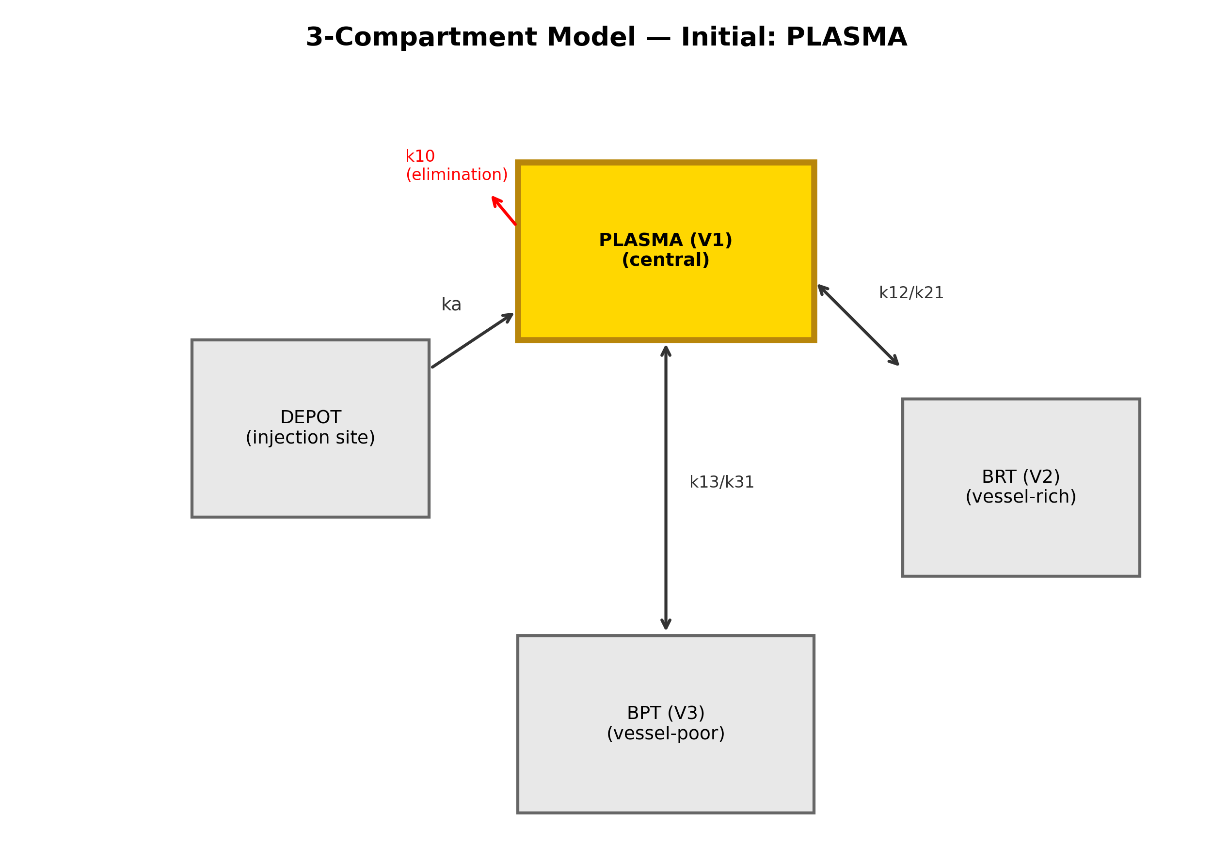
Fig. 1. Three-compartment PK model with optional depot input. The initial compartment (plasma highlighted) is a user-selectable argument; disposition rate constants are shared across scenarios.
3. Illustrative example
Comparing routes for bupivacaine 150 mg in a 70 kg patient takes a few lines; the same disposition parameters are reused across scenarios:
from yoshika import Simulator, Drug
sim = Simulator(drug=Drug.BUPIVACAINE, dose_mg=150, weight_kg=70)
results = sim.compare() # plasma / BRT / BPT scenarios
print(Simulator.summary_table(results))
4. Impact
yoshika enables research questions that intravenous-input simulators make awkward to ask: how much does the assumed deposition route change predicted peak concentration (C_{max}) and time-to-peak (T_{max}), and how well does a standard model reproduce concentrations actually observed after regional administration? To answer the second question the package bundles a reproducible external-validation pipeline. Using the built-in disposition parameters unchanged and calibrating only the depot absorption rate k_{a} to each study's reported T_{max} (one degree of freedom per study), yoshika was compared against 10 published clinical PK records spanning intercostal [7,8], fascial-plane [9], peripheral-nerve [10,11], and epidural [12] routes.
Across the 10 records the geometric mean fold error of predicted versus observed C_{max} was 1.51, with 90% of predictions within two-fold of observation and a Pearson correlation of r = 0.81 (Fig. 2). By contrast, the intravenous-input baseline overestimated C_{max} by roughly an order of magnitude and predicted an instantaneous peak (T_{max} = 0) for every study, whereas observed peaks occurred tens of minutes after injection. The tool thus reproduces the correct order of magnitude and the qualitative timing of systemic exposure across routes, while not being accurate enough for quantitative dosing decisions.
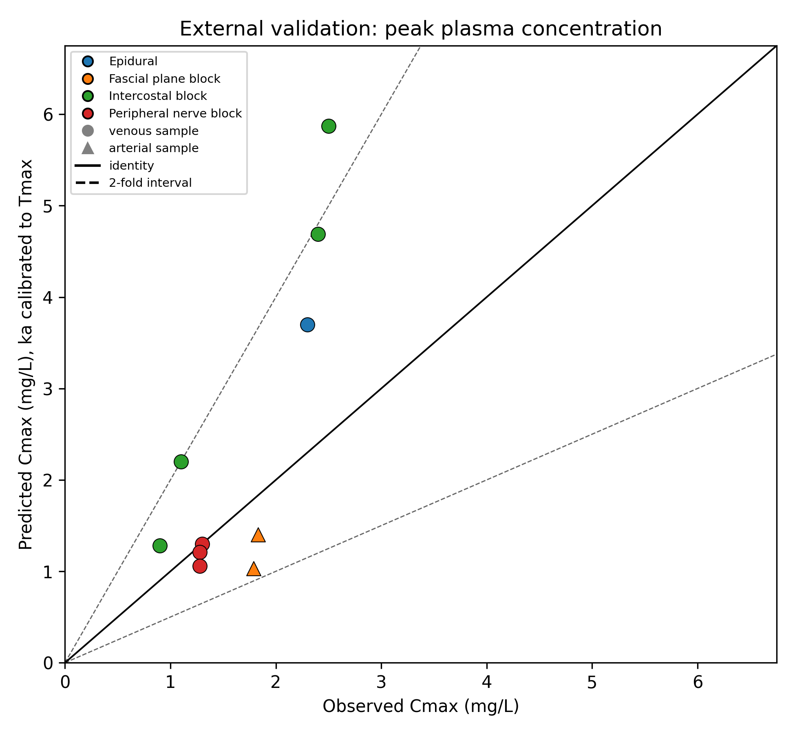
Fig. 2. External validation: observed versus predicted peak plasma concentration (depot model, k_{a} calibrated to observed T_{max}). Solid line, identity; shaded band, two-fold. 90% of predictions lie within two-fold (geometric mean fold error 1.51; r = 0.81).
These results supported a peer-reviewed study of route-dependent systemic-exposure and monitoring-window hypotheses [13], which is the scholarly publication enabled by the software. Beyond that study, the package is intended as an exploratory and educational tool: it lets clinicians and trainees visualize how injection site and absorption assumptions shift peak exposure and its timing, supports reconsidering how intravenous-derived mg/kg limits are applied to regional anesthesia [14], and provides a small, route-aware PKPD component that could be embedded in anesthesia information management systems. The bundled dataset and pipeline give a reproducible baseline for further comparison.
5. Limitations and future work
V₂ and V₃ are fitted lumped compartments, not anatomical spaces, and the disposition parameters are intravenous-derived; transferring them to peripheral injection sites is an approximation supported for order-of-magnitude and timing fidelity but not for quantitative dosing. Spinal (intrathecal) administration is not modeled. The validation relies on summary C_{max}/T_{max} from the literature rather than full digitized curves. Planned work includes additional agents and population-PK support, richer depot/absorption models, and prospective linkage of an objective block-success signal to measured plasma concentrations.
Acknowledgements
None.
Declaration of competing interest
The author declares no known competing financial interests or personal relationships that could have appeared to influence the work reported in this paper.
References
[1] Eleveld DJ, Colin P, Absalom AR, Struys MMRF. Pharmacokinetic-pharmacodynamic model for propofol for broad application in anaesthesia and sedation. British Journal of Anaesthesia 2018;120(5):942-959. https://doi.org/10.1016/j.bja.2018.01.018.
[2] Aubouin-Pairault B, Fiacchini M, Dang T. PAS: a Python Anesthesia Simulator for drug control. Journal of Open Source Software 2023;8(88):5480. https://doi.org/10.21105/joss.05480.
[3] Virtanen P, Gommers R, Oliphant TE, et al. SciPy 1.0: fundamental algorithms for scientific computing in Python. Nature Methods 2020;17(3):261-272. https://doi.org/10.1038/s41592-019-0686-2.
[4] Tucker GT, Mather LE. Clinical pharmacokinetics of local anaesthetics. Clinical Pharmacokinetics 1979;4(4):241-278. https://doi.org/10.2165/00003088-197904040-00001.
[5] Burm AGL. Clinical pharmacokinetics of epidural and spinal anaesthesia. Clinical Pharmacokinetics 1989;16(5):283-311. https://doi.org/10.2165/00003088-198916050-00002.
[6] Onishi T. yoshika: a Python package for pharmacokinetic-pharmacodynamic simulation of local anesthetics with selectable initial compartment (v0.1.0). Zenodo; 2026. https://doi.org/10.5281/zenodo.21816214.
[7] Behnke H, Worthmann F, Cornelissen J, Kahl M, Wulf H. Plasma concentration of ropivacaine after intercostal blocks for video-assisted thoracic surgery. British Journal of Anaesthesia 2002;89(2):251-253. https://doi.org/10.1093/bja/aef185.
[8] Kopacz DJ, Emanuelsson BM, Thompson GE, Carpenter RL, Stephenson CA. Pharmacokinetics of ropivacaine and bupivacaine for bilateral intercostal blockade in healthy male volunteers. Anesthesiology 1994;81(5):1139-1148. https://doi.org/10.1097/00000542-199411000-00008.
[9] Murouchi T, Iwasaki S, Yamakage M. Chronological changes in ropivacaine concentration and analgesic effects between transversus abdominis plane block and rectus sheath block. Regional Anesthesia and Pain Medicine 2015;40(5):568-571. https://doi.org/10.1097/AAP.0000000000000288.
[10] Hickey R, Blanchard J, Hoffman J, Sjovall J, Ramamurthy S. Plasma concentrations of ropivacaine given with or without epinephrine for brachial plexus block. Canadian Journal of Anaesthesia 1990;37(8):878-882. https://doi.org/10.1007/BF03006624.
[11] Vainionpaa VA, Haavisto ET, Huha TM, Korpi K, Nuutinen LS, Hollmen AI. A clinical and pharmacokinetic comparison of ropivacaine and bupivacaine in axillary plexus block. Anesthesia & Analgesia 1995;81(3):534-538. https://doi.org/10.1097/00000539-199509000-00019.
[12] Inoue R, Suganuma T, Echizen H, Ishizaki T, Kushida K, Tomono Y. Plasma concentrations of lidocaine and its principal metabolites during intermittent epidural anesthesia. Anesthesiology 1985;63(3):304-310. https://doi.org/10.1097/00000542-198509000-00011.
[13] Onishi T. yoshika: a Python package for pharmacokinetic-pharmacodynamic simulation of local anesthetics with selectable initial compartment. Array 2026;31:101106. https://doi.org/10.1016/j.array.2026.101106.
[14] Neal JM, Barrington MJ, Fettiplace MR, Gitman M, Memtsoudis SG, Morwald EE, et al. The Third American Society of Regional Anesthesia and Pain Medicine practice advisory on local anesthetic systemic toxicity. Regional Anesthesia and Pain Medicine 2018;43(2):113-123. https://doi.org/10.1097/AAP.0000000000000720.

