Cross-Script Sentiment Transfer for Tunisian Dialect: Midterm Report
Data Science midterm project · CRISP-DM phases 1 to 3 (business understanding through feature engineering)
Aziz, Khaoula, Mouhib, Iskander
25 October 2026

Summary
Tunisian dialect is written in Arabic script (‎عيشك‎) and in Arabizi, Latin letters plus digits (3aychek). The two scripts share no characters, so a sentiment model trained on plentiful Arabizi data fails on scarce Arabic-script data: in our preliminary baseline, macro-F1 falls from 0.95 within a script to 0.45 from Arabizi to Arabic. This midterm covers CRISP-DM phases 1 to 3: we defined measurable success criteria, cleaned and merged two public corpora without leakage, explored them with two hypothesis tests and a correlation analysis, and built a rule-based mapping of both scripts into one vowel-free Latin form, plus the feature set the models will use.
Result | Value
Clean dataset | 111,531 comments (6,988 Arabic script, 104,543 Arabizi); Arabic test set of 1,482
Script and sentiment (chi-square) | Linked but weakly: χ² = 227.5, p < 0.001, Cramér’s V = 0.12; “always negative” scores 57.5% on the test set
Arabic test words known to an Arabizi vocabulary | 2.1% without the mapping, 91.9% with it
Arabic test comments sharing no feature with Arabizi training | 71% without the mapping, 0% with it
Conversion error rate against human conversions | 0.105 on 58 comments (target ≤ 0.15)
The mapping closes the vocabulary gap and is accurate enough; whether it improves sentiment classification is measured in the modeling phase.

1. Business understanding
Context. Tunisians write their dialect in two scripts. Arabic script follows standard letters and usually omits short vowels. Arabizi uses Latin letters and digits that stand for Arabic sounds with no Latin equivalent (3 = ‎ع‎, 7 = ‎ح‎, 9 = ‎ق‎, 5 = ‎خ‎). Labeled Arabizi corpora are large; labeled Arabic-script Tunisian is scarce and costly to annotate.
Problem statement. A classifier trained on one script cannot read the other, because the two share no characters. Our preliminary baseline (TF-IDF + logistic regression on deduplicated TSAC, untuned, single run) shows the size of the gap:
Train script | Test script | Macro-F1
Arabic | Arabic | 0.95
Arabizi | Arabizi | 0.95
Arabic | Arabizi | 0.63
Arabizi | Arabic | 0.45
Research question. Given a large labeled Arabizi corpus and a small labeled Arabic-script corpus, does mapping both scripts to a common representation improve sentiment classification on Arabic-script text, and how does the gain vary with the number of Arabic-script training examples? We split it into four sub-questions:
- Q1. Does the mapping raise macro-F1 on Arabic-script test comments when no Arabic-script example is used in training (k = 0)?
- Q2. How does that gain change as k = 100, 500, 1,000 and all Arabic-script training examples are added?
- Q3. Which model benefits most: TF-IDF + logistic regression, multinomial Naive Bayes, or a character CNN/BiLSTM?
- Q4. How close is the automatic conversion to one written by a person?
Objectives. Business: sentiment analysis of Arabic-script Tunisian without new costly labeling. Data science: a reproducible cleaning pipeline, a conversion module, and three models compared with and without it. All models are trained from scratch; no pretrained models are used.
Success criteria. The proposal names macro-F1 as the metric; the targets below are the team’s own.
Criterion | Target | Rationale | Status at midway
Mapping gain | +0.10 macro-F1 at k = 0 over the same model without mapping | Recovers a fifth of the 0.50 cross-script drop, on identical training data | After modeling
Robustness | Gain larger than the standard deviation over 5 seeds | Rules out a lucky split | After modeling
Small-data value | With mapping, k = 500 scores at least as well as k = 1,000 without | The mapping halves the Arabic labels needed | After modeling
Sanity floor | Beat always predicting negative on the Arabic test set (57.5% accuracy) | Script and label are linked (section 4.2) | Floor measured
Conversion quality | Character error rate ≤ 0.15 against hand conversions | Leaves room for spelling variation | Met: 0.105
If the mapping misses the modeling targets, the result is reported as a negative finding; the cleaning, the per-script evaluation and the conversion module stand on their own.

2. Data understanding

2.1 Sources
Both corpora are public and were downloaded from their GitHub repositories.
 | TUNIZI V2 | TSAC
Reference | Fourati et al., WANLP 2021 | Medhaffar et al., WANLP 2017
Size | 100,000 comments, one file (text;label) | 17,069 comments in four files: 13,669 train / 3,400 test, one file per label
Script | Arabizi only | 54% Arabizi, 44% Arabic, 1% mixed
Labels | 1 (52.7%), −1 (43.8%), 0 = neutral (3.5%) | positive 51.9%, negative 48.1%
Origin | Tunisian social media | Facebook pages of Tunisian radio and TV, January 2015 to June 2016
Licence | MIT | LGPL-3.0
Role | Main Arabizi training data | Only source of Arabic script; the test set
TSAC holds both scripts from the same pages and period, which isolates the effect of the script from topic and time. Two parts are not used: the TUNIZI neutral class (3.5%, mostly off-topic) and TUNIZI V1 (6,194 of its 9,210 sentences are already in V2).

2.2 Variables
After integration every comment is one row of a master table (master_clean.csv); the conversion step adds two text columns (master_converted.csv).
Column | Type | Definition | Origin
id | text | Stable identifier set at load, before any row is removed (tunizi_000001, tsac_train_00001, tsac_test_00001) | raw
text | text | The comment after cleaning | raw
label | categorical | pos or neg: the target | raw
source | categorical | tunizi or tsac | raw
split | categorical | train or test; all TUNIZI rows are train | raw
script | categorical | arabic or arabizi (rule in section 3.3) | derived
n_chars | integer | Number of characters | derived
n_words | integer | Number of space-separated words | derived
has_emoji | boolean | At least one emoji | derived
has_arabizi_digits | boolean | A digit 2, 3, 5, 7, 8 or 9 touching a Latin letter (3aychek counts, 2016 does not) | derived
has_elongation | boolean | The same character three or more times in a row (ya3333jbni) | derived
text_norm | text | Normalized text, used in both conditions (section 5.1) | conversion
text_conv | text | Normalized and mapped to the shared form (section 5.2) | conversion
There are no units beyond counts. The final table has 111,531 rows, 11 columns and no missing values.

2.3 Initial quality issues
Profiling the raw files found:
- TSAC: 260 _x000D_ artifacts (a Windows line-break code left by an Excel export), empty lines, comments with no letters (only emoji or punctuation), identical texts with opposite labels, many duplicates, and test comments repeated in the training split. 71 comments use Arabic presentation forms (an old encoding of the same letters, for example ‎ﻻ‎ for ‎لا‎).
- TUNIZI V2: length outliers up to 1,721 words, 5 rows starting with an invisible character (U+FEFF), 2 duplicates; no emoji at all.
- Both: script correlates with label in TSAC (section 4.2), so results must be reported per script.

3. Data preprocessing
Each source is cleaned on its own, then the two are merged. Two rules hold throughout: cleaning removes rows and repairs encoding but never rewrites words (that is the conversion step), and every step is logged with rows before, after and removed (logs/*.csv).

3.1 Shared repairs
fix_text() is applied identically to both sources: _x000D_ becomes a space; invisible characters (U+FEFF, zero-width spaces, direction marks) are removed because they stop duplicates from matching; Arabic presentation forms are mapped to standard letters; spaces are collapsed. Without the presentation-form repair, 16 genuine Arabic comments would have been deleted as “no letters”.

3.2 Treatments and their effect
Step | Rationale | TUNIZI V2 | TSAC
Loaded | Ids assigned before any removal | 100,000 | 17,069 (13,669 / 3,400)
Drop neutral class | Binary task; neutral is 3.5% and off-topic | −3,522 | not present
Empty rows | Missing values: an empty line is a missing comment | 0 | −8
Rows without any letter | Only emoji, digits or punctuation: nothing to convert | 0 | −67
Comments over 200 words | Outliers up to 1,721 words are not real comments; guard: stop if more than 0.5% removed | −32 (0.03%) | not cut: the test set stays as published
Same text, opposite labels | True label unknowable: all copies removed | 0 | −107 (12 texts)
Duplicates | Keep the first copy; TSAC within each split | −2 | −1,374
Train copies of test texts | Leakage: removed from train, so the official test set stays intact and comparable with the TSAC paper | n/a | −312
Clean |  | 96,444 | 15,201 (11,993 / 3,208)
Types were made consistent at the same time: labels are mapped to pos/neg from TUNIZI’s 1/−1 and from TSAC’s file names. Checks before saving: no empty values, labels only pos/neg, unique ids, no text in both TSAC splits.

3.3 Integration
Step | Rationale | Rows
Stack the two clean files | Identical columns checked first | 111,645
Drop TUNIZI copies of TSAC texts | 45 shared comments, 14 of them TSAC test comments: keeping the TSAC copy protects the test set and TSAC’s script balance | −45
Detect script, drop mixed | 80% or more of the letters Arabic → arabic; 80% or more Latin → arabizi; otherwise mixed | −69
Master dataset |  | 111,531
The script rule counts Arabic letters (U+0621 to U+064A plus ‎ڤ‎ ‎پ‎ ‎چ‎ ‎گ‎) and Latin letters, ignoring digits, emoji and punctuation; the 80% threshold lets a comment contain a stray word in the other alphabet. On TSAC it gives 53.6% Arabizi, 45.9% Arabic and 0.4% mixed, close to the published 54 / 44 / 1. A hand check of 30 random rows (15 per script) found the rule correct on 30/30.
Source · split | Arabic | Arabizi | Total
TUNIZI · train | 0 | 96,399 | 96,399
TSAC · train | 5,506 | 6,437 | 11,943
TSAC · test | 1,482 | 1,707 | 3,189
Total | 6,988 | 104,543 | 111,531

3.4 Leakage prevention
Beyond the train/test deduplication above, every later transformation that learns from data (vocabularies, TF-IDF weights, chi-square selection, scaling, length cutoffs) is fitted on training rows only and then applied to test rows. The 1,482 Arabic-script test comments are never used for training or tuning.

4. Exploratory data analysis
All analyses use the master dataset; statistics that could shape modeling choices are computed on training rows only.

4.1 Class balance
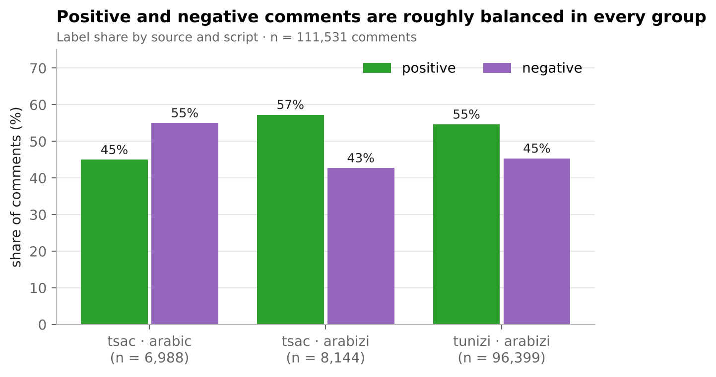
Figure 1. Label share by source and script (n = 111,531).
No group has less than 43% of either class, so the classes are close to balanced; the balance does shift with the script. We keep macro-F1 as the main metric because it weighs both classes equally and does not reward predicting the larger class.

4.2 Hypothesis test 1: is sentiment independent of script?
Both scripts in TSAC come from the same pages, so if script and sentiment were unrelated they would have the same positive share. H0: script and sentiment are independent in TSAC. Both variables are categorical (a 2 × 2 table) and the smallest expected count is 3,383, far above 5, so the chi-square test of independence is appropriate; Cramér’s V gives the effect size, since with 15,132 rows even a tiny difference is significant.
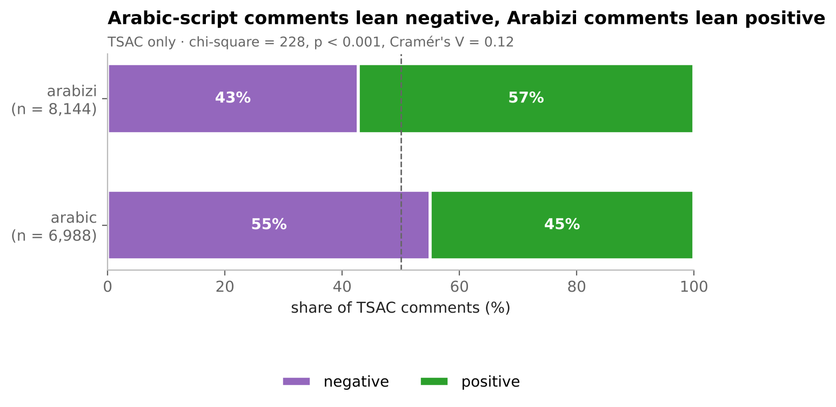
Figure 2. Sentiment by script in TSAC (n = 15,132).
 | Negative | Positive | Total
Arabic | 3,845 (55.0%) | 3,143 (45.0%) | 6,988
Arabizi | 3,480 (42.7%) | 4,664 (57.3%) | 8,144
Result: χ² = 227.5, 1 degree of freedom, p ≈ 2 × 10⁻⁵¹; H0 is rejected. Cramér’s V = 0.12, a weak association. Interpretation: script alone does not determine sentiment, but a model could partly exploit it as a shortcut. Every result is therefore reported per script, script is excluded as a feature (section 5.4), and on the Arabic test set (1,482 comments, 57.5% negative) always predicting “negative” reaches 57.5% accuracy: the floor any model must beat.

4.3 Comment length and hypothesis test 2
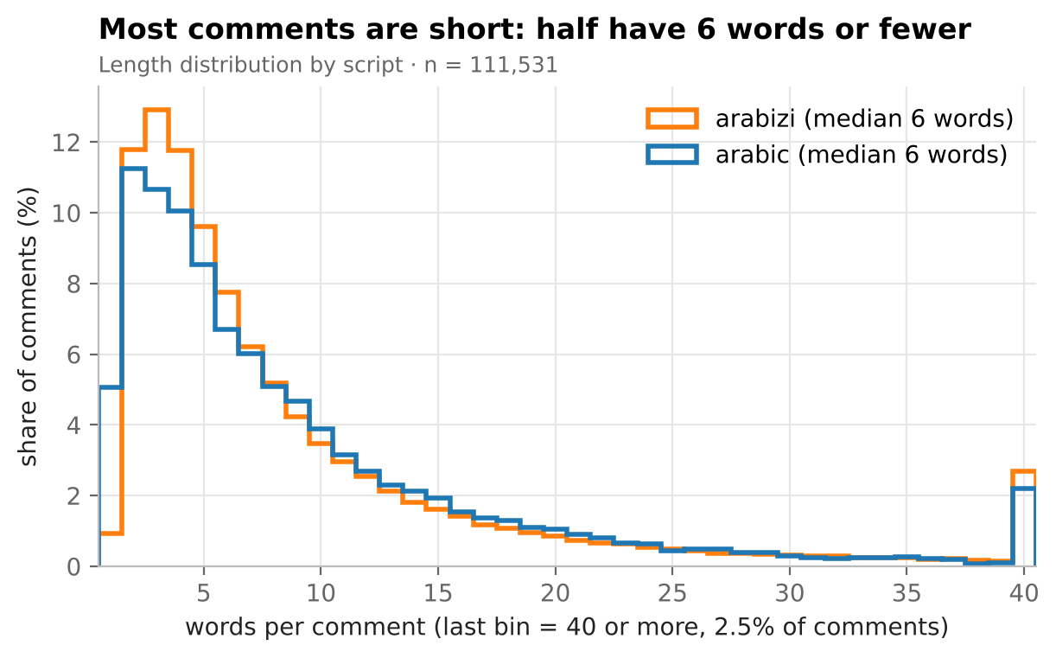
Figure 3. Length distribution by script; the last bin groups comments of 40 words or more (2.5% of comments).
Lengths are strongly right-skewed (median 6 words in both scripts, maximum 208), so we summarize with medians and percentiles. 95% of training comments have 172 characters or fewer.
H0: positive and negative comments have the same length distribution. Because lengths are far from normal, a t-test is not appropriate; the Mann-Whitney U test compares the distributions without assuming normality, run per script.
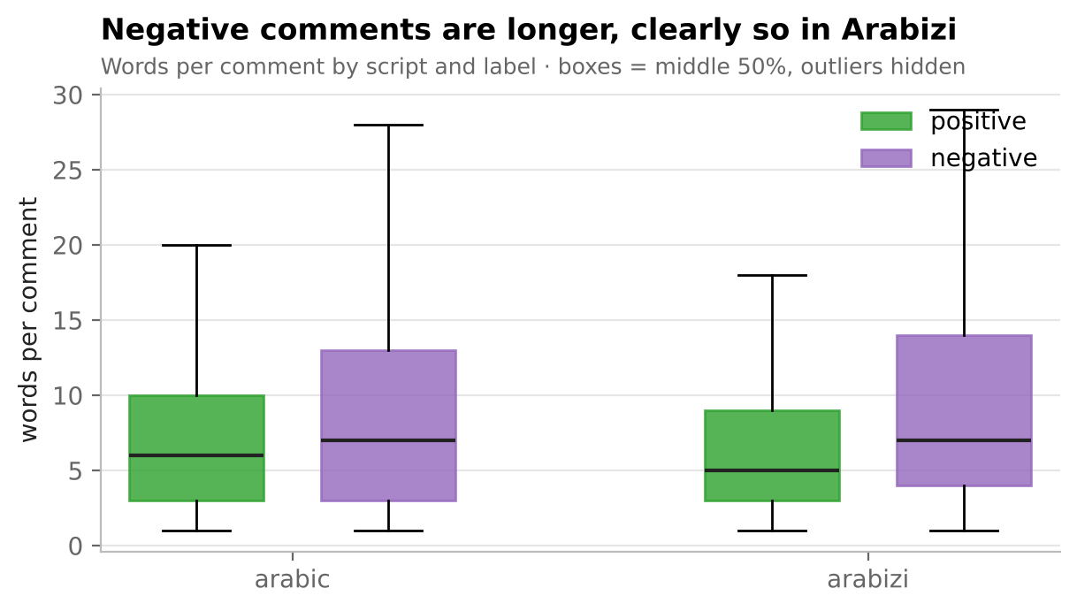
Figure 4. Words per comment by script and label (boxes: middle 50%; outliers hidden).
Script | n | Median positive | Median negative | p-value | Rank-biserial effect
Arabic | 6,988 | 6 | 7 | 2.6 × 10⁻⁸ | 0.08 (negligible)
Arabizi | 104,543 | 5 | 7 | < 10⁻³⁰⁰ | 0.25 (small)
Interpretation: H0 is rejected in both scripts, but with this many rows the effect size matters more than the p-value: negative comments are somewhat longer in Arabizi and barely in Arabic. Length is a weak extra signal, not a substitute for the words.

4.4 Words that carry sentiment
Raw frequency lists are dominated by function words shared by both classes, so words are ranked by the log-odds ratio between positive and negative training comments (+1 smoothing, words seen at least 30 times).
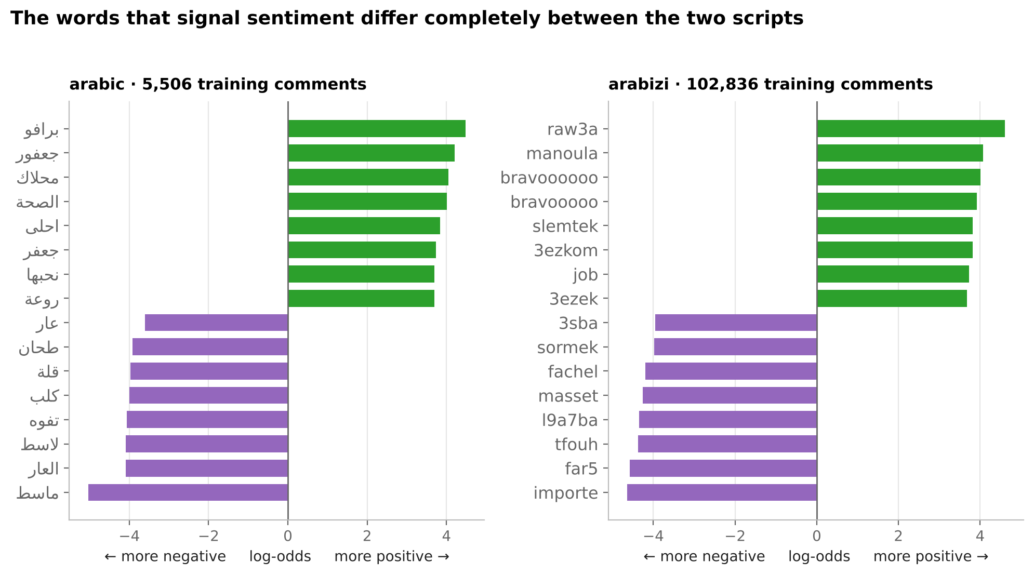
Figure 5. The 8 most positive and 8 most negative words per script (training rows).
Praise (‎برافو‎ / bravo, ‎روعة‎ / raw3a, ‎محلاك‎) and contempt (‎ماسط‎ / masset, ‎تفوه‎ / tfouh) appear in both scripts as the same words, with no character in common. A model trained on Arabizi has never seen ‎ماسط‎, only masset: this is the gap the mapping targets. The lists also show elongations splitting one word into several (bravooooo, bravoooooooo).

4.5 Digits as letters and noise
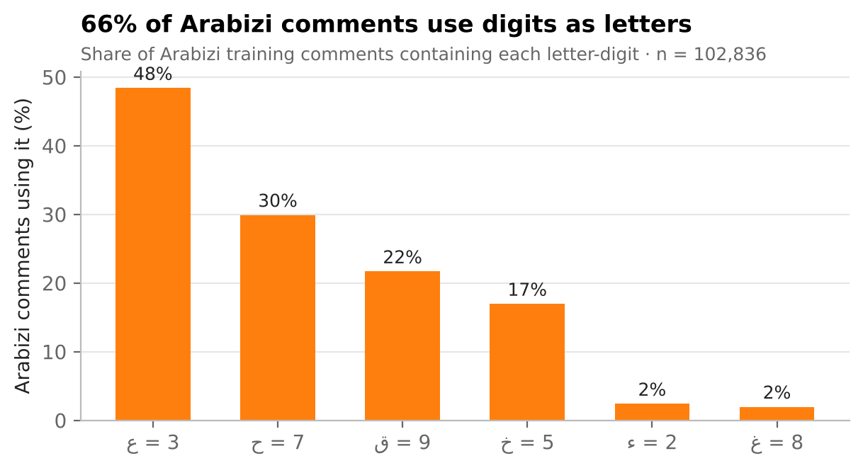
Figure 6. Share of Arabizi training comments using each digit as a letter (n = 102,836).
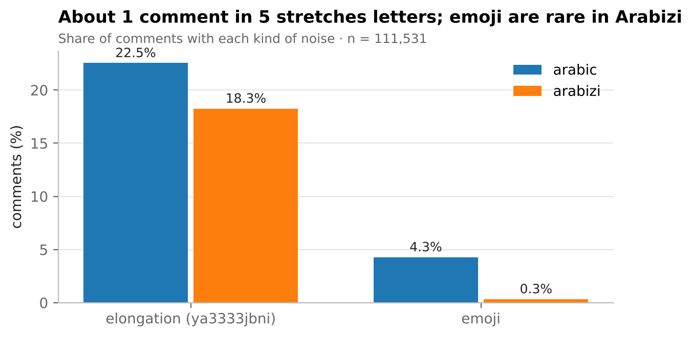
Figure 7. Share of comments with elongations and emoji, by script (n = 111,531).
66% of Arabizi comments use digits as letters, 3 (‎ع‎) in almost half, then 7 (‎ح‎), 9 (‎ق‎) and 5 (‎خ‎); digits must survive cleaning and the mapping writes these Arabic letters as the same digits. About one comment in five stretches letters (22.5% Arabic, 18.3% Arabizi), which normalization collapses. Emoji appear in 4.3% of TSAC comments and in none of TUNIZI, whose authors appear to have removed them: emoji are kept but listed as a limitation.

4.6 Correlations
All candidate numeric features are numeric or binary (label: positive = 1; script: Arabic = 1), so Pearson correlation is used; between two binary variables it equals the phi coefficient and between a binary and a numeric variable it is the point-biserial correlation.
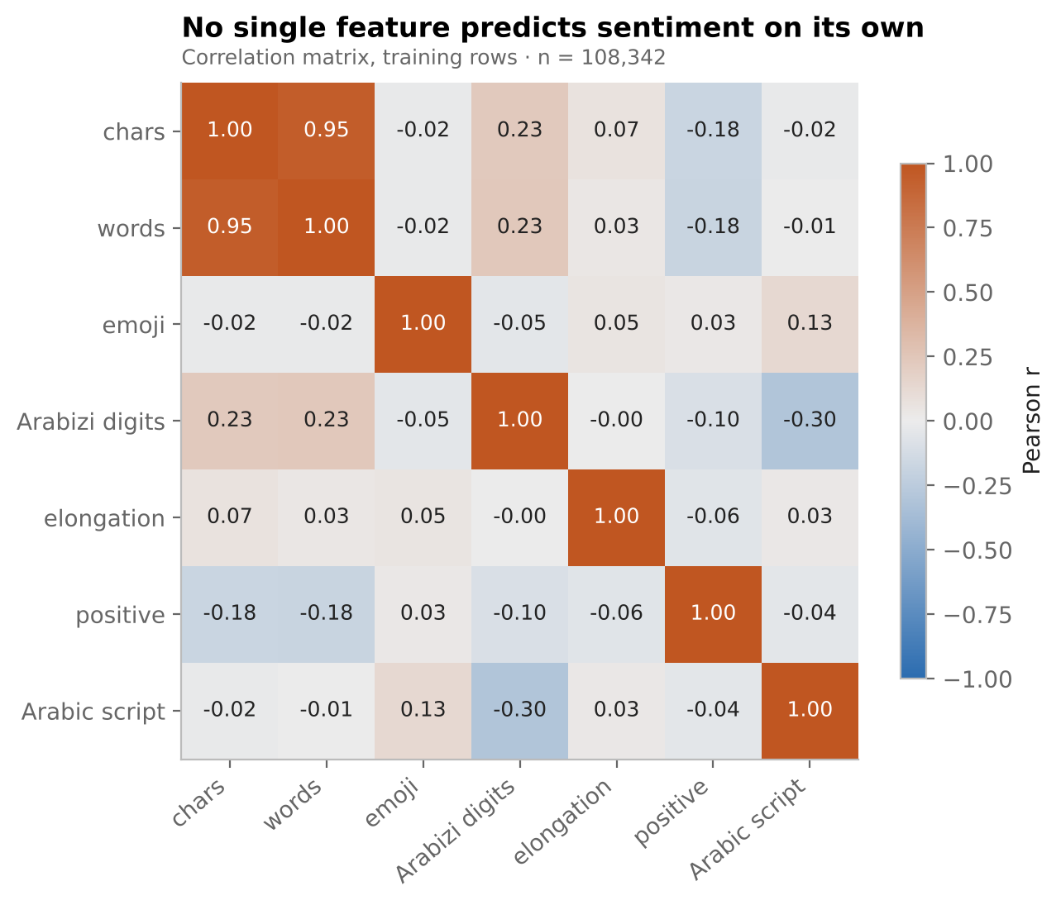
Figure 8. Pearson correlations on training rows (n = 108,342).
Character and word counts carry the same information (r = 0.95; Spearman 0.96), so only one is kept. The strongest link with sentiment is length (r = −0.18), consistent with section 4.3. The Arabizi-digit flag correlates with script (r = −0.30) by construction, which makes it a stand-in for script. Emoji and elongation barely relate to sentiment (|r| ≤ 0.06). No summary feature predicts sentiment on its own: the signal is in the text, which motivates character n-gram features.

4.7 Findings and their consequences
# | Finding | Consequence for preparation
1 | Script and sentiment linked, weakly (V = 0.12); test floor 57.5% | Report per script; exclude script as a feature; macro-F1
2 | Same sentiment words in both scripts, no shared characters | Build the cross-script mapping
3 | 66% of Arabizi comments use digits as letters | Keep digits; map ‎ع‎ ‎ح‎ ‎ق‎ ‎خ‎ to 3 7 9 5
4 | About 20% of comments stretch letters | Collapse repeated characters
5 | Short comments (median 6 words); 95% ≤ 172 characters | Character-level features; neural input length from the 95th percentile
6 | chars and words 95% correlated; length weakly tied to sentiment | Keep one length feature
7 | Emoji in TSAC only | Keep as tokens; state the limitation

5. Feature engineering
Feature engineering has three steps: a normalization shared by both conditions, the cross-script mapping that defines the “with mapping” condition, and the extraction and selection of the features the three models will use.

5.1 Normalization (both conditions)
Applying the same normalization with and without the mapping isolates the mapping’s own effect.
Step | Example | EDA finding behind it
Lowercase, strip French accents | Très → tres | French mixed into Arabizi
Arabic: remove diacritics and tatweel, unify ‎أ‎ ‎إ‎ ‎آ‎ → ‎ا‎ and ‎ى‎ → ‎ي‎, Arabic-Indic digits → 0–9 | e.g. ‎أَحْبَـــك‎ → ‎احبك‎ | Several spellings of the same word
Collapse 3+ repeated characters | ya3333jbni → ya3jbni | About 20% of comments (Figure 7)
Keep digits used as letters | 3aychek unchanged | 66% of Arabizi comments (Figure 6)
Space out emoji, drop skin-tone modifiers | top👍🏽! → top 👍 ! | 4.3% of TSAC comments

5.2 The cross-script mapping
Both scripts are reduced to one vowel-free Latin form. Arabic letters are written the way Arabizi writers already write them; Arabizi spellings are unified (sh → ch, kh → 5, 8 → gh); then all vowels are removed on both sides (a, e, i, o, u, w, y and the Arabic vowel letters) and repeated characters are collapsed.
Arabic letter | Shared form |  | Arabic letter | Shared form
‎ع‎ | 3 |  | ‎ش‎ | ch
‎ح‎ | 7 |  | ‎چ‎ | ch
‎خ‎ | 5 |  | ‎غ‎ | gh
‎ق‎ | 9 |  | ‎ث‎ | th
‎ء‎ | 2 |  | ‎ض‎ | dh
‎ئ‎ | 2 |  | ‎ظ‎ | dh
‎ؤ‎ | 2 |  | ‎ذ‎ | dh
‎ڤ‎ | g |  | ‎گ‎ | g
‎ج‎ | j |  | ‎پ‎ | p
‎ص‎ | s |  | ‎ط‎ | t
The other consonants keep their usual Latin letter (‎ب‎ b, ‎ت‎ t, ‎د‎ d, ‎ر‎ r, ‎ز‎ z, ‎س‎ s, ‎ف‎ f, ‎ك‎ k, ‎ل‎ l, ‎م‎ m, ‎ن‎ n, ‎ه‎ h). The vowel letters ‎ا‎, ‎و‎, ‎ي‎, ‎ى‎ and ‎ة‎ are removed.
Example: ‎عيشك‎ → 3chk and 3aychek → 3chk. Why remove vowels: Arabic script usually omits short vowels and uses ‎و‎/‎ي‎ ambiguously, while Arabizi spells vowels freely (3aychek, 3ichek, aichek). Vowels cannot be restored reliably on the Arabic side, so removing them on both sides is what makes the two versions meet. The cost is that some different words share a skeleton (7ob and 7abb both become 7b).

5.3 Evidence that the mapping works
Vocabulary overlap. Vocabularies are built from training rows only; the Arabic test set is compared with the Arabizi training set.
Measure | Without mapping | With mapping
Arabic test word occurrences found in the Arabizi training vocabulary | 2.1% | 91.9%
Distinct Arabic test words found | 1.5% | 73.1%
Character 3-gram overlap, Arabic train vs Arabizi train (Jaccard) | 1.4% | 32.5%
After mapping, 36% of test tokens are 1 or 2 characters long and match almost automatically (98%); counting only tokens of 3+ characters, coverage is still 88.4%.
Conversion accuracy (Q4). 60 comments from the training data (45 Arabic-script from TSAC, 15 Arabizi from TUNIZI; none from the test set) were rewritten by team members in the other script, the way they would naturally type them. Two were excluded because the annotator censored offensive words. Both the original and the human version go through the conversion, and the character error rate (CER) is the edit distance between the two outputs divided by the length of the converted human version.
Direction | CER | Words matching exactly | Comments
Arabic → Arabizi | 0.107 | 62% | 43
Arabizi → Arabic | 0.101 | 68% | 15
Overall | 0.105 | 64% | 58
Variant keeping w and y | 0.196 | 39% | 58
The target of 0.15 or less is met in both directions, and keeping w and y nearly doubles the error, which supports removing all vowels. The five worst comments show three error types: word boundaries (Arabic attaches the article ‎ال‎, writers type “el 7ounj” separately), spelling habits (h, k or th where the mapping gives 7, 9 or dh) and annotator slips (a dropped letter or emoji). The first is systematic and is the main target for version 2.

5.4 Final feature set
The features are built for the main experiment’s hardest setting, k = 0: fitted on the 102,836 Arabizi training comments and applied to the 1,482 Arabic test comments. Each learning-curve setting refits the same builders (src/features.py) on its own training set.
Encoding. The target becomes y = 1 for positive, 0 for negative. Script is not a feature: section 4.2 showed it could serve as a shortcut. Source and split are bookkeeping only.
Extraction. TF-IDF on character n-grams of 2 to 5 characters within word boundaries (char_wb), on text_norm (without mapping) or text_conv (with mapping). Character pieces still match when whole words do not, which suits short comments with no fixed spelling. Transformations built in: sublinear term frequency (1 + log tf) so a repeated piece does not dominate, and L2 row normalization so long and short comments are comparable.
Selection. First, frequency filters drop n-grams seen in fewer than 5 training comments (typos) or in more than 90% (no information): 373,511 → 114,684 n-grams without mapping, 101,107 → 34,995 with mapping (removing vowels merges spelling variants). Then a chi-square test on training labels keeps the 20,000 n-grams most associated with sentiment, the same budget in both conditions for a fair comparison. The strongest are readable even without vowels: brv (bravo), m3lm (m3allem, praise), rb (rabi) on the positive side; mst (masset) and tfh (tfouh) on the negative side.
Created numeric features. Length as log(1 + n_chars), which reduces skewness from 10.45 to 0.57, then standardized with a scaler fitted on training rows; and the elongation flag, which keeps the stretching signal that normalization removes. Not kept: n_words (duplicate of length), has_arabizi_digits (stand-in for script), has_emoji (absent from TUNIZI).
Neural input. Character-id sequences, cut at the 95th percentile of training lengths: 171 characters without mapping, 103 with mapping.
Verification.
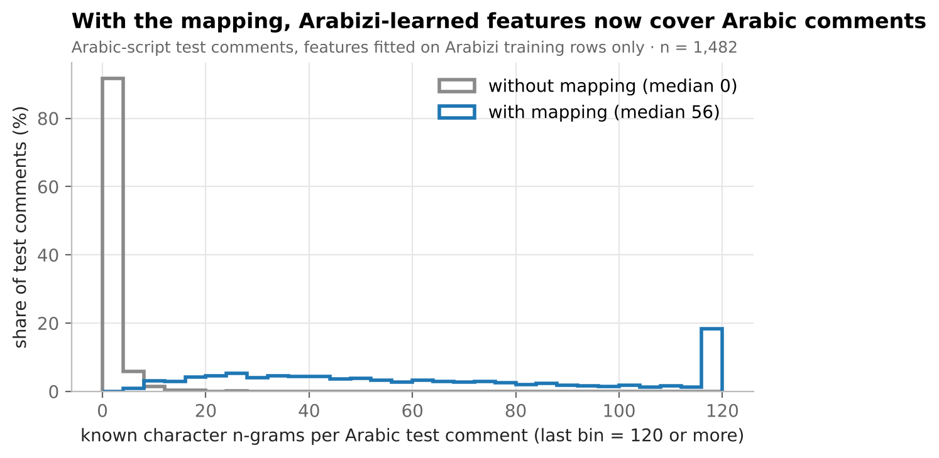
Figure 9. Number of character n-grams of each Arabic test comment that exist in the Arabizi-fitted vocabulary (n = 1,482).
Check on the Arabic test set | Without mapping | With mapping
Comments with no known n-gram | 71.1% | 0.0%
Known n-grams per comment (median) | 0 | 56
Comments with no selected n-gram (after chi-square) | 89.3% | 0.0%
Unknown characters for the neural model | 31.5% | 0.3%
Final matrix for the classical models (train) | 102,836 × 20,002 | 102,836 × 20,002
Without the mapping, a model trained on Arabizi is blind to most Arabic-script comments; with it, every test comment shares features with training. Multinomial Naive Bayes uses only the non-negative TF-IDF block.

6. Conclusions, limitations and next steps

6.1 Findings against the research questions
Question | Evidence at midway | Status
Q1: does the mapping help at k = 0? | Arabic test words known to the Arabizi vocabulary: 2.1% → 91.9%; test comments sharing no feature with training: 71% → 0% | Promising; decided by the models
Q2: how much Arabic data does it save? | Learning curve designed, k from 0 to 5,506 Arabic training comments | After modeling
Q3: which model gains most? | Features built for all three models, in both conditions | After modeling
Q4: is the conversion accurate? | CER 0.105 against human conversions (target ≤ 0.15); removing all vowels beats keeping w and y | Answered
The data is clean, merged without leakage and ready (111,531 comments; Arabic test set of 1,482). The EDA shows a real but weak link between script and sentiment, which fixes per-script reporting and a 57.5% accuracy floor, and shows that the sentiment words are shared across scripts but not their characters. The mapping makes those words meet at the feature level.

6.2 Limitations
- Overlap is not accuracy. Shared vocabulary does not prove better sentiment predictions; that requires the models.
- Collisions. Without vowels, some different words share a skeleton.
- Small manual sample. 58 scored comments, fewer than the 150 to 200 planned in the proposal; the CER estimate is therefore approximate.
- One source of Arabic script. All Arabic-script comments come from TSAC (Facebook pages of Tunisian media, 2015–2016), which limits how far results generalize.
- French and emoji. French code-switching is not mapped; TUNIZI contains no emoji, so emoji are a TSAC-only signal.
- Short mixed comments. One Latin word can push a short Arabic comment below the 80% threshold and drop it as mixed (69 comments).
- Known mapping gaps. The attached article ‎ال‎, the Tunisian letter ‎ڨ‎ (42 uses), a few rare letter variants, and repeated digits collapsed by normalization (1000 → 10, about 1% of comments, equally in both conditions).

6.3 Next steps (modeling phase)
- Train the three models (TF-IDF + logistic regression, multinomial Naive Bayes, character CNN/BiLSTM), each with and without the mapping, for k = 0, 100, 500, 1,000 and all, over 5 random seeds: 150 runs.
- Evaluate macro-F1 (primary), accuracy and confusion matrices per script, against the 57.5% floor and the success criteria in section 1.
- Analyze errors: sarcasm, negation, French code-switching and conversion failures.
- Release mapping version 2 for the gaps in 6.2, documenting each change, and recheck the CER.
If the mapping does not reach the targets, that is reported as a negative result.

References and reproducibility
Data
- Fourati, C., Haddad, H., Messaoudi, A., BenHajhmida, M., Ben Elhaj Mabrouk, A., Naski, M. (2021). Introducing a large Tunisian Arabizi dialectal dataset for sentiment analysis. Proceedings of the Sixth Arabic Natural Language Processing Workshop (WANLP 2021), pp. 226–230. Data: github.com/iCompass-ai/TUNIZI (MIT licence).
- Medhaffar, S., Bougares, F., Estève, Y., Hadrich-Belguith, L. (2017). Sentiment analysis of Tunisian dialects: linguistic resources and experiments. WANLP 2017, EACL. Data: github.com/fbougares/TSAC (LGPL-3.0 licence).
Code. The team repository (tunisian-sentiment) contains the raw data, all notebooks and the shared code. Run the notebooks in order; each reads only the outputs of the previous ones, and a full rerun from the raw files reproduces every number in this report.
Notebook | Produces
01_clean_tunizi, 01_clean_tsac | Cleaned sources and their step logs
01b_manual_sample | The 60-comment manual sample (not to be rerun)
02_merge | master_clean.csv, merge log, 30-row script check
03_eda | Figures 1–8 and both hypothesis tests
04_conversion | master_converted.csv, vocabulary overlap, CER
05_features | Feature set, selection and verification, Figure 9
Shared code: src/load_raw.py (stable ids), src/cleaning_utils.py, src/script_detect.py, src/transliteration.py (with 27 unit tests in tests/), src/features.py, src/plot_style.py. Packages: pandas, numpy, scipy, scikit-learn, matplotlib, rapidfuzz, openpyxl (requirements.txt). Random seed 42 throughout.

