7-8 FEBRUARY 2026:
I have found that one of the important things in cyber security is CIA triad :
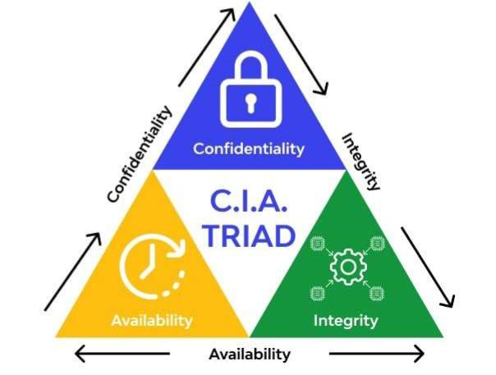
C.I.A stands for confidentiality, integrity, availability, first I thought the name familiar, but it’s not the spy one .
Let’s break it down by my own way :
- Confidentiality:
It’s about making sure people who we want them to enter have access to our site , service and documents in it , this can be by several authentication methods.
- Integrity :
It’s making sur that the documents,fiels or any service we provide is original , and there’s no
Modification accured by other parties , it checks of the source of every upload through it’s upload
Cycle.
- Availability:
This part make sure that all the content is accessible to All users 24/7 , it plays the role of a gate keeper against hackers attacks like DDOS attack.
DDOS ATTACKS:
We can explain it as a road that can only handle a Known amount of traffic in a known period of time
Also hackers Create a traffic that by spamming the server with bots , resulting in a down and damage in the server.

- Resources:
https://youtu.be/kPPFNrlN3zo?si=A_WerOyK52c_pdVK

