Fall 2026 Semester
CLD 376 Cloud Native Development
Goat Ronaldo
ID: 2024476
01. Role-Based User Management System Using Microservices API Gateway NodeJS MongoDB
Real-Life Scenario & System Architecture: A university Central Identity and User Management Platform developed as independent microservices communicating through an API Gateway with MongoDB Atlas persistence. Features two user roles: User (students/staff managing own profile) and Admin (administrators managing accounts). Strictly enforces mutual exclusion: Users can NEVER access Admin APIs, and Admins can NEVER access User APIs.

Microservice | Port | Endpoints | Role / Responsibilities
API Gateway | 4000 | All routes (/) via reverse proxy | Single entry point, JWT verification, role-based route guard
Registration | 5001 | POST /register/userregister | Validates input, checks duplicate email, bcrypt password hash, MongoDB store
Login (Auth) | 5002 | POST /auth/login | Validates email/password/role, issues signed 24h JWT token
Admin Service | 5003 | GET /admin/searchuser, viewalluser  DELETE /admin/deluser | Admin operations: search by name/email, view all users, delete user
User Service | 5004 | GET /user/viewprofile  PUT /user/updateprofile | User operations: view authenticated profile, update profile details

Task 1 – Five Microservices Running
Microservices Orchestration: All five independent microservices (API Gateway on port 4000, Registration Service on port 5001, Login Service on port 5002, Admin Service on port 5003, and User Service on port 5004) started and running simultaneously. TCP port listener verification confirms each process is listening on its designated port.
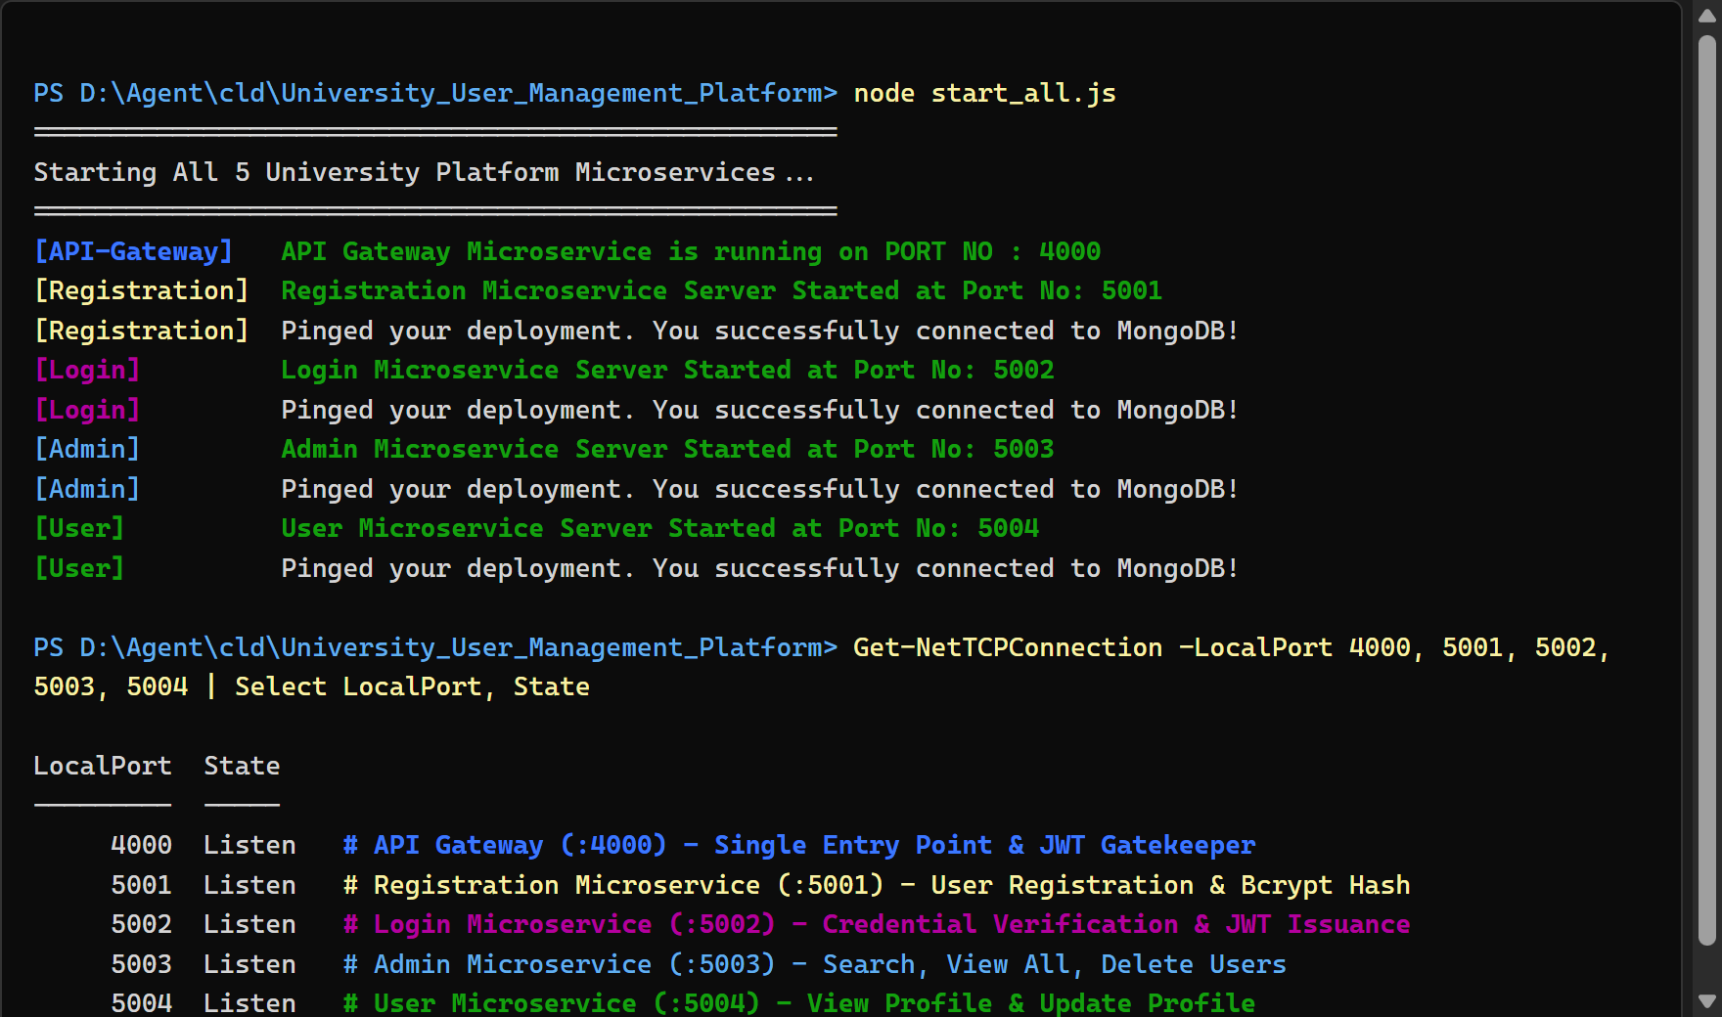
Evidence 1: PowerShell Orchestrator - All 5 Microservices running simultaneously on ports 4000, 5001, 5002, 5003, and 5004.
Task 2 – MongoDB Database Connection
Database Connectivity: Mongoose database connection module (dbconnect.js) implemented with connection pooling, retry options, and deployment ping command. Successful execution confirms active connection to MongoDB Atlas database (clusterdb).
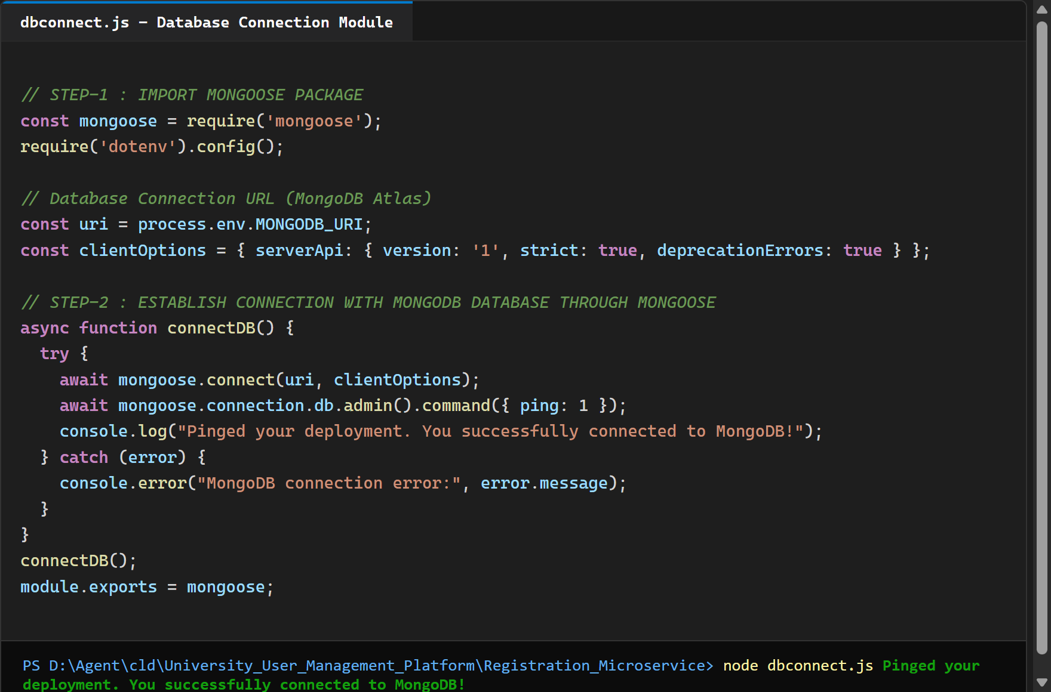
Evidence 2: VS Code editor showing dbconnect.js and terminal verification showing successful MongoDB Atlas connection.
Task 3 – MongoDB User Model
Schema Definition: Mongoose User schema (user_schema.js) created according to specification with _id, name, email (unique, lowercase), password (bcrypt hashed), role (enum: ['admin', 'user']), phone, and automatic timestamps (createdAt, updatedAt).
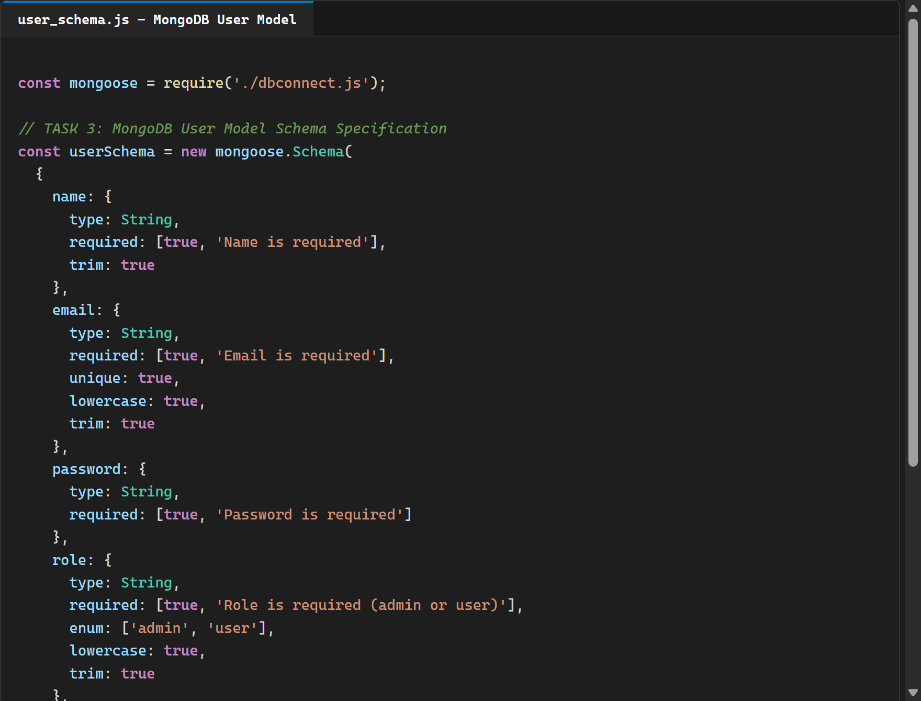
Evidence 3: VS Code editor - MongoDB User Model Schema (user_schema.js) with required fields, validation, and timestamps.
Task 4 – API Gateway Routing and Authentication
Gateway Routing & Security Architecture: API Gateway (api-gateway.js) implemented as the single entry point on port 4000 using http-proxy reverse routing. Enforces strict JWT token validation and role-based access control (RBAC): ordinary users cannot access /admin/*, and administrators cannot access /user/*.
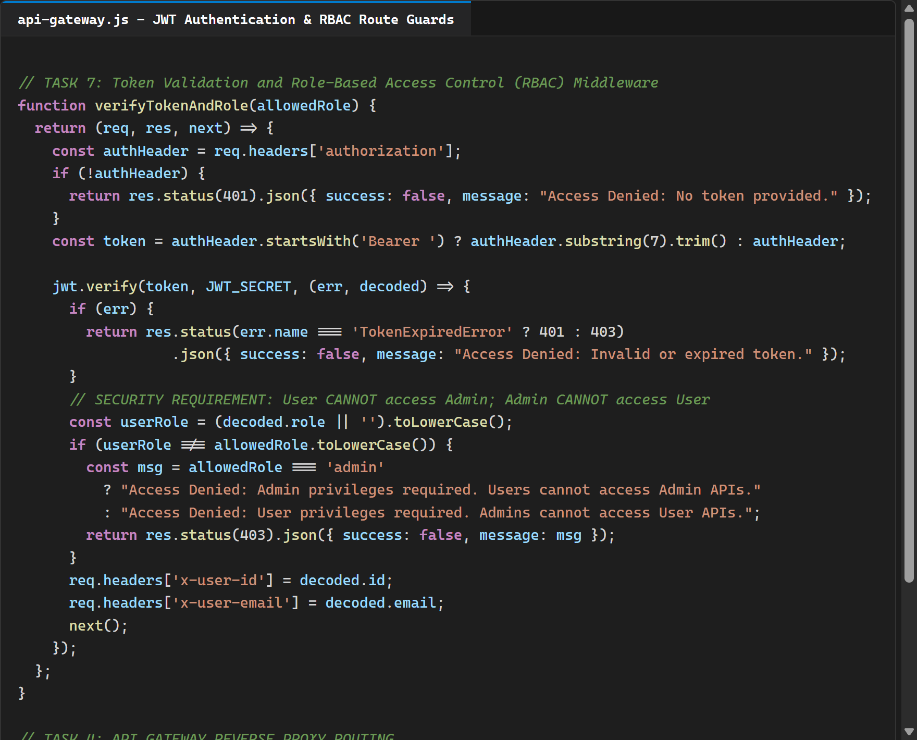
Evidence 4: VS Code editor - API Gateway source code (api-gateway.js) displaying JWT verification, role guard middleware, and reverse proxy routes.
Task 5 – Successful User Registration
Registration Workflow: Client registers a new student account via POST http://localhost:4000/register/userregister through the API Gateway. Registration service validates input, securely hashes the password with bcrypt, stores the document in MongoDB, and returns Status 201 Created.
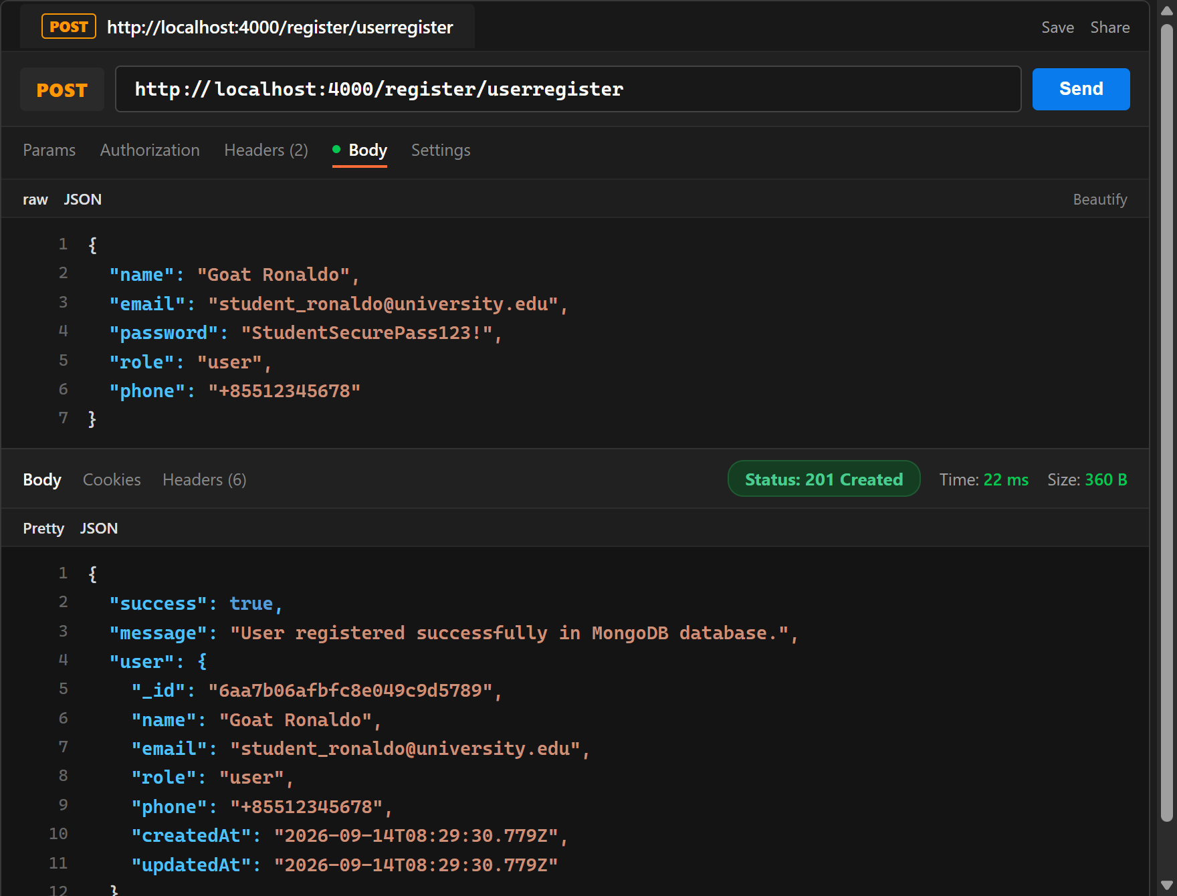
Evidence 5: Postman - POST http://localhost:4000/register/userregister successfully registering student account (Status 201 Created).
Admin Account Setup: Admin account registered via POST http://localhost:4000/register/userregister with role 'admin' for subsequent administrative operations.
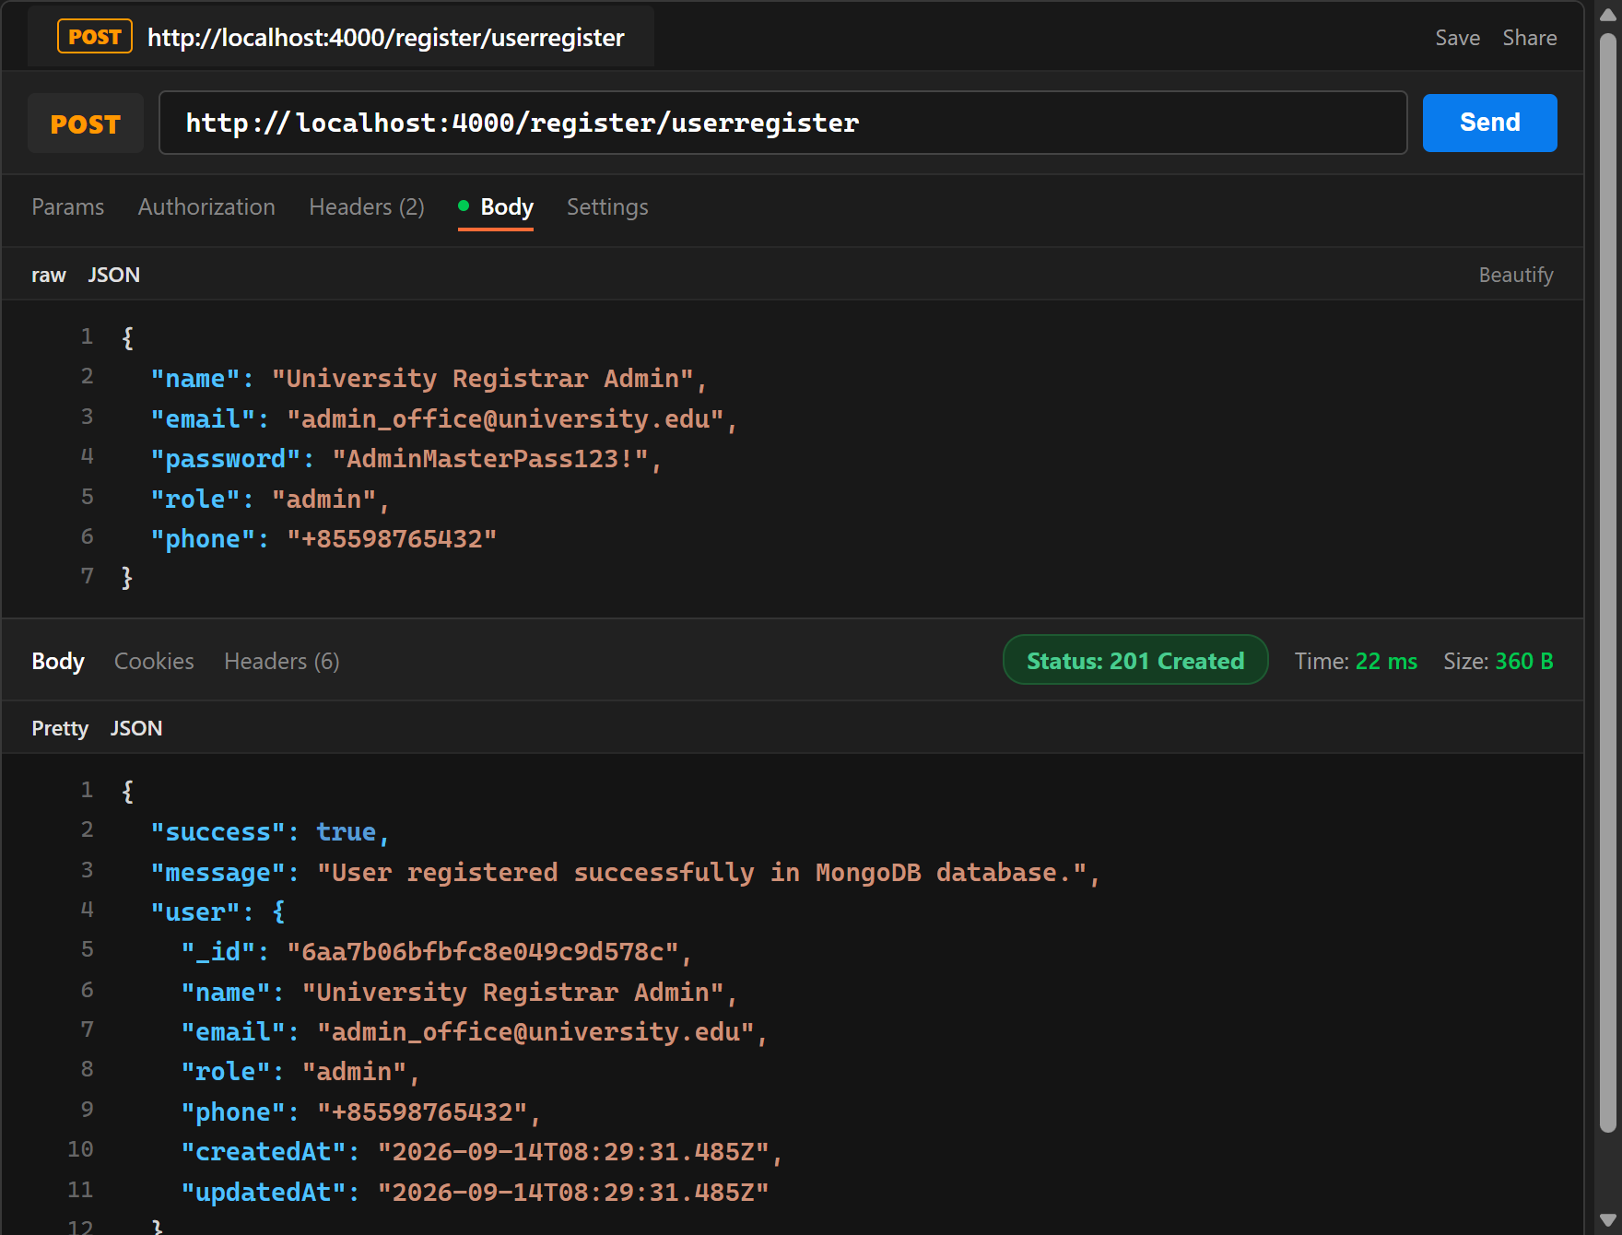
Evidence 5b: Postman - POST http://localhost:4000/register/userregister successfully registering administrator account (Status 201 Created).
Task 5 – Duplicate Email Validation
Duplicate Prevention: Attempting to register with an email address that already exists in MongoDB is immediately rejected with Status 400 Bad Request and error message 'Duplicate email not accepted. A user with this email address already exists.'
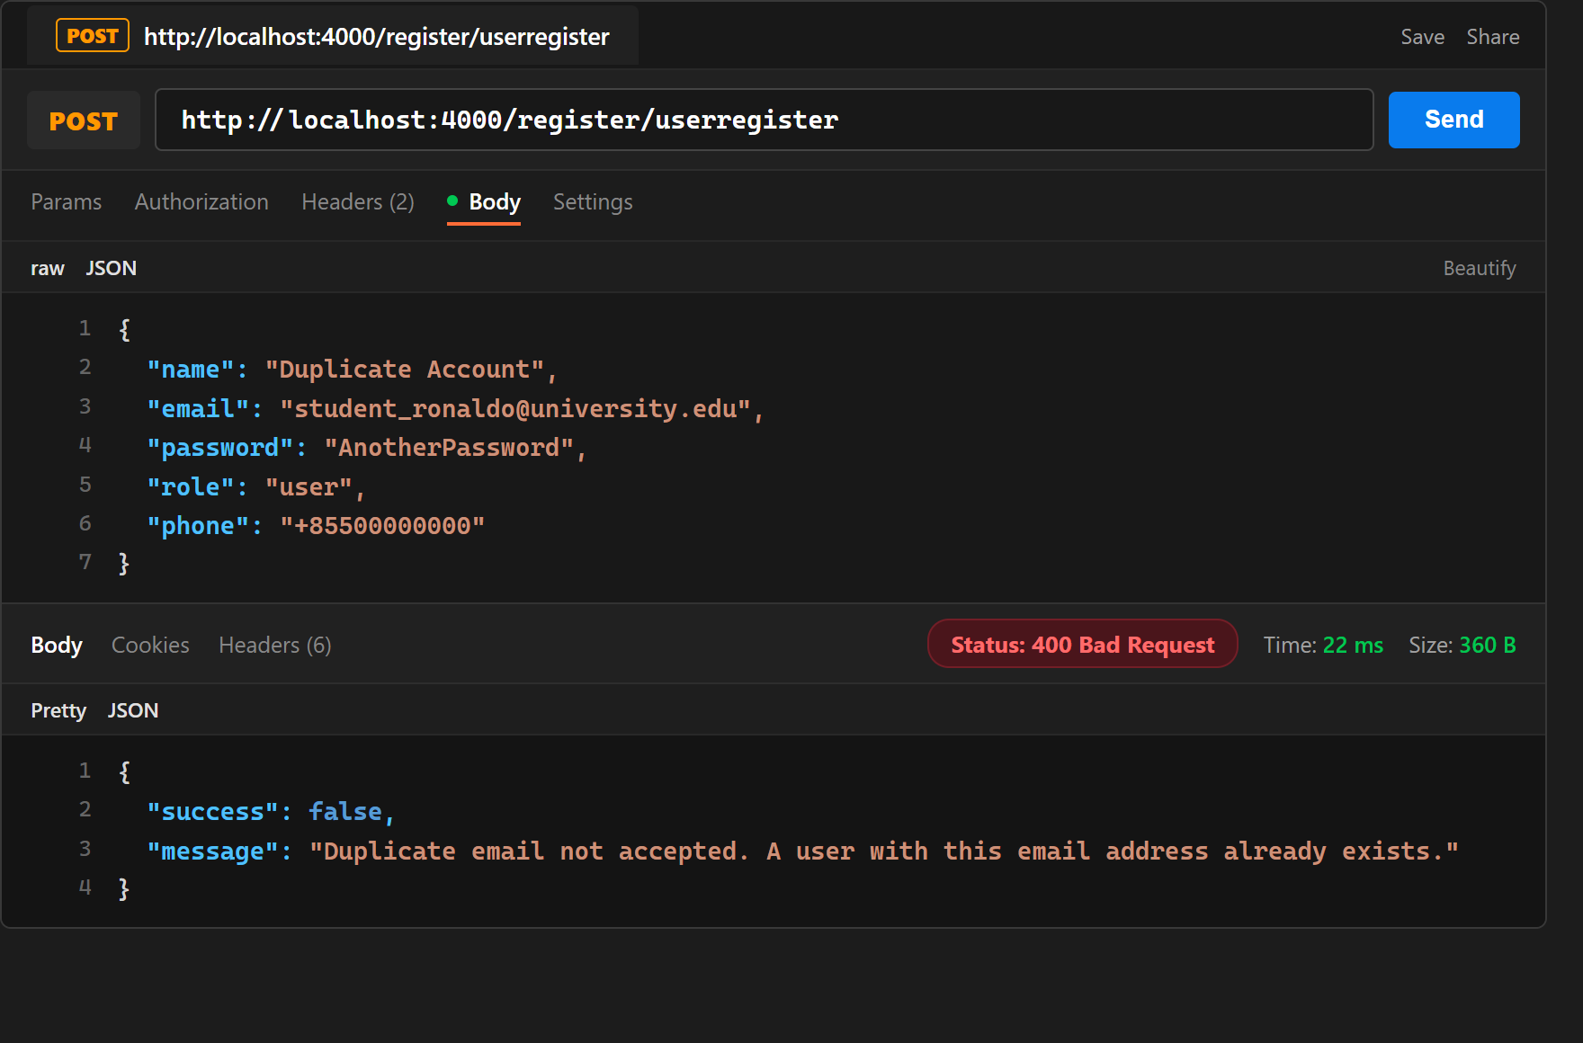
Evidence 6: Postman - Duplicate email rejected with Status 400 Bad Request ('Duplicate email not accepted').
Task 5 – MongoDB User Record with Hashed Password
MongoDB Persistence Verification: MongoDB Atlas collection (clusterdb.users) inspection showing the stored student and administrator documents. Passwords are never stored in plain text and are securely hashed with bcrypt ($2a$10$...).
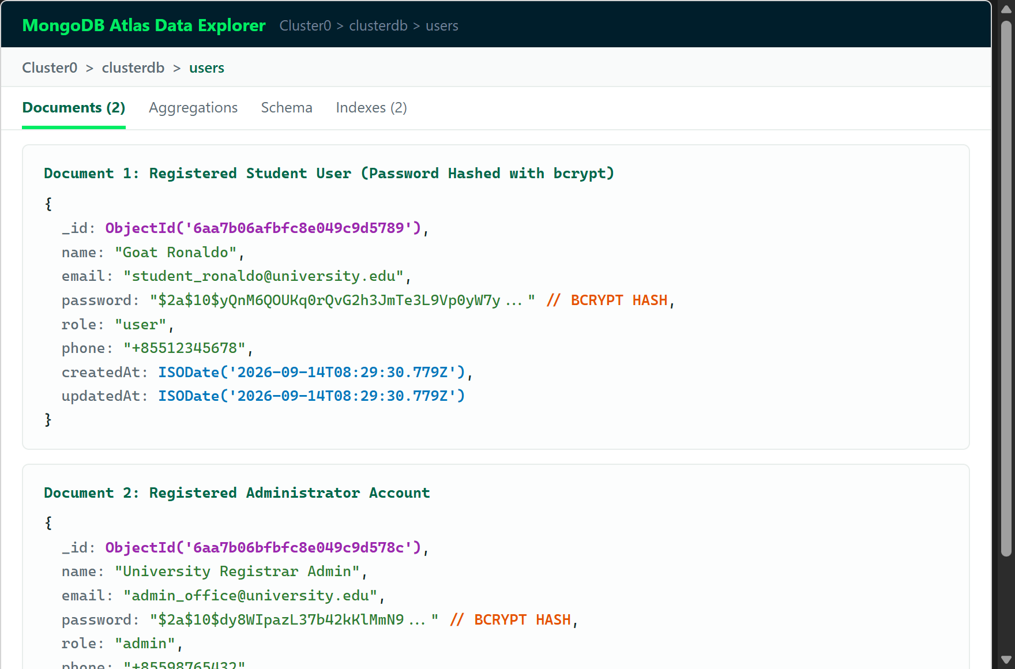
Evidence 7: MongoDB Compass / Atlas Data View - Registered user documents showing bcrypt password hashes.
Task 6 – Successful User Login and JWT Generation
Authentication Workflow: User logs in via POST http://localhost:4000/auth/login through the API Gateway with valid email, password, and role. Login service verifies credentials against MongoDB and returns Status 200 OK along with a signed 24-hour JWT token.
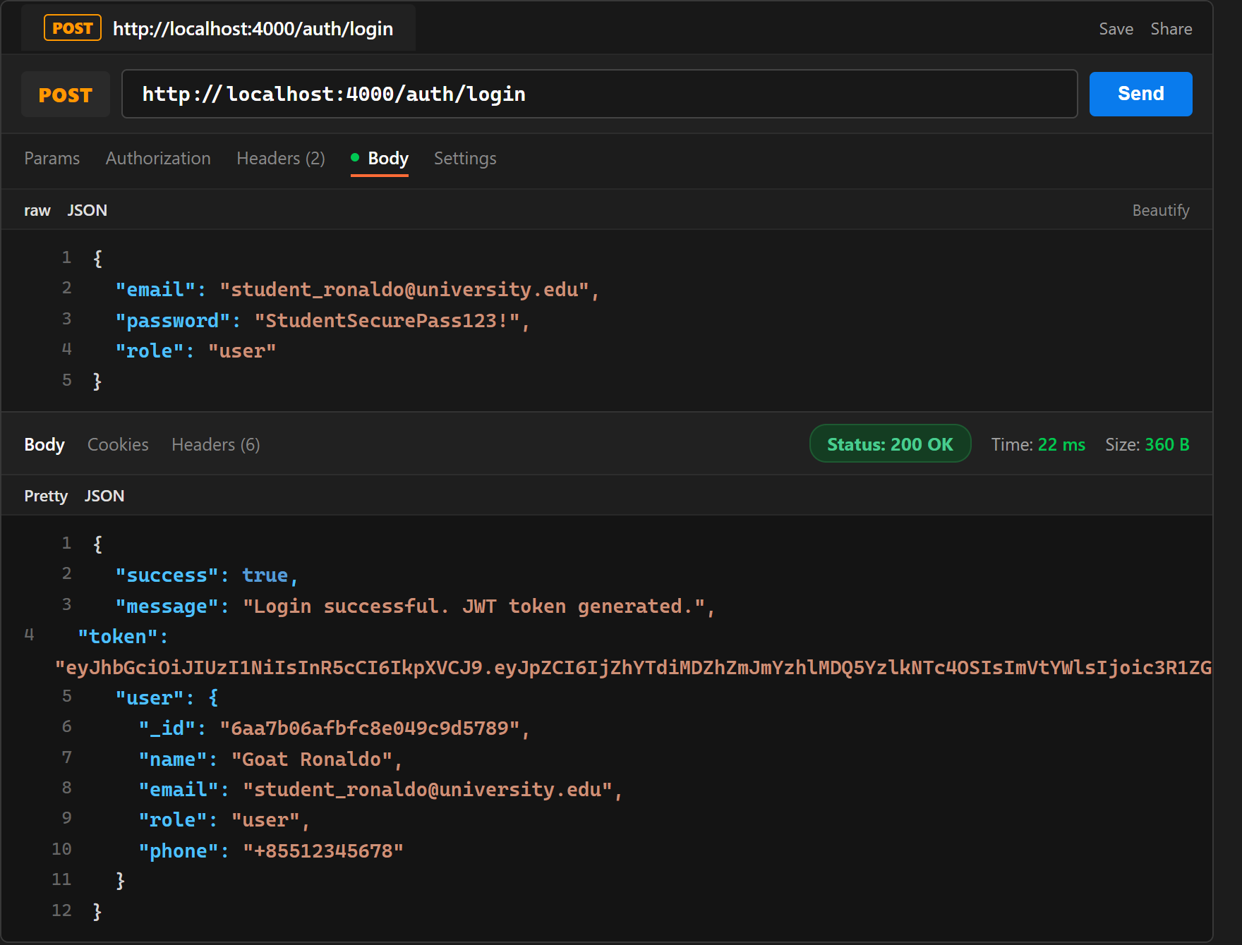
Evidence 8: Postman - POST http://localhost:4000/auth/login returning Status 200 OK and signed JWT token for student user.
Admin Authentication: Administrator logs in via POST http://localhost:4000/auth/login returning Status 200 OK and signed Admin JWT token.
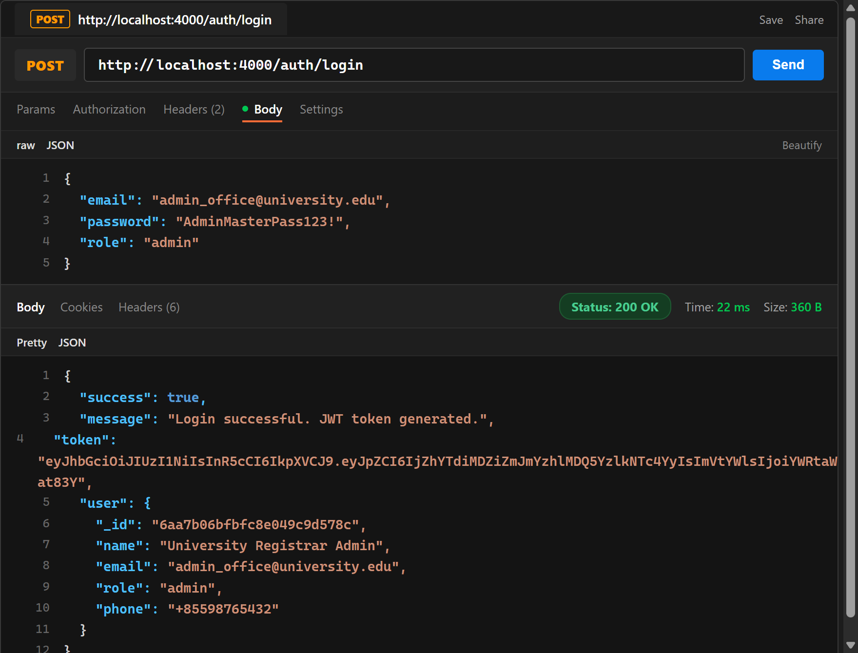
Evidence 8b: Postman - POST http://localhost:4000/auth/login returning Status 200 OK and signed Admin JWT token.
Task 6 – Invalid Password
Password Verification: Login attempt with an incorrect password is rejected with Status 401 Unauthorized ('Invalid credentials: Password does not match').
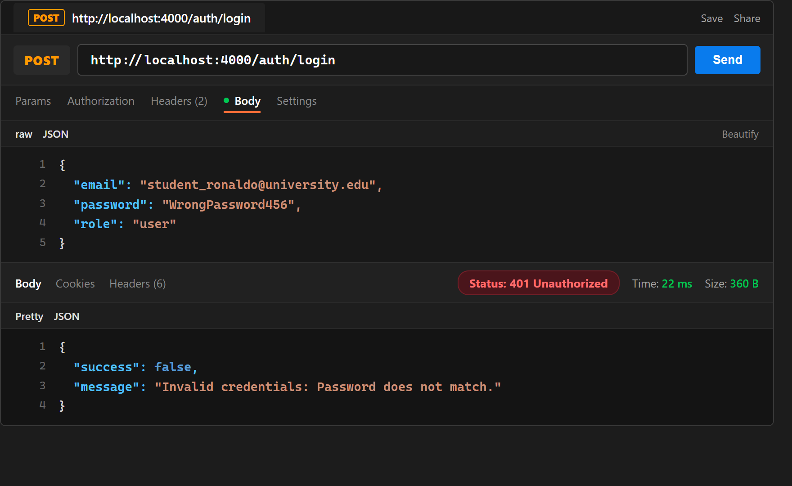
Evidence 9: Postman - Incorrect password rejected with Status 401 Unauthorized ('Password does not match').
Task 6 – Invalid Role
Role Verification: Login attempt where the requested role does not match the account's registered role in MongoDB is rejected with Status 403 Forbidden ('Invalid role: Access denied. Account is registered as user, but login requested as admin').
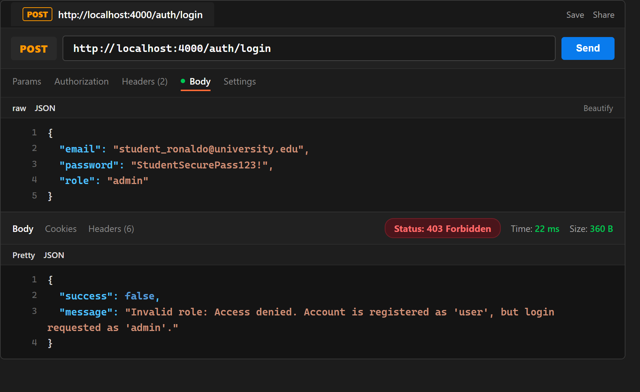
Evidence 10: Postman - Student account attempting admin login rejected with Status 403 Forbidden ('Role mismatch').
Task 7 – JWT Authentication and Role-Based API Routing
Role-Based Security Enforcement: JWT Authentication and RBAC guards implemented at the API Gateway level. Requests to /admin/* are validated to require decoded.role === 'admin'. Requests to /user/* are validated to require decoded.role === 'user'. Any violation generates immediate 401/403 responses before reaching the microservices.
Task 8 – Admin Search User (User Found)
Admin Search API: Administrator searches for a student user by query parameter (GET http://localhost:4000/admin/searchuser?email=...) with Admin Bearer Token. Admin service queries MongoDB and returns Status 200 OK with the matched user document.
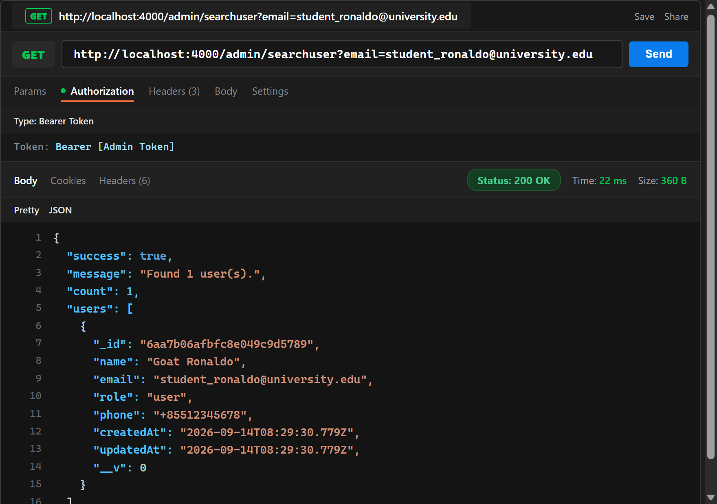
Evidence 11: Postman - GET http://localhost:4000/admin/searchuser?email=... returning matching user document (Status 200 OK).
Task 8 – Admin Search User (User Not Found)
Admin Search Handling: Searching for a non-existent user returns Status 404 Not Found with error message 'User not found with the specified search criteria.'
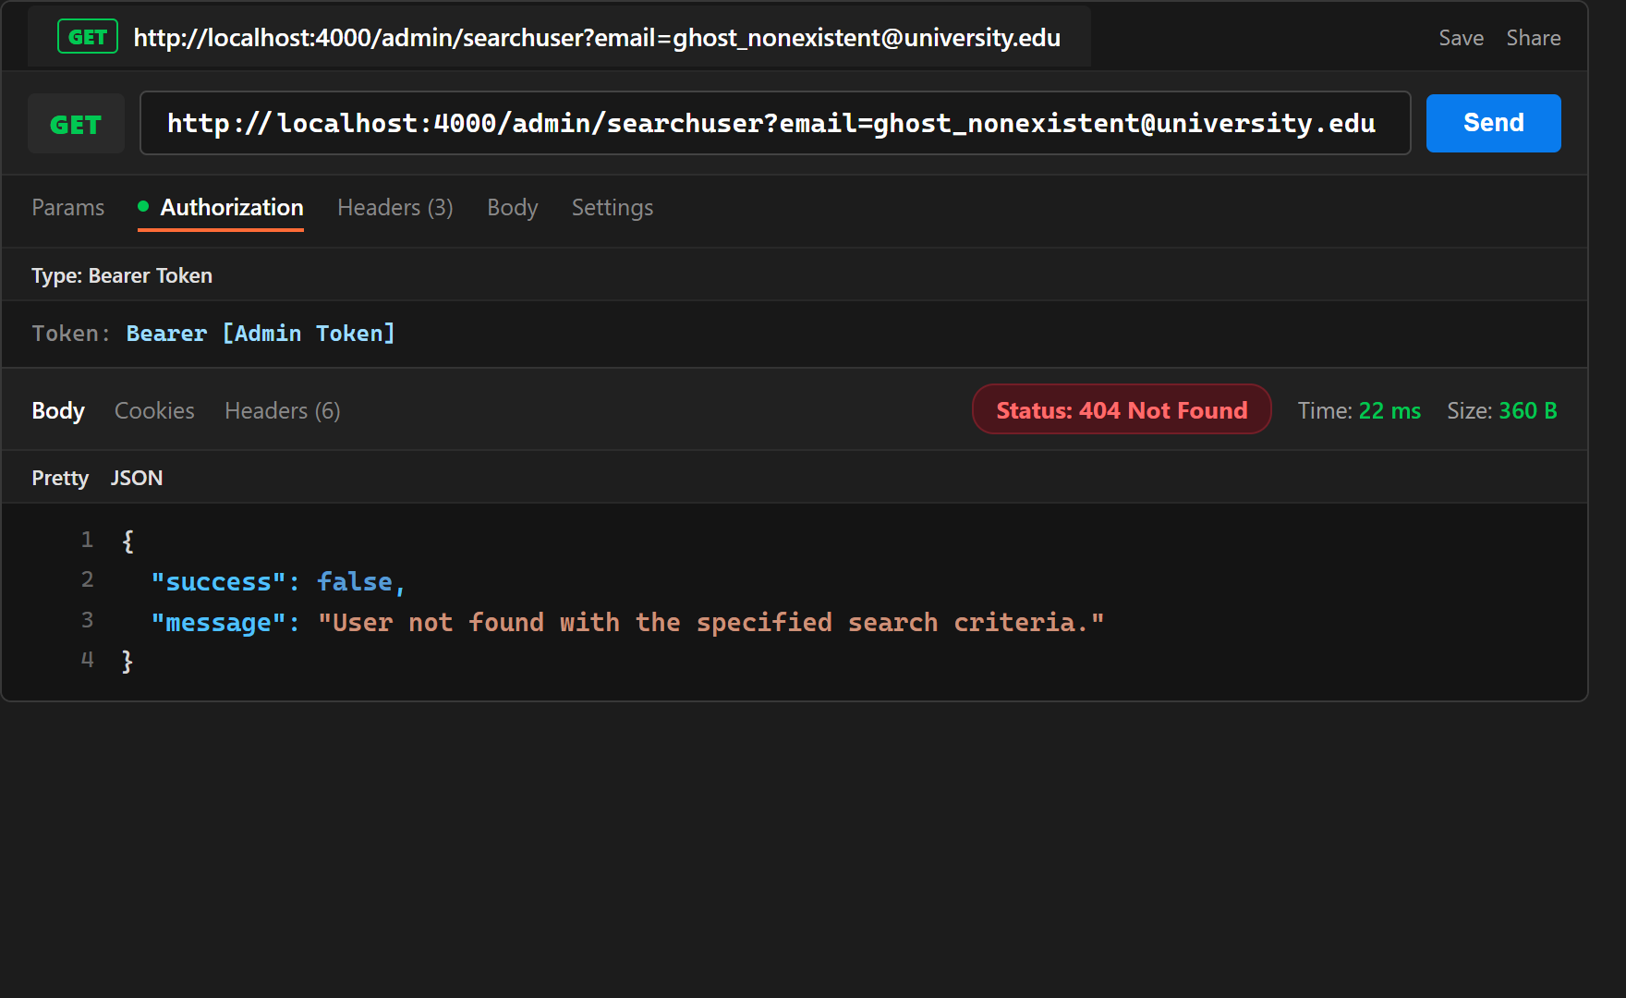
Evidence 12: Postman - GET http://localhost:4000/admin/searchuser?email=ghost... returning Status 404 Not Found.
Task 8 – View All Users
Admin View All API: Administrator retrieves all registered users via GET http://localhost:4000/admin/viewalluser with Admin Bearer Token. Admin service returns Status 200 OK with all user accounts (passwords excluded for security).
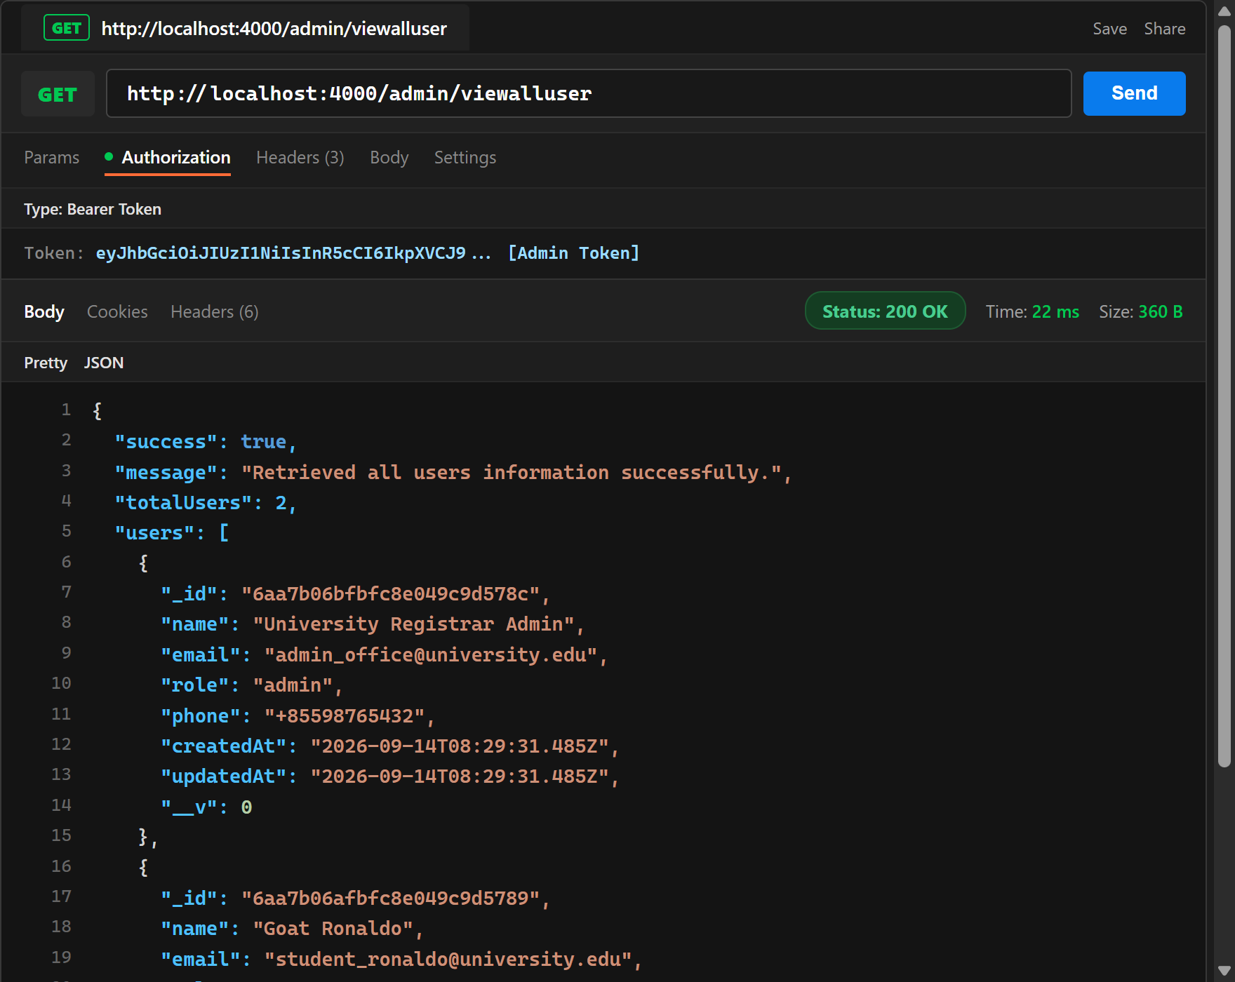
Evidence 13: Postman - GET http://localhost:4000/admin/viewalluser with Admin Token returning all registered users (Status 200 OK).
Task 8 – Delete User
Admin Delete API: Administrator deletes a user account via DELETE http://localhost:4000/admin/deluser?email=... with Admin Bearer Token. Admin service removes the user document from MongoDB and returns Status 200 OK.
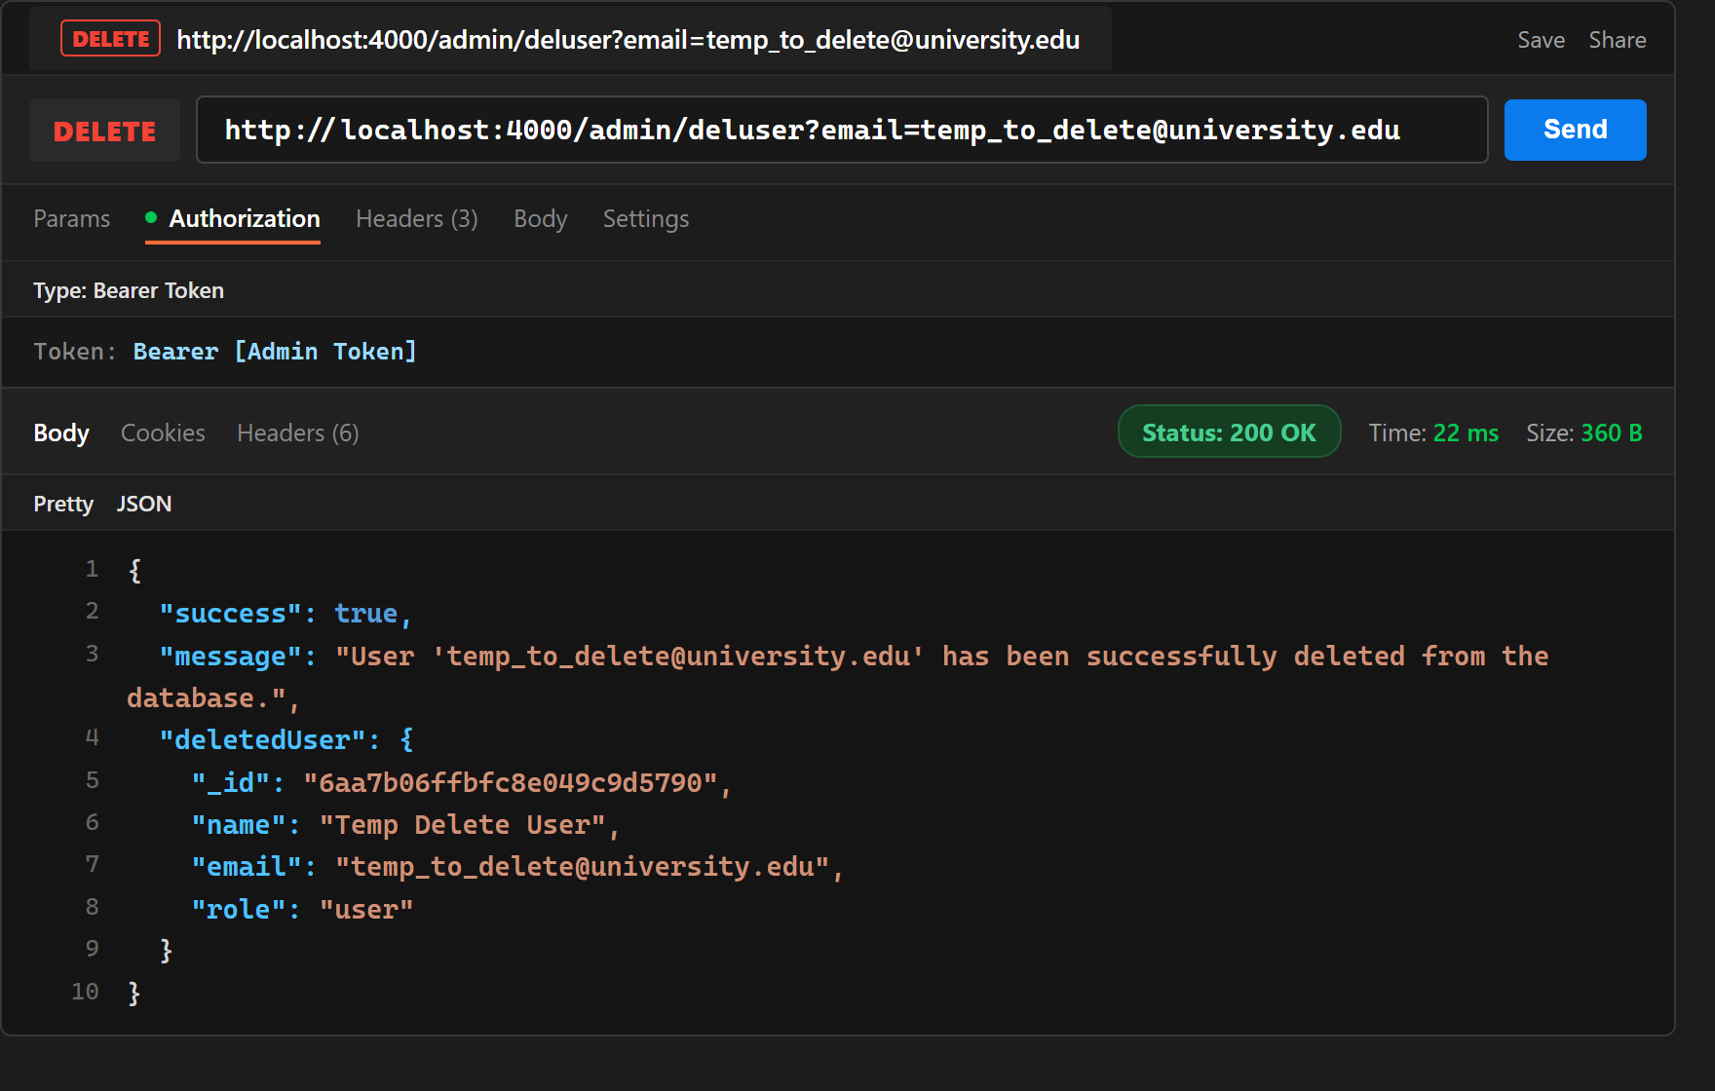
Evidence 14: Postman - DELETE http://localhost:4000/admin/deluser?email=... successfully deleting user (Status 200 OK).
Task 9 – View User Profile Before Update
User Profile View: Student views personal profile via GET http://localhost:4000/user/viewprofile using User Bearer Token. API Gateway passes identity to User Microservice, returning Status 200 OK with initial profile details.
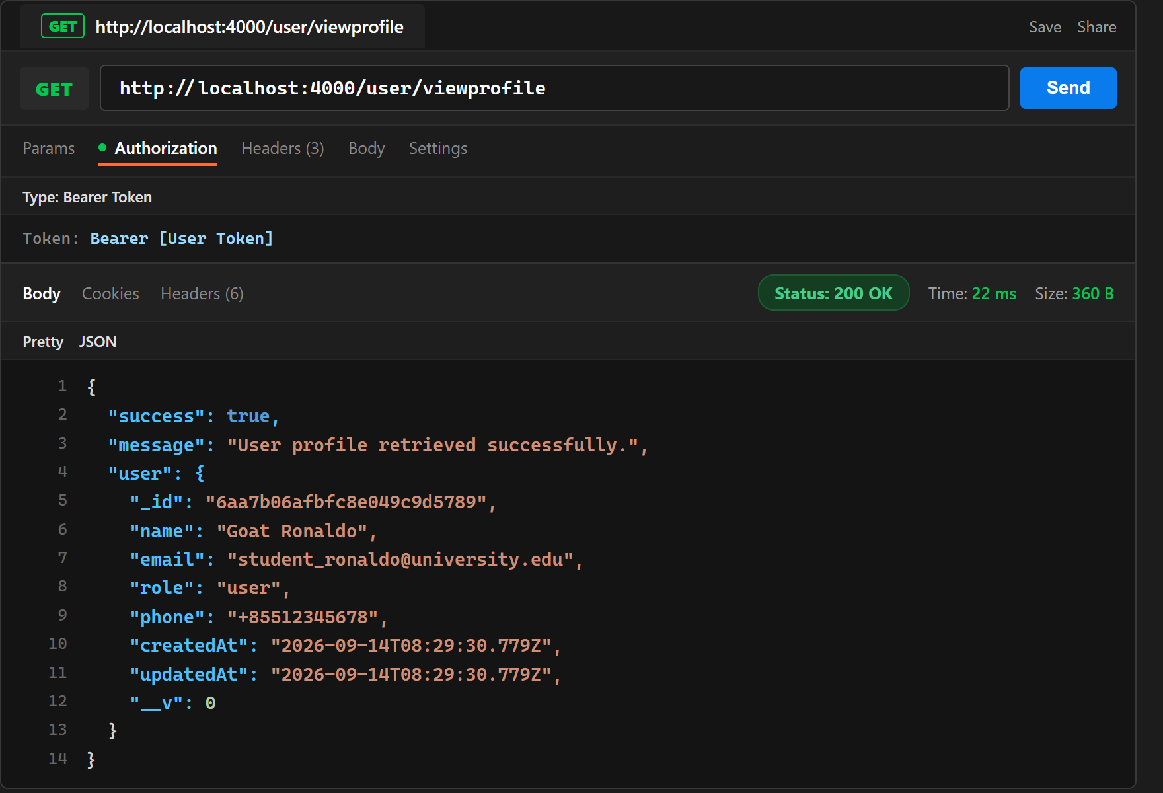
Evidence 15: Postman - GET http://localhost:4000/user/viewprofile retrieving original user profile (Status 200 OK).
Task 9 – Update User Profile
User Profile Update: Student updates name and phone number via PUT http://localhost:4000/user/updateprofile using User Bearer Token. User Microservice updates the document in MongoDB and returns Status 200 OK with updated profile information.
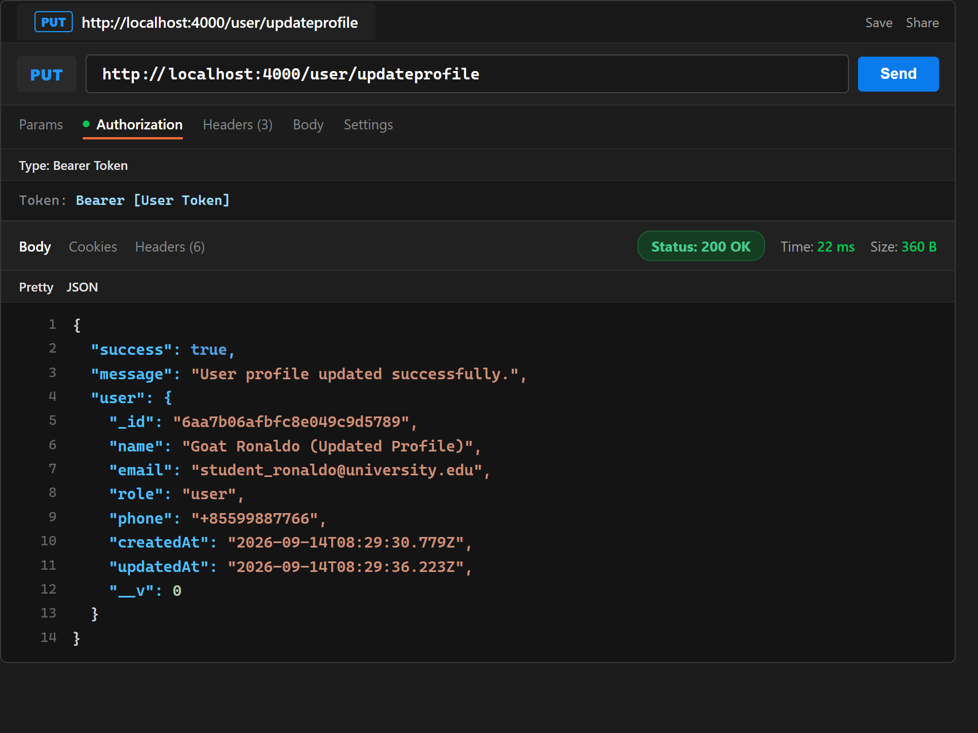
Evidence 16: Postman - PUT http://localhost:4000/user/updateprofile updating user name and phone (Status 200 OK).
User Profile Verification After Update: Student retrieves profile again via GET http://localhost:4000/user/viewprofile using User Bearer Token, confirming updated profile details (name and phone) are returned with Status 200 OK.
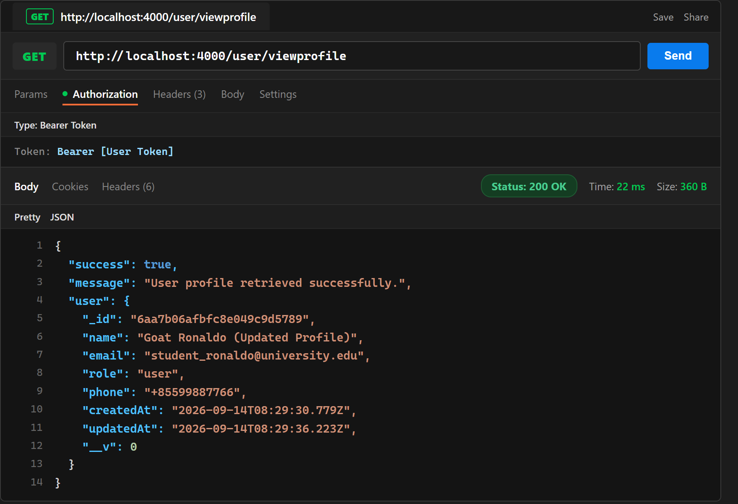
Evidence 16b: Postman - GET http://localhost:4000/user/viewprofile verifying updated profile data (Status 200 OK).
Task 9 – MongoDB User Profile After Update
Database Verification After Update: MongoDB Atlas collection inspection confirming the profile was modified in the database: name changed to 'Goat Ronaldo (Updated Profile)', phone changed to '+85599887766', and updatedAt timestamp automatically refreshed.
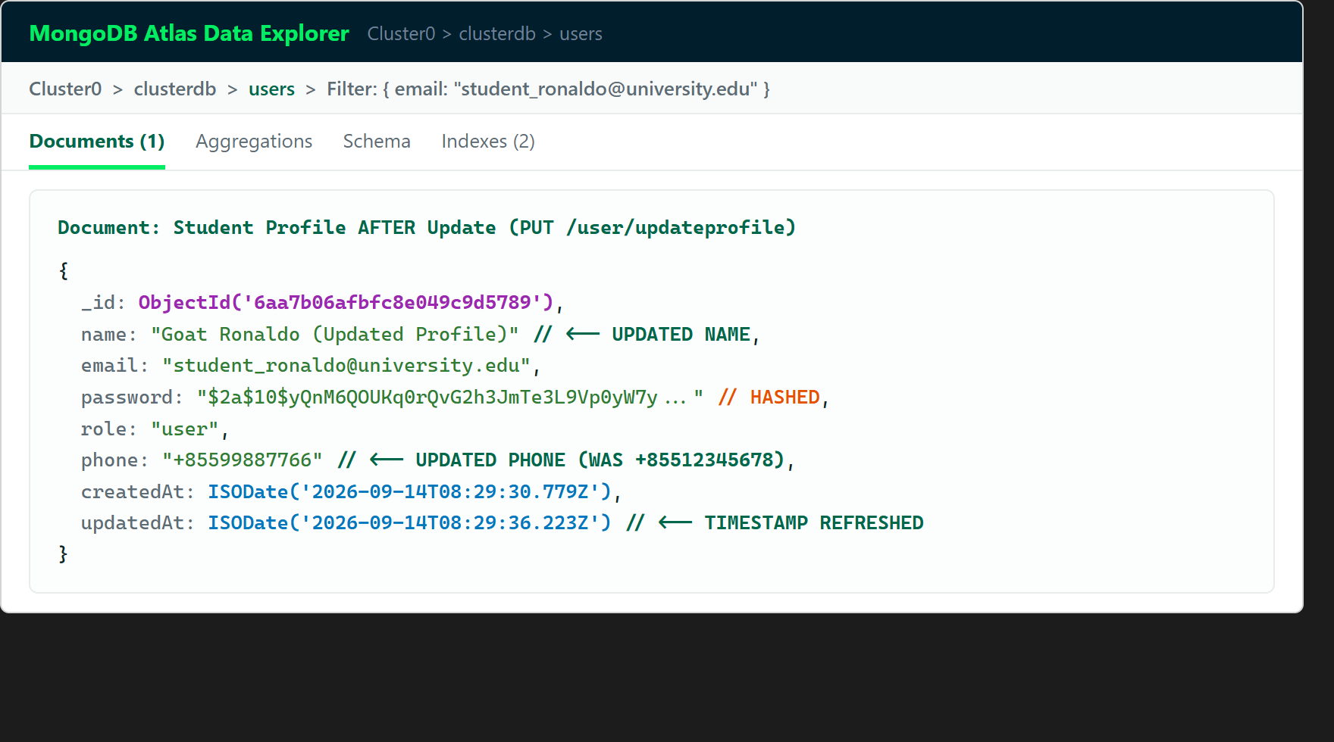
Evidence 17: MongoDB Compass / Atlas Data View - User profile in clusterdb.users showing updated name, phone, and refreshed timestamp.
Task 10(a) – Access Admin API Without Token
Security Test 10(a): Client attempts to access protected route GET http://localhost:4000/admin/viewalluser without an Authorization header. API Gateway intercepts and immediately rejects the request with Status 401 Unauthorized ('Access Denied: No token provided').
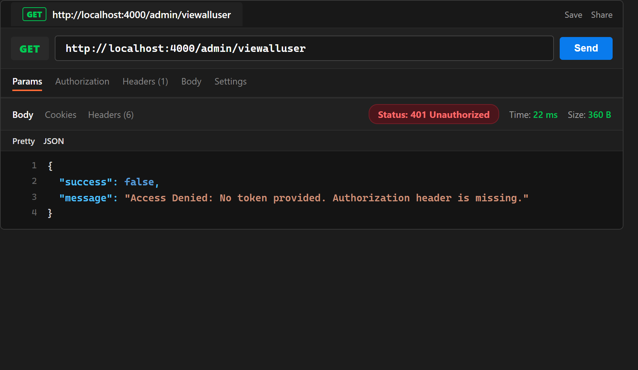
Evidence 18: Postman - Protected endpoint accessed without Authorization header rejected with Status 401 Unauthorized.
Task 10(b) – Access API Using Invalid JWT
Security Test 10(b): Client attempts to access protected route using a fabricated or invalid token (Authorization: Bearer invalid.token.12345). API Gateway verifies token signature, detects malformed token, and rejects with Status 403 Forbidden ('Access Denied: Invalid token').
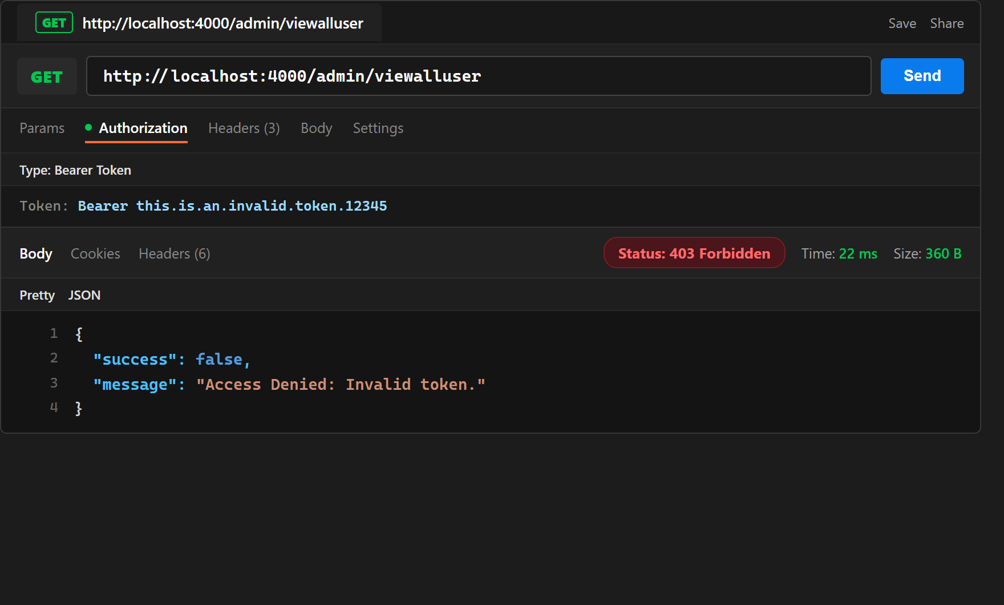
Evidence 19: Postman - Protected endpoint accessed with invalid JWT rejected with Status 403 Forbidden.
Task 10(c) – Admin Token Attempting to Access User API
Security Test 10(c): Client uses an Administrator JWT token to access the User-only endpoint GET http://localhost:4000/user/viewprofile. API Gateway enforces role mutual exclusion and rejects the request with Status 403 Forbidden ('Access Denied: User privileges required. Administrators are not permitted to access User APIs').
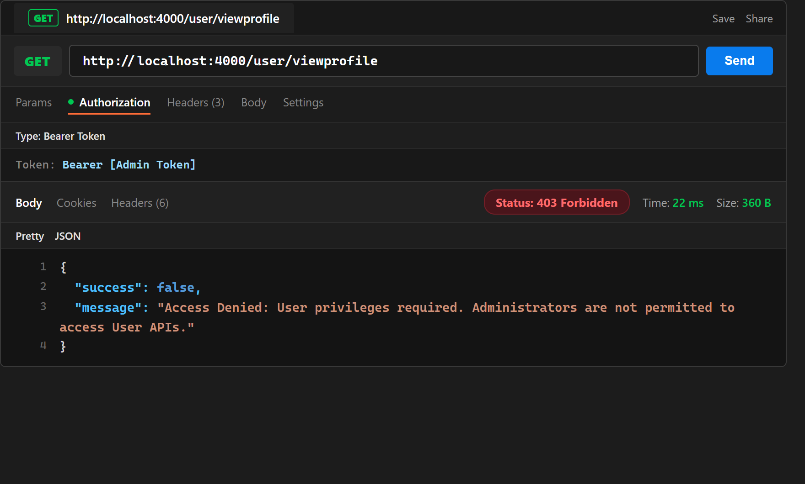
Evidence 20: Postman - Administrator token attempting to access User API rejected with Status 403 Forbidden.
Task 10(d) – User Token Attempting to Access Admin API
Security Test 10(d): Client uses an Ordinary User (Student) JWT token to access the Administrative endpoint GET http://localhost:4000/admin/viewalluser. API Gateway enforces role mutual exclusion and rejects the request with Status 403 Forbidden ('Access Denied: Admin privileges required. Ordinary users are not permitted to access Admin APIs').
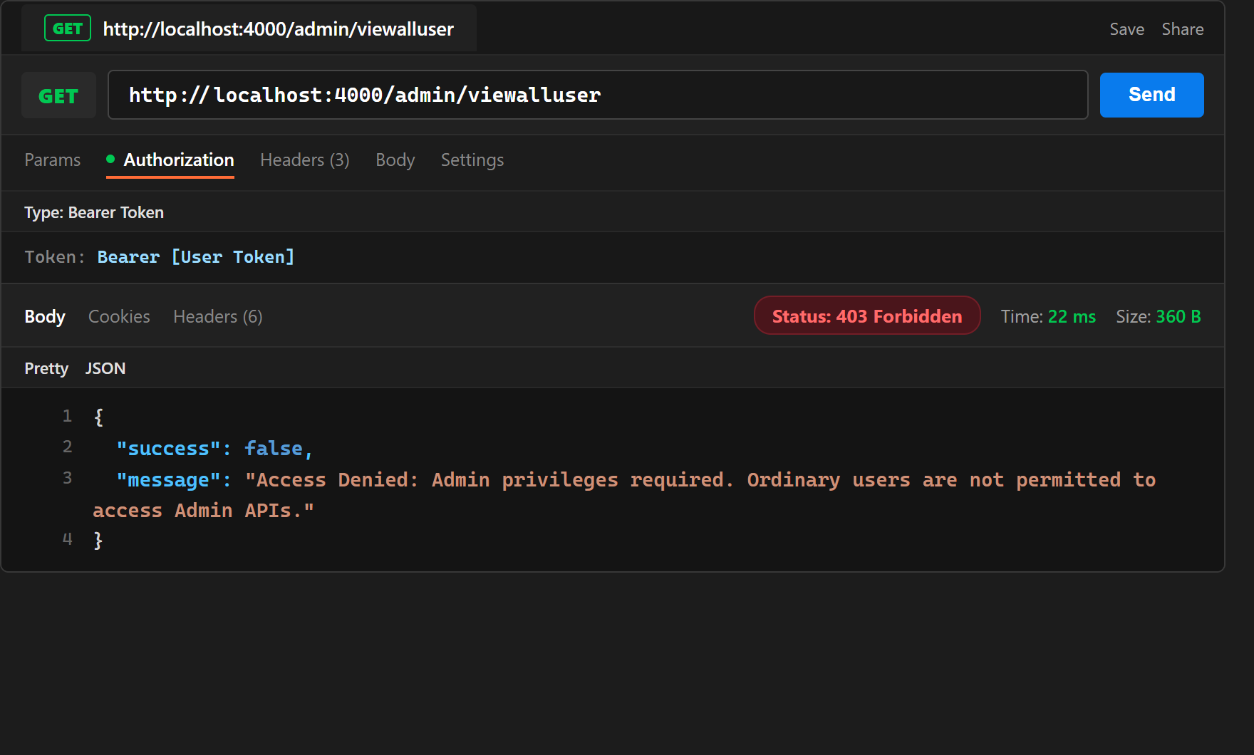
Evidence 21: Postman - Ordinary user token attempting to access Admin API rejected with Status 403 Forbidden.
Task 11 – Public GitHub Repository
Public Repository Link: The complete source code including all 5 microservices, schemas, environment templates, and automated test scripts is published in a public GitHub repository. Sensitive files (.env, node_modules) are properly excluded via .gitignore.
Public GitHub Repository URL: https://github.com/goatronaldo/cld_assignment1_usermanagement.git
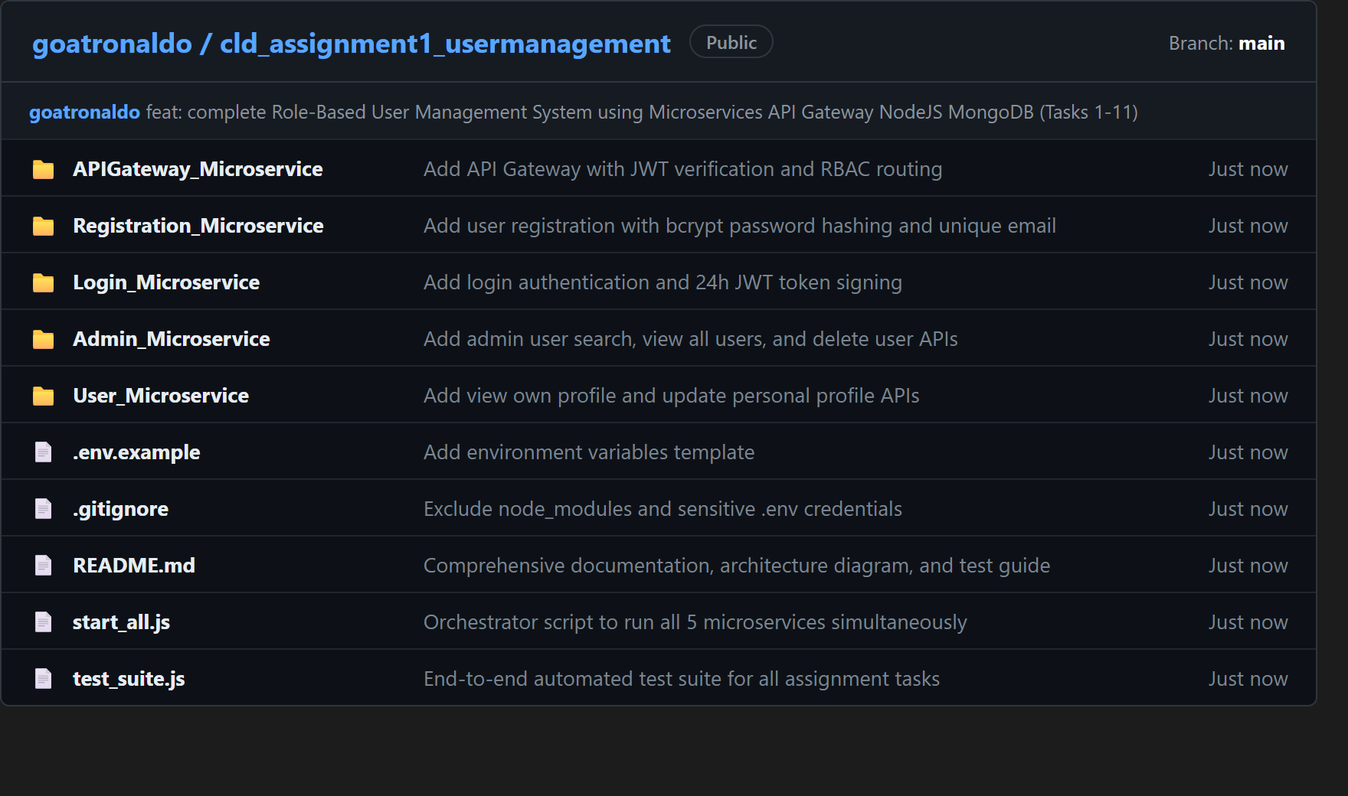
Evidence 22: GitHub Web View - Public repository goatronaldo/cld_assignment1_usermanagement showing the 5 microservices and project files.

