North American Private University

********

International Institute of Technologies

********

Department of Computer Engineering

********

Tunisian republic

********

Ministry of Education Superior and Scientific Research

********



**HUMAN MACHINE INTERFACE :**

**Social Forum**

**Work performed by:**

**Bouaziz Boulbeba**

**Mtibâa Mahdi**

**Ben barka mohamed el hedi**

**Chabchoub Ali**

Etudiants en deuxième année GLID

Under the supervision of :

***Dr. Ing Mohamed MAZOUZI***

***Année Universitaire : 2020 - 2021***

**CONTEXT**

This project is intended to be carried out with regard to the putting into practice of the elements seen during the course of the teaching of the subject "Human Machine Interface", which is a discipline devoted to the design, implementation and evaluation. interactive computer systems intended for human users as well as for the study of the main phenomena which surround them. Also among several themes at our disposal, we have looked into the "realization of a social forum website" in that the place of exchange of messages combining a large number of people as well as their experience in different fields and which is followed by a moment of conviviality.

**Table des matières**

**CONTEXTE** 2

**PARTIE I : CAHIER DE CHAGES** 4

**I.** **Présentation générale du projet** 4

**II.** **Présentation fonctionnelle du projet** 4

**1)** **Les acteurs (intervenants)** 4

**2)** **Action menée par chaque acteur** 4

**PARTIE II : CONCEPTION** 6

**I.** **Le diagramme des cas d’utilisation** 6

**II.** **Le diagramme des classes** 8

**III.** **Modèle de la base de données** 9

**PARTIE II : IMPLEMENTATION** 10

**I.** **Choix des outils** 10

**II.** **Quelques écrans IHM** 10

**CONCLUSION** 11

**PART I: SPECIFICATIONS**

**I. General presentation of the project**

**Title :** Development of a social forum website.

**Equipe :**

* Mohamed MAZOUZI : project manager, teacher responsible for the subject
* Bouaziz Boulbeba: member, student
* Mahdi Mtibâa : member, student
* mohamed el hedi Ben barka: member, student
* Ali Chabchoub : member, student

**Goals:**

* Set up this website
* Applying the principles of the "Human-Machine Interface" discipline to ensure a better user experience, this is an academic project.

Final user : the website is for anyone to change information and solve problems in different areas

## **Functional presentation of the project**

### **The actors (interveners)**

An actor is any person or system that has an impact (added value) to the application under development.

* member: it is a person using the site and who can make a possible posts and also make comments to other posts.
* Administrator: person who manages the moderators and access rights.
* Moderator: moderator allows to manage the site circumstance.
* Surfer : access to the site.

### **Actions carried out by each actor**

**Moderator**

* Can manage posts:
* Consultation and confirmation of posts.
* possibility to delete a post .
* possibility to block comments.
* Category management:
* Add.
* Update.
* Delete.
* Manage comments: delete comments.
* User Management :
* Blocking a user.
* Can penalize a user.

**member**

* Can consult the posts.
* Can comment on posts:
* Update
* Delete
* Profile management.
* Rate a comment (like or dislike )

**Surfer**

* View categories and posts.
* Can register and connect.
* Cannot comment on posts that the condition is verified (logged in as a user).

**L’ADMINISTRATEUR**

* Manage moderators.
* All right of access.

**system allows :**

* Automatically manage user names according to your choice
* Handling of different types of multimedia.
* Possibility of communication between users.

**PART II: DESIGN**

The design is the part that makes it possible to technically express all the functional needs expressed at the level of the specifications. We will express this using the object-oriented modeling language UML (Unified Modeling Language) in some of its different diagrams: the use case diagram and the class diagram.

## **The Use Case**

Use cases are a specific way of using a system, they describe in the form of actions and reactions the behavior of a system from the user's point of view.

**Diagramme des cas d’utilisation**

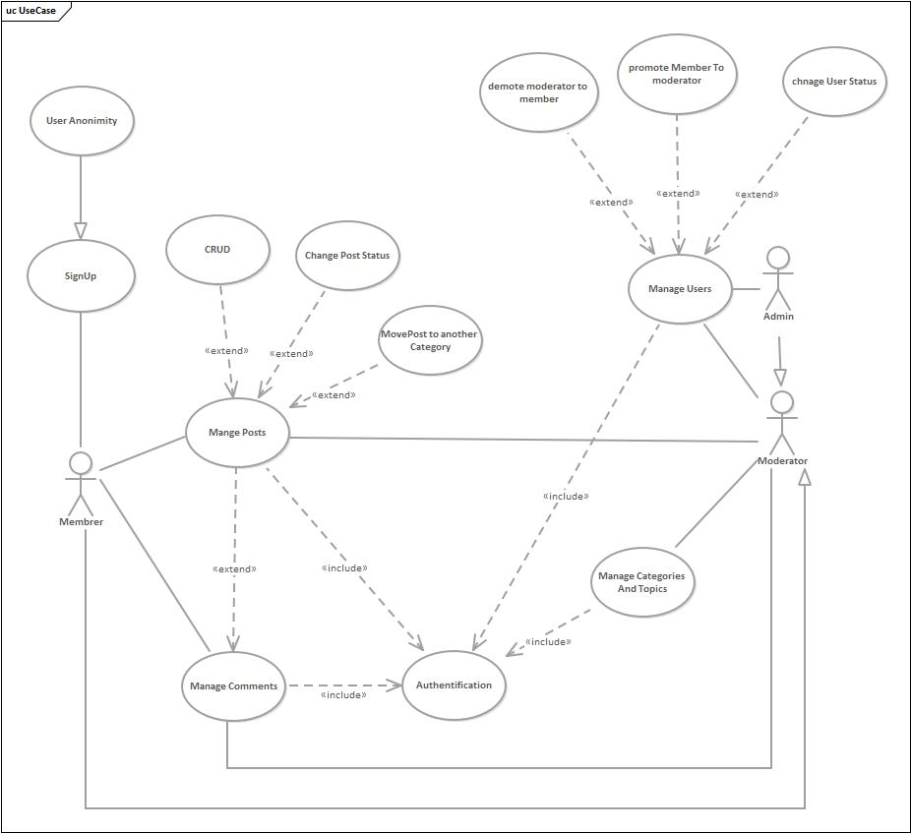

Figure 1 Use Case

## **The class diagram**

The class diagram expresses the static structure of a system in terms of classes and the relationships (associations) between them. A class describes a set of objects; An association describes the link between two or more classes; Objects are instances of classes.

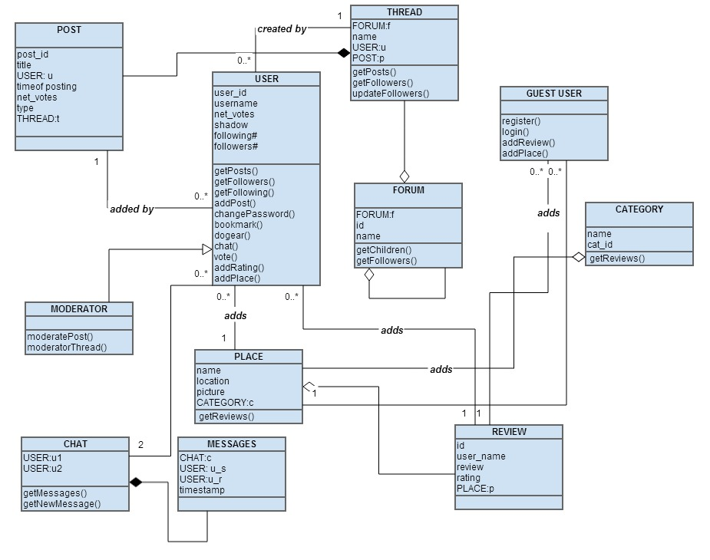

Figure 2 Diagram class

1. **: IMPLEMENTATION**

## **Choice of tools**

* Programming languages: spring boot backend vuejs frontend.
* Database manager: MySQL
* Application server: Apache

## **Some HMI screens**

1. Page d’accueil



1. Page d’inscription

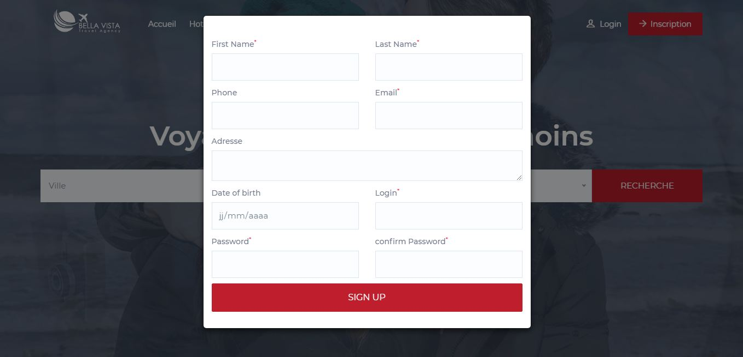

1. Page de réservation

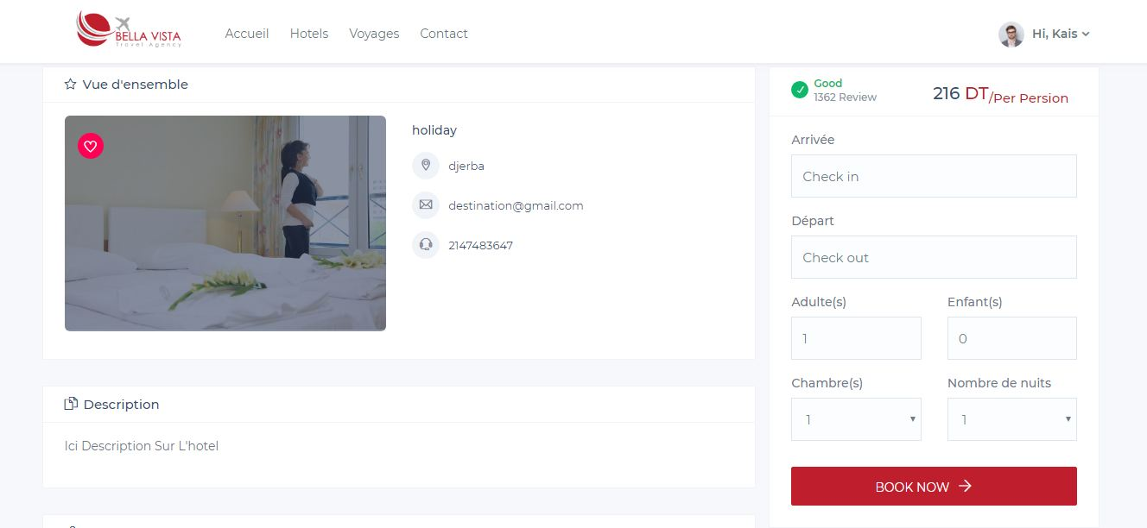

1. Page de connexion

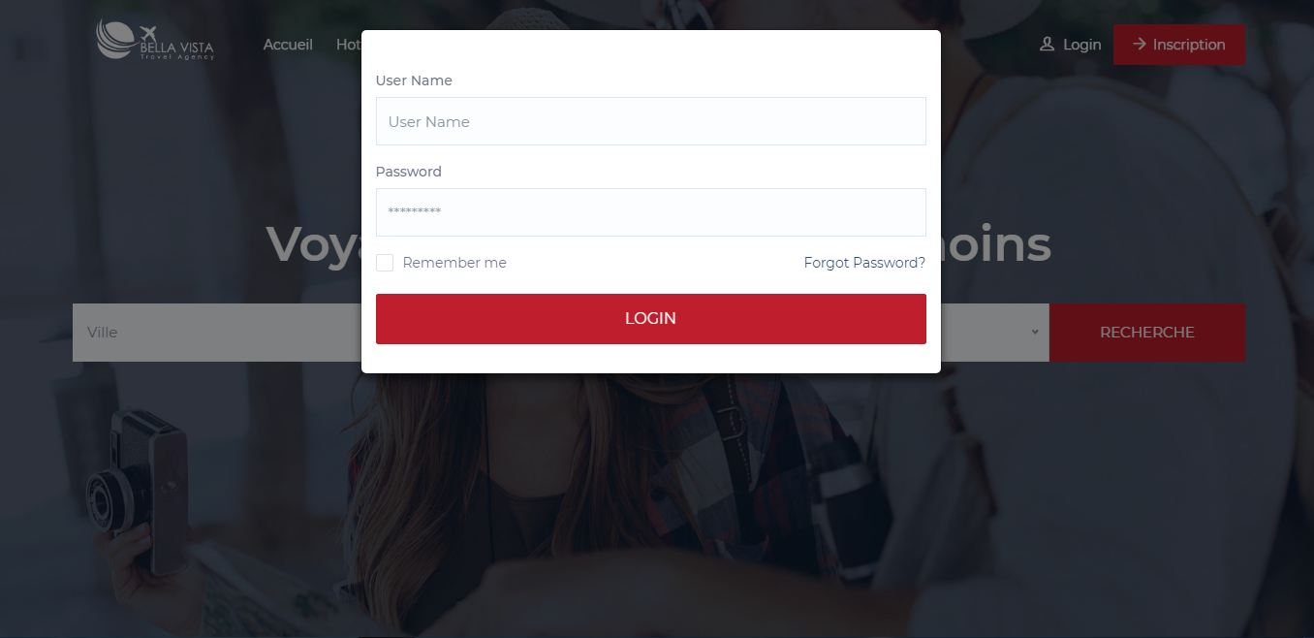

1. Gestion des hôtels

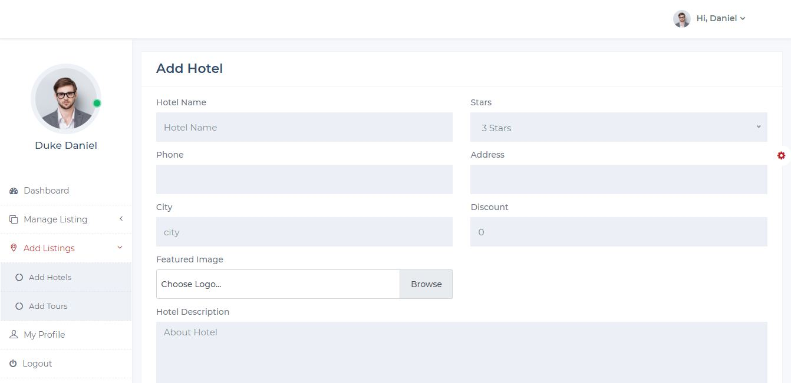

1. Gestion des chambres

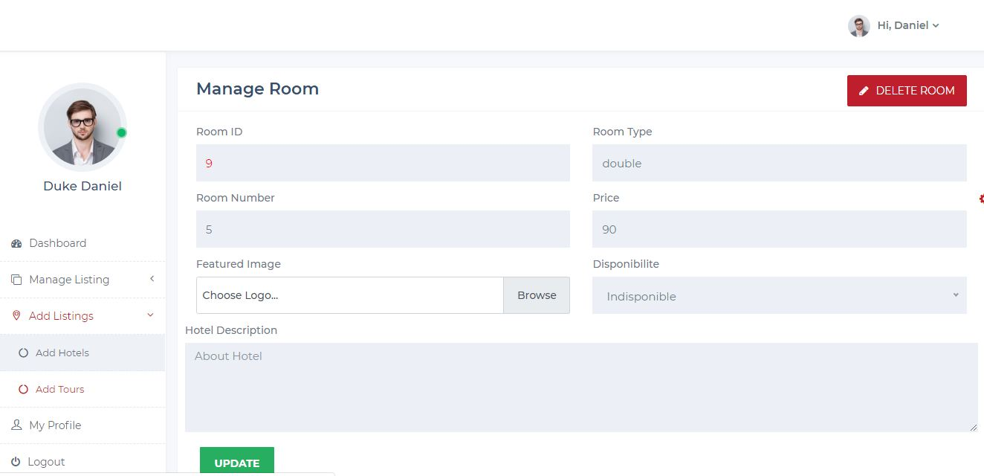

1. Liste hôtels à réserver

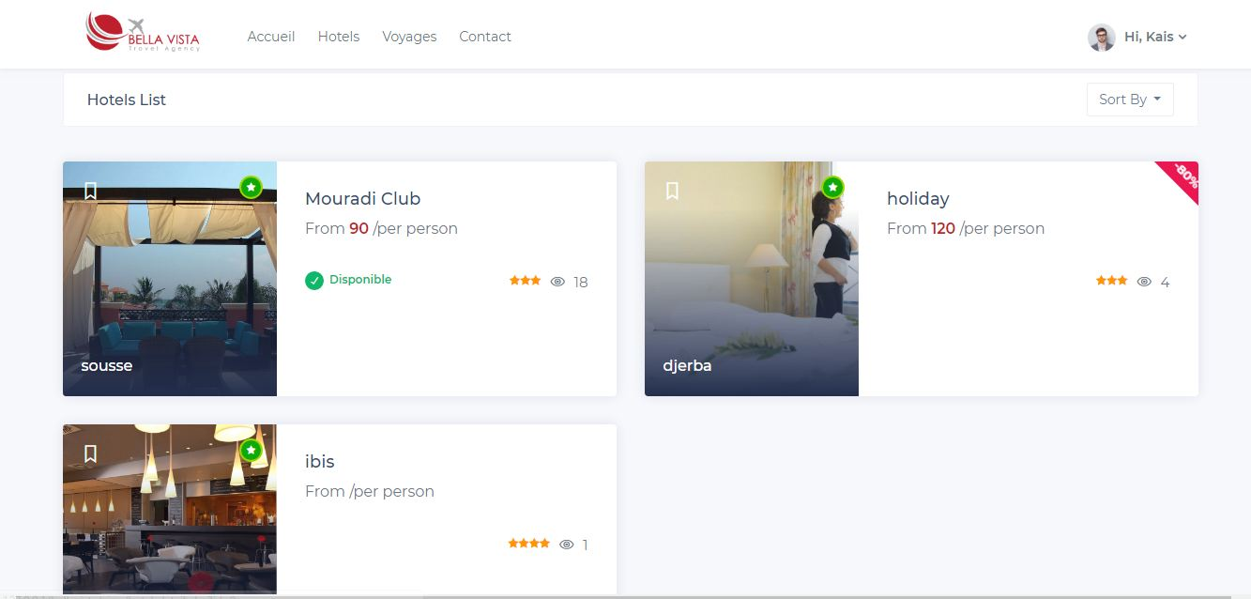

# **CONCLUSION**

At the end of this project, we can say that we were able to tackle themes that we had not done before such as the concept of "specifications" which allowed us to understand a little the beginning of the game. of an IT project. On the other hand the application of the principles of the ergonomics of a website, although not having been carried out in full, we were still able to highlight a few namely: readability, sobriety, the accessibility of our website. The future perspective is to make our site as ergonomic as possible and to finalize with all the functionalities presented in the specifications and to put the members to communicate with each other.