Hockey Team Success: A Sum of Its Parts

Molly McNamara

# Hockey and the Potential Impact of Data Science

The National Hockey League (NHL) is considered to be one of the four major professional sports leagues in the United States (though ranked behind baseball, football and basketball). The NHL operates between the United States and Canada (where hockey is by far the most popular sport). The economics of hockey are complicated by the shared border and exchange rates, but team success during the regular season and the playoffs ultimately drives financial success for the team and the league. Teams see an impact of improved performance and win totals on season ticket sales and sponsorship revenue.

Establishing the right balance of player skills and team needs to make a successful run at the playoffs is the challenge of every NHL general manager (GM). While in-game coaching decisions are left to the coaching staff, the GM is responsible for acquiring and dismissing players and coaches. A skilled GM evaluates the existing team members and identifies gaps or needs in order to find and obtain talent that will support and improve the team as a whole. Better analysis of player and league data can help guide a GM in improved decision making when acquiring team talent, hopefully resulting in a more successful team.

# The Data

The project dataset is a combination of NHL player and team statistics for years 2000-2011 and NHL draft data from the late 1980s through 2010. Variables include player names, ages and birthdates, countries of origin, positions played, scoring and defensive statistics by year, junior level and NHL teams and leagues played in, coaching records, and more. The information was gathered from several sources and in several separate files and formats.

### Data Wrangling

Player/team statistical data was available in CSV format, separated into files by topic; draft data required download, compilation in a TXT file and conversion of the entire dataset to CSV.

Five datasets were read into R: Master (basic demographic information on all NHL players from 1908 to 2011), Scoring (scoring statistics for all NHL players from 1908 to 2011), Teams (team statistics and playoff outcomes from 1908 to 2011), Goalies (defensive statistics for all NHL goaltenders from 1908 to 2011), and Draft (player draft information from 1979 to 2010). The date range for Draft data was determined by identifying the earliest drafted player still playing in the period of interest for this project (the project will evaluate game data from 2000-2011 - a player drafted in 1979 was still playing in 2000) and the latest possible drafted player who would play in this time period (2010). Note that there is no data for 2004 due to a league-wide labor dispute (lockout) wherein the entire season was cancelled and no games were played.

The R packages used for data wrangling were as follows:

library(dplyr)

library(readr)  
library(tidyr)  
library(countrycode)

Columns for all 5 datasets were renamed to understand the variables more easily. In the Draft dataset, the Player column was split into two columns, separating the player name and ID and AmateurTeam/League was split into team and league. The Master, Scoring, Goalies and Draft datasets were then joined/merged by Player_ID and Year into one dataset (AllData).

Unnecessary or duplicative variables were removed. Multiple fields were converted to factors or integers as appropriate. Birth and death month/day/year columns were joined into a single date column for each event. The datasets were subset to the years 2000 to 2011.

The datasets were evaluated with the summary() command to assess the presence of any obvious outliers. NA values in both sets were identified. In the case of certain variables, such as death statistics, NA is appropriate as most of the players in the subset timeframe had not yet died. Scoring statistics that displayed NA (for example, a player did not score any goals in a given year) were replaced with a 0.

New variables were created for team playoff success, birth regions, draft round, and additional scoring and goaltending statistics. Finally, the cleaned datasets were merged by year and team and the new cleaned data file was written and saved as CSV file.

### Final Dataset Composition

The variables in the final dataset are as follows:

Team ID, Conference and Division Team Season end rank and Playoff result Team made playoffs (0 or 1) Team Games, Wins, Losses, Ties, Overtime Losses, Points, Shootout Wins and Shootout Losses Team Goals For and Goals Against Team Penalty Minutes and Bench Minors Year (Season) Player ID First Name and Last Name Height and Weight Shooting Hand First and Last NHL season Years of Experience Position Played Birth Country, Birth State/Province, Birth City Death Country, Death State/Province, Death City Birthdate and Deathdate Birth Region Stint with team Games Played Goals, Assists and Points Penalty Minutes Plus Minus Rating Powerplay Goals and Assists Shorthanded Goals and Assists Gamewinning Goals and Gametying Goals Shots Goals and Shots Per Game Percent of Team Goals Scored Percent of Team Games Played Draft Pick and Draft Round Draft Year Draft Team Draft Age Amateur Team and League Goalie Minutes Played Goalie Wins and Losses Goalie Shutouts Goalie Goals Against Goalie Shots Against Goalie Save Percentage

## Limitations

Several limitations are readily apparent in the dataset prior to analysis: (a) the lack of player statistics prior to draft which might be especially predictive of future performance; (b) lack of draft combine results which is kept confidential by teh NHL; and (c) Time On Ice (TOI), a well-known statistic that tracks how much players are used in the game, was not available.

# Preliminary Exploration

The purpose of the initial data exploration was to screen for any obvious trends in the data and evaluate the relationships between player demographics and characteristics and teams making the playoffs.

Player birth countries were mapped to a world map to evaluate the many origins of players in this dataset.

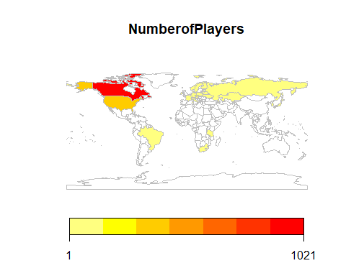

While it appears drafted players originate from many different countries, the NHL is based in the US and Canada; it might be useful to see regionally where the most players come from.

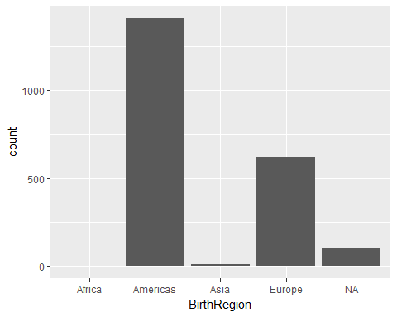

The Americas and Europe generate the vast majority of players drafted in the NHL.

Draft statistics were initially evaluated by viewing a distribution of the draft rounds of the players in this dataset. 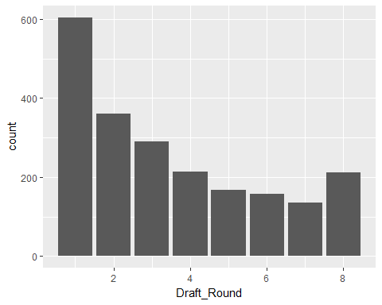

The draft round in the dataset appears to be skewed towards earlier rounds. A comparison between draft round and active years (up to 2012) in the NHL supports the idea that players from earlier draft rounds may have somewhat longer NHL careers. 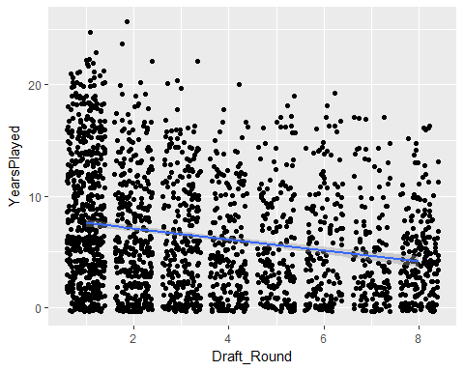

Another way to evaluate relationship between player draft position and team playoff success might be to see if higher-drafted players score more goals per game. It does look like there is a slight trend for more goals per game from higher-drafted players but it's not clear if this impacts making the playoffs.

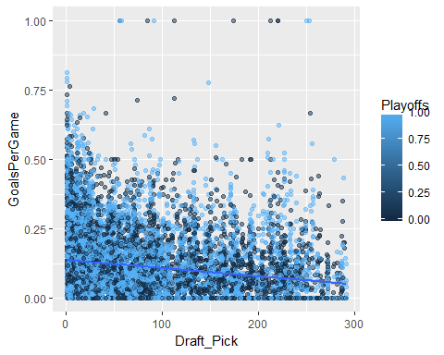

It should be expected that teams who score more goals in a year and allows less goals in a year are more likely to go to the playoffs. 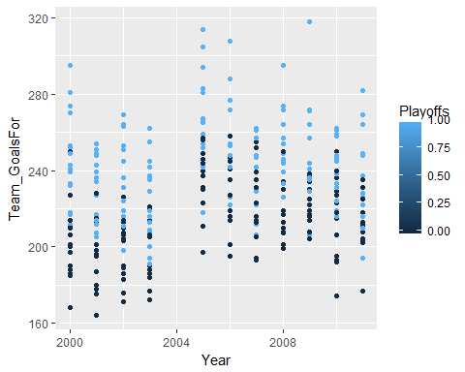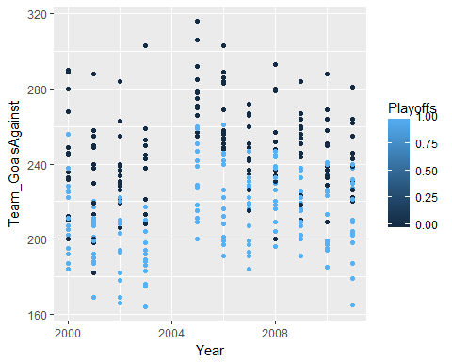

This hypothesis appears to be true for the highest goal-scoring teams and lowest goal-allowing teams year-to-year.

Another interesting area to evaluate is defensive statistics related to goaltenders. A goaltender's save percentage (the percent of shots they save from becoming goals) and shutouts (games where they don't allow the other team to score at all) should influence their team's win rate and perhaps making the playoffs.

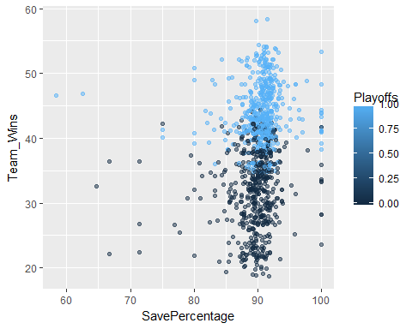

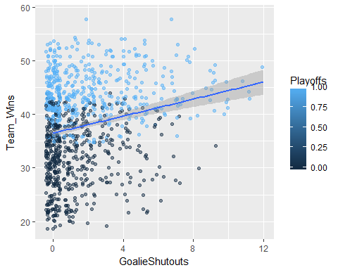

The relationship is not clear from these graphs but may be more apparent when the data is modeled.

# Modeling Approach

In examining the data in more detail over the course of the wrangling and exploring exercises, several simple truths are clear: teams that win more games, score more goals and allow less goals by their opposition go to the playoffs. However, as teams are built and restructured over years, the question still exists of what player characteristics contribute most strongly to success. The main goal of the project remains the primary focus from the project proposal - to determine what factors contribute to regular season success that is realized in a playoff berth.

The project approach at this point is to:  
Build the best predictive model of team success (defined as making the playoffs) from the player and draft characteristics.  
A secondary aim will be to define underrated and overrated players, determined by draft position and scoring history, and evaluate if player performance at the time of the draft is predictable by amateur team, amateur league, position played or other factors.

## Machine Learning Approach to Capstone Project

The main question for this project was what player demographic/draft/play characteristics are most predictive of team success (making the playoffs). The secondary question was whether player characteristics at the time they are drafted into the league, using a subset of underperforming and overperforming players, can predict their future performance. As this is labeled data, it was approached as a supervised learning problem.

The player features (independent variables) used to predict team success were Shooting Hand, Years of Experience, Position Played, Games Played, Goals, Assists, Shots and Points, Penalty Minutes, Plus-Minus Rating, Goals and Shots Per Game, Percent of Team Goals Scored, Percent of Team Games Played, Draft Pick, Draft Round, and Draft Age.

The player features (independent variables) that may be used to predict whether a player will over or under deliver in terms of performance post-draft were Height and Weight, Position Played, Draft Year, Draft Team, Draft Age, and Amateur League.

The primary question was evaluated using several different types of algorithms to build a model that allows for less than linear relationships between the variables; model performance was assessed to determine what type of algorithm produces the best model. The secondary question was evaluated using logistic regression to determine how the variables may impact the final outcome of player performance.

Repeated k-fold cross-validation was used with the caret package to estimate model accuracy for the various models predicting team performance. The logistic regression model for player performance was evaluated with a chi-squared test using ANOVA.

## Data Analysis

### Modeling Predictors of Team Success

A number of R packages were utilized for the modeling and analysis.

# load libraries  
library(mlbench)  
library(caret)

library(readr)  
library(rpart)  
library(dplyr)  
library(C50)  
library(plyr)

library(ipred)  
library(e1071)  
library(ROCR)

library(randomForest)

The trainControl function was set for all models to be run with three separate 10-fold cross-validations as the resampling scheme.

The formula to be used in the modeling was defined.

#Create the formula to evaluate the variables that may influence Playoffs  
formula <- Playoffs ~ Shooting_Hand + YearsExperience + Goals + Assists + Penalty_Minutes + Shots + GoalsPerGame + ShotsPerGame + PointsPerGame + PercentGoals + PercentGames + Draft_Pick + Draft_Round + Draft_Age + SavePercentage + GoalieShutouts + GoalieMinutes

The caret package in R was used to quickly run a number of different types of models on the same data. The data was evaluated using logistic regression, CART, C5.0, bagged CART, random forest and stochastic gradient boosting models.

The resamples function was used to aggregate the results from the models and method accuracy was compared across models.

## Call:

## summary.resamples(object = results, metric = "Accuracy")

##

## Models: logistic, cart, c50, bagging, rf, gbm

## Number of resamples: 30

##

## Accuracy

## Min. 1st Qu. Median Mean 3rd Qu. Max. NA's

## logistic 0.5194805 0.5648295 0.5898166 0.6008131 0.6306604 0.7473684 0

## cart 0.5536398 0.5697538 0.5747126 0.5751777 0.5778894 0.5967433 0

## c50 0.5354406 0.6027299 0.6340996 0.6259022 0.6594828 0.6791188 0

## bagging 0.5900383 0.6290709 0.6397129 0.6384139 0.6532661 0.6676245 0

## rf 0.6206897 0.6429598 0.6553379 0.6540559 0.6637931 0.6829502 0

## gbm 0.6159004 0.6388889 0.6452845 0.6443529 0.6526220 0.6695402 0

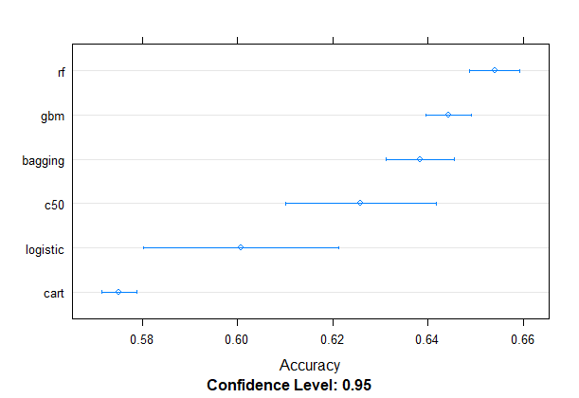

The random forest model showed the highest accuracy amongst the models. The various features that contribute to the model were evaluated to see their influence on the modeling.

## rf variable importance  
##   
## Overall  
## SavePercentage 100.00000  
## GoalieMinutes 76.68268  
## Draft_Pick 72.67494  
## PercentGames 68.47530  
## YearsExperience 63.05109  
## GoalieShutouts 47.48221  
## Penalty_Minutes 46.59246  
## PointsPerGame 43.92116  
## Draft_Round 36.32194  
## Draft_Age 25.97502  
## Assists 21.92445  
## Shooting_HandR 10.03559  
## ShotsPerGame 7.69649  
## Shots 4.72314  
## PercentGoals 0.24726  
## GoalsPerGame 0.07925  
## Goals 0.00000

A new model was generated using the variables of greatest importance.

formula2 <- Playoffs ~ PercentGoals + Draft_Pick + Penalty_Minutes + ShotsPerGame + PercentGames + PointsPerGame + YearsExperience + GoalsPerGame

fit.rf2 <- randomForest(formula2, data=dataset, trControl="oob", na.action = na.roughfix, preProcess=c("center", "scale"))## summary.resamples(object = results, metric = "Accuracy")

The mean decrease gini was plotted to determine the most important features, the AUC was calculated, and a ROC curve generated to assess the results of the model. 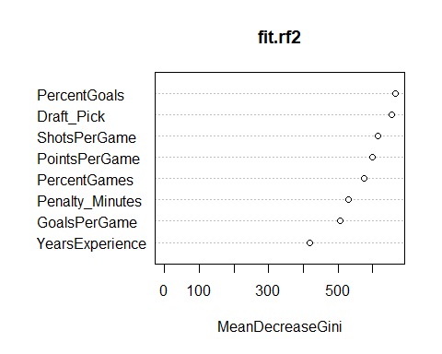

## auc  
## [1] 0.6788254

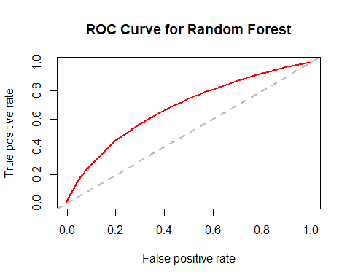

### Modeling Predictors of Future Player Performance

A secondary analysis aim was to define underrated and overrated players, determined by draft position and scoring statistics, and evaluate if player performance at the time of the draft is predictable by amateur team, amateur league, nationality, position played or other factors. A logistic regression model was used to assess the features which may differentiate future player performance.

##   
## Call:  
## glm(formula = OverUnder ~ Height + Weight + Position_Played +   
## Draft_Team + Draft_Age + BirthRegion + AmateurLeague, family = "binomial", data = Question2)  
##   
## Deviance Residuals:   
## Min 1Q Median 3Q Max   
## -2.9599 -0.2420 -0.0950 -0.0001 3.4502   
##   
## Coefficients:  
## Estimate Std. Error z value Pr(>|z|)   
## (Intercept) -1.823e+01 1.254e+04 -0.001 0.998840   
## Height -5.186e-01 8.885e-02 -5.837 5.32e-09 ***  
## Weight 5.826e-04 1.029e-02 0.057 0.954849   
## Position_PlayedD -1.913e+00 3.214e-01 -5.953 2.64e-09 ***  
## Position_PlayedL -1.422e+00 3.662e-01 -3.883 0.000103 ***  
## Position_PlayedR -2.366e-01 3.269e-01 -0.724 0.469168   
## Draft_TeamAtlanta Thrashers -5.048e-01 1.334e+00 -0.378 0.705069   
## Draft_TeamBoston Bruins -2.864e+00 9.890e-01 -2.896 0.003776 **   
## Draft_TeamBuffalo Sabres -1.065e-01 6.853e-01 -0.155 0.876495   
## Draft_TeamCalgary Flames -2.051e+00 7.793e-01 -2.632 0.008482 **   
## Draft_TeamCarolina Hurricanes -2.106e+01 2.584e+03 -0.008 0.993497   
## Draft_TeamChicago Blackhawks 1.227e-01 6.703e-01 0.183 0.854765   
## Draft_TeamColorado Avalanche -5.126e-01 7.405e-01 -0.692 0.488833   
## Draft_TeamColumbus Blue Jackets -1.600e+00 1.463e+00 -1.094 0.274162   
## Draft_TeamDallas Stars -2.286e+00 8.435e-01 -2.710 0.006732 **   
## Draft_TeamDetroit Red Wings -1.923e+01 1.992e+03 -0.010 0.992295   
## Draft_TeamEdmonton Oilers -1.374e+00 7.206e-01 -1.907 0.056533 .   
## Draft_TeamFlorida Panthers -1.815e+01 1.908e+03 -0.010 0.992409   
## Draft_TeamHartford Whalers -4.210e+00 1.266e+00 -3.325 0.000885 ***  
## Draft_TeamLos Angeles Kings -2.013e+01 1.721e+03 -0.012 0.990668   
## Draft_TeamMinnesota North Stars -1.688e+01 4.153e+03 -0.004 0.996757   
## Draft_TeamMinnesota Wild -2.092e+01 2.297e+03 -0.009 0.992731   
## Draft_TeamMontreal Canadiens -1.267e+00 7.022e-01 -1.805 0.071113 .   
## Draft_TeamNashville Predators -1.830e+01 2.522e+03 -0.007 0.994209   
## Draft_TeamNew Jersey Devils -1.474e+00 7.644e-01 -1.928 0.053834 .   
## Draft_TeamNew York Islanders -2.383e+00 9.715e-01 -2.453 0.014173 *   
## Draft_TeamNew York Rangers -3.594e+00 1.272e+00 -2.825 0.004722 **   
## Draft_TeamOttawa Senators -2.461e-02 7.372e-01 -0.033 0.973367   
## Draft_TeamPhiladelphia Flyers -4.283e+00 1.380e+00 -3.103 0.001916 **   
## Draft_TeamPhoenix Coyotes -3.819e-01 1.009e+00 -0.378 0.705111   
## Draft_TeamPittsburgh Penguins -2.969e-01 7.194e-01 -0.413 0.679842   
## Draft_TeamQuebec Nordiques -2.383e+00 1.487e+00 -1.603 0.108911   
## Draft_TeamSan Jose Sharks -2.166e+00 9.234e-01 -2.345 0.019007 *   
## Draft_TeamSt. Louis Blues -2.068e-01 7.449e-01 -0.278 0.781316   
## Draft_TeamTampa Bay Lightning -1.609e+00 1.033e+00 -1.558 0.119260   
## Draft_TeamToronto Maple Leafs -7.105e-01 8.380e-01 -0.848 0.396513   
## Draft_TeamVancouver Canucks -2.151e+00 9.572e-01 -2.247 0.024649 *   
## Draft_TeamWashington Capitals -2.632e+00 9.856e-01 -2.671 0.007566 **   
## Draft_TeamWinnipeg Jets -1.815e+01 2.174e+03 -0.008 0.993338   
## Draft_Age 2.066e+00 2.106e-01 9.807 < 2e-16 ***  
## BirthRegionAmericas 1.697e+01 1.254e+04 0.001 0.998920   
## BirthRegionAsia 2.097e+01 1.254e+04 0.002 0.998666   
## BirthRegionEurope 1.769e+01 1.254e+04 0.001 0.998874   
## AmateurLeagueAJHL -1.382e+01 1.254e+04 -0.001 0.999121   
## AmateurLeagueBCHL 1.390e+00 1.272e+00 1.093 0.274563   
## AmateurLeagueCCHA -2.442e+00 1.610e+00 -1.516 0.129491   
## AmateurLeagueECAC 6.630e-02 1.185e+00 0.056 0.955370   
## AmateurLeagueFinland 1.420e+00 1.265e+04 0.000 0.999910   
## AmateurLeagueH-East -2.633e+00 1.262e+00 -2.086 0.036947 *   
## AmateurLeagueHigh-CT 1.816e+00 2.734e+00 0.664 0.506510   
## AmateurLeagueHigh-IN -1.211e+01 1.773e+04 -0.001 0.999455   
## AmateurLeagueHigh-MA 2.094e+00 1.116e+00 1.877 0.060539 .   
## AmateurLeagueHigh-ME -1.536e+01 6.269e+03 -0.002 0.998044   
## AmateurLeagueHigh-MN 3.685e-01 1.477e+00 0.250 0.802904   
## AmateurLeagueHigh-NY -1.731e+01 4.728e+03 -0.004 0.997079   
## AmateurLeagueHigh-VT -1.504e+01 1.773e+04 -0.001 0.999323   
## AmateurLeagueIHL -2.350e+01 4.696e+03 -0.005 0.996008   
## AmateurLeagueNAHL -1.676e+01 1.254e+04 -0.001 0.998933   
## AmateurLeagueOHL -9.882e-02 1.053e+00 -0.094 0.925204   
## AmateurLeagueOJHL -1.937e+01 1.254e+04 -0.002 0.998768   
## AmateurLeagueQMJHL 1.737e+00 1.057e+00 1.643 0.100295   
## AmateurLeagueRussia -9.248e+00 2.093e+00 -4.418 9.98e-06 ***  
## AmateurLeagueRussia-3 -1.694e+01 8.865e+03 -0.002 0.998475   
## AmateurLeagueSlovakia -1.256e+00 1.784e+04 0.000 0.999944   
## AmateurLeagueSweden 8.561e-02 1.316e+00 0.065 0.948146   
## AmateurLeagueSweden-2 -1.664e+01 1.773e+04 -0.001 0.999251   
## AmateurLeagueSweden-Jr. -1.578e+01 6.683e+03 -0.002 0.998116   
## AmateurLeagueUSHL 2.334e+00 1.102e+00 2.118 0.034153 *   
## AmateurLeagueUSNTDP -1.790e+01 3.590e+03 -0.005 0.996022   
## AmateurLeagueWCHA -1.349e+00 1.139e+00 -1.185 0.236181   
## AmateurLeagueWCHL -1.698e+01 3.741e+03 -0.005 0.996379   
## AmateurLeagueWHL 1.121e+00 1.038e+00 1.080 0.280227   
## ---  
## Signif. codes: 0 '***' 0.001 '**' 0.01 '*' 0.05 '.' 0.1 ' ' 1  
##   
## (Dispersion parameter for binomial family taken to be 1)  
##   
## Null deviance: 1315.72 on 2324 degrees of freedom  
## Residual deviance: 677.49 on 2253 degrees of freedom  
## (695 observations deleted due to missingness)  
## AIC: 821.49  
##   
## Number of Fisher Scoring iterations: 19

## Analysis of Deviance Table  
##   
## Model: binomial, link: logit  
##   
## Response: OverUnder  
##   
## Terms added sequentially (first to last)  
##   
##   
## Df Deviance Resid. Df Resid. Dev Pr(>Chi)   
## NULL 2324 1315.72   
## Height 1 160.392 2323 1155.33 < 2.2e-16 ***  
## Weight 1 3.448 2322 1151.88 0.06331 .   
## Position_Played 3 71.022 2319 1080.86 2.579e-15 ***  
## Draft_Team 33 154.392 2286 926.47 < 2.2e-16 ***  
## Draft_Age 1 91.068 2285 835.40 < 2.2e-16 ***  
## BirthRegion 3 7.938 2282 827.46 0.04732 *   
## AmateurLeague 29 149.971 2253 677.49 < 2.2e-16 ***  
## ---  
## Signif. codes: 0 '***' 0.001 '**' 0.01 '*' 0.05 '.' 0.1 ' ' 1

## Conclusions

### References

Player and team statistics was obtained from: The Hockey Database([link](http://www.opensourcesports.com/hockey/)) by Doug Reynolds, via Open Source Sports.  
Draft data was obtained from: Sports Reference LLC. "NHL Entry And Amateur Draft History." Hockey-Reference.com - Hockey Statistics and History([link](http://www.hockey-reference.com/)).

All prior project reports, original and final data files, and R code can be found in the project Github repository([link](https://github.com/bouncebarkrun/SpringboardCapstoneProject)).