**API9 DESCRIPTION**

Web services that are based on REST Architecture are known as RESTful Web Services. REST is a web standards based architecture and it means representational state transfer. These web services use HTTP methods for data communication. In REST architecture, basically a REST Server provides access to resources and the REST client accesses and presents the resources.To represent a resource, REST uses various representations like JSON and XML.

In this API project , the JAVA programming language is chosen to create an API and JAX-RS is also determined to create RESTful API as a framework. Before starting to the project, we determined some functionalities to implement them in this API example.

=> login

=> signUp

=> getAllConcert

=> getConcert

=> createConcert

=> writeComment

=> getAllComment

These are some functionalities of our API that are used with HTTP mehods.

Generally, there are different kinds of HTTP methods , however methods in below are 4 of them that are commonly used

GET : read the resource and give information about it

PUT : create a new resource with the necessary informations

DELETE : remove a resource

POST : update a resoure or create a new resource.

to test our API with the given HTTP requests, we choose to use Postman. By using it , we can get the results in JSON format.

As an example, when we send the request in below,

GET localhost:8080/api9/rest/concert/5

the API gets this request and by using queries it gets the informations of the concert with the given id = 5 from database tables.

To store the actual data, we need to create the necessary tables for DataBase. There are some tables created by MySQL language.

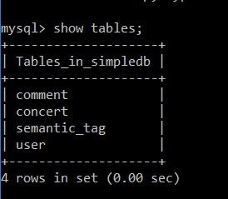

In this tables , the corresponding fields are also included. For example, the concert table has the fields

`id` : int(11)

`name` : varchar(100)

`owner_id` : int(11)

`artist_name` : varchar(100)

`location_x` : double

`location_y` : double

`min_price` : double

`max_price` : double

`rate` : double

`date_time` : datetime

PRIMARY KEY (`id`)

To sum up, by using Postman app , we send the HTTP request to the API and it manage that request with the functions inside it. With these methods in it , the query is created and the necessary information can be read from database or written to the tables that are created in database.