
Mes tables de multiplication
Pour commencer dans l’application
J’apprends > choisis une table > dans l’ordre > dans le désordre
TABLE DE 2  2 × 1 = 2  2 × 2 = 4  2 × 3 = 6  2 × 4 = 8  2 × 5 = 10  2 × 6 = 12  2 × 7 = 14  2 × 8 = 16  2 × 9 = 18  2 × 10 = 20 | TABLE DE 3  3 × 1 = 3  3 × 2 = 6  3 × 3 = 9  3 × 4 = 12  3 × 5 = 15  3 × 6 = 18  3 × 7 = 21  3 × 8 = 24  3 × 9 = 27  3 × 10 = 30 | TABLE DE 4  4 × 1 = 4  4 × 2 = 8  4 × 3 = 12  4 × 4 = 16  4 × 5 = 20  4 × 6 = 24  4 × 7 = 28  4 × 8 = 32  4 × 9 = 36  4 × 10 = 40
TABLE DE 5  5 × 1 = 5  5 × 2 = 10  5 × 3 = 15  5 × 4 = 20  5 × 5 = 25  5 × 6 = 30  5 × 7 = 35  5 × 8 = 40  5 × 9 = 45  5 × 10 = 50 | TABLE DE 6  6 × 1 = 6  6 × 2 = 12  6 × 3 = 18  6 × 4 = 24  6 × 5 = 30  6 × 6 = 36  6 × 7 = 42  6 × 8 = 48  6 × 9 = 54  6 × 10 = 60 | TABLE DE 7  7 × 1 = 7  7 × 2 = 14  7 × 3 = 21  7 × 4 = 28  7 × 5 = 35  7 × 6 = 42  7 × 7 = 49  7 × 8 = 56  7 × 9 = 63  7 × 10 = 70
TABLE DE 8  8 × 1 = 8  8 × 2 = 16  8 × 3 = 24  8 × 4 = 32  8 × 5 = 40  8 × 6 = 48  8 × 7 = 56  8 × 8 = 64  8 × 9 = 72  8 × 10 = 80 | TABLE DE 9  9 × 1 = 9  9 × 2 = 18  9 × 3 = 27  9 × 4 = 36  9 × 5 = 45  9 × 6 = 54  9 × 7 = 63  9 × 8 = 72  9 × 9 = 81  9 × 10 = 90 | TABLE DE 10  10 × 1 = 10  10 × 2 = 20  10 × 3 = 30  10 × 4 = 40  10 × 5 = 50  10 × 6 = 60  10 × 7 = 70  10 × 8 = 80  10 × 9 = 90  10 × 10 = 100
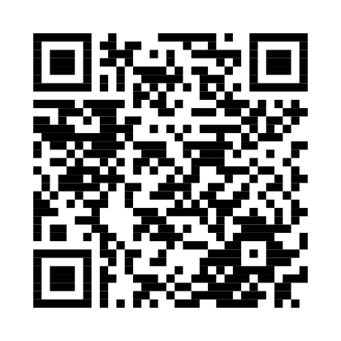 Scanne pour ouvrir Défi tables sur mathsgo.re

