**KittyBank**

Manage your bank system with purrrr-fection, this is the promise of KittyBank. With its performing API, you'll be able to easily manage your data regarding your customers, their accounts and their address.

**Home Page**

With its cute and refreshing design, Kitty Bank will help you work easier and with the happiness of a purring cat lying onto your lap!

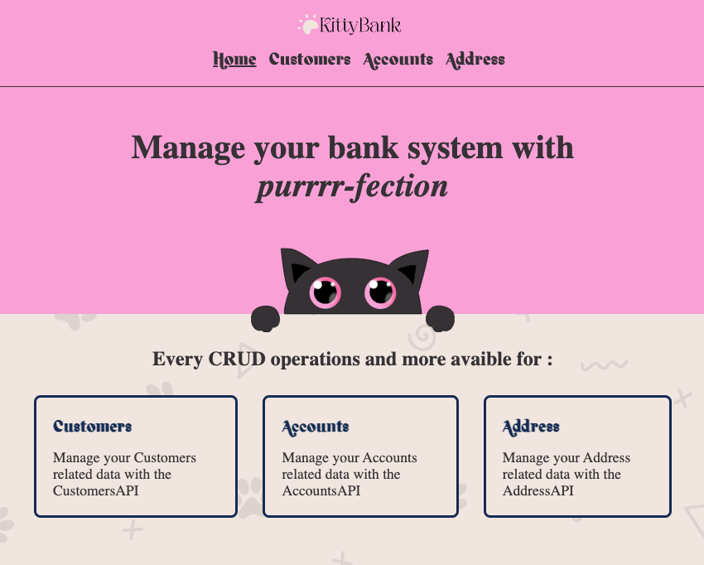

**Customers API**

* List all your customers
* Search a customer with its ID
* Add a new Customer (Link to Form Page)
* Update a customer's information (Link to Form Page)
* Delete a customer and all its related data (account, address)

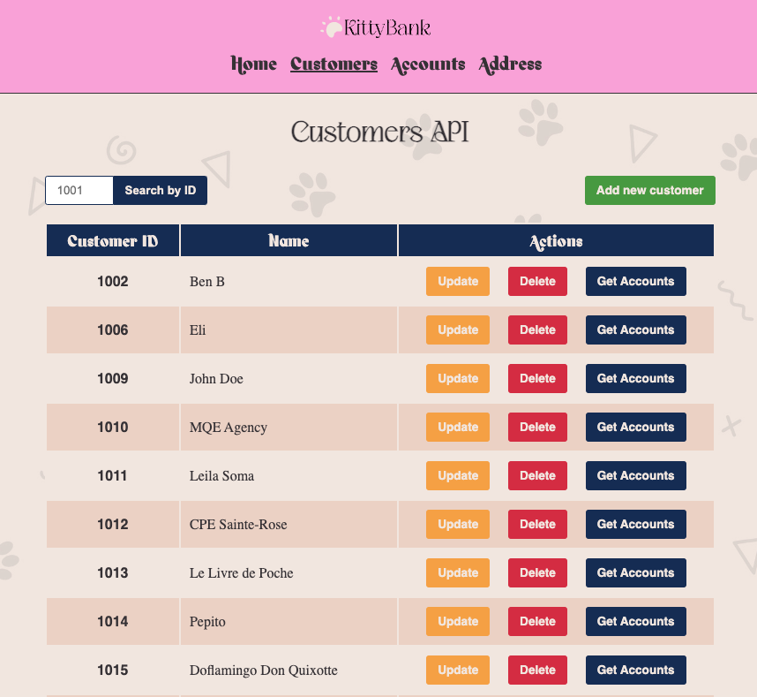

**Customer Form**

* Add a new customer. City and Province are automatically saved with the provided postal code
* Update information of an existing customer. Existing data will be automatically fulfilled. You can update customer's name, address' city, postal code and province

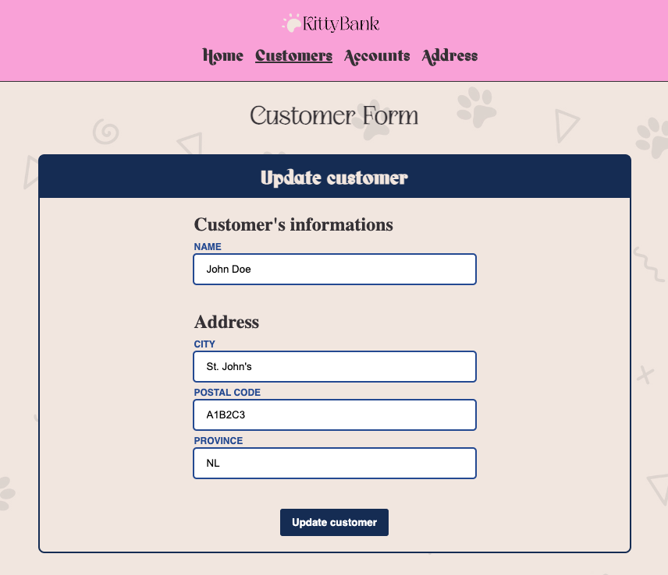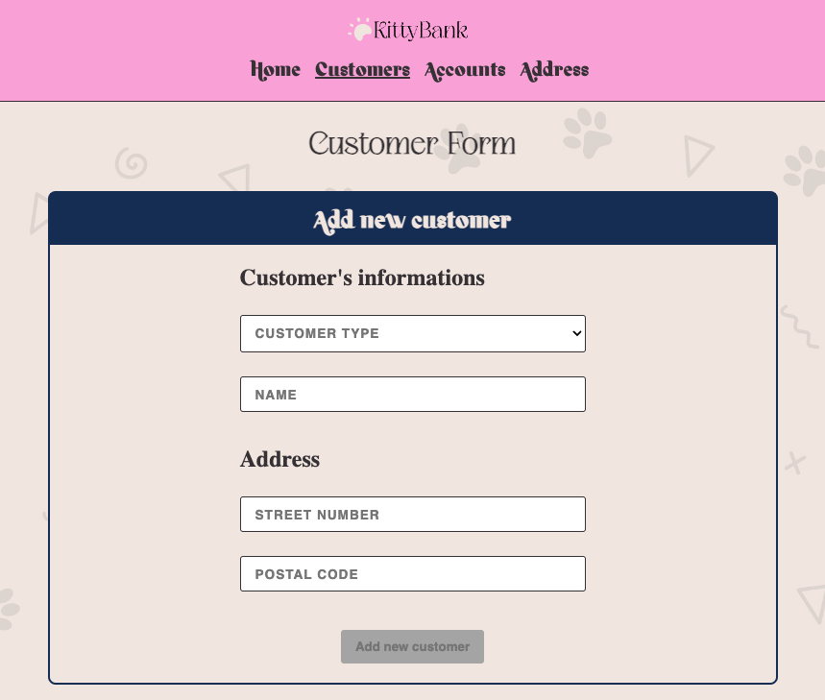

**Account API**

* List all accounts
* Search all accounts of a specific customer with its ID
* Add a new Account (Link to Form Page)
* Update an account's information (Link to Form Page)
* Delete an account

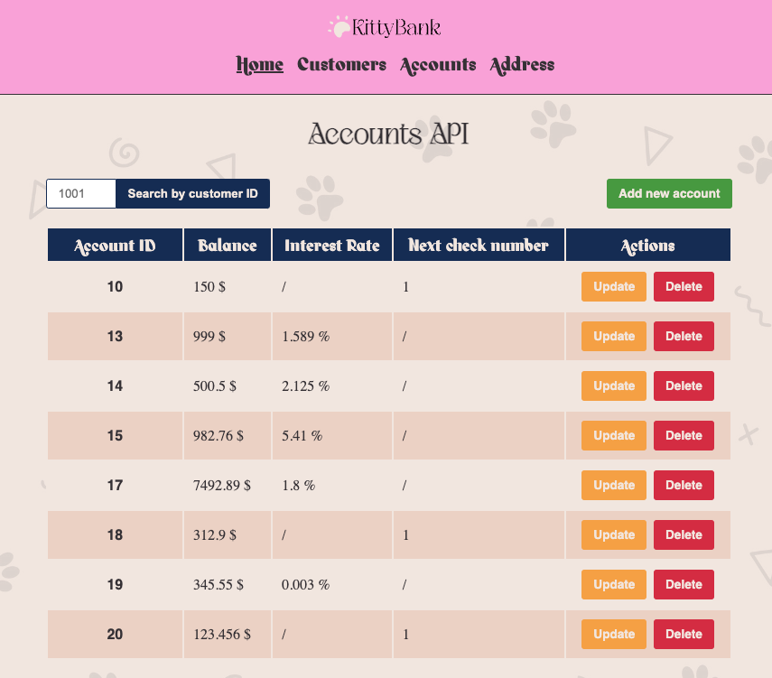

**Account Form**

* Add a new account. Customer IDs are coming from all existing ID, so no wrong or unknown ID can be provided
* Update information of an existing account. Existing data will be automatically fulfilled. You can update account's balance, and interest rate in the case of a savings account

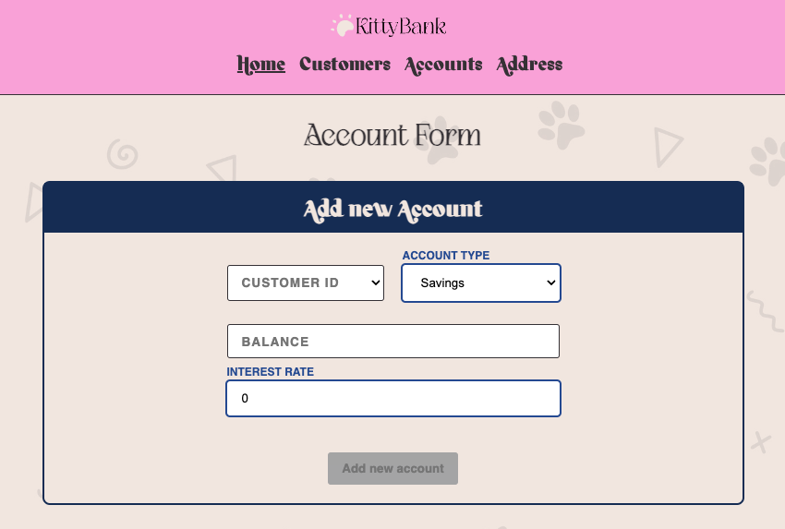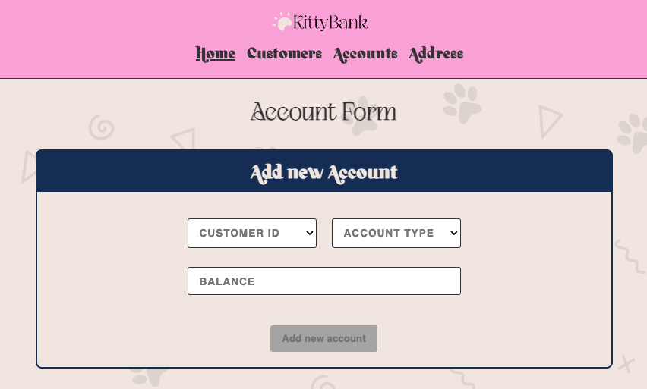

**Address API**

*Not yet implemented. It will work the same way as the two others API with all CRUD operations available*