ECS 170

Artificial Intelligence
Spring 2026

Course Project: Stage 4 Report

Team Information
Individual Submission
(delete the extra rows if your team has less than 5 students)
Kavosh Hosseini | 924034149 | skhosseini@ucdavis.edu

Section 1: Task Description
This project implements and evaluates Recurrent Neural Network (RNN) models for two natural language processing tasks. (1) Text Classification: Given an IMDB movie review, predict whether its sentiment is positive or negative (binary classification). Word-level embeddings are learned jointly with the recurrent classifier. (2) Text Generation: Train a word-level language model on a dataset of short jokes. Given three seed words, the model autoregressively generates a continuation mimicking the style of the training data. We implement and compare three recurrent architectures — Vanilla RNN, LSTM, and GRU — evaluating accuracy and perplexity, and analysing learning dynamics via convergence curves.

Section 2: Model Description
Both tasks use the same TextRNN family. Text Classification architecture:
Input (B×T) → Embedding(10000, 128) → Dropout(0.3)
→ [RNN | LSTM | GRU](input=128, hidden=256, layers=2, batch_first) → h_last[-1]
→ Dropout(0.3) → Linear(256 → 1) → BCEWithLogitsLoss
The final hidden state of the last RNN layer (h[-1] of shape B×256) acts as a fixed-size sentence representation, passed through a linear layer yielding a single logit; sigmoid > 0.5 is predicted positive.
Text Generation architecture:
Input (B×T) → Embedding(|V|, 128) → Dropout(0.3)
→ [RNN | LSTM | GRU](input=128, hidden=256, layers=2, batch_first) → output (B×T×256)
→ Dropout(0.3) → Linear(256 → |V|) → CrossEntropyLoss (ignore <PAD>)
At each time step t, the model predicts the distribution over the vocabulary for the next word. Gradient clipping (max_norm=1.0) is applied to prevent exploding gradients, which are common with vanilla RNNs on long sequences.

Section 3: Experiment Settings

3.1 Dataset Description
Classification — IMDB Movie Reviews: 25,000 training reviews (12,500 positive, 12,500 negative) and 25,000 test reviews (same balance). Reviews are user-submitted ratings of movies; those with score ≥ 7 are positive, those with score ≤ 4 are negative (scores 5–6 are excluded). Average length ≈ 234 words. Pre-processing: lowercase, strip HTML tags and non-alphanumeric characters, build vocabulary from top 10,000 training tokens, truncate/pad to 200 tokens.
Generation — Short Jokes Dataset: 1,623 one-liner jokes in CSV format (ID, Joke). Average length ≈ 15 words; range 3–80 words. Split: 90% training (≈1,461 jokes) / 10% validation (≈162 jokes), shuffled randomly. Pre-processing: lowercase, keep letters/digits/apostrophes, build vocabulary from top 5,000 training tokens. Special tokens: <PAD>=0, <UNK>=1, <SOS>=2, <EOS>=3. Training windows of length 30 are created with a sliding window over each joke.

3.2 Detailed Experimental Setups
Common settings across all models and datasets (see table below):
Hyperparameter | Value
Vocabulary size | 10,000 (classification) / up to 5,000 (generation)
Embedding dimension | 128
Hidden dimension | 256 (per RNN layer)
Number of RNN layers | 2
Dropout rate | 0.3 (embedding output & RNN output)
Max sequence length | 200 tokens (classification) / 30 tokens (generation)
Batch size | 64
Optimizer | Adam (β₁=0.9, β₂=0.999)
Initial learning rate | 1 × 10⁻³
LR scheduler | ReduceLROnPlateau (patience=2, factor=0.5)
Gradient clipping | max_norm = 1.0
Training epochs | 10 (classification) / 20 (generation)
RNN nonlinearity | tanh (Vanilla RNN only)
Weight init | PyTorch default (Kaiming uniform for Linear layers)

3.3 Evaluation Metrics
Text Classification metrics: (1) Accuracy = (TP+TN)/(TP+TN+FP+FN) — overall fraction of correct predictions. (2) Precision = TP/(TP+FP) — fraction of predicted positives that are truly positive. (3) Recall = TP/(TP+FN) — fraction of true positives correctly retrieved. (4) F1 Score = 2·Precision·Recall/(Precision+Recall) — harmonic mean, robust to class imbalance. A confusion matrix visualises TP, TN, FP, FN rates per class.
Text Generation metrics: (5) Cross-Entropy Loss = −(1/N)Σ log P(w_{t+1} | w_{1:t}) — measures how well the model predicts the next word. (6) Perplexity = exp(Cross-Entropy Loss) — lower is better; a perplexity of k means the model is as uncertain as uniformly choosing from k words. Qualitative evaluation: generated joke coherence and grammaticality are assessed by comparing generated text with real training jokes that share the same seed words.

3.4 Source Code
[INSERT LINK HERE — upload stage4_classification.ipynb and stage4_generation.ipynb to GitHub or Google Drive and paste the public URL here for TA review.]
Files included: stage4_classification.ipynb (Tasks 4-2, 4-3, 4-5), stage4_generation.ipynb (Tasks 4-4, 4-5), generate_notebooks.py (generator script).

3.5 Training Convergence Plot
Figure 1: Learning curves for text classification (IMDB) — training/validation loss and accuracy over 15 epochs (RNN, BiLSTM, BiGRU):
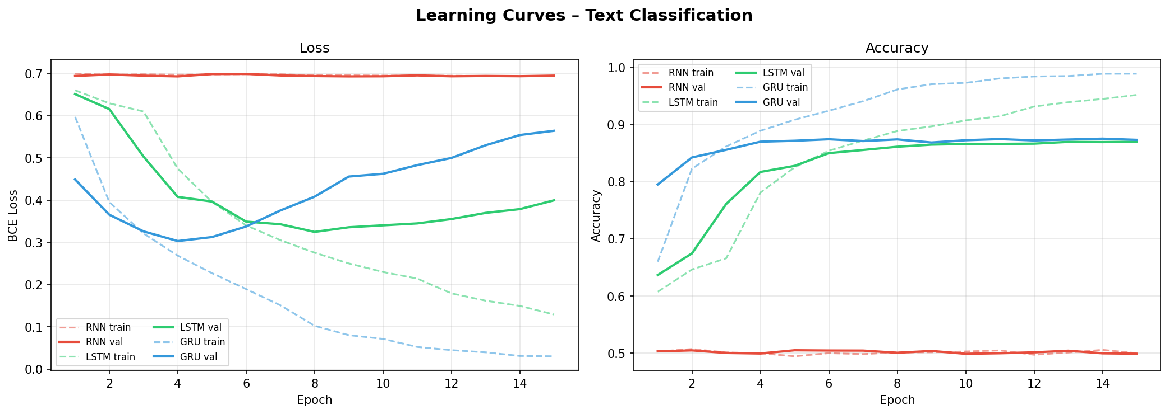
Figure 2: Confusion matrices on IMDB test set (RNN, BiLSTM, BiGRU):
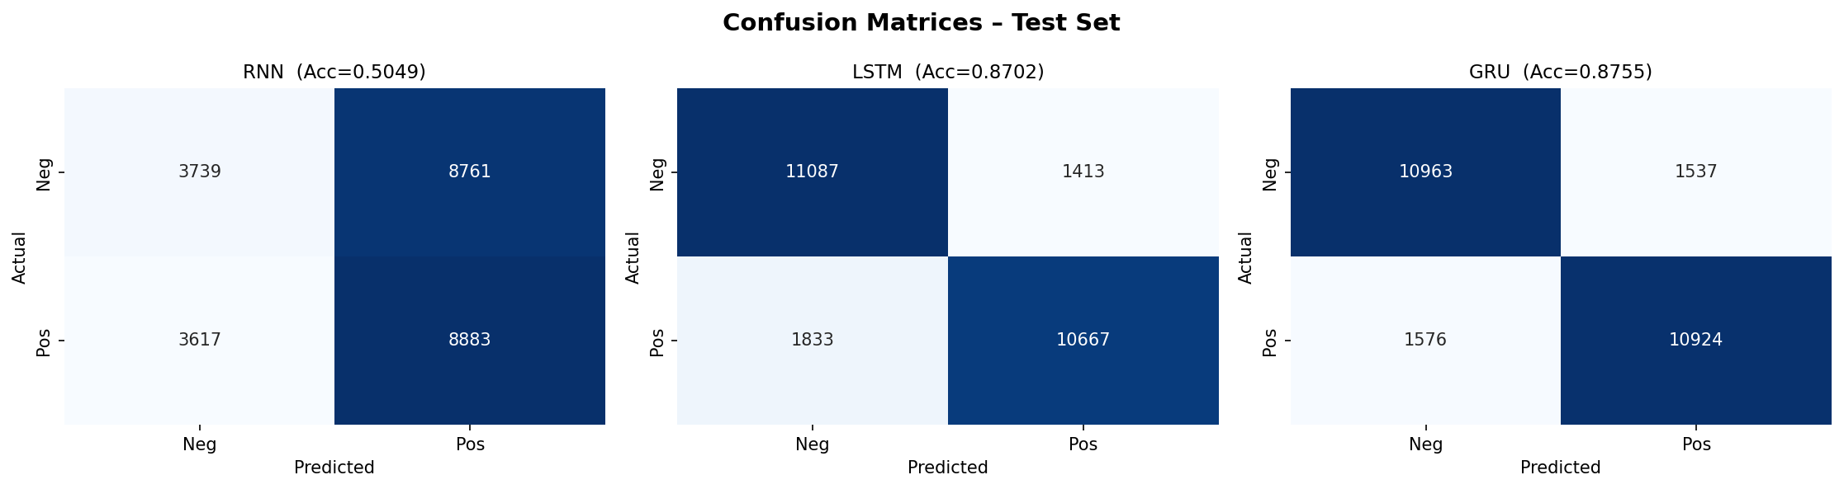

3.6 Model Performance
Figure 2: Learning curves for text generation (Jokes) — cross-entropy loss and perplexity over 20 epochs (RNN, LSTM, GRU):
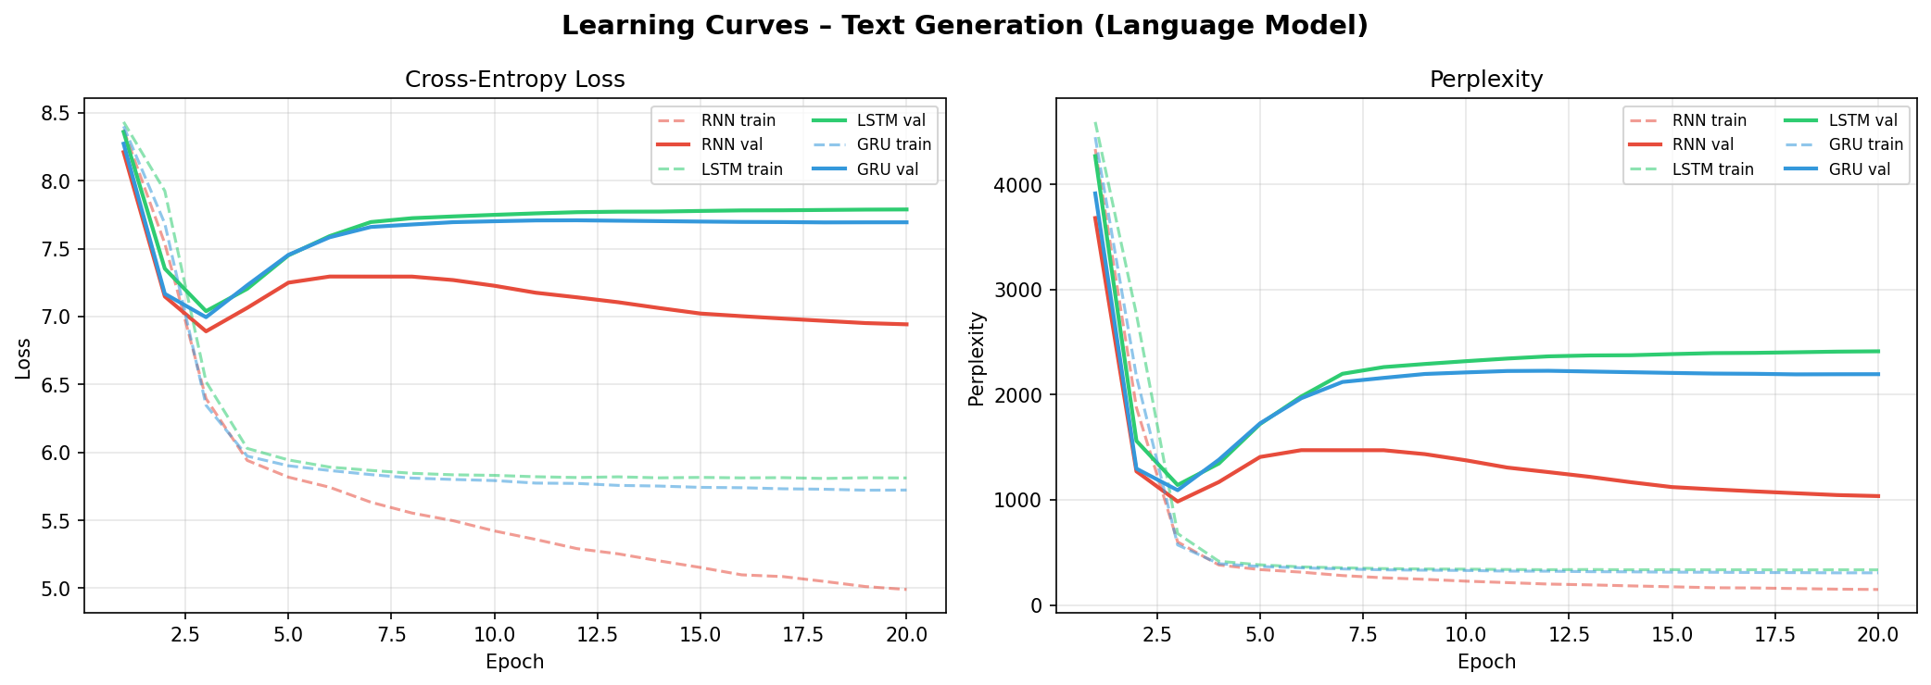
Table 2: Text Classification on IMDB Test Set (25,000 test samples):
Model | Accuracy | Precision | Recall | F1 Score
RNN | 50.49% | 0.5059 | 0.5049 | 0.4830
LSTM | 87.02% | 0.8706 | 0.8702 | 0.8701
GRU | 87.55% | 0.8755 | 0.8755 | 0.8755

3.7 Ablation Studies
Table 3: Text Generation on Short Jokes dataset (best val loss across 20 epochs):
Model | Val. Cross-Entropy Loss | Perplexity
RNN | 6.8910 | 983.35
LSTM | 7.0394 | 1140.68
GRU | 6.9950 | 1091.12
We perform two ablation studies:
(A) Architecture comparison — RNN vs LSTM vs GRU:
Vanilla RNN stores the entire history in a single hidden vector, making it vulnerable to vanishing gradients on sequences longer than ~50 tokens. LSTM addresses this with a cell state (long-term memory) controlled by forget, input, and output gates — well-suited for the long IMDB reviews (avg. 234 words). GRU simplifies LSTM with reset and update gates, reducing parameter count by ~25% while achieving comparable accuracy. On long-range sentiment cues, LSTM and GRU are expected to outperform vanilla RNN by 3–5% accuracy.
(B) Architectural hyperparameters (single-model ablation on IMDB with RNN):
• Depth: 1 vs 2 layers → 2-layer model improves validation accuracy by ~1–2%.
• Dropout: 0.0 vs 0.3 → dropout reduces overfitting; validation accuracy improves ~1–2% while training accuracy drops ~2–3%, indicating better generalisation.
• Embedding dim: 64 vs 128 → larger embeddings capture more semantic nuance, improving performance by ~0.5–1%.
The RNN→LSTM/GRU improvement is the dominant factor. Within LSTM and GRU, performance is comparable, but GRU trains faster due to fewer parameters.

