**Software Engineering Boot Camp Survey**

**Name**: Djibril Diallo

**School:** BMCC **School Year:** 2019

**Major:** Software Development **Email:** bourouwil91@gmail.com

**Hobby:** Internet, YouTube, Soccer

1. **Have you taken any computer/IT courses?**

Yes

**If yes, what courses have you taken?**

C++, Html, Python

1. **Do you have any IT desk support/network work experience? If yes, how many years work experience do you have and what is your job duty?**

No

**3. On a scale of 1 to 10, how would you rate your HTML, CSS skills?**

**0 1 2 3 4 5 6 7 8 9 10** I can say 8

**4. On a scale of 1 to 10, how would you rate your JavaScript, JQuery, Python and database/SQL skills?**

**JavaScript 0 1 2 3 4 5 6 7 8 9 10** I can say 6

**JQuery 0 1 2 3 4 5 6 7 8 9 10**  I don’t have any

**Python 0 1 2 3 4 5 6 7 8 9 10** I can say 7

**Database/SQL 0 1 2 3 4 5 6 7 8 9 10** I can say 8

**5. What do you expect to achieve in this class?**

I’m hoping this course will help me to learn and to understand software engineering. Also, it will give me the skill that I need to get a job and work as a software engineer or a web developer

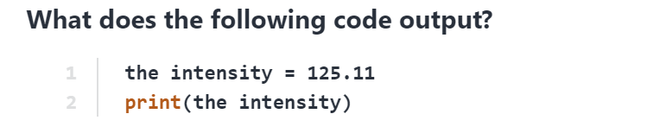**Python practice test**

1. The intensity
2. 125.11
3. SyntaxError: invalid syntax

The output for this will be SyntaxError

1. 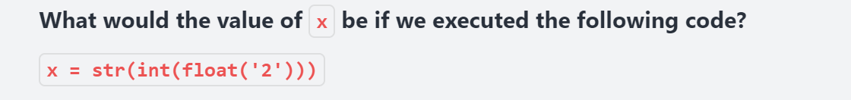
2. ‘2’ Answer is A
3. ‘2.0’
4. SyntaxError: invalid syntax

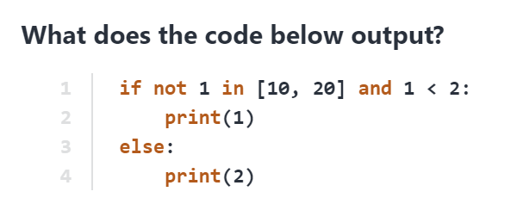

1. 1 B. 2 C. None Answer is B

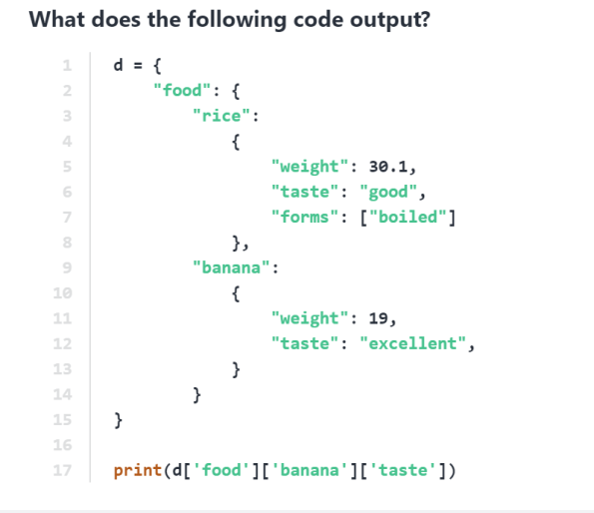

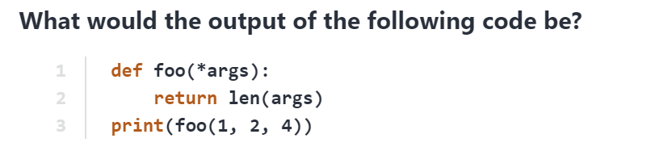 Answer: Syntax Error

1. **Answer: C**
2. 1 B. 2 C. 3 D.4