Software Requirements Specification
Tourism Management System
Version 1.0
<<Annotated Version>>

Esraa Nassan
Helen Al_te3
Rahaf Al_hamad
Boushra Al_Ali

Submitted in partial fulfillment
Of the requirements of
CS 310 Software Engineering

<<Any comments inside double brackets such as these are not part of this SRS but are comments upon this SRS example to help the reader understand the point being made.

Refer to the SRS Template for details on the purpose and rules for each section of this document.

This work is based upon the submissions of the Spring 2004 CS 310. The students who submitted these team projects were Thomas Clay, Dustin Denney, Erjon Dervishaj, Tiffanie Dew, Blake Guice, Jonathan Medders, Marla Medders, Tammie Odom, Amro Shorbatli, Joseph Smith, Jay Snellen, Chase Tinney, and Stefanie Watts. >>

Table of Contents

Table of Contents i
List of Figures ii
1.0. Introduction 1
1.1. Purpose 1
1.2. Scope of Project 1
1.3. Glossary 2
1.4. References 2
1.5. Overview of Document 2
2.0. Overall Description 4
2.1 System Environment 4
2.2 Functional Requirements Specification 5
2.2.1 Reader Use Case 5
Use case: Search Article 5
2.2.2 Author Use Case 6
Use case: Submit Article 6
2.2.3 Reviewer Use Case 7
Use case: Submit Review 7
2.2.4 Editor Use Cases 8
Use case: Update Author 8
Use case: Update Reviewer 9
Use case: Update Article 9
Use case: Receive Article 10
Use case: Assign Reviewer 11
Use case: Receive Review 11
Use case: Check Status 12
Use case: Send Response 12
Use case: Send Copyright 13
Use case: Remove Article 14
Use case: Publish Article 14
2.3 User Characteristics 15
2.4 Non-Functional Requirements 15
3.0. Requirements Specification 17
3.1 External Interface Requirements 17
3.2 Functional Requirements 17
3.2.1 Search Article 17
3.2.2 Communicate 18
3.2.3 Add Author 18
3.2.4 Add Reviewer 19
3.2.5 Update Person 19
3.2.6 Update Article Status 20
3.2.7 Enter Communication 20
3.2.8 Assign Reviewer 21
3.2.9 Check Status 21
3.2.10 Send Communication 22
3.2.11 Publish Article 22
3.2.12 Remove Article 23
3.3 Detailed Non-Functional Requirements 23
3.3.1 Logical Structure of the Data 23
3.3.2 Security 25
Index 26

List of Figures

Figure 1 - System Environment 4
Figure 2 - Article Submission Process 6
Figure 3 - Editor Use Cases 8
Figure 4 - Logical Structure of the Article Manager Data 23

1.0. Introduction

1.1. Purpose
The purpose of this document is to present a detailed description of the Tourism management System. It will explain the purpose and features of the system, the interfaces of the system, what the system will do, the constraints under which it must operate and how the system will react to external stimuli. This document is intended for both the stakeholders and the developers of the system.

1.2. Scope of Project

The Tourism Management System project is an implementation of a managing Tourism website which helps the customers to search the availabilityof various tourist places and prices of various hotel rooms in particular places, along with the different packages available with the reservations. This project also covers various features like online registration of the users, modifying the details of the website by the management staff or administrator of the website, by adding, deleting or modifying the customer details or packages information. In general, this website would be designed to perform like any other Tourist management website available online .

1.3. Glossary
Term | Definition
Active Article | The document that is tracked by the system; it is a narrative that is planned to be posted to the public website.
Author | Person submitting an article to be reviewed. In case of multiple authors, this term refers to the principal author, with whom all communication is made.
Database | Collection of all the information monitored by this system.
Editor | Person who receives articles, sends articles for review, and makes final judgments for publications.
Field | A cell within a form.
Historical Society Database | The existing membership database (also HS database).
Member | A member of the Historical Society listed in the HS database.
Reader | Anyone visiting the site to read articles.
Review | A written recommendation about the appropriateness of an article for publication; may include suggestions for improvement.
Reviewer | A person that examines an article and has the ability to recommend approval of the article for publication or to request that changes be made in the article.
Software Requirements Specification | A document that completely describes all of the functions of a proposed system and the constraints under which it must operate. For example, this document.
Stakeholder | Any person with an interest in the project who is not a developer.
User | Reviewer or Author.

1.4. References
IEEE. IEEE Std 830-1998 IEEE Recommended Practice for Software Requirements Specifications. IEEE Computer Society, 1998.

1.5. Overview of Document
The next chapter, the Overall Description section, of this document gives an overview of the functionality of the product. It describes the informal requirements and is used to establish a context for the technical requirements specification in the next chapter.
The third chapter, Requirements Specification section, of this document is written primarily for the developers and describes in technical terms the details of the functionality of the product.
Both sections of the document describe the same software prod-uct in its entirety, but are intended for different audiences and thus use different language.

. 2.0 Overall Description
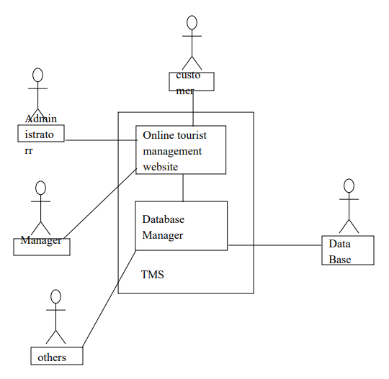
Figure 1 - System Environment

The Web Publishing System has four active actors and one cooperating system.
The Customer, Administrator, or Manger accesses the Online tourist management website through the Internet. Any Administrator or Manger communication with the system is through email. The Others accesses the entire system directly. There is a link to the (existing) Historical Society.
<< The division of the Web Publishing System into two component parts, the Online Tourist Management Website and the Database Manager, is an example of using domain classes to make an explanation clearer. >>

2.2 Functional Requirements Specification
This section outlines the use cases for each of the active customer separately. The customer, the administrator and the manger have only one use case apiece .

2.2.1 customer Use Case

Use case: Search Customer
Diagram:
Customer
Search location

Brief Description
The Customer accesses the Online tourist management Website, searches for an article and downloads it to his/her machine.

Initial Step-By-Step Description
Before this use case can be initiated, the Reader has already accessed the Online Journal Website.

- The Reader chooses to search by location name,or country,or keyword.
- The system displays the choices to the Customer.
- The Customer selects the location desired.
- The system presents the abstract of the locationo the customer.
- The customer chooses to download the location .
- The system provides the requested location.

Xref: Section 3.2.1, Search Article

Manger
Manger
Active location
Submit
Publish

Figure 2 - location Submission Process

2.2.2 Administrator Use Case
The one who operates the system , modifies ,add or delete the customer records in databases.

Use case: Submit Location
Administrator
Submit Location
Diagram:

Brief Description
The administrator either submits an original location or resubmits an location detailes.

Initial Step-By-Step Description
Before this use case can be initiated, the Administrator has already connected to the Online Toursim Managment Website.

Xref: Section 3.2.2, Communicate

2.2.3 Manger Use Case

Use case : Submit Manger
Diagram:
manger
Submit Manger
Brief Description
The manger submits a review of an location.

Initial Step-By-Step Description
Before this use case can be initiated, the Manger has already connected to the Online Tourism Managment Website.

- The manger chooses the Email location button.
- The System uses the sendto HTML tag to bring up the user’s email system.
- The Manger fills in the Search line and attaches the location as directed and emails it.
- The System generates and sends an email acknowledgement.

Xref: Section 3.2.2, Communicate

2.3 User Characteristics
The Reader is expected to be Internet literate and be able to use a search engine. The main screen of the Online location Website will have the search function and a link to “Administrator/Manger Information.”
The Adminnistartor and Manger are expected to be Internet literate and to be able to use email with attachments.

2.4 Non-Functional Requirements

Performance Requirements

The Tourism management System application should be able to respond to the queries submitted by the customer without much delay. When a user searches for a tour location, the application should not take much time to return the results, similarly for the motel and package information. Considering that the application is of moderate size, it should be able to display 10 results at a time on each page, when the customer looks up for any particular data. Since the Online tourism websites have much traffic, the user should also be able to logon to the system using high speed internet. Most of the requests sent to the application should be answered in less than 5 seconds.

Security Requirements

It must be ensured that access will be provided to the authorized persons through user ID and password. Network security will be provided by the use of firewalls. Checks can be performed at regular internals to ensure data integrity .

Software Quality Attributes Reliable:

For all services that rely on TMS for access control, lack of availability of the supported services. The product should not crash under any circumstance such as user entering invalid values, user trying to find unusual data etc. It should show appropriate message for every user generated message.

Transparent:

Ideally, the user should not be aware that authentication is taking place beyond the requirement to enter a password.

Scalable:

The system should be capable of supporting large number of client and servers.This suggests modular, distributed architecture

Portable: Our product will be portable to carry and will run in any machine provided it runs a Windows Operating System

3.0. Requirements Specification

3.1 External Interface Requirements

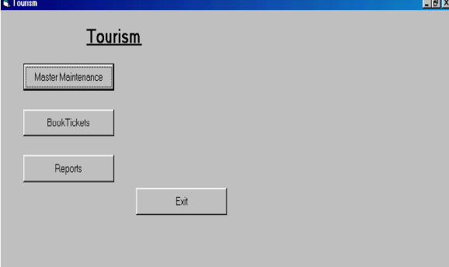
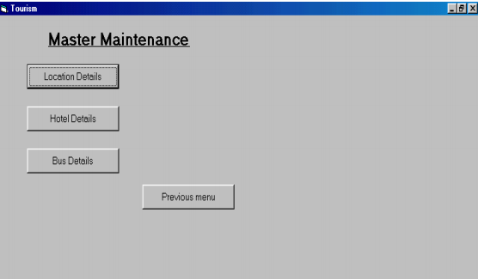
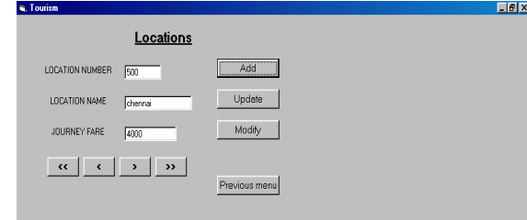

3.2 Functional Requirements
The Logical Structure of the Data is contained in Section 3.3.1.

3.2.1 Customer
Use Case Name | Search customer
Xref | Section 2.2.1, Search location  SDD, Section 7.1
Trigger | The Customer assesses the Online Tourism Managment Website
Precondition | The Web is displayed with grids for searching
Basic Path | - The Customer chooses how to search the Web site. The choices are by Administrator, by Location, and by Keyword.  - If the search is by Admiinistrator, the system creates and presents an alphabetical list of all location in the database. The Customer selects an location.  - The system creates and presents a list of all location by that keyword in the database.  - The customer selects an location.  - The system displays the Abstract for the location.  - The customer selects to download the location or to return to the location list or to the previous list.
Alternative Paths | In step 2, if the Customer selects to search by Location, the system creates and presents a list of all Location in the database.  - The Customer selects a Location.  - The system creates and presents a list of all location in that keyword in the database. Return to step 5.  In step 2, if the Customer selects to search by keyword, the system presents a dialog box to enter the keyword or phrase.  - The Customer enters a keyword or phrase.  - The system searches the Abstracts for all location with that keyword or phrase and creates and presents a list of all such location in the database. Return to step 5.
Postcondition | The selected location is downloaded to the client machine.
Exception Paths | The Customer may abandon the search at any time.
Other | The categories list is generated from the information provided when location are published and not predefined in the Online Tourism Management database.

3.2.2 Administrator
Use Case Name | Administrator
Xref | Section 2.2.2, Submit location; Section 2.2.3, Section 7.2
Trigger | The user selects a mailto link.
Precondition | The user is on the Communicate page linked from the Online Tourism Management Main Page.
Basic Path | This use case uses the mailto HTML tag. This invokes the client email facility.
Alternative Paths | If the user prefers to use his or her own email directly, sufficient information will be contained on the Web page to do so.
Postcondition | The message is sent.
Exception Paths | The attempt may be abandoned at any time.
Other | None

3.2.8 Manager
Use Case Name | Manager
Xref | Section 2.2.4, Manager  SDD, Section 7.8
Trigger | The manger chooses the Email location button..
Precondition | The System uses the sendto HTML tag to bring up the user’s email system.
Basic Path | The Manger fills in the Search line and attaches the location as directed and emails it
Alternative Paths | None.
Postcondition | - The System generates and sends an email acknowledgement.

3.3 Detailed Non-Functional Requirements

3.3.1 Logical Structure of the Data

The logical structure of the data to be stored in the internal Article Manager database is given below.

Managment
manager
location
Administrator
writes
sent to
writes
has
Figure 3 - Logical Structure of the tourism Manager Data

The data descriptions of each of these data entities is as follows:

Manager Data Entity
Data Item | Type | Description | Comment
Name | Text | Name of principle Manager
Email Address | Text | Internet address
location | Pointer | location entity

location Data Entity
Data Item | Type | Description | Comment
Name | Text | Name of principle location
ID | Integer | ID number of Historical Society member | Used as key in Historical Society Database
Email Address | Text | Internet address
location | Pointer | location entity of
History | Text | Comments on past performance

The Logical Structure of the data to be stored in the Online Tourism Managment database on the server is as follows:

Published Location Entity
Data Item | Type | Description | Comment
Name | - | Name of location
Administrator | Text | Name of one Administrator | May be several
Abstract | Text | Abstract of location | Used for keyword search
Content | Text | Body of location
Category | Text | Area of content | May be several

3.3.2 Security

It must be ensured that access will be provided to the authorized persons through user ID and password. Network security will be provided by the use of firewalls. Checks can be performed at regular internals to ensure data integrity

Index

Abstract, 6, 17, 27
add, 9, 11, 19, 20, 21
Add, 8, 9, 19
Article, 1, 5, 6, 7, 8, 9, 10, 11, 12, 13, 14, 15, 16, 17, 18, 19, 20, 21, 22, 23, 24, 25, 26, 27, 28
Article Manager, 5, 8, 9, 10, 11, 12, 13, 14, 15, 16, 19, 20, 21, 22, 23, 24, 25, 28
Author, 1, 4, 5, 6, 7, 8, 9, 13, 14, 16, 17, 19, 20, 22, 23, 25, 26, 27
Category, 5, 14, 17, 18, 20, 21, 23, 26, 27
Database, 2, 9, 11, 14, 15, 16, 17, 18, 19, 20, 21, 22, 24, 25, 26, 27
Editor, 1, 4, 5, 6, 7, 8, 9, 10, 11, 12, 13, 14, 15, 16, 17, 19, 20, 21, 22, 23, 24, 25, 28
Field, 17, 19, 20
Form, 1, 6, 9, 10, 11, 12, 14, 19, 20, 21, 23, 24, 27
Grid, 9, 11, 12, 19, 20, 21
Historical Society, 1, 5, 9, 11, 16, 17, 19, 20, 26
Online Journal, 4, 5, 6, 7, 15, 16, 17, 18, 24, 27, 28
Reader, 4, 5, 6, 16, 17, 18
Review, 1, 7, 11, 12, 18, 21, 23, 26, 27
Reviewer, 1, 4, 5, 6, 7, 9, 11, 16, 17, 19, 20, 21, 22, 23, 26, 27
Security, 27, 28
Status, 11, 12, 13, 14, 17, 21, 22, 23, 27
update, 9, 11, 20, 21
Update, 8, 9, 10, 11, 12, 13, 14, 15, 17, 19, 20, 21, 22
User, 7, 16, 18
Web Publishing System, 1, 4, 5, 17

