Operational Concept Description (OCD)
Women At Work (WAW)

Team 14

Venkata Dinesh Reddy Yeduguru (Software Architect)
Srikanth Madahava (Project Manager)
Phaneendra Maryala (Life Cycle Planner)
Rohit Kudva (Feasibility Analyst)
Nishant Jani (Prototyper)
Sanath Bhandary (Operation Concept Engineer)
Praneeth Surana (Requirement Engineer)
Brian Bousman (Requirement Shaper and Tester)
Date | Author | Version | Changes made | Rationale
10/13/2014 | PP | 1.0 | - Original template | - Initial draft for use v1.0
Version History

Table of Contents
Operational Concept Description (OCD) i
Table of Contents iii
Table of Tables iv
Table of Figures v
Introduction 1
A.1.1 Purpose of the OCD 1
A.1.2 Status of the OCD 1
A.2. Shared Vision 2
A.2.1 Benefits Chain 3
A.2.2 System Capability Description 3
A.2.3 System Boundary and Environment 4
A.3. System Transformation 5
A.3.1 Information on Current System 5
A.3.2 System Objectives, Constraints and Priorities 10
A.3.3 Proposed New Operational Concept 12
A.3.4 Organizational and Operational Implications 16

Table of Tables
Table 1: The Program Model 2
Table 2: Capability Goals 10
Table 3: Level Of Service Goals 10
Table 3: Relation to Current System 11

Table of Figures
Figure 2: Benefits Chain Diagram 3
Figure 4: System Boundary and Environment Diagram 4
Figure 3: Element Relationship Diagram 12
Figure 8: Business Workflow Diagram of Registration System 13
Figure 9: Business Workflows Diagram for feedback 14
Figure 6: Business Workflows Diagram for Onsite Registration 15
* Left Blank for future additions

Introduction

Purpose of the OCD
This document provides, the detailed objectives and goals of the stakeholders of the Women at Work (WAW). The success-critical stakeholders of the project are Camille Levee as project owner, Cecilia Avila and WAW staff as maintainers; Clients of WAW as users.

Status of the OCD
This OCD is currently in its first version of development phase.

Shared Vision
Table 1: The Program Model
Assumptions Users are willing to use online registration form
Users are willing to give feedback

Stakeholders  (Who is accountable for the initiatives) | Initiatives  (What to do to realize benefits) | Value Propositions  (Benefits i.e Why) | Beneficiaries  (Who derives value)
- Developers  - Cecilia (Maintainer/DBA) | - Develop/System re-design.  - Training of staff/clients/users | - Improved data management.  - Improved usability for clients.  - Easier/Improved report generation. | - Clients of WAW  - Board members  - Cecilia (Maintainer/DBA)
Legend:
Initiatives that need to be undertaken to help beneficiaries derive value from the expected benefits/value propositions
Initiatives that need to be undertaken to help deliver value to the beneficiaries (i.e. “how” will the benefits reach the beneficiaries?)

Benefits Chain

Below is an example of a Benefit Chain Diagram:

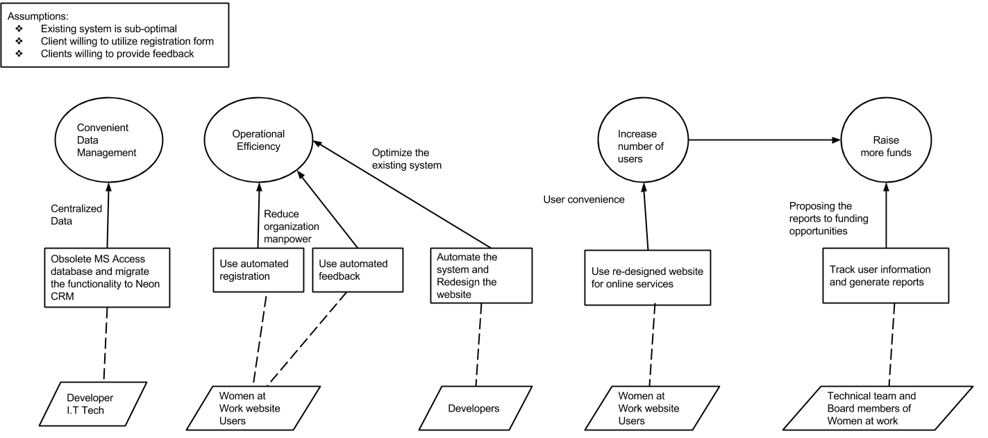

Figure 1: Benefits Chain Diagram

System Capability Description
- On Site Check in
Speeds the check-in process, there by saving the time of WAW staff.
- Online Registration
Clients of WAW can conveniently register online, even before visiting WAW.
- Client Feedback automation
Eliminates the manual process of calling the clients to obtain feedback.
- Report Generation
Helps WAW to make better business decisions based on the reports generated.

System Boundary and Environment

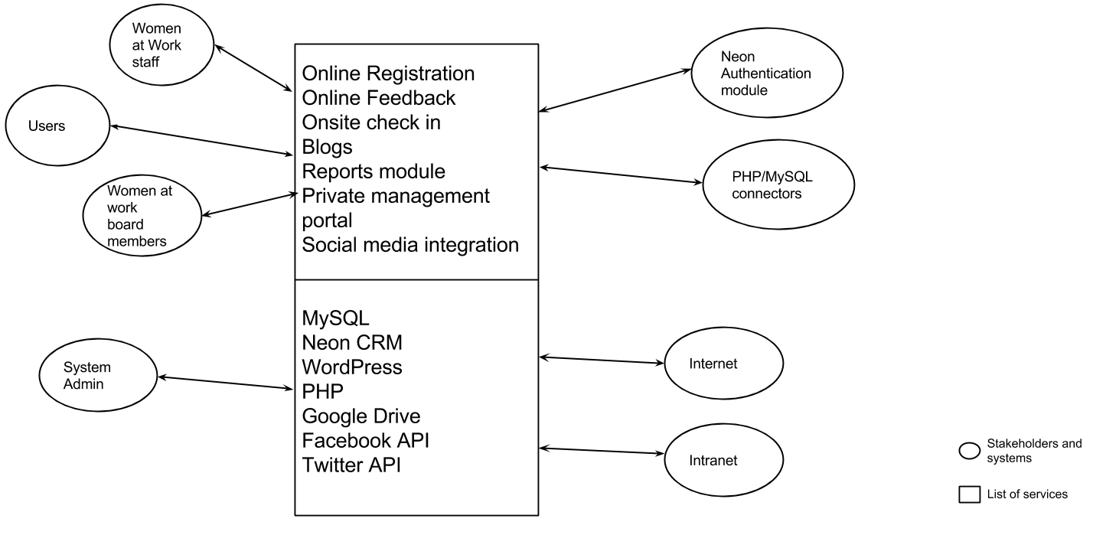
Figure 2: System Boundary and Environment Diagram

System Transformation

Information on Current System

Infrastructure
- A cloud based CRM Platform called Neon is used for storing client data, donor information, payment gateway, product offerings and scheduling.
- A Wordpress powered website that is the front end of this organization. It’s a content centric website that provides information about job offerings, career fairs, workshops etc. It also allows users to purchase the featured products.
- Registration and payment for the products endorsed in the website is handled by Neon.
- The client data is currently being entered into the Neon System manually.
- The Access database is a roster to collect the information of the clients visiting classes or using various services. The data collected in Access is used generate various statistical reports in order to help the organization get an insight about it’s business model which can shape future decisions.
- A VB Script present on a terminal is used to capture the above roster information and store it in Access.

Artifacts
NeonCRM Solution

NeonCRM is a web-based fundraising and membership system that provides nonprofit organizations with all the tools required to increase donations and memberships while automating common processes and streamlining staff's day-to-day tasks.

WordPress

WordPress is a free and open source blogging tool and a content management system (CMS) based on PHP and MySQL. Features include plugin architecture and a template system. WordPress was used by more than 22.0% of the top 10 million websites as of August 2013. WordPress is the most popular blogging system in use on the Web, at more than 60 million websites.

MS Access

Microsoft Access, also known as Microsoft Office Access, is a database management system from Microsoft that combines the relational Microsoft Jet Database Engine with a graphical user interface and software-development tools. It is a member of the Microsoft Office suite of applications, included in the Professional and higher editions or sold separately.

VB Based Terminal

It provides a user interface for the clients/attendees to sign in. It also allows the user to select the program, which they are attending

A Paper-based Registration Form

This form registers the new users visiting the organization. This form collects the general information associated with the client, which is later manually entered into the NeonCRM System.

Current Business Workflow

REGISTRATION ACTIVITY DIAGRAM

Client fills the registration from

Manual entry in to Neon CRM system

PURCHASE ACTIVITY DIAGRAM

Click on purchase event link
Click on register for class
Select the ticket type
If registered
Login
Purchase tickets
Register
Select the class
If registered
Login
Register
Register for class

Visit website

ONSITE CHECK-IN DIAGRAM

Enter the Phone number

If Exists
Select Services

System Objectives, Constraints and Priorities

Capability Goals
Table 2: Capability Goals

Capability Goals | Priority Level
OC-1: Provide online registration | 9
OC-2: Onsite check in | 9
OC-3: Feedback | 8
OC-4: Private Management portal | 8
OC-5: Automated Report Generation | 8
OC-6: Social Media Integration | 5
OC-7: Blogs | 5

Level of Service Goals
Table 3: Level of Service Goals
Level of Service Goals | Priority Level
LOS -1: The system shall not be down for more than 2hours. | Must have

Organizational Goals

OG-1: Convenient Data Management through data centralization.
OG-2: Increase Operational Efficiency through Automation
OG-3: Increase number of users via website redesign
OG-4: Raise funds through proposal of statistical data (generated by report module).

Constraints
CO-1: Windows as an Operating System: The onsite checking system must be able to run on
Windows platform.
CO-2: Zero Monetary Budget: The selected NDI/NCS should be free or no monetary cost.
CO-3: Use Neon CRM: Neon CRM should be used for storing the details of the clients.

Relation to Current System
Table 4: Relation to Current System
Capabilities | Current System | New System
Roles and Responsibilities | * The Staff manually enters the user data into Neon CRM.  * The Sysadmin generates reports manually.  * The Staff collects feedback via telephonic calls.  * Board Members use emails for document sharing. | * The Staff enters user data into Neon CRM through online form.  * The Sysadmin will generate reports via report generation module.  * The feedback system automatically collects the feedback.  * Board Members shall use online file sharing system.
User Interactions | * Users register through paper form.  * Users can check-in through one on-site machine.  * Users give feedback through telephonic call | * Users register via online form  * Users can check-in via multiple machines.  * Users give feedback through online form.
Infrastructure | GoDaddy for hosting, Neon CRM for storing user data and machines for check-in at the site. | No Changes.
Stakeholder Essentials and Amenities | Our clients manually undertake the process of registration and report generation | The process of registration and report generation will be automated
Future Capabilities | Register through online form,  Automated feedback and report generations. | None

Proposed New Operational Concept

Element Relationship Diagram

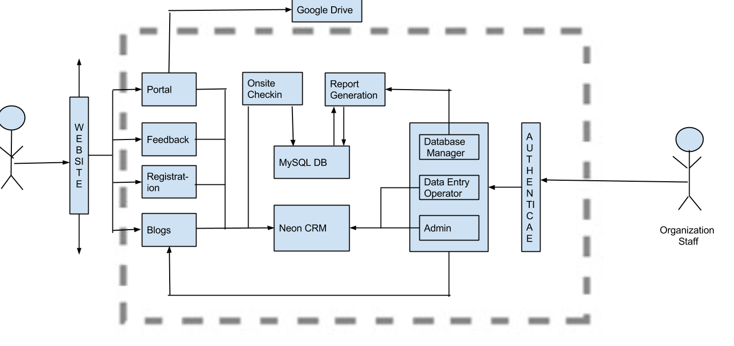

Figure 3: Element Relationship Diagram

Business Workflows

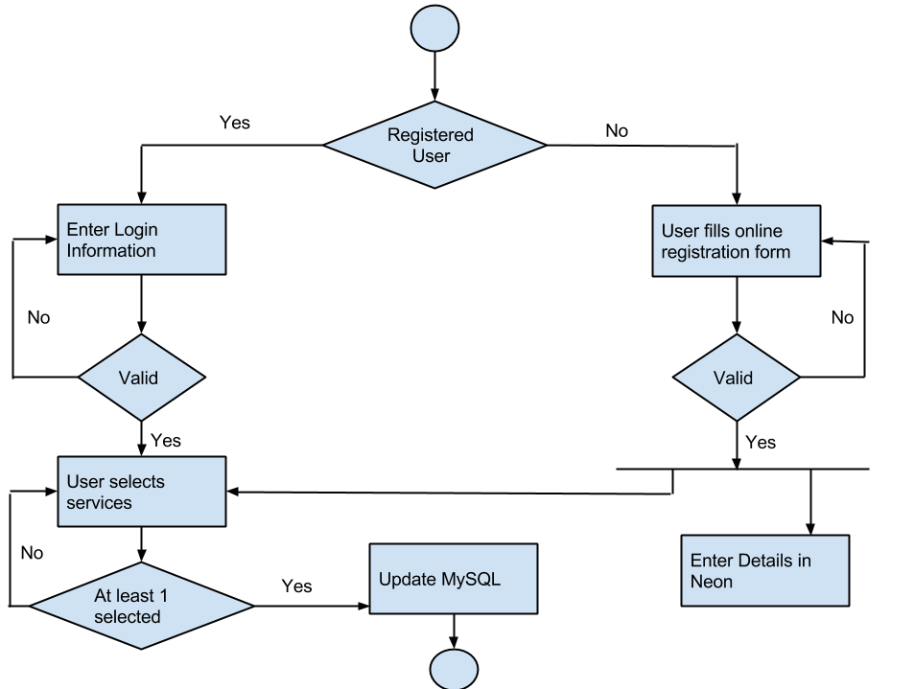
Figure 4: Business Workflow Diagram of Registration System

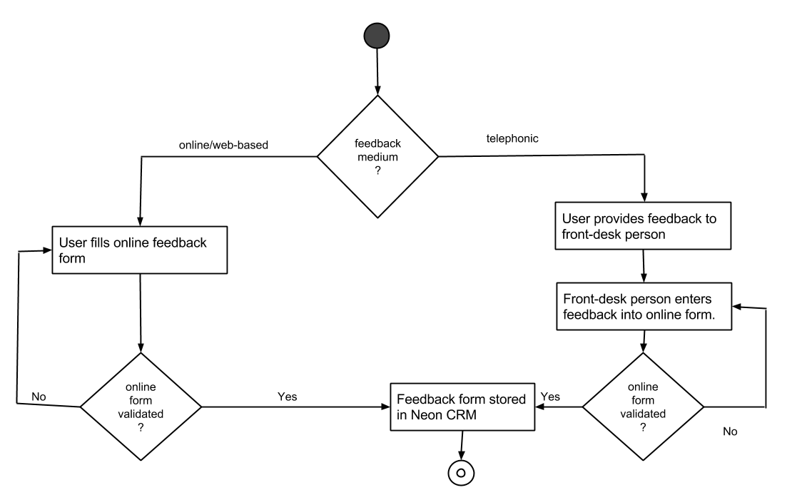
Figure 5: Business Workflows Diagram for feedback

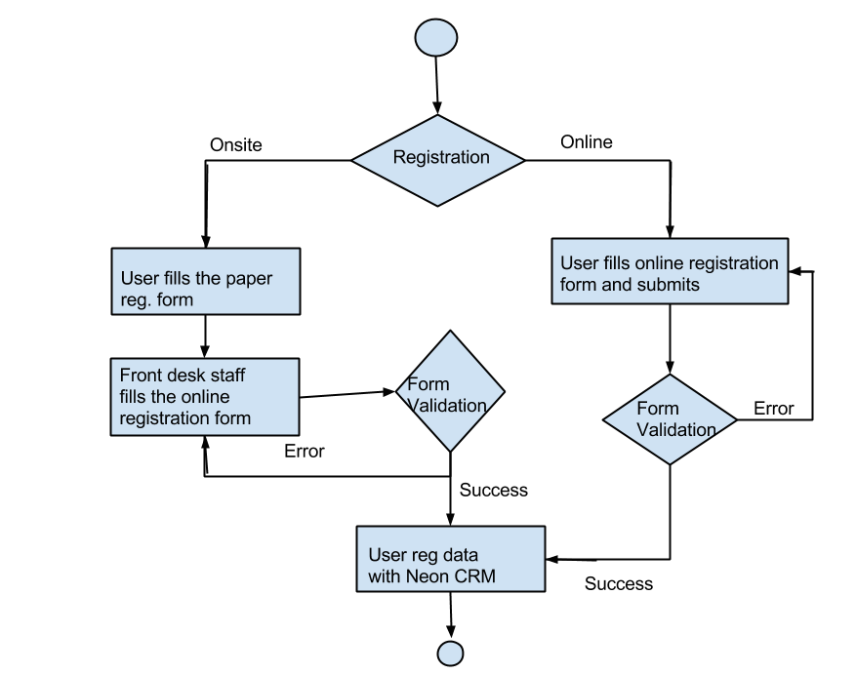

Figure 6: Business Workflows Diagram for Onsite Registration

Organizational and Operational Implications

Organizational Transformations
- The staff working at WaW needs to be trained on the usage of Wordpress engine, report module and the usage of online file sharing tool.
- Staff should be taught the usage of PhpMyAdmin for accessing database.

Operational Transformations

- Elimination of email as the medium for sharing of the documents by the board members
- Elimination of manual report generation by the Sysadmins.
- The elimination of time consuming manual entry into Neon CRM by the staff. Use of online form instead of this.
- Elimination of staff to make telephonic calls to each client individually. Replaced by the online feedback form.
- Funders have a detailed statistics about the turnout of the users and whether their money is worth spending.

