Prototype Report
Women at Work

Team No: 14

Sr no | Name | Role
1 | Srikant Madhava | Project Manager
2 | Sanath Bhandary | Operational Concept Engineer
3 | Rohit Kudva | Feasibility Analyst
4 | Varma Maryala | Life Cycle Planner
5 | Praneet Surana | Requirements Engineer
6 | Dinesh Yeduguru | Software Architect
7 | Nishant Jani | Prototyper
8 | Brian Bousman | IIV&V

9/27/2014

Version History
Date | Author | Version | Changes made | Rationale
10/11/14 | Nishant Jani | 1.0 | - Original for CSCI577a; Tailored from ICSM PRO Template | - To fit CS577a course content

Table of Contents
Prototype Report i
Version History ii
Table of Contents iii
Table of Tables iv
Table of Figures v
1. Introduction 1
1.1 Purpose of the prototype report 1
1.2 Status of prototype 1
2. Prototype 2

Table of Tables
Table 1: Demonstrate Neon CRM REST API .………………………………….…………………………………………………………………… 2
Table 2: Prototype for registration form…………………………….………………………………….………………………………………….. 3
Table 3: Prototype for feedback form …………………………….………………………………….……………………………………………… 5

Table of Figures

Figure1: Saving sample data to Neon CRM using REST API……………………………………………………………………………….. 2
Figure 2: Fetching Existing data to Neon CRM using REST API.…………..………………………………….…………………………. 2
Figure 3(a): Basic overview of the online registration form………………….………………………………….………………………. 3
Figure 3(b): Demonstrating components of the registration form………………….………………………………….……………. 4
Figure 3(c): Demonstrating components of the registration form………………….………………………………….…………….. 4
Figure 4(a): Basic overview of the online feedback form ……………………….………………………………….……………………. 5 Figure 4(b): Demonstrating components of the online feedback form………….………………………………….………………. 6

Introduction

Purpose of the prototype report

The purpose of the prototype report is to provide project specification for client (Women at Work) according to the requirements discussed during the win-win negotiation sessions. The prototypes aim to provide the client a visual view of the requirements, so that we can reduce ambiguous requirements and mitigate risks identified in the project.

Status of prototype

This is the first version of the prototype report which includes:
- Demonstration of the REST API (in beta phase), to interact with NEON CRM.
- Screenshots of the online registration and feedback form so that the client have a clear understanding of the UI. The mock up forms are designed using HTML5, JavaScript and twitter bootstrap.

Prototype
Table 1: Demonstrate Neon CRM REST API
Description | The current REST API, to interact with Neon CRM is in the beta stage. We have demonstrated the use of this API using a PHP library.
Related Capability | Offers a proof of concept for the ability to interact with Neon CRM via an API.
Pre-condition | Sufficient and valid information is passes to the API.
Post condition | Use the same API to implement various CRUD functionality in the system.
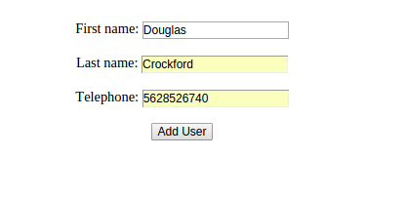

Figure 1: Save sample data to Neon CRM using REST API
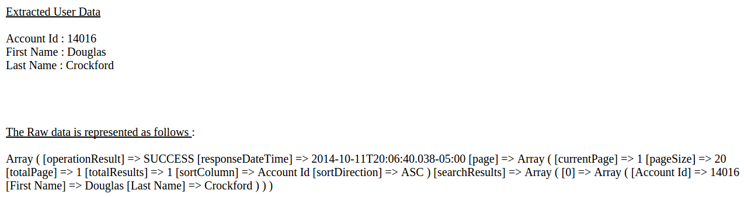
Figure 2: Fetch existing data from Neon CRM via REST API

Table 2: Prototype for Registration form
Description | This is the prototype for the online registration form.
Related Capability | Allows users to fill the online registration form at their leisure, instead of visiting the women at work center and filling it manually.
Pre-condition | Users are expected to register before attending a session.
Post condition | Users add valid information while filling the online registration form.

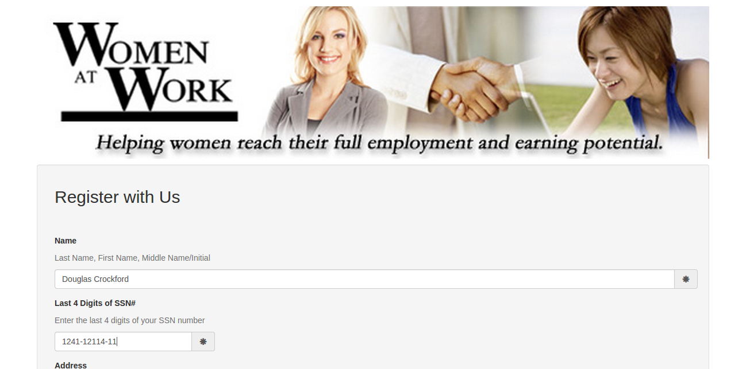
Figure 3(a): Basic overview of the online registration form

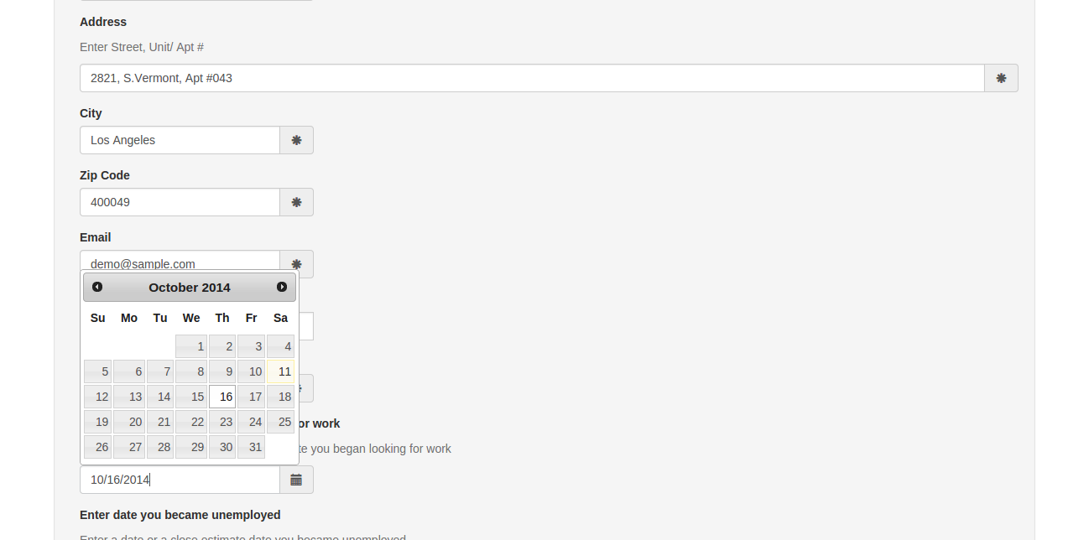
Figure 3(b): Demonstrating the components of online registration form

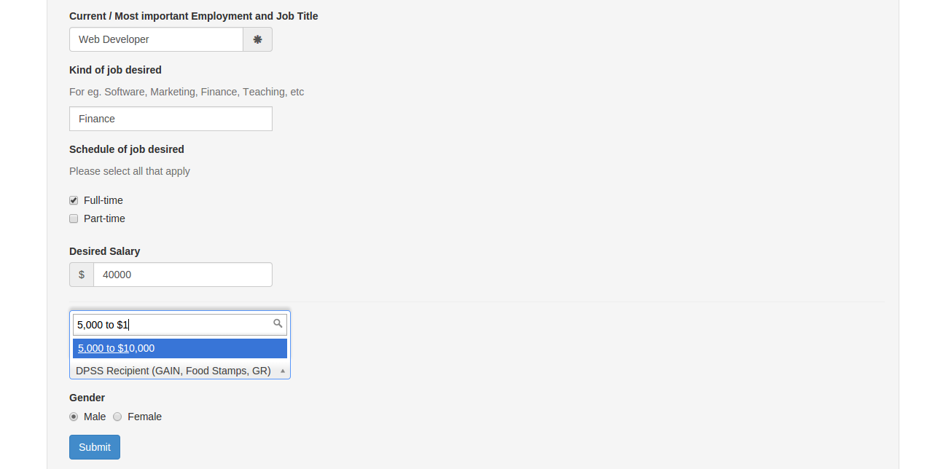
Figure 3(c): Demonstrating the components of online registration form

Table 3: Prototype for Feedback form
Description | This is the prototype for the online feedback form
Related Capability | Allow users to provide feedback on their experience with women at work, in private and at their leisure.
Pre-condition | The user will be emailed on their personal email id to provide their feedback.
Post condition | The feedback will be stored in the Neon CRM.

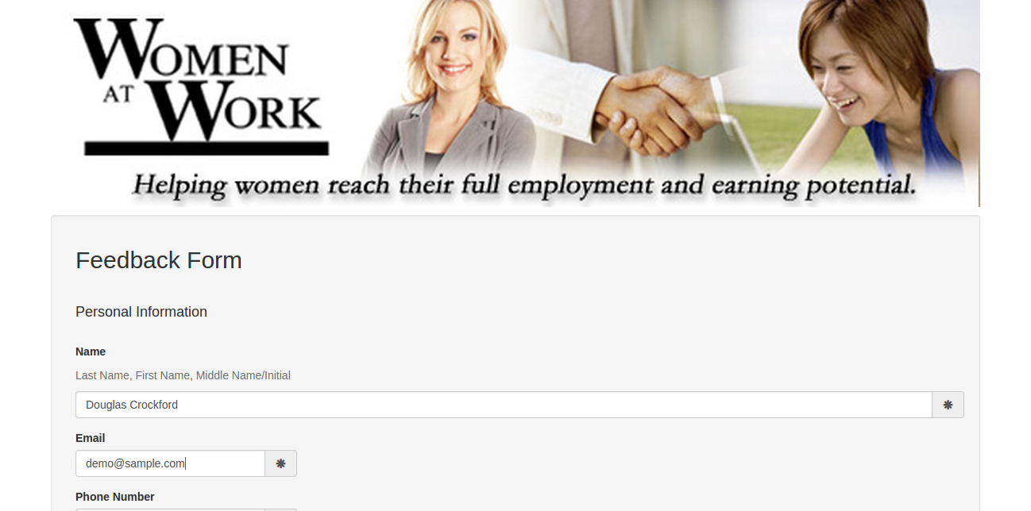
Figure 4(a): Basic overview of the online feedback form

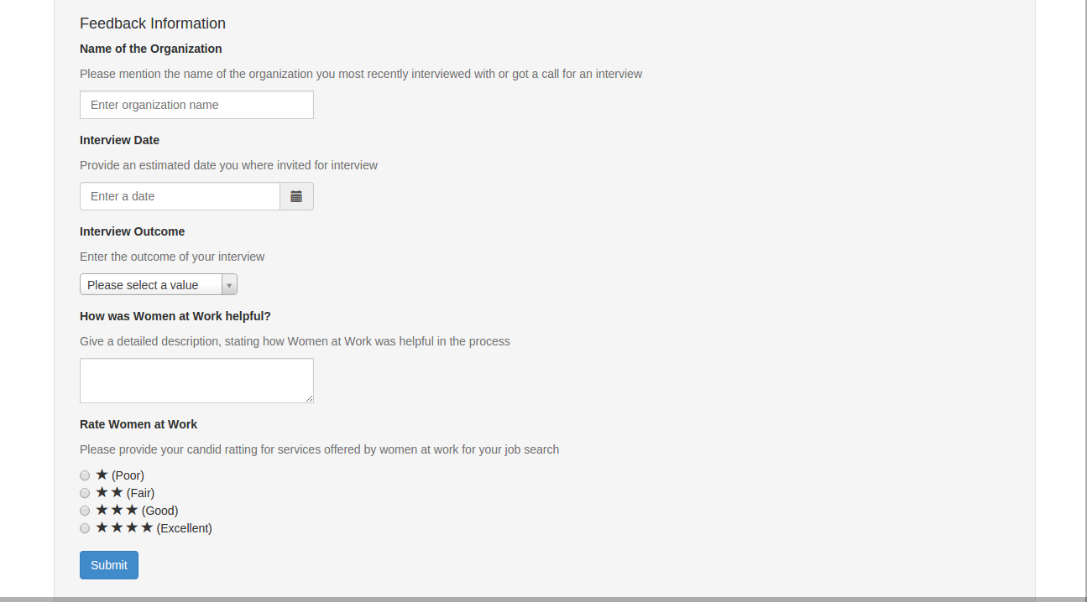

Figure 4(b) Demonstrating the components of online feedback form

