System and Software Architecture Description (SSAD)

Women at Work Website Redesign

Team 14

Sr no | Name | Role
1 | Srikanth Madhava | Project Manager
2 | Sanath Bhandary | Operational Concept Engineer
3 | Rohit Kudva | Feasibility Analyst
4 | Varma Maryala | Life Cycle Planner
5 | Praneet Surana | Requirements Engineer
6 | Dinesh Yeduguru | Software Architect
7 | Nishant Jani | Prototyper
8 | Brian Bousman | IIV&V

Version History
Date | Author | Version | Changes made | Rationale
10/12/14 | Dinesh Yeduguru  Srikanth Madhava | 1.0 | - Original template for SSAD  - Various diagrams for system context, use case, behavior have been inserted  - Have written description for each section | - Initial draft version 1.0 of SSAD  - To fulfill exit condition of Draft FC package

Table of Contents

System and Software Architecture Description (SSAD) i
Version History ii
Table of Contents iii
Table of Tables iv
Table of Figures v
A.1. Introduction 1
A.1.1 Purpose of the SSAD 1
A.1.2 Status of the SSAD 1
A.2. System Analysis 2
A.2.1 System Analysis Overview 2

Table of Tables

Table 1: Actors Summary 4
Table 2: Artifacts and Information Summary 5
Table 3: Online Registration Process Description 7
Table 4: Typical Course of Action 7
Table 5: Alternate Course of Action 7
Table 6: Online Feedback Process Description 8
Table 7: Typical course of action 8
Table 8: Alternate course of action 9
Table 9: On-line check-in process description 9
Table 10: Typical course of action 9
Table 11: Alternate course of action 10
Table 12: Secure document management upload process description 10
Table 13: Typical course of action 11
Table 14: Alternate course of action 11
Table 15: Secure document management view process 11
Table 16: Typical course of action 12
Table 17: Alternate course of action 12
Table 18: Report generation process 12
Table 19: Typical course of action 13

Table of Figures

Figure 1: System Context Diagram 3
Figure 2: Artifacts and Information Diagram 5
Figure 3: Process Diagram 6

Introduction

Purpose of the SSAD

The purpose of this document is to show the results of the object oriented analysis and design of the system being developed. The SSAD is used by the developer as reference to the system architecture. The website and the solution being developed should be faithful to the architecture specified in the SSAD. Furthermore, the SSAD is used by the maintainer and clients to help understand the structure of the system once the proposed website is delivered.

Status of the SSAD

This version is the initial version of the document submitted for the foundation phase.

System Analysis

System Analysis Overview
The system being developed for Women at Work has the following purposes:
- Automated online registration form for the user.
- Automated online feedback form for the user to fill at his/her convenience.
- Onsite check-in system for the users
- Website redesign for easy access to the data
- Blogging and social media integration for wider outreach
- Secure document sharing portal for the board members
- Report generation module to collect user statistics

System Context

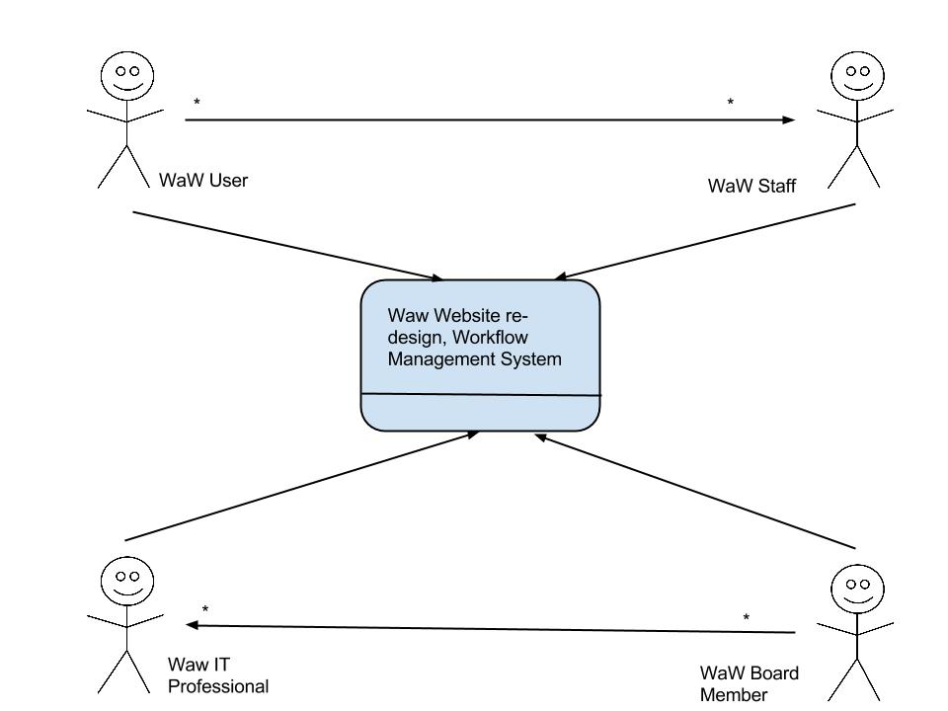
Figure 1: System Context Diagram

Table 1: Actors Summary
Actor | Description | Responsibilities
WaW Staff | WaW staff includes front desk staff | - Help users with registration  - Help users with check-in  - Help users with getting appointment with councilors  - Point of contact for the users who arrive at the location
WaW User | WaW users are the clients who signup for the programs | - User shall register in order to attend the programs  - User shall check-in before attending a program  - User shall submit feedback about the progress
WaW Board Member | These include the directors, presidents and secretaries of the organization | - Raise funds for the organization  - Manage the organization  - Board members shall use the portal for document management  - Board members shall publish blogs in the website
WaW IT professional | This include the system administrators and database administrators at WaW | - Maintain the IT infrastructure  - Troubleshoot issues  - Generate Reports  - Add articles to the website through wordpress blogging engine

Artifacts & Information

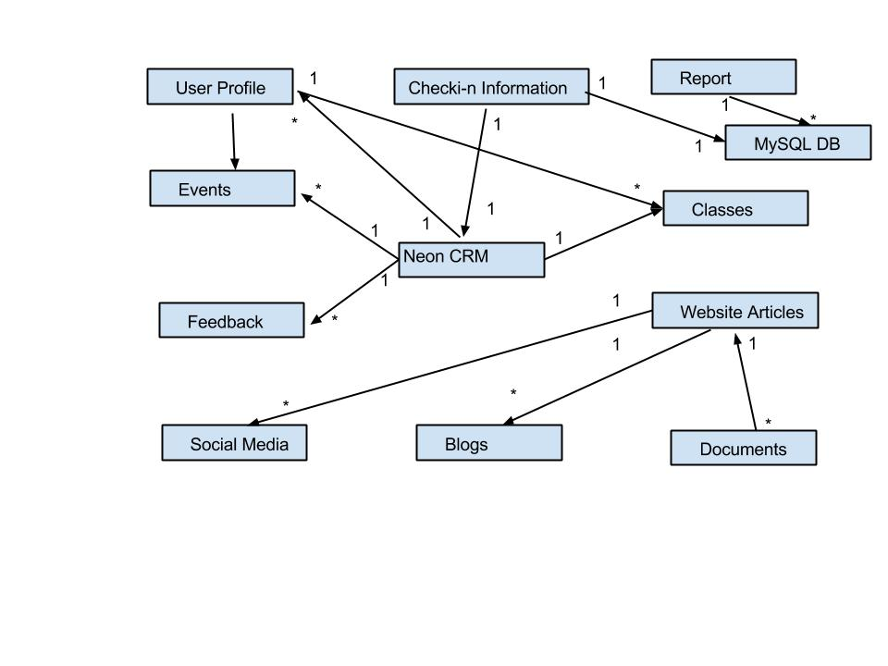Figure 2: Artifacts and Information Diagram

Table 2: Artifacts and Information Summary
Artifact | Purpose
User Profile | Information about the user is stored here
Check-In | The user check-in information
Events | Events hosted at WaW
Classes | Classes conducted at WaW
Feedback | Feedback submitted by the user
Social Media | Updates to social media posted by WaW personnel
Blogs | Blogs posted by WaW personnel
Documents | Documents uploaded for sharing by the Board of directors
Website Articles | Articles added to the website
MySQL DB | DB used to store data about check-in
Reports | Reports generated from the check-in information

Behavior

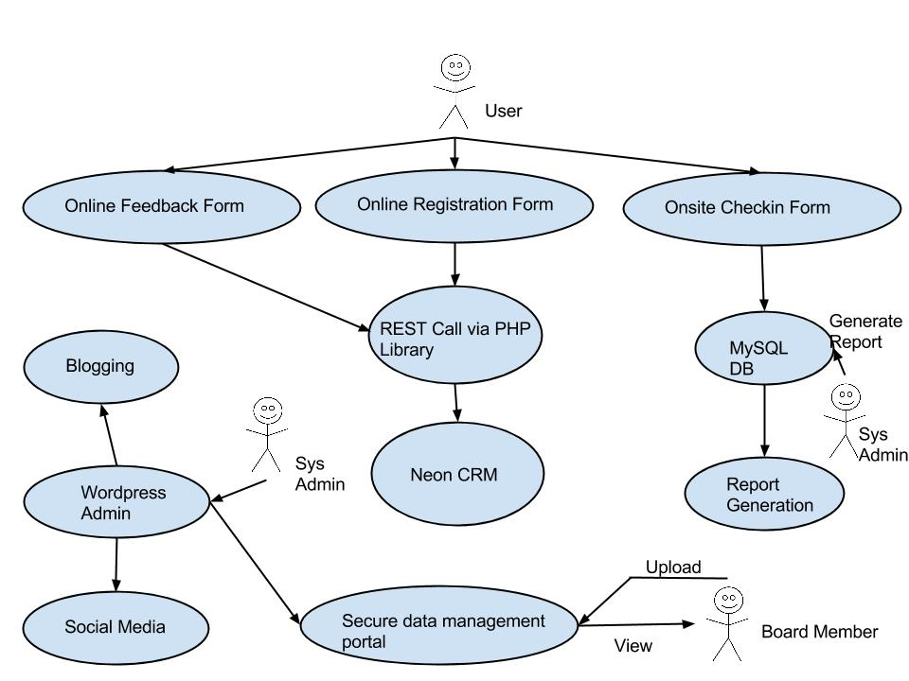

Figure 3: Process Diagram

Registration Capability

Online Registration Process
Table 3: Online Registration Process Description
Identifier | UC-1: Online User Registration
Purpose | For the user to register with WaW. This replaces the paper registration form.
Requirements | CR-1: Automated User Registration
Development Risks | None
Pre-conditions | - Neon CRM is in a working condition  - User should have access to a computer with browser capability and connected to Internet
Post-conditions | If user enters valid data, the data is stored into Neon CRM. Otherwise, an error is displayed to the user

Table 4: Typical Course of Action
Seq# | Actor’s Action | System’s Response
1 | [user] clicks Register Online button | Redirects user to registration page
2 | [user] enters registration details and submits | System makes an REST Call with Registration details to NEON CRM.
3 | [NeonCRM] validates data
4 |  | [valid] Inserts registration data into the NEON CRM.

Table 5: Alternate Course of Action
Seq# | Actor’s Action | System’s Response
1-3 |  | Refer to the typical course of action
4 |  | [invalid] Displays an error message to the user with the corresponding error code.

Feedback Capability

Online Feedback Process

Table 6: Online Feedback Process Description
Identifier | UC-2: Online User Feedback
Purpose | For the user to give feedback to WaW. This replaces the telephonic feedback process.
Requirements | CR-2: Automated User Feedback
Development Risks | None
Pre-conditions | - User should be registered  - User should receive a notification to submit feedback  - User should be willing to give feedback
Post-conditions | If user enters valid data, the data is stored into Neon CRM. Otherwise, an error is displayed to the user

Table 7: Typical course of action
Seq# | Actor’s Action | System’s Response
1 | [Neon CRM] sends mail to the user notifying to submit the feedback
2 | [user] Clicks the submit feedback button | redirects to the feedback form
3 | [user] enters the feedback and submits | System makes an REST Call with Feedback details to NEON CRM.
4 | [NeonCRM] Validates the feedback data
5 |  | [valid] Inserts feedback data into the NEON CRM.

Table 8: Alternate course of action
Seq# | Actor’s Action | System’s Response
1-4 |  | Refer to the typical course of action
5 |  | [invalid] Displays an error message to the user with the corresponding error code.

Onsite User Check in

Onsite User check in process

Table 9: On-line check-in process description
Identifier | UC-3: Onsite User Checkin
Purpose | For the user to check in at WaW location so as to keep track all the users visited.
Requirements | CR-3: Automated User Checkin
Development Risks | None
Pre-conditions | - User should be registered  - User should arrive at the location  - Should be able to access a machine connected to the intranet
Post-conditions | If user enters valid data, the data is stored into MySQL DB. Otherwise, an error is displayed to the user

Table 10: Typical course of action
Seq# | Actor’s Action | System’s Response
1 | [user] user selects all the options that apply to him
2 | [user] Clicks the submit button | System makes an REST Call with user details to NEON CRM
3 | [NeonCRM] Verifies if user is registered
4 |  | [valid] Inserts checkin data into the MySQL DB.

Table 11: Alternate course of action
Seq# | Actor’s Action | System’s Response
1-3 |  | Refer to the typical course of action
5 |  | [invalid] Displays an error message to the user with the corresponding error code.

Secure Document Management

Secure Document Management upload process

Table 12: Secure document management upload process description
Identifier | UC-4: Secure Document Management
Purpose | For the board members to provide secure document management portal to share the confidential documents.
Requirements | CR-4: Secure Data Management Portal
Development Risks | None
Pre-conditions | - Board members should be registered  - Board members should have access to a computer with browser capability and connected to Internet
Post-conditions | The uploaded documents can be accessed from a secure third party data portal

Table 13: Typical course of action
Seq# | Actor’s Action | System’s Response
1 | [user] Board members will login as Board from WaW website
2 | [user] Clicks the upload link to upload the document | System redirects the user to upload page
3 | [user] Uploads the document
4 |  | [valid] The document is stored in the secure data management portal.

Table 14: Alternate course of action
Seq# | Actor’s Action | System’s Response
1-3 |  | Refer to the typical course of action
5 |  | [invalid] Displays an error message to the user with the corresponding error code.

Secure Document Management view process

Table 15: Secure document management view process
Identifier | UC-5: Secure Document Management
Purpose | For the board members to provide secure document management portal to view the confidential documents.
Requirements | CR-5: Secure Data Management Portal
Development Risks | None
Pre-conditions | - Board members should be registered  - Board members should have access to a computer with browser capability and connected to Internet
Post-conditions | The uploaded documents can be accessed from a secure third party data portal

Table 16: Typical course of action
Seq# | Actor’s Action | System’s Response
1 | [user] Board members will login as Board from WaW website
2 | [user] Clicks on document which needs to be viewed
3 |  | [valid] System redirects the user to the document

Table 17: Alternate course of action
Seq# | Actor’s Action | System’s Response
1-2 |  | Refer to the typical course of action
3 |  | [invalid] Displays an error message to the user with the corresponding error code.

Report Generation

Report Generation process

Table 18: Report generation process
Identifier | UC-6: Report Generation
Purpose | To collect various statistics by generating reports to make better business deciscions.
Requirements | CR-6: Report generation
Development Risks | None
Pre-conditions | NONE
Post-conditions | NONE

Table 19: Typical course of action
Seq# | Actor’s Action | System’s Response
1 | [System admin] logs into Admin interface
2 | [System admin] runs the procedure. | MySql runs various queries to generate reports and dumps it into Excel

