**How to Validate and Generate Policy Simulator**

**Step 1:** download the library “PolicySimulator” from Gitlab and unzip it. Save the file at any location on your system.

**Step 2:** Open R studio and go to File 🡪 New File 🡪R script.

**Step 3:** Install devtools library by writing below code in R Script.

install.packages("devtools")

library(devtools)

Please note if you copy and paste this code make sure you change the inverted comma.

In case you have this library installed so it will show you an dialog like this

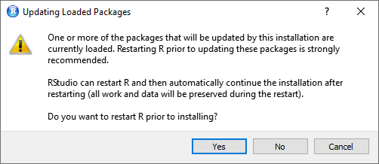

Select **Cancel** or **cross bar** and skip the step of install.packages and load the library using command library(devtools).

If you get the error in console that states “Error in library(devtools) : there is no package called ‘devtools’.

Then you need to install the package you need to select the option **Yes** if

dialog appears.

Please Note: This library may take time to get installed if installing for the first time (2-4 mins).

**Step 4:** set the working directory using command

setwd()

In the braces of setwd() , please provide the path of the library where you have saved the library

For example:

setwd(“C:/user/ OECD_Policy_Simulator/PolicySimulator”)

**Step 5:** Write devtools::install() in R script

Inside the braces of devtools::install() ,please provide the path of the library where you have saved the library.

For example:

devtools::install(“C:/user/ OECD_Policy_Simulator/PolicySimulator”)

**Step 6:** Check your library is installed successfully

If you receive message like this in your console it means library is installed successfully.

*** installing help indices

'PolicySimulator' for package finding HTML links ...

done

\alidation html

** building package indices

** testing if installed package can be loaded

*** arch - i386

*** arch - x64

**\* DONE (PolicySimulator)**

**In R CMD INSTALL**

**Step 7:** load the library

To do this write following command:

library(PolicySimulator)

**Step 8:** Calling the Validation and Generation function

Write the following command

ValidationandGeneration()

In the braces of this command 2 parameter are needed:

1: path where you want your policy simulator generator to save

2: path to the Matrix_Simulator_Template.xlsx that is located

For Example:

ValidationandGeneration(“C:/User/desktop/”,"D:/OECD_Policy_Simulator/Matrix_Simulator_Template.xlsx")

**Step 9:** Run each line one by one or Select all lines using CTRL+A and press CTRL+ENTER

**Step 10:** A folder will get generated at the location which you have mentioned in function ValidationandGeneration(“C:/User/desktop/”,"D:/OECD_Policy_Simulator/Matrix_Simulator_Template.xlsx")

The location is 1st parameter of the function E.g. “C:/User/desktop/”.

The name of the folder will be name of the policy simulator that is assigned in the Matrix simulator template in Apps sheet

For example: Product Market Regulation

**Step 11:** Open the folder and you will find the directory which contains folder name “data”,”lib”,”www” and one R file name app.R

Open app.R in R studio and click on the down arrow at Run button on R studio.

Select option Run External. The web page will open and policy simulator gets generated.

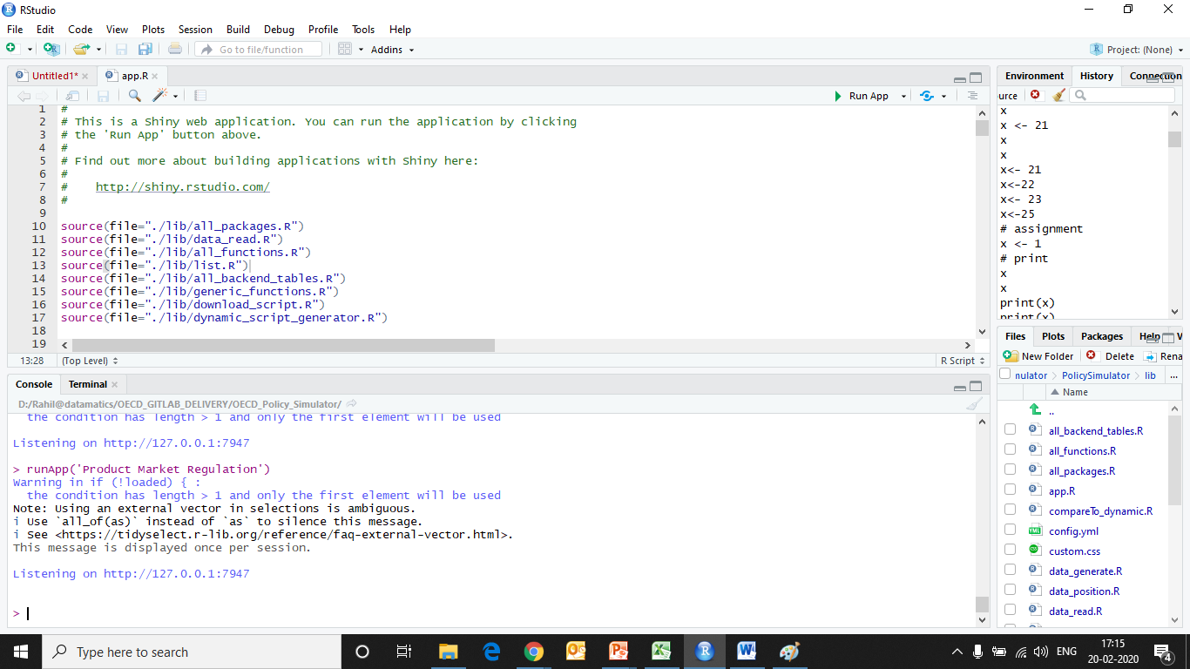

****************************THE END****************************

Snippet for running the complete code:

install.packages("devtools ")

library(devtools)

setwd("D:/OECD_Policy_Simulator/PolicySimulator") ## Change the path

devtools::install("D:/OECD_Policy_Simulator/PolicySimulator") #Change the path

library(PolicySimulator)

ValidationandGeneration("D:/User/Desktop” , “D:/OECD_Policy_Simulator/Matrix_Simulator_Template.xlsx") ## Change the paths