OECD SIMULATOR

Manual

Version - 1.0

Created on: 20th JANUARY 2019

**Table of Contents**

|  |  |
| --- | --- |
| **Sr#** | **Components (Use hot key Ctrl+Click on Components to navigate)** |
| 1 | Logo Image |
| 2 | Title Text |
| 3 | Copyright Text |
| 4 | HTML Text View – (About Policy Simulator Text) |
| 5 | HTML Text View – (Home Policy Simulator Text) |
| 6 | Reset Button |
| 7 | Share Button |
| 8 | Download Button |
| 9 | Dropdown Selector 1 – (Indicators) |
| 10 | Dropdown Selector 2 – (Country Name) |
| 11 | Dropdown Selector 3 – (Compare to Countries) |
| 12 | Graph 1 -- (Indicator vs Country) |
| 13 | Graph 2 – (Countries Comparison) |
| 14 | Collapsible Tabular Structure -- (Table Calculations) |
| 15 | How to configure the template |
| 16 | How to Validate and Run the Policy Simulator |

|  |  |
| --- | --- |
| 1. Logo Image |  |

* It is an image (logo) in the UI (User Interface). It is clickable & contains link (for e.g. <http://www.oecd.org/>) which diverts to new page.
* The default size of image are as below: -  
  Height (Vertical) = 46 pixels   
  Width (Horizontal) = 180 pixels
* This logo is configurable from template. One can change image by putting link in column named ‘Name’ of row named ‘Logo’ in the file ‘Matrix_Simulator__Template.xlsx’ and then image gets saved into folder named “www” & can be viewable for the same.

|  |  |
| --- | --- |
| 1. Tittle Text |  |

* This is the header of UI.
* It is configurable, input source comes from column named ‘Name’ of row named ‘Application name’ from excel file ‘Matrix_Simulator__Template.xlsx’.

|  |  |
| --- | --- |
| 1. Copy Right Text |  |

* This is the copyright text in the UI.
* It contains link which diverts to new page.  
  (for e.g. <http://www.oecd.org/termsandconditions/>)
* The content and link are driven from column named ‘Name’ & ‘Link’ of ‘Copyright’ row from excel file ‘Matrix_Simulator__Template.xlsx’.

|  |
| --- |
| 4. HTML Text View – (About Policy Simulator Text) |

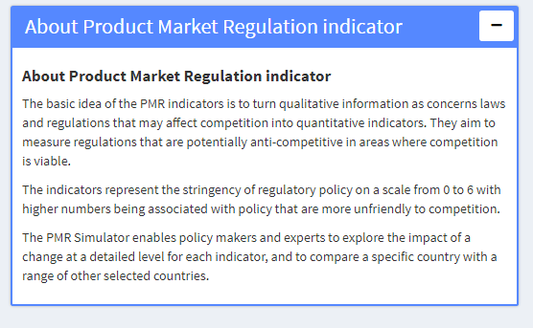

* It is configurable and its contents are driven from column ‘Name’ & ‘Link’ of row named ‘About’ from excel file ‘Matrix_Simulator__Template.xlsx’. It is collapsible & expandable when one click on the blue header   
  ().
* The content of cell written in HTML format. So, don’t copy and directly paste it from the website. It will lead to error due to special characters.

|  |
| --- |
| 5. HTML Text View – (Home Policy Simulator Text) |



* Label and content are driven from column named ‘Name’ & ‘Link’ of row ‘Homepage’ from excel file ‘Matrix_Simulator__Template.xlsx’. It is collapsible & expandable when one click on the blue header.
* This is also written in HTML format.

|  |  |
| --- | --- |
| 6. Reset Button |  |

* It is used to reset the complete page.
* After reset, all the values in drop down selectors ( INDICATOR, COUNTRYNAME, and COMPARE TO COUNTRYNAME), graphs (Indicators vs Countries and Countries Comparison) & tables ( Table Calculations) gets set to default state.

|  |  |
| --- | --- |
| 7. Share Button |  |

* It is used to reproduce the state of UI.
* Clicking on ‘Share’ button enables the simulated data link (i.e. exact replica of the user interface as it was before pressing the share button). You will be able to see below screenshot post clicking on ‘Share’ button:-

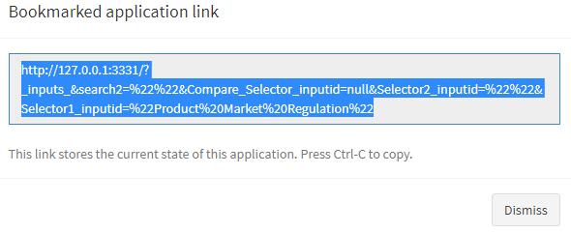

* You have to copy this link and paste in the web browser to view the replica of simulation as mentioned in above steps.

|  |  |
| --- | --- |
| 8. Download Button |  |

* User will be able to download the simulated data for all countries and new calculated value for country chosen in excel format (.xlsx extension) after clicking the download button.

|  |  |
| --- | --- |
| 9. Dropdown Selector 1  ( Indicator) |  |

* The dropdown is configurable from template (Matrix_Simulator__Template.xlsx).
* User will have to select ‘Yes’ in any row of column name ‘Selector 1’. Then it takes its corresponding row name as title of Dropdown Selector. Only one ‘Yes’ allowed and rest will have to be ‘No’ (Null or NA are not allowed) in a column.
* Data will populated as per the code column.

|  |  |
| --- | --- |
| 10. Dropdown Selector 2  (Countryname) |  |

* User can select any one country from the given list of countries.
* It is configurable and will have to select ‘Yes’ in any row of column name ‘Selector 2’. Then it takes its corresponding row name as title of Dropdown Selector. Only one ‘Yes’ allowed and rest will have to be ‘No’ (Null or NA are not allowed) in a column.
* User can select only one country.
* After selection of a country, below changes will occur:-

- The second graph (Countries Comparison) will open.

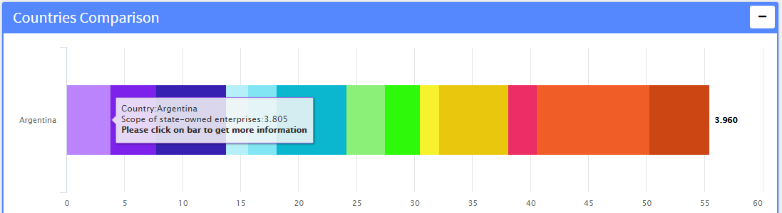

- The table (‘ Table Calculation’) will open.

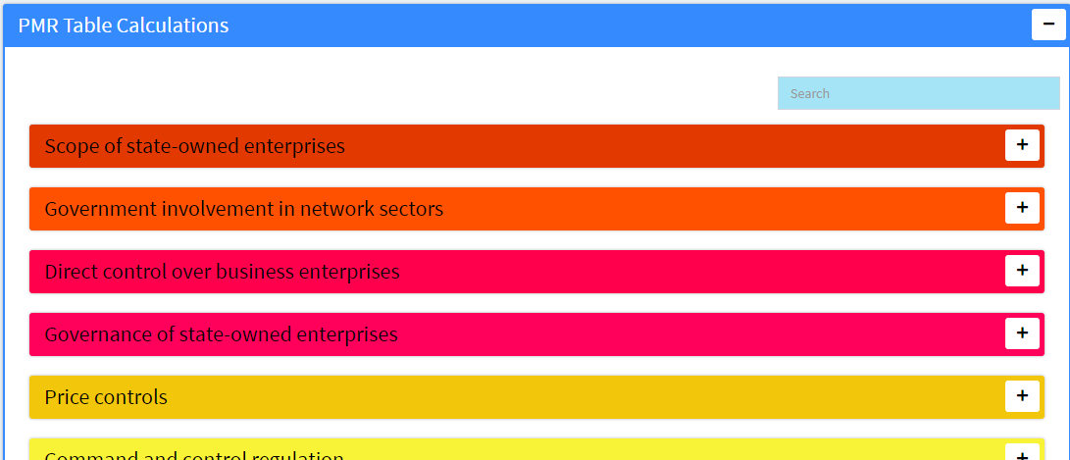

* The column values in the table gets changed according to selected country on dropdown selector 2. There will be no data available in table if there is no any country selected.

|  |  |
| --- | --- |
| 11. Dropdown Selector 3 (Compare to Countryname) |  |

* The multiple dropdown selectors will contain list of countries. We can select multiple countries at a time. Accordingly “Countries Comparison” graph will show the comparisons among selected countries.
* The last column named ‘ComparedTo’ of the table ( Table Calculations) will also be updated with the country data (the last selected option, for e.g. it will be ‘Bulgaria’ in above screenshot)
* It is configurable and will have to select ‘Yes’ in any row of column name ‘Selector 3’. Then it takes its corresponding row name as title of Dropdown Selector. Only one ‘Yes’ allowed and rest will have to be ‘No’ (Null or NA are not allowed) in a column.

|  |
| --- |
| 12. Graph 1 -- (Indicator vs Country) |

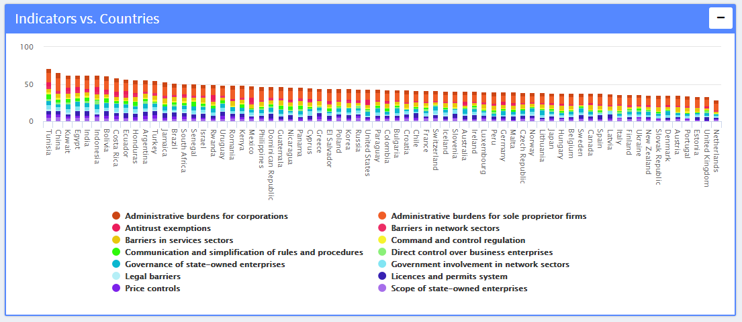

* It is graphical representation of ‘Countries’ based upon any 1 ‘Hierarchy Level’ which is selected from file ‘Matrix_Simulator__Template.xlsx’.
* It contains aggregated (from N values to N-1) for all the hierarchy.
* The legends at the bottom of this graph acts as filter (disable/enable). If one click on any legend (say ‘Administrative burdens for corporations’ it will be disabled/removed from the data. Clicking on same again will enable/include the corresponding data into main data).
* All the stacks have different predefined set of colors and every stack indicates different indicator.
* Columns are arranged in decreasing order by aggregated values.
* It includes values of other hierarchy sectors with Hover functionality (refer black box below) on it.

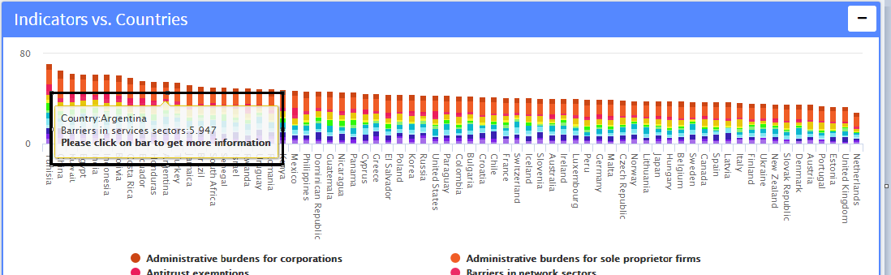

* It also shows additional information (tooltip functionality) when one clicks on the adjacent portion of the bar with hover instruction ‘Please click on bar to get more information’ (refer last line of black box above). Below is the output snapshot:-

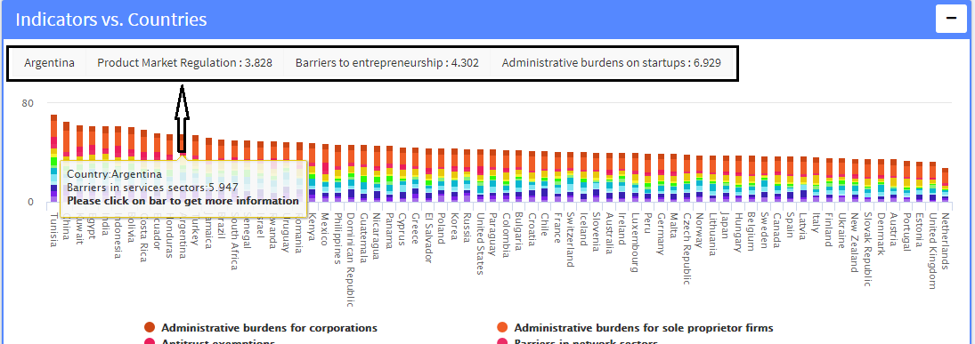

* Hover shows country name along with indicator name & it’s corresponding value.
* X-axis contains name of Countries in above graph.
* The graph ‘Indicator vs. Countries’ gets collapsed after clicking on dropdown selector2 ‘COUNTRYNAME’.
* Once you click on button ‘RESET’ the graph reverts to its default state.

|  |
| --- |
| 13. Graph 2 – (Countries Comparison) |

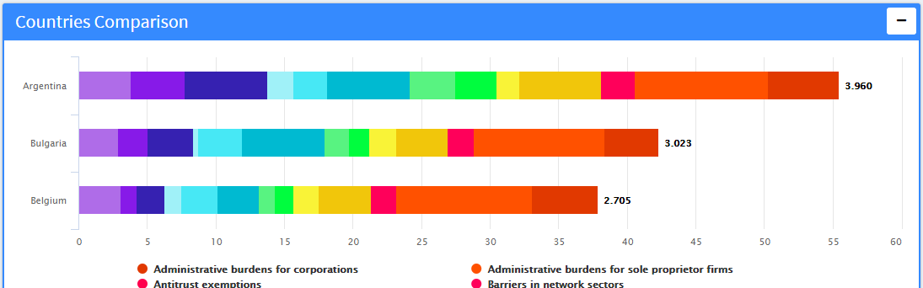

* It is graphical representation of multiple countries and any 1 hierarchy level as per the file ‘Matrix_Simulator__Template.xlsx’.
* It contains all the aggregated value of any 1 hierarchy level data. It also includes values of other hierarchy sectors (Hover).
* The graph opens only after clicking on ‘Dropdown Selector2 i.e. COUNTRYNAME’
* All the stacks have different predefined set of colors for each indicator.
* The graph also contains legend functionality which works as a filtration on graph (enable/disable data as mentioned earlier).
* Each horizontal country bar shows aggregated average value at the end of stack bar (for e.g. 3.960 in below snapshot).



* User can compare countries by selecting multiple countries in ‘Dropdown Selector 3 i.e. COMPARE TO COUNTRYNAME’. Horizontal stack bars are created for each country with aggregated average value in decreasing order.



* It also contains hover and tooltip functionality. Once you click on the adjacent portion of the bar with hover instruction ‘Please click on bar to get more information’ from second black box below. You will be able to see the additional information (refer first black box below).

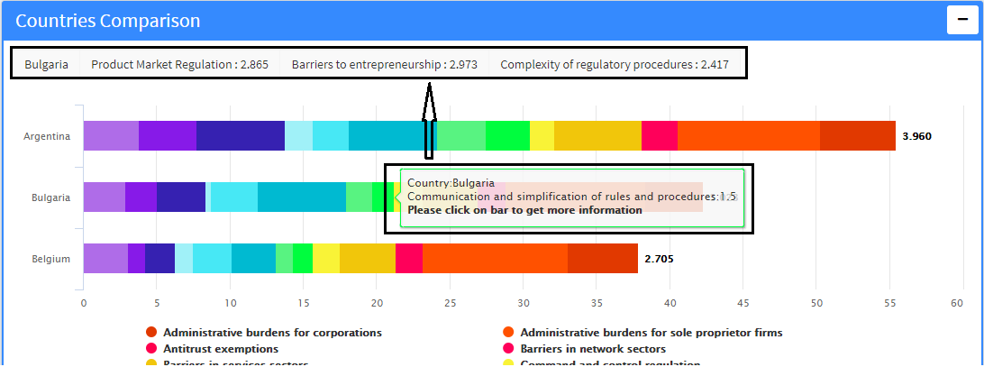

* Hover shows country name along with indicator name and its corresponding value.
* Once you click on button ‘RESET’ the graph reverts to its default state.

|  |
| --- |
| 14. Collapsible Tabular Structure ( Table Calculations) |

* It contains the functionality of collapsibility.
* Each layer denotes different indicators
* The color of each indicator is in synchronization with both the graphs i.e. ‘Indicator vs. Countries’ & ‘Countries Comparison’.

It contains multiple tables (indicators). Each table has fixed set of columns stated as below: -  
 Questions, Answer, Value, Score, EditedValue, EditedScore, ComparedTo

It contains dynamic internal components in column ‘Answer’. Below are the types covered:-



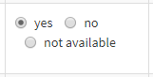





* Search Functionality:   
  You will find 2 types of search options mentioned as below:-  
  Option 1. To Search Across All Indicators (refer red box below):

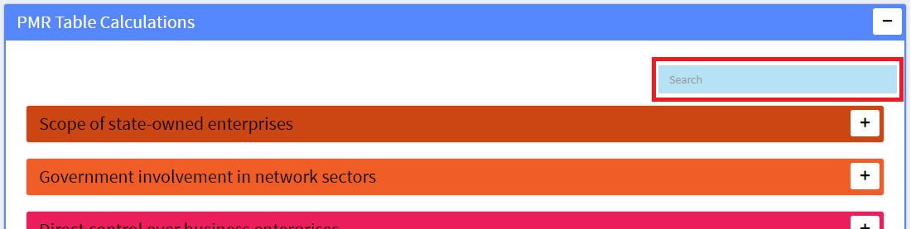

* This search box will provide facility to search texts (say company, refer below screenshot). It will expand/open all the indicators which contains text ‘company’. The rest indicators will be in collapsed format only.

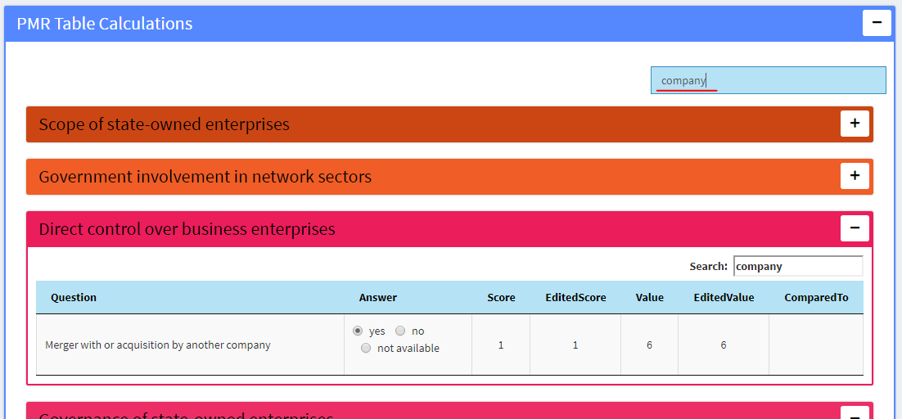  
  
Option 2: To search within each indicator  
by default the master search (i.e. search text from option 1 viz. ‘company’) will be there into the option 2 search box. This can be changed for each indicator table (say replaced ‘company’ with ‘import’). All the attributes/rows with text ‘import’ will only appear for the corresponding indicator. It is nested example of search within search i.e. search by ‘company’ and then search by ‘import’.

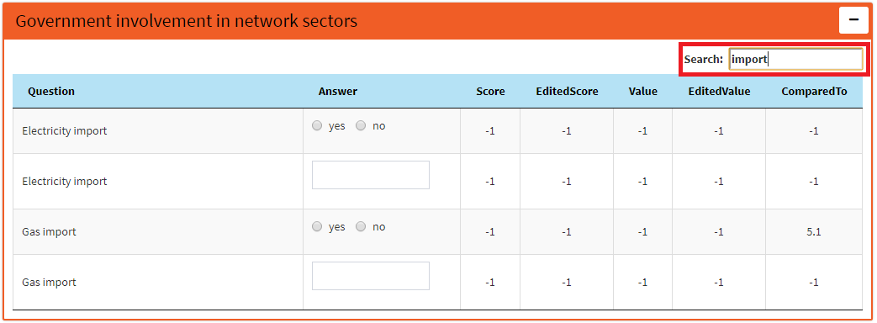

* According to preference, user can change the value from column ‘Answer’. Below are some examples:  
  - Can change radio button options (yes to no, yes to not available)  
  - Can change value from dropdown options (‘for some consumers’ to ‘no’ for Indicator ‘Price controls’)  
  - Can enter numerical value [0.0382576 for indicator ‘Barriers to FDI’ for option ‘If yes, index value (between 0 and 1)’]

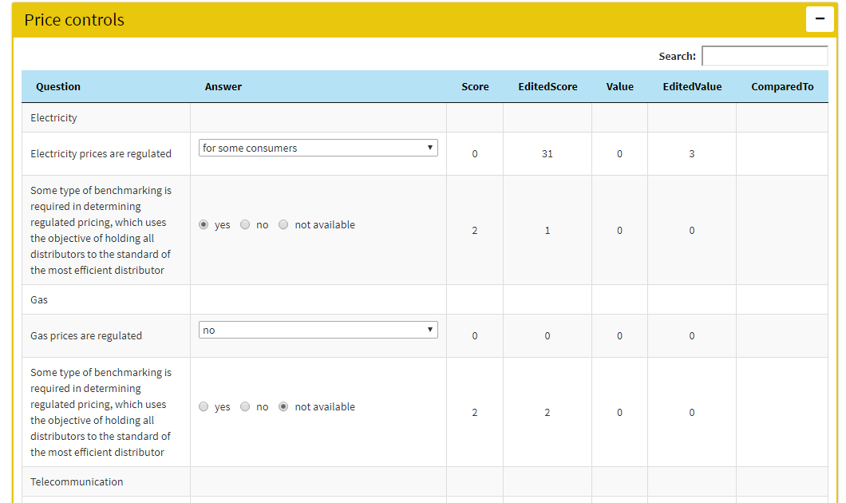

* Once the values are changed as mentioned in above steps, it will have impact on below things:-
  + The column named ‘Edited Value’ & ‘Edited Score’ will be updated according to selection done. The Score and Value column are by default values.
  + The ‘Country Comparison’ graph will also be updated. It will create a new horizontal bar with the changed values taken into consideration. This new horizontal bar will be referred as “<Country Name><Calc>” i.e. if it’s about say country ‘Austria’ then changed values for this country will appear as “Austria Calc” with aggregated values (refer below snapshot).

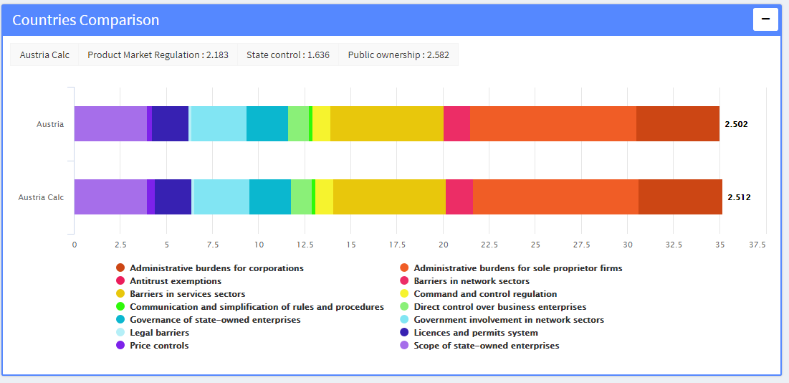

**HOW TO** **CONFIGURE THE TEMPLATE**

The excel file named “Matrix_Simulator_Template.xlsx” is the file that needs to be configured in order to view the policy simulator as per user requirement.

This file contains 5 sheets namely

1. Apps
2. Hierarchy
3. Data
4. Indicator
5. List

Apps Sheet:

The Sheet named Apps contains 3 columns “Metadata”, “Name”, “Link”

Metadata contains feature names updated such as Application Name, Logo, About, Copyright, Homepage and these features can be configured through this sheet.

In “Name” column we can provide the text that needs to be displayed on Web Application.

E.g.: Application Name: PMR Policy Simulator

In “Link” column we can provide the functionality that needs to be performed when clicked on any feature.

E.g. when we click on OECD Logo it calls out a web link and divert the page to http://www.oecd.org/.

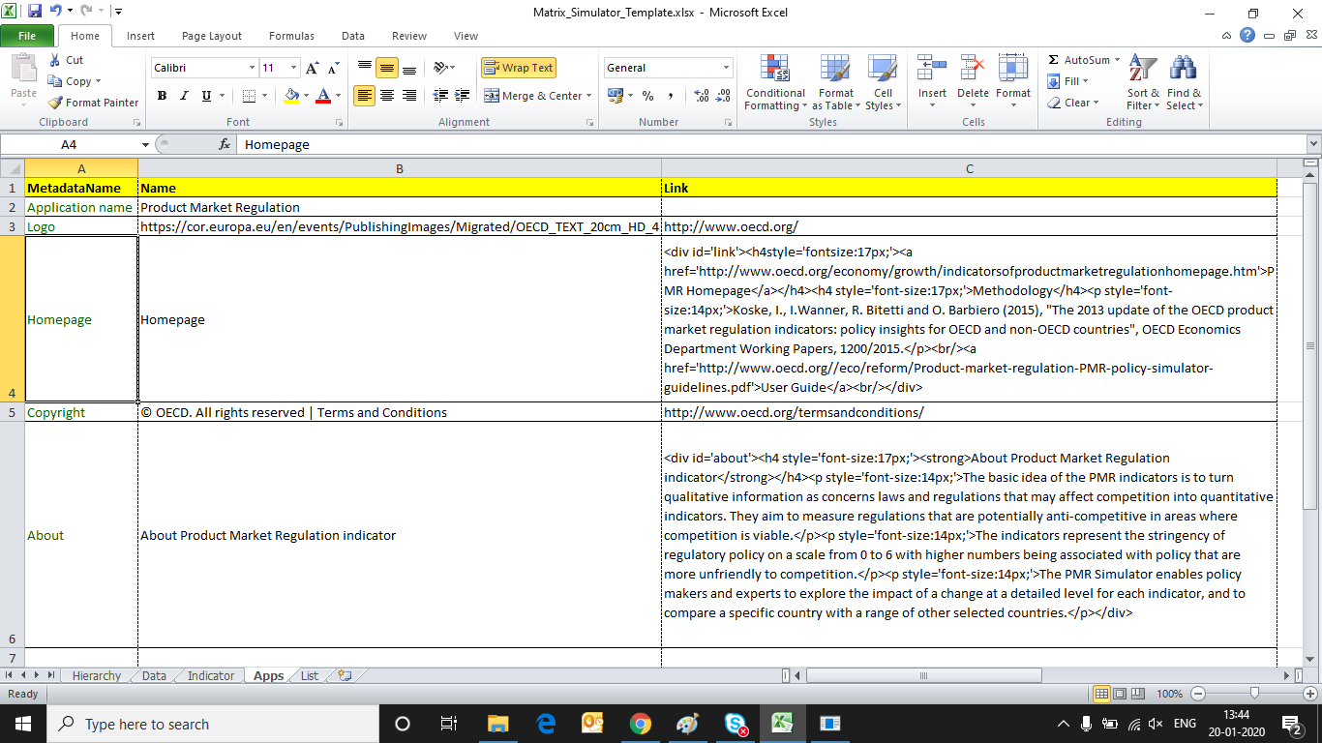

**Application Name**

**Logo**

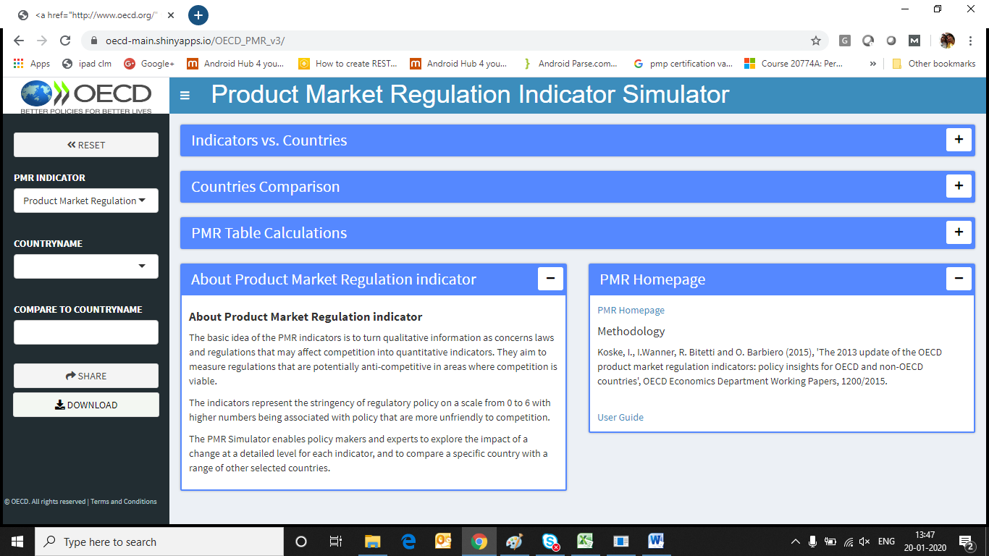

**Homepage**

**About**

**Copyright**

**Hierarchy Sheet:**

This sheet configures the data with respect to table and Graph. It also allow user to define to Name and type of data that needs to be assigned.

There are columns named as “Code”, ”Name”, ”Aggregation method”, ”Aggregation of missing data”, “Selector1”, “Selector2”, “Compare Selector”, ” Display as”, “Hover”, “Display Value”, “Display Score”, “Display Best Practice”, “Display Edited Value”, “Display Edited Score”, “Display Compare Value”, ”Include in Report”.

Name: This column contains the title name and reference name which is associated with the features.

Code: This column is basically related to what value you want to assign to features. It is also related to Name Column

E.g. 1st value of Name is countryname. It is also the title which will be displayed on Webpage. The corresponding code is countryname from Data Sheet which contains list of all the countries.

E.g. 2nd Value of name is PMR Indicator. It is also the title which will be displayed on Webpage. The corresponding code is CH0 from Data Sheet which contains list of all the PMR Indicator.

**Selector1:** Select ‘Yes’ in any row of column name ‘Selector 1’. Then it takes its corresponding row name as title of Dropdown Selector. Only one ‘Yes’ allowed and rest will have to be ‘No’ (Null or NA are not allowed) in a column. Data will populated as per the code column

**Selector2:** Select ‘Yes’ in any row of column name ‘Selector 1’. Then it takes its corresponding row name as title of Dropdown Selector. Only one ‘Yes’ allowed and rest will have to be ‘No’ (Null or NA are not allowed) in a column. Data will populated as per the code column

**Compare Selector:** Select ‘Yes’ in any row of column name ‘Selector 1’. Then it takes its corresponding row name as title of Dropdown Selector. Only one ‘Yes’ allowed and rest will have to be ‘No’ (Null or NA are not allowed) in a column. Data will populated as per the code column

**Please Note:** Other Columns are not in working status for current phase.They will be in working status in next phase.

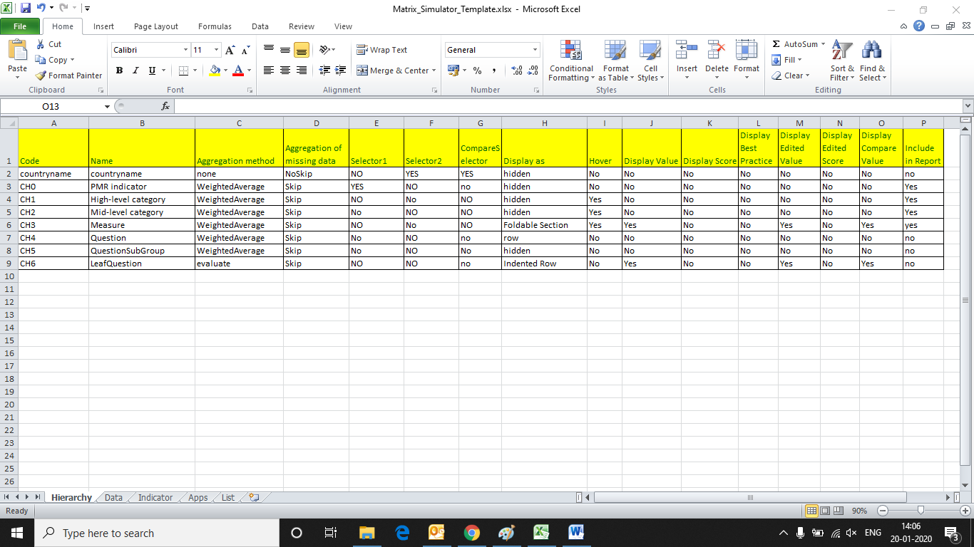

Selector 1 with code column as data and name column as Title

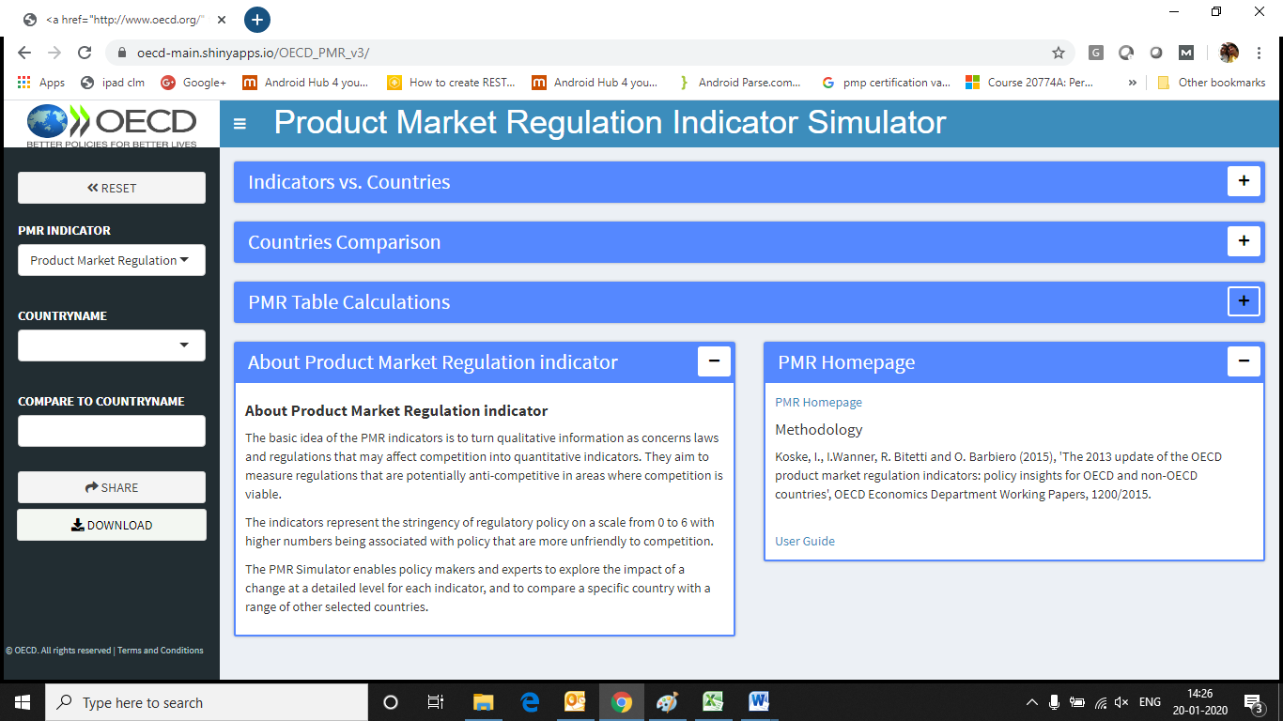

Compare Selector with code column as data and name column as Title

Selector 2 with code column as data and name column as Title

**Data Sheet:**

The Data sheet contains data related to policy simulators. The column names are used in Hierarchy sheet in column named code to display the data.

**Indicator Sheet:**

The Indicator sheet contains data related to policy simulators. The column names are used in Hierarchy sheet in column named code to display the data.

For Scoring Condition E.g. Cond0 , Cond1 , Cond2 …. Cond[x] and Score0, Score1, Score2… Score[x]

Variable which needs to be used are “numans” and “num[xxx]”. It should not contain any other text in either Cond[x].The logical operators which are authorized are “==” , ”&” , ”! =” , ”|” , ”>” , ”<” , ”>=” , ”<=”.

For Score0,Score1… Score[x] it can contain numeric or new condition which contains “numans” and “num[xxx]” .The logical operators which are authorized are “==” , ”&” , ”! =” , ”|” , ”>” , ”<” , ”>=” , ”<=”.

The general logic for scoring based starting from the score0 and evaluating each condition until one is true or there is no more to evaluate. Hence no more than 1 condition should be satisfied.

**List Sheet:**

The List sheet contains data related to policy simulators. It contains the data are related to UI Element column in Indicator sheet. It play vital role providing the numans and value as the output.

Documentation should specify:

**HOW TO VALIDATE AND RUN THE POLICY SIMULATOR**

The Policy Simulator contains 2 Steps:

1. Validation of Data
2. Run the Simulator

Validation of Data: It includes Validation of Data that entered as answer by the user in template. In Policy Simulator file named as “Matrix_Simulator_Template” is used in which Sheet named “Data” contains column name “answer”.

The values in this column need to be properly filled with respect to another sheet in “Matrix_Simulator_Template” named “List”. Also please unzip the 'Datafile.csv' in data folder .

This is temperory file and is used only for testing purpose. later it will be removed and will be automated with template file. Validation will happen on the local machine so setting the path may be required.

**To run the Validator **

Step 1: Open validation.R file in folder named OECD_PMR_v3

Step 2: Set path_to_Project and path_to_read_excel_template.

"path_to_Project" is the path where Policy Simulator project is located.

"path_to_read_excel_template" is the path where you current "Matrix_Simulator_Template.xlsx" is situated.

Please change the "\" slash to "/" while providing the path.

The name of the xlsx file needs to be "Matrix_Simulator_Template" and it should be xlsx file.

E.g. path_to_Project = "C:/Data/Polciy_Simulator"

E.g. path_to_read_excel_template = "C:/Files/Matrix_Simulator_Template.xlsx"

Step 3: Run the file.

If there are is any Error in the data, It will generate “Error.csv” file in data folder. If there is no error detected then it will start the calculation logic and generate the value. Once the process is finished “Datafile.csv” is generated which will act as consumable file for generating policy simulator in data folder.

**To the run simulator **

Step 1: Open app.R file

Step 2: Set Path

Step 3: Run the file.