Final assignment (Task #3)

0. There is no error.
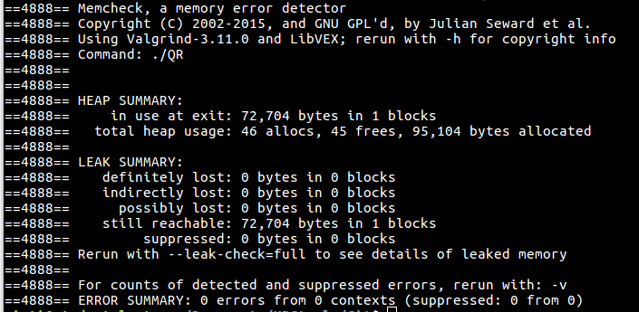

1. I performed a simple code parallelization in the function that deals with the matrix product. At this point, three loops for are nested and can be easily parallelized.
The speed of execution is concidably increased.
Indeed, the basic code requires about 2 min to be executed for a matrix 250x250 (with option -O3). After parallelization and using 2 and threads we obtain respectively a time of 56.51sec and 30.80sec which is almost a speedup of 2.

2. Not surprisingly, it is the matrix multiplication function that takes the longest time. Knowing that householder's QR decomposition requires a lot of matrix product, I had already done a preliminary study to identify the hotspots of my code ( using the chorno library)

The following table gives the execution time of the different functions of my program for a total execution time of 120sec.

3. The vectorization of my code offers a performance gain of 2.01 and is at 100%.
The recommandation. Advisor's recommendation is to compile my code using the AVX2 instruction set ( -xCore-AVX2 option).
Another recommendation is to add data padding in my matrix multiplication.
Since I'm already 100%. No improvement can further increase performance.

