1 Start Bit 8 Data Bits (no parity) 1 Stop Bit.Example: ASCII “3” (Hex 33)

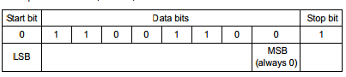

NOTE: The MSB is used by some equipment as a parity bit; however, Optomux units ignore this bit in host-to-unit transmissions.

http://www.opto22.com/documents/1572_Optomux_Protocol_Guide.pdf