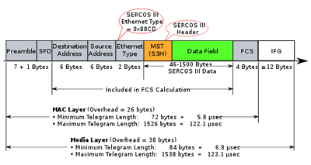

*Sercos III Telegram Structure*  
  
**Telegram format**  
  
All Sercos III telegrams conform to the IEEE 802.3 & ISO/IEC 8802-3 MAC (Media Access Control) frame format.

***Destination address***   
The destination address for all Sercos III telegrams is always 0xFFFF FFFF FFFF (all 1s), which is defined as a broadcast address for Ethernet telegrams. This is because all telegrams are issued by the master, and are intended for all slaves on the network.   
  
***Source address***   
The source address for all Sercos III telegrams is the MAC address of the master, as it issues all telegrams.   
  
***Ethernet type***   
A unique EtherType value of 0x88CD has been assigned via the IEEE EtherType Field Registration Authority for Sercos III.   
  
***Sercos III header***   
The beginning of the Ethernet-defined data field always begins with a Sercos III header, which contains control and status information unique to Sercos.   
  
***Sercos III data field***   
The Sercos III header is followed by the Sercos III data field, which contains a configurable set of variables defined for each device in the network.

**Telegram types**  
  
Two types of telegrams are used within the Sercos III cycle: the Master Data Telegram (MDT), and the Acknowledge Telegram (AT), both issued by the master.  
  
The MDT contains information provided by the master to slaves. It is filled by the master with commands and data and read by slaves.  
  
The AT is issued by the master, but actually is populated by each slave with its appropriate response data (feedback values, input states, etc.). More than one slave uses the same AT, filling its pre-determined area in the AT telegram, updating checksums, and then passing the telegram to the next device. This method reduces the impact of the Ethernet frame overhead on the performance of the network without compromising IEEE 802.3 & ISO/IEC 8802-3. The amount of data sent from the master to slaves, as well as the sum of the data returned by the slaves, may exceed the 802.3-specified maximum 1500-byte data field size. To comply with this limit, Sercos III may use more than one MDT telegram in a cycle, as well as more than one AT telegram (up to 4 in each case).

http://www.sercos.com/technology/telegrams.htm