# 协议名称

TTEthernet (Time-Triggered Ethernet)

# 协议提出厂商

TTTech

# 协议格式

The TTEthernet frame format is compatible with the standard Ethernet (IEEE 802.3) frame format.

Three message types are provided:[[2]](https://en.wikipedia.org/wiki/TTEthernet#cite_note-white-2)

* **Time-triggered messages** are sent over the network at predefined times and take precedence over all other message types. The occurrence, temporal delay and precision of time-triggered messages are predefined and guaranteed. The messages have as little delay on the network as possible and their temporal precision is as accurate as necessary. However, "synchronized local clocks are the fundamental prerequisite for time-triggered communication".[[3]](https://en.wikipedia.org/wiki/TTEthernet#cite_note-3)[[note 1]](https://en.wikipedia.org/wiki/TTEthernet#cite_note-sync_efficiency-4)
* **Rate-constrained messages** are used for applications with less stringent determinism and real-time requirements. These messages guarantee that bandwidth is predefined for each application and delays and temporal deviations have defined limits.
* **Best-effort messages** follow the usual Ethernet policy. There is no guarantee whether and when these messages can be transmitted, what delays occur and if messages arrive at the recipient. Best-effort messages use the remaining bandwidth of the network and have lower priority than the other two types.

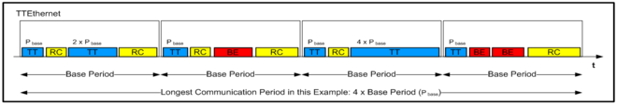

# 协议存在的漏洞