Appendix A

Contents:

Replacing a Steering Servo A-2
Replacing a Steering Servo with the Tower Hobbies TS-59 Servo A-5
Replacing the Tilt Servo A-12
Replacing a Drive Motor A-18
Installing the Faster, 42rpm @ 12v DC Motors A-20
Replacing the Camera A-21
Replacing the Pan Servo A-23

Replacing a Steering Servo

- Remove the two screws securing the servo and then lift the servo from the rover. Make sure to remove the white servo horn as well.

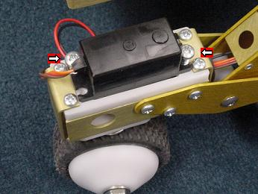

- Cut the two zip ties that secure the wires in the rover’s “legs”. Unplug the servo and remove it.

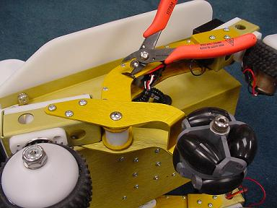

- Thread the new servo wires back through the leg in the same way as the servo you just removed. Connect the servo, making sure to align the brown and black wires.

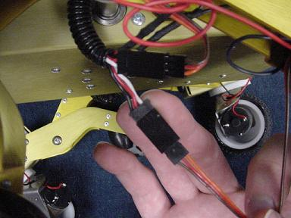

- Turn on the rover and connect to it using the Calibration software. Load the servo calibration from the rover. Center the slider of the new servo. This is a good time to make sure that the servo works and is connected correctly. Position the servo horn on the servo as close to vertical as possible. Making sure that the wires are out of the way, replace the servo and secure the screws. Once the servo is in place, it is a good idea to double check the calibration. The servo may have moved slightly off center during installation. Remember to save the calibration to the rover.

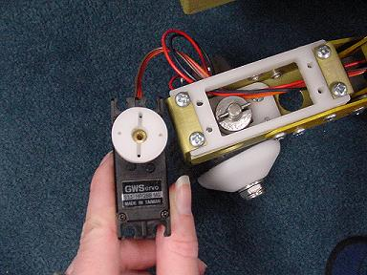

- Tuck all of the wires carefully back in to the leg and secure with zip ties. Try to keep the wires and zip ties tucked inside the leg as much as possible. This will keep the center omni wheel from hitting the wires. The black tubing around the wires should extend in to the leg so that the bare wires will not be pinched by the rocker.

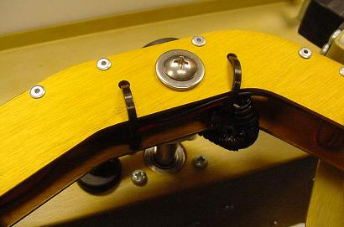

Replacing a Steering Servo with the Tower Hobbies TS-59 Servo
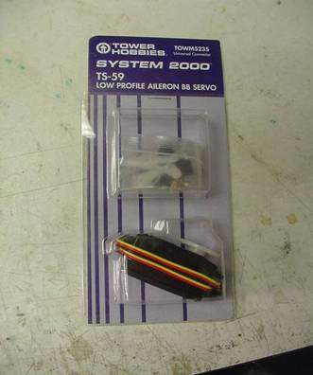

- Remove the two screws securing the servo and then lift the servo from the rover. Make sure to remove the white servo horn as well.

- Cut the two zip ties that secure the wires in the rover’s “legs”. Unplug the servo and remove it.
- The white steering coupler which attached the servo to the steering shaft can be put together one of two ways. These are what they look like:
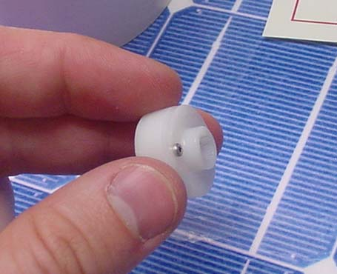 | 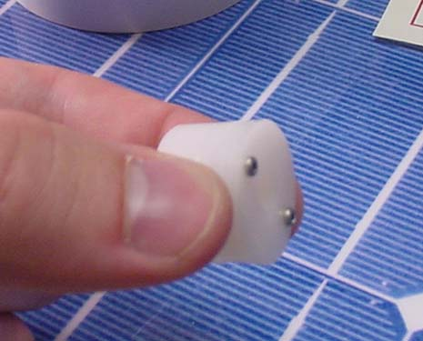

In either case, you need to separate the two pieces of the coupler. These screws require the T5 driver. Make sure to save the screws you remove, we will need them later.

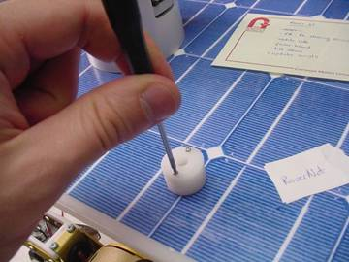
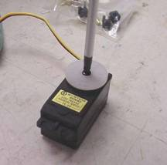
- You now need to attach a servo horn to the lower piece of the coupler, such that we can interface the new servo with the steering shaft. Start by removing the horn which comes attached to the new servo.
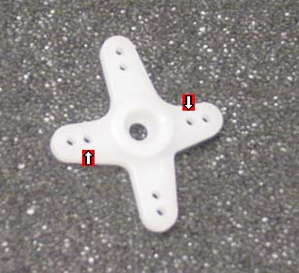 | 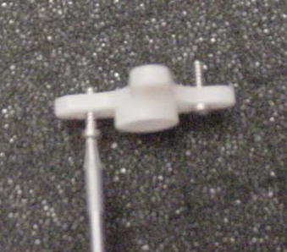
- Next select the cross shaped servo horn from the bag of servo accessories and insert the two screws you saved into the new horn in the two holes closest to its center. These are the holes on the shorter axis of the cross nearest the center hole. Thread the screws all the way into these holes and continue turning them, so that they strip the threads that they just cut in the plastic.
- This step is the most difficult. You must attach the servo horn to the servo coupler, but the holes do not line up precisely. Start by threading one of the screws (still threaded through the horn) into the coupler. Thread it in only a couple of turns. Now you must push the second screw in until we can get it started in the other hole. Once they are both started screw them the rest of the way in. The tips of the screws may extend slightly on the bottom of the coupler. This is ok.
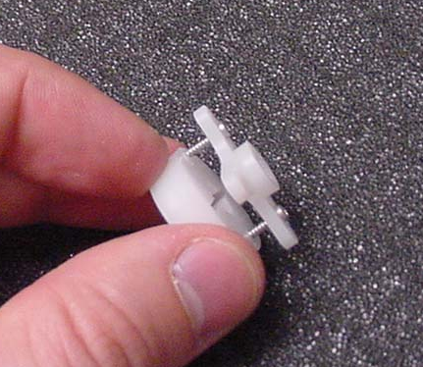 | 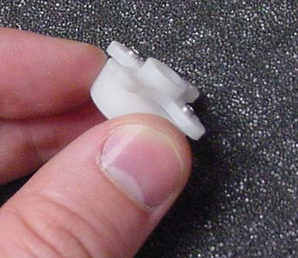
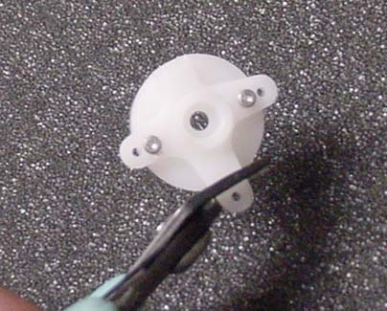 | 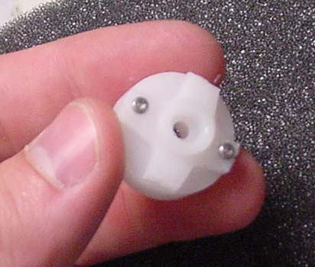
- In order for the servo horn to fit, you need to trim the pieces of the horn which protrude outside of the circle of the coupler.
- Now thread the wire from the new servo through just as it was in the original configuration. Make sure to align the black wires when plugging the servo in to the servo extender.

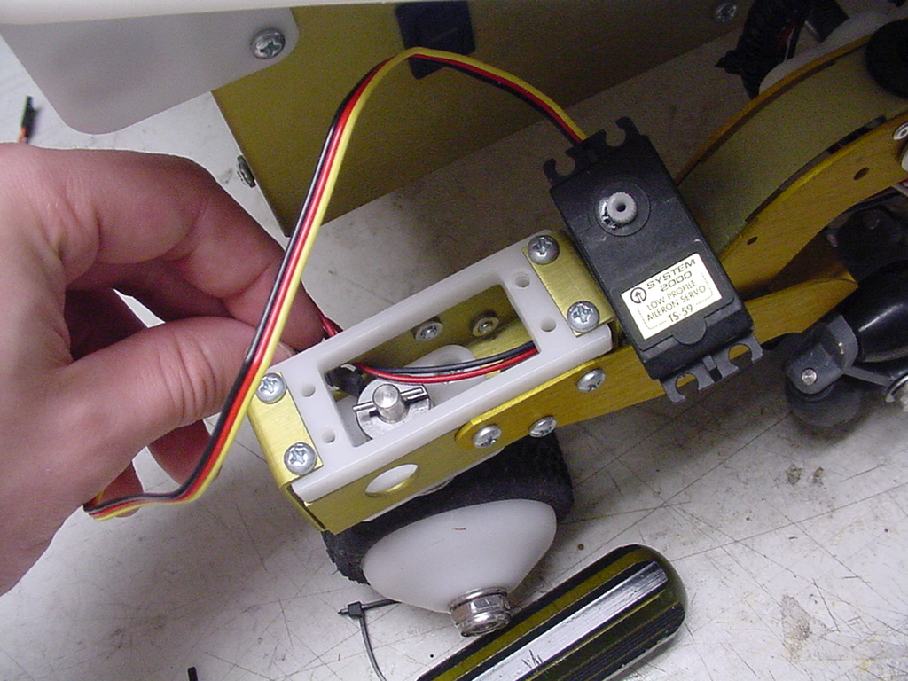 | 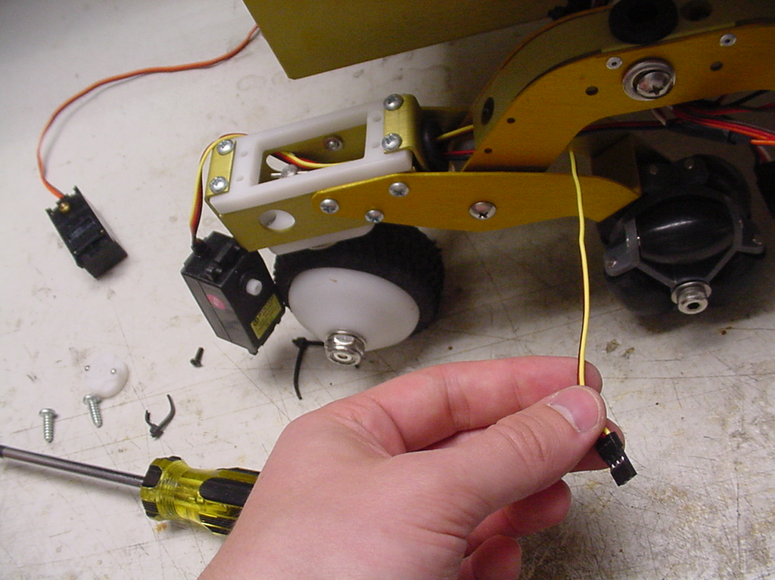

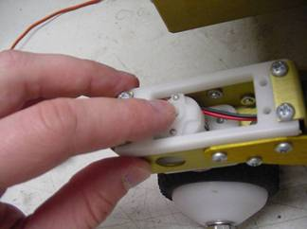
- Press the new servo horn coupler combination down onto the steering shaft. The servo horn might have slightly warped the coupler, so it may be a tighter fit then before. It may require some force before the coupler pops into place.

- Last, the servo must be installed. Power on the robot and center the servo to 128 using the servo Calibration program. Also, you’ll need to reverse the sign of the range of the servo you are replacing. In other words, you’ll need to change the negative 97 to positive 97. Now align the servo horn with the servo output spline, and press these together. The body of the servo is slightly wider than the original servo, so the servo won’t immediately fit down into the servo mount. As you screw the servo down, it will pop into place.

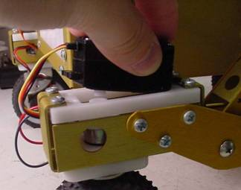
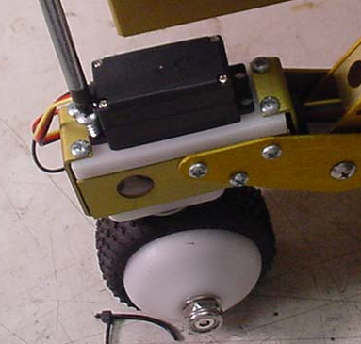 | 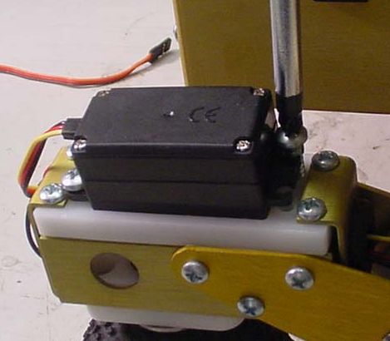

- Your finished product should look like this. Zip tie the wires back inside the leg and you’re done.

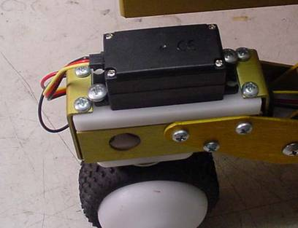

Replacing the Tilt Servo

- Remove the rover’s head cover. Then remove three of the four screws on the left side of the rover’s head. You will need a T5 torx wrench.

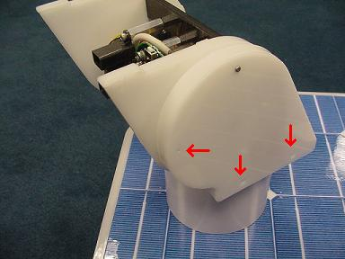

- Swing the outer piece of plastic out of the way and remove the screw in the center of the panel underneath. This screw holds the servo horn on the servo.

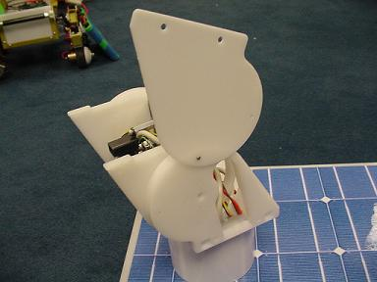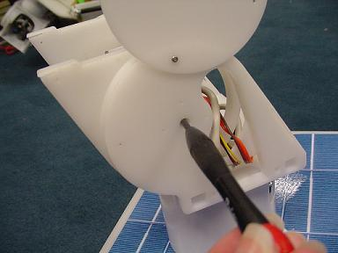

- Separate the outer panels and servo horn from the head.

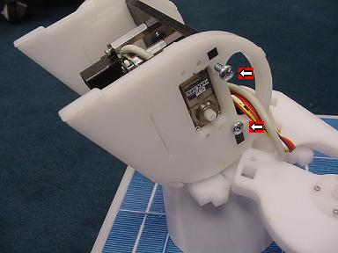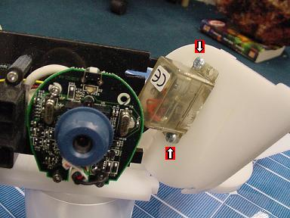

- Remove the two screws holding the final layer of plastic in place and gently pull the plastic piece from the rover’s head. Then remove the two screws securing the servo and remove it from the plastic. Unplug the servo from the servo extender and remove the servo. For old style servos (clear), the connection will probably be just behind the rover’s head. For new style servos (black), the connection may be inside the rover’s neck or inside the green tubing.

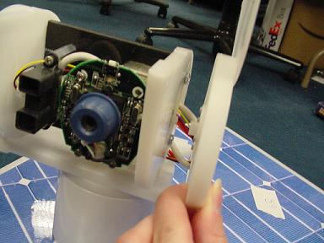

- Remove the screw holding the servo horn on the replacement servo.

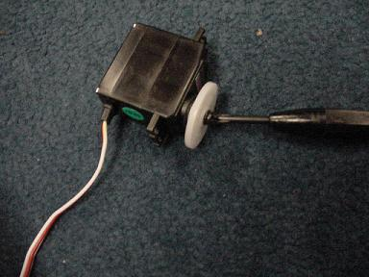

- If you are changing from an old style servo (clear) to a new style servo (black), remove the four screws securing the old servo horn to the rover’s side head panel. Use two of the screws to attach the new servo horn. This is a little difficult because the widest holes on the new servo horn are slightly too narrow. You may need to enlarge the appropriate holes in the new servo horn or put the screws in at an angle. When you have finished, make sure that the servo horn, the thin plastic layer, and the thick plastic layer are all flush with each other.

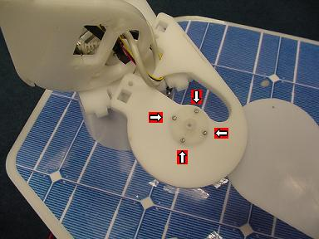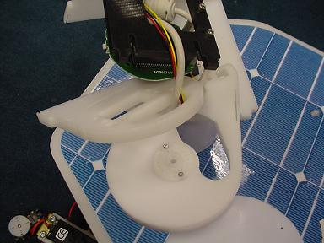

- Thread the servo wires back through the head in the same way as the servo that was removed. The servo wires follow the same path as the camera and IR wires. Be sure that the wires run through the right-most hole in the rover’s neck. Reconnect the servo and servo extender. Push the servo in to the rectangular hole of the inner most plastic layer and secure with two screws.

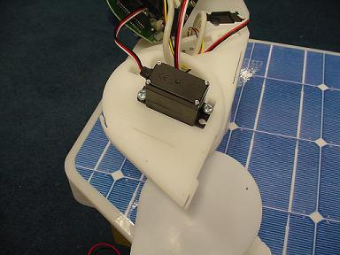

- Reattach the inner most plastic layer to the rover’s head with two screws.

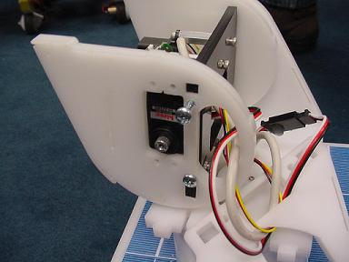

- Turn the rover on and connect to it using the Calibration software. Load the servo calibration from the rover. Center the tilt servo slider. This is a good time to make sure that the new servo is working. For the new style servo, set the tilt servo range to -90. This is because the new all-metal gear servo moves in the opposite direction than the old style servo does.

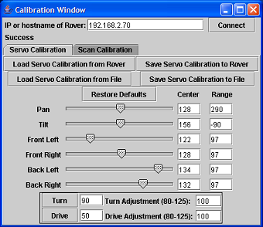

- If you are installing a new style (black) servo, remove the washer from the screw that secures the servo horn to the servo. Align the next plastic head layer and fit the servo horn on to the servo. The head should be level at this point. Secure with the screw making sure that the screw is tight. This takes longer than expected. Keep turning until the screw is tight.

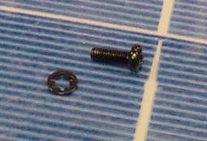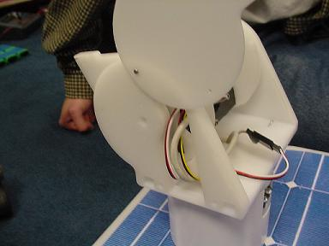

- Secure the outer head layer with the three remaining screws. Pull any excessive slack in the servo wire to the back of the head, but be sure that the head still has full range of motion without putting tension on the wires. Use a small dab of hot glue to make sure that the servo does not come unplugged.

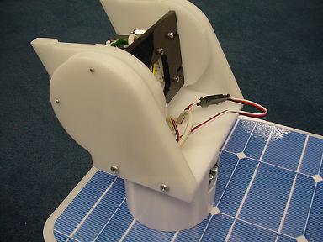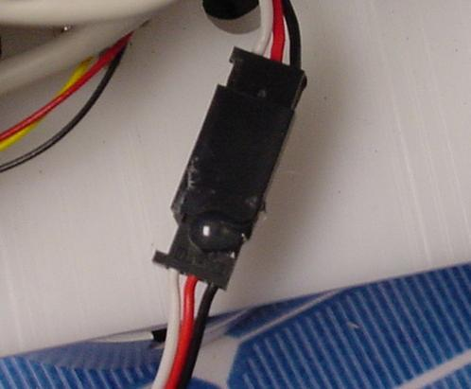

- For the new style servos, there will be enough slack in the wires for the connector to fit inside the robot rather than sit at the back of the robot’s head. Open the rover and remove the green tubing. Pull the connector down through the neck of the robot and then replace the tubing. Again, make sure that there is sufficient slack in the wires at the back of the rover’s head. Test this by tilting the head up and down while it is panned completely to the left and completely to the right. The head should be able to do this without putting tension on the wires.
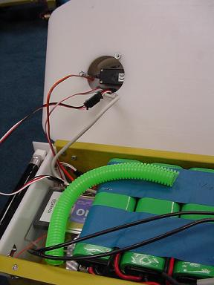

- Replace the rover’s head cover. Now that the new servo is installed, calibrate the rover using the Calibration program. For the new style servo, make sure to set the tilt servo range to -90. Remember to save the calibration to the rover.

Replacing a Drive Motor

- Remove the bolt attaching the wheel to the motor.

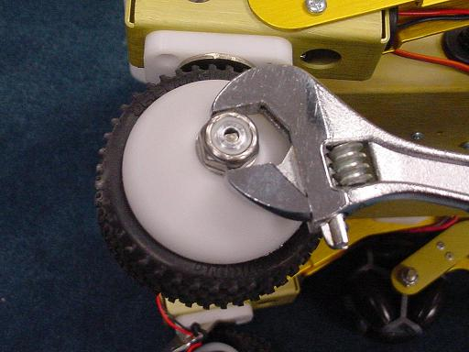

- Remove the two black screws on either side of the motor. Loosen the two set screws that hold the aluminum hub on the motor shaft flat, and pull the aluminum hub off the motor shaft.

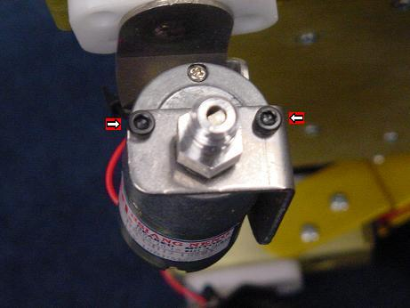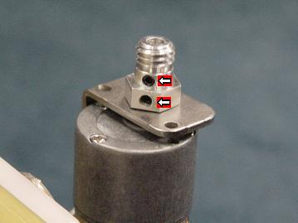

- Unsolder the black and red wires from the motor and remove the motor. Thread the tips of the wires in to the leads on the new motor and solder in place. Note that the red wire connects to the positive pole and the black wire connects to the negative pole.

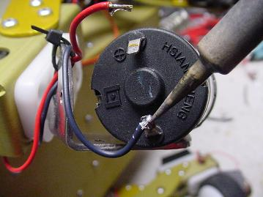

- Replace the two black screws holding the motor to the metal angle. Fit the aluminum hub on to the motor shaft so that the set screws will be aligned with the flat side of the shaft. Tighten the set screws using a drop of Loctite 242 to keep them secure. Make sure the set screws are firmly against the motor shaft flat.

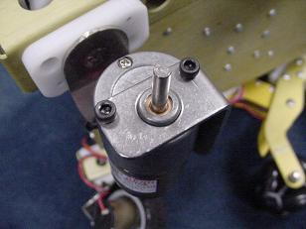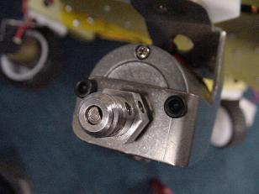

- Fit the wheel back in place. Wiggle the wheel to verify that is it completely seated. Replace the washer and fasten with the bolt. Be careful not to over tighten the bolt.

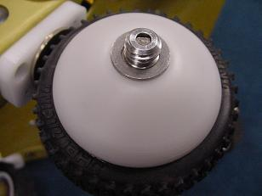

Installing the Faster, 42rpm @ 12v DC Motors

These motors are a drop in replacement for the original motors only they are geared four times faster. They differ only in calibration and usage. Also, using these motors requires the use of exhibit firmware version 2.1 or later.

- Replace the motors as per the instructions located above.
- Run the calibration program. The drive adjustment and turn adjustment will both need to be changed to a negative number and reduced. The likely calibrations will be about -27, although this will need to be adjusted slightly for each robot.

Replacing the Camera

- Open the rover and remove the four screws holding down the clear plastic plate. Remove the plate and unplug the camera’s USB cable from the Stayton (or Stargate) board. Note which USB port the camera was plugged in to. You may need to unscrew the Stargate board in order to get the USB cable out. There are two white nuts which mount the Stargate inside the rover.

- Remove the rover’s head cover. Note the way the camera’s USB cable is wrapped in the rover’s head. You will want to wrap the new camera in the same way.

- Remove the three screws on the front of the camera that secure the camera to the robot’s head.

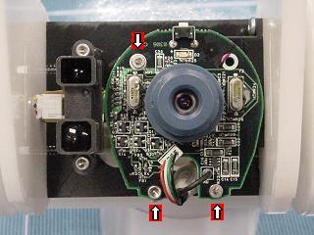

- Remove three of the four screws on the left side of the rover’s head. You will need a T5 torx wrench. Swing the outer layer of plastic out of the way. Both ends of the camera are now free and the camera can be removed.

- Attach the new camera being sure to wrap the USB cable in the same way as the camera that was removed. The cable should go down through the right-most hole in the rover’s neck. Test that there is enough slack in the cable by fully panning the head from side to side and tilting the head fully at both extremes. Replace the side head panel screws, and connect the camera to the Stayton (or Stargate) board. If you removed the Stargate board, secure it with the white nuts.
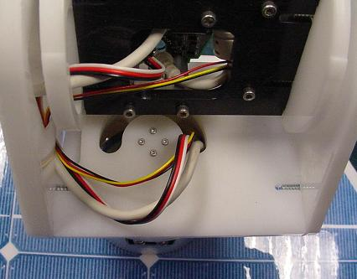

- When you replace the clear plastic panel inside the rover, the green tubing should go through the front right hole and the power cable to the battery pack should go through the front left hole. The power cable should then be zip tied to the plastic panel so that pulling on the cable will not stress the cable’s connection to the power board inside the rover.

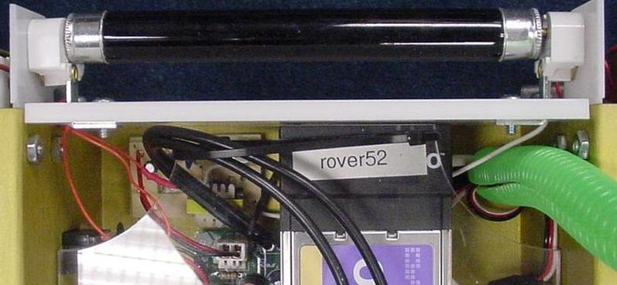

Replacing the Pan Servo

- Open the lid of the rover and unscrew the three nuts on the underside of the lid. You may need a wrench because the nuts are secured with Loctite.

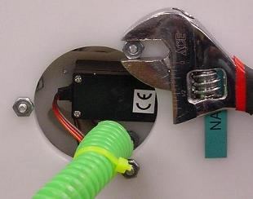
- Close the lid and lift the rover’s head and neck straight up. Then separate the neck collar from the head.
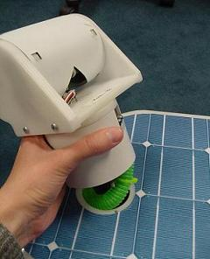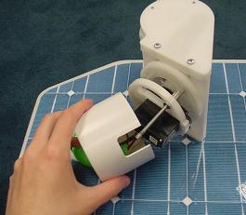
- Unscrew the three remaining nuts and remove the plastic ring containing the servo from the upper portion of the head.

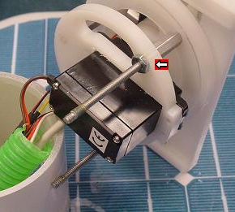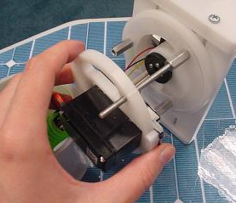
- Now that all six nuts are free, it is a good idea to clean off all of the old Loctite from the nuts and posts so that the nuts turn easily on the posts. You may have a hard time getting the nuts appropriately tight in later steps if old Loctite is still on the posts or inside the nuts. Spinning the nuts up and down the posts a few times will help remove the old Loctite.
- Unscrew the four screws securing the servo. Open the rover and unplug the servo from the servo extender. You may need to remove the green tubing.
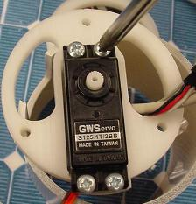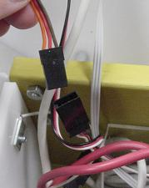
- Remove the servo by pushing the bottom edge through the hole first. Replace the broken servo with the new servo.
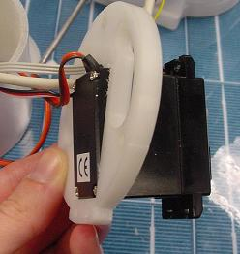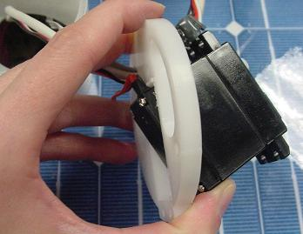
- Make sure that the orientation is correct and then replace the four screws. Connect the servo wires to the servo extender making sure that the brown and black wires are aligned.
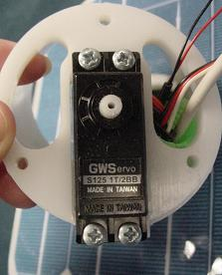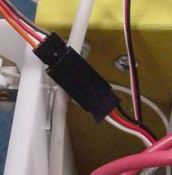
- Turn the rover on and connect to it with the Calibration program. Load the calibration settings from the rover. Reset the Pan Range to the default value. For the GWServo 125 1T/2BB with Cerebellum firmware cereb15, the default Pan Range is 290. See the Calibration Chart for the default values if using a different servo or different firmware version. Then center the pan slider and save the calibration to the rover.
- Reattach the servo to the top portion of the head. Make sure that the back of the servo is parallel to the back of the head before fitting the servo into the servo horn.
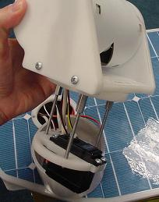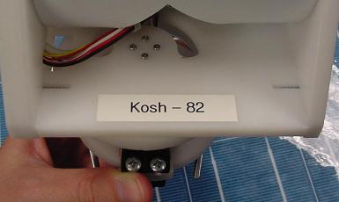
- Use a small drop of Loctite 222 or a similar weak thread locker to secure each nut. IMPORTANT: Do not over tighten the nuts. The nuts should be only finger tight. As long as the nuts and posts are clean of old Loctite, you should be able to tighten the nuts sufficiently with just one finger. Do not use a wrench.
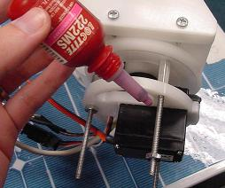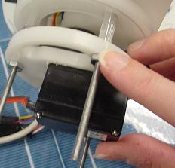
- Put the neck collar back in place and then put the head back on to the rover’s body.
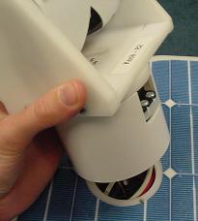
- Use a small drop of Loctite 222 to secure the final three nuts underneath the rover’s lid. Again, do not over tighten the nuts. The nuts should be only finger tight. If the nuts and posts are clean, you should be able to make the nuts sufficiently tight with just one finger. Do not use a wrench. The nuts should be tight enough so that the rover’s head is not loose but not so tight as to put undue pressure on the pan servo.

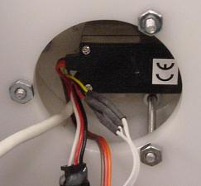
- Replace the green tube if you have removed it. Use the Calibration program to make sure that the pan servo’s center point is properly calibrated. Use the Exhibit program to take a test panorama. Make any calibration adjustments needed using the Calibration program. If you notice that the panorama has a lot of horizontal duplication at the first few seams and at the last few seams, but the middle images line up correctly, this is a sign that the nuts are too tight.

