# Configuring Alma Pull Slips for CBB Stickers

## Opening and editing the emailed files

Download the files from your email and **open them in Notepad (Windows) or TextEdit (Mac)**. Do not try to open them in Microsoft Word or your browser.

Make one small edit in **ful_slip_xsl_no_tables.xsl** – where it says “Return to: Bowdoin -“ (most of the way down the file, under the comment “<!-- return to -->”), you’ll probably want to put in the name of your institution.

## Installing the templates in Alma

This part needs to be done by a Letter Administrator or General System Administrator.

1. In Alma, click **Configuration** (bottom of the left-hand side-bar), then **General** (on the left-hand sidebar), then **Components Configuration** (under “Letters”) — here’s [a YouTube video to help you find it](https://youtu.be/QLq-yU5d7Ro?t=152), if you run into trouble.
2. Open **recordTitle.xsl**, and paste in the content from the emailed file **recordTitle.xsl**.
3. Click “Save” (top right).
4. Now go to **Letters Configuration** (General 🡪 Letters Configuration, under “Letters”)
5. Edit **Ful Resource Request Slip Letter** (page 3 on the letters list, or you can search for it)
6. In the XSL area (the first box), paste in your edited version of **ful_slip_xsl_no_tables.xsl**
7. Click “Save.”
8. Click “Back” to exit configuration (bottom of the left-hand sidebar).

This part does *not* require Letter Administrator access, but you do need administrative permissions on the Printing Multiple Slips Per Page cloud app. It only has to be done once per Alma institution zone.

1. A screenshot of a computer

   Description automatically generatedClick the “Cloud App Center” icon and then click “Printing Multiple Slips Per Page” to open the app
2. Click the two arrows to expand the app to full screen  
   A screenshot of a phone

   Description automatically generated
3. Click the ellipsis to get access to settings.   
   A white square with black and blue symbols

   Description automatically generated
4. Click the wrench to get access to Admin Configuration   
   A screenshot of a computer

   Description automatically generated
5. Click the folder icon, and choose any existing template (ours is closest to “Standard 2 per line format”) to create a new template.  
   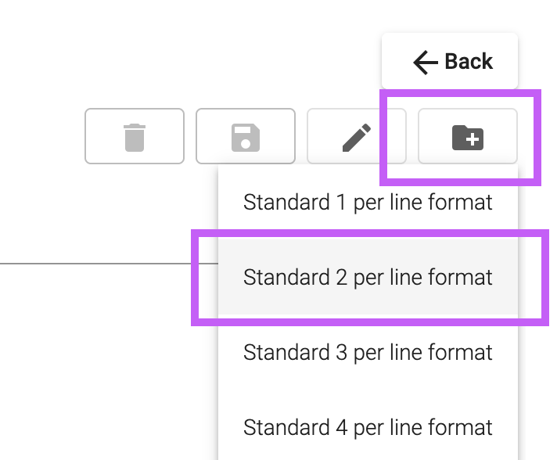
6. Call the new template “Print for our labels” (or call it something else, but then you’ll want to change the directions for “Configuring label printing” before sharing them)  
   A screenshot of a computer

   Description automatically generated
7. Paste in the contents of the file **template_for_two_column_print_alma.css**.
8. Click the “save” icon.  
    A computer with a floppy disk

   Description automatically generated

## Configuring label printing

These directions must be followed one time at setup and may need to be repeated when the browser is updated or used to print something else with different settings.

1. Open your browser’s print settings. (Choose “Print” from the menu.)  
   A screenshot of a computer

   Description automatically generated A screenshot of a computer

   Description automatically generated
2. Make sure the margins are set to 0.17” on all four sides. In Firefox on a Mac, this is accomplished by choosing “Minimum,” and you can verify the setting is correct by choosing “Custom.” In Chrome, you will need to click “More Settings” and “Custom,” and then you can drag the margins on the print preview pane.

These directions must be followed one time **for each account that will be printing pull slips**.

1. Click the “Cloud App Center” icon and then click “Printing Multiple Slips Per Page” to open the app
2. Click the two arrows to expand the app to full screen  
   A screenshot of a phone

   Description automatically generated
3. Click the ellipsis to get access to settings.   
   A white square with black and blue symbols

   Description automatically generated
4. Click the gear icon  
    A screenshot of a computer

   Description automatically generated
5. When the settings open, the template chosen will likely be “Standard  
   A screenshot of a computer

   Description automatically generated