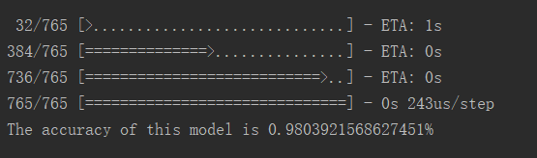

CNN when the train and test on the same nest

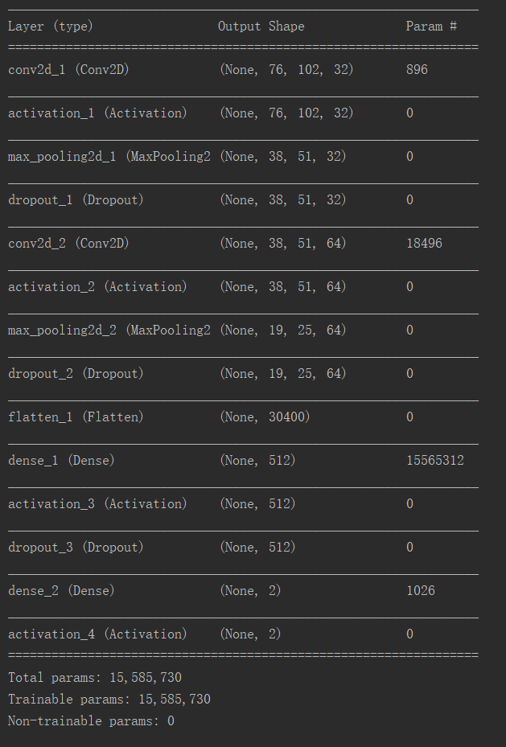

Structure of the CNN.

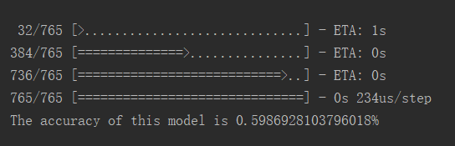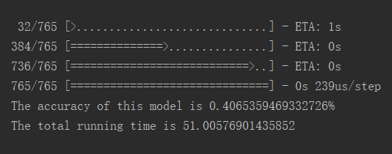

Another possible result, since the dataset is not balanced. We can assume this is not converge.

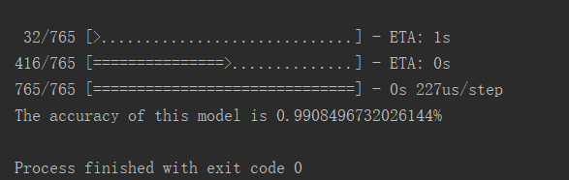

The result can be even better.

CNN will read the colored image, svm and knn only read greyscale image.

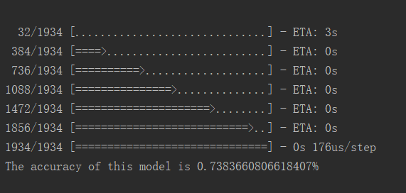

CNN when the the test dataset has some never seen nest.

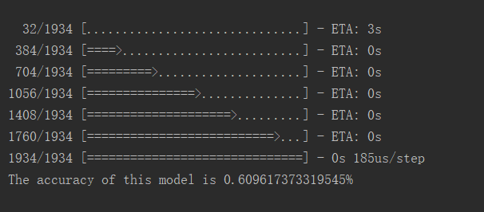

Result when model not converge

Svm:

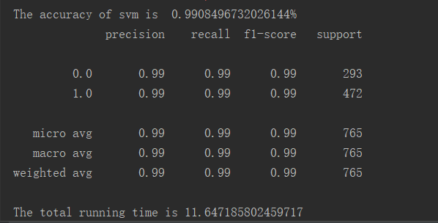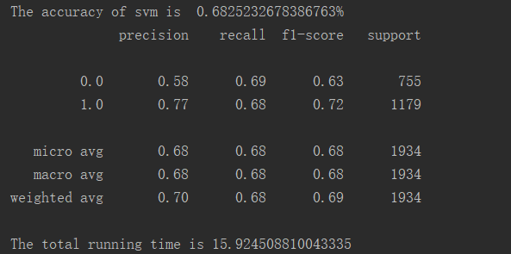

Knn:

