CREATING TABLES IN CRAWLERDB.DB DATABASE:

CAUTION: Before you start creating a table, make sure that the JSON data that you are trying to insert in the table has the same field names as the column names of the table. For e.g. If the JSoN object that you plan to insert into the table is:  
**{**  
 "id"**:** **1,**  
 "name"**:** **"**A green door**",**  
 "price"**:** **12.50,**  
 "tags"**:** **["**home**",** **"**green**"]**  
**}**

then while creating the table, set the column names of table to the same name as the field names of JSON object i.e. id, name, price and tags. This is not mandatory but will save you a lot of effort.

Crawlerdb.db is the central database for our web crawler. Inside this database multiple tables/views can be created to store and retrieve data. The steps needed to create a table in this database are as follows:

1. Open up the path git/Webcrawler/db/SQLiteStudio in your file explorer and double-click the ‘sqlitestudio’ executable  
   Once sqlitestudio opens up, you will be shown a screen similar to this:  
     
   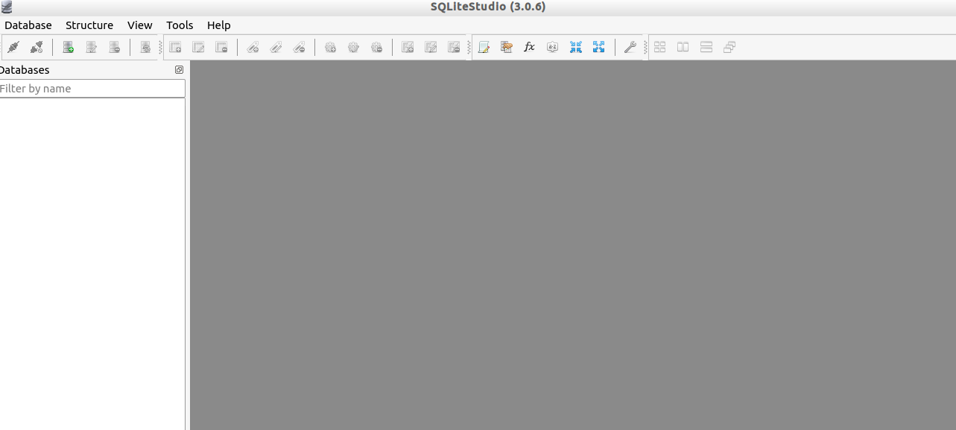
2. Click on Database > Add a database  
   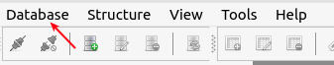
3. Select ‘crawlerdb.db’ file from Git as the database. Click OK.  
   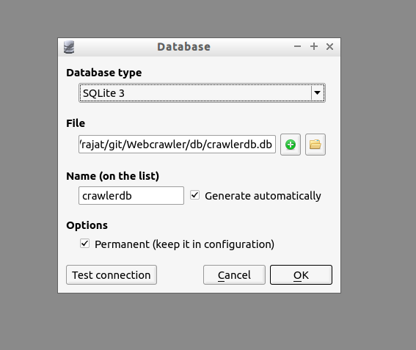
4. The database will be added in the databases pane. Right-click on the database and select ‘Connect to the database’  
   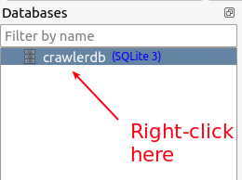
5. Right-click on tables and select ‘Create a table’  
   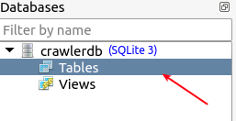
6. Give the table a name e.g. ‘TestTable’ and click on the button ‘Add column’ as shown in image below:  
   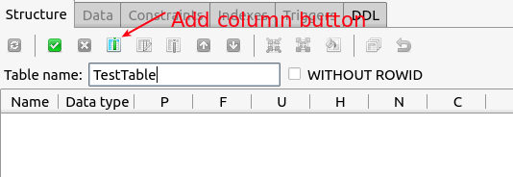
7. Give the column a name e.g. ‘ID_PRIMARY’, a data type e.g. ‘INTEGER’ and select any constraints to put on this column e.g. ‘PRIMARY_KEY’. Like this you can add as many columns as you want in table.  
   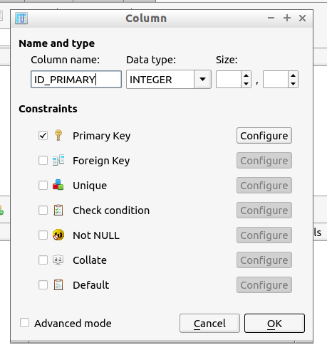  
   NOTE: If you want to make a primary key auto incrementing, click on ‘Configure’ button next to Primary key constraint and check ‘Auto increment’
8. Once you’re done adding columns to the table, click on ‘Commit’ button to save your table.  
   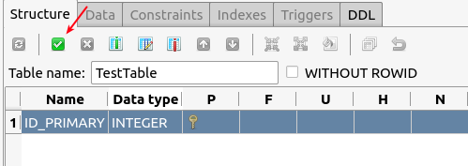

RUNNING PYTHON REST SERVER FOR SQLite DB:

The Rest server needs to be running if you want to perform any operations on the database crawlerdb.db from python code. The steps needed to run the server are as follows:

1. Install tornado by running the below command on terminal:  
   **sudo pip install tornado**
2. cd into the git path - Webcrawler/db/RestServer and run command:

**python web.py**

1. To check whether the server ran correctly, open a web browser and enter this URL: <http://localhost:8888/>  
   If server is running correctly, you will get the following screen in your browser showing crawlerdb.db:  
     
   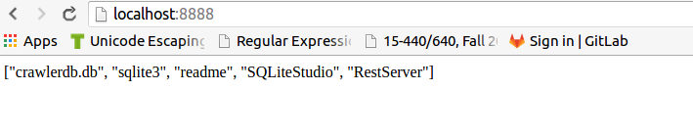

Tip: Once you have created a table for e.g. TestTable in crawlerdb.db database and have the Rest server running, you can browse the contents of the table by going to URL: <http://localhost:8888/crawlerdb.db/TestTable/> in your web browser.

To learn how you can use this server to perform CRUD operation on the database using python code, refer the Git location Webcrawler/db/examples.