CS 230 – Deep Learning
https://stanford.edu/~shervine
Max pooling
Average pooling
VIPCheatsheet: ConvolutionalNeuralNetworks
Eachpooling operation selectsthe
maximumvalueofthecurrentview
Eachpooling operation averages
thevaluesofthecurrentview
Purpose
Illustration
Comments
AfshineAmidiandShervineAmidi
November26,2018
-Preservesdetectedfeatures
-Mostcommonlyused
-Downsamplesfeaturemap
-UsedinLeNet
Overview
ÌFullyConnected(FC)–Thefullyconnectedlayer(FC)operatesonaﬂattenedinputwhere
each input is connected to all neurons. If present, FC layers are usually found towards the end
ofCNNarchitecturesandcanbe usedtooptimizeobjectivessuchasclassscores.
ÌArchitectureofatraditionalCNN–Convolutionalneuralnetworks,alsoknownasCNNs,
areaspeciﬁc typeofneuralnetworksthataregenerallycomposed ofthefollowinglayers:
Theconvolutionlayerandthepooling layercanbe ﬁne-tunedwithrespect tohyperparameters
thataredescribed inthenextsections.
Filter hyperparameters
Theconvolutionlayercontainsﬁltersforwhichitisimportanttoknowthemeaningbehind its
hyperparameters.
Types of layer
ÌDimensions of a ﬁlter–AﬁlterofsizeF×F appliedtoaninputcontainingC channelsis
aF ×F ×C volumethatperforms convolutionsonaninputofsizeI×I×C andproduces an
outputfeaturemap(alsocalledactivationmap)ofsizeO×O×1.
Ì Convolutional layer (CONV) – The convolution layer (CONV) uses ﬁlters that perform
convolutionoperationsasitisscanningtheinputI withrespecttoitsdimensions. Itshyperpa-
activationrametersincludemap. theﬁltersizeF andstrideS. TheresultingoutputO iscalledfeature map or
Remark: the application of K ﬁlters of size F ×F results in an output feature map of size
O×O×K.
Ì
Stride–Foraconvolutionalorapoolingoperation,thestrideSdenotesthenumberofpixels
bywhichthewindowmovesaftereachoperation.
Remark: the convolution step can be generalized to the 1D and 3D cases as well.
ÌPooling(POOL)–Thepoolinglayer(POOL)isadownsamplingoperation,typicallyapplied
after a convolution layer, which does some spatial invariance. In particular, max and average
poolingarespecialkindsofpoolingwherethemaximumandaveragevalueistaken,respectively.
Stanford University
1
Winter 2019
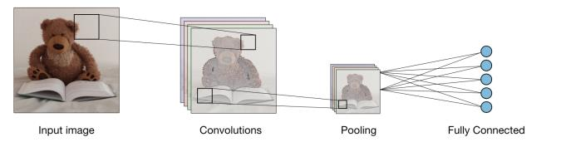
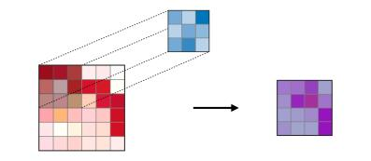
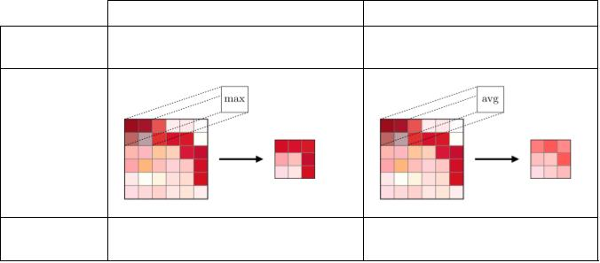
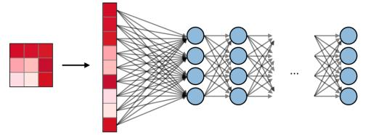
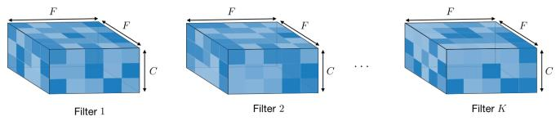
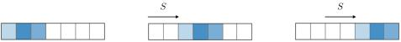

CS 230 – Deep Learning
https://stanford.edu/~shervine
Ì Zero-padding – Zero-padding denotes the process of adding P zeroes to each side of the
boundariesoftheinput. Thisvaluecaneitherbemanuallyspeciﬁedorautomaticallysetthrough
oneofthethreemodes detailedbelow:
CONV
POOL
FC
Valid
Same
Full
Illustration
j
k
Ie−
I+F−
S
Pstart=
Pend=
Sd
S
[[0,F −1]]
2
Pstart∈
Pend
=F −1
Value
P =0
l
m
SdIe−I+F−
S
Input size
I×I×C
O×O×K
I×I×C
O×O×C
Nin
S
2
Output size
Nout
Number of
parameters
(F ×F ×C+1)·K
0
(Nin+1)×Nout
Illustration
-Inputisﬂattened
-Onebiasparameter
per ﬁlter
-Inmostcases,S<F
-Acommonchoice
K C
is2
-Poolingoperation
donechannel-wise
-Onebiasparameter
per neuron
Remarks
-ThenumberofFC
neuronsisfreeof
-Maximumpadding
suchthatend
convolutionsare
appliedonthelimits
oftheinput
-Filter’sees’theinput
end-to-end
-Paddingsuchthatfeature
-Inmostcases,S=
-Nopadding
F
l m
for
structuralconstraints
mapsizehassize
-Outputsizeis
mathematicallyconvenient
-Alsocalled’half’ padding
I
-Dropslast
convolutionif
dimensionsdonot
match
S
Purpose
Ì Receptive ﬁeld – The receptive ﬁeld at layer k is the area denoted Rk×Rk of the input
that each pixel of the k-th activation map can ’see’. By calling F the ﬁlter size of layer j and
j
S the stride value of layer i and with the convention S0 =1, the receptive ﬁeld at layer k can
i
be computedwiththeformula:
Tuning hyperparameters
X
k
j
Y
−
1
Rk =1+
(F −1)
Ì Parameter compatibility in convolution layer – By noting I the length of the input
volume size, F the length of the ﬁlter, P the amount of zero padding, S the stride, then the
outputsizeO ofthefeaturemapalongthatdimensionisgivenby:
Si
j
j=1
i=0
5In. theexamplebelow,wehaveF =F =3andS =S =1,whichgivesR =1+2·1+2·1=
O= I−F +Pstart+Pend +1
1
2
1
2
2
S
theRemark:formulaoftenabove.times, Pstart =Pend ,P, in which case we can replace Pstart+Pend by 2P in
Ì Understanding the complexity of the model – In order to assess the complexity of a
Commonly used activation functions
Ì
Rectiﬁed Linear Unit – The rectiﬁed linear unit layer (ReLU) is an activation function g
model, it is often useful to determine the number of parameters that its architecture will have. thatisusedonallelementsofthevolume. Itaimsatintroducingnon-linearitiestothenetwork.
Inagivenlayerofaconvolutionalneuralnetwork,itisdoneasfollows:
Itsvariantsaresummarizedinthetablebelow:
Stanford University
2
Winter 2019
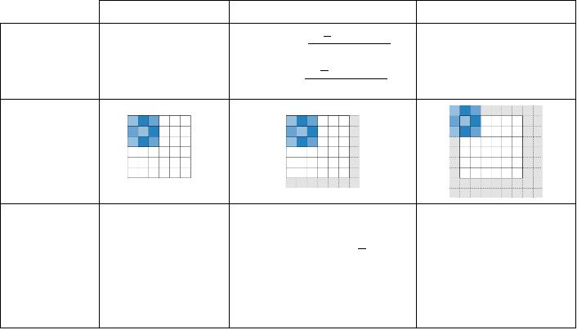
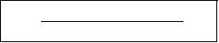
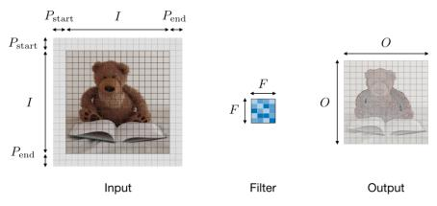
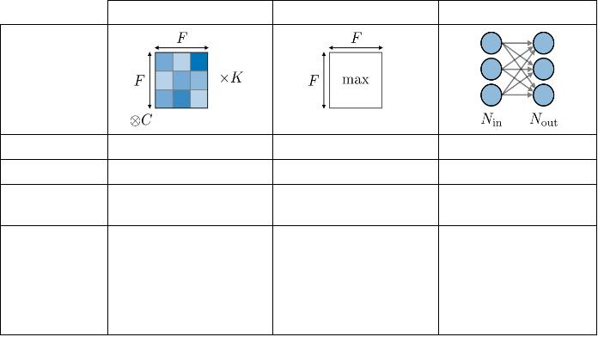
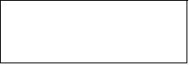
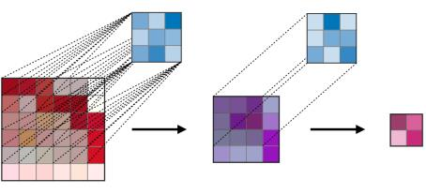

CS 230 – Deep Learning
https://stanford.edu/~shervine
ReLU
Leaky ReLU
ELU
Bounding box detection
Landmark detection
g(z)=max(¤z,z)
with¤1
g(z)=max(α(ez−1),z)
-Detectsashape orcharacteristicsof
anobject (e.g. eyes)
-Moregranular
g(z)=max(0,z)
Detectsthepartoftheimagewhere
theobject islocated
withα1
Non-linearitycomplexities
biologicallyinterpretable
AddressesdyingReLU
issuefornegativevalues
Diﬀerentiableeverywhere
Boxofcenter(b ,b ),heightbh
x
y
Referencepoints(l1 ,l1y),...,(lnx,lny)
x
ÌSoftmax–Thesoftmaxstepcanbeseenasageneralizedlogisticfunctionthattakesasinput
andwidthbw
avectorofscoresx∈R andoutputsavectorofoutputprobabilityp∈Rn throughasoftmax
n
functionattheendofthearchitecture. Itisdeﬁnedasfollows:
Ì
Intersection over Union – Intersection over Union, also known as IoU, is a function that
quantiﬁes how correctly positioned a predicted bounding box Bp is over the actual bounding
. Itisdeﬁnedas:

p1
.
.
.
exi
p=
where
pi=
box
Ba
X
n
p
n
exj
B ∩Ba
IoU(B ,B )=
p
j=1
p
a
B ∪B
p
a
Object detection
Ì Types of models – There are 3 main types of object recognition algorithms, for which the
natureofwhatispredictedisdiﬀerent. Theyaredescribed inthetablebelow:
Classiﬁcation
w. localization
Image classiﬁcation
Detection
Remark: wealwayshaveIoU∈[0,1]. Byconvention,apredictedboundingboxB isconsidered
p
as being reasonably good if IoU(B ,B )>0.5.
p
a
Ì Anchor boxes – Anchor boxing is a technique usedto predict overlapping bounding boxes.
Inpractice,thenetworkisallowedtopredictmorethanoneboxsimultaneously,whereeachbox
prediction is constrained to have a given set of geometrical properties. For instance, the ﬁrst
predictioncanpotentiallybearectangularboxofagivenform,whilethesecondwillbeanother
rectangularboxofadiﬀerentgeometricalform.
-Detectsobject inapicture
-Predictsprobabilityof
object andwhereitis
located
-Detectsuptoseveralobjects
inapicture
-Predictsprobabilitiesofobjects
andwheretheyarelocated
-Classiﬁesapicture
-Predictsprobability
ofobject
Ì
Non-max suppression – The non-max suppression technique aims at removing duplicate
overlapping bounding boxes of a same object by selecting the most representative ones. After
havingremovedallboxeshavingaprobabilitypredictionlowerthan0.6,thefollowingstepsare
repeated whilethereareboxesremaining:
TraditionalCNN
SimpliﬁedYOLO,R-CNN
YOLO,R-CNN
• Step1: Picktheboxwiththelargestpredictionprobability.
Ì Detection – In the context of object detection, diﬀerent methods are used depending on
whether we just want to locate the object or detect a more complex shape in the image. The
twomainonesaresummedupinthetablebelow:
• Step2: DiscardanyboxhavinganIoU>0.5withthepreviousbox.
Stanford University
3
Winter 2019
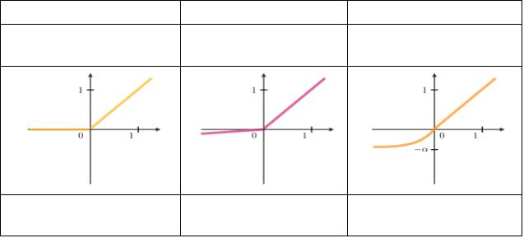
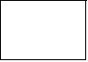
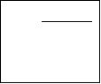
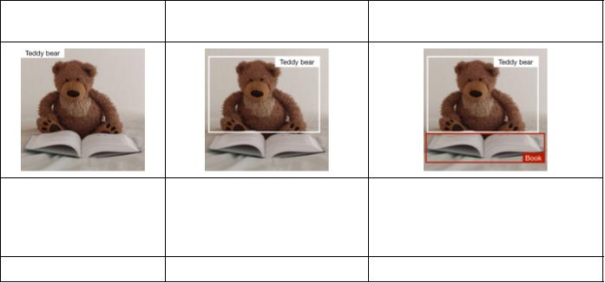
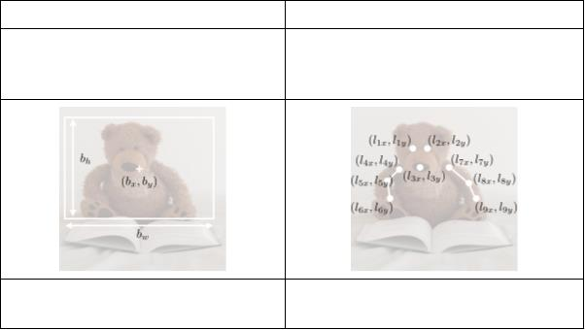
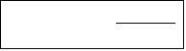
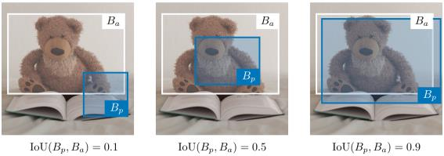

CS 230 – Deep Learning
https://stanford.edu/~shervine
Face veriﬁcation and recognition
ÌTypes of models –Twomaintypesofmodel aresummedupintablebelow:
Face veriﬁcation
Face recognition
-Isthisthecorrectperson?
-One-to-onelookup
-IsthisoneoftheK persons inthedatabase?
-One-to-manylookup
Ì YOLO – You Only Look Once (YOLO) is an object detection algorithm that performs the
followingsteps:
• Step1: DividetheinputimageintoaG×Ggrid.
• Step2: Foreachgridcell,runaCNNthatpredictsy ofthefollowingform:

y= pc,b ,b ,b ,bw,c1,c2,...,c ,...
T
(5+p)
∈RG×G×k×
x
y
h
p
|
{z
}
repeated k times
where pc is the probability of detecting an object, b ,b ,b ,b are the properties of the
x
y
h
w
Ì
One Shot Learning–OneShotLearningisafaceveriﬁcationalgorithmthatusesalimited
trainingsettolearnasimilarityfunctionthatquantiﬁeshowdiﬀerenttwogivenimagesare. The
detected bouding box, c ,...,c is a one-hot representation of which of the p classes were
1
p
detected,andk isthenumberofanchorboxes.
similarityfunctionappliedtotwoimagesisoftennotedd(image1,image2).
• Step3: Runthenon-maxsuppressionalgorithmtoremoveanypotentialduplicateover-
Ì
SiameseNetwork–SiameseNetworksaimatlearninghowtoencodeimagestothenquantify
how diﬀerent two images are. For a given input image x( ), the encoded output is often noted
lappingbounding boxes.
i
asf(x( )).
i
ÌTriplet loss–Thetripletloss`isalossfunctioncomputedontheembeddingrepresentation
of a triplet of images A (anchor), P (positive) and N (negative). The anchor and the positive
examplebelong toasameclass,whilethenegativeexampletoanotherone. Bycallingα∈R+
themarginparameter,thislossisdeﬁnedasfollows:
`(A,P,N)=max(d(A,P)−d(A,N)+α,0)
Remark: when pc = 0, then the network does not detect any object. In that case, the corre-
sponding predictions b ,...,cp have to be ignored.
x
ÌR-CNN–RegionwithConvolutionalNeuralNetworks(R-CNN)isanobjectdetectionalgo-
rithmthatﬁrstsegmentstheimagetoﬁndpotentialrelevantbounding boxesandthenrunthe
detectionalgorithmtoﬁndmostprobableobjects inthosebounding boxes.
Neural style transfer
Remark: although the original algorithm is computationally expensive and slow, newer archi- Ì Motivation – The goal of neural style transfer is to generate an image G based on a given
tectures enabled the algorithm to run faster, such as Fast R-CNN and Faster R-CNN.
contentC andagivenstyleS.
Stanford University
4
Winter 2019
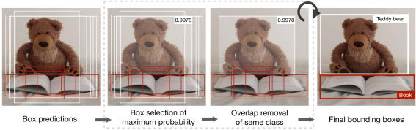
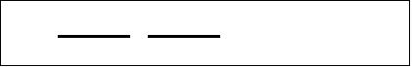
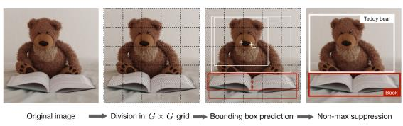
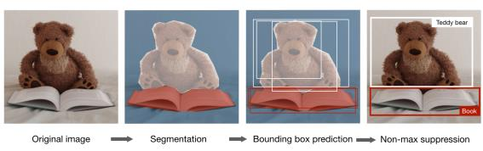
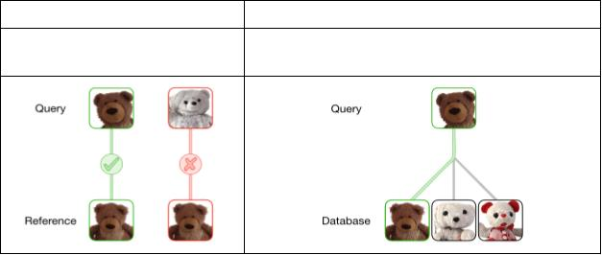
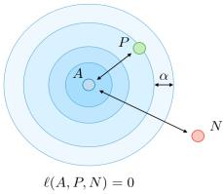
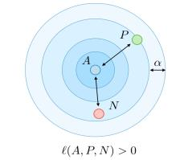

CS 230 – Deep Learning
https://stanford.edu/~shervine
ÌActivation–Inagivenlayerl,theactivationisnoteda[l] andisofdimensionsnH×nw×nc
ÌContent cost function–ThecontentcostfunctionJcontent(C,G)isusedtodeterminehow Remark: use cases using variants of GANs include text to image, music generation and syn-
thegeneratedimageGdiﬀersfromtheoriginalcontentimageC. Itisdeﬁnedasfollows:
thesis.
Ì
ResNet–TheResidualNetworkarchitecture(alsocalledResNet)usesresidualblockswitha
1
2
Jcontent(C,G)= ||a[l](C)−a[l](G)||2
highnumberoflayersmeanttodecreasethetrainingerror. Theresidualblockhasthefollowing
characterizingequation:
a[l+2]=g a[l]+z[l+2])
(
Ì Style matrix – The style matrix G[l] of a given layer l is a Gram matrix where each of its
elementsG[l] quantiﬁeshowcorrelatedthechannelsk andk0 are. Itisdeﬁnedwithrespect to
kk0
Inception Network – This architecture uses inception modules and aims at giving a try
×
1
Ì
activationsa[ ] asfollows:
l
at diﬀerent convolutions in order to increase its performance. In particular, it uses the 1
convolutiontricktolowertheburdenofcomputation.
[l]
[ ]
w
n
n l
XX
H
[l]
kk0
[l] [l]
a
G
=
a
ijk
ijk0
?
?
?
i=1 j=1
Remark: the style matrix for the style image and the generated image are noted G[ ](S) and
l
[l](G) respectively.
G
Ì Style cost function – The style cost function Jstyle(S,G) is used to determine how the
generatedimageGdiﬀersfromthestyleS. Itisdeﬁnedasfollows:

X
n
2
1
1
(2nHnwnc)2
c
[l]
style
(S,G)= (2nHnwnc)2||G[l](S)−Gl G)||F2
[ ](
[l](S)
kk0
[l](G)
−Gkk
0
J
=
G
k,k0=1
Ì Overall cost function – The overall cost function is deﬁned as being a combination of the
contentandstylecostfunctions,weightedbyparametersα,β,asfollows:
J(G)=αJcontent(C,G)+βJstyle(S,G)
Remark: a higher value of α will make the model care more about the content while a higher
value of β will make it care more about the style.
Architectures using computational tricks
ÌGenerativeAdversarialNetwork–Generativeadversarialnetworks,alsoknownasGANs,
are composed of a generative and a discriminative model, where the generative model aims at
generating the most truthful output that will be fed into the discriminative which aims at
diﬀerentiatingthegeneratedandtrueimage.
Stanford University
5
Winter 2019
