**Number of dangerous heat days in Bangladesh will increase with future climate change**

**Kelsea B. Best1, Ralf Bennartz1, Jonathan Gilligan1**

1 Vanderbilt University, Earth and Environmental Science, 5726 Stevenson Center, Nashville, TN 37240 USA

**Corresponding Author:** Kelsea Best, [kelsea.b.best@vanderbilt.edu](mailto:kelsea.b.best@vanderbilt.edu)

**Key Points**

* Extreme heat poses a threat to the health of vulnerable populations in Bangladesh.
* Dangerous heat days are projected to increase rapidly in Bangladesh under RCP pathways.
* Consecutive days of extreme heat could pose a particular threat of prolonged heat exposure.

**Abstract**

Extreme heat poses a threat to human health, especially in less developed countries. The combined effect of heat and moisture is captured in wet bulb temperature (WBT). Using an ensemble of climate model runs and adjusted model runs, we present a range of future scenarios of WBT in Bangladesh. Annual number of days exceeding a dangerous threshold of 30 oC WBT are expected to rise in northern and southern (coastal) Bangladesh under various Representative Concentration Pathways (RCP’s), and under different global warming levels (GWL’s) with the potential of exceeding 60 to 80 days based on conservative models, and exceeding 140 days in adjusted models. Annual consecutive dangerous heat days could exceed 30 days by 2100, suggesting risks of prolonged heat exposure. Maximum annual WBT is shown to likely exceed 32 oC, with some projections exceeding 35 oC. Even conservative estimations of warming would also have serious implications for health and productivity.

**Number of dangerous heat days in Bangladesh will increase with future climate change**

**1 Introduction**

Future climate change poses a wide variety of threats to human health and well-being (Intergovernmental Panel on Climate Change, 2018; Patz et al., 2007). One such threat is the direct impacts of rising global temperatures and heat stress on human health (Kjellstrom, 2009; Kovats & Hajat, 2008; Luber & McGeehin, 2008; Xu et al., 2020). Heat stress is already the leading cause of fatalities from natural phenomena and heat-related deaths are expected to increase due to anthropogenic climate change (Dahl et al., 2019; Knutson & Ploshay, 2016; Matthews et al., 2017; Sherwood & Huber, 2010),. This threat is especially concerning in regions of the world that are less developed and have a large percentage of population that lives and works without access to air conditioning, as these populations are more vulnerable to extreme heat (Lundgren et al., 2013).

Bangladesh is highly vulnerable to climate change (Black et al., 2008; Passalacqua et al., 2013; Walsham, 2010),. Rural communities in Bangladesh, where it is estimated that two-thirds of workers are dependent on agriculture as a primary source of livelihood, are especially vulnerable to environmental conditions (World Bank, 2016, p. 200). While future precipitation, flooding, exposure to natural disasters, and even salinity encroachment have received widespread attention by researchers studying climate impacts in Bangladesh, extreme temperatures in Bangladesh have been the subject of fewer studies (Chen & Mueller, 2018; Dasgupta et al., 2015; Haque & Jahan, 2015; Karim & Mimura, 2008).

Extreme heat has direct implications on human health. Exposure to extreme heat is especially dangerous for the very young, very old, and those with preexisting medical conditions (Chan & Yi, 2016; Coffel et al., 2017). Under hot conditions, it is critical for people to be able to cool down either by escaping the heat or by thermal regulating through sweat evaporation, but the ability to cool down through sweat evaporation largely depends on air humidity (Davis et al., 2016). For this reason, indicators of heat stress that depend solely on measures air temperature may not sufficiently capture the impacts of heat on human health. One indicator of heat stress that incorporates both temperature and humidity is wet bulb temperature (WBT), which is utilized for this work (Li et al., 2017; Raymond et al., 2020; Wang et al., 2019; Willett & Sherwood, 2012).

It is broadly understood that humans cannot survive in environments where WBT exceeds 35 oC, as this is the point where thermal regulation by sweat evaporation is not possible, and core body temperatures will rise (Coffel et al., 2017; A. J. McMichael & Dear, 2010; Raymond et al., 2020; Sherwood & Huber, 2010). Even below the deadly threshold, high temperatures can be dangerous, especially for physical laborers who work outdoors (Kjellstrom, 2009, 2016; Riley et al., 2018). This poses threats to worker health and productivity in places where heat and humidity are high (Dunne et al., 2013). As climate change is projected to increase global temperatures, future WBT is also expected to increase, especially in tropical locations that experience high temperatures and humidity levels (Diffenbaugh & Scherer, 2011; Hyatt et al., 2010),. Existing work has shown that some parts of the world may exceed the deadly threshold of 35 °C with future climate change, rendering these places inhospitable to human life without air conditioning (Pal & Eltahir, 2016; Sherwood & Huber, 2010). Not only would this dramatically impact human health, but also energy demand, agriculture, recreation, and more (Kang et al., 2019). For this reason, some scholars have argued that WBT beyond 35 °C may represent a limit to human’s ability to adapt to climate change (Pal & Eltahir, 2016).

Though increases in future temperatures pose a threat to human health and socioeconomic growth in Bangladesh, the possible magnitude of such threats is poorly understood and not broadly studied with climate models. Some work has used regional models to predict temperature, precipitation, and monsoon strength across South Asia, without particular focus on Bangladesh (Bhaskaran et al., 2012; Immerzeel, 2008; Rajib Mohammad Adnan et al., 2011). Other work has investigated projected changes to temperature and precipitation in Bangladesh by 2100 under climate change scenarios, but has not made the connection to human health (Caesar et al., 2015; Islam et al., 2008).

Due to its tropical climate and large percentage of population working outdoors in agriculture and other labor, Bangladeshi communities are highly vulnerable to future heat exposure. To this end, this work investigates future projections of WBT in Bangladesh under various Representative Concentration Pathways (RCP’s) and global warming levels (GWL’s), using an ensemble of global climate model runs from the Community Earth System Model Large Ensemble Project (CESM-LE) (Kay et al., 2015). Using CESM-LE, we predict how WBT will evolve to the year 2100 in Bangladesh by assessing annual days exceeding a dangerous threshold for human health, consecutive days above this threshold, and annual maximum WBT. We further contextualize the results from the CESM-LE model by comparing results to historical weather station data and results from the Coupled Model Intercomparison Project 5 (CMIP5) (Taylor et al., 2011).

**2 Materials and Methods**

**2.1 Calculating WBT from CESM-LE model runs**

CESM-LE is an ensemble of 35 model runs, each of which consists of full coupling between land, atmosphere, ocean, and sea ice (Kay et al., 2015). Model spatial resolution is approximately 1o by 1o grids (Kay et al., 2015). We compiled data from each of the 35 ensemble members from the year 1920 to 2100 under RCP 8.5 forcing (Riahi et al., 2011). We extracted variables for daily maximum temperature (*Tmax*) in Kelvin, daily minimum temperature (*Tmin*) in Kelvin, daily average specific humidity, and daily surface pressure for analysis from model results. We then restricted data to a range of latitude and longitude from 88o to 92.5o E and 20.5o to 26.5o N, representing the geographic range of Bangladesh. We selected two grid cells located in northern Bangladesh and southern, coastal Bangladesh for regional comparison.

From daily data from the CESM-LE, daily WBT was calculated by first calculating near-surface relative humidity (*RH*) at both *Tmax*and *Tmin* (daily maximum/minimum near-surface temperature) from near-surface specific humidity (*q)*, and surface pressure (*P)*, using the following equations:

(Eqn. 1)

(Eqn. 2)

Where *e* is the vapor partial pressure of water, is a constant (0.622) based on the specific gas constants for dry air and water vapor, and *es* is the saturation vapor pressure as a function of temperature calculated based on Clausius-Clapeyron’s equation. All input values in **Eqn. 1** and **Eqn. 2** are provided in SI units. *RH* is in percent from 0 to 100. From RH, the equation from Stull is used to calculate the WBT with the calculated RH at both *Tmax*and *Tmin* (Stull, 2011).

**2.2 Comparison to historical data**

In order to compare CESM-LE results to historical observations, we obtained weather data from 34 weather stations across Bangladesh from the Bangladesh Meteorology Department, capturing daily minimum temperature, maximum temperature, and relative humidity data from 1988 to 2017. Data from one station (Chittagong) were dropped because of data quality concerns. The remaining stations were filtered to split northern and coastal stations. Northern stations were selected as any station with latitude greater than 24.5o N and between 89o and 91o E longitude. Coastal stations were selected as stations with less than 23.5o N latitude and between 89o and 91o E longitude. This filtering resulted in a remaining 3 stations in northern Bangladesh (Rangpur, Mymensingh, and Bogra) and 9 stations in coastal Bangladesh (Khepupara, Patuakhali, Bhola, Satkhira, Barisal, Khulna, Madaripur, Jessore, and Chandpur) (**Fig. S6**).

Historical *RH*, which represents a daily maximum *RH*, was adjusted to calculate an estimated daily average *RH.* This was done by calculating daily average temperature (*Tav*) as the average between daily *Tmax* and *Tmin* and then calculating the saturation pressure (*esat*) at *Tav* and *Tmax.* Average *RH* was then calculated as the reported *RH* multiplied by the ratio of *Psat* at the daily average temperature and *Psat* at the daily *Tmax*. This adjusted *RH* and historical *Tmax* were used to calculated daily maximum WBT at each weather station (Stull, 2011). Annual mean *Tmax, RH,* and WBT from the northern and coastal stations were compared to annual maximum values from CESM-LE (**Fig. S1, S2**).

For northern Bangladesh, mean CESM-LE *Tmax* is, on average, 0.64 °C cooler than mean historical data. For coastal Bangladesh, mean CESM-LE *Tmax* is, on average, 2.3 °C cooler than mean historical data. In northern Bangladesh, mean model *RH* is an average of 9.0% less than mean historical *RH.* In coastal Bangladesh, mean model *RH* is an average of 0.97% less than mean historical *RH*. Finally, mean maximum annual predicted WBT for northern Bangladesh is 2.4 °C less than mean historical WBT while mean annual maximum predicted WBT for coastal Bangladesh is 2.3 °C cooler than mean historical WBT. Despite these discrepancies, mean model results fall within a standard deviation of historical data for each of the variables assessed (**Fig. S1, S2**). This comparison to historical data indicates that estimates of WBT from the CESM-LE model ensemble are likely conservative, as they underestimate *Tmax, RH*, and WBT. Furthermore, the model is unable to reproduce extremes in the historical data.

**2.3 CESM-LE adjustment informed by CMIP5**

To further assess the validity of CESM-LE predictions, we compared results of the CESM-LE runs to results from the fifth phase of the Climate Model Intercomparison Project (CMIP5) obtained from colleagues at the National Oceanic and Atmospheric Administration (NOAA) (Taylor et al., 2011). CMIP5 data used in this analysis was from the same climate model used in CESM-LE but with slightly updated physics. CMIP5 also allowed us to consider RCP 4.5 and RCP 6 emissions scenarios, which represent more optimistic future emissions.

Annual mean *Tmax* from CMIP5 was, on average, 1.6 oC warmer than CESM-LE in northern Bangladesh, and 0.77 oC warmer in coastal Bangladesh. CMIP5 annual mean *RH* was approximately 2.4% lower (drier) in northern Bangladesh and 2.5% higher (wetter) in coastal Bangladesh as compared to CESM-LE. These differences corresponded to WBT that was higher by, on average, 0.75 oC in northern Bangladesh and 1.09 oC in coastal Bangladesh. These results again indicated drier, cooler conditions predicted with CESM-LE, especially in coastal Bangladesh. Based on this finding of differences between CESM-LE and CMIP5 model predictions, we devised a method to adjust the CESM-LE predicted WBT based on the relationship between CESM-LE and CMIP5 data.

We evaluated the difference between CMIP5 daily maximum WBT and CESM-LE daily maximum WBT versus several variables, including CESM-LE WBT and CESM-LE RH. Daily values were plotted in density plots for both models from the years 1950 to 2100, representing 55,114 observations for coastal and northern Bangladesh each in order to select an appropriate method for adjusting CESM-LE results. We fit a linear regression to the data using the *lm( )* function in R. The intercept, coefficient, and R2 results for coastal and northern Bangladesh linear models are given in **Table S1**. CESM-LE RH was selected as the variable based on which to conduct the adjustment of CESM-LE versus CESM-LE WBT due to a higher value of R2 for test regression. We also fit a loess model to the data to allow for non-linearity. Both the linear model and loess model were plotted on the density plots (**Fig S7).**

The linear model and loess model of difference in WBT as a function of CESM-LE *RH* were used to conduct the adjustment of CESM-LE model results based on CMIP5 results. To apply the adjustments, the linear and loess models previously fit to the data were used to predict the difference between CESM-LE and CMIP5 based on CESM-LE predicted *RH*. This difference was then applied to each daily CESM-LE maximum WBT for each ensemble member.

Finally, we compare the adjustment annual mean WBT max from CESM-LE, linear adjusted CESM-LE, loess adjusted CESM-LE, CMIP5, and historical data (**Fig. S9**). Though there are challenges associated with the historical weather station data due to uncertainties, we see that both the linear and loess adjustments to the CESM-LE data bring the predicted WBT closer to the WBT calculated from the weather station data. A full description of adjustment methodology can be found in **Supporting Materials**. The adjustments to CESM-LE predictions help to highlight the spread of possible future scenarios and inherent uncertainty in the climate models.

**2.4 Assessing GWL’s**

Due to limitations of RCP’s, especially the possibility that RCP 8.5 may be extreme, we also investigate the impacts of GWL’s of 1.5o C, 2.0o C, 3.0o C, and 4.0o C. We establish a 30-year reference period of 1950 to 1970 and use NASA observational GISS Surface Temperature Combined Land-Surface Air and Sea-Surface Water Temperature Anomalies (Land-Ocean Temperature Index, LOTI) to adjust for preindustrial levels (GISS Team, 2020; Lenssen et al., 2019). 30-year periods corresponding to GWL’s in global CESM-LE model output were calculated for each of the 35 CESM-LE ensemble members based on previously established methodology (Abiodun et al., 2019; Naik & Abiodun, 2020).

**3 Results**

**3.1 Annual dangerous heat days**

We use a WBT threshold of 30 oC to define dangerous conditions, as this is a level that would be dangerous for outdoor workers and other individuals with increased vulnerability to heat exposure while still falling within a range where human adaptation may be possible (Kjellstrom et al., 2009). This level also corresponds to a “dangerous” heat stress risk level according to the NOAA National Weather Service Heat Index, with WBT above 31 oC corresponding to “extreme danger” (Im et al., 2017). Using daily WBT, we estimate the annual number of days above the 30 oC threshold for northern and coastal Bangladesh (**Fig. 1, Table 1**). Before the year 2050, under RCP 8.5, WBT in Bangladesh does not exceed the dangerous level of 30 oC based on the unadjusted CESM-LE, but after 2050 the annual number of days above this threshold increases rapidly. By 2100, the mean of the model ensemble predicts more than 56 days annually above the danger threshold at daily maximum temperatures in northern Bangladesh, and more than 45 days in coastal Bangladesh. Upper bounds of the unadjusted ensemble predictions estimate 85 dangerous days in the north and 69 in the south. However, the CESM-LE adjustments based on CMIP5 show that days annually above the danger threshold may start increasing as early as 2025 and reach as many as 128 days in northern Bangladesh and 148 in coastal Bangladesh by 2100 (**Fig. S3, Table 1**).

**3.2 Consecutive dangerous heat days and prolonged heat exposure**

Prolonged exposure to extreme heat, without relief, may increase risks to human health (Sharma et al., 2019). For this reason, the days where minimum temperatures exceed a dangerous threshold can provide additional insights into future human health risks. Our analysis suggests that up to 13 days may be above the dangerous threshold at daily minimum temperatures in northern Bangladesh, and up to 30 days in coastal Bangladesh. To further investigate risks of prolonged exposure to extreme heat, we also analyzed annual consecutive days above the 30 oC WBT threshold (**Fig. 2**). Consecutive days above the dangerous threshold at the maximum daily temperature could exceed 30 days in both northern and coastal Bangladesh by 2100 in conservative projections. In addition, the number of consecutive days where the dangerous WBT threshold is exceeded at the daily minimum temperature is also expected to rise. Here, coastal Bangladesh could experience between 5 and 15 consecutive days of dangerous heat without any relief, even at night, while northern Bangladesh could experience up to 10 days of dangerous heat without relief. The adjustments suggest even more severe prolonged heat exposure, with coastal Bangladesh potentially experiencing more than 50 and northern Bangladesh experiencing more than 36 consecutive days of extreme heat without relief **(Fig. S4)**.

Bangladesh experiences a tropical monsoonal climate, with the rainy monsoon season lasting from June to October every year. By dividing each year of data into a monsoon season from June to October, and a non-monsoon season capturing the remaining months, we can assess the seasonality of extreme WBT (**Fig. 3**). Especially in coastal Bangladesh, the majority of annual days above a dangerous threshold occur during the monsoon season. Results show that an average of approximately 94% of annual days exceeding a dangerous WBT from the year 2070 to 2100 are predicted to occur in the monsoon season in coastal Bangladesh, compared to more than 90% in northern Bangladesh.

**3.3 Annual maximum WBT**

We are also interested in annual maximum WBT, not just the number of days exceeding a dangerous threshold, as even a single day of extreme heat can be dangerous. Though results show that WBT in Bangladesh is not expected to exceed the deadly 35 oC threshold, it is expected to exceed 32 oC by 2100 in both northern and coastal Bangladesh based on the unadjusted model (**Fig. S8**).The adjusted models show that maximum WBT could exceed 33 oC in both northern and coastal Bangladesh (**Fig. S8)**. In northern Bangladesh, the loess adjustment predicts that WBT could exceed 34 oC with a maximum prediction of 35.3 oC, exceeding the 35 oC deadly threshold. In coastal Bangladesh, the linear and loess adjustments are quite similar, and predict a maximum WBT in 2100 between 32.1 and 33.7 oC.

**3.4 Additional RCP’s and GWL’s**

This analysis under RCP 8.5 represents a possible future scenario at the high end of defined RCP pathways, so we also used CMIP5 RCP 4.5 and RCP 6 scenarios to assess the number of days exceeding a dangerous WBT threshold under the less drastic emission scenarios. Even with these more optimistic emissions scenarios, northern Bangladesh may experience as many as 50 or 80 dangerous heat days annually under RCP 4.5 and RCP 6 respectively, while coastal Bangladesh may experience more than 30 or 45 days under RCP 4.5 and RCP 6 respectively (**Fig. S5**).

By assessing GWL’s, we are able to compare GWL’s to a preindustrial baseline to assess impacts on WBT in Bangladesh. From these results, we can see that annual dangerous heat days increase rapidly and nonlinearly beginning with global warming of 3.0o C above pre-industrial levels (**Fig. 4**).

**4 Conclusions**

These results highlight the potential dangers of future increases in WBT in Bangladesh under climate change scenarios. Under RCP 8.5, our results indicate that as many as 40% of days out of every year could exceed a level that is dangerous for the health of vulnerable people and outdoor laborers by the year 2100. Such a scenario could have implications for communities in coastal Bangladesh who already experience severe environmental challenges such as frequent cyclones, flooding, and salinity encroachment. Even under RCP 4.5 and RCP 6, these results suggest that extreme heat as a result of anthropogenic climate change will be a challenge that Bangladesh will face in the future. Despite RCP’s, Bangladesh can expect rapid increases in WBT with a GWL of 3.0o C. By analyzing consecutive days above the dangerous threshold, our results also suggest that Bangladeshis living in coastal communities will experience more days without any relief from the heat. While wealthier households will be able to escape the heat with access to air conditioning, poorer households will not have such an escape (Im et al., 2017). The seasonality of dangerous WBT may pose additional challenges for people trying to adapt to extreme heat, as the monsoon season is also a time when annual flooding and waterlogging are likely to occur, creating additional environmental pressures.

In this work, it is also important to consider annual maximum WBT. The adjustments did show the possibility of WBT exceeding the deadly threshold of 35 oC in northern Bangladesh. However, even the conservative maximum WBT of 32 oC predicted would undoubtedly result in increases in mortality and morbidity for Bangladeshi communities, especially in individuals who are very old, very young, or have a pre-existing medical condition. 32 oC WBT could also have health impacts for the majority of the Bangladeshi individuals who earn their livelihood through physical labor outdoors, including agricultural workers, rickshaw drivers, and others. Physical limitations on productivity caused by heat could further entrap already vulnerable laborers into conditions of poverty (Diffenbaugh & Burke, 2019). Due to uncertainties in these models, it is difficult to assert whether or not WBT in Bangladesh will reach the 35 oC deadly threshold in the future. Despite this, comparison to historical data highlights that both CESM-LE and CMIP5 do not sufficiently capture extremes in meteorological conditions. Historical data shows that WBT’s exceeding 33 oC, though rare, have already been recorded in Bangladesh, and it is reasonable to expect that such conditions will become more frequent and reach 35 oC with future warming.

Beyond the obvious impacts on human health and productivity, the projected increases in WBT from this analysis would likely also have impacts on food production, access to freshwater, disease transmission, and energy use in Bangladesh, to name a few (A. J. McMichael & Dear, 2010). It is also possible that these changes in WBT could result in human migration, as people leave increasingly inhospitable environments in attempt to adapt (Cattaneo & Peri, 2016; C. McMichael et al., 2012; Mueller et al., 2014; Xu et al., 2020). Future work is necessary to explore these additional implications of WBT increases in Bangladesh. This work does not attempt to quantify losses in terms of human health or productivity associated with future increases in WBT in Bangladesh, though it is clear that the effects would be significant. This work is also unable to detect finer scale spatial differences in WBT across Bangladesh, such as differences between urban and rural environments, which would be important to understand in future work (Fischer et al., 2012; Oleson et al., 2015).

**Acknowledgements:** Support for this work was in part from the National Science Foundation Coupled Human-Natural Systems Grant No. 1716909 and from the National Science Foundation’s NNA Grant No. 1928112. Thank you to Alice DuVivier at NCAR for access to CESM-LE and CMIP5 data and for helpful discussions about interpreting the data. Thank you to John Rausch for technical support.

**Data Availability:** CESM-LE and CMIP5 data was obtained from NCAR, and meteorological data was obtained from the Bangladesh Meteorology Department.

**References**

Automatic citation updates are disabled. To see the bibliography, click Refresh in the Zotero tab.

**Tables**

**Table 1. Model predicted annual number of days above 30 oC dangerous threshold at daily maximum temperature.**

|  |  |  |  |  |  |  |
| --- | --- | --- | --- | --- | --- | --- |
|  | **Northern Bangladesh** | | | | | |
| **Years** | **CESM-LE** | **Linear Adjustment** | **Loess Adjustment** | **CMIP5 RCP 4.5** | **CMIP5 RCP 6.0** | **CMIP5 RCP 8.5** |
| 1980-1990 | 0 | 0 | 3 | 1 | 1 | 1 |
| 1991-2000 | 0 | 0 | 3 | 2 | 2 | 2 |
| 2001-2010 | 0 | 0 | 6 | 4 | 4 | 4 |
| 2011-2020 | 0 | 0 | 9 | 5 | 7 | 9 |
| 2021-2030 | 0 | 1 | 13 | 9 | 11 | 10 |
| 2031-2040 | 0 | 3 | 21 | 11 | 10 | 20 |
| 2041-2050 | 0 | 10 | 30 | 17 | 14 | 27 |
| 2051-2060 | 2 | 24 | 45 | 23 | 22 | 44 |
| 2061-2070 | 6 | 47 | 61 | 24 | 24 | 59 |
| 2071-2080 | 15 | 74 | 79 | 26 | 41 | 79 |
| 2081-2090 | 28 | 95 | 89 | 28 | 47 | 106 |
| 2091-2100 | 47 | 119 | 104 | 34 | 52 | 120 |
|  | **Coastal Bangladesh** | | | | | |
| **Years** | **CESM-LE** | **Linear Adjustment** | **Loess Adjustment** | **CMIP5 RCP 4.5** | **CMIP5 RCP 6.0** | **CMIP5 RCP 8.5** |
| 1980-1990 | 0 | 0 | 0 | 0 | 0 | 0 |
| 1991-2000 | 0 | 0 | 0 | 0 | 0 | 0 |
| 2001-2010 | 0 | 0 | 0 | 0 | 0 | 0 |
| 2011-2020 | 0 | 0 | 0 | 0 | 0 | 0 |
| 2021-2030 | 0 | 0 | 0 | 2 | 2 | 2 |
| 2031-2040 | 0 | 2 | 1 | 4 | 2 | 1 |
| 2041-2050 | 0 | 9 | 5 | 10 | 3 | 4 |
| 2051-2060 | 0 | 24 | 16 | 21 | 7 | 9 |
| 2061-2070 | 2 | 50 | 39 | 38 | 8 | 8 |
| 2071-2080 | 7 | 82 | 68 | 57 | 11 | 14 |
| 2081-2090 | 17 | 108 | 91 | 91 | 8 | 24 |
| 2091-2100 | 35 | 136 | 118 | 114 | 15 | 27 |

The ten-year average predicted annual number of days about the dangerous threshold for CESM-LE, linear adjusted CESM-LE, loess adjusted CESM-LE, and CMIP5 at each RCP pathway are presented for both northern and coastal Bangladesh.

**Figures**

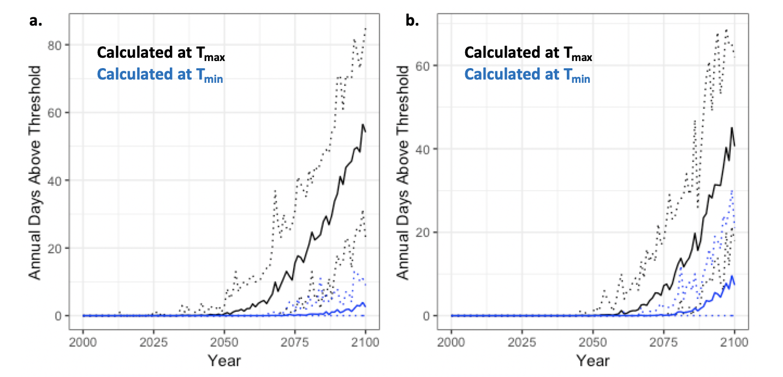

**Figure 1. Annual number of days above 30 oC WBT dangerous threshold under RCP 8.5.** Model predicted annual days above dangerous threshold of WBT under RCP 8.5 for northern (a.) and coastal (b.) Bangladesh from the year 2000 to 2100 calculated at both daily Tmax and Tmin. Solid lines indicate the average of the 35 model ensemble members, and dashed lines indicate the upper and lower ranges given by the ensemble.

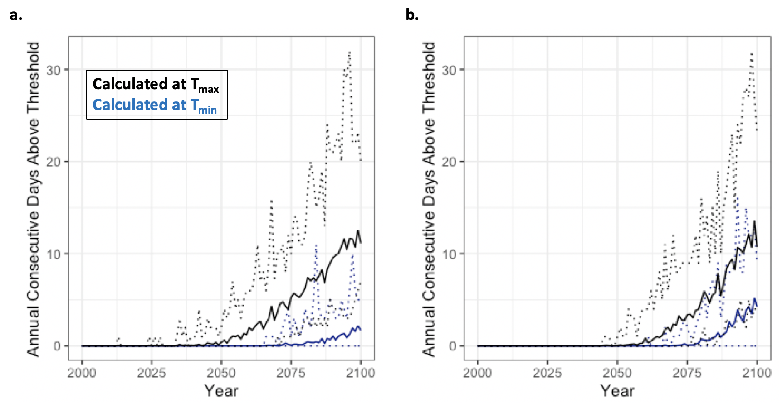

**Figure 2. Annual number of consecutive days above 30 oC WBT dangerous threshold under RCP 8.5.** Model predicted annual consecutive days above dangerous threshold of WBT under RCP 8.5 from the year 2000 to 2100 at daily maximum and daily minimum temperatures for northern (a.) and coastal (b.) Bangladesh. Solid lines indicate the average of the 35 model ensemble members, and dashed lines indicate the upper and lower ranges given by the ensemble.

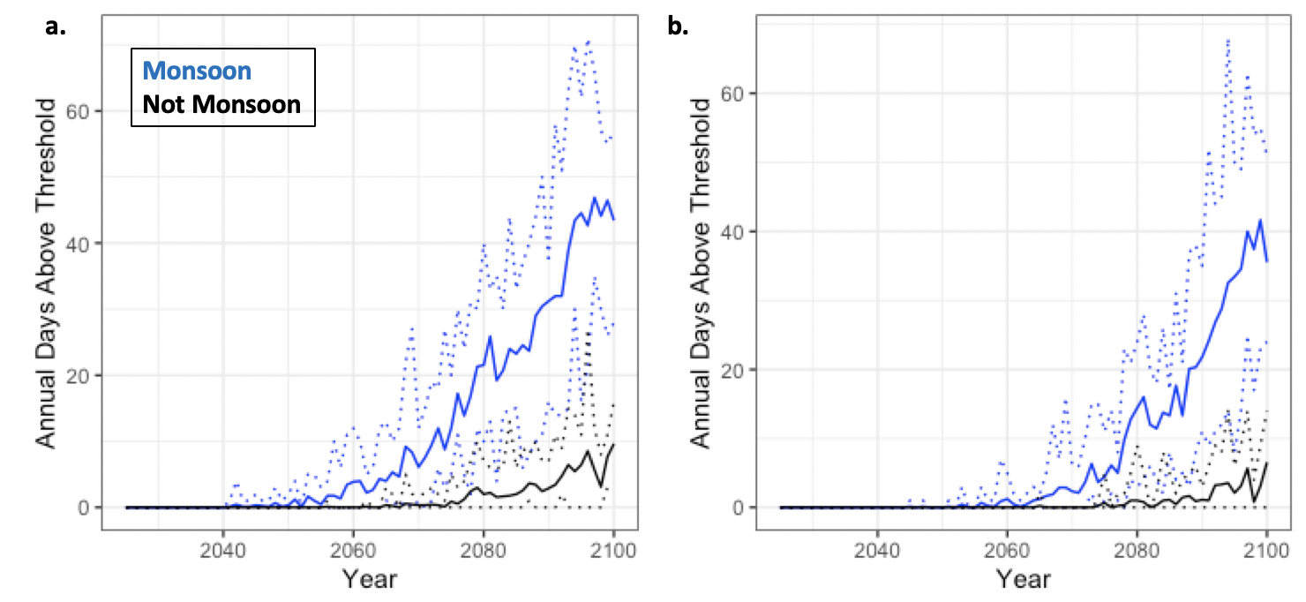

**Figure 3. Annual number of days above 30 oC WBT dangerous threshold divided into monsoon and non-monsoon season under RCP 8.5.** Model predicted annual days above dangerous threshold of WBT under RCP 8.5 for northern (a.) and coastal (b.) Bangladesh from the year 2000 to 2100 split into monsoon season (June – October) and non-monsoon season. Solid lines indicate the average of the 35 model ensemble members, and dashed lines indicate the upper and lower ranges given by the ensemble.

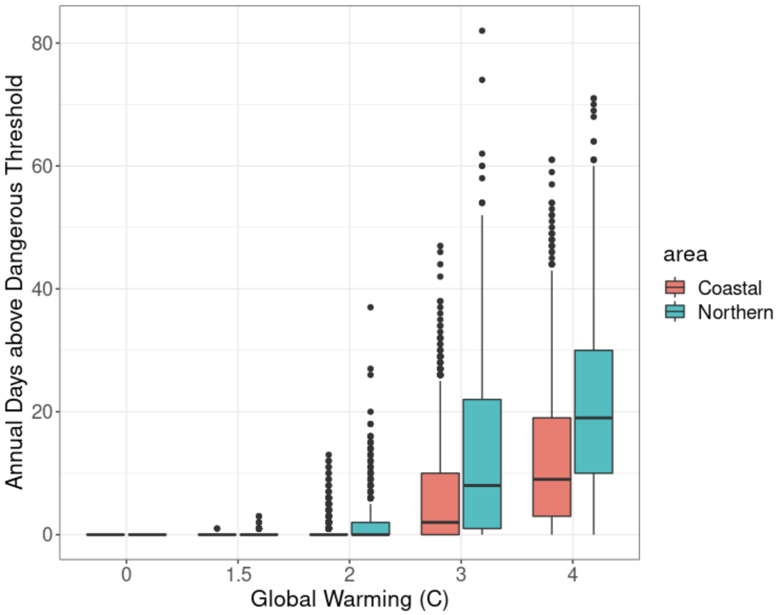

**Figure 4. Annual number of days above 30 oC WBT dangerous threshold by GWL.** CESM-LE predicted annual days above dangerous threshold of WBT under baseline (0), and GWL’s of 1.5, 2, 3, and 4o C. Solid line in boxes represents the median, while top and bottom limits of colored boxes indicate 75% and 25% percentiles respectively. Vertical lines span to the largest value within 1.5 times interquartile range above 75% (up) and the smallest value within 1.5 times the interquartile range below 25% (down).