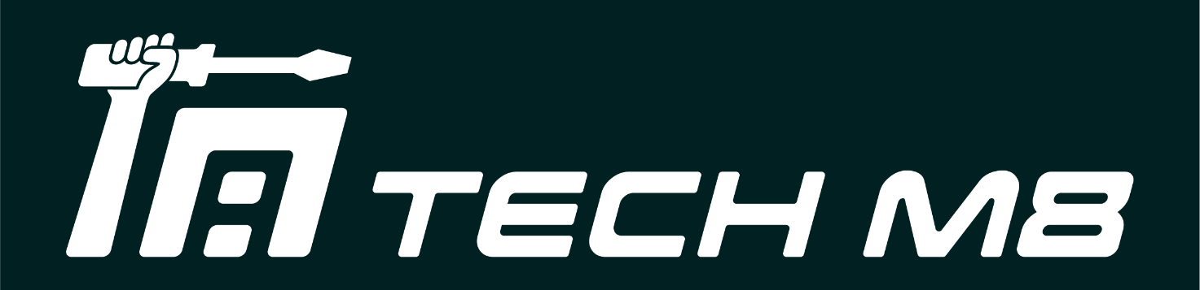

TECH M8 North Lakes
Tech M8 North Lakes, Shop/1114A N Lakes Dr, North Lakes QLD 4509
North Lakes QLD 4509
ABN: 12 645 861 463

Virus Report

Date: 24/03/2026
Customer Name: Rosemary Lawson
Device Model: iPhone 16 Pro Max Gold
Serial no/IMEI: 354267950039583

To whom it may concern,

The customer has presented an iPhone 16 Pro Max Gold, Serial no/IMEI: 354267950039583. The phone has been fully tested. No more virus is retained in the device, and security software have been upgraded to the latest version.

Kind regards,

Bowen

Tech M8 Technician
Northlakes

