Africa AI: Runbook – KMFK – KOFIA

Summary | We are collecting monthly data from the KOFIA report.
Source name | Korean Financial Investment Association - KOFIA
Link to the source | http://freesis.kofia.or.kr/
Dataset name | Kofia MF Korean - KMFK
Frequency | Monthly
SLA | Check for new release daily. Usually, data has ~2 weeks of delay for KOFIA to publish.
Expected Time | N/A

Instructions:

NB! This data should be processed only via your AWS workspace.
1. Go to the link: http://freesis.kofia.or.kr/
2. Click on the tab that is in red in the image:
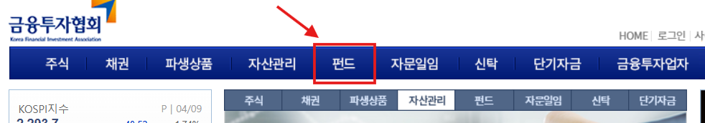
3. Click on the options according to the sequence given in the screenshot:
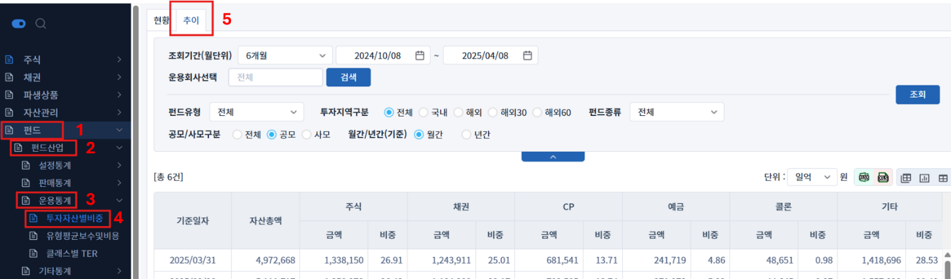
4. RawDataEquity: Adjust Query Settings to fetch the data. Follow sequence in the image.
- Set time window to 5 years
- Select Fund Type = Equity Funds (2nd option in menu)
- Make sure to select the first option.
- Select the first Option
- Set Fund Universe = Total.
- Select the field.
- Click on Search to retrieve the data. Click on the Excel icon to download the file.주식형
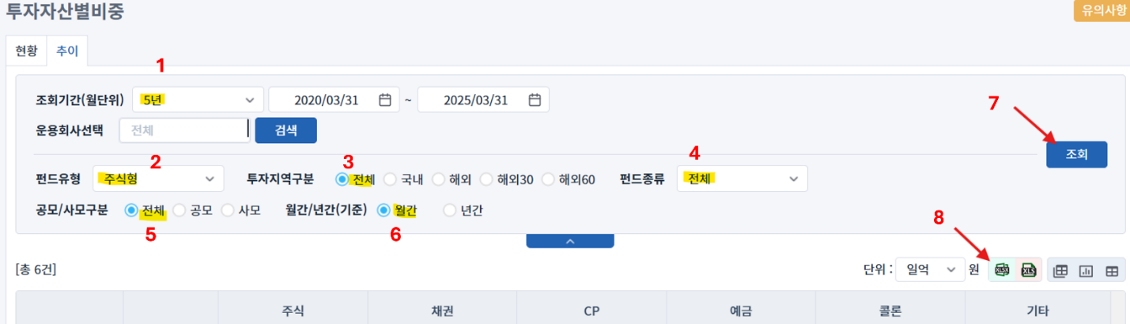
5. RawDataDomesticEquity: Using the settings from step 4 make one adjustment to the settings like the image below:
- Set region to Domestic
- Click on search to retrieve data
- Click Excel icon to download
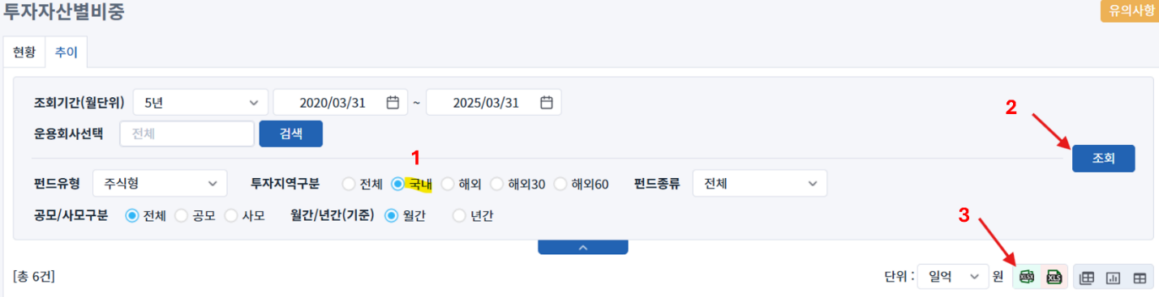
6. RawDataHybridEquity: Using the settings from step 4 make 2 adjustments to the settings like the image below:
- Select Fund Type = Hybrid Equity (3rd option in drop down box).
- Make sure that first option is selected.
- Click on Search to retrieve the data.
- Click on the Excel Icon to download the file.
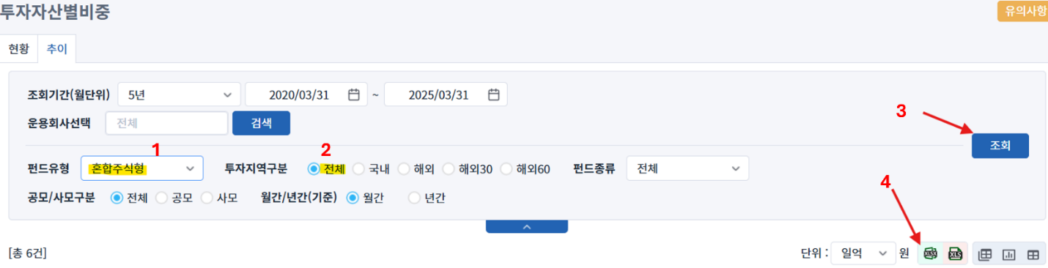
7. RawDataHybridDomesticEquity: Using the settings from step 4 make 2 adjustments to the settings like the image below:
- Select Fund Type = Hybrid Equity (3rd option in drop down box).
- Set region to Domestic
- Click on Search to retrieve the data.
- Click on the Excel Icon to download the file.

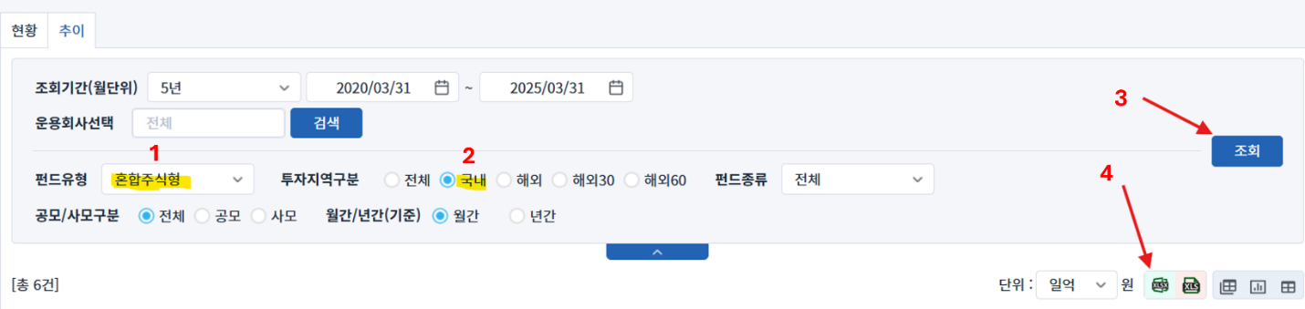
8. RawDataHybridBond: Using the settings from step 4 make 2 adjustments to the settings like the image below:
- Select Fund Type = Hybrid Bond (4th option in drop down box).
- Make sure that first option is selected.
- Click on Search to retrieve the data.
- Click on the Excel Icon to download the file.

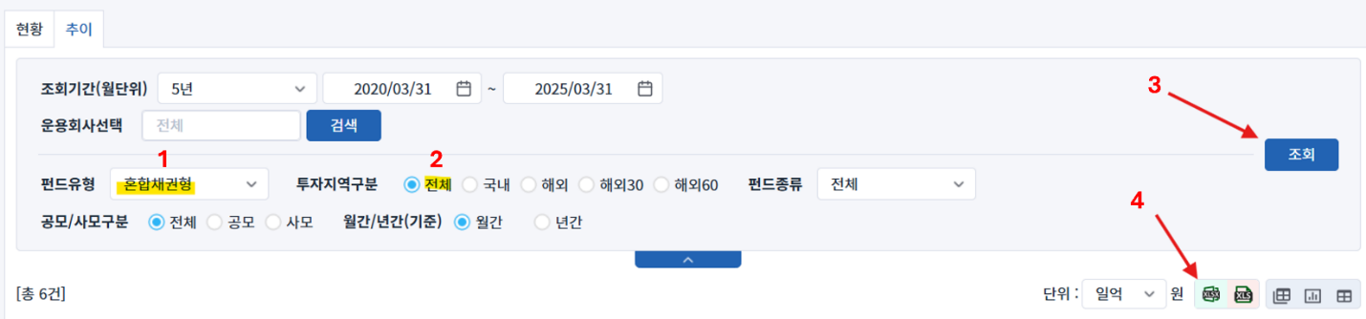
9. RawDataHybridDomesticBond: Using the settings from step 4 make 2 adjustments to the settings like the image below:
- Select Fund Type = Hybrid Bond (4th option in drop down box).
- Set region to Domestic.
- Click on Search to retrieve the data.
Click on the Excel Icon to download the file.
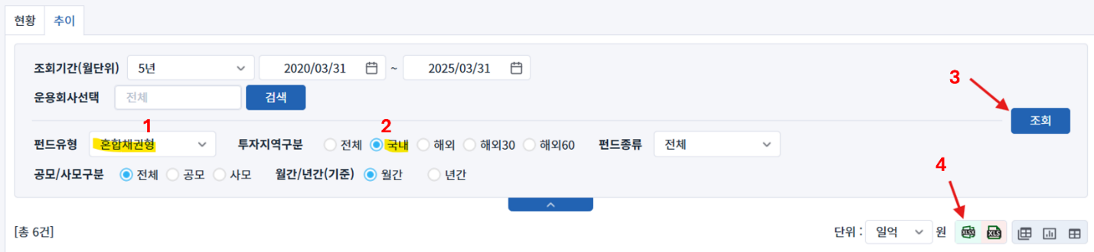
10. RawDataBond: Using the settings from step 4 make 2 adjustments to the settings like the image below:
- Select Fund Type = Bond (5th option in drop down box).
- Make sure that first option is selected.
- Click on Search to retrieve the data.
- Click on the Excel Icon to download the file.
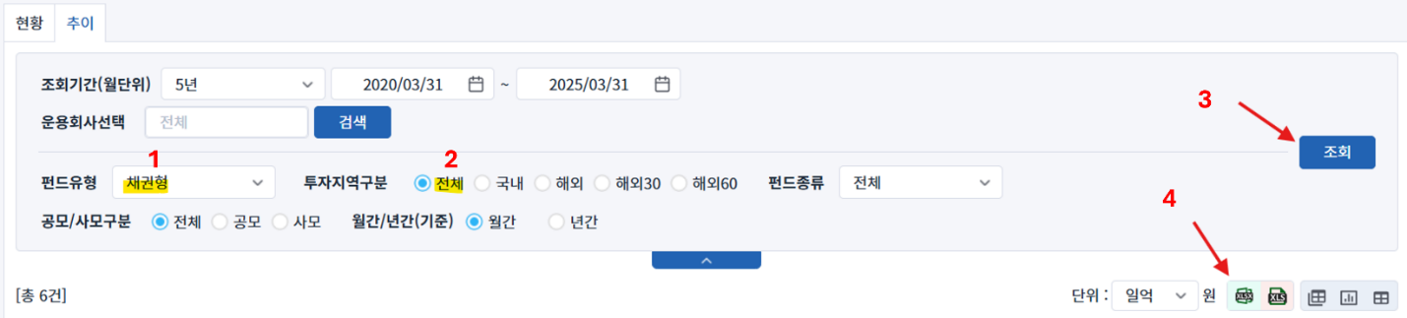
11. RawDataDomesticBond: Using the settings from step 4 make 2 adjustments to the settings like the image below:
- Select Fund Type = Bond (5th option in drop down box).
- Set region to Domestic
- Click on Search to retrieve the data.
- Click on the Excel Icon to download the file.
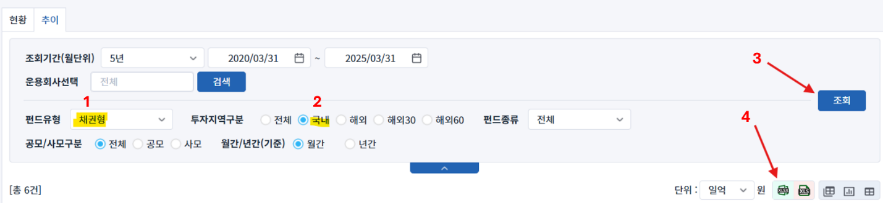
12. RawDataHybridAsset: Using the settings from step 4 make 2 adjustments to the settings like the image below:
- Select Fund Type = This is the last category on the drop down (14th )
- Make sure that first option is selected.
- Click on Search to retrieve the data.
- Click on the Excel Icon to download the file.
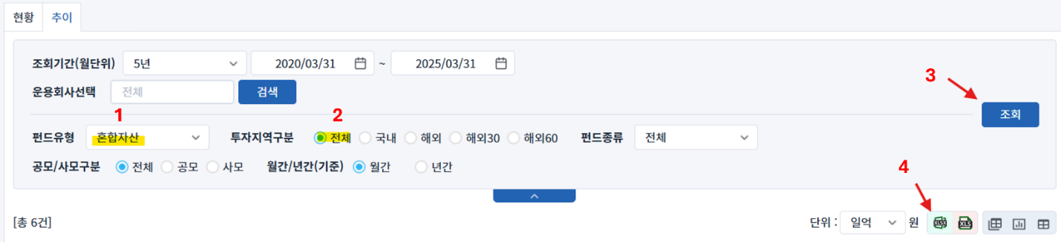
13. RawDataDomesticHybridAsset: Using the settings from step 4 make 2 adjustments to the settings like the image below:
- Select Fund Type = This is the last category on the drop down (14th )
- Set region to Domestic
- Click on Search to retrieve the data.
- Click on the Excel Icon to download the file.

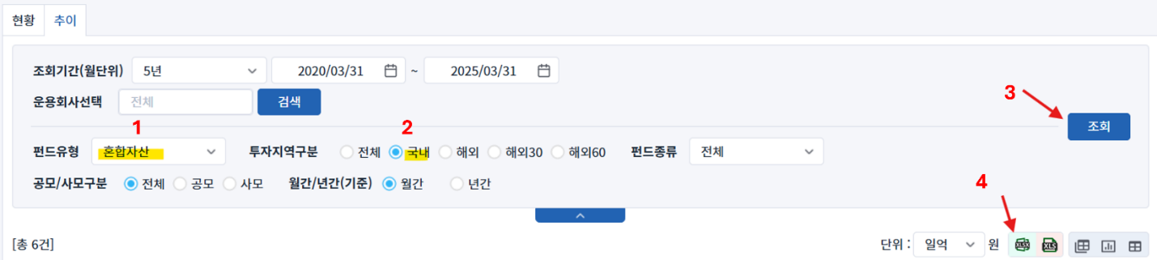
14. RawDataMoneyMarket: Using the settings from step 4 make 2 adjustments to the settings like the image below:
- Select Fund Type = Money Market. (6th option in drop down box).
- Make sure that first option is selected.
- Click on Search to retrieve the data.
- Click on the Excel Icon to download the file.

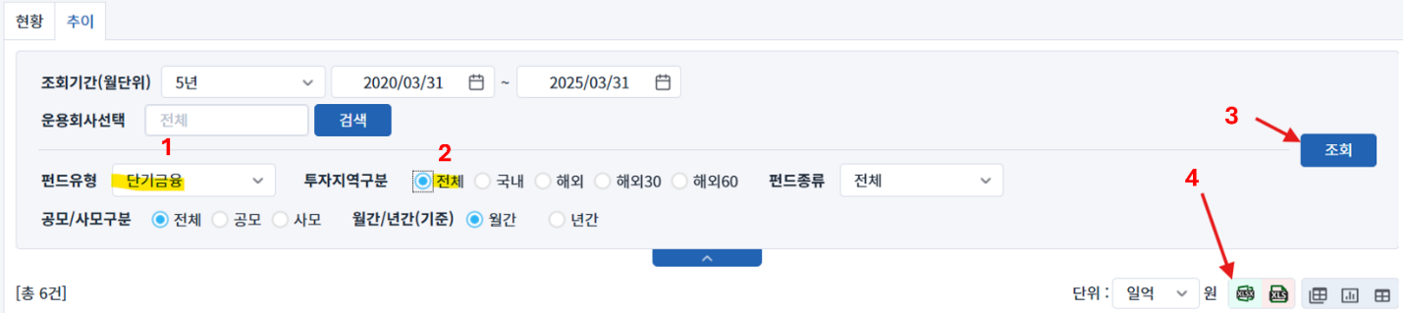
Save all data from all downloaded files using runbook section name (without RawData) and the following mapping:
File row 3 | File row 4 | Decription
자산총액 |  | Total assets
주식 | 금액 | Stock: Amount
 | 비중 | Stock: Weight
채권 | 금액 | Bonds: Amount
 | 비중 | Bonds: Weight
CP | 금액 | CP: Amount
 | 비중 | CP: Weight
예금 | 금액 | Deposit: Amount
 | 비중 | Deposit: Weight
콜론 | 금액 | Call loan: Amount
 | 비중 | Call loan: Weight
기타 | 금액 | Others: Amount
 | 비중 | Others: Weight

For example, for the value below (highlighted in yellow), from the file downloaded according to RawDataEquity section of the runbook, the description of the measure will be - Equity: Stock: Amount

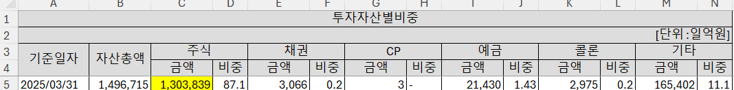
Use the time period from the first column of the files and convert to YYYY-MM format (for example, 2025/03/31 -> 2025-03). Save each release data in a separate DATA file.

Only for initial release enter the date 2025-03-31 in the filter field. In future, use the current date (it will be set automatically by default).
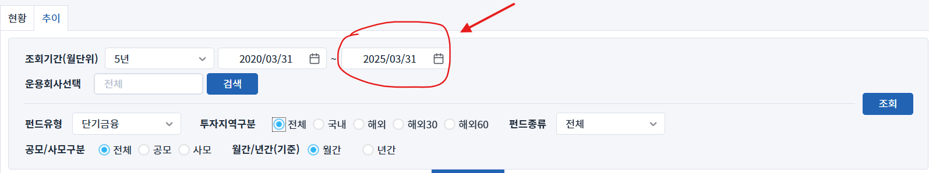

Please inform the DataOps and DataEngineering teams in case of changes in the source tables.

Requirements to the data provided by AfricaAI

Data files format
For on-boarding new datasets and processing new releases the following requirements are applied:
- there should be one archive in .ZIP format that contains 2 files provided in .XLS format per one release - one file with DATA and one file with METADATA (both files are mandatory). Archive name should be as "DATASET_YYYYMMDD.ZIP"", where "DATASET" - specified abbreviation for a dataset, "YYYYMMDD" - timestamp when the file was created, where YYYY - year, MM - month number, DD – day;
- the files format is strictly defined and cannot be changed by AfricaAI team.

File with DATA
Template for file name: “DATASET_DATA_YYYYMMDD.xls”, i.e.” MEXPENFND_DATA_20220601.xls”
Requirements to the file with DATA:
- format - XLS, encoding - Unicode (UTF-8);
- file name: should follow pattern "DATASET_DATA_YYYYMMDD.xls", where "DATASET" - specified abbreviation for a dataset, "YYYYMMDD" - timestamp when the file was created, where YYYY - year, MM - month number, DD - day;
- file content:
  - for data with daily/ weekdaily frequency: YYYY-MM-DD, where YYYY - year, MM - month, DD – day;
  - for data with weekly frequency: YYYY-WW, where YYYY - year, WW - week number (should be two-digits, i.e. 2022-01, 2022-02, etc.). Week number is defined based on the reporting date: reporting date is considered the end of the week, i.e. if reporting date is Wednesday the week is calculated from Thursday till Wednesday – based on that rule the number of the week is defined;
  - for data with monthly frequency: YYYY-MM, MM - month number (should be two-digits, i.e. 2022-01, 2022-02, etc.);
  - for data with quarterly frequency: YYYY-QX, where YYYY - year, X - quarter number;
  - for data with annual frequency: YYYY, where YYYY – year;
  - if provider specifies for reported period that data is Not Available (that could provided in corresponding notes or other way) - fill in that data point with "NA" value;
  - if provider does not specify that data is Not Available and report Empty value for reported period - leave Empty cell;
  - if provider skips some of reporting period - skip it also in the file with data as well;
  - data is provided on one sheet only (multiple sheets are forbidden);
  - two-dimensional format where rows represent reported periods and columns contain timeseries values;
  - reported period(s) should be provided in the following format:
  - values to be provided in decimal format with "." as delimiter (number of digits after "." is limited only by provided value by the source). In order to interpret data correctly the following requirements are applied:
  - column names to be provided in two first rows: in the first row - timeseries ID (CODE), in the second row – timeseries description (description in DATA file is identical to description in file with METADATA).
NB! Timeseries with different frequencies could be provided within the same file as there are different patterns for providing reported periods

File with METADATA
Template for file name: “DATASET_META_YYYYMMDD.xls”, i.e.” MEXPENFND_META_20220601.xls”
Requirements to the file with METADATA:
- format - XLS, encoding - Unicode (UTF-8);
- file name: should follow pattern "DATASET_META_YYYYMMDD.xls", where "DATASET" - specified abbreviation for a dataset, "YYYYMMDD" - timestamp when the file was created, where YYYY - year, MM - month number, DD - day;
- file content: specified metadata attributes that are static unless provider changes something or new timeseries should be added. In case of new timeseries should be added/ updated/ changed - escalate that to Data Engineering team Special BWAT-DFAC Data Engineering <SpecialBWAT-DFACDataEngineering@epam.com> at and Cc: Data Operations team at Special BWAT-DFAC DataOps <SpecialBWAT-DFACDataOps@epam.com>
Notes on METADATA fields from file “DATASET_META_YYYYMMDD.xls”
- With every data release attach file with METADATA
- With every release change only on attribute in the file with METADATA in column “NEXT_RELEASE_DATE” – set “YYYY-MM_DDThh:mm:ss” (YYYY – year, MM – month, DD – day, hh – hour, mm – minutes, ss – seconds. Time should be provide in UTC time) to the time when the next release is going to be processed.

Saving ZIP archive on SFTP
Save the releases in specified per “DATASET” folder (you may create new folder for new DATASET in case of absence of such folder).
Details on SFTP are the following:
1) Dev env
Host: africaai.datadev.dfac.io
2) PRODVAL env
Host: africaai.prodval.data-factory.io
3) PRODHA env
Host: africaai.prodha.data-factory.io
Port: 22

