<$Scr_Ps::0>NANOWRIMO 2022<!$Scr_Ps::0>

<$Scr_Ps::1>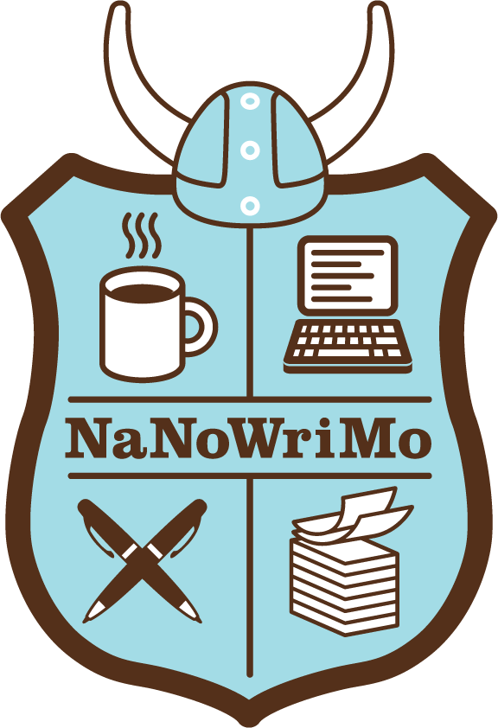

Before You Begin
It's that time again! Thanks for choosing to make Scrivener part of your novel-writing adventure for NaNoWriMo. Although you can just dive in and start using Scrivener straight away, to get the most out of the program we recommend taking a look at some of the following resources:<!$Scr_Ps::1>

<$Scr_Cs::3><$Scr_Ps::2>Tutorial:<!$Scr_Cs::3> An interactive tutorial is available from the <$Scr_Cs::4>Help<!$Scr_Cs::4> menu (you can also find it under the “Getting Started” section of the template chooser, which appears when you go to<$Scr_Cs::4> File ► New Project…<!$Scr_Cs::4>). This is a Scrivener project that walks you through all of the main features of the program as you use it. It’s thorough and takes a while to go through, but once you’ve finished it you’ll be well on your way to becoming a Scrivener expert, and will be able to decide which of its tools will work best for you.

<$Scr_Cs::3>Videos:<!$Scr_Cs::3> We have a range of tutorial videos available on our website at https://www.literatureandlatte.com/learn-and-support/video-tutorials.

<$Scr_Cs::3>Manual:<!$Scr_Cs::3> You may want to take a look at the “Quick Start” guide in the PDF manual, which you can view by selecting Scrivener Manual from the Help menu.<!$Scr_Ps::2><$Scr_Ps::5>
About This Template<!$Scr_Ps::5>
This template has been set up to provide some useful tools for your daily writing sessions. At the end of the month, you will want to compile (<$Scr_Cs::4>File ► Compile…<!$Scr_Cs::4>) your novel for export. By default, when you do so, this project will generate a document in the standard manuscript format for novels. Settings are also provided to make it easy to compile to a paperback-style PDF for self-publishing or an ePub or Kindle ebook.
What This Template Provides
<$Scr_Ps::1>This template is mostly the same as the standard “Novel” project template, except that the following tweaks have been made for NaNoWriMo:<!$Scr_Ps::1><$Scr_Ps::6>
- Project Targets (<$Scr_Cs::4>Project ► Project Targets<!$Scr_Cs::4>) have already been set up for you with a total manuscript target of 50,000 words by default.<!$Scr_Ps::6><$Scr_Ps::7>
- If you are aiming for a different word count, to change the target simply open the panel and click into the manuscript target word count to edit it.
  - You can keep this panel open as you write and watch the bars fill up, but you don’t need to—your progress will also be shown in the search field in the middle of the toolbar. As you write, a thin blue bar will appear at the top of the search field to represent your total progress, and a second bar will show your daily progress at the bottom of the field.
  - The daily session goal has been set (via “Options…” in the Project Targets panel) to calculate the word count target automatically based on how many days there are left until the deadline, so this will change each day, depending on how much you’ve written so far. You can change these options and have a stable daily goal instead if you prefer.<!$Scr_Ps::7><$Scr_Ps::6>
- There is an extra “Daily Target” template document available, which provides a document target of 1,667 words (the number of words you would need to write every day to reach 50,000 words in 30 days). See below for more information on this.<!$Scr_Ps::6><$Scr_Ps::5>
How To Use This Template<!$Scr_Ps::5><$Scr_Ps::1>
Inside the “Manuscript” folder, create a new folder for each chapter and title each folder with the name of the chapter. If you don’t intend to use chapter names, just use something descriptive that tells you what the chapter is about. (You do not need to—and indeed shouldn’t—title the folders “Chapter One” and so on, because chapter numbering will be taken care of automatically during the compile process.) The first chapter folder has been created for you with the placeholder title “Chapter”.<!$Scr_Ps::1><$Scr_Ps::6>
<$Scr_Cs::8>⁠Note:<!$Scr_Cs::8> The “Manuscript” folder is what we refer to in the documentation as the “Draft folder”. It’s just been renamed “Manuscript” in this template.<!$Scr_Ps::6><$Scr_Ps::1>

Create a new text document for each scene inside the chapter folders. (Upon compile, scenes will be separated with the “#” character for standard manuscript format and with a blank line for other formats.)

If you want to keep track of your daily writing by creating a new file for each day’s work, select “Daily Target” from the <$Scr_Cs::4>Project ► New From Template<!$Scr_Cs::4> menu at the start of the day to create a new document. This will create a blank document that has already been set up with a word-count goal of 1,667 words. As you write, you can watch the progress bar in the right of the footer fill as you approach your goal. You can change the target by clicking on the progress bar in the footer.

If you are aiming for a total word count other than 50,000, calculate the number of words you’ll need each day and edit the target in the “Daily Target” document inside the “Template Sheets” folder. (This is the master document that gets copied whenever you use <$Scr_Cs::4>New From Template ► Daily Target<!$Scr_Cs::4>.)

Information about characters can be placed in the “Characters” folder, and information about locations can be placed in the “Places” folder. (These are just regular folders that have had custom icons assigned to them using the <$Scr_Cs::4>Documents ► Change Icon<!$Scr_Cs::4> feature.)

Character and setting sketch sheets have been provided which can be used for filling out information about the people and places in your novel. These are located with the Daily Target document in the “Template Sheets” folder.<!$Scr_Ps::1><$Scr_Ps::6>
- You should not edit the documents in the “Template Sheets” folder directly unless you wish to change the templates (which you are free to do—you may wish to customise the sketch sheets or get rid of them entirely).
- To create a new character sheet, click on the “Characters” folder (or wherever you want to create your new character sheet) and select <$Scr_Cs::4>Project ► New From Template ► Character Sketch<!$Scr_Cs::4>. This creates a new character sketch document for you to edit and fill in with your character details. You can create setting sketch sheets in the same way.
- Alternatively, you can just click “Add”, or hit <$Scr_Cs::4>Ctrl+N<!$Scr_Cs::4>, with the “Characters” or “Places” folders selected to automatically create a new character or setting sketch document in that folder instead of a regular blank text document. This is because each of these folders is set to use the appropriate sketch template as its default document type. This has been set via <$Scr_Cs::4>Documents ► Default Template for Subdocuments<!$Scr_Cs::4>.
- You can view character and setting sketches in the Inspector as follows:<!$Scr_Ps::6><$Scr_Ps::7>
- Select the “Bookmarks” pane in the Inspector.
- If necessary, click on “Document Bookmarks” at the top and switch to “Project Bookmarks” (or use the keyboard shortcut <$Scr_Cs::4>Ctrl+6<!$Scr_Cs::4> to toggle between them).
- Click on the dropdown arrow next to the “Characters” or “Places” folders in the Bookmarks list and choose the sheet you wish to view.<!$Scr_Ps::7>
- A “Notes” folder has been provided for project-level notes. This has been set as the default Bookmarks folder in <$Scr_Cs::4>Project ► Project Settings…<!$Scr_Cs::4>, so that when you create a new document from the Bookmarks sidebar in a Quick Reference panel, the document will be added to this folder.

<$Scr_Ps::1>Remember that only the text of documents contained inside the “Manuscript” folder counts towards your word count, so you can place support materials and make notes anywhere else.

Also, it’s important to know that this project template is merely one suggested way of working with Scrivener—you don’t have to write scenes individually (see “Working with chapters instead of scenes” in the Making Changes document). You’re free to structure things however you want and adjust the compile settings to match. This template just uses one common way of structuring a novel (chapters and scenes) and is designed to work well with a range of Scrivener’s compile formats.<!$Scr_Ps::1>
Compiling
<$Scr_Ps::1>To export your whole book, you “Compile” it via <$Scr_Cs::4>File ► Compile…<!$Scr_Cs::4> You will want to edit the title pages and other front matter in the “Front Matter” folder depending on the final format you want. The “Sample Output” folder inside the Research folder contains examples of documents that have been created by compiling from this template:<!$Scr_Ps::1><$Scr_Ps::6>
- “Standard Manuscript” shows the results when compiling to “Manuscript (Courier)”.
- “Paperback Novel” shows the results when compiling to “Paperback (5.06” x 7.81”)” format with chapter subtitles included, as described in Making Changes.<!$Scr_Ps::6><$Scr_Ps::1>

However: there is no need to compile the project during NaNoWriMo. Instead, you can simply use <$Scr_Cs::4>Update NaNoWriMo Word Count<!$Scr_Cs::4> in the <$Scr_Cs::4>Project<!$Scr_Cs::4> menu to have Scrivener automatically update your word count on the NaNoWriMo servers—see Updating Your Word Count for more information.<!$Scr_Ps::1>
Final Note
Scrivener project templates are flexible and are not intended to restrict you to a particular workflow. You can change, delete or move the files and folders contained in the template to suit how you work.

Like all templates in Scrivener, this project was originally created from the “Blank” template. We’ve simply added a few folders and set everything up in ways that should be useful to novel writers. Everything you can do with this project, you could equally do by creating a “Blank” project and setting it up yourself. You can even enable the “Update NaNoWriMo Word Count” feature if you wish.

You can create your own templates by setting up a skeletal project with the files, folders and settings you would like to use for new projects and using <$Scr_Cs::4>File ► Save As Template…<!$Scr_Cs::4>

<$Scr_Ps::1>That's it! We wish you the best of luck in reaching your goal this year, and remember that if you win, you will receive a coupon which can be used to buy Scrivener for only 50% of the regular price. This coupon can be used for the Mac or Windows versions of Scrivener. Even if you don’t win, you’ll still have a few days to enter “NANOWRIMO22” into the coupon code section of our store to apply a 20% discount.

Happy writing!
—Literature & Latte Team<!$Scr_Ps::1>

