**融云集成基础修改说明**

字体颜色修改

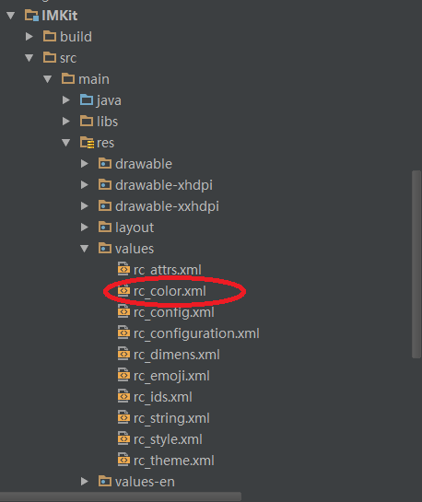

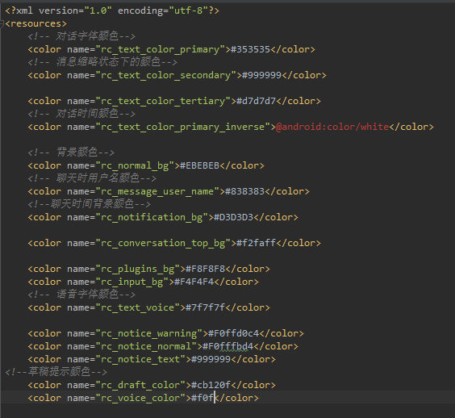

**气泡修改**

将对应的.9图片换成你需要的.9图片

命名和SDK一致



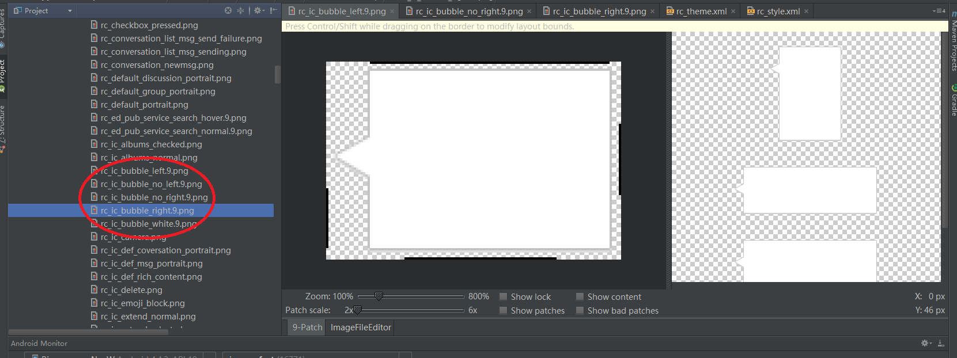

背景图片修改

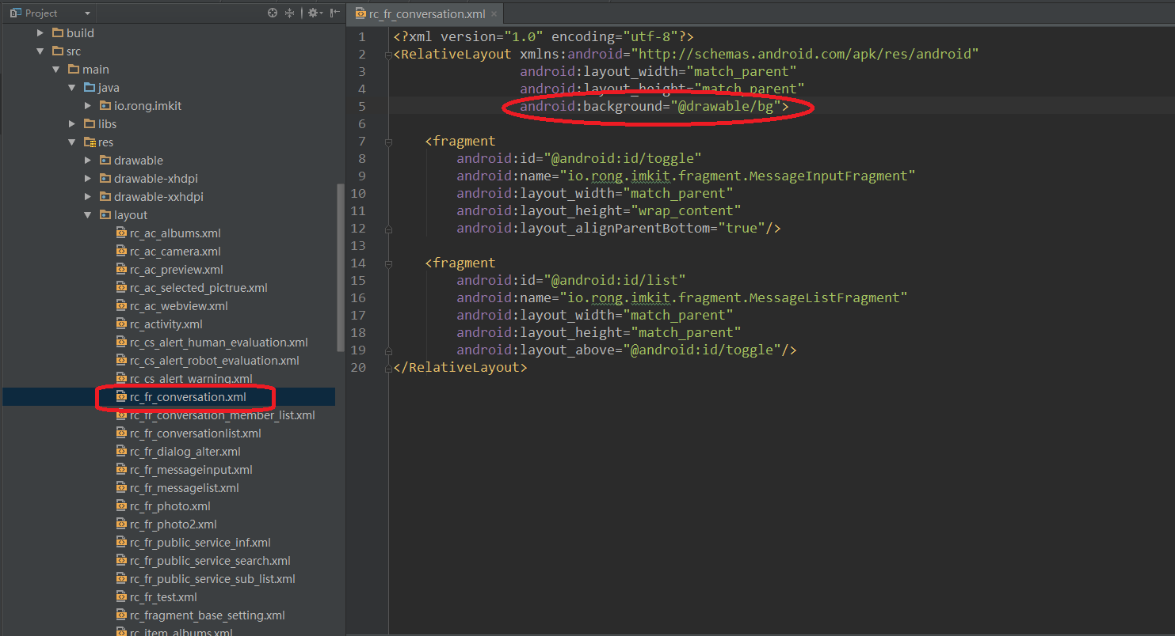

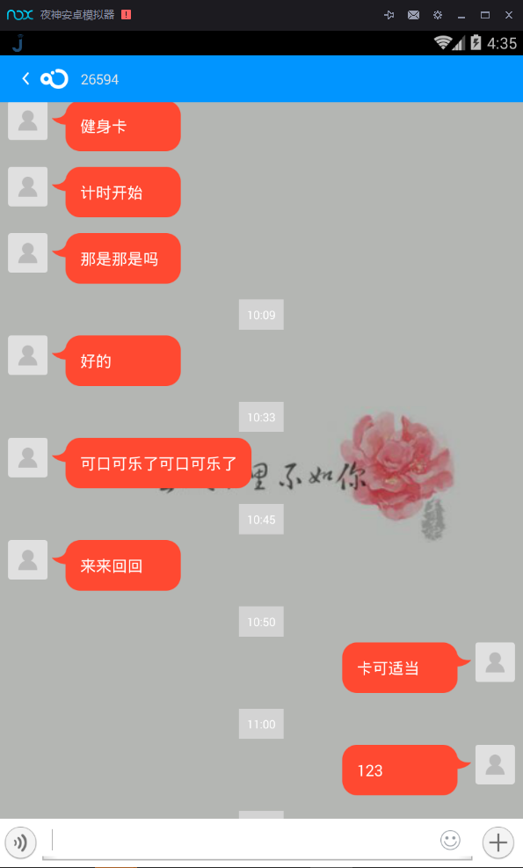

switch (ev.getAction()) {  
  
 case MotionEvent.*ACTION_DOWN*:  
 mDownx = ev.getX();  
 mDowny = ev.getX();  
 getParent().requestDisallowInterceptTouchEvent(true);  
  
 break;  
 case MotionEvent.*ACTION_MOVE*:  
 float a = ev.getX();  
 float b = ev.getY();  
  
 if (Math.*abs*(ev.getX() - mDownx) > Math.*abs*(ev.getY() - mDowny)) {  
 getParent().requestDisallowInterceptTouchEvent(true);  
 } else {  
 getParent().requestDisallowInterceptTouchEvent(false);  
 }  
 break;  
 case MotionEvent.*ACTION_UP*:  
 case MotionEvent.*ACTION_CANCEL*:  
 getParent().requestDisallowInterceptTouchEvent(false);  
 break;  
  
 default:  
 break;  
}