18.065 Lab 3

Dimitris Koutentakis

[dkout@mit.edu](mailto:dkout@mit.edu)

In this lab we implement least squares regression in order to fit four different types of data to polynomial functions of different order N from N=0 to N = 9. The four different types of data we tested were points that come from the function

(a) f(x) = sin(x),

(b) f(x) = sin(pi\*x)/(pi\*x),

(c) a function that is f(x) = -x for x in [0,1] and 0 for x>0 and

(d) a function that is f(x) = x for x in [-1,0], f(x) = -x for x in [0,1] and 0 elsewhere.

For the first two we used 10 points to fit to the data and for the last two we used 11. The function we try to fit is in shown in a thick blue line, the points we are fitting are in light blue circles and the rest is according to the legend.

As we can see from the attached figures, the polynomials fit locally quite well but don’t work well in the whole range of the function. As the degree of the polynomial increases, the fit becomes better. It is also interesting to note how for the odd functions, case (a) and (c) the polynomials of odd degree work well (N = 2k-1 works just as well as N = 2k-2) and for the even functions, polynomials of even degree work well (N = 2k works just as well as N = 2k+1). We can see that by adding degrees to our fit, the fitted function has more oscillations to try to fit better the given function. The most interesting case in my opinion is the last one, where we can see that each new degree makes a difference to how closely we can approximate our function.

The plots follow.

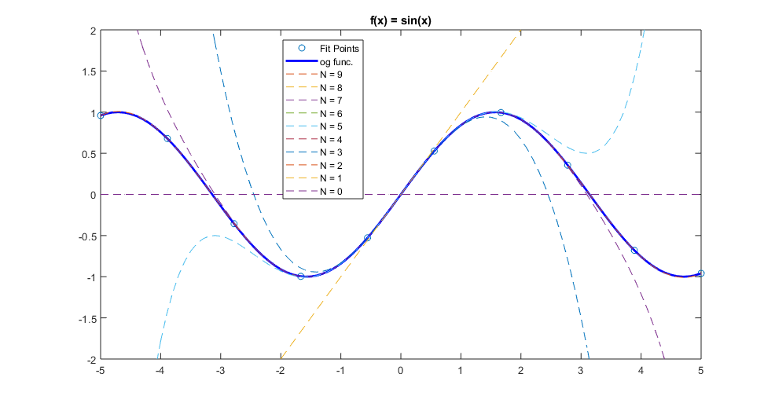(a)

(b)

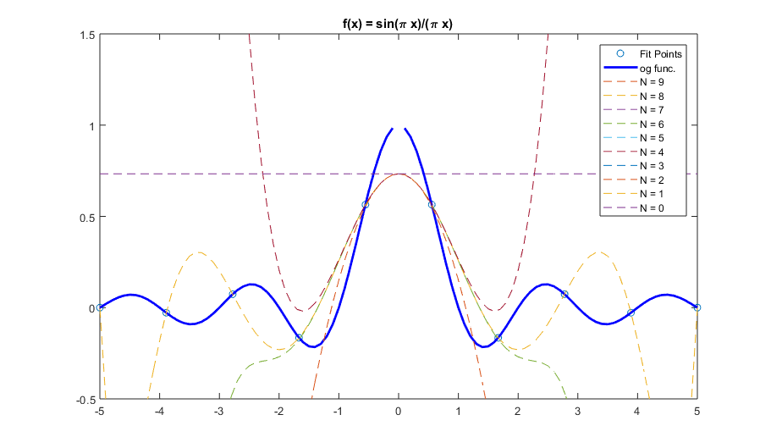

(c)

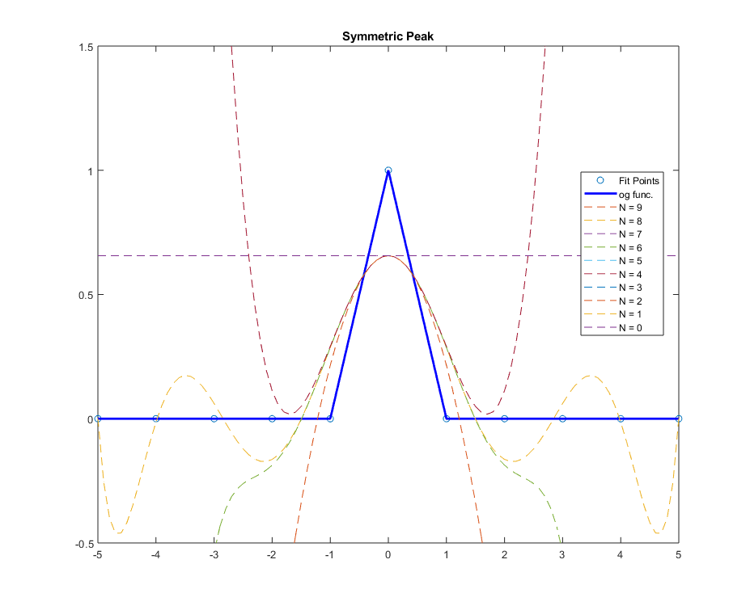

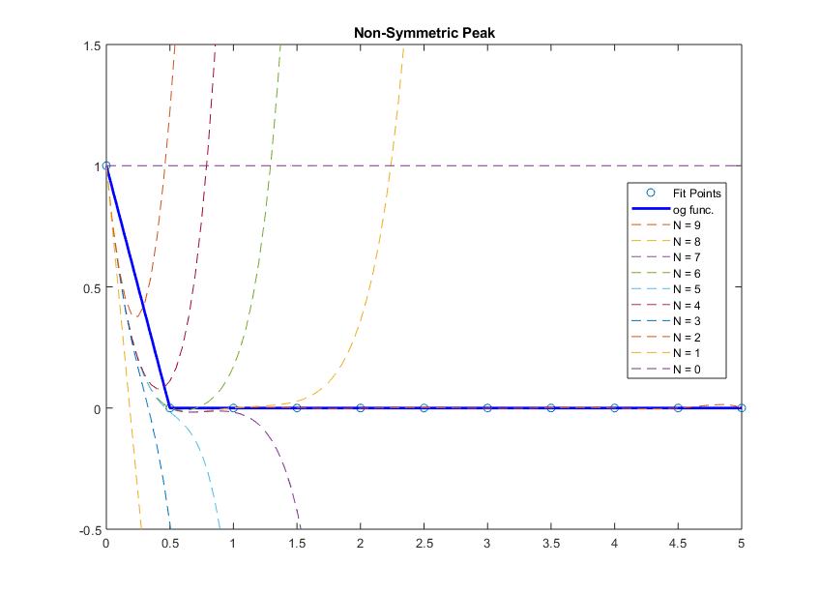(d)