Lab#8: Brandon Kowal, Bernard Owusu Sefah

Binary Adder and Subtractor

Abstract

The lab we had to design a half subtractor and a full subtractor. This will help us with our combinational logic circuit minimization techniques with derivation of minimal two-level SOP form. The half subtractor will display the difference and borrow and the full subtractor displays the difference and the B-out. The IC 7483 is used to design the adder or subtractor and display the binary answer.

Introduction

This lab is to design a binary adder and subtractor. This lab will help our combinational logic circuit minimization techniques with derivation of minimal two-level SOP form, use standard MSI/LSI combinational logic building blocks and use WinlogiLab for design and simulation.

Methods

1.Construct a half subtractor using all nand gate and tested the circuit simulation using winlogilab.

2. We then constructed another half full subtractor using all nand gates and combined it with the first subtractor created to make a full subtractor.

3. We first had to construct the half subtractor on the ETS-7000 and the test its functionality using a truth table.

4. We went on to build the second half subtractor and added it to the first half subtractor to make a full subtractor and tested its functionality to make sure it worked.

5. Finally, we had to construct the 4-bit parallel adder subtractor based on the 7483 IC as finalized in Pre-Lab Task 6

Results

Fig 1 showing half subtractor with a carry

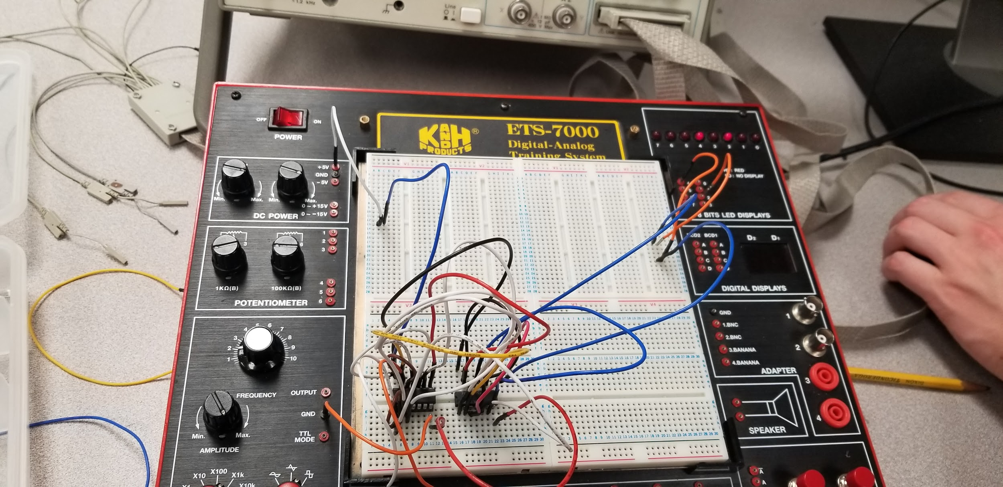

Fig 2 showing half subtractor without carry

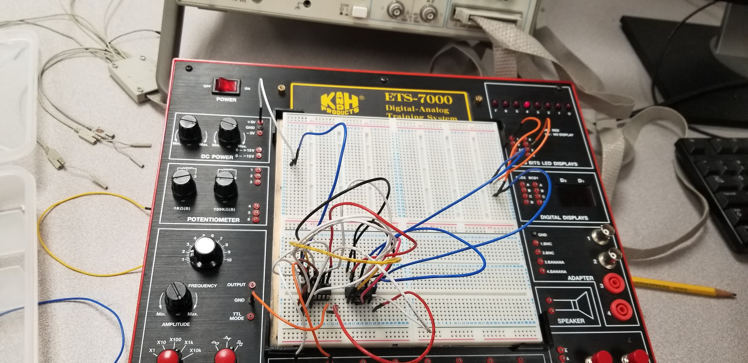

Fig 3 showing full subtractor with a carry

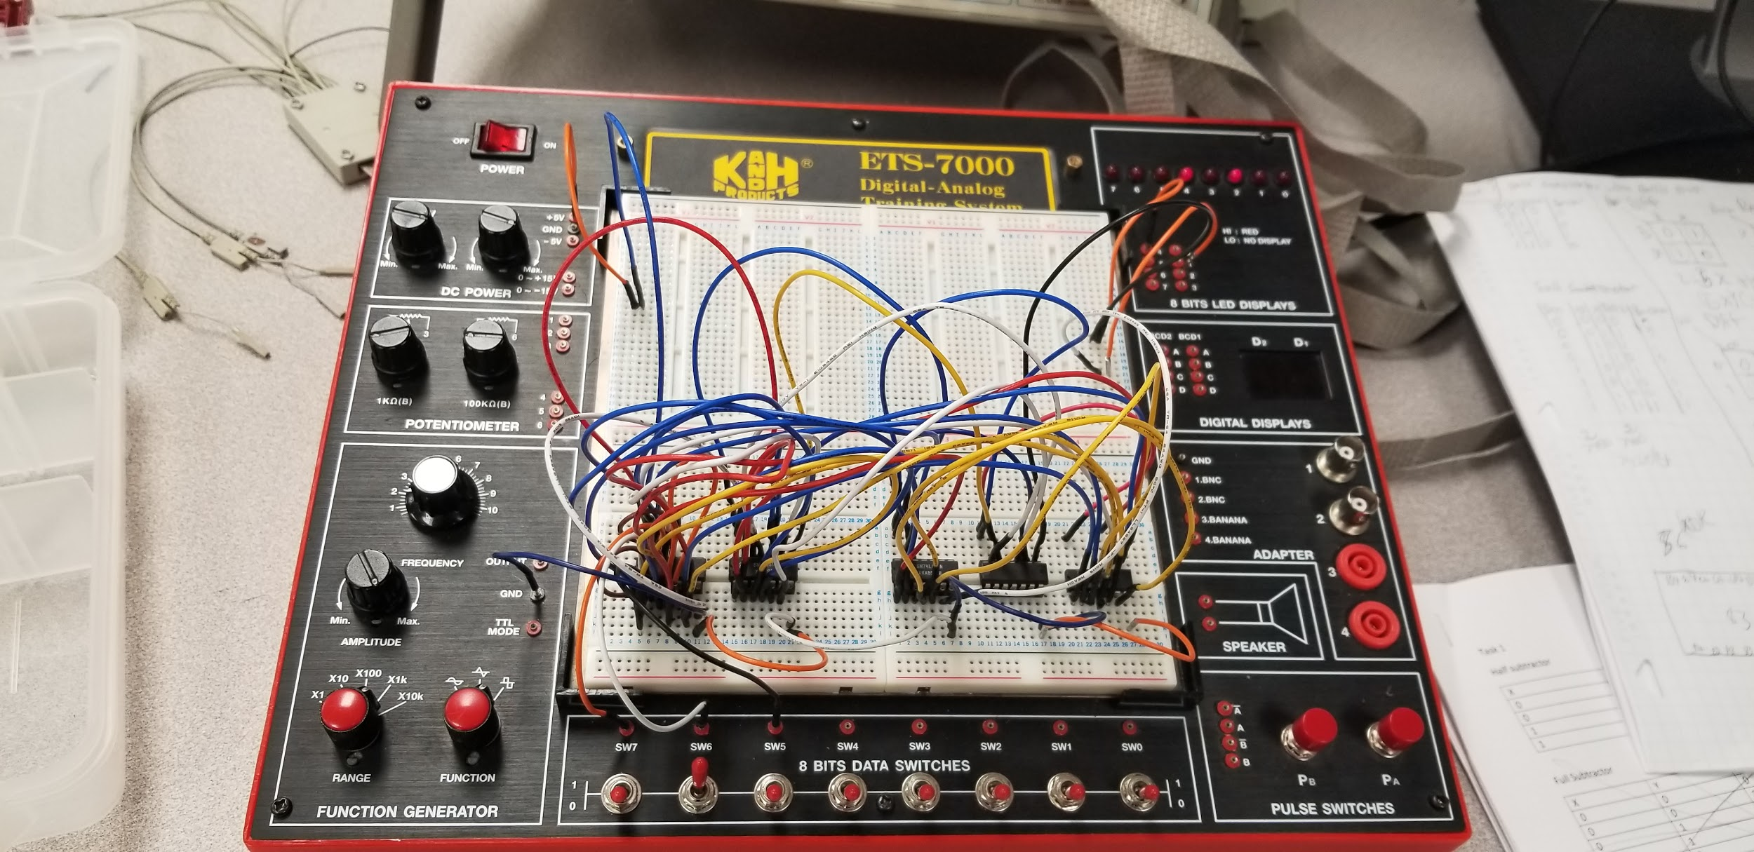

Fig 4 showing 4-bit binary parallel adder subtractor based on the 7483 IC as finalized in Pre-Lab Task 6

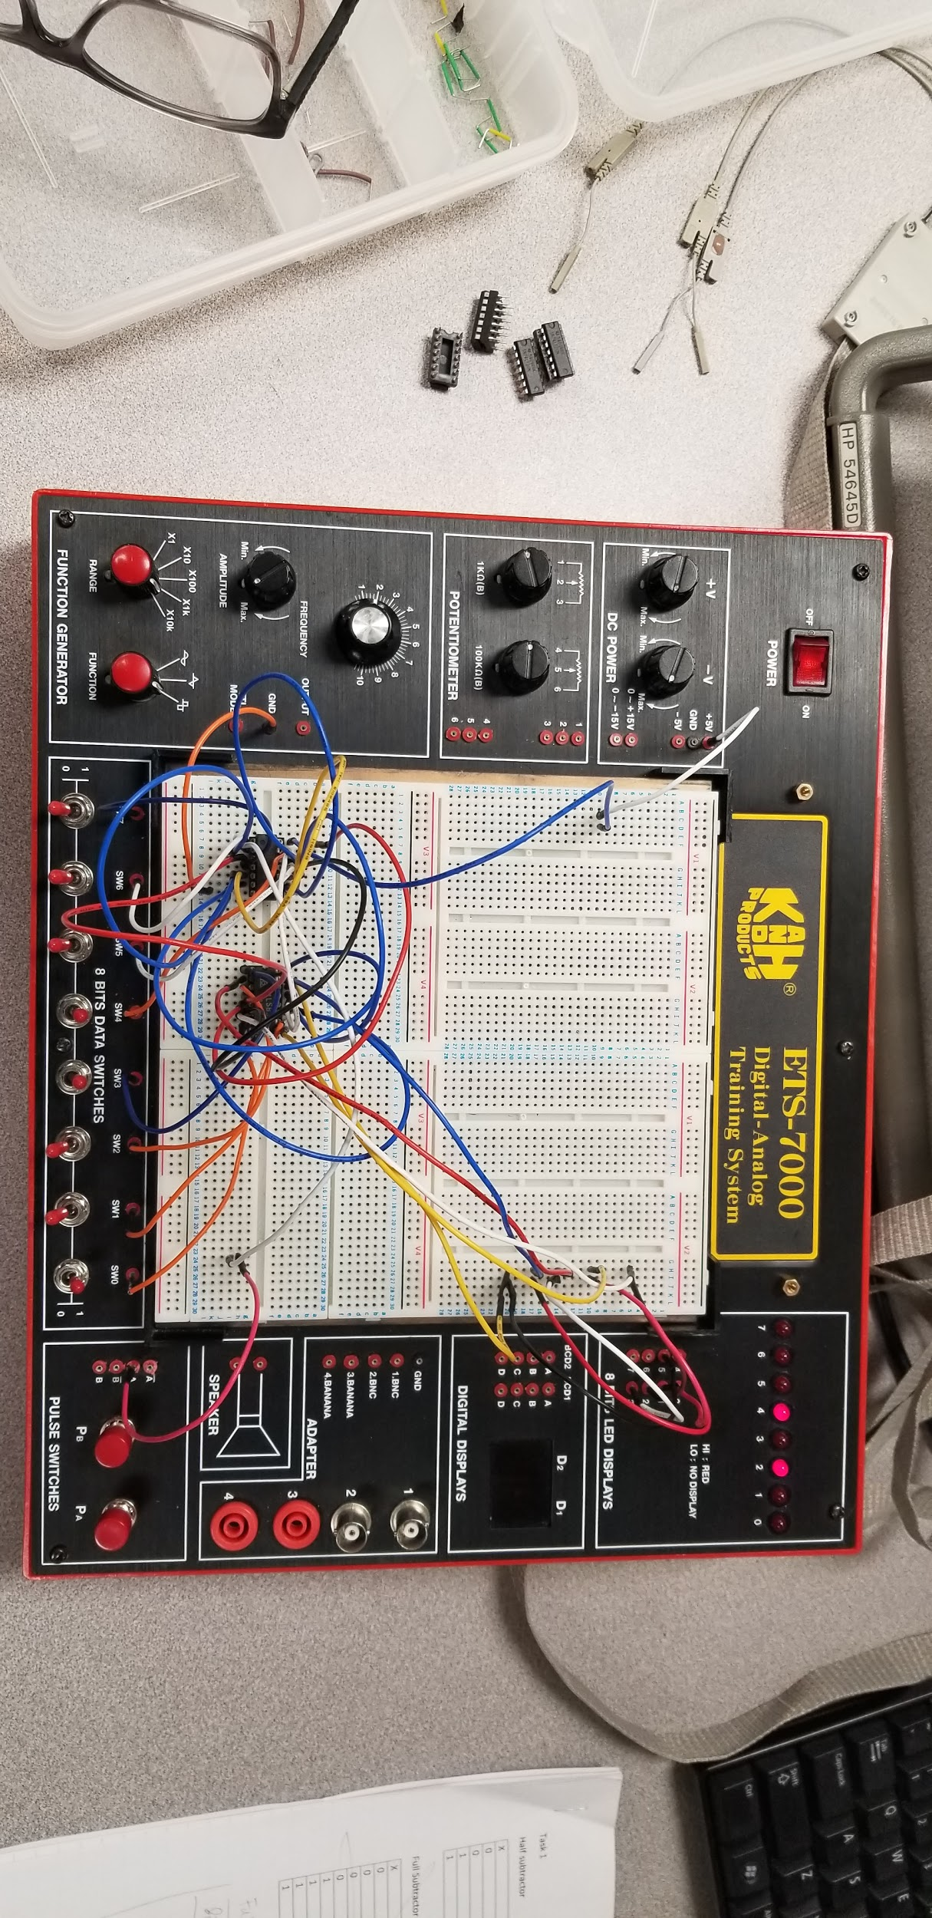

Discussion

We were able to display lights from the half subtractor showing the borrow and difference. Than for the full subtractor we were able to display the difference and B-out. For the final task we used the 7483 and 7486 to make a full adder or subtractor the Mode button would choose if it was an adder or a subtractor and we were able to display the correct binary outputs.

Conclusion

We concluded that making a full subtractor and testing its functionality helped us understand more about what adders and subtractor’s were better than we did in class because this was more of a hands-on experience.

Appendix

Lab Attendance:         Bernard Owusu Sefah: Yes     Brandon Kowal: Yes

Involvement in Lab:        Bernard Owusu Sefah: 55 Brandon Kowal: 45

Involvement in Lab Report:     Bernard Owusu Sefah: 55 Brandon Kowal: 45