Secure Hash Algorithm Classes

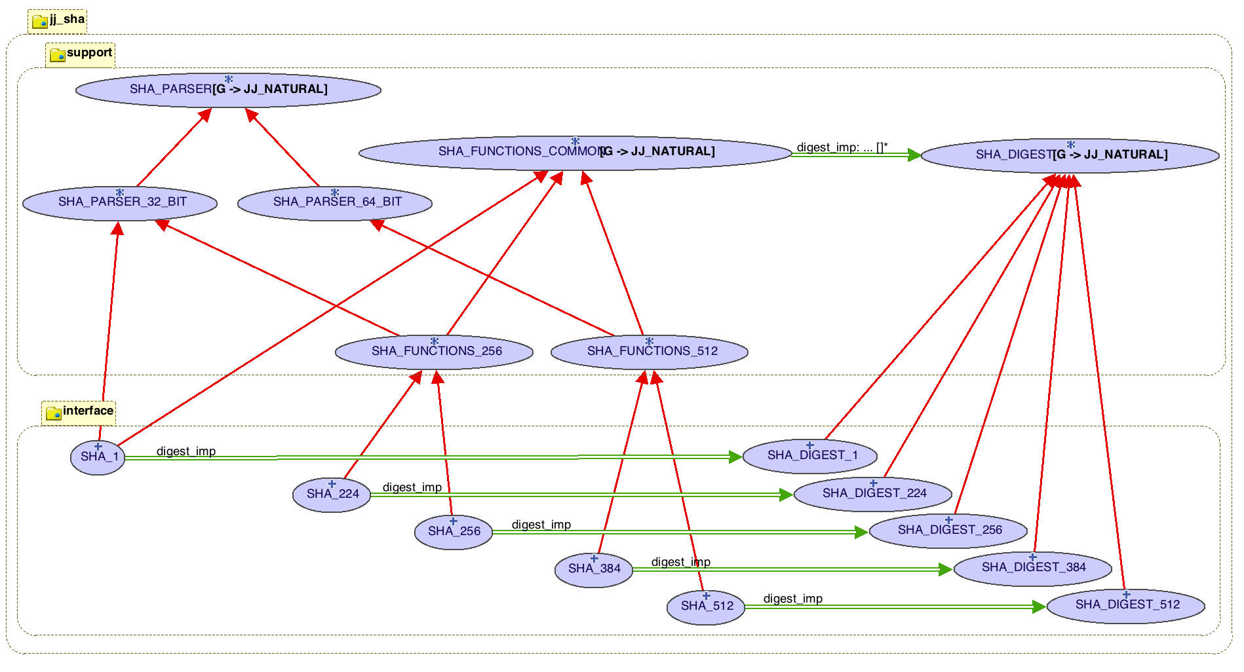

# Interface Cluster

The classes in the interface provide methods for producing a SHA-xxx hash value from a string. An SHA_xxx object performs the calculations, placing the resulting hash value in a corresponding SHA_DIGEST_xxx object.

local

sha_1: SHA_1

sha_512: SHA_512

d_1: SHA_DIGEST_1

d_512: SHA_DIGEST_512

m: STRING_8

do

-- Example classes and two ways to use an SHA_xxx class

m := “abc”

create sha_1.make (m)

create sha_512

sha_512.set_message (m)

-- Calculate and print the SHA hash tags

d_1 := sha_1.digest

d_512 := sha_512.digest

print (“SHA-1 value: “ + d_1.as_string + “%N”)

print (“SHA-512 value: “ + d_512.as_string + “%N”)

end

The output (with some formating) is shown here:

SHA-1 value: a9993e36 4706816a ba3e2571 7850c26c 9cd0d89d

SHA-512 value: ddaf35a193617aba cc417349ae204131 12e6fa4e89a97ea2 0a9eeee64b55d39a

2192992a274fc1a8 36ba3c23a3feebbd 454d4423643ce80e 2a9ac94fa54ca49f

# Support Cluster

The support cluster contains classes that do the work. The SHA_PARSER and descendents preprocess and pad a message and the SHA_FUNCTION_xxx classes perform the hashing. Hash values for the calculations are initialized and maintained in the SHA_DIGEST_xxx classes.